Technical Proposal
Simulator-Ready Steel Welding Training Tutorial
Revised Version with 30 / 60 / 90 / 180 Minute VR Options
VR-First Welding Training System for Bangladesh
SMAW | GMAW/MIG | Bangla-first Delivery | Safety-Gated Assessment | Duration-Based Segments
Prepared By: Riseup Labs


Table of Contents
1. Executive Summary 3
2. Project Understanding 3
3. Duration-Based VR Options 4
4.1 Option Overview 4
4.2 Duration-Wise Simulator Behavior 4
4.3 Indicative Time Distribution per Learner Session 5
4.4 Scope Depth by Option 5
5. Proposed Scope 5
5.1 Learner VR Training Application 6
5.2 Instructor Web Dashboard 6
5.3 Backend and Content Management 6
5.4 Future Scalability 6
6. Proposed Technical Approach 6
6.1 VR-First Implementation Approach 6
6.2 Modular Simulator Design 6
6.3 Safety-Gated Assessment Logic 8
6.4 Localization Approach 8
7. Technical Diagrams 8
8. Proposed Technical Stack 11
8.1 Recommended Deployment Model 11
9. Development Methodology 11
10. Deliverables 12
10.1 Deliverables by Duration Option 12
11. Testing and Quality Assurance 12
12. Assumptions and Initial Boundaries 13
12.1 Key Assumptions 13
12.2 Initial Implementation Boundary 13
13. Conclusion 13

1. Executive Summary
Riseup Labs proposes to develop a simulator-ready steel welding training solution for Bangladesh. The solution will convert the approved tutorial direction into a VR-first immersive learning system focused on safe, guided practice for steel welding learners. The system will support Bangla-first guidance, English technical terms where required, safety-gated progression, structured practice modules, visual inspection learning, scoring, and instructor visibility.
This revised version adds the client-requested duration-based VR options: 30 minutes, 60 minutes, 90 minutes, and 180 minutes. These options are intended to explain how the simulator behaves under different training durations and how the implementation effort can be segmented for budget planning. The minutes represent the approximate learner-side VR experience duration, not the development timeline.

2. Project Understanding
The training product is positioned as a professional welding simulator tutorial for Bangladesh with four clear priorities: SMAW, GMAW/MIG, VR-first immersive delivery, and safety-gated assessment. The proposed technical solution keeps these priorities as the foundation of the system design.
Design Area | Proposal Alignment
Primary learner level | Novice to lower-intermediate practical trainee
Metal scope | Steel / carbon steel first
Core welding processes | SMAW and GMAW/MIG for the initial simulator scope; TIG kept as future scalability
Delivery language | Bangla-first UI and voice prompts with English technical terms retained where required
Delivery setting | Technical institute, short-course center, fabrication training bay, or similar controlled training environment
Skill emphasis | Safety, setup discipline, torch/electrode control, visual inspection, shutdown, and instructor review

Source Direction | Technical Response
VR-first immersive delivery | Unity-based VR application using XR Interaction Toolkit, OpenXR, and headset build support.
Safety-gated assessment | Mandatory PPE, hazard scan, emergency readiness, setup, practice, inspection, and shutdown gates before score completion.
SMAW and GMAW/MIG focus | Two core process modules with a shared training engine and process-specific setup/practice behavior.
Bangladesh delivery context | Bangla-first content model, SI units, and institute-friendly training workflow.
Visual inspection and defect diagnosis | Guided defect recognition, accept/retry logic, and instructor review dashboard.
Duration-based options | Four VR experience options: 30, 60, 90, and 180 minutes for budget segmentation.

3. Duration-Based VR Options
The following options are designed to help the client select a practical VR simulator package based on the required training depth and available budget. The shorter options reduce development effort by limiting scene count, content depth, practice variations, scoring complexity, 3D asset scope, and QA cycles. The longer options provide a more complete training experience with deeper interaction, more attempts, better reporting, and stronger assessment coverage.

4.1 Option Overview
Option | VR Duration | Positioning | Recommended Use | Budget Segment
Option A | 30 minutes | Starter VR Welding Simulation | Short demo, pilot, investor/client showcase, or basic introductory training. | Entry / lowest scope
Option B | 60 minutes | Core VR Training Package | Basic institutional training where learners need safety, setup, one process practice, and result tracking. | Standard
Option C | 90 minutes | Enhanced VR Training Package | More complete training with deeper process practice, corrective feedback, and inspection logic. | Advanced
Option D | 180 minutes | Full VR Training Package | Complete simulator-ready training experience for serious deployment across training centers. | Full / highest scope

4.2 Duration-Wise Simulator Behavior
Training Phase | 30 Min | 60 Min | 90 Min | 180 Min
Learner onboarding | Quick intro, language selection, basic controls. | Guided intro with VR control familiarization. | Detailed onboarding with comfort checks and scenario briefing. | Complete onboarding, device orientation, job card briefing, and learner readiness check.
Safety gate | PPE selection and essential hazard scan. | PPE, hazard scan, emergency stop awareness. | PPE, hazard scan, emergency readiness, hot-metal awareness. | Full safety gate with PPE, hazard scan, emergency readiness, fire safety prompts, housekeeping, and mandatory pass/fail logic.
Process setup | One simplified setup path, preferably SMAW starter setup. | Core setup path for selected primary process with guided steps. | SMAW and GMAW/MIG setup steps with guided validation. | Full setup coverage for SMAW and GMAW/MIG with consumables, settings, shielding/gas awareness, clamp/workpiece prep, and wrong-action correction.
Practice activity | One guided bead/practice attempt with basic visual cues. | One or two practice attempts with technique prompts. | Multiple guided attempts with corrective prompts and limited retry logic. | Full practice sequence with multiple attempts, process-specific technique cues, retry path, attempt history, and detailed scoring.
Visual inspection | Basic pass/fail visual check. | Common defect identification and short explanation. | Defect diagnosis with guided feedback and remediation hints. | Detailed visual inspection activity covering common discontinuities, learner decision, defect feedback, remediation route, and instructor visibility.
Scoring and report | Basic completion result. | Score summary and instructor dashboard record. | Detailed score by safety, setup, practice, and inspection. | Complete rubric-based score, attempt history, failed gate details, repeated mistakes, remediation notes, and exportable reporting.

4.3 Indicative Time Distribution per Learner Session
Session Component | 30 Min | 60 Min | 90 Min | 180 Min
Onboarding and VR control familiarization | 3 min | 5 min | 8 min | 12 min
PPE, hazard scan, and emergency readiness | 6 min | 10 min | 15 min | 25 min
Job card and process setup | 7 min | 15 min | 20 min | 35 min
Welding practice interaction | 10 min | 22 min | 32 min | 78 min
Visual inspection and defect diagnosis | 3 min | 6 min | 12 min | 20 min
Shutdown, result, and instructor report | 1 min | 2 min | 3 min | 10 min
Total | 30 min | 60 min | 90 min | 180 min

4.4 Scope Depth by Option
Area | Option A - 30 Min | Option B - 60 Min | Option C - 90 Min | Option D - 180 Min
VR scenes | Single compact welding booth scene. | Welding booth plus guided setup/inspection flow. | Multiple guided scenes or scene states for setup, practice, and inspection. | Full scene flow with structured module journey and reusable simulator engine.
3D asset depth | Essential PPE, workpiece, welding booth, and basic equipment props. | More complete equipment visuals and process-specific objects. | Improved props, workpiece states, cues, and defect visuals. | Full optimized asset pack for PPE, tools, equipment, booth, warning cues, workpiece states, and defect visuals.
Training content | Introductory script and short guided task. | Core training script with basic assessment. | Expanded script with remediation and learner guidance. | Complete training content pack, detailed prompts, Bangla-first guidance, and English technical terms.
Scoring logic | Completion-based score. | Basic rubric by safety, setup, and practice. | Detailed rubric with retry logic and failed gate tracking. | Full safety-gated rubric, process scoring, attempt history, repeated mistake tracking, and instructor review.
Instructor visibility | Basic completion record. | Learner progress and score summary. | Attempt history and score breakdown. | Full dashboard with module status, failed gates, repeated mistakes, remediation needs, and exportable reports.
Best fit | Proof of concept / demo. | Basic training deployment. | Balanced training product. | Complete training product.

5. Proposed Scope
The proposed scope remains focused on the core welding simulator and does not add unrelated LMS, marketplace, live machine integration, or multi-user VR features in the initial implementation. The scope below can be adjusted based on the selected duration option.

5.1 Learner VR Training Application
- Learner onboarding with language selection and module access.
- Job card screen showing process, material, joint type, pass criteria, and required safety checks.
- VR-guided PPE selection and hazard scan using immersive visual cues and pass/fail gates.
- Emergency readiness module covering stop control, extinguisher location, exit awareness, and hot-metal tagging logic.
- SMAW setup and practice module covering setup, simulated electrode control, bead guidance, slag-removal prompts, and attempt scoring.
- GMAW/MIG setup and practice module covering wire/gas setup sequence, gun angle, travel consistency, shielding awareness, and attempt scoring.
- Visual inspection and defect diagnosis screens for common visible discontinuities and learner decision-making.
- Safe shutdown and housekeeping checklist before attempt completion.
- Duration-based content unlocking so the selected option can control how much training depth is exposed to the learner.

5.2 Instructor Web Dashboard
- Basic instructor login and role-based access.
- Learner list, module completion status, attempt history, and score details.
- Review of failed safety gates, repeated mistakes, and remediation needs.
- Content visibility controls for published training modules and assessment rubrics.
- Exportable progress summary for training-center reporting.
- Option-wise reporting depth based on selected VR duration package.

5.3 Backend and Content Management
- Central API for authentication, module delivery, assessment rules, score submission, and reports.
- Database for learners, instructors, modules, attempts, rubric weights, and result history.
- Asset storage for 3D models, VR environment assets, safety illustrations, voice prompts, and localized content files.
- Admin-side content publishing workflow so reviewed modules can be released without rebuilding the full app each time.
- Configurable option flag to manage whether a client build is 30, 60, 90, or 180 minutes.

5.4 Future Scalability
The meeting discussion mentioned planning around basic welding categories and future expansion such as TIG. The revised proposal keeps TIG as a future scalability option rather than adding it into the first release by default. This keeps the initial development cost controlled while allowing the technical architecture to support additional process modules later.

6. Proposed Technical Approach

6.1 VR-First Implementation Approach
The solution will use VR-first delivery because the training content depends heavily on immersive practice, guided observation, setup discipline, safety scanning, and visual inspection. VR allows trainees to practice inside a controlled virtual welding booth with prompts, warnings, scoring cues, and instruction panels before entering real workshop practice.

6.2 Modular Simulator Design
- Each module will be built around a job card, safety gate, setup activity, simulated practice task, inspection task, score result, and remediation path.
- SMAW and GMAW/MIG will share a common engine for safety gates, scoring, reports, and content delivery while keeping process-specific training logic separate.
- The app will support 3D/VR asset reuse so common objects such as PPE, welding booth elements, coupons, clamps, and warning signs do not need to be rebuilt for each module.
- Training content will be structured as configurable module data where possible, reducing hard-coded changes and supporting easier updates after technical review.
- The duration option can be controlled through content configuration and module availability rather than rebuilding the complete system for each package.

6.3 Safety-Gated Assessment Logic
Gate | Assessment Area | System Behavior
Gate 1 | PPE selection and hazard scan | Mandatory pass before setup opens. Shorter options may use a compact version; full option includes detailed pass/fail feedback.
Gate 2 | Emergency readiness | Mandatory check before process-specific setup.
Gate 3 | Machine and consumable setup | Minimum score required before practice attempt.
Gate 4 | Practice control | Technique scoring with corrective prompts and retry path based on selected option.
Gate 5 | Inspection and shutdown | Completion score requires visual defect decision and safe closeout.

6.4 Localization Approach
- Bangla-first UI and voice prompts will be supported through a localization file structure.
- English technical labels will be retained for accepted process names, controls, electrode/wire identifiers, and machine terminology where useful.
- Units will follow practical training labels such as mm, V, A, and L/min.
- The final content pack should be reviewed by a welding/mechanical subject-matter expert and a senior welding technician before production release.

7. Technical Diagrams
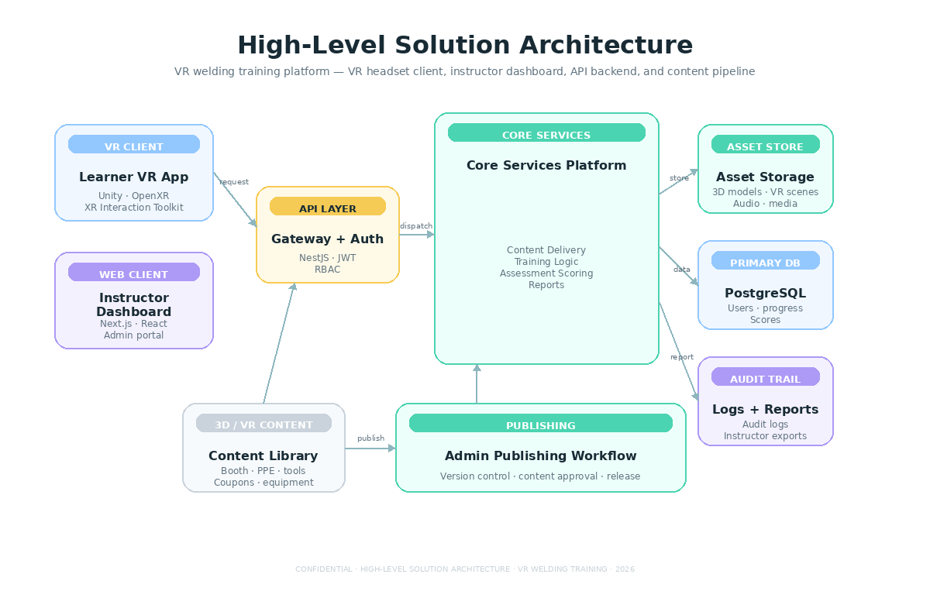

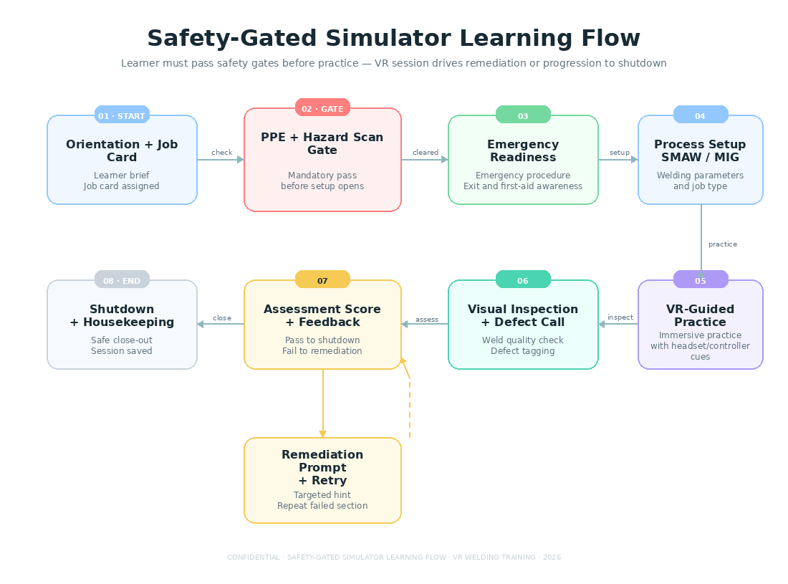

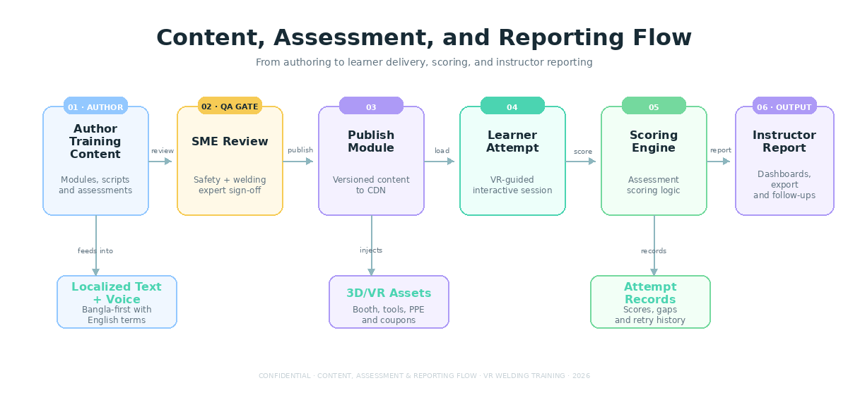

8. Proposed Technical Stack
Layer | Recommended Technology | Reason
VR Training App | Unity, C#, XR Interaction Toolkit, OpenXR, Meta Quest / PC VR support | Immersive VR delivery with headset/controller interaction support and reusable training scenes and 3D assets.
Web Dashboard | Next.js, React, TypeScript | Fast instructor portal for learner progress, content visibility, score review, and reports.
Backend API | NestJS, Node.js, TypeScript | Structured API layer for authentication, module delivery, scoring, option configuration, and reporting.
Database | PostgreSQL | Reliable relational storage for learners, instructors, modules, attempts, rubrics, option mapping, and audit records.
Asset Storage | S3-compatible object storage with CDN | Stores 3D models, images, audio prompts, VR environment assets, and downloadable reports.
Authentication | JWT/session-based auth with RBAC | Separates learner, instructor, and admin-level access.
DevOps | Docker, GitHub Actions, cloud VM/container hosting | Repeatable build, staging, and deployment workflow.
Testing Tools | Unity Test Framework, Jest, Playwright, Postman/Newman | Supports automated checks across VR logic, API, dashboard, and regression flows.

8.1 Recommended Deployment Model
- VR application distributed through controlled headset build, side-loaded package, Meta Quest/PC VR package, or app-store release based on client preference.
- Backend and instructor dashboard deployed to a secured cloud environment with staging and production separation.
- Media and 3D assets served through cloud storage and CDN to reduce VR application package size.
- Role-based access and encrypted communication for learner records and instructor data.
- Option-wise builds can be managed through configuration, licensing, or published module access depending on the selected commercial model.

9. Development Methodology
The project will follow an Agile delivery model with fixed-scope planning at the feature level, sprint-based development, internal QA at the end of each sprint, and controlled releases to staging before production deployment.
Workstream | Activities
Discovery and validation | Confirm final module scope, learner roles, duration option, content structure, training rubrics, device assumptions, and review responsibilities.
UX/UI and instructional design | Create learner journey, instructor dashboard screens, safety gate flows, duration-wise learning paths, and VR interaction patterns.
3D and VR environment preparation | Prepare optimized 3D models, VR welding booth environment, PPE visuals, equipment assets, warning cues, and process-specific interaction assets based on selected option.
Backend and dashboard development | Build APIs, database schema, admin/instructor screens, scoring rules, option configuration, and reporting features.
VR application development | Build VR scenes, job cards, safety gates, setup modules, practice feedback, inspection screens, and local content handling.
QA and release | Run functional, VR device, interaction, performance, localization, security, and regression tests before deployment.
Handover | Deliver source code, deployment package, admin guide, technical documentation, and training session.

10. Deliverables
Deliverable | Description
Requirement and Scope Matrix | Confirmed module list, user roles, duration option, content assumptions, and acceptance criteria.
UX/UI Design Pack | Learner app screens, instructor dashboard screens, key interaction flows, and image placeholder layouts.
Technical Architecture Document | System architecture, database model, API overview, deployment model, option configuration, and security approach.
VR Training Application | VR headset-ready training application with duration-based SMAW and GMAW/MIG training flow.
Instructor Web Dashboard | Learner tracking, attempt history, score view, module visibility, and report export.
Backend API and Database | Authentication, module delivery, scoring, content management, option mapping, attempt records, and reporting APIs.
3D/VR Asset Pack | Optimized welding booth elements, PPE, coupons, equipment visuals, warning cues, and placeholder-ready assets based on selected package.
QA Documentation | Test cases, QA execution summary, defect log, compatibility notes, and release checklist.
Deployment Package | Staging and production deployment setup with environment configuration guide.
Handover Documents | Admin guide, instructor quick guide, technical handover notes, and source code repository handover.

10.1 Deliverables by Duration Option
Deliverable Area | 30 Min | 60 Min | 90 Min | 180 Min
VR learning flow | Compact guided demo flow. | Core guided learning flow. | Enhanced module flow with feedback. | Full structured simulator learning journey.
Process coverage | Primary starter process path. | Primary process with intro to second process where approved. | SMAW and GMAW/MIG with stronger depth. | Full SMAW and GMAW/MIG coverage for initial release.
Practice attempts | Single guided attempt. | Limited attempts. | Multiple guided attempts. | Full attempt history and retry pathway.
Assessment | Basic completion score. | Basic safety/setup/practice score. | Detailed score breakdown. | Complete rubric-based assessment.
Dashboard | Completion view. | Learner score summary. | Attempt history and failed gate details. | Full instructor reporting and export.
Documentation | Basic handover guide. | Admin/instructor guide. | Detailed guide and QA notes. | Full technical handover package.

11. Testing and Quality Assurance
QA will be embedded across the project to ensure that the simulator is stable, safe in its instructional flow, understandable to learners, and reliable for instructors. The test depth will scale based on the selected duration option.
- Requirement coverage testing against approved scope, selected duration option, and module acceptance criteria.
- Functional testing for learner onboarding, job card access, safety gates, setup steps, practice flow, inspection, scoring, and shutdown.
- VR headset tracking and usability testing on selected VR devices, including headset/controller tracking, interaction accuracy, motion comfort, session recovery behavior, and session stability.
- Content accuracy review support for welding terminology, PPE prompts, safety gates, process labels, scoring logic, and defect examples.
- Dashboard testing for learner records, attempt history, report generation, filters, and role-based access.
- API testing for authentication, content delivery, scoring submission, report APIs, validation errors, and data integrity.
- Security testing for login, authorization, session handling, API access control, password policy, and basic vulnerability checks.
- Localization testing for Bangla-first labels, English technical terms, content overflow, voice prompt mapping, and unit display.
- Performance testing for app load time, VR scene frame-rate stability, asset loading, dashboard response time, and backend API response time.
- Regression testing after every sprint release and before final deployment.

12. Assumptions and Initial Boundaries

12.1 Key Assumptions
- The initial release focuses on SMAW and GMAW/MIG training modules only, unless the client separately approves TIG as an additional scope.
- The selected duration option will define the training depth, number of practice attempts, assessment depth, reporting depth, and 3D asset scope.
- Training content will be finalized and technically reviewed by client-side or appointed welding subject-matter experts.
- The app will simulate training behavior and scoring; it will not directly control or connect to a live welding machine in the first release.
- The target VR headset/devices will be finalized before development so performance, interaction comfort, and compatibility can be tested properly.
- Final acceptance thresholds will be configured based on the rubric approved by the client or technical reviewers.
- Voice prompts, illustrations, and 3D assets will be prepared according to the approved script and content structure.

12.2 Initial Implementation Boundary
Category | Details
Included in selected release | VR training simulator, duration-based learner flow, SMAW/GMAW-MIG modules as approved, safety gates, inspection, scoring, instructor dashboard, backend, content storage, reports, and handover.
Kept for future consideration | TIG module, multi-user VR classroom/session, advanced haptic welding tools, IoT/live welding machine sensor integration, formal certification issuance, and full LMS expansion.

13. Conclusion
The revised Steel Welding Simulator Training Platform proposal now provides a clear structure for four duration-based budget options: 30 minutes, 60 minutes, 90 minutes, and 180 minutes. This makes the proposal easier for the client to compare from a scope, cost, and training-depth perspective.
The 30-minute option can support a controlled pilot or demonstration, the 60-minute option can provide basic training usability, the 90-minute option can deliver stronger training value, and the 180-minute option remains the most complete simulator-ready training experience. The overall architecture remains scalable, cost-controlled, and aligned with the practical training needs of Bangladesh-based welding learners and institutions.

