Technical Proposal
Corporate Website Redesign & Redevelopment
WordPress Custom Theme, Elementor Pro, SEO-First Architecture, English & Arabic RTL Support

Prepared by: Riseup Labs


1. Executive Summary
The client intends to redesign and redevelop its corporate website with a modern visual experience, SEO-first page architecture, fast frontend performance, and bilingual English-Arabic capability. The proposed solution is a WordPress-based corporate website using a custom theme foundation with Elementor Pro templates for controlled content editing. The Arabic version will include right-to-left layout support and a language switcher so users can access corresponding English and Arabic pages.

2. Understanding of Requirements
- Redesign the corporate website with modern, professional UI/UX aligned with the shared design references.
- Develop the website in WordPress using a custom theme and Elementor Pro as the page builder.
- Support English and Arabic content with RTL layout handling and a visible language switcher.
- Implement an SEO-focused architecture with service and sub-service pages targeting relevant search keywords.
- Prepare individual service pages so they can function as PPC landing pages with clear conversion-focused structure.
- Optimize frontend delivery for Core Web Vitals, page speed, and mobile usability.
- Allow the client team to manage pages, service content, testimonials, case studies, images, and basic SEO metadata from the CMS.

3. Project Objectives
Objective | Description
Modern UI/UX | Deliver a polished corporate website experience inspired by premium digital agency and consulting websites.
SEO Readiness | Create a crawlable, keyword-focused page structure with optimized metadata, heading hierarchy, internal linking, and sitemap readiness.
Multilingual Reach | Enable English and Arabic users to browse localized pages with correct LTR/RTL behavior.
Performance | Build with lightweight templates, optimized media, caching, and frontend optimization to support fast loading.
CMS Control | Provide reusable page templates and editable content sections so the client can maintain the website after launch.

4. Proposed Scope of Work

4.1 Design Scope
- UI/UX direction based on the approved brand style and provided website references.
- Responsive web design for desktop, tablet, and mobile layouts.
- Template-based design system for reusable sections such as hero, service overview, benefits, process, testimonials, case studies, CTA, and contact form blocks.
- Design coverage for the expected main templates: homepage, service landing page, sub-service page, about/company page, case study page, blog/insights page, contact page, and standard content page.
- Dedicated Arabic layout review for spacing, alignment, navigation, buttons, and form direction.

4.2 Development Scope
- WordPress CMS installation and configuration on the selected hosting environment.
- Custom theme setup with clean structure, global styles, reusable components, and Elementor Pro compatibility.
- Elementor Pro template implementation for approved page types and reusable sections.
- Creation of main pages, service pages, and sub-service pages based on the approved sitemap and provided content.
- Multilingual setup for English and Arabic, including language switcher and translation relationship mapping.
- Contact form setup with required fields and notification routing.
- Blog/insights, testimonials, and case study content structures if included in the approved sitemap.
- Yoast SEO Premium compatible configuration for metadata, XML sitemap readiness, canonical handling, and basic structured data support.
- Performance optimization setup, including image optimization, caching, asset optimization, lazy loading, and responsive media handling.

4.3 Content Scope
- Client-provided content will include images, service descriptions, testimonials, case studies, core business content, and any approved brand assets.
- Supporting/filler content may be drafted by AI or a content writer, subject to client review and approval before publishing.
- Arabic content creation, Arabic copywriting, and Arabic translation review should be handled as a separate content workstream if the client does not provide finalized Arabic copy.

4.4 Sitemap-Based Feature List and Page Scope
The attached TAD Gulf Website - SEO & Sitemap file defines the website page structure, homepage content elements, service category pages, sub-service SEO pages, location pages, blog, work/case study pages, careers, and contact page elements. The implementation will follow this sitemap as the approved page and feature scope while keeping page templates reusable and cost-controlled.
Feature / Page Area | Included Scope from Sitemap | Implementation Approach
Homepage | Hero section, quick overview, main services, digital/other services, featured work/case studies, clients/brands, testimonials, and primary CTA. | Implemented as a conversion-focused landing page using reusable Elementor sections.
About / Agency | Company overview, vision and mission, leadership/team, why choose us, clientele/associations. | Structured as a standard corporate profile page with trust-building sections.
Services Main Page | Central service index showcasing all service categories and linking to sub-service pages. | Built as the SEO hub for all service areas with clear navigation and internal links.
Service Category Pages | Brand Activation, Experiential Marketing, Sales Promotions, Event Management Services, Production & Fabrication, Digital Marketing, Creative Design, Videography & Photography, Marketing Audits, Merchandising, and Staffing. | Built using reusable service category template with service overview, value points, proof/CTA, and related sub-service links.
Sub-Service SEO Pages | Dedicated pages for keyword-focused sub-services such as In-store Activation, Corporate Events, POSM Production, SEO/GEO/ASO, Social Media Marketing, 3D Design, Photography, Mystery Shopping, Sales Promoters, and related sitemap items. | Implemented using a lean SEO landing-page template to avoid unnecessary custom development for every page.
Locations | UAE, Kuwait, Qatar, Oman, Bahrain, KSA, and GCC & Levant pages. | Location landing pages will support regional service visibility and inquiry flow.
Blogs / Insights | Blog listing and article detail structure. | CMS-managed publishing area to support future SEO content.
Work & Case Studies | Case study landing structure with Brand Activation, Sales Promotion, Event Management, and Digital Marketing case study categories. | Proof-focused templates connected to relevant service pages.
Careers | Open positions and life at company sections. | Simple CMS-editable careers page without advanced recruitment workflow.
Contact Us | Inquiry form, all market office addresses, map integration, phone, and email. | Lead capture and contact information page with responsive layout and form notifications.

Service and Sub-Service Page Scope
The following service page structure will be implemented from the attached sitemap. Sub-service pages with minimal content will use a standardized SEO landing-page layout to maintain development efficiency and avoid unnecessary custom page work.
Service Category | Sub-Service Pages / Scope
Brand Activation | In-store Activation; Mall Activation; Outdoor Activation; Retail Activation
Experiential Marketing | Main category page as per sitemap
Sales Promotions | In-store Promotions; Sampling Promotions; Outdoor Promotions; Brand Talk Promotions
Event Management Services | Corporate Events; Product Launches; Exhibitions & Trade Shows; Conferences & Seminars; Virtual & Hybrid Events
Production & Fabrication | Point of Sale Materials Production; Exhibition Stand Production; Display Unit Production; Kiosks Production; Marketing Materials Production; Interior Fit-outs
Digital Marketing | Website Design & Development; SEO, GEO & ASO; Social Media Marketing; Influencer Marketing; Performance Marketing; Content Creation
Creative Design | Branding Design; 3D Design; 2D Design; Stand Design
Videography & Photography | Corporate Video Production; Event Video Production; 2D & 3D Animation; Social Media Video Production; TV Commercial Production; Photography; AI Video Production
Marketing Audits | POSM Inspections; Mystery Shopping; Digital Audits
Merchandising | Main category page as per sitemap
Staffing | Sales Promoters; Brand Ambassadors; Models; Hostesses; Event Staff; Artists & Entertainers

5. Proposed Information Architecture and Sitemap Approach
The sitemap will be implemented based on the client-approved structure. Because the sitemap contains multiple service and sub-service pages, the implementation should follow a parent-child architecture that allows the website to target service keywords without creating unnecessary page design variations.

5.1 Recommended SEO Structure
Page Type | SEO/UX Purpose
Homepage | Brand positioning, summary of services, proof points, case studies/testimonials, and primary conversion paths.
Service Category Pages | High-value service hubs that explain the broader service area and link to related sub-services.
Sub-Service Pages | Focused SEO keyword pages using a lean landing-page structure with unique copy, CTA, and internal links.
Case Studies | Proof-oriented pages connected to relevant services.
Insights / Blog | Optional content publishing area if included in the sitemap, supporting SEO topics and internal linking.
Contact | Lead capture page with contact details, enquiry form, and conversion tracking readiness.

5.2 Sitemap Restructuring Recommendation
- Keep distinct sub-service pages only when they target a clear and unique service intent or PPC keyword.
- Avoid creating multiple near-duplicate pages with only small keyword changes, as this can weaken SEO quality and increase maintenance effort.
- Use service category pages as hubs and link sub-service pages under the relevant parent service.
- For pages with minimal content, use a consistent lean landing-page template rather than custom design for every page.
- Add internal links between service pages, case studies, and contact sections to support both SEO and conversion journeys.

6. Proposed Technical Approach

6.1 WordPress Architecture
- Use WordPress as the primary CMS to support page, service, case study, blog, and media management.
- Develop a custom theme foundation to control global layout, performance assets, typography, colors, header, footer, and template structure.
- Use Elementor Pro for reusable page templates and editable sections, limiting unnecessary widgets and heavy animation effects.
- Create reusable content structures for services, sub-services, case studies, testimonials, and CTAs to reduce repetitive manual page work.
- Maintain a controlled plugin strategy to reduce compatibility, security, and performance risks.

6.2 Elementor Implementation Approach
- Build global design tokens for typography, colors, spacing, buttons, forms, and section containers.
- Use Elementor Pro templates for homepage sections, service landing pages, sub-service pages, blog/case study detail pages, header, footer, and CTA blocks.
- Use Flexbox/container-based Elementor layout instead of nested sections where possible to reduce DOM size.
- Avoid unnecessary motion effects, excessive widgets, and third-party Elementor add-ons unless specifically approved.
- Use reusable templates and dynamic fields where useful, while keeping the editing workflow simple for the client team.

6.3 Arabic and RTL Implementation Approach
- Configure English and Arabic as the primary website languages.
- Add a language switcher in the header and/or footer to connect translated page equivalents.
- Enable RTL direction for Arabic pages and test header navigation, buttons, forms, icons, sliders, spacing, and responsive layouts.
- Use RTL-compatible theme styles and adjust custom CSS where visual mirroring is required.
- Map English pages to Arabic equivalents to support search indexing and user navigation.

6.4 SEO Optimization Approach
- Set SEO-friendly URL slugs for service and sub-service pages based on the approved sitemap.
- Apply a clean heading hierarchy using one H1 per page, structured H2/H3 sections, and scannable service content blocks.
- Configure Yoast SEO Premium compatibility for page metadata, canonical URLs, XML sitemaps, breadcrumbs, and schema support.
- Prepare each service page with landing-page sections suitable for PPC traffic: headline, value proposition, service overview, benefits, process, proof points, CTA, and enquiry form.
- Add image alt text, internal links, and page-specific metadata for English and Arabic pages.
- Prepare the website for Search Console submission and post-launch indexing review.

6.5 Performance Optimization Strategy
- Optimize images before upload and serve responsive sizes where possible.
- Use lazy loading for non-critical images and media.
- Configure page caching, browser caching, database optimization, and optional CDN delivery.
- Minimize unnecessary CSS/JS, reduce unused widgets, and avoid unnecessary plugin overlap.
- Preload critical fonts or use locally hosted fonts where suitable to reduce render delay.
- Test Core Web Vitals indicators such as LCP, INP, and CLS during staging and before launch.

6.6 CMS and Content Management Approach
- Create editable templates so the client can update service copy, images, testimonials, case studies, and contact information.
- Organize media with optimized naming and alt text conventions.
- Create a simple admin content structure for pages, services, case studies, testimonials, and blog/insights if included in the sitemap.
- Provide a short handover guide covering page editing, media updates, SEO metadata, language switcher usage, and content publishing workflow.

7. Proposed Technical Stack
Layer | Recommended Technology | Purpose
CMS | WordPress | Primary website content management system.
Theme Layer | Custom WordPress Theme | Controls global layout, styling, templates, performance assets, and Elementor compatibility.
Page Builder | Elementor Pro | Reusable templates and editable page sections for client-friendly maintenance.
Backend Runtime | PHP 8.x | WordPress-compatible server-side runtime.
Database | MySQL 8.x or MariaDB | Stores pages, posts, custom content, media references, menus, and settings.
Frontend | HTML5, CSS3, JavaScript | Responsive frontend, RTL styles, forms, interactions, and performance optimization.
SEO | Yoast SEO Premium Compatible | Metadata, XML sitemap readiness, breadcrumbs, canonical settings, and schema support.
Multilingual | WPML or Polylang Pro | English/Arabic content management, language switcher, translation relationships, RTL support.
Forms | Elementor Forms or approved form plugin | Enquiry/contact form creation and notification setup.
Performance | Caching plugin, image optimizer, optional CDN | Page caching, asset optimization, image compression, and delivery improvement.
Analytics Readiness | GA4/GTM integration readiness | Tracking implementation can be configured if client provides IDs.
Hosting | Managed WordPress hosting with SSL | Staging, backups, caching, PHP 8.x, database, and secure deployment support.

8. Technical Diagrams

8.1 Proposed Website Architecture
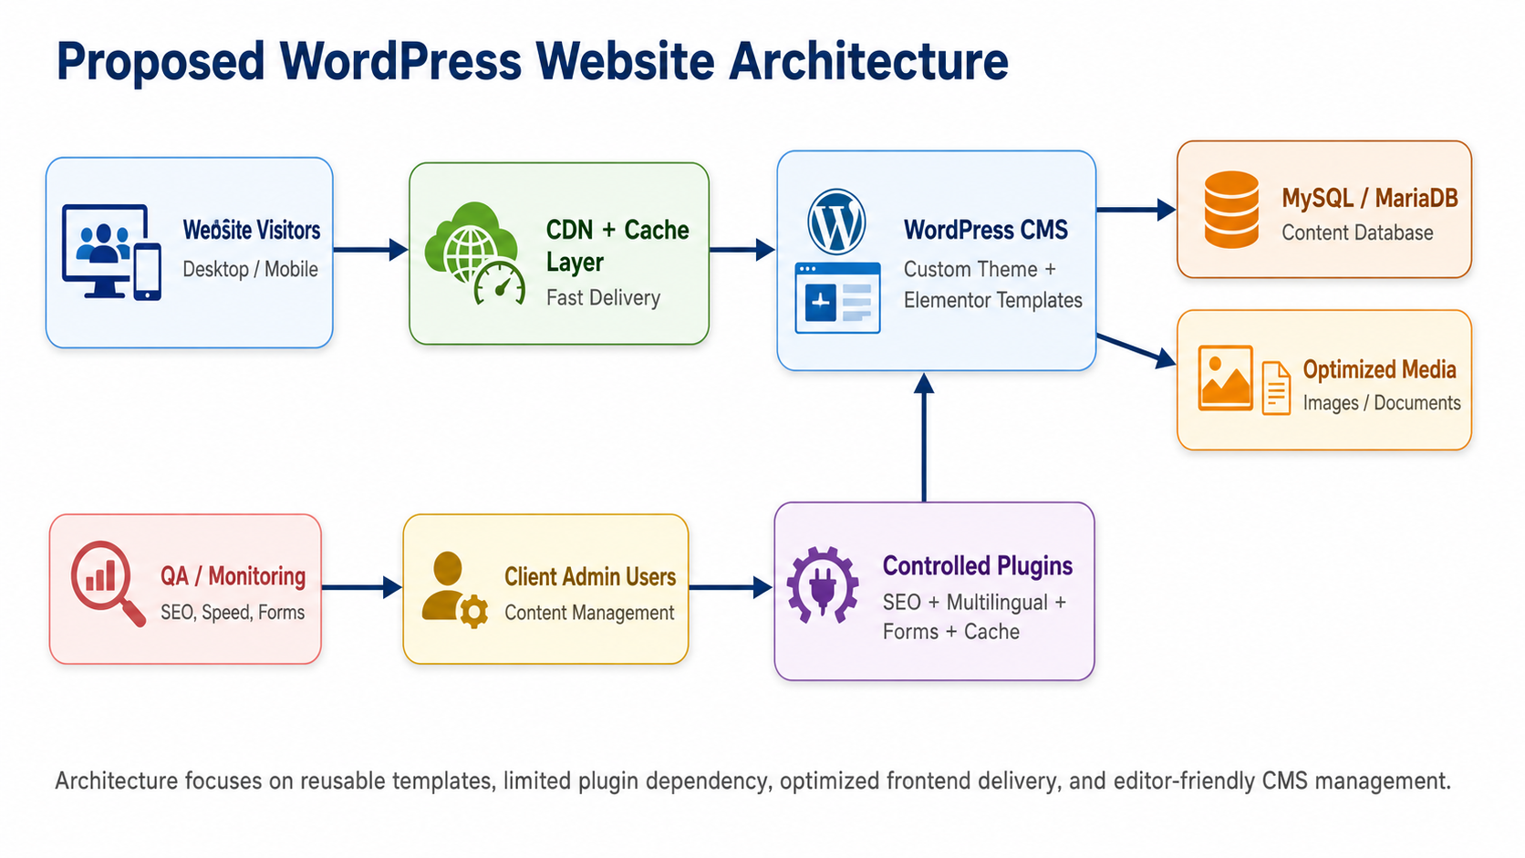
Figure 1: Proposed WordPress website architecture using custom theme, Elementor templates, controlled plugins, caching/CDN, and client CMS management.

8.2 Multilingual SEO and RTL Flow
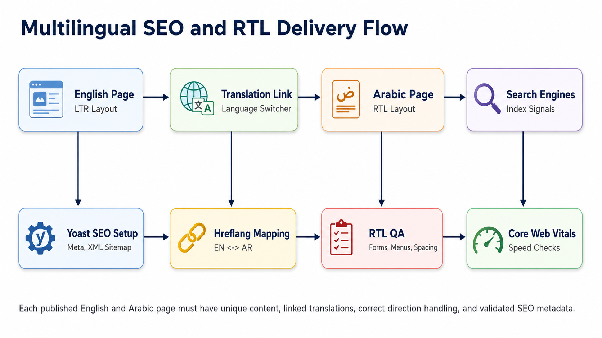
Figure 2: English-Arabic delivery flow showing translation mapping, language switcher, RTL QA, SEO metadata, hreflang mapping, and performance validation.

8.3 Implementation Methodology Flow
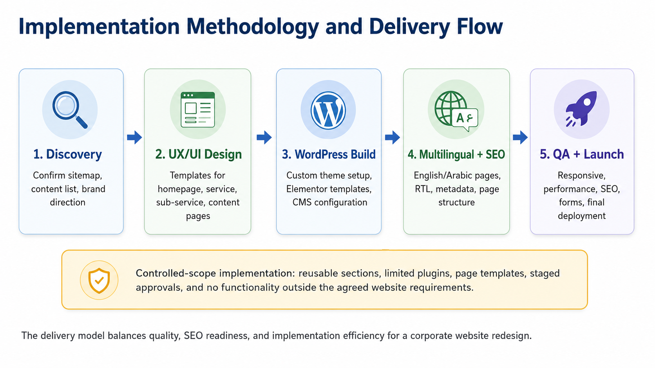
Figure 3: Controlled implementation workflow from discovery through design, development, multilingual/SEO setup, QA, and launch.

9. Development Methodology
A structured iterative delivery methodology is recommended. Each phase will have a clear output and approval checkpoint so the project remains focused, predictable, and aligned with the approved sitemap and content availability.
Phase | Activity | Key Output
Phase 1 | Discovery and Planning | Confirm sitemap, page list, content availability, brand assets, SEO page priorities, and approval workflow.
Phase 2 | UX/UI Design | Prepare UI direction, responsive templates, and reusable section patterns for approval.
Phase 3 | WordPress Setup | Configure WordPress, custom theme base, Elementor Pro, global styles, menus, and CMS structure.
Phase 4 | Page Development | Develop homepage, service templates, sub-service templates, standard pages, contact forms, and reusable blocks.
Phase 5 | Multilingual and SEO Setup | Set up English/Arabic pages, RTL styles, language switcher, SEO metadata, sitemap, and internal linking.
Phase 6 | QA and Launch | Perform responsive, browser, SEO, content, RTL, form, performance, and deployment testing.

10. Deliverables
Deliverable | Expected Output
Project kickoff and requirement confirmation notes | Approved scope baseline
Finalized website sitemap and page list | Page structure for development
Responsive UI/UX design templates | Designs for core page types
WordPress custom theme setup | Theme foundation and global layout
Elementor Pro templates and reusable sections | Editable page templates and components
Developed English website pages | Approved English content implementation
Developed Arabic website pages | Arabic pages with RTL layout
Language switcher and multilingual mapping | Connected English/Arabic page navigation
SEO-ready configuration | Metadata, heading structure, sitemap readiness, image alt text, internal linking
Contact form setup | Lead capture and notification configuration
Performance optimization setup | Caching, image optimization, frontend optimization checks
QA report | Issues list, resolution status, and launch readiness
Deployment support | Final website launch to approved hosting/server
CMS handover guide | Basic client training document for content editing and SEO fields
Sitemap-based feature and page scope matrix | Confirmed implementation list for main pages, service pages, sub-service pages, locations, blogs, case studies, careers, and contact elements
Service and sub-service SEO page templates | Reusable landing-page template for category and sub-service pages
Location page template setup | CMS-editable regional landing pages for UAE, Kuwait, Qatar, Oman, Bahrain, KSA, and GCC & Levant

11. Testing and Quality Assurance
QA Area | Testing Coverage
Functional Testing | Menus, buttons, links, forms, language switcher, CMS templates, contact notifications.
Responsive Testing | Desktop, tablet, and mobile views for English and Arabic layouts.
Cross-Browser Testing | Latest Chrome, Safari, Firefox, and Edge on standard viewport sizes.
RTL Testing | Arabic page alignment, navigation direction, form fields, icons, spacing, buttons, and visual consistency.
SEO QA | Metadata, URL slugs, headings, image alt text, sitemap readiness, canonicals, internal links, and indexability checks.
Performance QA | Image size, cache behavior, Core Web Vitals checks, asset optimization, and page speed review.
Content QA | Content placement, spelling review based on client-approved copy, media placement, and page consistency.
Security and Deployment QA | SSL, admin access review, plugin updates, backup readiness, and live deployment verification.

12. Third-Party Licensing Requirements
License / Service | Status | Purpose
Elementor Pro | Required | Page builder and theme/template building capability.
Yoast SEO Premium | Required if premium SEO tooling is expected | SEO metadata, redirects, internal linking support, and advanced SEO workflow compatibility.
WPML or Polylang Pro | Required or recommended | English-Arabic multilingual setup, language switcher, translation management, and page mapping.
Caching / Performance Plugin | Recommended | Page caching, asset optimization, lazy loading, and performance support.
Image Optimization Plugin | Recommended | Compression and optimized image delivery.
Hosting, SSL, CDN, Backup | Required / Recommended | Stable server environment, security, speed, backups, and deployment support.

13. Assumptions, Dependencies, and Risk Mitigation

13.1 Assumptions
- The client will provide final sitemap, brand guidelines, images, core business content, service descriptions, testimonials, and case studies.
- Arabic content will either be provided by the client or handled through a separate content workstream.
- Hosting, domain, SSL, plugin licenses, and administrative credentials will be provided or approved before deployment.
- Major structural changes after design approval may affect the delivery timeline.

13.2 Key Risks and Mitigation
Risk | Impact | Mitigation
Large sitemap with thin pages | SEO quality may be reduced if many pages have minimal or duplicate content. | Use a parent-child sitemap and lean but unique sub-service page template.
Elementor performance overhead | Heavy widgets, nested sections, and too many add-ons can slow pages. | Use containers, reusable templates, minimal add-ons, optimized assets, and caching.
Arabic RTL layout issues | Menus, icons, sliders, forms, and spacing may need manual RTL fixes. | Perform dedicated Arabic/RTL QA on desktop and mobile.
Content delay | Page implementation and QA can be delayed if content is not ready. | Start with approved priority pages and use placeholders only where approved.
Plugin conflicts | Multiple plugins may affect speed or compatibility. | Use a controlled plugin stack and test on staging before launch.

14. Similar WordPress Experiences
Riseup Labs: https://riseuplabs.com/

GigaBPO: https://gigabpo.com/

Gigatester: https://gigatester.com/

Applian: https://appilian.com/
WriteRush: AI Content Assistant: https://riseuplabs.com/writerush/
ContentOS: AEO & GEO Content Automation: https://riseuplabs.com/contentos/
CodeCanel: https://riseuplabs.com/codecanel/
Lipsumhub: Dummy Text Generator Platform: https://riseuplabs.com/lipsumhub/
Dekko ISHO: https://riseuplabs.com/dekkoisho/
Rise Above Donation Platform: https://riseuplabs.com/rise-above-foundation-cebu/
Shanti Jewels eCommerce Website: https://riseuplabs.com/shaanti-jewels/

15. Conclusion
The proposed approach delivers a modern, SEO-ready, bilingual corporate website using WordPress, custom theme architecture, Elementor Pro templates, and controlled plugin usage. The implementation prioritizes reusable page structures, high-performance frontend practices, Arabic RTL compatibility, PPC-ready service pages, and manageable CMS workflows. This provides the client with a professional corporate website that can support organic search, paid campaign landing pages, and ongoing content management without introducing unnecessary functionality beyond the stated requirements.

