Technical & Financial Proposal
Project: Humm – Premium iOS Wellness Application
Scope: Development Only (UI/UX Design Excluded)
Date: February 19, 2026

1. Introduction
This proposal outlines the technical and financial plan for developing the Humm mobile application from scratch as a native iOS application. The scope strictly includes development activities only. UI/UX design, branding, and visual identity creation are excluded and will be provided by the client.

2. Project Objective
To develop a premium, editorial-feeling, performance-optimized iOS application that enables women to curate daily routines, rituals, and nervous-system-first experiences including Habit Library, Stacks, Reset Orb, Journeys, Bloom Scroll, and Daily Content modules.

3. Proposed Technical Stack
Frontend: Swift + SwiftUI (Native iOS)
Architecture: MVVM with scalable modular structure
Backend (MVP): Node.js / Python (FastAPI)
Database: PostgreSQL
Authentication: Apple Sign-In + Email
Push Notifications: Firebase Cloud Messaging
Payments: RevenueCat Integration
Analytics: Mixpanel or Amplitude
Crash Reporting: Firebase Crashlytics or Sentry
Storage: Supabase Storage / Firebase Storage

4. Development Methodology
Agile methodology with milestone-based delivery. Each phase will include development, integration testing, QA validation, and client review before moving to the next phase.

5. Scope Breakdown – 3 Phases

Phase 1: Foundation & Core Systems (3 Weeks)
- Project setup, architecture design
- Authentication & account flow
- Energy Windows configuration
- Habit Library backend setup
- Local-first data persistence
- Offline and error handling
- Notification system logic

Phase 2: Core Product Experience (2 Weeks)
- Daily Pulse (Morning & Evening)
- Ritual & Stack Management (inline editing, reorder, frequency)
- Habit Detail editorial system
- Reset Orb breathing module
- Bloom Scroll feed
- Journeys (7–21 day system)

Phase 3: Content, Optimization & Launch (1.5 Weeks)
- Wisdom Drop & Nourish Dose modules
- Profile management
- Analytics integration
- RevenueCat payment integration
- QA & performance optimization
- App Store deployment

6. Deliverables
- Production-ready iOS application
- Backend configuration & APIs
- Notification logic implementation
- Data persistence rules
- App Store deployment package
- Technical documentation

7. Human Resources & Responsibilities
Project Manager: Planning, coordination, milestone approval
iOS Tech Lead: Architecture & code standards
iOS Developer(s): Feature development & integration
Backend Developer: API & database setup
QA Engineer: Testing & regression validation
DevOps: Deployment & environment configuration

11. Diagram Placeholders
1. High-Level Mobile Architecture Diagram

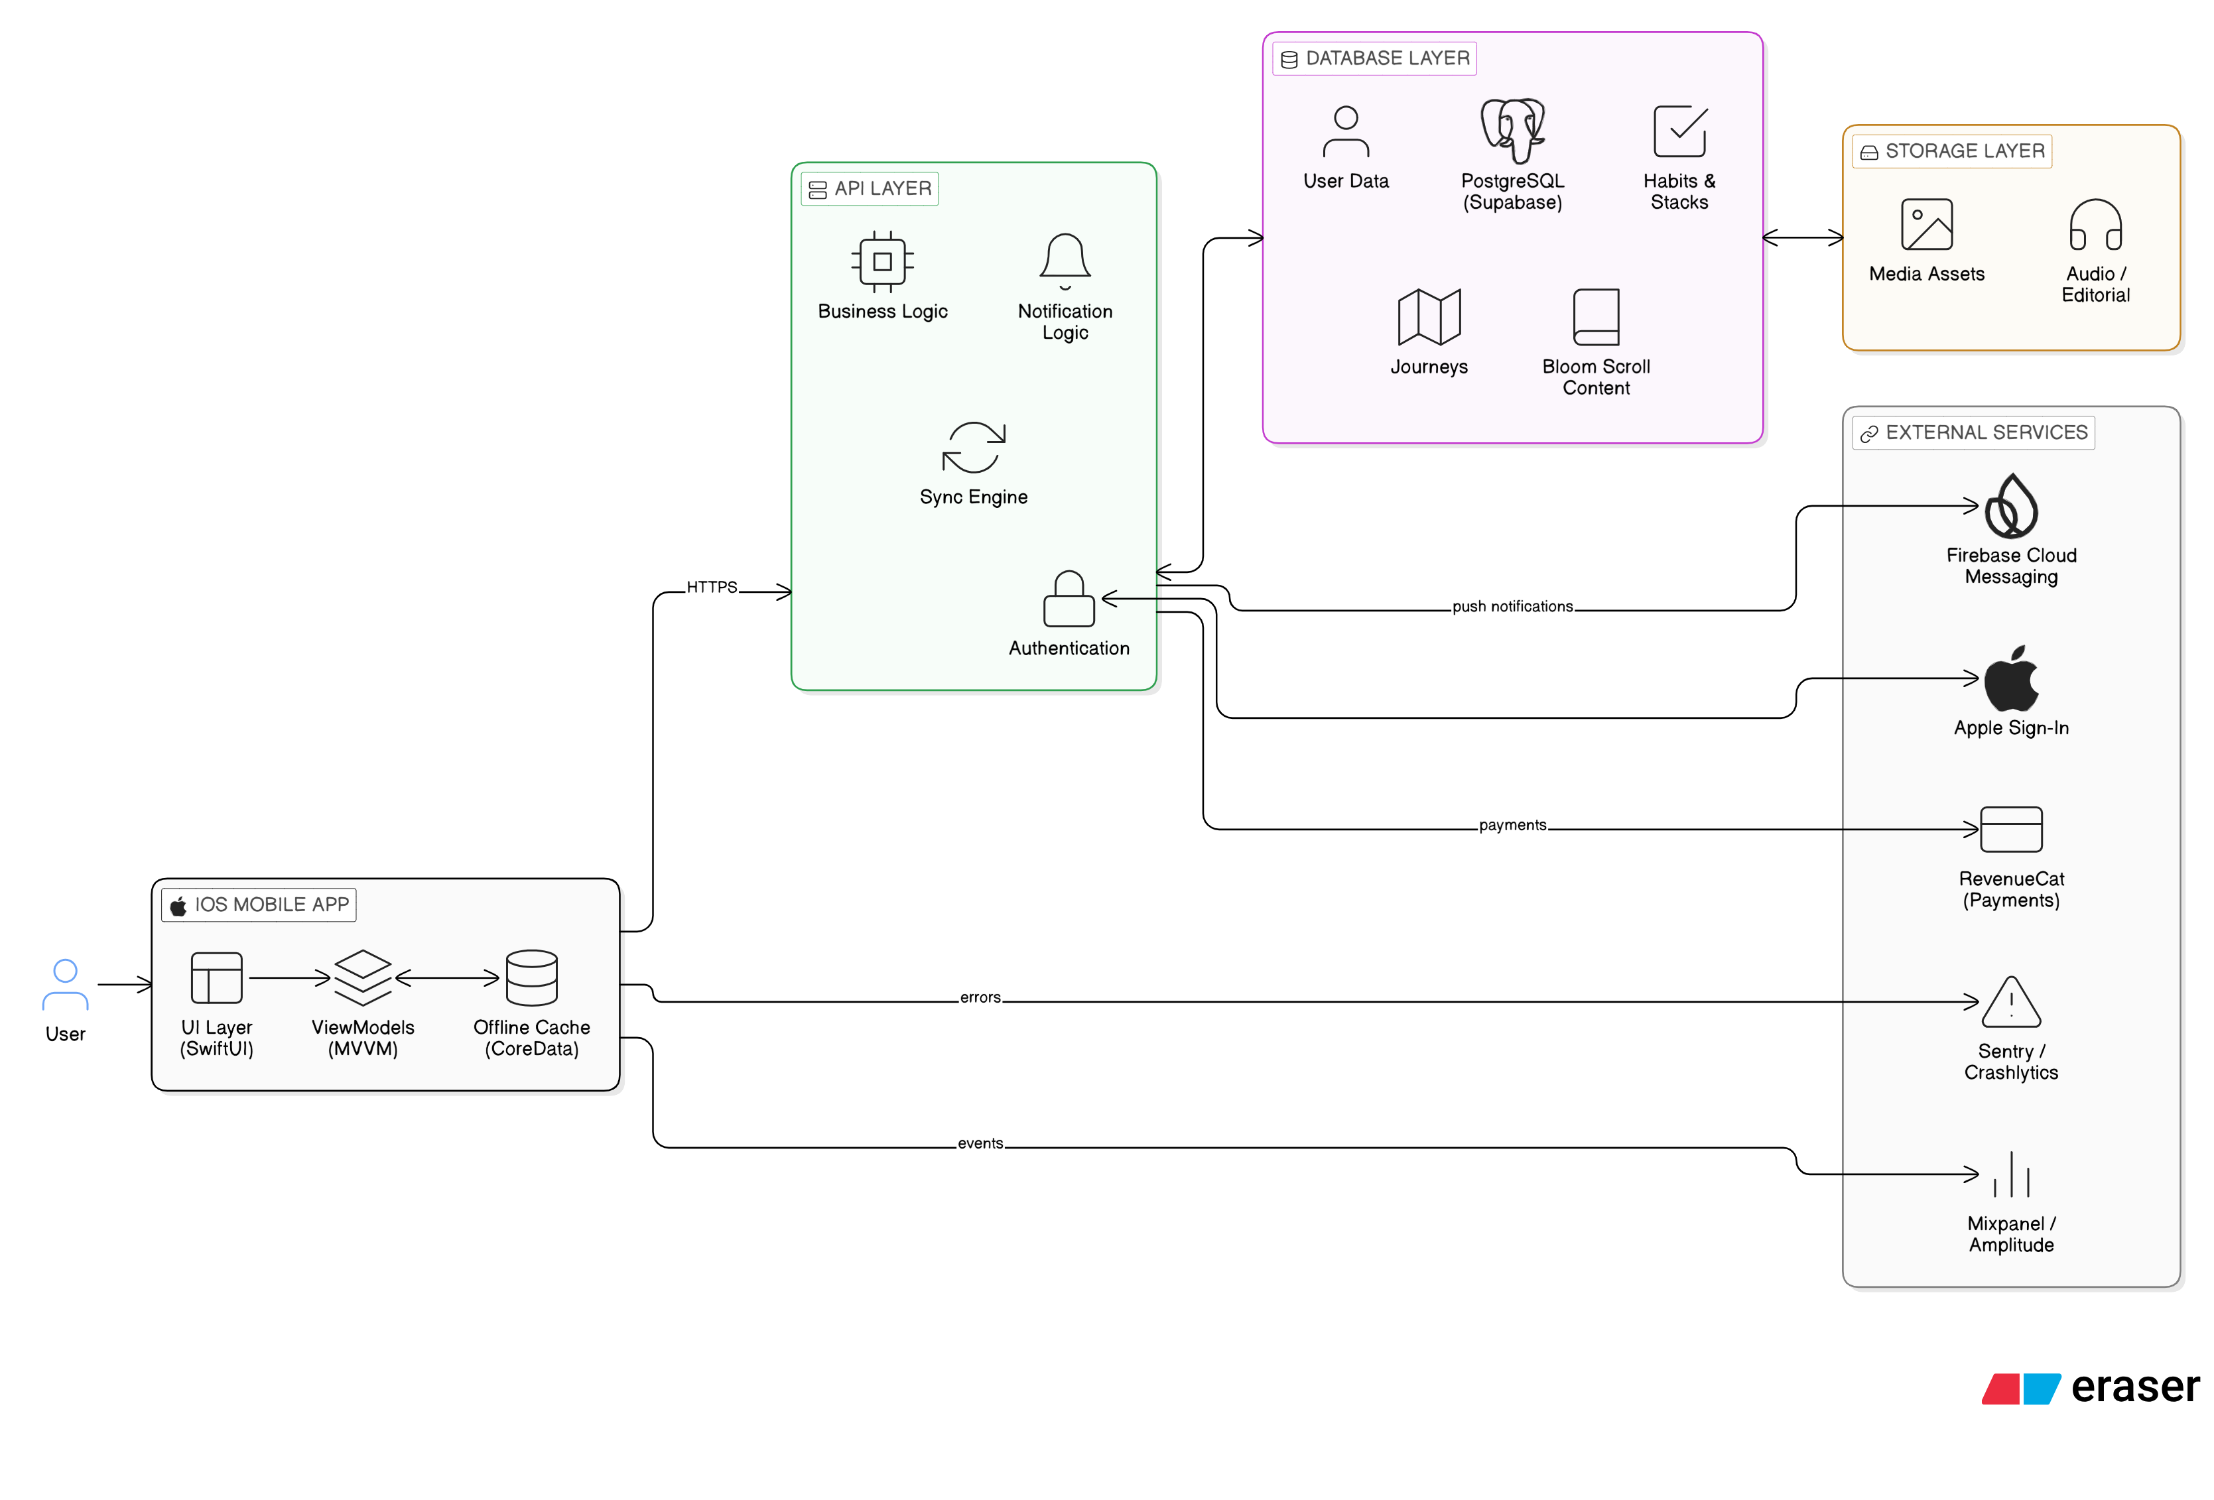
2. Authentication & Data Flow Diagram

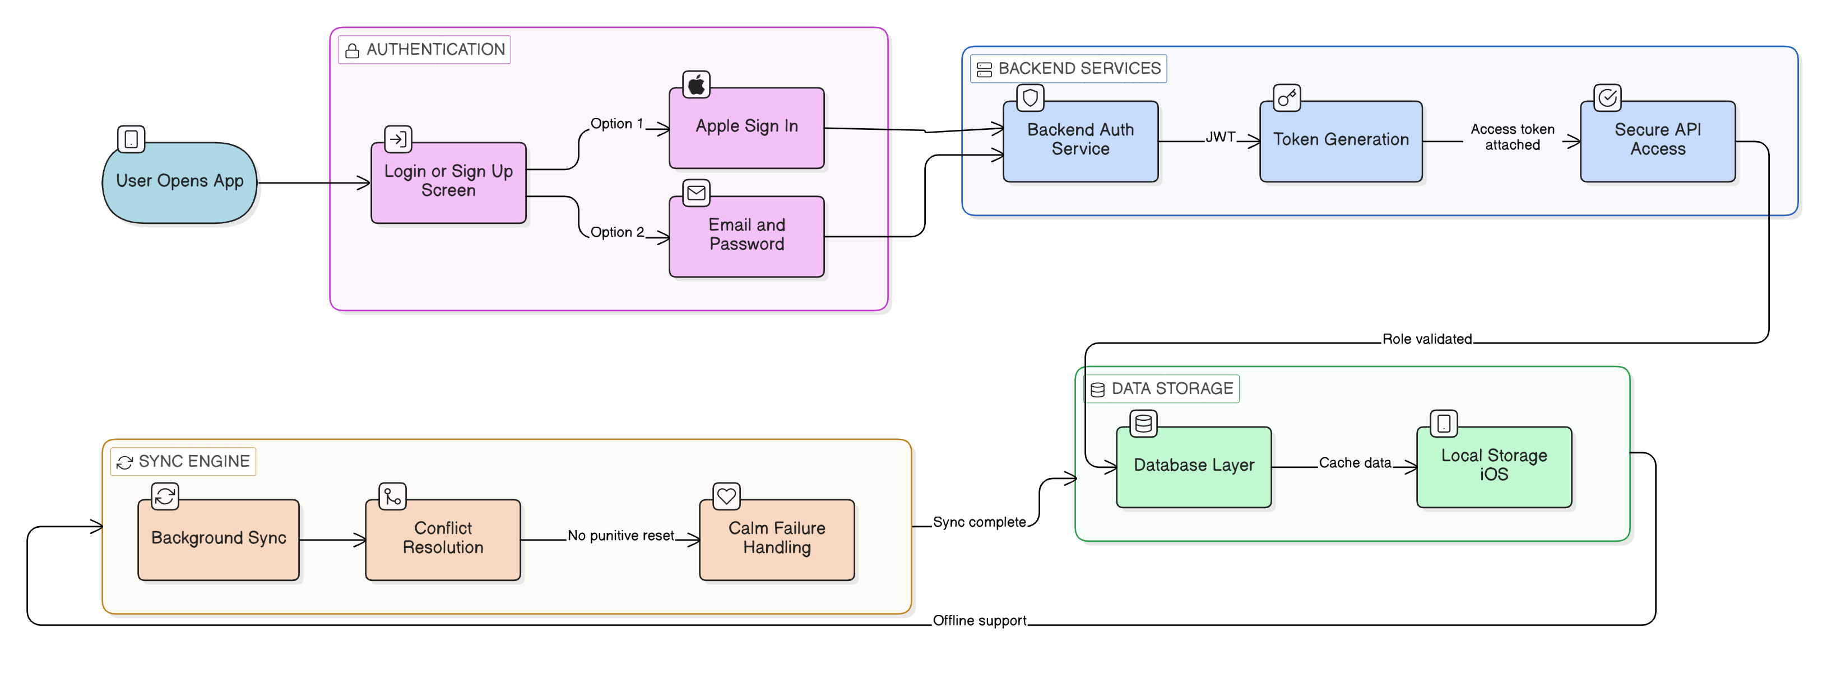

3. Notification & Sync Logic Flow Diagram

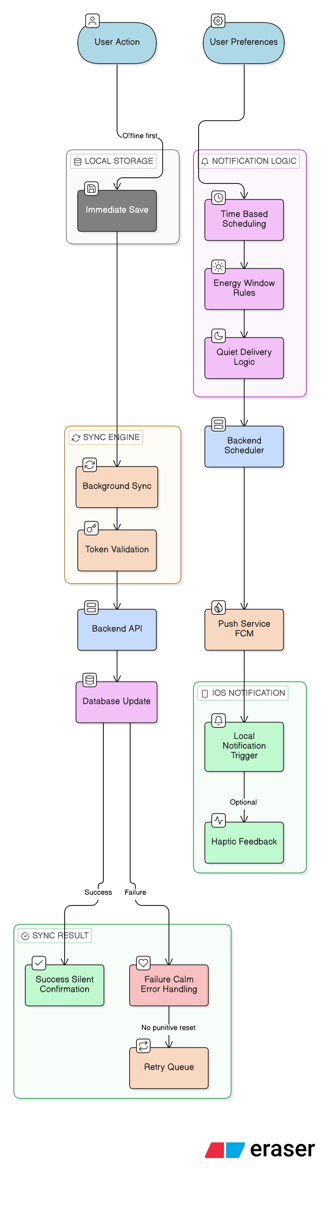

8. Suggested Timeline
Total Estimated Duration: 6.5 weeks

9. Financial Proposal
Phase | Timeline | Estimated Cost (USD)
Phase 1 | 3 Weeks | $2,000
Phase 2 | 2 Weeks | $1,500
Phase 3 | 1.5 Weeks | $1,500
Total Estimated Cost: $5,000

9.1 Payment Terms
30% Advance upon project kickoff
30% After Phase 1 completion
30% After Phase 2 completion
10% Upon final production deployment

9.2 Change Request (CR)
CR Man-day Rate: USD 150 per man-day or USD 25 per man-hour.

10. Complimentary Support (1 Month)
After production launch and final handover, we will provide one (1) month of complimentary support focused on the delivery scope.
Included:
- Bug fixing for reproducible issues introduced by the delivered work.
- Minor adjustments within existing UI patterns (small layout/copy/config changes).
- Support for analyzing logs and error reports where access is provided.
Excluded:
- New features or major enhancements beyond the agreed scope.
- Changes due to third-party provider policy changes or credential delays.
- Fixing pre-existing issues unrelated to the delivered modules.
.

