Technical Proposal
Skill-Based Cash Gaming App
Blitz Clone Platform - iOS, Android, Backend and Admin Console
Prepared by: Riseup Labs


1. Executive Summary
This proposal outlines a simple and implementation-focused technical approach for developing a mobile skill-based cash gaming platform modeled on the Blitz - Win Cash experience. The platform will support iOS and Android users, free practice play, paid tournament participation, wallet balances, payment and withdrawal flows, KYC-gated cash-out, social features, store functionality, card collection, admin operations, anti-cheat controls and responsible-play features.
The recommended approach is to build the project as a modular platform where the wallet, tournament engine, payments, KYC, anti-cheat, admin console and compliance rules form the shared foundation. Solitaire, Tile Match and Bubble Shooter will plug into this foundation for the current development scope. This helps keep the product simple, controlled and scalable without increasing unnecessary development cost.

2. Project Understanding
Based on the project provided brief and client clarification, the target product is a real-money skill-based gaming platform where players can warm up in free practice mode and then participate in paid asynchronous tournaments. Players do not wait for another opponent. Instead, each participant completes their game session, the score is logged, and the tournament result is displayed after players finish or when the tournament timer closes.
- The product will be developed from scratch for both iOS and Android using a single-codebase approach where possible.
- Solitaire, Tile Match and Bubble Shooter will support practice mode and cash mode.
- Tournaments will mainly follow asynchronous participant-count leaderboard logic.
- Tournament closing will happen when all joined players have a result logged or when the tournament timer is reached.
- Wallet balances will separately track Real Cash, Bonus Cash and Gems.
- Real Cash will be withdrawable after KYC; Bonus Cash will require playthrough; Gems will remain soft currency only.
- The platform scope includes wallet, tournaments, admin panel, KYC/payments and anti-cheat, with Solitaire, Tile Match and Bubble Shooter plugged into this platform.

3. Proposed Scope Coverage
The proposal keeps the scope aligned with the provided requirement. No additional product features have been added beyond the requested platform coverage.
Scope Area | Included Requirement Coverage
Wallet and Payments | Real Cash, Bonus Cash and Gem balances; deposits through Apple Pay, PayPal, Venmo and cards via Stripe; withdrawals through supported payout rails with KYC; separate ledger and withdrawal rules.
Tournament and Game Layer | Free practice and cash mode for Solitaire, Tile Match and Bubble Shooter; asynchronous tournament system; deterministic shared seed; server-authoritative scoring; replay capture and dispute support.
Engagement and Monetization | XP/level system, reward pack offers, score-tier leaderboards, daily missions, prize wheels, ticket bundles, piggy bank, deposit funnel, card packs, event offers and referral bonus cash as specified.
Social Features | Facebook, Apple and Google sign-in; friends and gifting; global/friends/weekly leaderboards; clans/teams, clan chat, clan leaderboards, clan tournaments; player profiles and share hooks.
Card Collection Meta-Game | Themed albums, sub-collections, card rarities, album rewards, card shop, trade center, soft currency for unlocking/trading cards and limited-time event albums.
Store | Cash bundles, Gem bundles, Starter Pack, rewarded-video free gems and one-time level-pack offers with timers.
Compliance and Admin | 18+ gating, T&C acceptance, geo-blocking for restricted states, KYC at withdrawal, anti-cheat checks, fraud queue, payout review, contest scheduler, A/B test configuration and responsible-play tools.

3.1 Selected Game Scope
The current scope includes the same core platform scope, with the selected game count limited to Solitaire, Tile Match and Bubble Shooter.
Scope | Game Count | Selected Games | Scope Note
Current Development Scope | 3 games | Solitaire, Tile Match, Bubble Shooter | Develop from scratch for the current launch scope

3.2 Game Inventory Reference
# | Game | Type | Complexity
1 | Solitaire | Card | Low
2 | Tile Match | Puzzle | Medium
3 | Bubble Shooter | Arcade | Medium

4. Proposed Technical Approach

4.1 Modular Platform Approach
The platform should be developed as a shared core system with game modules connected to it. This means the wallet, tournament engine, payment/KYC layer, admin console, leaderboards, anti-cheat and compliance controls will be built once and reused across each game. This reduces duplicated development effort and keeps Solitaire, Tile Match and Bubble Shooter aligned with the same platform logic.

4.2 Mobile and Game Layer
- Develop the iOS and Android game client using Unity as the preferred game layer for a single-codebase delivery.
- Support practice mode and cash mode for each selected game.
- Use deterministic seed handling so each tournament can produce fair and comparable results.
- Capture score breakdown details such as base score, streaks, completion bonus and time bonus where applicable.
- Record replay or session data required for disputes and server-side validation.

4.3 Tournament and Scoring Logic
- Use asynchronous participant-count tournament logic instead of live head-to-head waiting rooms.
- Log each player score after the session is completed and update the leaderboard accordingly.
- Close tournaments when all participating players have logged a result or when the defined tournament timer is reached.
- Keep scoring server-authoritative to reduce manipulation risk.
- Support progressive result resolution and payout settlement through the wallet ledger.

4.4 Wallet, Payment and Withdrawal Logic
- Maintain separate balances for Real Cash, Bonus Cash and Gems.
- Support deposits through Apple Pay, PayPal, Venmo and card payments via Stripe.
- Support withdrawals through the clarified payout methods after KYC verification.
- Apply the clarified limits: $1 minimum deposit, $10-20 minimum withdrawal and $200 daily maximum.
- Keep Bonus Cash locked until it is used in paid games and playthrough requirements are met.
- Keep Gems as soft currency only and non-withdrawable.
- Support soft-currency trading at launch and cash or gem gifting as clarified.

4.5 Admin, Compliance and Anti-Cheat
- Build a role-based admin console for user search, manual credits/debits, fraud queue, payout review, contest scheduler and A/B test configuration.
- Implement 18+ gating, T&C acceptance and state-based geo-blocking for cash play where required.
- Apply KYC at first withdrawal using Persona, Veriff or Jumio based on final vendor selection.
- Use anti-cheat controls including server scoring, replay validation, multi-account detection and device fingerprinting.
- Include responsible-play controls such as deposit limits, self-exclusion and session reminders.

5. Technical Diagrams

5.1 High-Level System Architecture
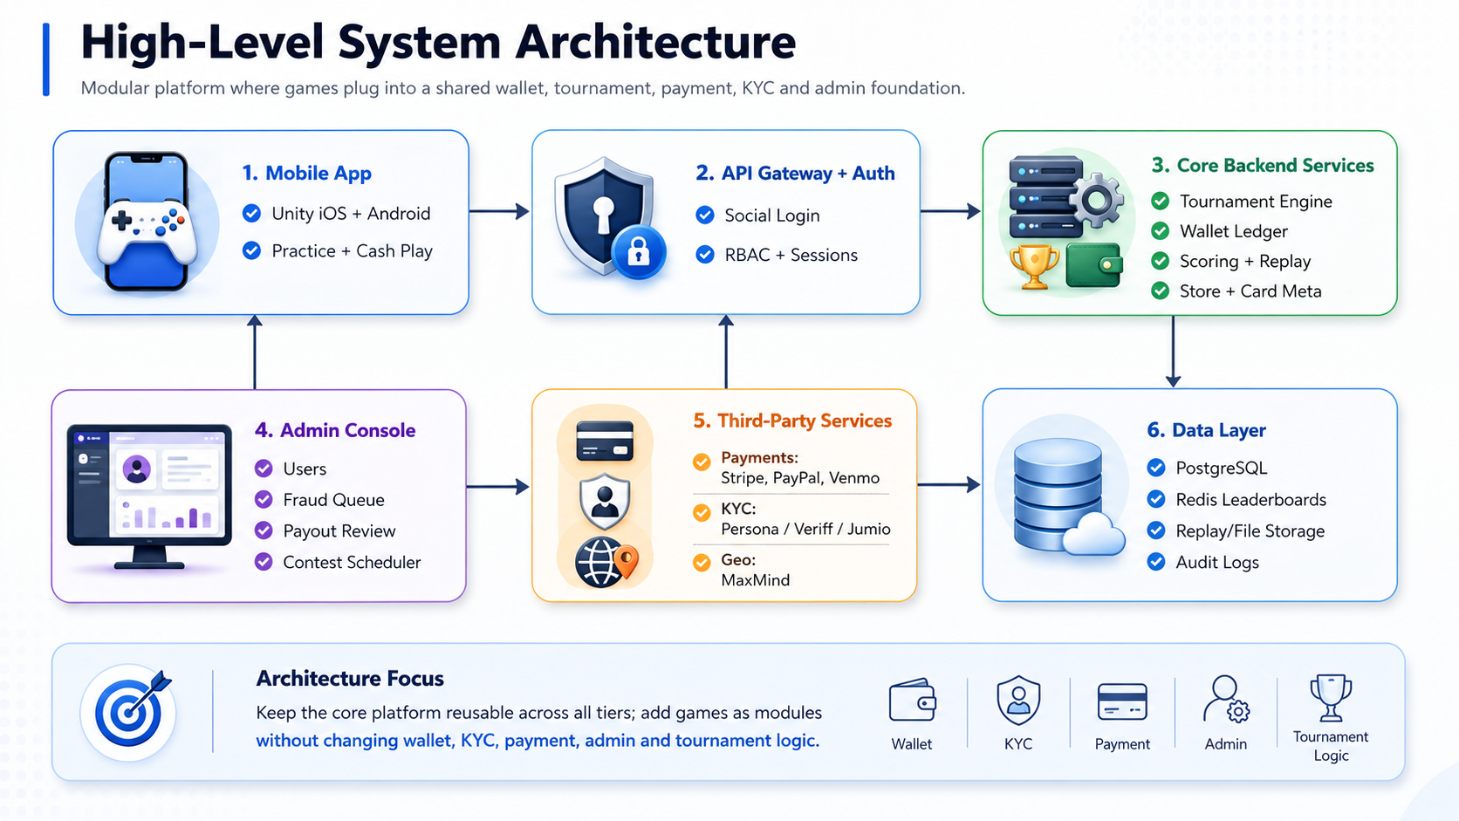
Figure 1: High-level system architecture for the mobile app, backend, admin console, data layer and third-party services.

5.2 Asynchronous Tournament Workflow
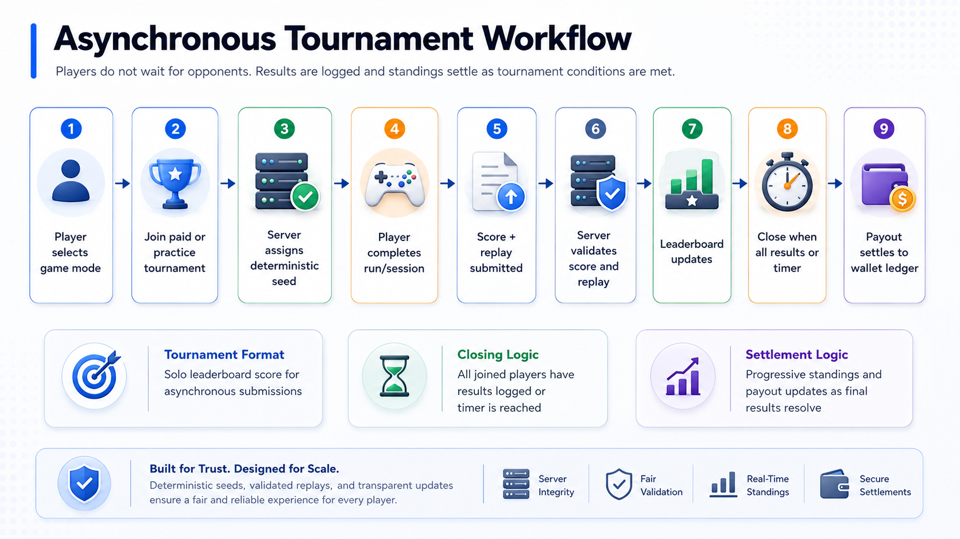
Figure 2: Tournament flow based on asynchronous leaderboard submissions and timer/all-results closing logic.

5.3 Wallet and Withdrawal Control Flow
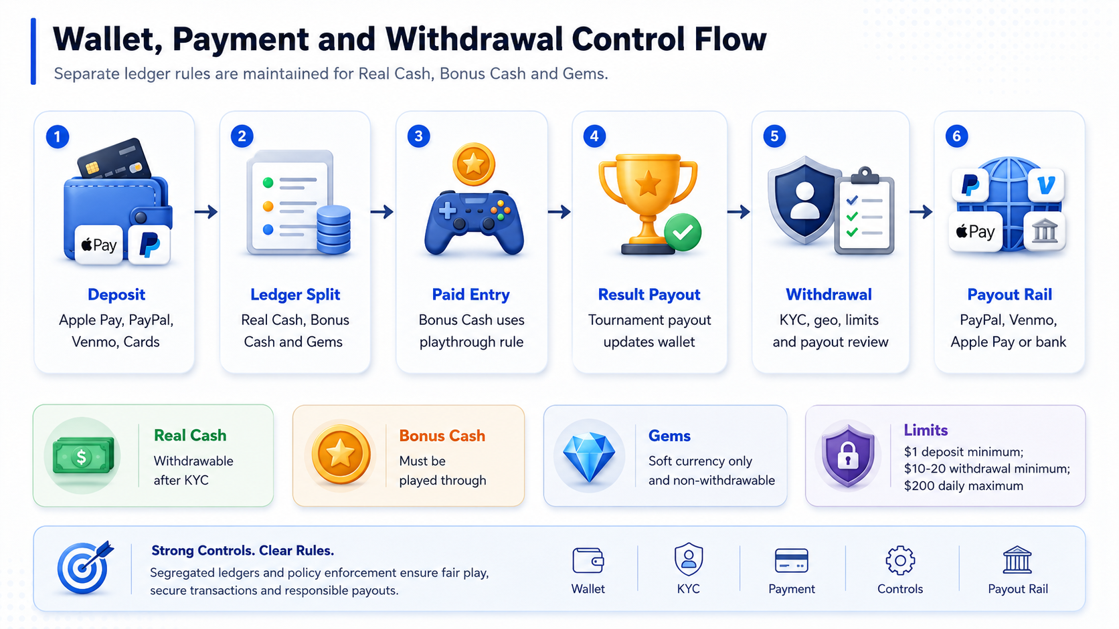
Figure 3: Wallet balance, payment, withdrawal, KYC and limit-control flow.

6. Proposed Technical Stack
The stack below follows the client-provided platform preference and keeps the implementation simple, scalable and suitable for a game-heavy mobile product.
Layer | Recommended Technology | Purpose
Mobile App and Game Layer | Unity | Preferred game layer for iOS and Android with shared game logic and faster multi-platform delivery.
Backend API | Node.js / NestJS or Go | Modular APIs for auth, wallet, tournament, scoring, store, social and admin operations. Final choice can be confirmed during architecture planning.
Database | PostgreSQL | Core transactional data, users, wallet ledger, tournaments, game history and admin records.
Cache and Leaderboards | Redis | Fast leaderboard ranking, tournament state and matchmaking/tournament queues.
Realtime Communication | WebSockets | Live state updates for tournament results, leaderboard updates and admin monitoring.
Payments | Stripe, Apple Pay, PayPal, Venmo, Plaid/ACH if required | Deposits, cards, payout rails and bank transfer support based on selected integration availability.
KYC | Persona / Veriff / Jumio | KYC verification before withdrawal. Final provider to be selected with client approval.
Geo-Blocking | MaxMind | State-based cash-play restriction and free-play allowance in restricted states.
Admin Console | React / Next.js | Role-based internal console for users, contests, wallet actions, fraud review and payout review.
Cloud and Storage | Client cloud account, object storage | Backend deployment, replay/session capture, logs and operational storage.

7. Development Methodology
A lean Agile delivery methodology is recommended so the core platform can be validated early while keeping the scope controlled. Development should proceed through short iterations, with the selected game scope of Solitaire, Tile Match and Bubble Shooter determining the game integration workload.
Delivery Step | Description
Step 1: Scope Confirmation | Confirm selected game scope of Solitaire, Tile Match and Bubble Shooter, payment/KYC vendors, state restrictions, wallet rules and admin roles.
Step 2: Product and Architecture Planning | Finalize technical architecture, data model, API contracts, tournament rules, wallet ledger rules and deployment plan.
Step 3: Core Platform Development | Build authentication, wallet, payments, KYC, tournament engine, leaderboards, admin console and compliance controls.
Step 4: Game Module Development | Implement selected games with practice/cash mode, deterministic seed handling, scoring and replay capture.
Step 5: Integration and Stabilization | Connect game modules to wallet, tournament, leaderboard, admin, payment/KYC and anti-cheat flows.
Step 6: QA, Store Submission and Launch Support | Complete QA cycles, prepare release builds, submit to App Store and Play Store and provide post-launch bug-fix support.

8. Testing and Quality Assurance
Testing will focus on validating the core platform, wallet accuracy, tournament fairness, payment/KYC flows, admin operations, game scoring and app stability across supported devices.
QA Area | Testing Focus
Functional Testing | Validate mobile app, practice/cash modes, store, social login, card collection, gifting, leaderboards and admin workflows.
Tournament and Scoring Testing | Verify deterministic seeds, score breakdowns, server-authoritative scoring, replay capture, leaderboard updates and closing logic.
Wallet and Ledger Testing | Validate Real Cash, Bonus Cash and Gem balance rules, playthrough logic, deposits, withdrawals, limits and payout settlement.
Payment and KYC Testing | Test payment/KYC provider integration in sandbox/staging, withdrawal gating and error handling.
Compliance Testing | Validate 18+ gating, T&C acceptance, geo-blocking, restricted cash play and responsible-play tools.
Admin Testing | Verify user search, manual wallet actions, fraud queue, payout review, scheduler, A/B configuration and role-based access.
Security and Anti-Cheat Testing | Check authentication, authorization, device fingerprinting, multi-account indicators, replay validation and API protections.
Regression and Release Testing | Run final regression, device compatibility checks and store-submission readiness validation before launch.

9. Deliverables
The following deliverables are aligned with the provided project requirement.
- Published iOS application with App Store submission support.
- Published Android application with Play Store submission support.
- Backend deployed to the client cloud account.
- Admin console with role-based access.
- Source code with full IP assignment and no third-party encumbrance, subject to final contractual terms.
- Architecture documentation.
- API reference documentation.
- On-call runbook.
- QA test execution summary and release readiness notes.
- 60-day post-launch warranty and bug-fix support window.

10. Assumptions and Exclusions

10.1 Assumptions
- The current game scope includes Solitaire, Tile Match and Bubble Shooter and will be confirmed before detailed sprint planning.
- The client will confirm payment, KYC and geo-location providers before integration starts.
- The client will provide or approve legal content including T&C, responsible-play wording and cash-play eligibility rules.
- The client will provide access to app store accounts, cloud account, payment provider accounts, KYC provider account and required business documents.
- Solitaire, Tile Match and Bubble Shooter will connect to the same tournament, scoring, wallet, replay and admin framework.

10.2 Exclusions
- Third-party provider fees, hosting costs, app store fees, payment processing fees and KYC verification fees are excluded unless separately agreed.
- Additional games beyond Solitaire, Tile Match and Bubble Shooter are excluded.
- Additional engagement hooks or monetization mechanics outside the provided requirement are excluded unless separately approved.
- Legal, regulatory licensing, tax filing operations and financial compliance advisory services are excluded from the development scope.

11. Conclusion
The proposed solution focuses on building a controlled, modular and scalable skill-based cash gaming platform for iOS and Android. The approach keeps the shared platform foundation consistent while limiting the current development scope to Solitaire, Tile Match and Bubble Shooter. This reduces unnecessary complexity, keeps the proposal aligned with the provided requirements and supports future extension through additional game modules after launch.

