TECHNICAL PROPOSAL
Online Module Development
For BRAC Head Office Onboarding Programme
Prepared By


Table of Contents
1. Executive Summary 3
2. Understanding of the Assignment 3
Key understanding: 3
3. Proposed Scope of Work 3
3.1 Module Details 4
4. Proposed Technical Approach 4
4.1 Learning Design Approach 4
4.2 Module-wise Creative Direction 4
5. Development Methodology 5
6. Proposed Technical Stack 5
7. Technical Diagrams 6
Diagram 1: Content-to-Module Production Workflow 6
Diagram 2: Module Structure Map 6
Diagram 3: Review and QA Gates 7
8. Deliverables 8
9. Testing and Quality Assurance 8
10. Assumptions and Dependencies 9
11. Proposed Out of Scope 9
12. Conclusion 9

1. Executive Summary
BRAC requires a qualified production partner to design, produce, and deliver three high-quality online learning modules for the Head Office onboarding programme. The modules will help new joiners understand BRAC's strategic direction, core values, and Internal Audit responsibilities through clear, engaging, and visually structured learning content.
Riseup Labs proposes a simple production-led approach that combines instructional design, scriptwriting, storyboarding, animation/motion graphics, optional human interaction, video editing, sound design, QA, and LMS-ready final delivery. The approach is aligned with the ToR and keeps the work focused on the required modules only.

2. Understanding of the Assignment
The online modules will support BRAC's onboarding journey for Head Office new joiners. Each module will be hosted on BRAC's internal digital learning platform and will be accessible only to BRAC staff members.
Module | Core Purpose | Content Approach | Duration
BRAC Strategy (2025-2030) | Explain the 5-year strategic vision and priorities. | Simplify strategic concepts through visual storytelling, infographics, and segmented narration. | Maximum 20 minutes
BRAC Values | Promote understanding and application of BRAC's core values. | Develop four separate value-based segments, each with a distinct learning objective and creative approach. | 4 x max 5 minutes
Internal Audit | Explain audit processes, compliance requirements, controls, and staff responsibilities. | Use process visualization, scenario examples, and clear workflow graphics to make technical content easier to understand. | Maximum 15 minutes

Key understanding:
- The work is primarily a learning content production assignment, not a new software development or LMS development assignment.
- BRAC will provide raw/foundational content and SME support; the selected agency will transform the content into engaging learning modules.
- The modules should be concise, easy to follow, visually engaging, and appropriate for staff onboarding.
- Internal Audit content requires extra emphasis on visual process explanation because it is process-heavy and technical.

3. Proposed Scope of Work
The proposed scope is limited to the required three online learning modules and related production activities.
- Content review and learning objective mapping with BRAC SMEs.
- Creative concept development for each module.
- Scriptwriting and narration planning based on BRAC-provided content.
- Visual storyboard and styleframe development.
- Animation/motion graphics production and/or hybrid video production where required.
- Professional video editing, sound design, voiceover integration, and post-production.
- Caption/subtitle file preparation for improved accessibility and LMS usability.
- Feedback incorporation at agreed review milestones.
- Final HD digital delivery optimized for BRAC's internal digital learning platform.

3.1 Module Details
The following module details are aligned with the ToR and the provided summary. Each module will be developed from BRAC-provided content and converted into a clear, engaging online learning video.
Module | Objective | Structure and Duration | Content / Production Direction
Module 1: BRAC Strategy (2025-2030) | Help new joiners understand BRAC's bigger picture, 5-year strategic vision, priorities, and overall strategic direction. | Divided into logical segments. Total runtime will not exceed 20 minutes. | BRAC will provide raw content. The production will simplify high-level strategy through visual storytelling, roadmap/timeline visuals, key message cards, narration, and short recap frames.
Module 2: BRAC Values | Support cultural alignment by helping staff understand BRAC's core values and how those values should be practiced in day-to-day work. | Split into 4 separate segments, one for each core value and practice parameter. Each segment will have a distinct learning objective and approach, with a maximum duration of 5 minutes per segment. Total runtime will not exceed 20 minutes. | BRAC will provide foundational content. The production will use relatable workplace scenarios, simple animation/hybrid storytelling, examples, and value-based takeaways to make the content practical and actionable.
Module 3: Internal Audit | Educate staff on BRAC's control mechanisms, compliance protocols, accountability frameworks, audit processes, and individual responsibilities. | Structured logically to explain audit processes step by step. Total runtime will not exceed 15 minutes. | The module will focus on clear visual explanation of process-heavy content using workflow diagrams, role-based responsibilities, checkpoints, scenario examples, and motion graphics.
Note: Final module files will be prepared in agreed digital formats suitable for BRAC internal platform integration. Development or customization of the learning platform itself is not part of this production scope.

4. Proposed Technical Approach
The technical approach focuses on converting BRAC-approved content into concise, structured, and visually engaging learning modules. The production method will be selected after reviewing the raw content, but the recommended approach is a hybrid of animation, motion graphics, narration, and selective human interaction where it improves clarity.

4.1 Learning Design Approach
- Define one clear learning goal for each module and one micro-objective for each logical segment.
- Break complex information into short segments to maintain attention and reduce cognitive load.
- Use simple narration, visual hierarchy, icons, process maps, examples, and recap frames.
- Maintain consistent branding, tone, and visual language across all three modules.
- Use captions/subtitles and clear audio to support accessibility and comprehension.

4.2 Module-wise Creative Direction
Module | Recommended Treatment | Output Focus
BRAC Strategy | Animated strategy roadmap, timeline visuals, key priority cards, narrator-led explanation, and summary frames. | Make the 2025-2030 direction easy to understand and remember.
BRAC Values | Four short value-based segments using relatable workplace scenarios, light character animation, and practical behavior examples. | Connect each value with day-to-day staff practice.
Internal Audit | Process flow animation, role-based accountability visuals, control/checkpoint graphics, and simple compliance examples. | Demystify audit workflows and staff responsibilities.

5. Development Methodology
The proposed methodology follows a simple ADDIE-based production flow with iterative BRAC review gates. This keeps the project structured while allowing feedback before heavy production work begins.
Phase | Activities | Key Output
Analyze | Review raw content, audience, module objectives, LMS requirements, and SME inputs. | Learning outline and production plan
Design | Prepare creative concept, script direction, visual treatment, and storyboards. | Approved scripts and storyboards
Develop | Create animation/video assets, record voiceover, edit modules, and add sound/captions. | Draft module videos
Implement | Prepare delivery files and support BRAC's internal platform upload/testing process. | LMS-ready final files
Evaluate | Conduct QA checks, collect feedback, revise, and finalize outputs. | Approved final deliverables

6. Proposed Technical Stack
The stack is selected for practical production quality, compatibility with common learning platforms, and ease of review by BRAC stakeholders.
Area | Tools / Standards | Purpose
Instructional Design | MS Word / Google Docs, PowerPoint, Figma | Scripts, storyboards, visual planning, SME review
Visual Design | Adobe Illustrator, Figma | Icons, infographics, layouts, styleframes
Animation / Motion Graphics | Adobe After Effects | Animated explainers, process flows, typography animation
Video Editing | Adobe Premiere Pro / DaVinci Resolve | Final editing, transitions, color correction, export
Audio | Adobe Audition / Audacity, professional microphone setup | Voice cleanup, sound design, volume leveling
Delivery Format | MP4 H.264, 16:9 Full HD 1080p, AAC audio | Standard high-definition video delivery for platform upload
Accessibility Support | SRT/VTT captions, transcript-ready script | Captioning and easier learner comprehension
Optional LMS Packaging | SCORM 1.2/2004 or xAPI wrapper only if required by BRAC's platform | Tracking/packaging support without changing the learning scope

7. Technical Diagrams
The following diagrams illustrate the proposed production flow and review checkpoints.

Diagram 1: Content-to-Module Production Workflow
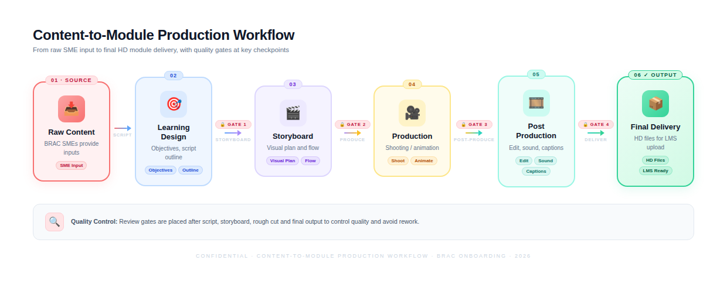

Diagram 2: Module Structure Map
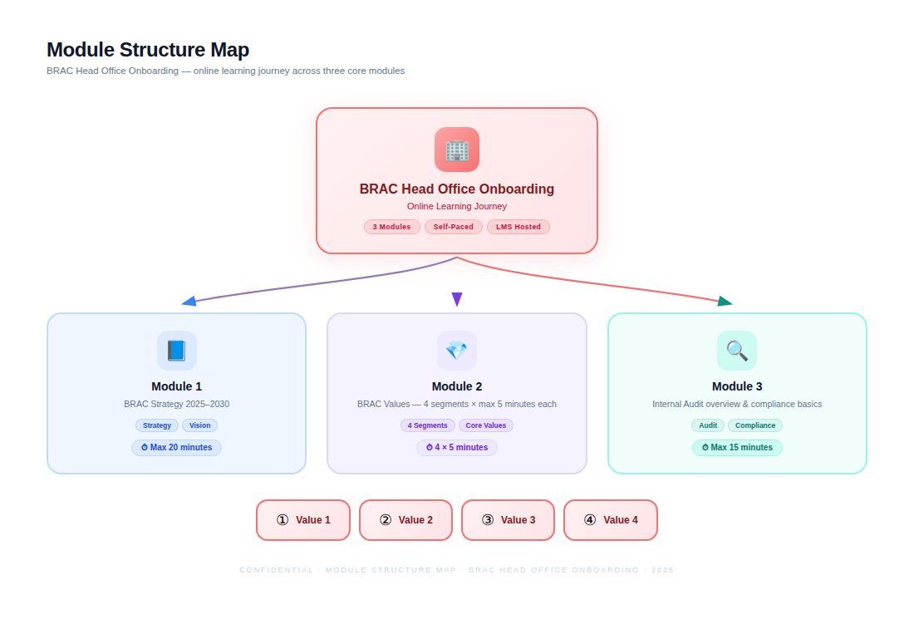

Diagram 3: Review and QA Gates
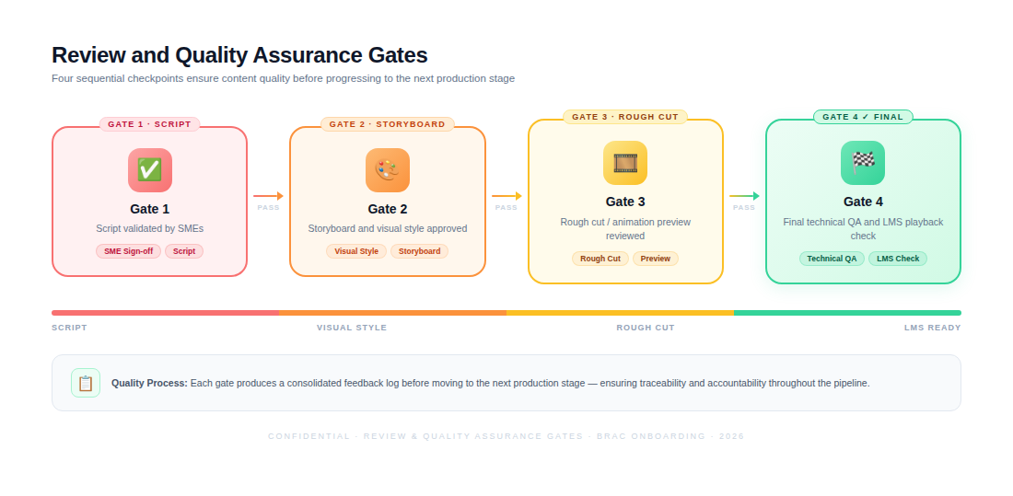

8. Deliverables
Deliverable | Description | Format
Inception and Production Plan | Project plan, review process, production schedule, and communication flow. | DOCX/PDF
Creative Concept Note | Module-wise creative direction and recommended visual treatment. | DOCX/PDF
Scripts | Narration and dialogue scripts based on BRAC-approved content. | DOCX
Storyboards | Scene-by-scene storyboard with visual direction, narration, and asset notes. | PDF/PPTX
Styleframes | Sample visual frames to confirm look and feel before full production. | PNG/PDF
Draft Videos | Rough cut/animation previews for BRAC review. | MP4
Final Video Modules | Three finalized high-definition modules: Strategy, Values, and Internal Audit. | MP4 1080p
Captions/Subtitles | Caption files synchronized with the final videos. | SRT/VTT
Final Handover Pack | Final files, transcripts/scripts, and agreed production assets. | Digital folder

9. Testing and Quality Assurance
- Content accuracy validation with BRAC SMEs.
- Script and storyboard review before production.
- Learning objective alignment check for each module/segment.
- Runtime verification against module-wise duration limits.
- Brand consistency and visual style review.
- Audio clarity, volume leveling, and noise check.
- Caption/subtitle synchronization check.
- Spelling, grammar, terminology, and on-screen text review.
- Video export quality check for resolution, aspect ratio, frame rate, and compression artifacts.
- Playback testing on standard desktop/laptop browsers/devices used by BRAC staff.
- LMS upload/playback compatibility check with BRAC's internal digital learning platform.
- Final approval checklist before handover.

10. Assumptions and Dependencies
- BRAC will provide all raw/foundational content, brand guidelines, and relevant reference materials.
- BRAC SMEs will validate content accuracy and provide consolidated feedback at agreed review gates.
- BRAC will confirm required final file format and any LMS-specific packaging requirement before final export.
- Human interaction/interview-based shooting will depend on participant availability and filming permissions.
- The proposed timeline depends on timely feedback and approval from all required stakeholders.

11. Proposed Out of Scope
- BRAC internal digital learning platform/LMS development or customization
- LMS hosting, user management, tracking, or configuration
- Original policy, strategy, audit, or values content creation
- Translation, dubbing, multilingual production, or localization
- Live training delivery, facilitation, or trainer support
- Interactive quiz, assessment, certification, or scoring system development
- Long-term maintenance or future content updates after final approval
- Additional modules beyond BRAC Strategy, BRAC Values, and Internal Audit
- Any feature or service not specifically mentioned in the ToR scope

12. Conclusion
Riseup Labs will support BRAC in transforming the provided onboarding content into three focused, engaging, and easy-to-understand online learning modules. The proposed approach combines instructional design discipline with practical video and animation production, ensuring that each module remains aligned with the ToR, suitable for BRAC's internal learning platform, and useful for new joiners.

