TECHNICAL PROPOSAL
Development and Delivery of Two E-Learning Courses on Digital Accessibility and Disability Inclusion
Prepared By: Riseup Labs


Table of Contents
1. Executive Summary 3
2. Understanding of the Assignment 3
2.1 Background Context 3
2.2 Key Objectives Interpreted from the ToR 3
2.3 Proposed Response 3
3. Scope Alignment and Controlled Scope 4
3.1 In-Scope Components 4
3.2 Controlled Scope and Exclusions 4
4. Proposed Technical Approach 4
4.1 Inception and Needs Validation 4
4.2 Curriculum and Instructional Design 5
4.3 Content Development and Audio-Visual Production 5
4.4 Accessibility-by-Design Approach 5
4.5 MuktoPaath Integration and Configuration 5
4.6 Pilot Testing, ToT, Rollout Support, and MEL 6
5. Development Methodology 6
6. Proposed Technical Stack 7
7. Technical Diagrams 8
8. Deliverables 10
9. Testing and Quality Assurance 11
10. Implementation Timeline 11
11. Project Governance and Communication 11
12. Key Risks and Mitigation 12
13. Conclusion 12

1. Executive Summary
The assignment aims to design, develop, deploy, and support the delivery of two structured e-learning courses on digital accessibility and disability inclusion: Digital Accessibility Training (DAT) and Disability and Digital Inclusion Training (DDT). The proposed approach is accessibility-first, participatory, and aligned with the MuktoPaath platform requirements described in the ToR.
The solution will not introduce a new learning platform or unnecessary custom software. Instead, the work will focus on high-quality course design, accessible multimedia production, MuktoPaath configuration, pilot validation, Training of Trainers (ToT), monitoring, and knowledge transfer. This keeps the scope practical, compliant with the ToR, and cost-conscious from an implementation perspective.

2. Understanding of the Assignment

2.1 Background Context
Bangladesh has advanced significantly in digital services and e-governance, but many digital platforms still create barriers for persons with disabilities due to issues such as poor keyboard navigation, lack of screen reader compatibility, missing captions, inaccessible documents, and weak accessibility awareness. The assignment responds to this gap by creating scalable e-learning content that builds practical skills, policy awareness, and institutional readiness for disability-inclusive digital transformation.
The two courses have complementary purposes. DAT will focus on technical accessibility skills for designers, developers, content creators, and ICT professionals. DDT will focus on disability inclusion, policy, governance, rights-based approaches, and participation of persons with disabilities in the digital ecosystem.

2.2 Key Objectives Interpreted from the ToR
- Build technical capacity of at least 300 participants in accessible design and development practices.
- Improve participant knowledge scores by at least 30% between pre- and post-assessments.
- Promote national and international accessibility standards in digital services.
- Support policymakers and institutions to integrate disability inclusion into digital policies and programs.
- Enable meaningful participation of persons with disabilities, including a target of at least 10% representation during learning and feedback activities.
- Support a wider rollout target of at least 500 participants through MuktoPaath.

2.3 Proposed Response
The proposed response is to deliver a complete, accessible, and deployment-ready e-learning package for MuktoPaath. The work will combine instructional design, subject-matter review, audio-visual production, accessibility compliance, platform configuration, pilot testing, ToT, monitoring, and final handover. The methodology will use sample-module approval before full production to reduce rework and ensure alignment with a2i/UNDP expectations.

3. Scope Alignment and Controlled Scope

3.1 In-Scope Components
- Course 1: Digital Accessibility Training (DAT): digital accessibility fundamentals, assistive technologies, accessible web/mobile design, accessible documents and multimedia, accessibility testing, AI and accessibility, practical demonstrations and case studies.
- Course 2: Disability and Digital Inclusion Training (DDT): disability inclusion, inclusive development, digital divide, rights-based frameworks, inclusive policy and governance, participation of persons with disabilities, inclusive innovation, and assistive technology.
- Course structure: 25-30 modules following a standardized template with introduction, learning objectives, core content, example/demo, summary, and quiz.
- Content production: HD 1080p video lectures and demonstrations, one promo video under one minute, scripts, storyboards, reading materials, quizzes, certificate design, thumbnails, and 40+ downloadable resources.
- Accessibility package: SRT subtitles, transcripts, accessible documents, alt text, semantic structure, color contrast consideration, screen reader-friendly materials, and sign language where feasible for key modules.
- Deployment: upload, configuration, assessment setup, certification criteria, UAT, and accessibility checks on MuktoPaath in coordination with a2i.
- Delivery support: pilot testing, ToT for at least 20 trainers, monitoring of participation and completion, progress reporting, final evaluation, and knowledge transfer.

3.2 Controlled Scope and Exclusions
- No new LMS, mobile app, or custom learning platform will be developed under this proposal.
- Platform work will be limited to MuktoPaath upload, configuration, testing, and coordination as required in the ToR.
- No additional course topics will be added beyond DAT and DDT unless approved through change control.
- Financial pricing, payment percentages, and commercial terms are intentionally excluded from this technical proposal.
- Advanced interactive simulations or custom AI tools will not be included unless MuktoPaath already supports them and they are approved within the defined scope.

4. Proposed Technical Approach

4.1 Inception and Needs Validation
The project will begin with an inception phase to validate learner profiles, stakeholder expectations, technical constraints, and accessibility requirements. This phase will include review of relevant policies, existing studies, MuktoPaath requirements, and consultation inputs from government stakeholders, OPDs, accessibility experts, academia, and relevant institutions.
- Confirm final audience groups, language needs, accessibility needs, and learning outcomes.
- Finalize consultation plan, risk approach, implementation workplan, and MEL framework.
- Map MuktoPaath upload and formatting requirements before production begins.
- Prepare the inception report as the first approval gate.

4.2 Curriculum and Instructional Design
The curriculum will follow adult learning principles and modular micro-learning practices. Each module will be designed around clear learning objectives, practical examples, short assessments, and application-oriented learning. A standardized module template will be used for consistency across both courses.
- Define module sequence, competency outcomes, expected duration, and assessment logic.
- Design pre-test, post-test, module quizzes, and certification assessment criteria.
- Use Bangladesh-relevant examples, public service context, and practical accessibility scenarios.
- Create a sample module before full-scale production for early review and approval.

4.3 Content Development and Audio-Visual Production
After approval of the curriculum and sample module, the production workflow will convert module outlines into scripts, storyboards, video lectures, demonstrations, reading materials, and downloadable resources. Production will focus on clarity, consistent visual language, clean audio, readable graphics, and practical demonstrations.
- Prepare scripts and storyboards for 100% of planned video content.
- Produce 15-20 hours of HD 1080p video content with practical demonstrations and case studies.
- Create one promo video under one minute to support course communication and rollout.
- Prepare course thumbnail and certificate design in the required dimensions and editable formats.
- Submit edited and raw production files during handover.

4.4 Accessibility-by-Design Approach
Accessibility will be embedded from the script and storyboard stage rather than added only at the end. Course materials will be designed and checked against WCAG 2.2 AA principles where applicable, including perceivable, operable, understandable, and robust learning content. For platform-level issues outside the implementation partner’s direct control, limitations will be documented and practical mitigation will be recommended.
- Provide captions/subtitles in SRT format and transcripts for video modules.
- Use semantic document structure, proper headings, alt text, readable tables, and accessible PDF/DOC formatting.
- Check color contrast, font size, focus order, keyboard accessibility, and screen reader compatibility where applicable.
- Include persons with disabilities in validation and pilot feedback loops.
- Prepare an accessibility validation report before final deployment sign-off.

4.5 MuktoPaath Integration and Configuration
The courses will be uploaded and configured on MuktoPaath in coordination with a2i. The integration work will focus on course metadata, module sequencing, navigation, quiz configuration, certificate criteria, learner access flow, and UAT. The approach assumes MuktoPaath remains the target hosting and delivery platform.
- Configure course title, description, objectives, target audience, and module sequence.
- Upload videos, reading materials, downloadable resources, quizzes, transcripts, subtitles, and certificate assets.
- Configure assessment and certification criteria, including the minimum 70% assessment score requirement.
- Conduct UAT for content access, navigation, quizzes, certificate flow, and accessibility readiness.

4.6 Pilot Testing, ToT, Rollout Support, and MEL
The pilot phase will collect structured feedback from diverse participants, including persons with disabilities, before wider rollout. ToT will prepare at least 20 trainers to facilitate, support learners, and sustain the courses. Monitoring will track participation, engagement, completion, assessment performance, accessibility feedback, and disaggregated inclusion indicators where appropriate.
- Conduct pilot testing and refine course content based on findings.
- Deliver ToT sessions with facilitator guide, slides, and support materials.
- Monitor at least 500 participants during rollout with participation, engagement, and completion indicators.
- Track learning improvement through pre/post assessments and prepare regular progress reports.
- Complete final evaluation, lessons learned, recommendations, and full knowledge transfer.

5. Development Methodology
A hybrid Agile and stage-gate methodology is recommended. Agile-style iteration will be used for course content development, review, and refinement, while formal approval gates will control major outputs such as the inception report, curriculum, sample module, scripts, production package, accessibility package, UAT, pilot refinement, and final handover.
- Inception and requirements validation: confirm scope, stakeholders, platform constraints, learning outcomes, accessibility requirements, and workplan.
- Curriculum and instructional design: develop structured course outlines, module templates, assessment framework, and sample module design.
- Prototype and approval gate: produce a sample module and script/storyboard for review before full production.
- Iterative content production: develop scripts, storyboards, videos, reading materials, quizzes, and resources in controlled batches.
- Accessibility packaging and validation: add subtitles, transcripts, accessible documents, alt text, and test outputs with assistive technologies.
- Platform integration and UAT: configure the courses on MuktoPaath, test navigation, assessments, certification, and accessibility readiness.
- Pilot, ToT, rollout, and handover: pilot with diverse learners, train trainers, monitor participants, report outcomes, and transfer all assets.

6. Proposed Technical Stack
The proposed technical stack focuses on e-learning content production, accessibility validation, MuktoPaath deployment, and reporting. Final tools can be adjusted based on a2i/MuktoPaath operational requirements, but outputs will remain platform-compatible and transferable.
Stack Area | Proposed Tools / Standards | Purpose
Instructional Design & Authoring | Microsoft Word / Google Docs, PowerPoint, Figma, Miro or FigJam, H5P/HTML5 only if supported by MuktoPaath | Module outlines, scripts, storyboards, slides, interactive learning assets where supported
Audio-Visual Production | OBS/Camtasia for screen capture, Adobe Premiere Pro or DaVinci Resolve for editing, Adobe Audition or Audacity for audio cleanup | HD 1080p videos, demonstration recordings, edited master files, raw files
Graphics & Branding Assets | Figma, Adobe Illustrator, Adobe Photoshop or open-source alternatives such as Inkscape/GIMP | Thumbnails, infographics, certificate design, diagrams, visual explainers
Subtitles & Transcripts | Subtitle Edit, Aegisub, SRT workflow, manual transcript review | SRT subtitle files, transcripts, captioned multimedia
Accessibility Testing | WCAG 2.2 AA checklist, WAVE, axe DevTools, NVDA, VoiceOver/TalkBack, keyboard-only testing, color contrast tools, PDF accessibility checks | Accessibility validation notes, issue log, compliance report, remediation actions
Platform Deployment | MuktoPaath LMS and related admin/configuration tools provided by a2i | Course upload, metadata, module sequencing, quizzes, certification setup, UAT
Monitoring & Reporting | MuktoPaath reports, Excel/Google Sheets, Power BI or Looker Studio where data export is available | Progress reports, completion analysis, pre/post assessment analysis, disaggregated reporting
Data Protection | Role-based access to working files, encrypted storage/sharing where available, consent templates, controlled access folders | Secure handling of learner and pilot data, ethical data collection, handover package

7. Technical Diagrams
The following diagrams are included to make the proposal easier to evaluate. These can be replaced later with branded visual diagrams during final formatting, while keeping the same titles, logic, and technical scope.

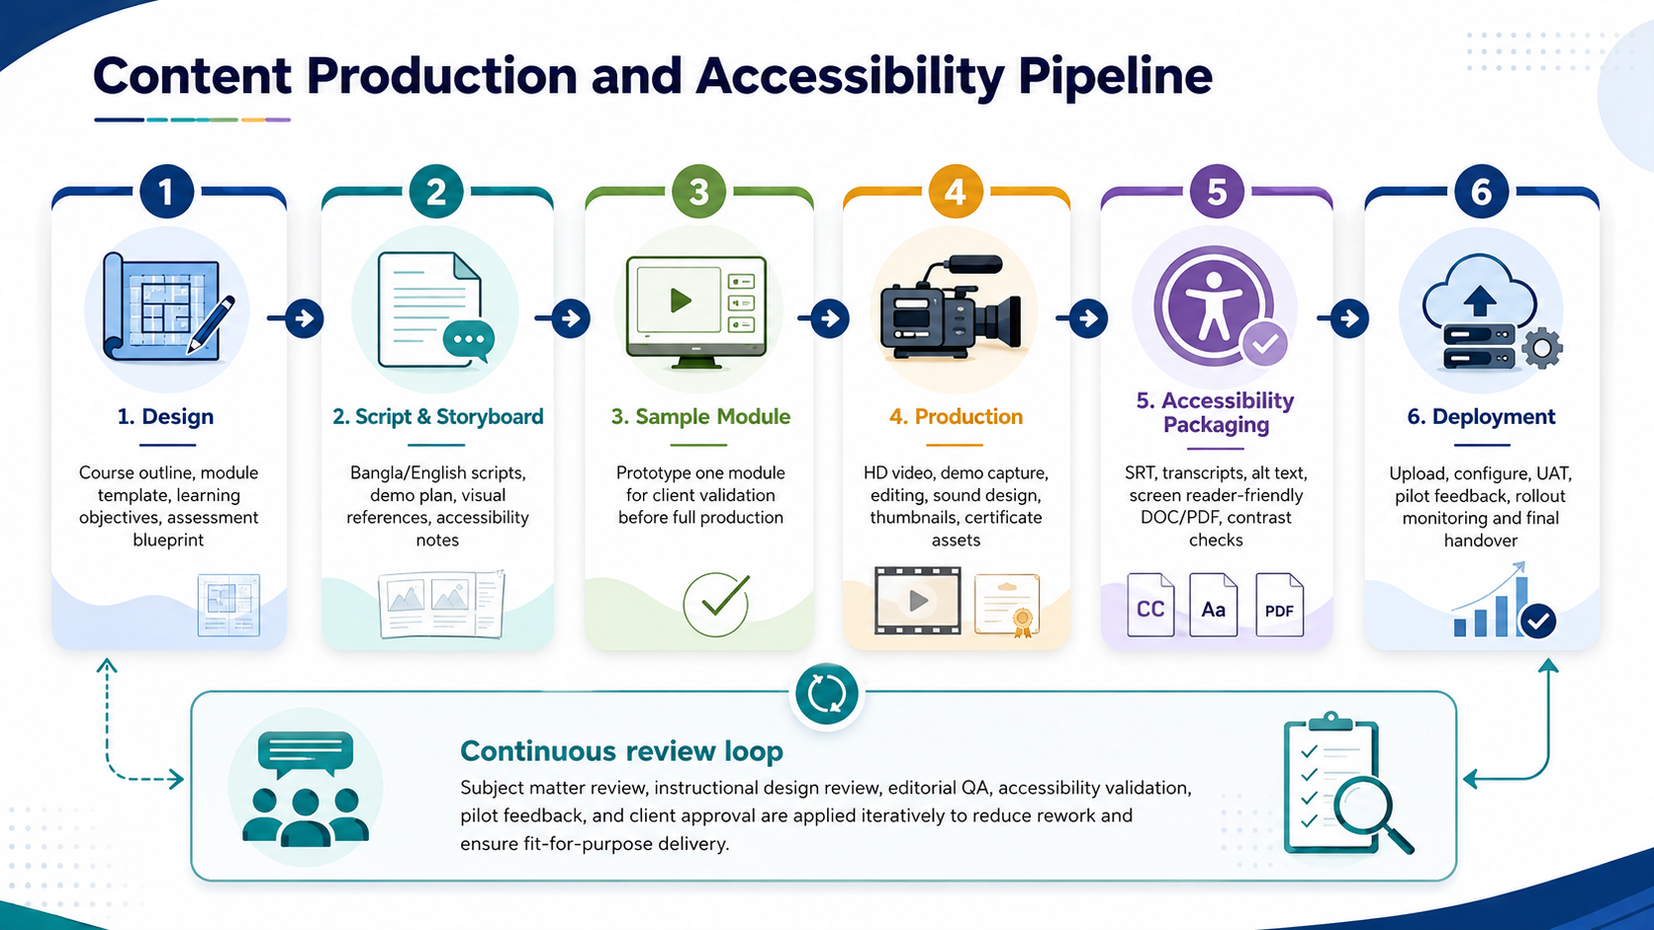
Figure 1: Content production and accessibility pipeline.

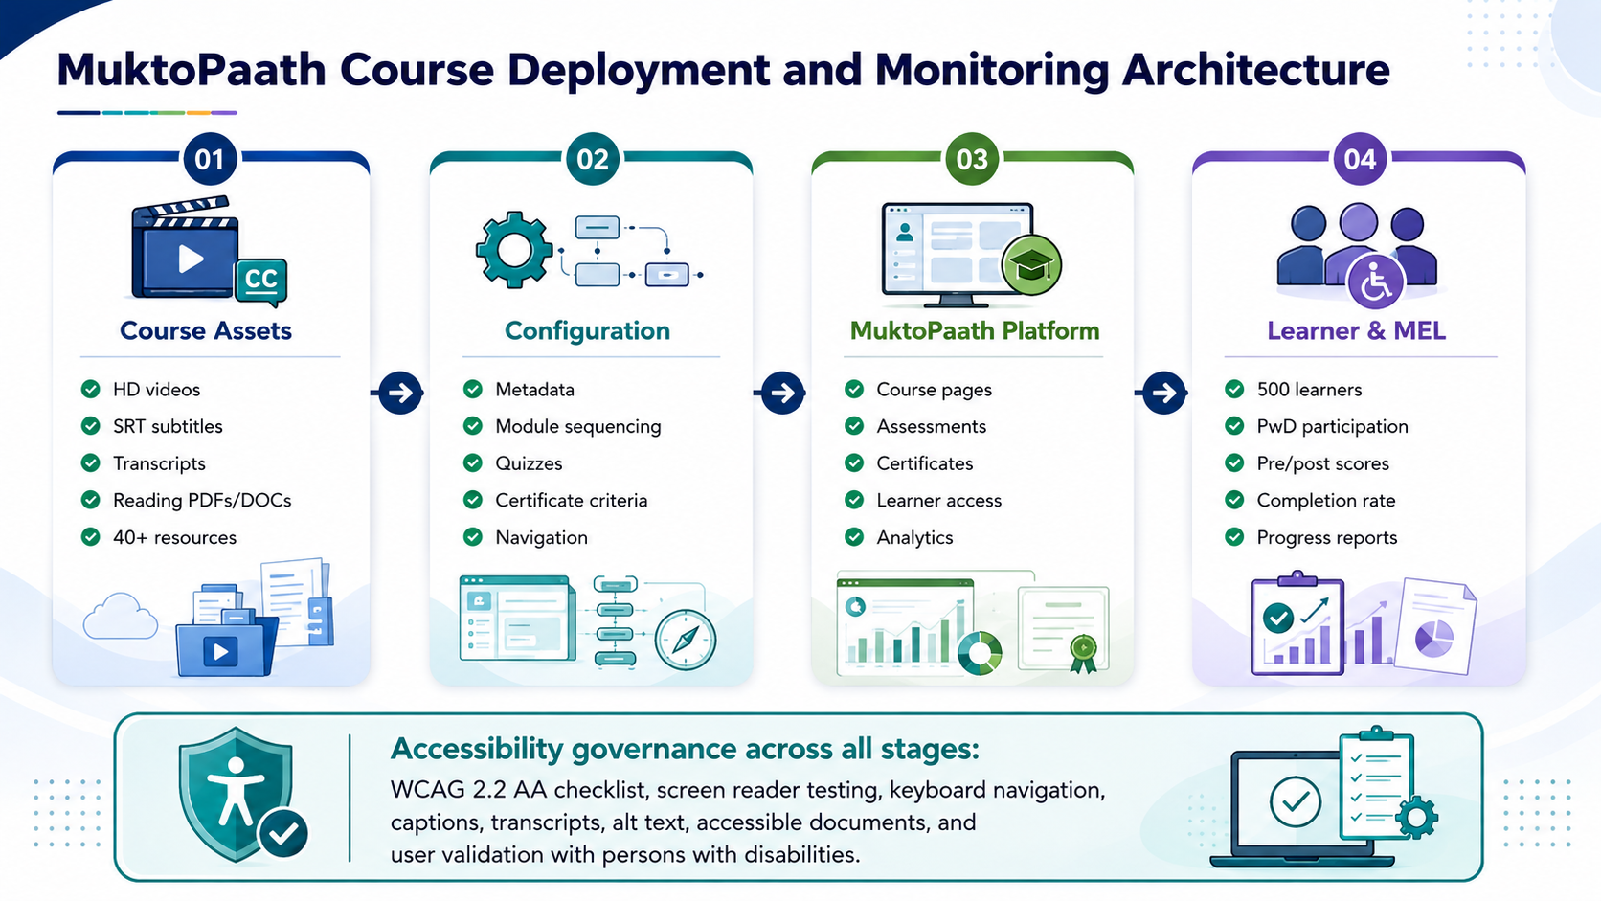
Figure 2: MuktoPaath deployment and monitoring architecture.

8. Deliverables
Serial | Deliverable | Key Outputs | Acceptance Basis
1 | Inception Report and Workplan | Methodology, stakeholder consultation plan, workplan, risk approach, MEL framework, pre/post assessment design. | Approved inception report.
2 | Curriculum and Instructional Design Package | Final DAT and DDT structure, 25-30 modules, objectives, duration, sequencing, module outlines, assessment framework. | Approved course structure and module template.
3 | Scripts and Content Development Package | Scripts for all video content, storyboards, reading materials, draft downloadable resources, draft quizzes. | Approved scripts/storyboards and content package.
4 | Audio-Visual Production Package | 15-20 hours of edited HD video, demonstrations, case studies, one promo video, edited and raw files. | Reviewed and accepted AV production package.
5 | Accessibility Compliance Package | SRT subtitles, transcripts, accessible DOC/PDF materials, sign language where feasible, accessibility validation report. | Accessibility validation completed and issues resolved or documented.
6 | MuktoPaath Integration and Deployment | Course upload, metadata, module sequencing, assessments, certification criteria, accessibility features, UAT. | Courses configured and UAT completed on MuktoPaath.
7 | Pilot Testing and ToT Delivery | Pilot testing with diverse users including persons with disabilities, feedback report, refinement, ToT for at least 20 trainers, facilitator materials. | Pilot feedback addressed and ToT completed.
8 | Training Rollout and Monitoring | Monitoring of 500 participants, progress reports, completion and engagement analytics, inclusion metrics, learning improvement evidence. | Regular progress reports and monitoring evidence submitted.
9 | Final Report and Knowledge Transfer | Final evaluation, analytics, lessons learned, recommendations, source files, datasets, editable assets, handover materials. | Final acceptance and handover completed.

9. Testing and Quality Assurance
Testing and quality assurance will be kept practical and focused on course quality, accessibility, platform readiness, and learner experience. The QA approach will include the following points:
- Content accuracy review by subject matter experts before production and before final submission.
- Instructional design review to ensure each module has clear objectives, examples, summary, and quiz alignment.
- Editorial QA for clarity, terminology consistency, Bangla Unicode text quality, and bilingual content accuracy where applicable.
- Audio-visual QA for resolution, sound clarity, caption sync, visual readability, and consistent branding.
- Accessibility QA against WCAG 2.2 AA principles where applicable, including captions, transcripts, document structure, alt text, keyboard navigation, screen reader compatibility, and color contrast.
- MuktoPaath UAT to check upload quality, module sequence, navigation, quiz logic, assessment scoring, certificate flow, and learner access.
- Pilot testing with diverse learners, including persons with disabilities, followed by issue logging, prioritization, and refinement.
- Data protection QA to ensure consent, privacy, secure handling of participant information, and ethical reporting.

10. Implementation Timeline
Proposed Timeline: 2.5 Months

11. Project Governance and Communication
A simple governance structure will be used to keep the project controlled and transparent without creating unnecessary administrative burden.
- Project focal points: one focal person from the implementation partner and one focal person from a2i/UNDP for coordination and approvals.
- Weekly progress updates: short updates on completed work, ongoing tasks, risks, pending approvals, and next steps.
- Approval checkpoints: inception report, curriculum package, sample module, scripts/storyboards, AV package, accessibility package, UAT, pilot refinement, and final handover.
- Issue management: maintain a shared issue log for content, accessibility, platform, and schedule risks.
- Change control: any new modules, additional formats, or platform customization outside the ToR will require written approval before implementation.

12. Key Risks and Mitigation
Risk | Level | Mitigation
Delay in stakeholder feedback | Medium | Use fixed review windows, approval checkpoints, and consolidated feedback templates.
MuktoPaath technical constraints | Medium | Validate platform requirements during inception and test sample uploads early.
Accessibility issues discovered late | Medium | Apply accessibility checks from script/storyboard stage and run iterative validation.
Over-expansion of course scope | Medium | Use approved module list and formal change control for any additions.
Low learner completion rate | Medium | Use shorter modules, clear learning paths, reminder support through platform process, and monitor reports.
Insufficient PwD participation in pilot | Medium | Coordinate early with OPDs and relevant stakeholder networks to support inclusive participation.
Data privacy concerns | Low-Medium | Use informed consent, limited data access, secure storage, and anonymized reporting where appropriate.

13. Conclusion
This technical proposal presents a focused and practical approach for developing and delivering two accessible e-learning courses on digital accessibility and disability inclusion. The proposed solution aligns with the ToR by concentrating on curriculum design, accessible content production, MuktoPaath deployment, pilot testing, ToT, monitoring, and knowledge transfer. It avoids unnecessary platform development or extra feature expansion, while ensuring the outputs are scalable, reusable, and suitable for institutional adoption.
Through accessibility-by-design, stakeholder participation, structured instructional design, practical demonstrations, and continuous QA, the proposed approach will support improved awareness, technical capacity, and inclusive digital transformation in Bangladesh.

