INTERNEE.PK WEBSITE REDESIGN
WordPress Website Development Project
Submitted By: Sadia Shabir
Project: Internee.pk Website Redesign
Platform: WordPress
Development Environment: XAMPP / Localhost
Project Type: Website Redesign and Optimization
1. Introduction
The purpose of this project is to redesign the Internee.pk website using WordPress. The website was developed in a local WordPress environment using XAMPP.
The main objective was to create a clean, organized, user-friendly and responsive website while implementing essential SEO, security, performance and content-management features.
The redesigned website provides an organized structure for internship opportunities, courses, company information and contact information.
2. Objectives
The main objectives of this project were:
- To set up a WordPress website in a local environment.
- To customize the WordPress theme according to the required design.
- To organize website content into appropriate pages and sections.
- To configure essential WordPress plugins.
- To implement basic on-page SEO.
- To configure SEO-friendly URLs.
- To improve website security and performance.
- To create documentation for future website maintenance.
3. Development Environment
The website was developed and tested locally using:
Technology / Tool | Purpose
WordPress | Website development and content management
XAMPP | Local development environment
Apache | Local web server
MySQL | Database management
Elementor | Page design and customization
HTML/CSS | Website structure and styling
Rank Math SEO | Search engine optimization
Wordfence | Website security
UpdraftPlus | Website backup
Only include plugins that you actually installed and configured.
4. WordPress Installation
WordPress was installed in the XAMPP "htdocs" directory and configured using a local MySQL database.
The website was accessed through the following local URL:
"http://localhost/internee/"
Screenshot: XAMPP
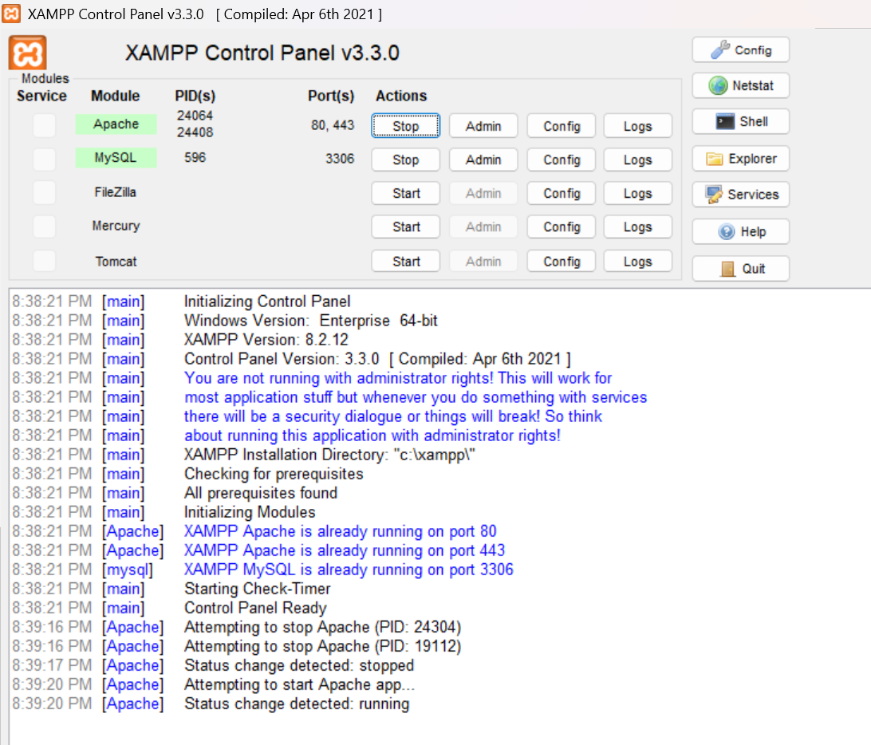
Screenshot: WordPress Dashboard

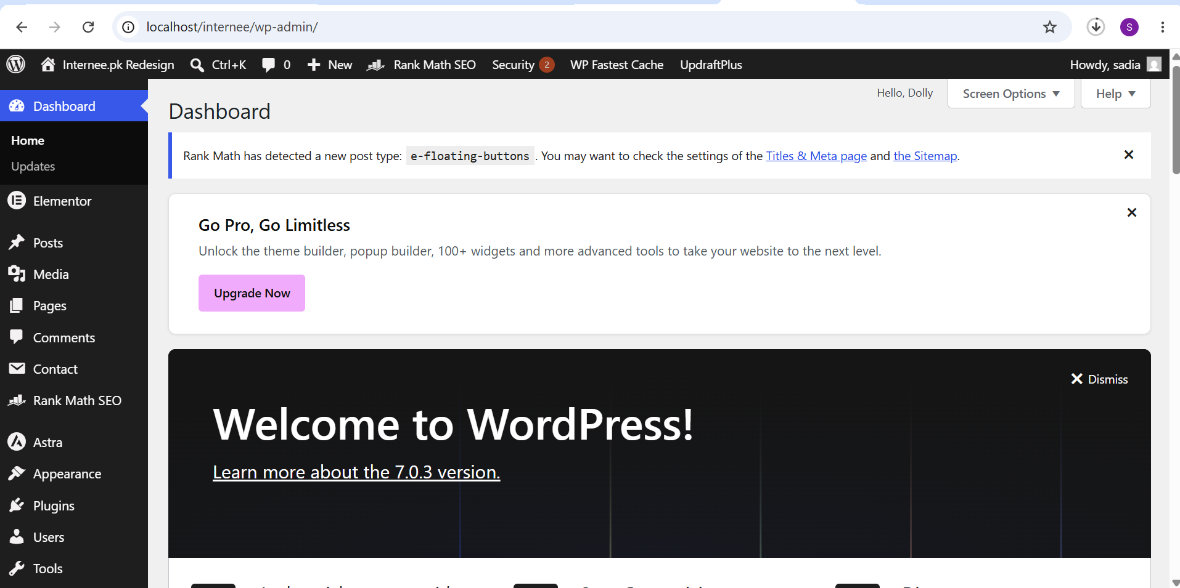
5. Website Structure
The website was organized into the following main pages:
- Home
- About
- Internships
- Courses
- Contact
The navigation menu was configured to provide easy access to the main sections of the website.
Screenshot: Pages
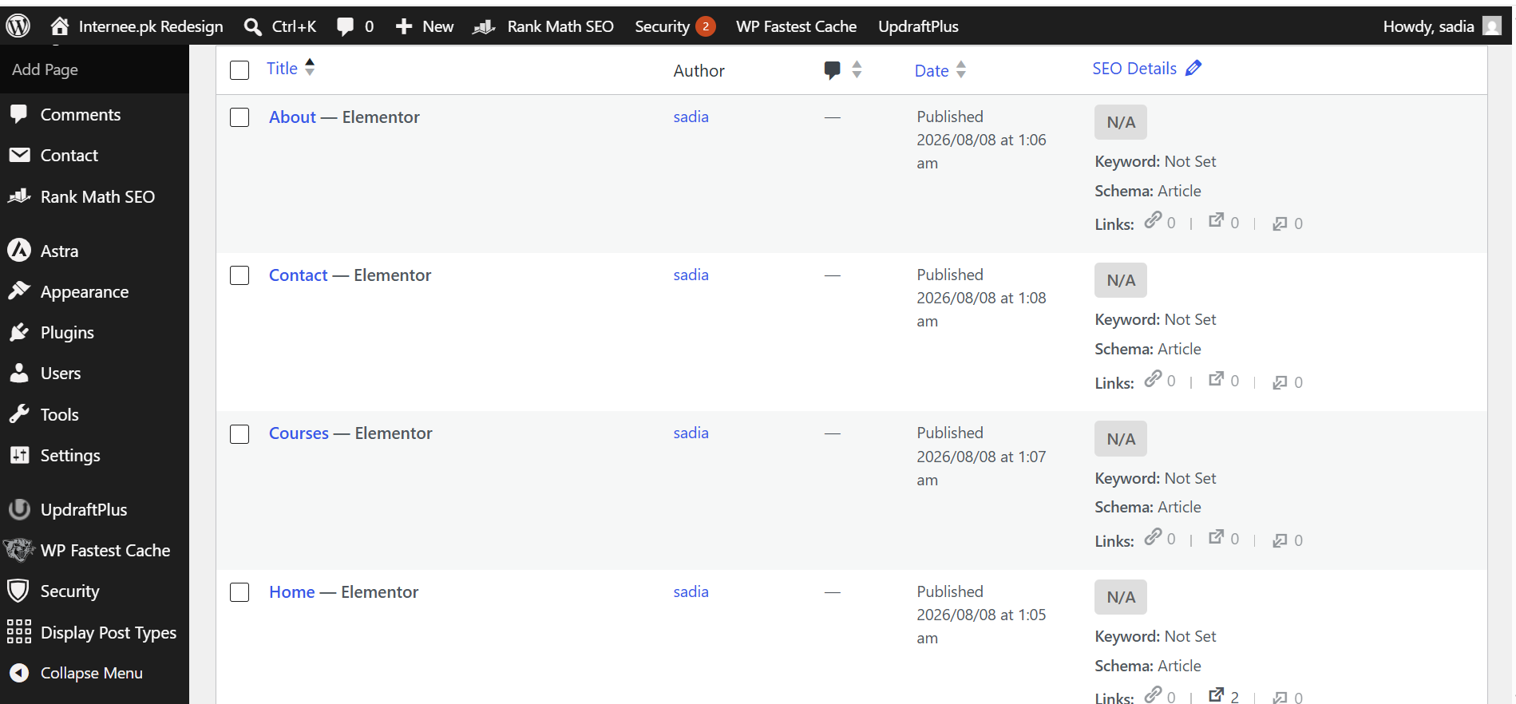
6. Homepage Design
The homepage was redesigned to provide important information in a clear and organized manner.
Hero Section
The hero section introduces the website and provides clear call-to-action buttons.
About Section
This section provides a brief introduction to Internee.pk.
Internship Categories
Different internship areas are presented in an organized card-based layout.
Why Choose Us
Important benefits and features are highlighted for students.
Featured Opportunities
Internship opportunities are presented in an easy-to-understand format.
Contact Section
Users can access contact information and the contact form.
Screenshot: Homepage
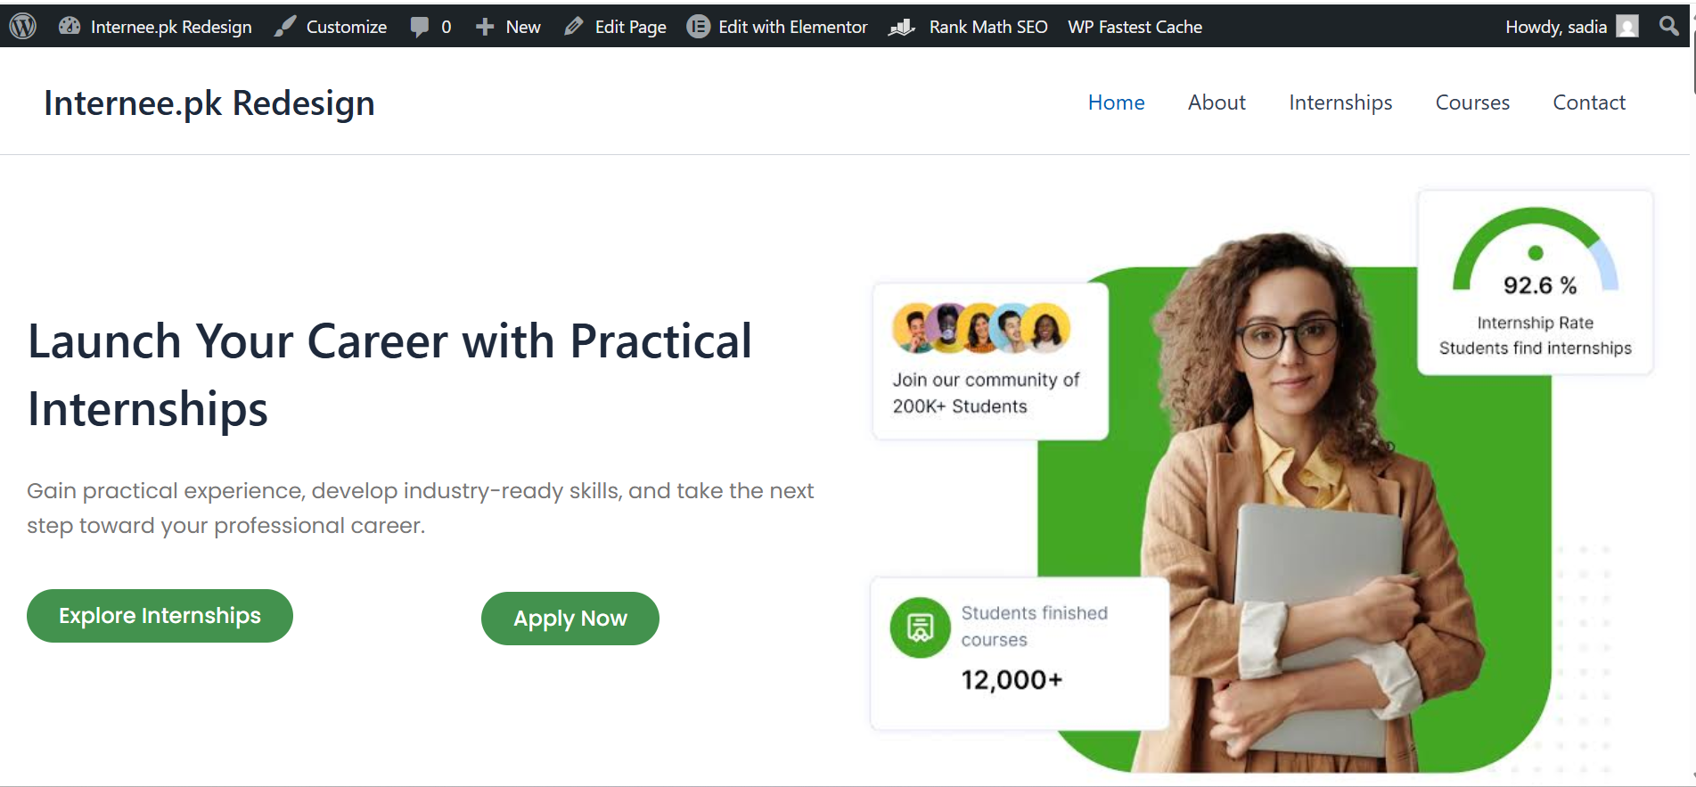

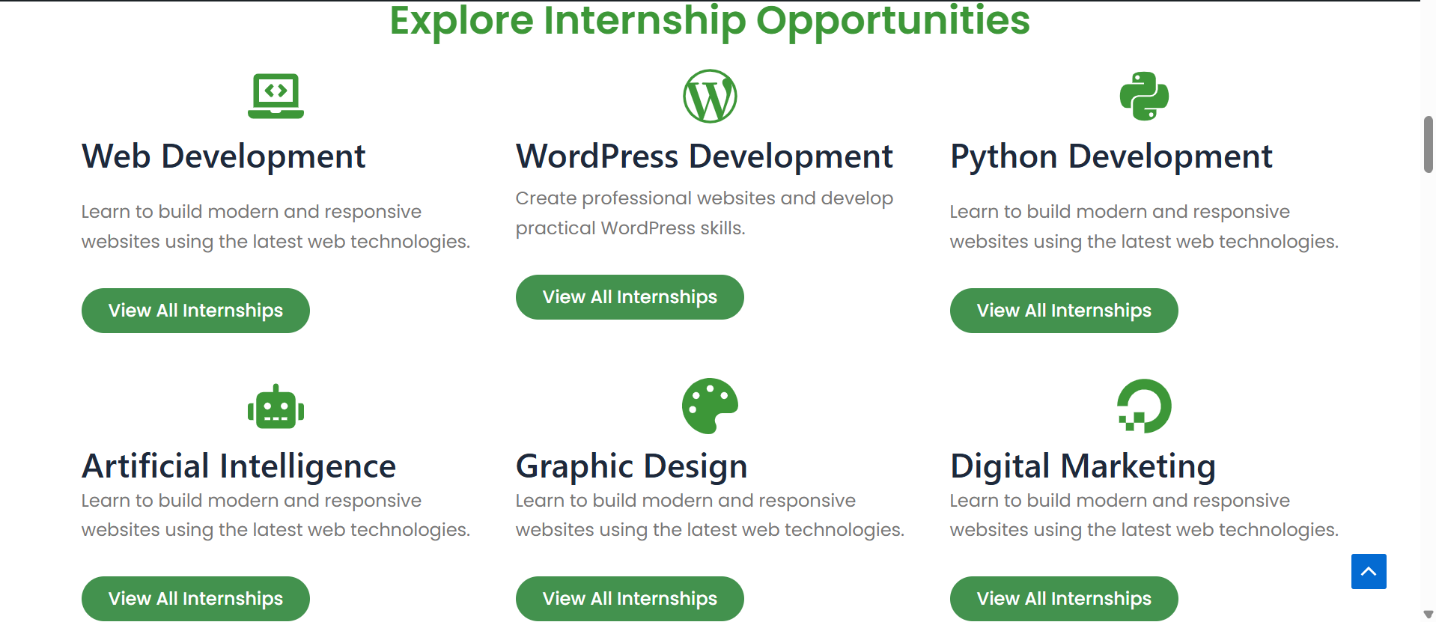
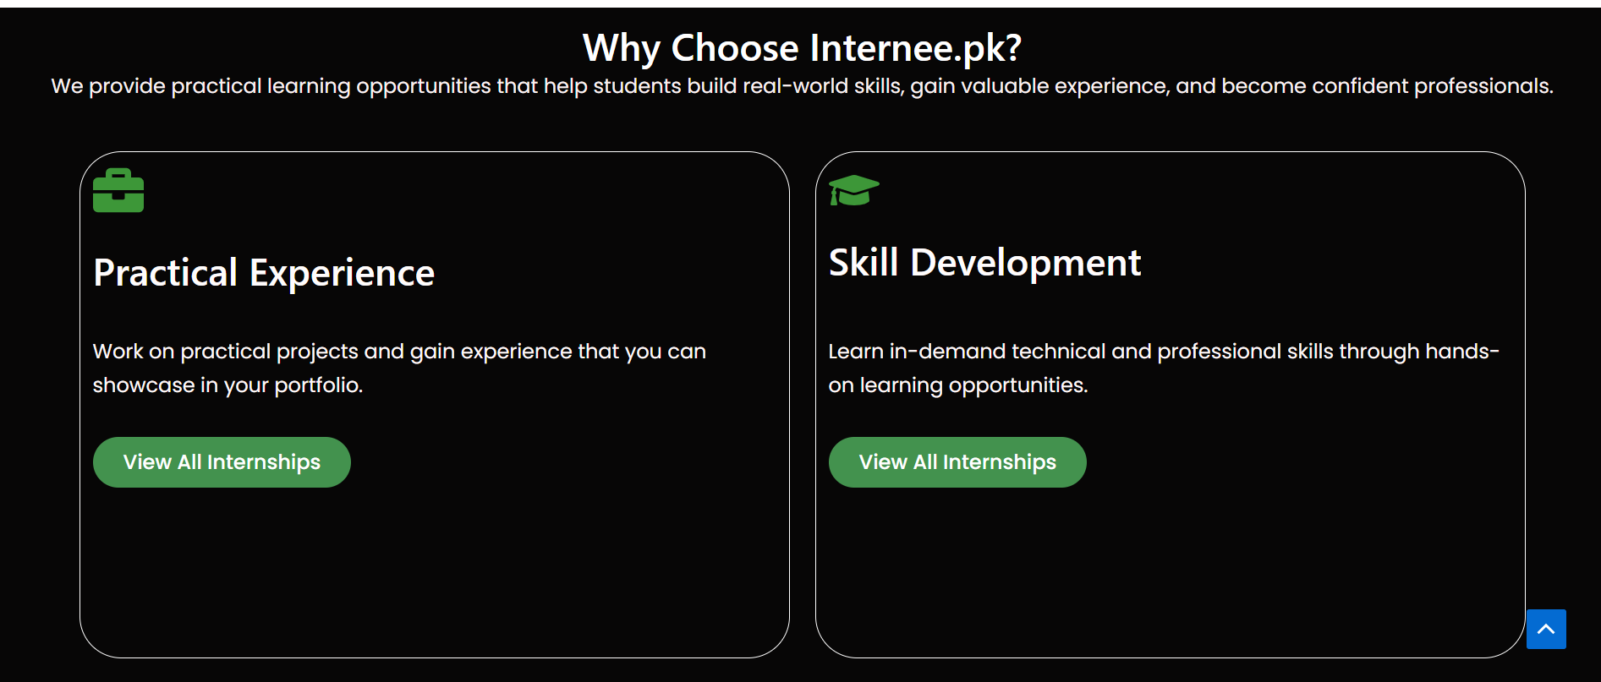

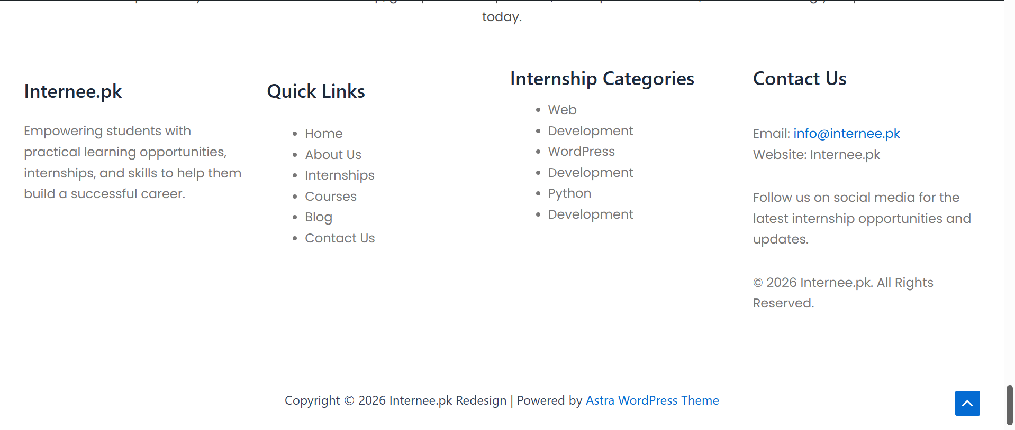
7. About Page
The About page provides information about Internee.pk and its purpose.
The page was designed with appropriate headings, text sections and visual elements to make the information easy to understand.
Screenshot: About Page
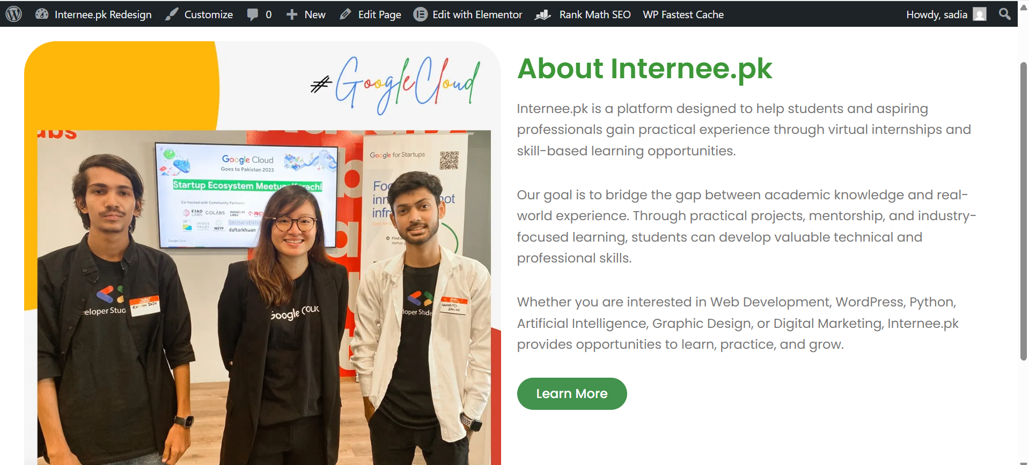
8. Internships Page
The Internships page organizes internship opportunities into different categories.
Examples of categories include:
- Web Development
- WordPress
- Python
- Artificial Intelligence
- Graphic Design
- Digital Marketing
The page uses structured sections/cards to make internship information easier to browse.
Screenshot: Internships Page

9. Courses Page
The Courses page presents available learning opportunities in an organized layout.
Course information is displayed using headings, descriptions and suitable visual elements.
Screenshot: Courses Page
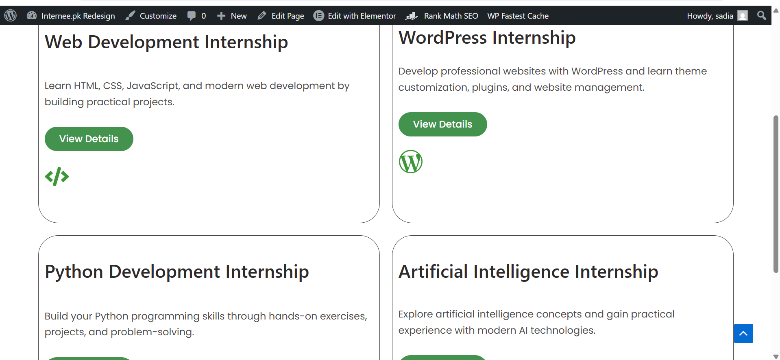
10. Contact Page
A Contact page was created to provide users with a convenient way to communicate with the organization.
The page contains contact information and a contact form with fields such as:
- Name
- Email
- Subject
- Message
Screenshot: Contact Page
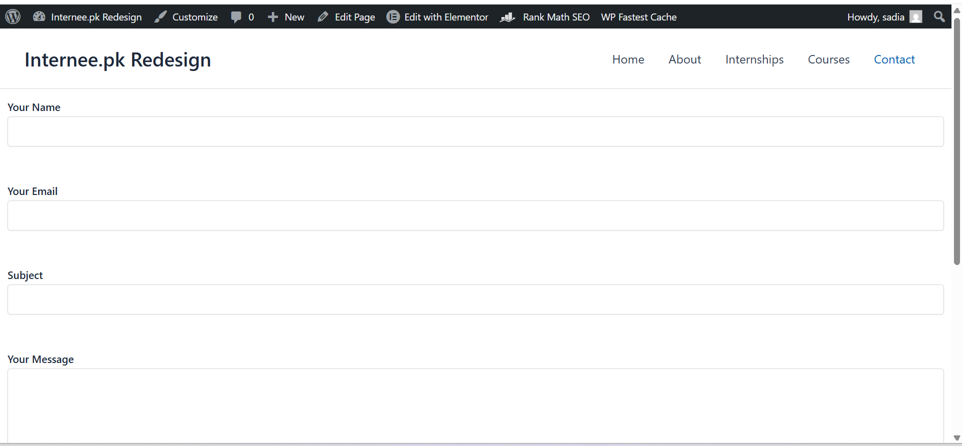
11. Theme Customization
The WordPress theme was customized to create a consistent appearance across the website.
The following elements were customized:
Page layouts
Typography
Buttons
Navigation menu
Images
Content sections
Footer
Spacing and alignment
Elementor was used to create and customize page sections.
12. Plugins
The required WordPress plugins were installed and configured according to the website requirements.
SEO Plugin
Used for managing SEO titles, meta descriptions and other on-page SEO settings.
Security Plugin
Used to improve website security and perform security scans.
Backup Plugin
Used to create backups of the website.
Performance Plugin
Used to improve caching and website performance.
Screenshot: Installed Plugins
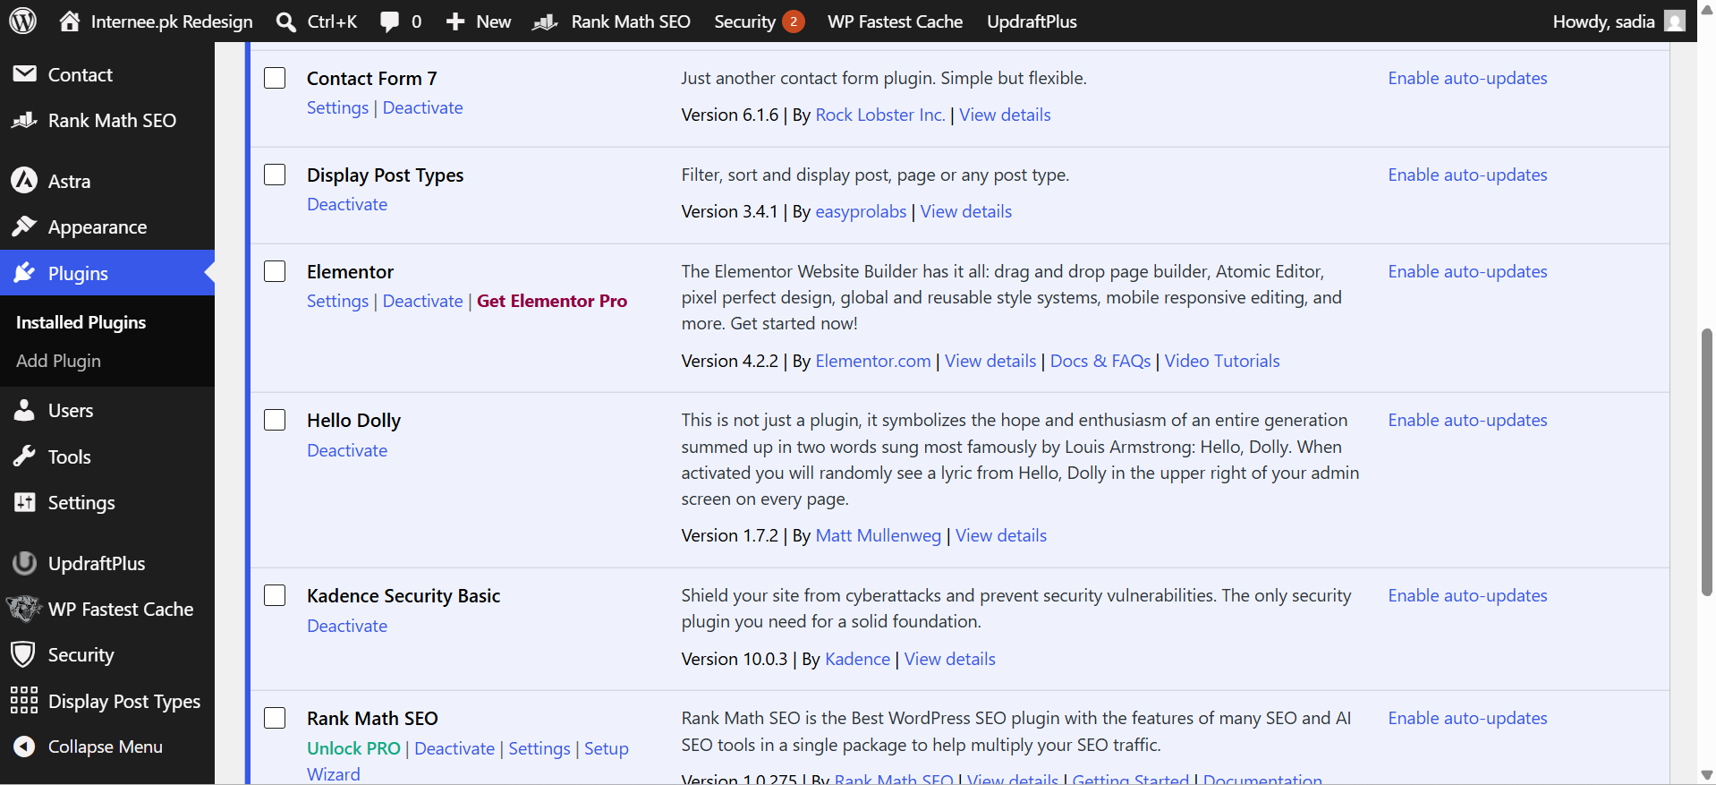
13. Content Organization
Website content was organized into separate pages and sections to make information easy to access.
The navigation structure allows users to move between the Home, About, Internships, Courses and Contact sections easily.
Relevant headings, images and content sections were used to maintain a clear structure throughout the website.
14. SEO Optimization
Basic on-page SEO was implemented throughout the website.
The following SEO elements were configured:
- SEO-friendly page titles
- Meta descriptions
- Proper heading structure
- Image alt attributes
- Internal navigation
- SEO-friendly URLs
The website content was organized using appropriate headings to improve readability and search engine understanding.
Screenshot: SEO Settings
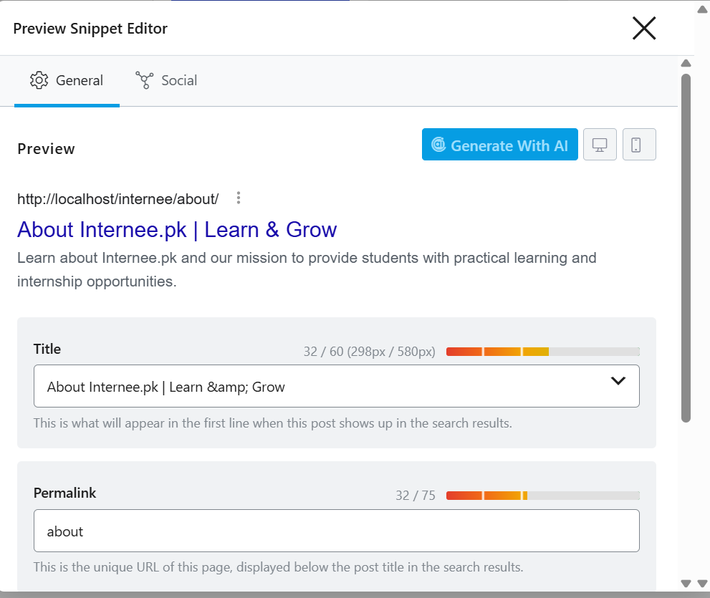
15. Permalink Configuration
SEO-friendly permalinks were configured through:
WordPress Dashboard → Settings → Permalinks
The Post Name structure was selected.
This creates cleaner URLs that are easier for users and search engines to understand.
Screenshot: Permalink Settings

16. Security Configuration
Website security was improved using a WordPress security plugin.
Security measures included:
- Security scanning
- Firewall configuration
- Monitoring WordPress security
- Keeping plugins and themes updated
Regular backups are also recommended to protect website data.
17. Performance Optimization
Performance optimization was considered to improve the website's loading experience.
The following practices were used where applicable:
- Caching
- Image optimization
- Lazy loading
- Optimized website assets
- Removing unnecessary plugins
These techniques help improve website performance and user experience.
18. Website Maintenance Guide
The website can be maintained through the WordPress Dashboard.
Updating a Page
- Login to WordPress Dashboard.
- Go to Pages.
- Select the required page.
- Edit the content.
- Click Update.
Updating Image
- Open the required page.
- Select the image.
- Replace it with a new image.
- Add suitable alt text.
- Click Update.
Adding a New Internship
- Open the relevant page.
- Add a new internship section/card.
- Enter the internship title and description.
- Add the relevant image.
- Update the page.
Updating Plugins
- Go to Plugins → Installed Plugins.
- Check available updates.
- Update plugins when required.
- Test the website after updating.
Creating Backups
Regular backups should be created using the installed backup plugin. Backups should be maintained before major updates or changes.
19. Testing
The website was tested in the local WordPress environment.
The following elements were checked:
- Navigation menu
- Website pages
- Buttons and links
- Images
- Contact form
- Page layout
- Responsive design
- SEO settings
- Permalink structure
The website was reviewed to ensure that the major sections were functioning correctly.
20. Conclusion
The Internee.pk website was successfully redesigned using WordPress in a local XAMPP environment.
The project included WordPress setup, theme customization, content organization, plugin configuration, SEO optimization, security and performance improvements.
The redesigned website provides a structured and user-friendly interface for presenting internship opportunities, courses and other important information.
The project also includes documentation to help with future website updates and maintenance.

