SCIT PAYMENT REMINDER & RECONCILIATION AGENT

Project Documentation
Payment follow-up automation using Zapier Agents, Gmail, and Google Sheets

1. Project Overview
The SCIT Payment Reminder and Reconciliation Agent is an automation project built with Zapier Agents, Google Sheets, and Gmail. It is designed to read invoice records, identify pending payments, send reminder emails, review payment-related replies, and update the matching spreadsheet row according to configured rules.
The Google Sheet acts as the central invoice register. Gmail is used for reminder messages and incoming responses. Agent instructions coordinate the tools and define how pending invoices, completed invoices, and replies should be handled.

2. Problem Statement
Manually checking invoice sheets, writing reminder emails, searching inbox replies, and changing payment statuses can take time and lead to missed follow-ups or inconsistent records. This project aims to reduce repetitive work by connecting the invoice spreadsheet with email actions through an AI agent.

3. Objectives
- Read invoice records from the SCIT Invoice Google Sheet.
- Identify records marked Pending.
- Send reminder emails to the intended recipients.
- Find and review replies that indicate a payment may have been made.
- Capture a transaction/reference number when provided.
- Match each reply to the correct invoice before updating the spreadsheet.
- Avoid changing records already marked Completed.

4. Tools and Components
Component | Purpose | Role in this project
Zapier Agents | Agent configuration and orchestration | Follows project instructions and uses available tools
Google Sheets | Invoice data and status tracking | Stores invoice IDs, names, types, amounts, bank details, and statuses
Gmail: Send Email | Outgoing email | Sends reminders for pending invoices
Gmail: Find Email | Email search | Locates relevant payment replies
Google Sheets: Update Spreadsheet Row(s) | Update records | Changes the status of a matched invoice row
Default Tools: Visit Site & Web Search | General web access | Available to the agent, but not central to this workflow

5. Spreadsheet Structure
The supplied sheet is titled “SCIT Invoice”. Its visible columns are Sr, Invoice ID, Type, Name, Amount, Account No, Bank Name, and Status. Use a unique invoice ID to identify the correct record and preserve other fields when updating a row.
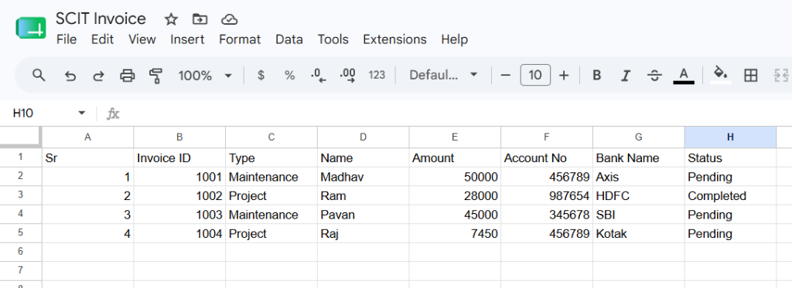
Figure 1. Initial invoice register in Google Sheets
The screenshot shows four sample records: invoice 1001 for Madhav (Maintenance, ₹50,000) is Pending; invoice 1002 for Ram (Project, ₹28,000) is Completed; invoice 1003 for Pavan (Maintenance, ₹45,000) is Pending; and invoice 1004 for Raj (Project, ₹7,450) is Pending. These values may change in the live sheet.

6. End-to-End Workflow
- Read: the agent reads invoice rows from the SCIT Invoice sheet.
- Filter: it identifies pending invoices and skips rows already marked Completed.
- Remind: it prepares and sends a reminder email to the intended recipient.
- Find replies: it searches Gmail for responses relevant to an invoice or reminder.
- Review: it extracts payment claims and transaction/reference details when present.
- Match: it matches the reply to the correct invoice using reliable identifiers.
- Update: it updates only the matched row when the configured confirmation conditions are met.

7. Setup Instructions

Step 1: Prepare Google Sheets
- Create a Google Sheet named SCIT Invoice.
- Add the required columns and use a unique Invoice ID for each record.
- Use consistent status values such as Pending and Completed.
- Restrict access to account numbers and financial details.

Step 2: Configure the Zapier agent
- Open Zapier Agents and create or open the payment reminder agent.
- Set the trigger to On Demand or the schedule suitable for the use case.
- Write instructions for reading pending invoices, sending reminders, finding replies, and updating statuses.

Step 3: Connect tools
- Connect Google Sheets and select the SCIT Invoice spreadsheet and correct worksheet.
- Connect Gmail and configure Send Email and Find Email.
- Configure Update Spreadsheet Row(s) to target the correct row using a unique invoice ID or row identifier.
- Add the sheet as a knowledge source if needed by the agent configuration.

Step 4: Test safely
- Use sample invoice data and a test mailbox first.
- Check that Pending invoices are identified and Completed invoices are skipped.
- Verify recipient, subject, invoice ID, category, and amount before sending.
- Test replies with a transaction reference and ambiguous replies.
- Confirm that only the intended spreadsheet row changes.

8. Screenshot Explanations
The supplied screenshots document the sample data, reminder email, incoming reply, connected tools, and the agent's instructions and preview.
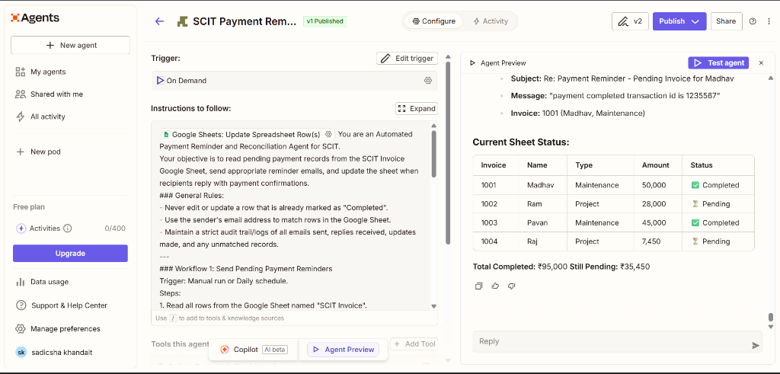
Figure 2. Zapier agent configuration and test preview
The screenshot shows the SCIT Payment Reminder agent, an On Demand trigger, instructions to read the sheet and send reminders, and a preview of invoice statuses. The preview shows completed and pending totals. Confirm live tool behavior separately before relying on the preview.
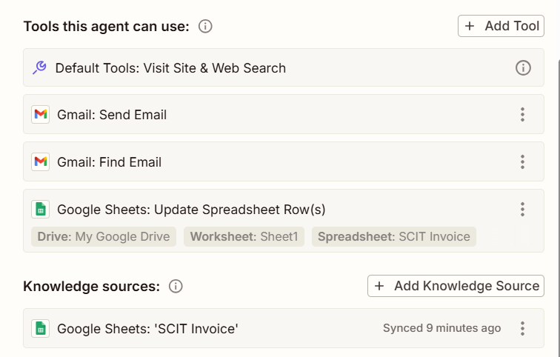
Figure 3. Connected tools and knowledge source
The agent has web search, Gmail Send Email, Gmail Find Email, and Google Sheets Update Spreadsheet Row(s) tools. The SCIT Invoice sheet is also listed as a knowledge source. Tool availability alone does not guarantee an action will run; instructions and tool configuration must specify when and how each tool is used.
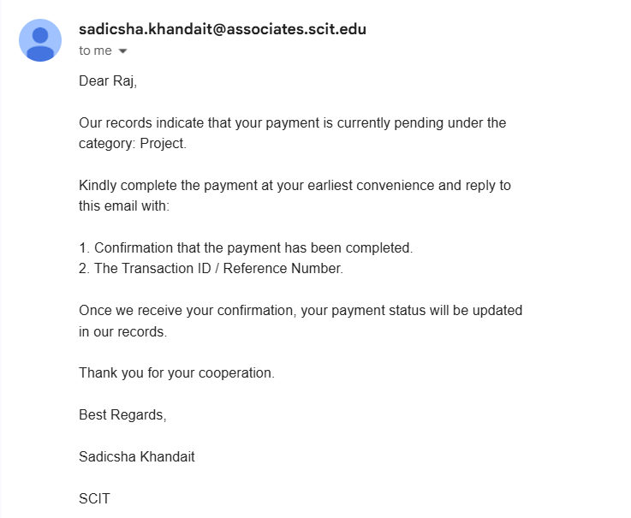
Figure 4. Example payment reminder email
The subject is “Payment Pending – Action Required”. The message addresses Pavan and identifies the Maintenance category, asking the recipient to complete the pending payment. In a production workflow, include the correct invoice ID and amount, and verify the recipient before sending.
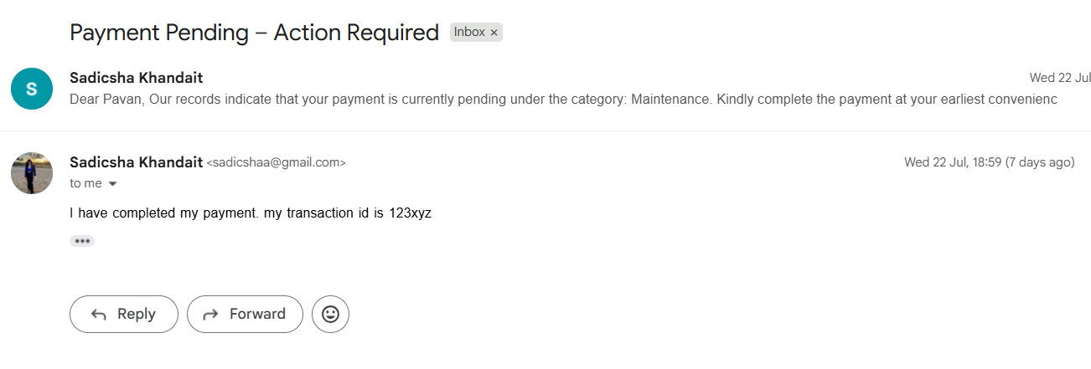
Figure 5. Example incoming payment reply
The reply claims the payment is complete and provides transaction ID 123xyz. The agent can use this as a signal to investigate the corresponding invoice. An email claim is not independent proof that funds have settled; use an approved verification process before marking an invoice Completed.

9. Testing and Expected Results
The agent preview shows four sample records and totals of ₹95,000 completed and ₹35,450 pending. These totals match the displayed sample sheet: ₹28,000 completed and ₹50,000 + ₹45,000 + ₹7,450 pending.
The supplied email screenshots show a reminder for Pavan and a reply claiming payment completion with transaction ID 123xyz. They demonstrate the intended scenario, but do not by themselves prove that every step ran automatically or that a bank transaction was verified.

Suggested test cases
Test | Expected behavior | What to verify
Pending invoice | Reminder sent/drafted as configured | Correct recipient and invoice details
Completed invoice | No duplicate reminder or status change | Completed remains unchanged
Reply with reference | Reply matched to correct invoice | Sender, invoice, and reference match
Ambiguous reply | No automatic completion without enough evidence | Keep pending or request review
Unmatched reply | No unrelated row is changed | Log or escalate the reply

10. Security and Limitations
- Do not upload private account numbers, customer email addresses, API keys, or credentials to a public repository.
- Use only the permissions needed for Gmail and Google Sheets.
- Prevent duplicate reminders where possible and maintain an audit trail.
- Email replies can be incomplete, misleading, or sent from an unexpected address.
- The screenshots do not show a direct bank API or bank-statement verification integration.
- Do not treat an email claiming payment as confirmed bank settlement; use human review or an approved verification method.

11. Future Improvements
- Add reminder schedules and escalation rules for overdue invoices.
- Create an audit log of invoice ID, email date, reply date, and action taken.
- Prevent duplicate reminders.
- Add a manual approval step before changing payment status.
- Add secure transaction verification through an authorized finance system if available.
- Generate a weekly summary of pending invoices and reminder outcomes.

12. Conclusion
The SCIT Payment Reminder and Reconciliation Agent demonstrates how Zapier Agents can coordinate Gmail and Google Sheets to support invoice follow-up. It brings invoice data, reminder communication, and payment-related replies into one workflow. It can reduce repetitive administrative work, but correct invoice matching, privacy, and independent payment verification remain essential.

