RETAILWISE: AI RETAIL ASSISTANT

Project Documentation
A visual language-model workflow for retail questions

SADICSHA KHANDAIT
25030242046
Agentic AI
SCIT

1. Project Overview
RetailWise is a conversational AI assistant intended to answer everyday retail questions about products, inventory, pricing, discounts, promotions, orders, and returns. The workflow is built visually: a chat input supplies the question, a prompt template describes the assistant's role, a language model generates a response, and chat output displays it. Message-history components are included to retrieve and store conversation context.
The sample interface shows RetailWise answering: “What factors should a retailer consider before offering a discount?” Its response highlights product cost, profit margin, customer demand, competitor prices, stock levels, and expected sales lift.

2. Problem Statement
Retail decisions involve several factors, and teams may need quick explanations or a starting point for analysis. RetailWise aims to provide accessible natural-language guidance to retail-related questions through a reusable AI workflow.

3. Objectives
- Accept retail questions through a chat interface.
- Use a prompt template to guide the assistant's role and scope.
- Generate clear responses using a language model.
- Display responses through the Chat Output component.
- Use message history to support follow-up questions, subject to configuration.
- Provide a foundation for future connection to verified retail data and tools.

4. Tools and Components
Component | Purpose | Role in the workflow
Chat Input | Receives the question | User enters a retail question
Message History — Retrieve | Provides prior context | Connects stored messages to the prompt's memory input
Prompt Template | Defines role and instructions | Sets the RetailWise persona and topic scope
Language Model | Generates text | Screenshot shows `openai/gpt-oss-20b` selected
Chat Output | Displays the answer | Shows the generated response
Message History — Store | Stores conversation messages | Can provide context for later turns, depending on configuration

5. Workflow Explanation
- The user enters a question in Chat Input.
- The Retrieve Message History component can provide earlier messages as context.
- The Prompt Template combines the RetailWise instructions with the current question and connected context.
- The Language Model generates a response from the prompt.
- Chat Output displays the response in the Playground.
- The Store Message History component receives the output so the conversation may retain context for later turns.
The screenshots show the intended component connections. Exact variable mapping and memory behavior depend on the component settings and runtime configuration.

6. Setup and Usage Steps

Step 1: Configure the prompt
- Open the Prompt Template component.
- Set the role, for example: “You are RetailWise, a helpful retail assistant.”
- List the supported topics: products, inventory, pricing, discounts, promotions, orders, and returns.
- Tell the assistant not to invent live stock, prices, or order details when no verified data source is connected.

Step 2: Configure the language model
- Open the Language Model component and confirm the selected provider/model.
- Configure any credentials required by the environment.
- The screenshot visibly shows `openai/gpt-oss-20b`; availability may depend on the environment and provider.
- Check that Chat Input and Prompt Template are connected to the intended model inputs.

Step 3: Configure message history
- Connect Retrieve Message History to the prompt's memory/context input.
- Connect the final response to the Store Message History component.
- Test multiple turns to confirm earlier messages are retrieved and new messages are stored.
- If conversation retention is not required, disable storage and follow applicable privacy requirements.

Step 4: Run a test
- Open the Playground or chat interface.
- Enter a retail question.
- Run the flow and review the response in Chat Output.
- Ask a follow-up question to test context handling.
- Verify business-critical recommendations against actual data.

7. Screenshot Explanations
The three supplied screenshots document the sample answer and the visual workflow structure.
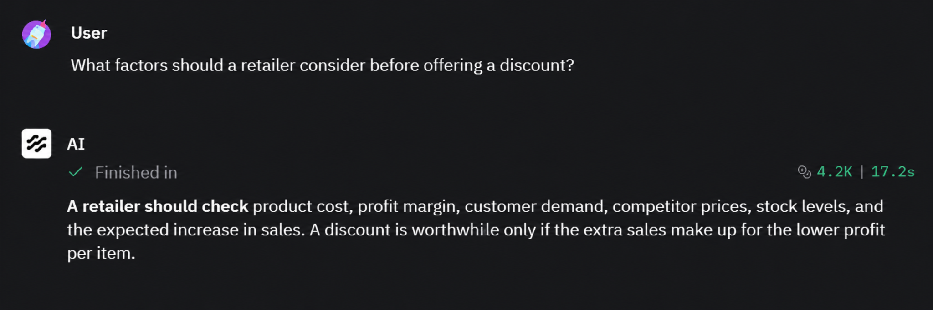
Figure 1. RetailWise chat interface and sample answer
The user asks what factors a retailer should consider before offering a discount. The AI mentions product cost, profit margin, customer demand, competitor prices, stock levels, and expected sales increase. It explains that extra sales should compensate for lower profit per item. This is general guidance, not a calculation using the retailer's own sales data.
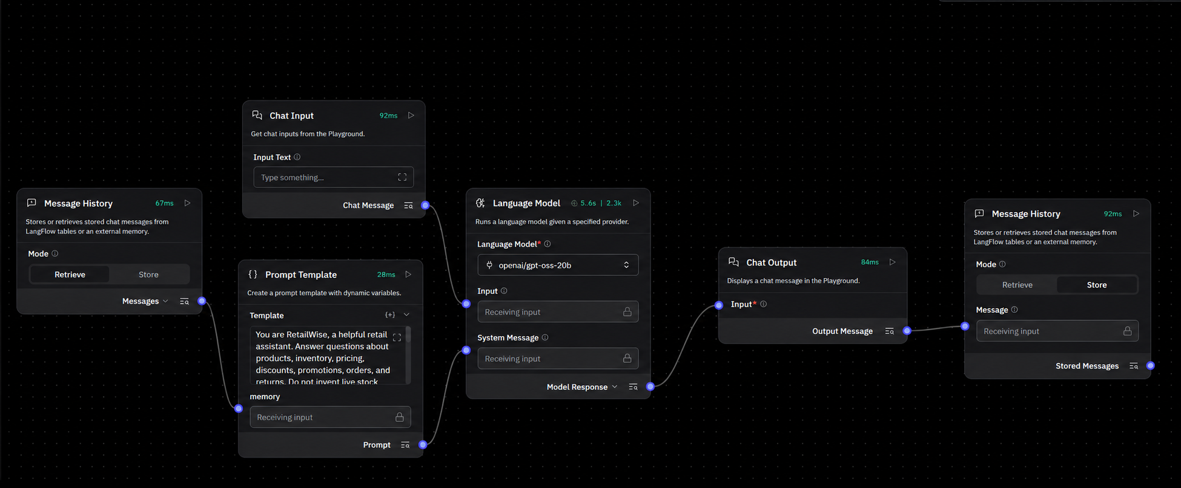
Figure 2. RetailWise visual node graph
The graph contains Message History, Prompt Template, Chat Input, Language Model, Chat Output, and a second Message History component. The prompt defines RetailWise as a retail assistant. The selected model shown is `openai/gpt-oss-20b`. Connections represent the intended flow of user input, prompt/context, model response, and stored conversation.
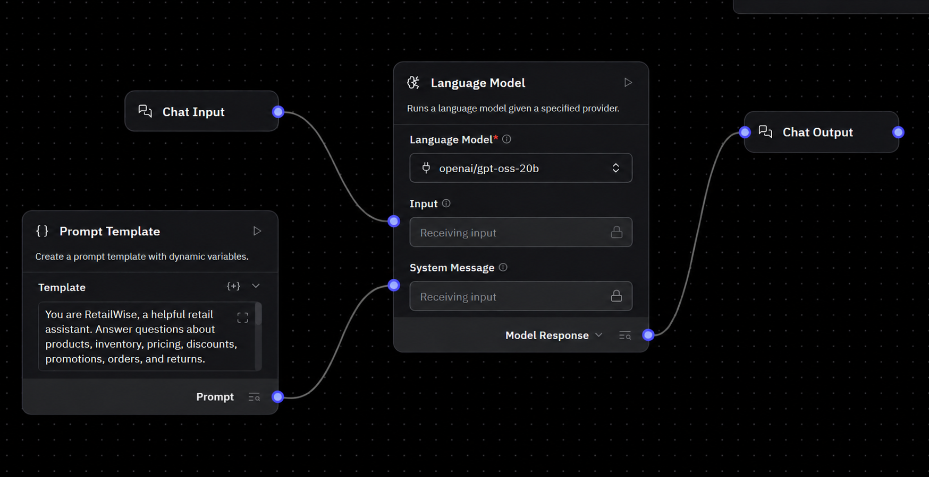
Figure 3. Main workflow connections in detail
This closer view shows Chat Input feeding the model input, Prompt Template feeding the model's system-message input, and the model response connecting to Chat Output. Message History retrieval connects to the prompt's memory input, while the output is also connected to history storage. Check component settings to confirm exact variable mapping and persistence behavior.

8. Example Use Case: Discount Decision Support
Question: “What factors should a retailer consider before offering a discount?”
- Cost and margin: calculate how much profit remains after reducing the price.
- Demand: estimate whether a lower price is likely to attract more buyers.
- Competitors: compare competitor prices and offers.
- Stock: consider whether inventory is excessive, limited, seasonal, or aging.
- Sales lift: estimate whether extra units sold can offset the lower profit per unit.
A future version could calculate discount profitability using actual product costs, sales history, inventory levels, and promotion results. The screenshots do not show a connected sales database or calculation tool, so the current answer should be treated as general guidance.

9. Testing Suggestions
Test question | Expected behavior | What to check
What factors affect discount decisions? | Lists relevant considerations | Answer is clear and balanced
How can a retailer reduce excess stock? | Provides general suggestions | Does not claim live inventory access
What is the current stock of product X? | States live data is unavailable unless connected | Does not invent stock quantities
Can you explain that more simply? | Answers the follow-up using context | Message history works as expected

10. Limitations and Improvements

Current limitations
- The screenshots show a prompt-based assistant, not a live retail database integration.
- The assistant may produce inaccurate or overly general information.
- Real-time product availability, prices, orders, and returns cannot be assumed without connected data sources.
- Message-history behavior depends on storage configuration and may have privacy implications.

Possible improvements
- Connect a trusted product catalogue or inventory database.
- Add a pricing calculator to estimate margin after a discount.
- Connect sales history to evaluate promotion performance.
- Provide source links when external research is used.
- Add validation rules to prevent unsupported claims about stock, prices, and orders.
- Document how conversation history is stored, retrieved, and deleted.

11. Conclusion
RetailWise demonstrates a visual workflow for answering retail questions with a language model. The prompt template defines the assistant's role, the model generates a response, and chat output displays it. Message-history components are intended to support continuity across turns. The project can become more useful for business decisions when connected to verified retail data and appropriate calculation tools.

