Personal Finance Chatbot: Intelligent Guidance for Savings, Taxes, and Investments
Project Description:
The AI Financial Literacy Advisor is an intelligent web-based application designed to make personal financial guidance accessible, simple, and free for everyone particularly students and young professionals in India. Built using Python and Flask on the backend and powered by Meta's LLaMA 3 (8B Instruct) model via the Hugging Face Inference API, the platform combines AI-generated financial advice with deterministic mathematical calculations to deliver a complete financial assistance experience.
The application offers three core modules. The Financial Concept Explainer allows users to type or select any financial term such as SIP, Compound Interest, or PPF and receive a plain-language, structured explanation that includes a definition, real-life example, and actionable tip. The Personalized Budget Planner takes user income, categorized monthly expenses, and financial goals as inputs, computes a 50/30/20 budget breakdown, renders an interactive doughnut chart, and generates a detailed AI-powered budget plan with step-by-step recommendations. The Scenario Analysis Engine supports three financial scenarios savings growth, debt repayment, and investment planning where users input parameters and receive both mathematically computed projections visualized through bar and line charts, and AI-generated narrative insights recommending India-specific instruments such as FD, RD, ELSS, NPS, and SIP.
The frontend is built with HTML5, CSS3, JavaScript, and Chart.js, offering a clean and responsive three-tab interface with all monetary values formatted in Indian Rupees (₹). The modular backend architecture ensures that the AI provider can be swapped seamlessly, making the system highly maintainable and scalable for future enhancements.

Scenarios:
Scenario 1: A user enters their monthly salary of ₹50,000 along with expenses such as rent, food, transport, and utilities using the structured budget form. The system automatically calculates total spending, computes the monthly surplus, and displays a percentage breakdown of each expense category through an interactive doughnut chart. The AI then generates a personalized budget plan highlighting areas of overspending and recommending an ideal 50/30/20 allocation with actionable steps to improve savings.
Scenario 2: A college student types "What is SIP and should I start investing?" into the Explain Concept module. The LLaMA 3 model responds with a beginner-friendly explanation covering what SIP means, why it matters for wealth creation, a relatable real-life example of investing ₹1,000 per month over 10 years, and one practical tip to get started immediately all in simple, jargon-free language tailored for a first-time investor.
Scenario 3: A working professional adds monthly expense categories including UPI transactions, food delivery, fuel, shopping, and EMIs into the budget planner. The AI analyses the spending distribution, detects red flags such as excessive food delivery charges consuming over 20% of income, and displays visual warnings through charts along with specific recommendations to rebalance the budget and increase the monthly savings rate.
Scenario 4: A user enters a financial goal of saving ₹1,00,000 for a laptop within 12 months. Based on their current income of ₹45,000 and total monthly expenses of ₹38,000, the savings scenario engine calculates that they need to save ₹8,334 per month which exceeds their current surplus. The AI then provides a step-by-step plan to cut discretionary spending, suggesting specific categories to reduce in order to meet the goal on time.
Scenario 5: A user inputs ₹5,000 per month in savings at 7% annual interest over 5 years into the Savings Growth Scenario. The system computes a year-by-year compound growth projection and renders a bar chart comparing total balance versus total amount deposited. The AI insight recommends the best Indian savings instruments such as PPF, RD, and liquid mutual funds, and calculates exactly how many months it will take to reach their target amount of ₹3,00,000.

Technical Architecture:

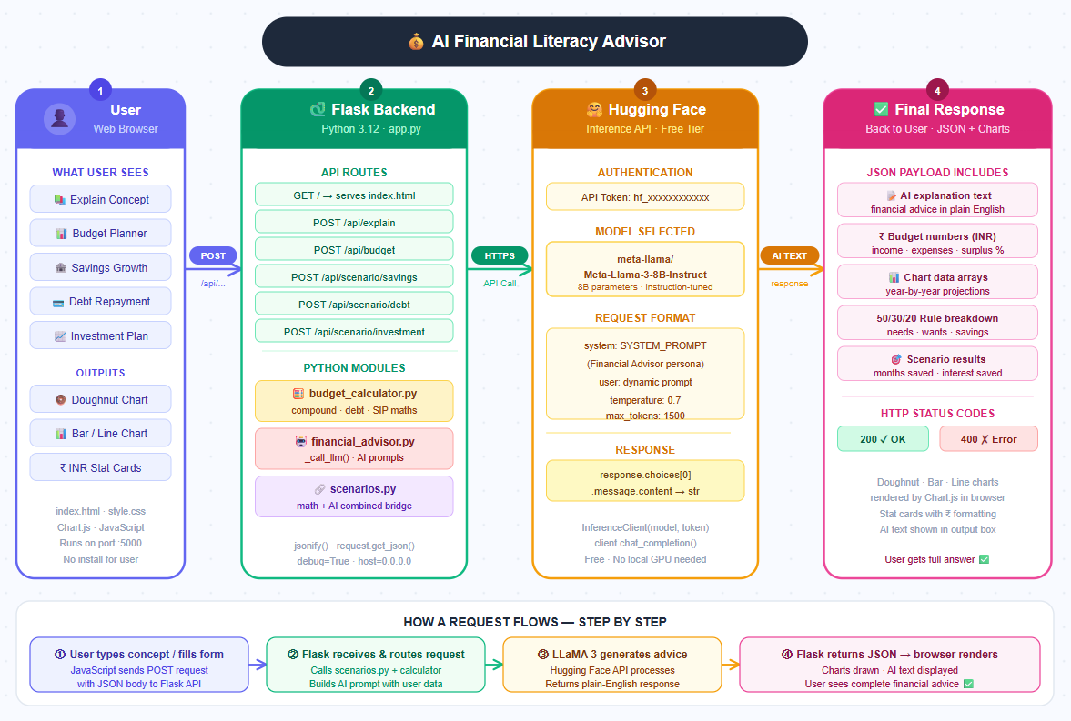

Project Folder Structure:

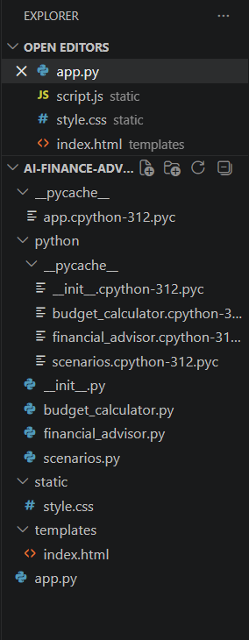

Pre-requisites:
1. Python Programming - https://docs.python.org/3/
2. Flask Web Framework - https://flask.palletsprojects.com/
3. Hugging Face Inference API – https://huggingface.co/docs/api-inference/
4. Meta LLaMA 3 Model – https://huggingface.co/meta-llama/Meta-Llama-3-8B-Instruct
5. Hugging Face Hub Library – https://huggingface.co/docs/huggingface_hub/
6. Vanilla HTML/CSS/JavaScript – https://developer.mozilla.org/en-US/docs/Web
7. Chart.js for Visualization – https://www.chartjs.org/docs/latest/
8. Python Data classes – https://docs.python.org/3/library/dataclasses.html
9. Python JSON Handling – https://docs.python.org/3/library/json.html
10. Environment Configuration – https://pypi.org/project/python-dotenv/

Project Workflow:

🔹 Milestone 1: Project Setup & Architecture Design
● Activity 1.1: Set up development environment (Python, VS Code, libraries)
● Activity 1.2: Select technologies (Flask, HTML, CSS, JavaScript, AI API)
● Activity 1.3: Design system architecture and workflow
● Activity 1.4: Configure API keys and environment setup
● Activity 1.5: Perform initial testing and setup validation

🔹 Milestone 2: Backend Development
● Activity 2.1: Develop Flask application and define routes
● Activity 2.2: Implement input handling and data processing
● Activity 2.3: Design prompt structure for AI responses
● Activity 2.4: Integrate AI model with backend

🔹 Milestone 3: Core Logic & Processing
● Activity 3.1: Validate user inputs
● Activity 3.2: Implement financial data processing logic
● Activity 3.3: Format AI-generated responses
● Activity 3.4: Handle errors and exceptions

🔹 Milestone 4: Frontend Development
● Activity 4.1: Design UI using HTML
● Activity 4.2: Apply styling using CSS
● Activity 4.3: Display dynamic output on UI

🔹 Milestone 5: Testing & Optimization
● Activity 5.1: Perform functional testing
● Activity 5.2: Debug and fix issues
● Activity 5.3: Optimize performance
● Activity 5.4: Conduct final testing

🔹 Milestone 6: Conclusion

Milestone 1: Project Setup & Architecture Design

This milestone establishes the complete development environment installing all required tools, selecting the technology stack, designing the system architecture, configuring API credentials, and validating the initial setup before any feature code is written.

🔹 Activity 1.1: Set up development environment
In this activity, the development environment is prepared and project structure is organized.
- Python is installed and verified using the command python --version.
- Add to PATH: During installation check 'Add python.exe to PATH' — this is mandatory.
- Visual Studio Code is installed as the development environment and add the Python extension.
- Open PowerShell inside the project folder and install all required libraries.

- A project folder named AI-Finance-Advisor is created.
- Inside the project, a structured folder system is implemented:
  - app.py → main Flask application
  - python/ → contains core logic modules
    - budget_calculator.py
    - financial_advisor.py
    - scenarios.py
  - templates/ → contains index.html
  - static/ → contains style.css and script.js
- Required libraries are installed: pip install flask transformers torch
- The transformers library from Hugging Face is used for integrating AI models.
- The environment is now ready for development.

🔹 Activity 1.2: Select technologies
In this activity, appropriate technologies are selected for building the system. The technology stack is selected based on simplicity, free availability, and suitability for a financial literacy application targeting Indian users with INR formatting.
- Flask is selected as the backend framework to manage server-side operations.
- HTML is used to design the structure of the web interface.
- CSS is used to enhance the visual appearance of the application.
- JavaScript is used to handle user interaction and send requests to the backend.
- Hugging Face is selected as the AI platform to generate financial advice using pre-trained models.

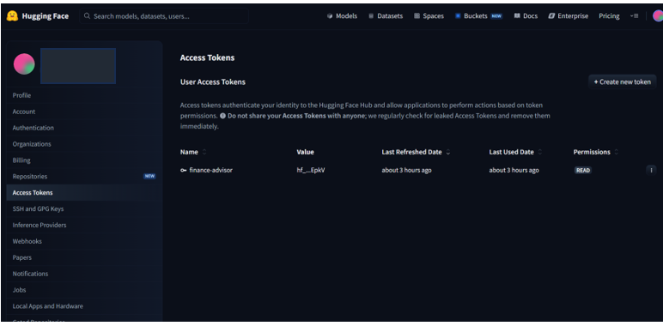
- Python modules are used to separate logic:
  - Budget calculations
  - Financial advice generation
  - Scenario-based analysis
- This combination ensures a modular and scalable application design.

Technology | Purpose in This Project
Python 3.12 | Core programming language for all backend logic and calculations
Flask | Lightweight web framework — serves HTML and handles all API routes
Hugging Face API | Free cloud inference API — connects to LLaMA 3 AI model
LLaMA 3 8B Instruct | Open-source Meta AI model — generates all financial advice text
HTML5 / CSS3 | Frontend structure and styling for the browser interface
JavaScript (Vanilla) | Handles form inputs, fetch API calls, and dynamic UI updates
Chart.js (CDN) | Renders doughnut, bar, and line charts from financial projection data

🔹 Activity 1.3: Design system architecture and workflow
In this activity, the system workflow is designed and structured. The application follows a modular three-layer architecture browser frontend, Flask backend, and Hugging Face AI layer. Each layer has a clearly defined responsibility.

- The system is divided into the following components:
  - Frontend (HTML, CSS, JavaScript)
  - Backend (Flask application)
  - Logic Layer (Python modules)
  - AI Model (Hugging Face transformer model)
- The workflow is defined step-by-step:
  - User enters financial data in the UI
  - JavaScript collects input and sends request to Flask backend
  - Flask backend processes request
  - Backend calls appropriate Python module:
    - budget_calculator.py for calculations
    - financial_advisor.py for AI advice
    - scenarios.py for scenario analysis
  - Hugging Face model generates financial suggestions
  - Backend sends response back to frontend
  - Frontend displays output to user
- API endpoint /get_advice is used for communication.
- This architecture ensures:
  - Clear separation of logic
  - Easy debugging
  - Scalability for future features
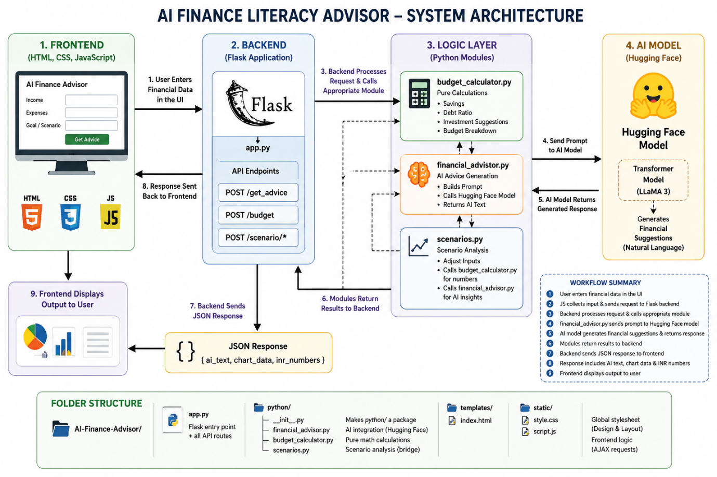

🔹 Activity 1.4: Configure Hugging Face model and environment setup
In this activity, the AI model is integrated using Hugging Face. The Hugging Face API token is the only credential required. It provides free access to the LLaMA 3 model for all AI-generated financial advice.

- Go to https://huggingface.co/join and create a free account.
- Navigate to https://huggingface.co/settings/tokens and click 'New token'.
- Token settings: Name it finance-advisor, select 'Read' access, click Generate.
- Copy the token it looks like hf_xxxxxxxxxxxxxxxx.
- Open python/financial_advisor.py and paste the token into HF_API_KEY variable.

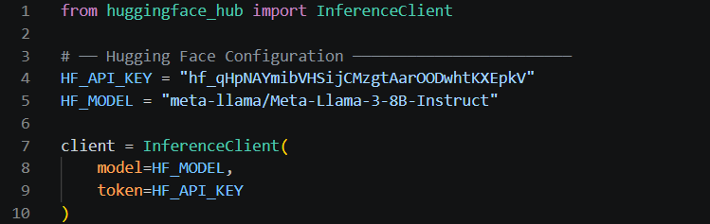

🔹 Activity 1.5: Perform initial testing and setup validation
In this activity, the application is tested to ensure everything works correctly. Before writing feature code the environment is validated by running a minimal Flask server and confirming the Hugging Face connection works.
- The Flask server is started using: python app.py
- The application runs on: http://127.0.0.1:5000
- The application is opened in a browser.
- The UI is checked for:
  - Proper loading
  - Input fields visibility
- Sample inputs are entered (income, expenses, goal).
- The backend processes the request and calls Hugging Face model.
- The generated financial advice is displayed on the screen.
- Errors (if any) are identified and fixed.
- This confirms that the system is fully functional.

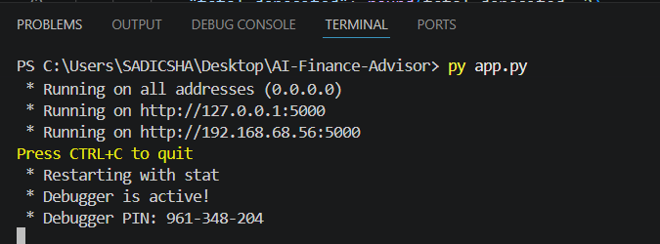

🔹 Milestone 2: Backend Development
This milestone builds the complete Flask backend creating all API routes in app.py, implementing input handling, designing the AI prompt structure, and integrating the Hugging Face LLaMA 3 model.

● Activity 2.1: Develop Flask application and define routes
app.py is the main entry point of the application. Six routes are defined one for serving the HTML frontend and five REST API endpoints for the financial features.
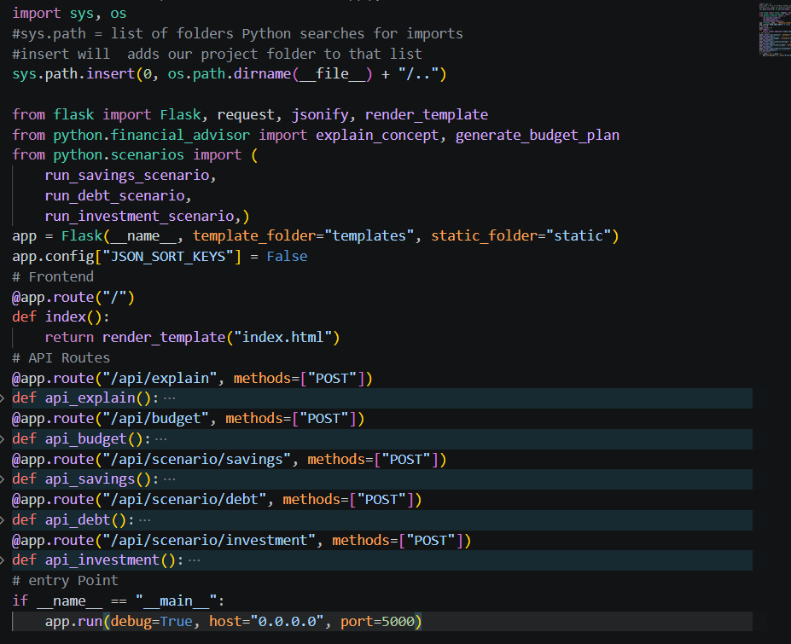
● Activity 2.2: Implement input handling and data processing
Each route reads structured JSON from the browser, extracts and type-converts values, and validates before calling AI or math functions.

# Input handling for /api/budget route
@app.route('/api/budget', methods=['POST'])
def api_budget():
data = request.get_json(silent=True) or {}
income = float(data.get('income', 0))
expenses = {k: float(v) for k,v in data.get('expenses',{}).items()}
goals = data.get('goals', 'general financial stability')
if income <= 0:
return jsonify({'error': 'Please provide a valid income.'}), 400
plan = generate_budget_plan(income, expenses, goals)
total_exp = sum(expenses.values())
return jsonify({
'income' : income,
'total_expenses': total_exp,
'surplus' : income - total_exp,
'savings_rate' : round((income - total_exp)/income*100, 1),
'rule_50_30_20' : {
'Needs (50%)': round(income*0.50, 2),
'Wants (30%)': round(income*0.30, 2),
'Savings (20%)': round(income*0.20, 2),
},
'ai_plan': plan,
})

● Activity 2.3: Design prompt structure for AI responses
Prompts are engineered to give LLaMA 3 precise instructions with user data, expected output format, and Indian financial context to ensure high-quality, relevant responses.

# Structured prompt for budget plan generation
def generate_budget_plan(income: float, expenses: dict, goals: str) -> str:
expense_lines = '\n'.join(
f' - {cat}: Rs.{amt:,.0f}' for cat,amt in expenses.items())
total_expenses = sum(expenses.values())
surplus = income - total_expenses
prompt = f'''
User financial details:
Monthly Income : Rs.{income:,.0f}
Monthly Expenses:
{expense_lines}
Total Expenses : Rs.{total_expenses:,.0f}
Monthly Surplus: Rs.{surplus:,.0f}
Financial Goals: {goals}
Create a personalised budget plan with:
1. Spending breakdown as percentage of income
2. Areas to optimise or reduce
3. Ideal 50/30/20 allocation for this income
4. Step-by-step savings roadmap
5. 3 to 5 actionable steps for this month
Use Indian Rupee (Rs.) formatting throughout.'''
return _call_llm(prompt)

● Activity 2.4: Integrate AI model with backend
The _call_llm() function is the single integration point between Flask and the Hugging Face LLaMA 3 model. Every AI request is sent with the financial advisor system prompt.

# AI integration — core function
SYSTEM_PROMPT = '''You are an expert AI Financial Literacy Advisor.
Your role is to explain financial concepts in clear jargon-free language,
generate personalised budget plans, and provide scenario-based insights.
Always use clear headings, bullet points, and actionable steps.
Keep tone encouraging and beginner-friendly.'''
def _call_llm(prompt: str) -> str:
try:
response = client.chat_completion(
messages=[
{'role': 'system', 'content': SYSTEM_PROMPT},
{'role': 'user', 'content': prompt},
],
temperature = 0.7,
max_tokens = 1500,
)
return response.choices[0].message.content
except Exception as exc:
return f'AI Error: {str(exc)}'

🔹 Milestone 3: Core Logic & Processing
This milestone implements all core financial logic user input validation, mathematical calculations in budget_calculator.py, the scenarios.py bridge module combining math and AI, and structured error handling across the application.

● Activity 3.1: Validate user inputs
Every API route validates its inputs before processing. Invalid or missing values return a descriptive HTTP 400 error instead of crashing the server.

# Input validation patterns across all routes
# 1. Numeric income check
income = float(data.get('income', 0))
if income <= 0:
return jsonify({'error': 'Please provide a valid income.'}), 400
# 2. Text concept check
concept = data.get('concept', '').strip()
if not concept:
return jsonify({'error': 'Please provide a concept.'}), 400
# 3. Safe type conversion with defaults
monthly_savings = float(data.get('monthly_savings', 0))
interest_rate = float(data.get('interest_rate', 6))
years = int(data.get('years', 5))
# 4. Expense dictionary conversion
expenses = {k: float(v) for k,v in data.get('expenses',{}).items()}
● Activity 3.2: Implement financial data processing logic
budget_calculator.py implements all mathematical calculations independently of the AI model compound savings growth, debt payoff timelines, and investment projections using CAGR.

# python/budget_calculator.py — Mathematical Engine
from dataclasses import dataclass
from typing import Dict, List, Tuple
# 1. Compound savings growth
def compound_savings(monthly_amount: float,
annual_rate: float, years: int) -> List[Dict]:
monthly_rate = annual_rate / 100 / 12
balance, records = 0.0, []
for year in range(1, years + 1):
for _ in range(12): # loop 12 months each year
balance += monthly_amount # add monthly deposit
balance *= 1 + monthly_rate # apply compound interest
deposited = monthly_amount * 12 * year
records.append({'year': year, 'balance': round(balance,2),
'total_deposited': round(deposited,2),
'interest_earned': round(balance - deposited,2)})
return records
# 2. Debt payoff timeline
def debt_payoff_months(principal, monthly_payment, annual_rate):
monthly_rate = annual_rate / 100 / 12
balance, months, total_paid = principal, 0, 0.0
while balance > 0 and months < 600:
interest = balance * monthly_rate
principal_paid = min(monthly_payment - interest, balance)
if principal_paid <= 0: return (-1, -1.0)
balance -= principal_paid
total_paid += monthly_payment if balance>0 else (principal_paid+interest)
months += 1
return (months, round(total_paid - principal, 2))
# 3. Investment projection (reuses compound_savings with CAGR)
def investment_projection(monthly_investment, annual_cagr, years):
records = compound_savings(monthly_investment, annual_cagr, years)
final = records[-1] if records else {}
return {'projected_value': final.get('balance',0),
'total_invested': final.get('total_deposited',0),
'wealth_created': final.get('interest_earned',0),
'year_by_year': records}
● Activity 3.3: Format AI-generated responses
scenarios.py combines numerical projections with AI narrative to create complete structured responses. Each function returns both chart data and AI-written financial advice.
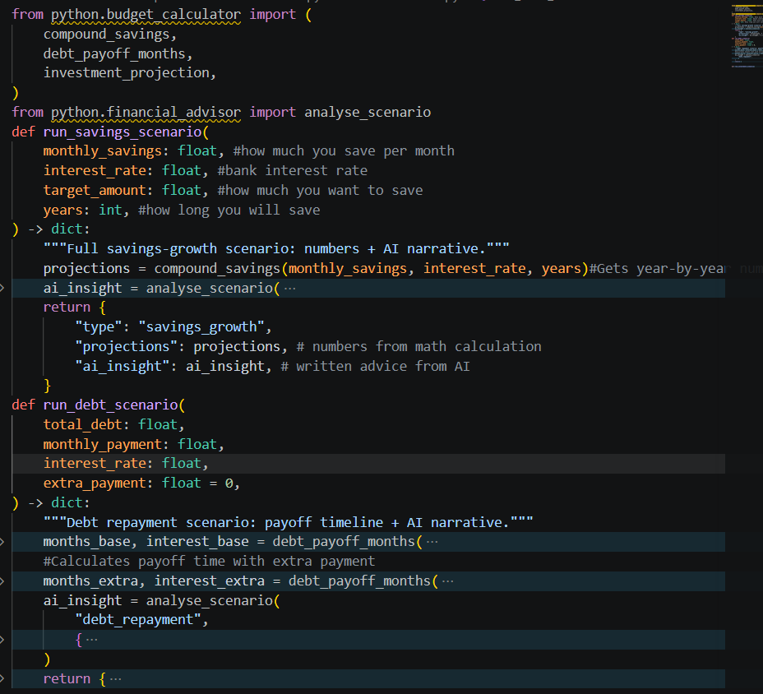
● Activity 3.4: Handle errors and exceptions
All error-prone operations are wrapped in try-except blocks. Hugging Face API failures return friendly messages, Flask routes return HTTP 400 for invalid inputs, and the JavaScript frontend shows graceful error messages.

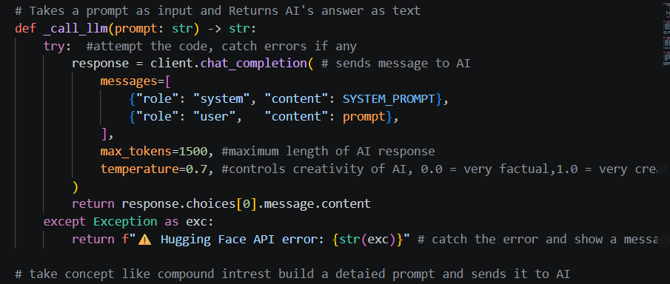

🔹 Milestone 4: Frontend Development
● Activity 4.1: Design UI using HTML
index.html is the single frontend file with a sticky header, three-tab sections, input forms for each feature, and output containers for AI text and charts.

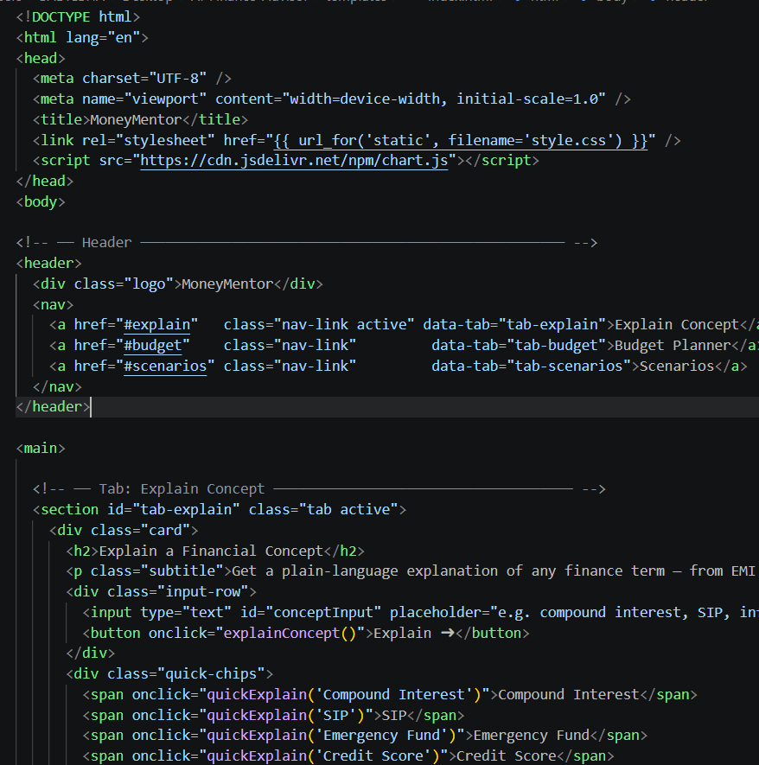
● Activity 4.2: Apply styling using CSS
style.css uses CSS custom properties for consistent theming, provides card-based layouts, color-coded stat cards, loading spinner animation, and responsive media queries for mobile devices.
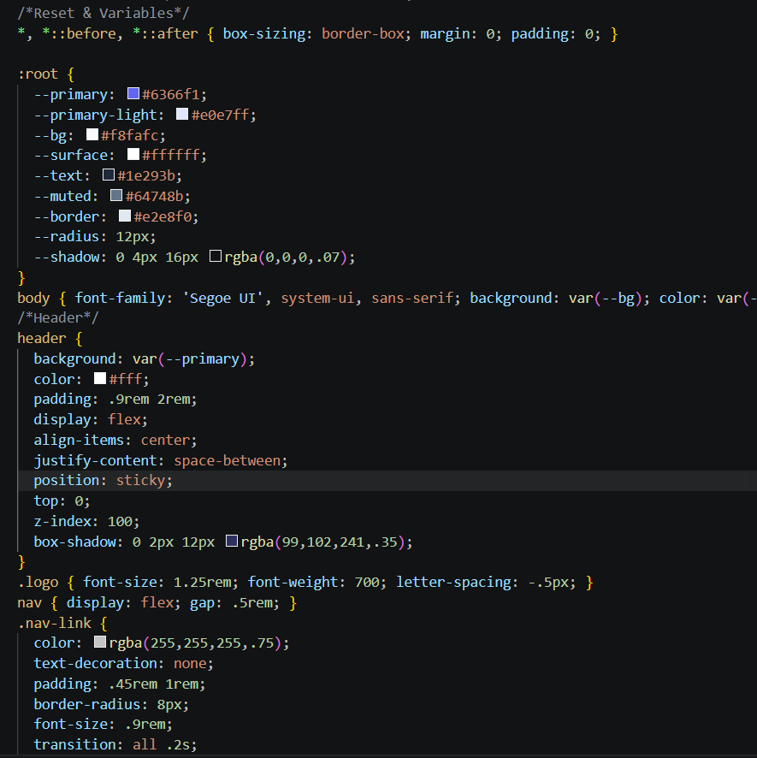
● Activity 4.3: Display dynamic output on UI
The JSON response received from the Flask backend is displayed dynamically on the webpage without refreshing the browser. When the user clicks a button, JavaScript sends the request to the API and waits for the response. Once the response arrives, the AI-generated financial advice text is inserted directly into the output box on the page using innerHTML.
For the Budget Planner feature, the response contains numerical values like total income, total expenses, monthly surplus, and savings rate. These numbers are extracted from the JSON response and displayed as styled summary cards on the screen. All monetary values are formatted in Indian Rupees using JavaScript's built-in Intl.NumberFormat('en-IN') function so numbers like 50000 appear as ₹50,000 in proper Indian format.
For the Scenario features like Savings Growth, Debt Repayment, and Investment Planning, the response contains both calculated numbers and AI-generated advice text. The numbers are shown in colour-coded stat cards green for income, red for expenses, blue for surplus, and yellow for savings rate. The AI advice text is shown below the cards in a styled output box with proper formatting.
A loading spinner with the text "Thinking…" is shown immediately when the button is clicked so the user knows the system is working. Once the response is ready, the spinner is replaced with the actual output. If any error occurs such as an empty input field a friendly error message is shown instead of crashing the page.

🔹 Milestone 5: Testing & Optimization
This milestone covers end-to-end functional testing of all features, debugging issues encountered during development, performance optimizations for a better user experience, and a final validation run before submission.

● Activity 5.1: Perform functional testing
Each of the five features is tested with realistic Indian financial data. Results are verified against expected outputs for both mathematical accuracy and AI response quality.

Feature | Test Input | Expected Output
Explain Concept | Click 'SIP' chip | 4-part explanation: meaning, importance, example, tip
Budget Planner | Income Rs.50,000 — Expenses: Rent Rs.12,000 Food Rs.6,000 | Doughnut chart + stat cards + AI budget plan
Savings Scenario | Rs.5,000/month — 7% — Rs.3L target — 5 years | Bar chart + AI advice on savings instruments
Debt Scenario | Debt Rs.2L — Payment Rs.5,000 — Rate 12% — Extra Rs.2,000 | Months saved and interest saved + AI strategy
Investment Scenario | Rs.5,000/month — Moderate — 10 years — Retirement | Line chart + SIP/ELSS/NPS AI recommendations

● Activity 5.2: Debug and fix issues
Several API and environment issues were encountered during development. Each was diagnosed using terminal error messages and resolved with targeted fixes.
Issue Encountered | Resolution Applied
OpenAI API — Error 429 quota exceeded | Migrated to Hugging Face free inference API
Gemini API — limit: 0 in India region | Identified via error log; switched to Hugging Face
HF model not supporting chat format | Tested models; LLaMA 3 8B Instruct confirmed working
Python not found in PowerShell | Used py command; verified PATH during reinstall
Flask app ran from wrong directory | Established cd AI-Finance-Advisor workflow
Mixed provider code in one file | Replaced entire financial_advisor.py from scratch
● Activity 5.3: Optimize performance
Performance improvements focus on reducing perceived latency on the free Hugging Face tier and keeping the frontend responsive while AI requests process.

- Loading indicators: A CSS spinner with 'Thinking...' text displays immediately on button click while waiting for the AI response.
- Chart instance management: Chart.js instances are stored and destroyed before re-rendering to prevent memory leaks on repeated calls.
- max_tokens=1500: Limits AI response length to reduce API response time without sacrificing response quality.
- Silent JSON parsing: request.get_json (silent=True) prevents crashes on malformed requests without extra try-except overhead.
- Default parameter values: All API parameters have sensible defaults so partial form submissions still return useful results.
● Activity 5.4: Conduct final testing
A complete end-to-end validation run is performed starting the server fresh, testing all five features in sequence, and confirming the application works on the local network from another device.
# Final validation run
# Expected terminal output:
# * Serving Flask app 'app'
# * Debug mode: on
# * Running on http://127.0.0.1:5000 (local)
# * Running on http://192.168.29.x:5000 (network)

# Final validation checklist:
# [x] Explain Concept — click SIP chip -> AI explanation appears
# [x] Budget Planner — income + expenses -> doughnut chart + AI plan
# [x] Savings Scenario — values -> bar chart + AI advice
# [x] Debt Scenario — values -> months saved stat cards + AI strategy
# [x] Investment — values -> line chart + AI recommendations
# [x] Error handling — empty income -> error message shown, no crash
# [x] Mobile/network — open 192.168.x.x:5000 on phone -> works

Exploring Website’s Web Pages:
Dashboard:
Finance Chatbot:
Input and output for chat:
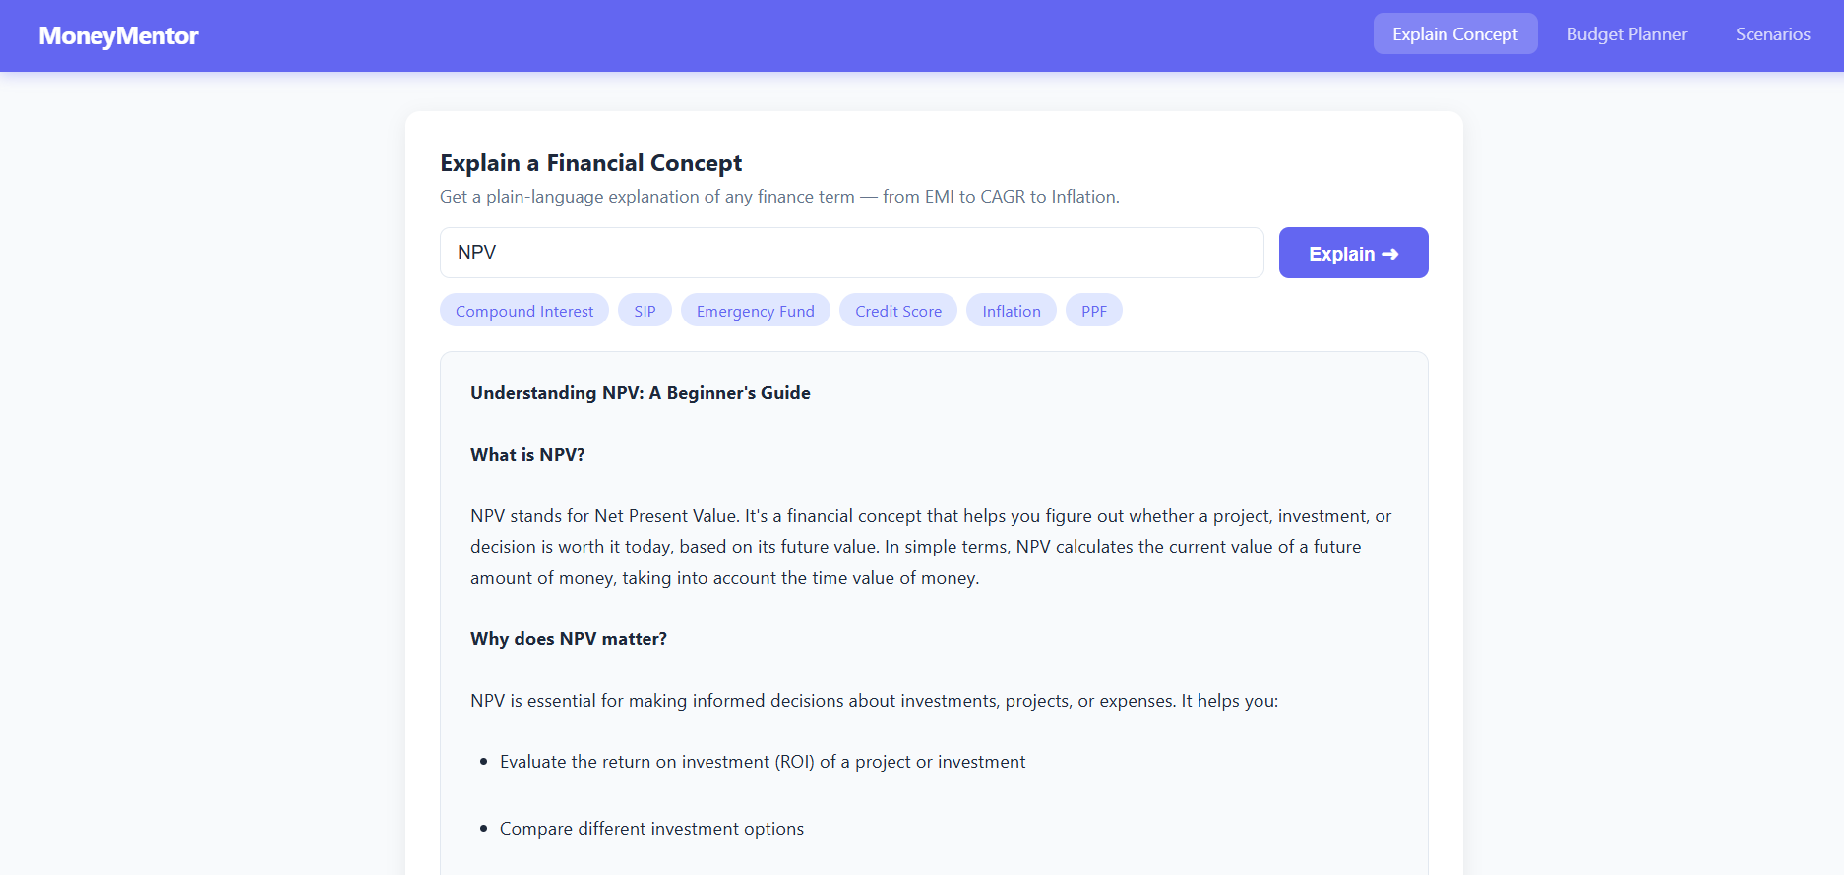
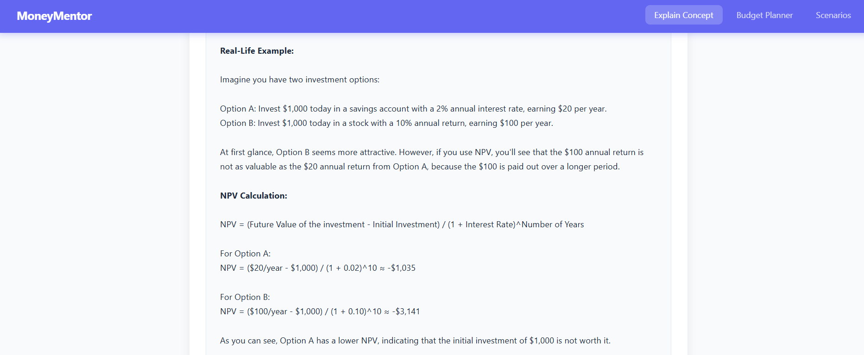
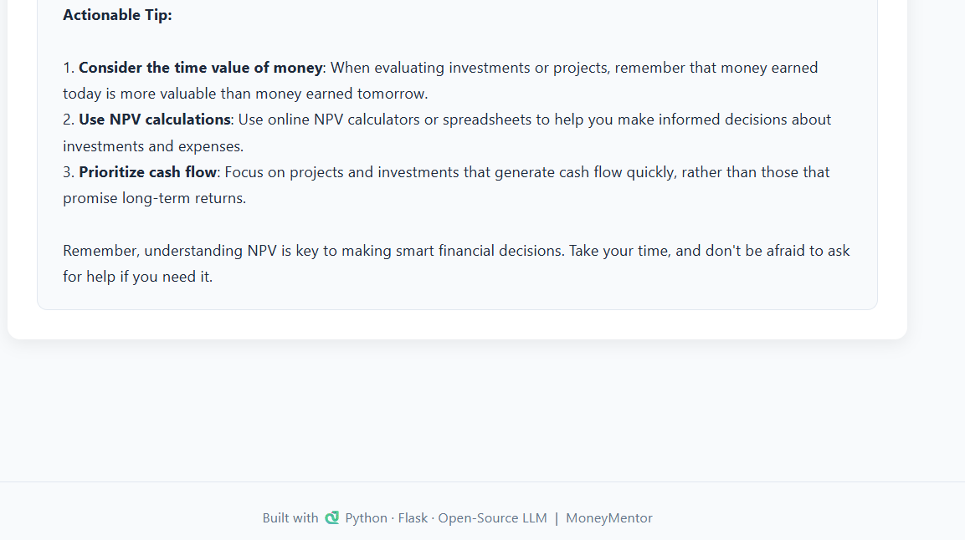

Description:
This tab allows users to learn any financial term in simple, easy-to-understand language. The user either types a financial concept into the text box or clicks one of the quick-chip buttons like Compound Interest, SIP, Emergency Fund, Credit Score, Inflation, or PPF. When the Explain button is clicked, the request is sent to the Flask backend which passes it to the LLaMA 3 AI model via Hugging Face API. The AI responds with a four-part structured explanation covering what the concept means, why it matters, a real-life Indian example with INR amounts, and one actionable tip the user can follow immediately. This feature is designed for complete beginners who have never studied finance before.

Budget Summary:
Input for Budget Summary:
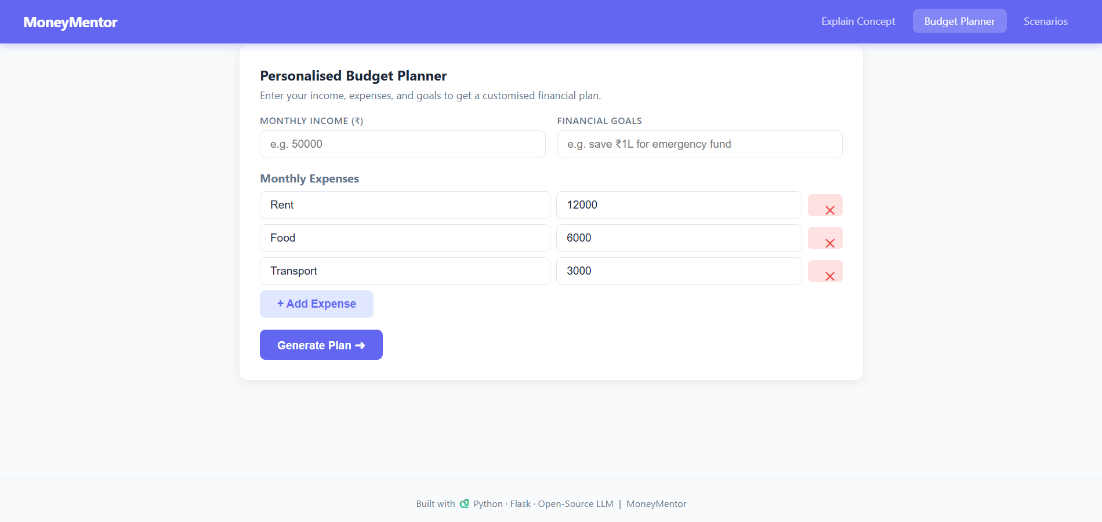
Monthly Budget:
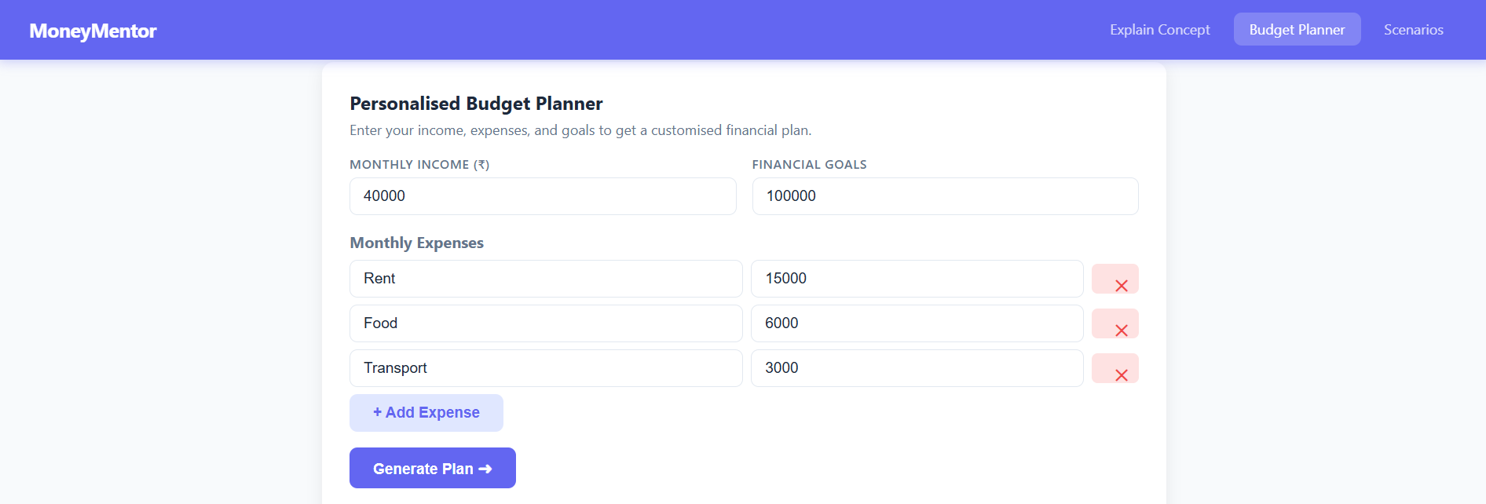

Output for Budget Summary:
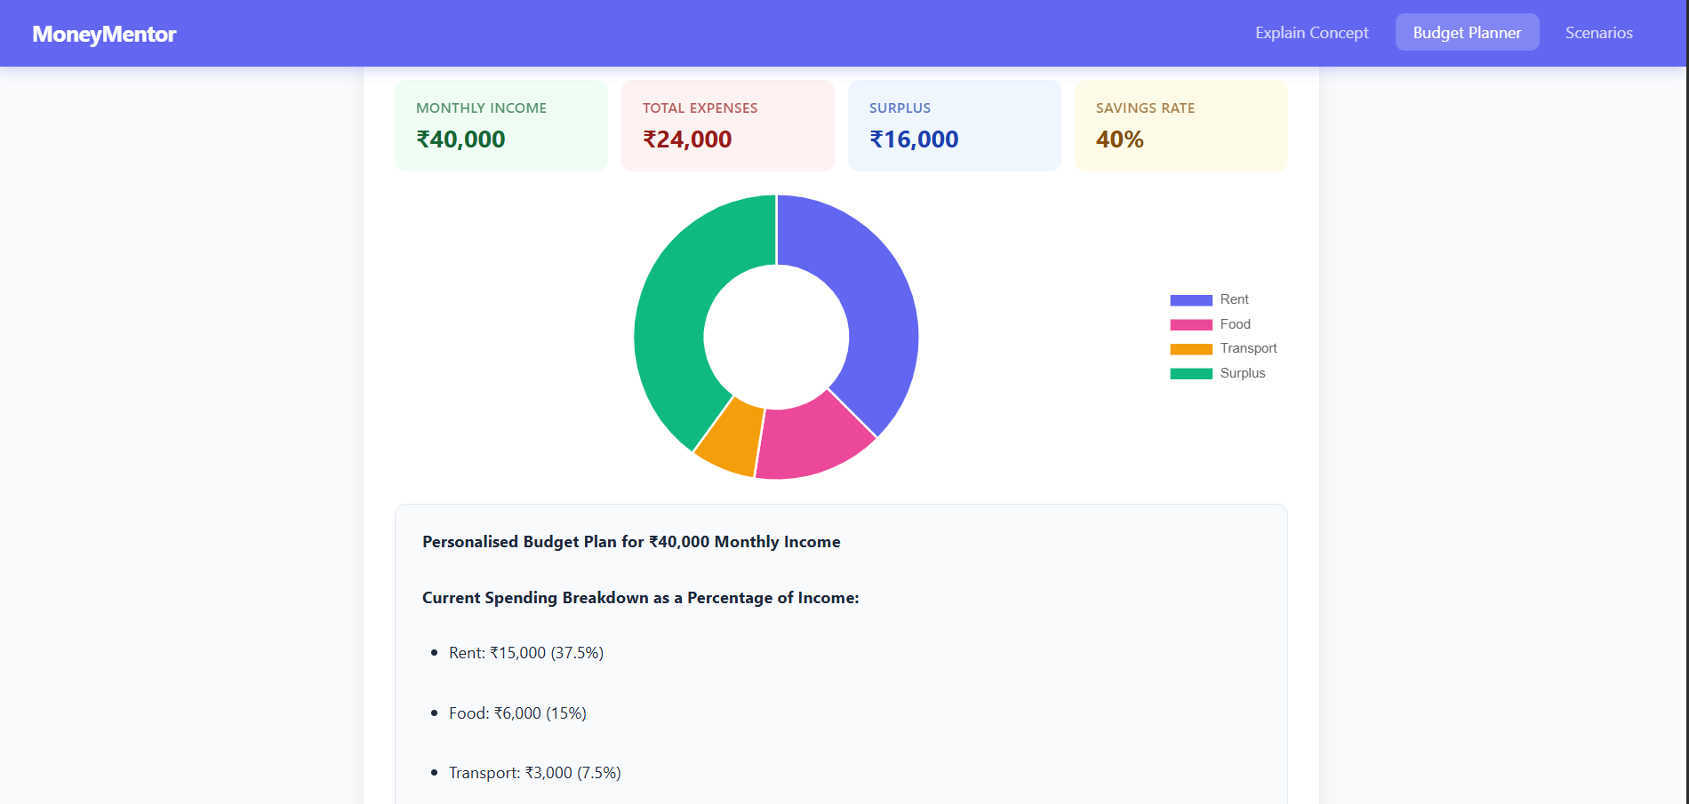
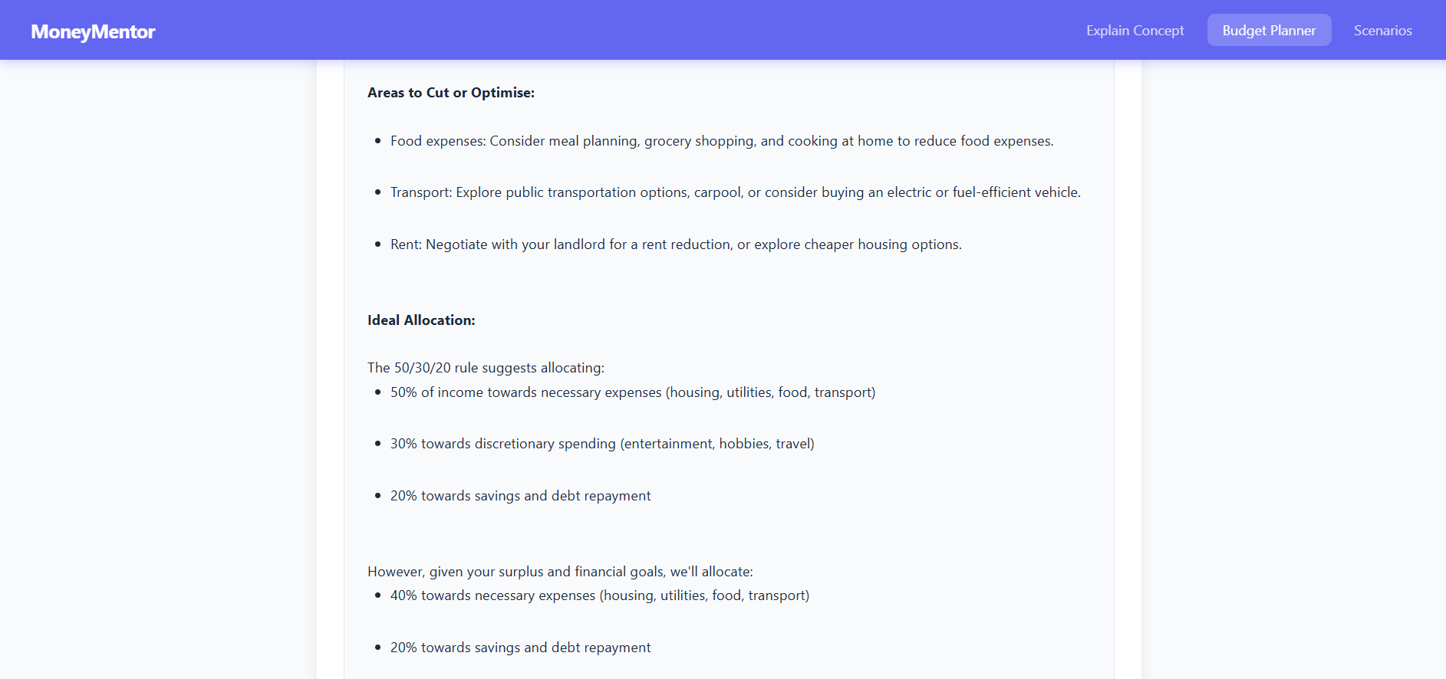
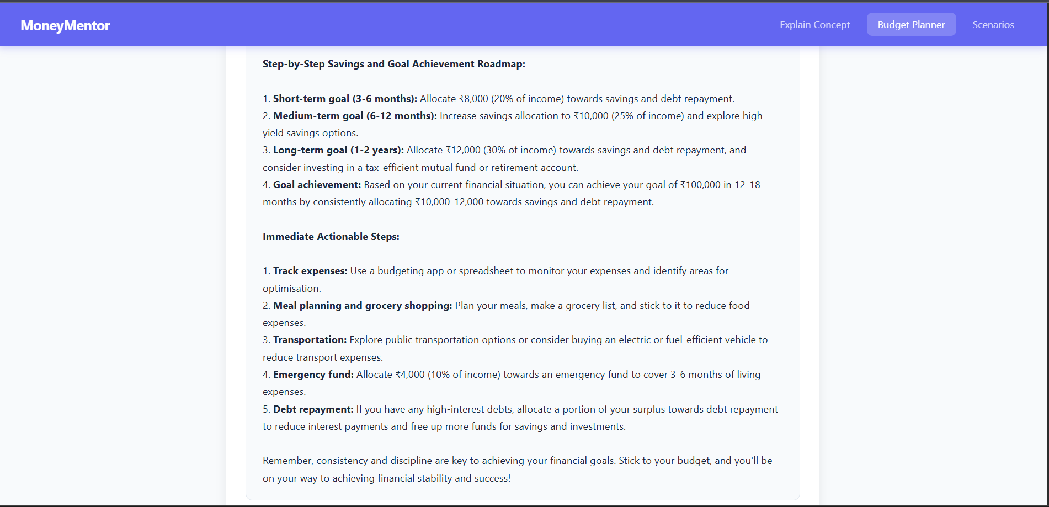

Description: This tab helps users create a personalized monthly budget plan based on their actual income and expenses. The user enters their monthly take-home salary, adds expense categories like Rent, Food, Transport, and Entertainment with their amounts, and describes their financial goals. When the Generate Plan button is clicked, the system calculates total expenses, monthly surplus, and savings rate automatically. It also applies the popular 50/30/20 budgeting rule allocating 50% for needs, 30% for wants, and 20% for savings. The results are displayed as color-coded summary stat cards showing income, expenses, surplus, and savings rate all formatted in Indian Rupees. The AI then generates a detailed personalized budget plan with step-by-step actionable recommendations.

Scenarios
- Savings Growth Scenario input
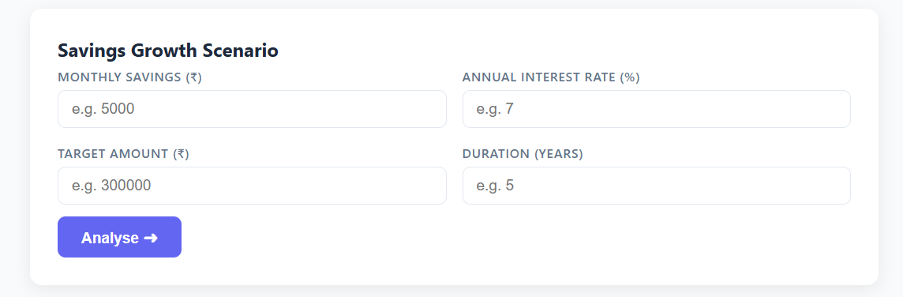
Savings Growth Scenario output
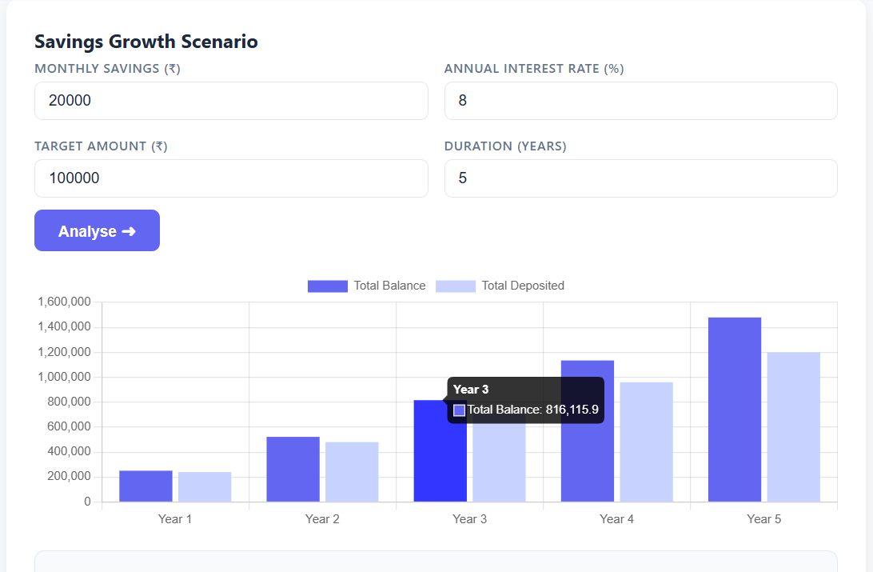
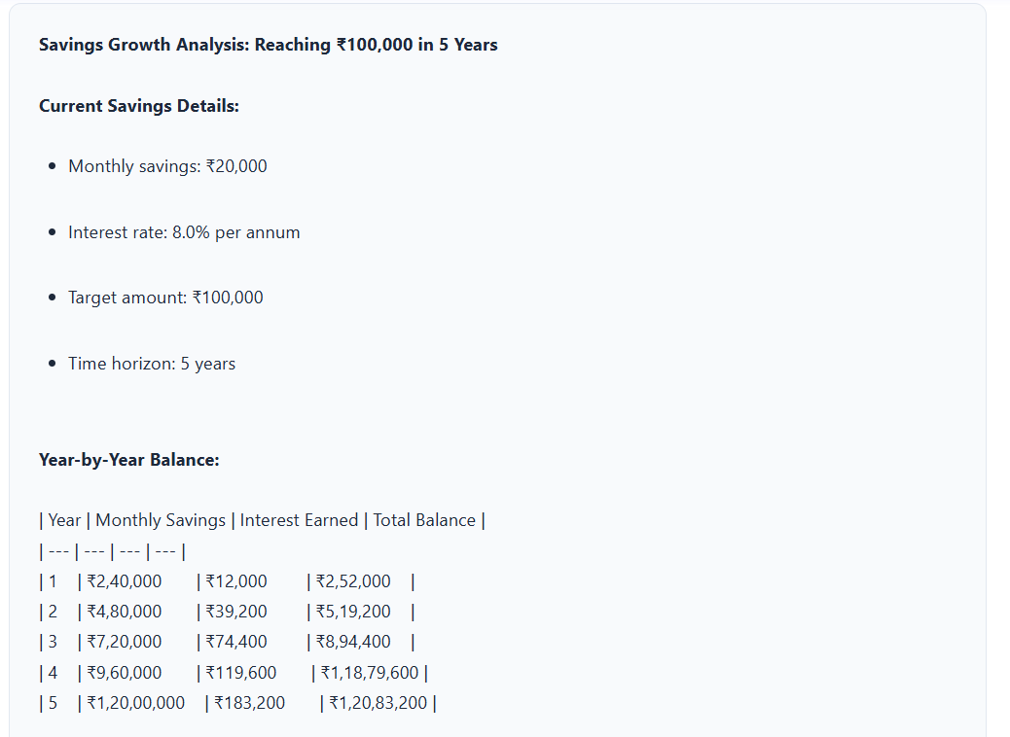
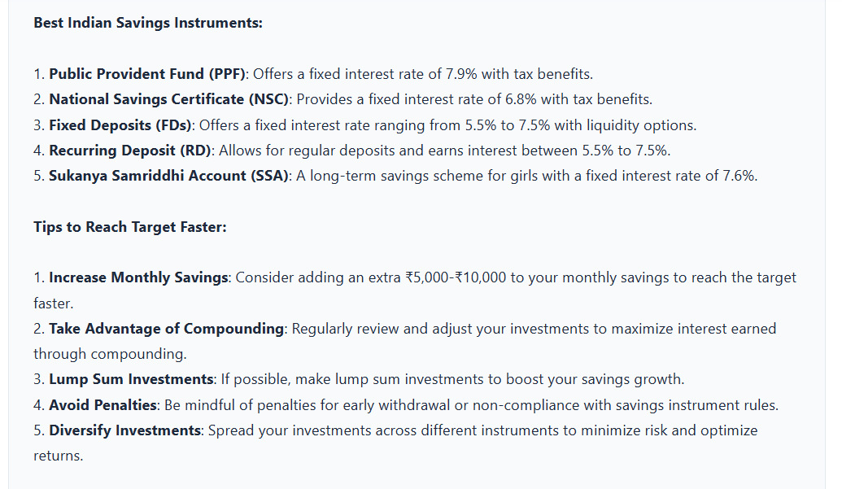
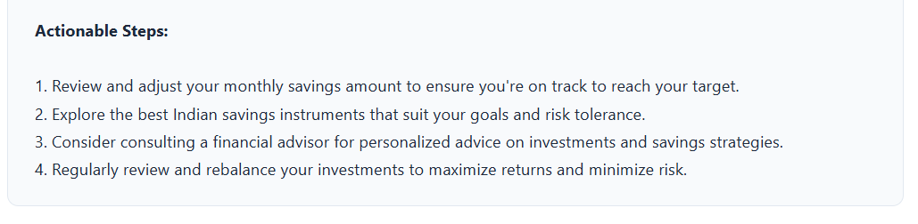
Description: Savings Growth allows users to enter their monthly savings amount, interest rate, target amount, and time duration. The system calculates year-by-year compound growth and the AI recommends the best Indian savings instruments like FD, RD, and PPF to reach the target faster.

- Debt Repayment Scenario input
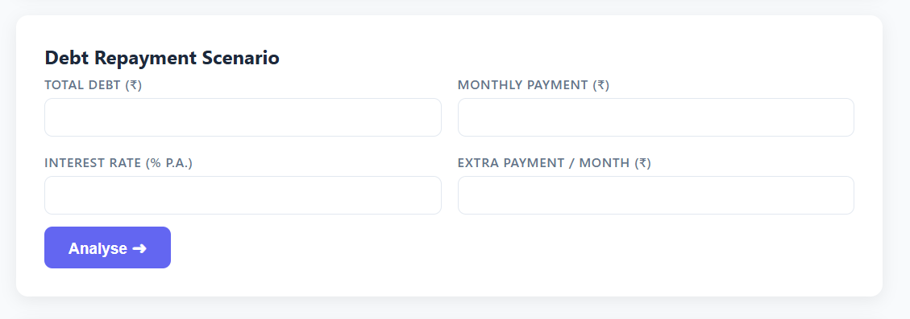
Debt Repayment Scenario output
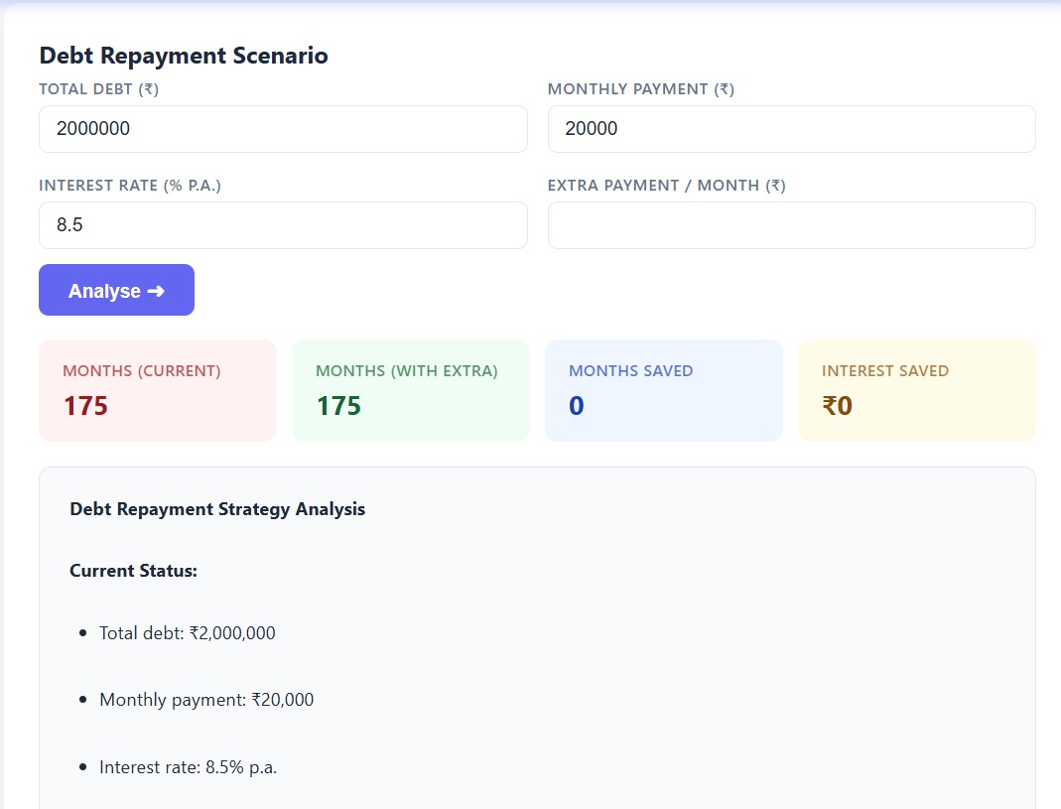
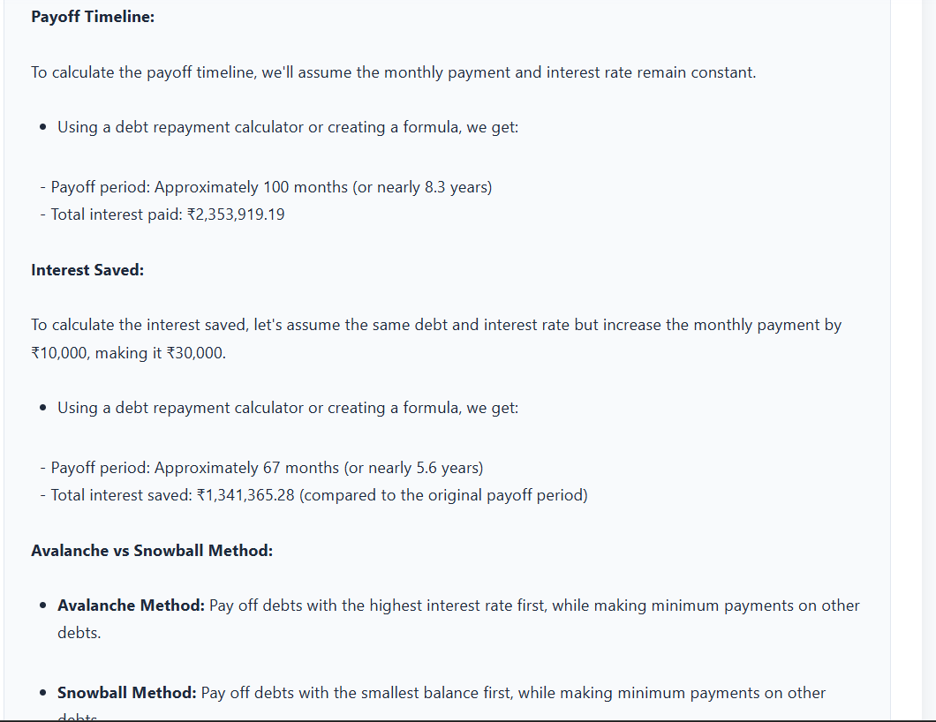
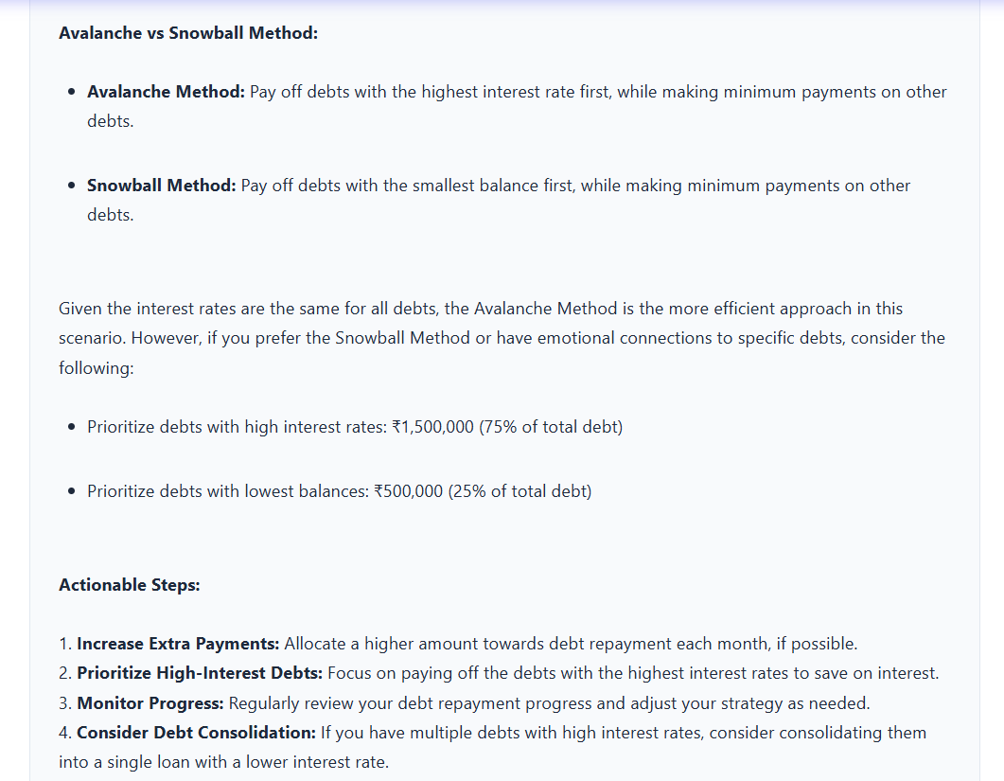
Description: Debt Repayment allows users to enter their total outstanding debt, monthly EMI, interest rate, and any extra payment they can make. The system compares two timelines — with and without the extra payment — and shows exactly how many months and how much interest the user can save by paying a little extra each month.

- Investment Planning Scenario input
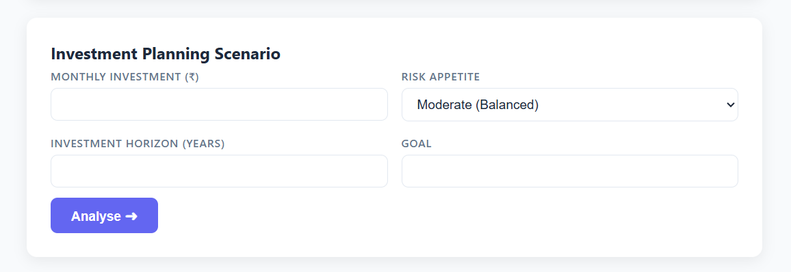
Investment Planning Scenario output
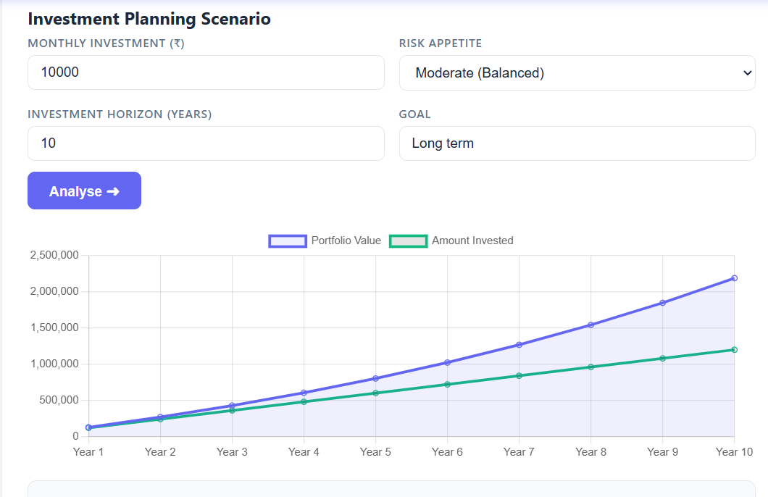
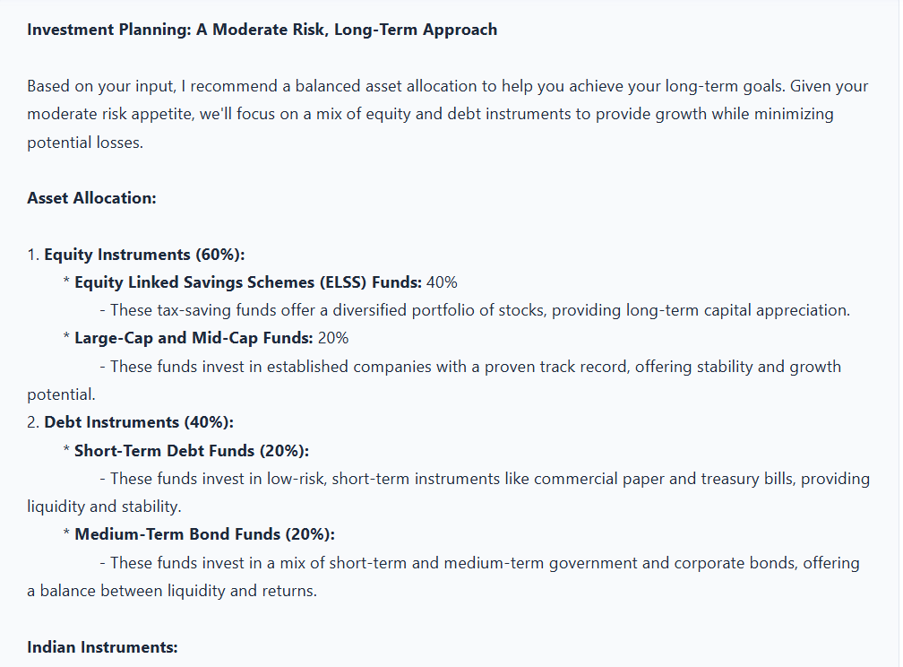
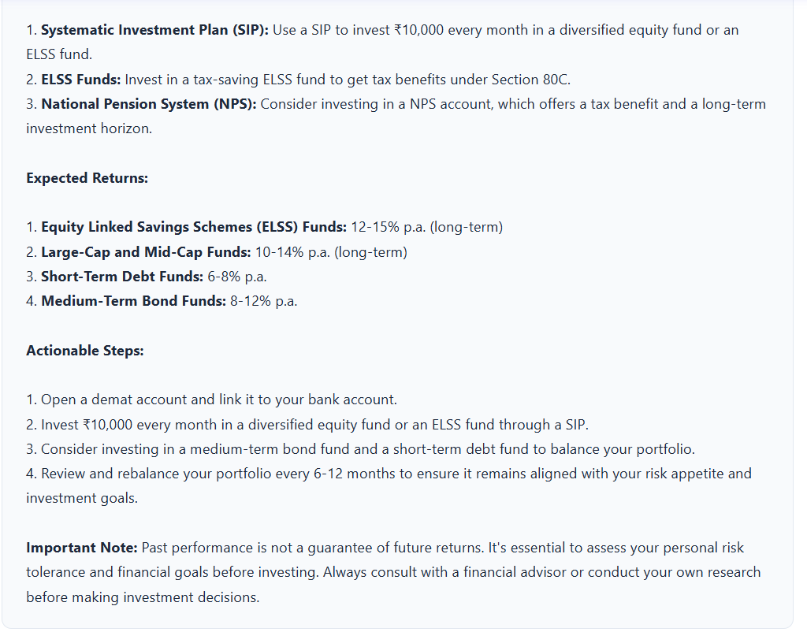
Description: Investment Planning allows users to enter their monthly investment amount, risk appetite (Low, Moderate, or High), time horizon in years, and investment goal. The system maps the risk level to a realistic CAGR 7% for low risk, 11% for moderate, and 15% for high risk and projects the portfolio value year by year. The AI then recommends suitable Indian investment instruments like SIP, ELSS, NPS, and index funds based on the user's profile.
Conclusion:
The AI Financial Literacy Advisor was successfully developed as a fully functional web application that makes expert-level financial guidance free, accessible, and easy to understand for students and young professionals in India. The project combines Python-based financial mathematics with Meta's LLaMA 3 language model — delivered through a Flask REST API backend and an interactive Chart.js-powered browser frontend.

All six milestones were completed as planned from environment setup and AI model integration to mathematical engine development, frontend construction, and final testing. The application runs locally on any Windows machine with Python installed, requires no paid subscriptions, and provides real-time AI-powered financial advice in plain English with INR formatting throughout.

Successfully integrated Meta LLaMA 3 (8B Instruct) via Hugging Face free inference API. Built five complete financial features: Concept Explainer, Budget Planner, Savings Growth, Debt Repayment, Investment Planning. Developed a modular Python architecture cleanly separating AI logic, math calculations, and scenario routing. Created interactive Chart.js visualizations doughnut, bar, and line charts from real financial projection data. Resolved multiple API provider issues and successfully delivered a stable, free solution. All monetary values formatted in Indian Rupee (INR) using international number format.

