AI-Powered RAG Chatbot Using n8n and Google Gemini

Detailed Project Documentation
Tools: n8n • Google Drive • Google Gemini • Gemini Embeddings • Simple Vector Store • AI Agent

SADICSHA KHANDAIT
25030242046
Agentic AI
SCIT

1. Project Overview
This project is a document-based chatbot built with n8n, Google Drive, Google Gemini, Gemini Embeddings, a Simple Vector Store, and an AI Agent. It uses Retrieval-Augmented Generation (RAG): document content is indexed first, then relevant passages are retrieved when the user asks a question, and Gemini generates a response.

2. Problem Statement
Credit appraisal policies contain multiple eligibility rules and limits. Searching them manually can be slow. This chatbot lets a user ask questions in natural language and receive a response based on retrieved content from the uploaded policy. The response should remain grounded in the document and should not invent rules that are absent.

3. Objectives
- Download a policy document from Google Drive.
- Load and embed the document for semantic retrieval.
- Store document content in a vector store.
- Accept user questions through the n8n chat trigger.
- Retrieve relevant passages using a vector-store tool.
- Generate readable answers with Google Gemini.
- Keep conversational context through Simple Memory.
- Reduce dependence on locally hosted language models.

4. Technology Components
Component | Purpose
n8n | Connects and runs the workflow nodes.
Google Drive | Source for the policy document.
Default Data Loader | Loads the document content for indexing.
Google Gemini Chat Model | Generates natural-language answers.
Embeddings Google Gemini | Creates vector representations of text.
Simple Vector Store | Stores the indexed document content and embeddings.
AI Agent | Handles user questions and invokes the retrieval tool.
Simple Memory | Carries conversational context for the session.

5. System Architecture

5.1 Document ingestion and indexing
- The user starts ingestion using the manual 'When clicking Execute workflow' trigger.
- The Google Drive Download file node retrieves the selected Credit Appraisal Policy document.
- The Default Data Loader extracts/prepares the document content.
- Embeddings Google Gemini converts the text into numerical vector representations.
- The Simple Vector Store stores the document content and embeddings for later retrieval.

5.2 Chat and retrieval
- The user sends a question through 'When chat message received'.
- The AI Agent receives the question and uses Google Gemini as its chat model.
- The Simple Vector Store1 node is configured as 'Retrieve Documents (As Tool for AI Agent)'.
- The retrieval node searches the indexed content and returns relevant document text.
- Google Gemini uses the retrieved context to compose a response for the user.
- Simple Memory is connected to support conversational context across the configured session.

6. Policy Facts Used for Demonstration
The supplied policy document visibly contains these example rules:
- Car loan: maximum LTV 80% for new petrol/diesel passenger vehicles and 85% for new battery-electric passenger vehicles.
- Car loan: minimum bureau score 700, maximum tenor 36 months, and age at maturity no more than 70 years.
- Home loan: minimum bureau score 700, maximum FOIR 50%, maximum LTV 80%, maximum tenor 20 years, and age at maturity no more than 70 years.
- The policy says to identify the loan product first, apply the matching rules, evaluate conditions independently, and state when a requested parameter is not provided.

7. Key Configuration Details
- Chat model: Google Gemini Chat Model using a model available to the configured API key.
- Embedding model: models/gemini-embedding-001, as selected during setup.
- Embedding consistency: use the same embedding model when indexing and retrieving documents.
- Ingestion operation: Simple Vector Store is configured for Insert Documents.
- Retrieval operation: Simple Vector Store1 is configured for Retrieve Documents (As Tool for AI Agent).
- Retrieval limit: 4 documents in the captured configuration.
- Metadata: Include Metadata is enabled in the retrieval configuration.
- Memory: Simple Memory uses the session ID from the chat trigger, with a context window length of 5 in the captured configuration.
- The retrieval tool description should be aligned with the credit appraisal policy use case rather than unrelated boilerplate.

8. Screenshots and Explanations

Screenshot 1— Workflow Canvas
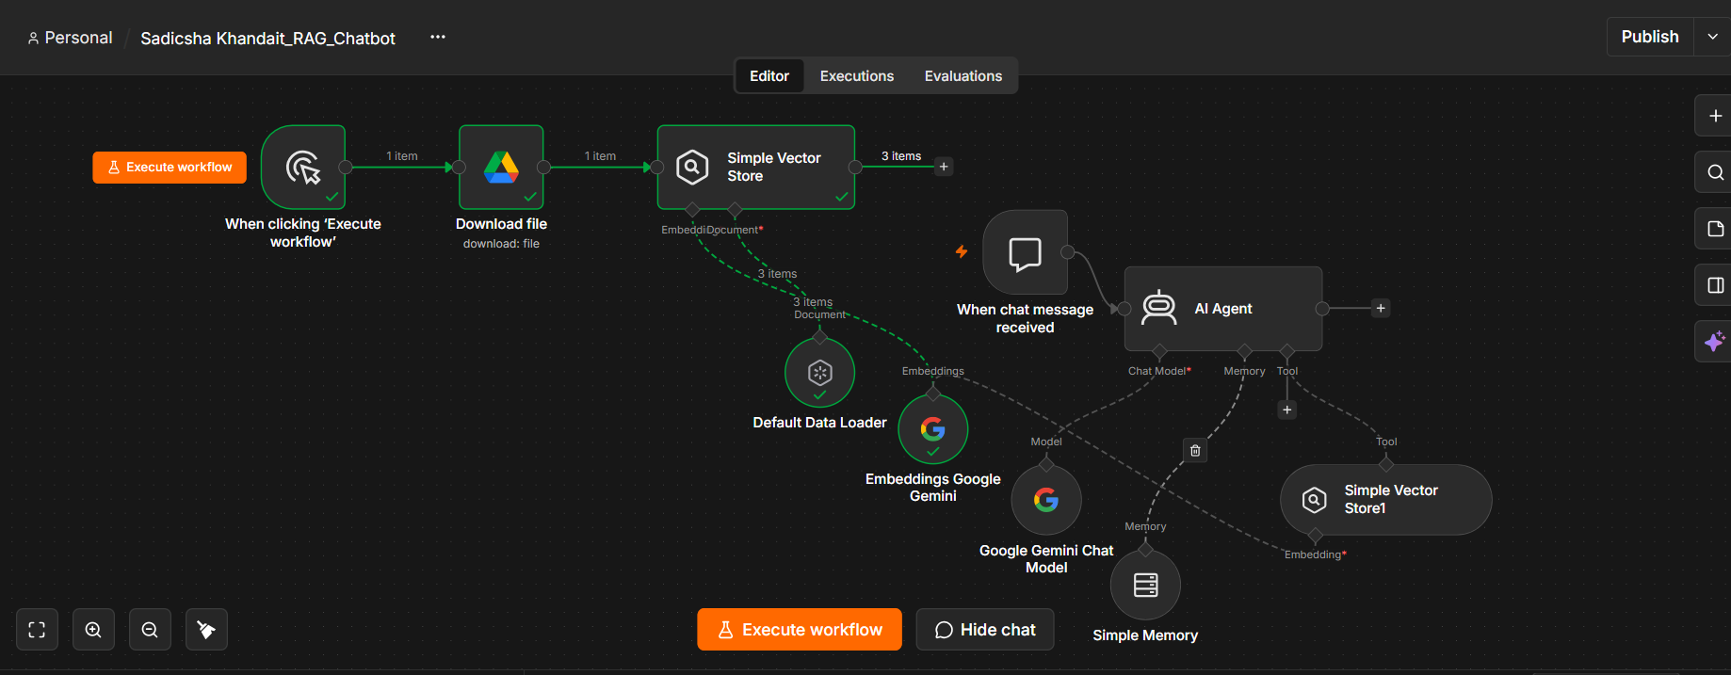
What is shown: This screenshot shows the overall n8n workflow layout. The top path is the ingestion workflow: manual trigger → Google Drive download → Simple Vector Store, supported by Default Data Loader and Gemini embeddings. The lower/right path is the chat workflow: chat trigger → AI Agent, connected to Gemini Chat Model, Simple Memory, and Simple Vector Store1 as a retrieval tool.
Why it matters: This is the best high-level view of how the parts fit together. Document ingestion prepares the searchable knowledge base; the chat workflow retrieves from it and generates answers.
Key takeaway: The project is an n8n + RAG chatbot with one AI Agent and a vector-store retrieval tool. It is not a multi-agent system unless separate agents are added and coordinated.

Screenshot 2 — AI Agent's Connected Tools and Models
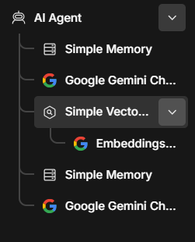
What is shown: This screenshot shows the AI Agent's connected components in a compact tree view, including Simple Memory, Google Gemini Chat Model, Simple Vector Store, and the embedding component. It provides a quick view of the model/tool arrangement.
Why it matters: The AI Agent uses a chat model to generate responses, memory for conversation context, and a vector-store tool to retrieve document content. The embedding model supports similarity search in the vector store.
Key takeaway: This screenshot documents the main agent dependencies. It does not indicate multiple independent agents; the shown architecture is one AI Agent with supporting components.

Screenshot 3 — Successful Document Ingestion
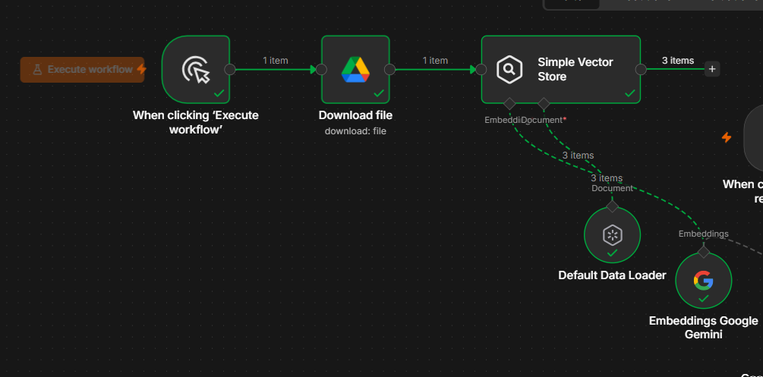
What is shown: This screen shows the manual trigger, Google Drive Download file node, Simple Vector Store, Default Data Loader, and Embeddings Google Gemini with green checks. The vector-store output indicates three items were processed.
Why it matters: This confirms that the ingestion workflow ran successfully for the selected document and that the document loader and embedding step were executed.
Key takeaway: Three processed items are shown in this run. The count represents the items produced by the workflow, not necessarily three separate source files.

Screenshot 4 — Google Drive Download File Node
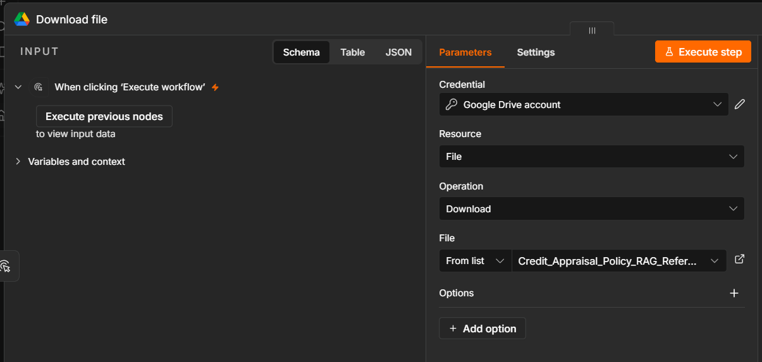
What is shown: This screen shows the Download file node in n8n. The Google Drive credential is selected, the resource is set to File, and the operation is Download. A specific file named Credit_Appraisal_Policy_RAG_Reference.doc is selected.
Why it matters: This node brings the source policy document from Google Drive into the workflow. It is the starting point for document ingestion: the chatbot cannot search a document until the workflow obtains and processes it.
Key takeaway: The workflow is configured to download the policy reference file using the connected Google Drive account. The screenshot shows configuration; successful execution is evidenced by the later green-check screenshots.

Screenshot 5 — Simple Vector Store: Insert Documents
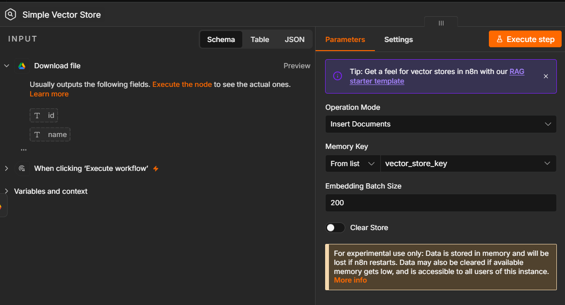
What is shown: This screenshot shows the Simple Vector Store configured with Operation Mode set to Insert Documents. It also shows the Memory Key vector_store_key, an embedding batch size of 200, and Clear Store turned off. The node receives the downloaded file and is intended to store the processed document chunks and their embeddings.
Why it matters: Insertion is the indexing stage of RAG. It places document content into a store so that the chatbot can retrieve relevant pieces later. Keeping Clear Store off avoids clearing existing entries during this run, though duplicate indexing may need to be considered if ingestion is repeated.
Key takeaway: This node is configured for document indexing, not question answering. The Simple Vector Store is in-memory, so its contents may be lost when n8n restarts.

Screenshot 6 — Credit Appraisal Policy
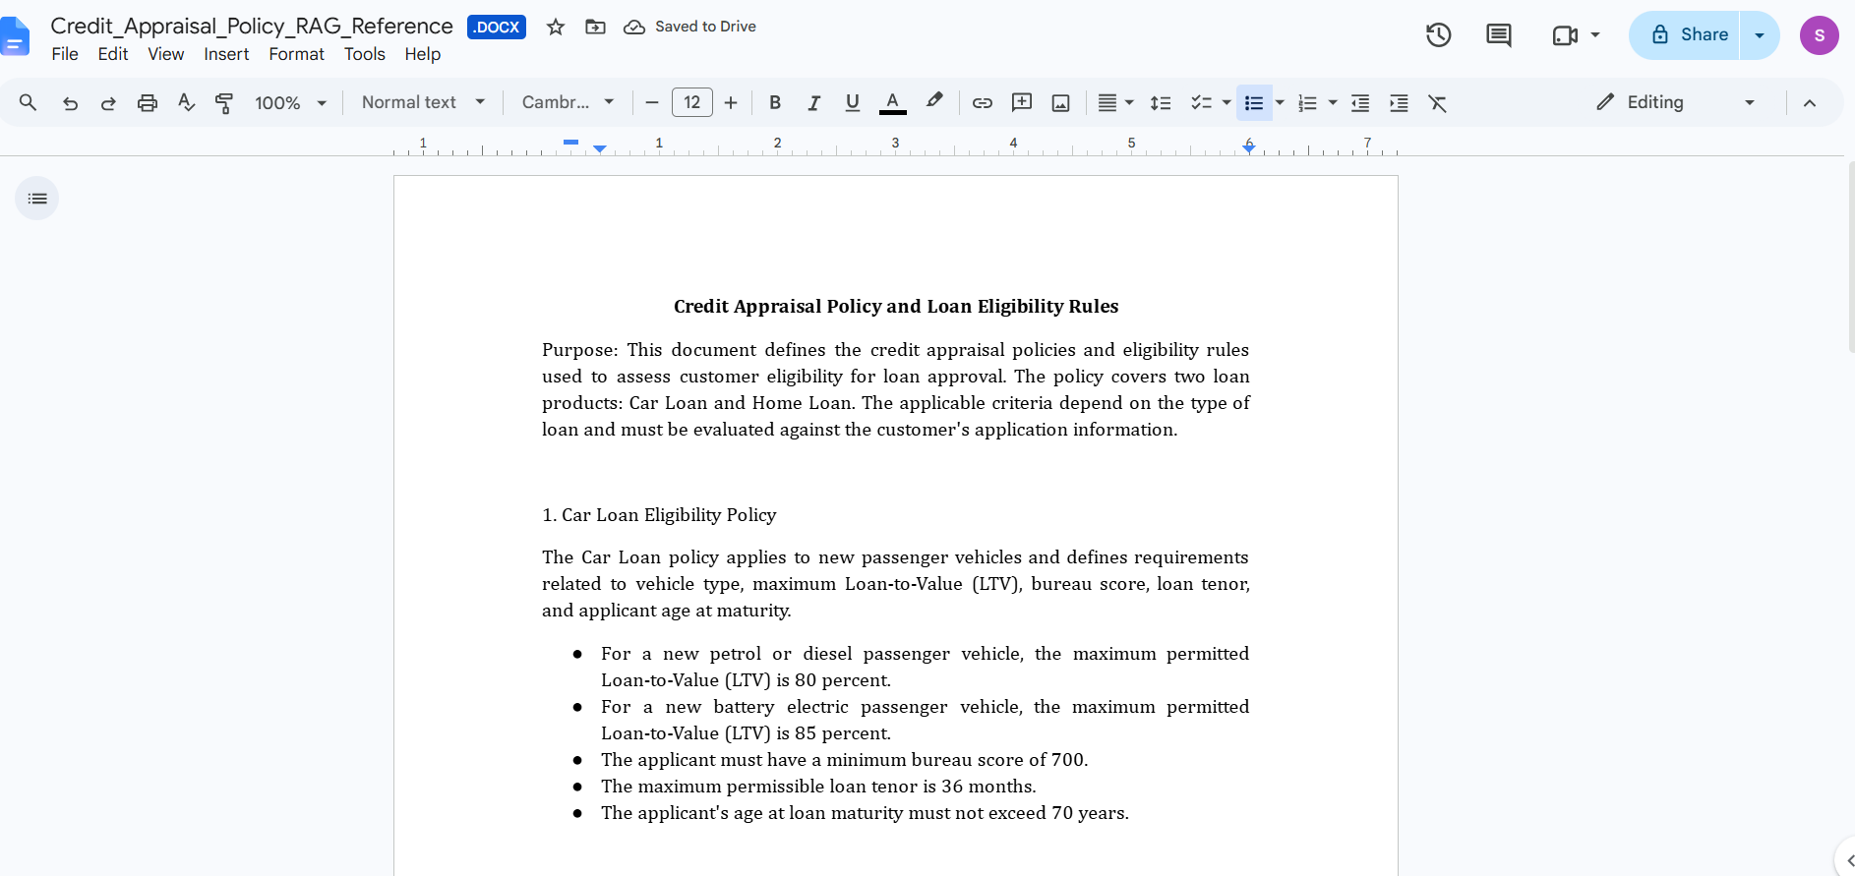
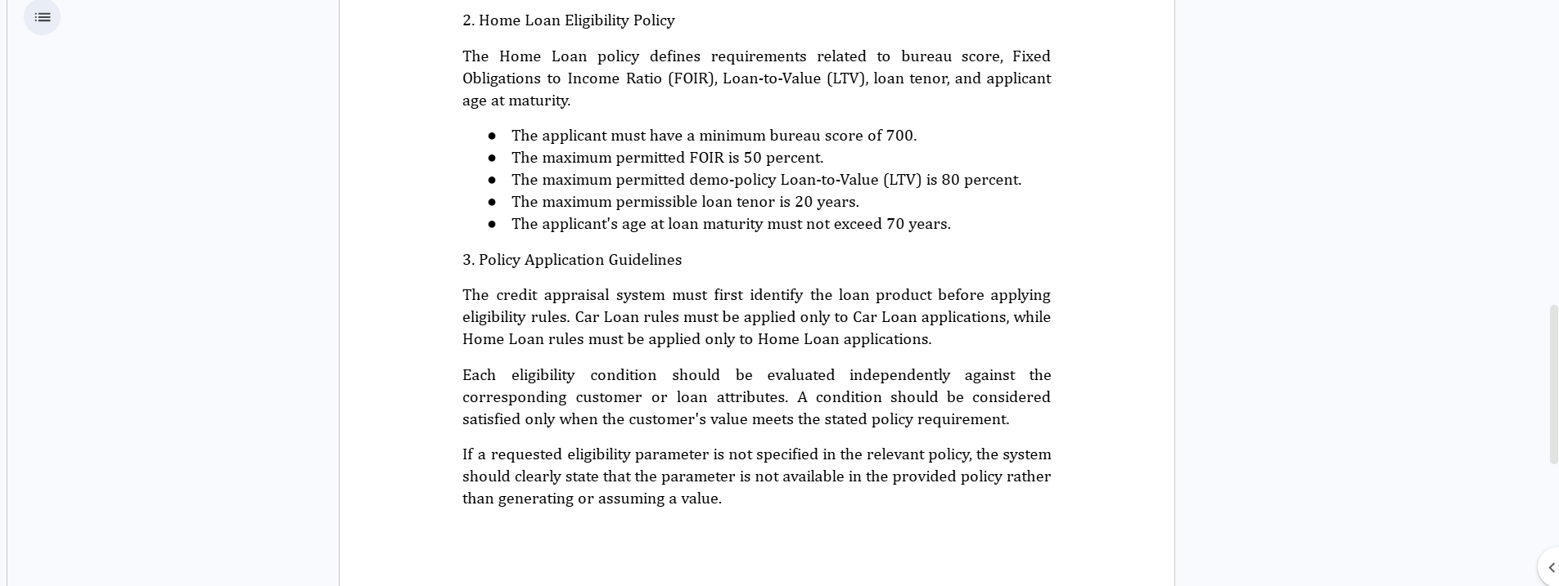
What is shown: This screenshot shows the reference document, titled Credit Appraisal Policy and Loan Eligibility Rules. It explains that the document defines eligibility rules for car loans and home loans. The visible car-loan rules include maximum LTV of 80% for new petrol/diesel vehicles, 85% for new battery-electric passenger vehicles, minimum bureau score of 700, maximum tenor of 36 months, and maximum age at loan maturity of 70 years. Visible home-loan rules include minimum bureau score 700, maximum FOIR 50%, maximum LTV 80%, maximum tenor 20 years, and age at maturity no more than 70 years. The guidelines say the system should identify the loan product first, apply only the relevant rules, evaluate each condition independently, and state when a requested parameter is not present in the policy.
Why it matters: This is the knowledge source the RAG chatbot is expected to use. When a user asks about car-loan requirements, the workflow should retrieve relevant text from this document instead of guessing. These instructions help define what a correct chatbot answer should look like. The bot should distinguish car-loan rules from home-loan rules and avoid inventing missing values.
Key takeaway: The document contains explicit policy facts that can be used to test whether retrieval and answer generation are working. The source document gives policy boundaries and also instructs the system how to handle missing information.

Screenshot 7 — Successful AI Agent and Tool Execution
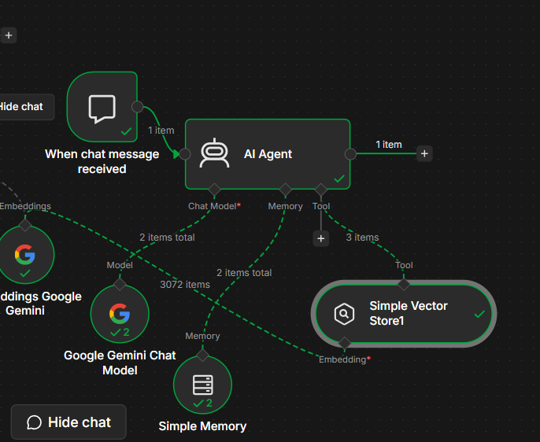
What is shown: This screenshot shows green execution indicators on the chat trigger, AI Agent, Gemini chat model, Simple Memory, and Simple Vector Store1. Green paths and item counts indicate that the chat run completed through the connected components.
Why it matters: It demonstrates that the chat workflow can execute end to end for the test question, including the model and retrieval tool connections.
Key takeaway: The captured test execution completed successfully. A green check confirms node execution, while answer accuracy still needs to be checked against the source document.

Screenshot 8 — AI Agent Generates a Summary
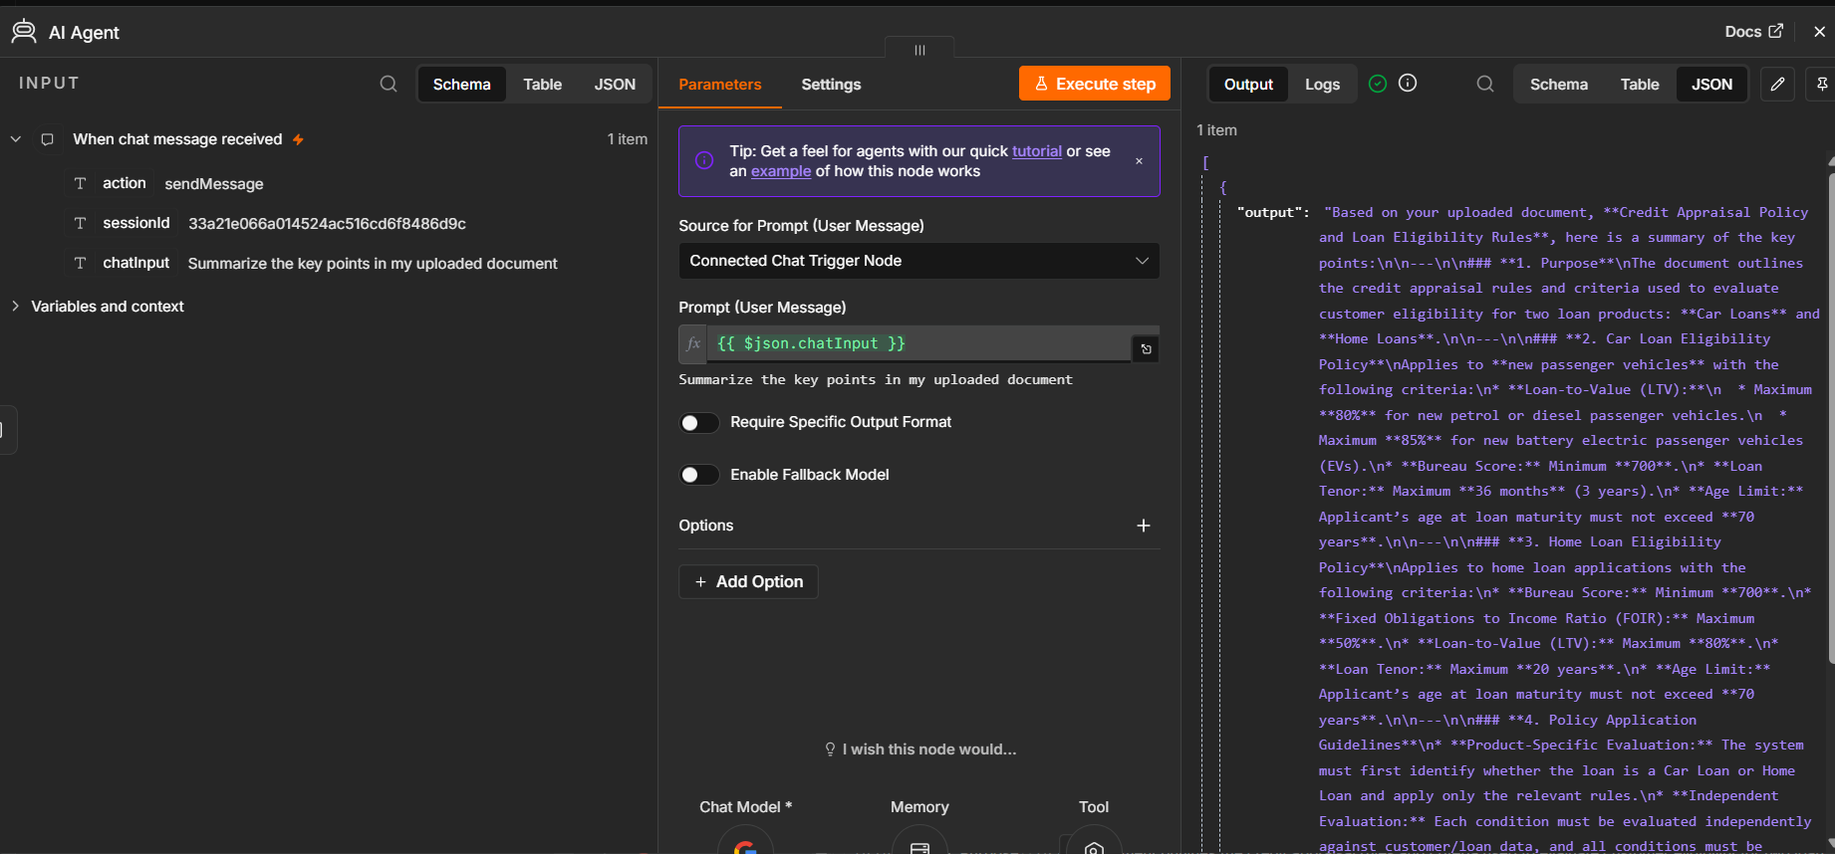
What is shown: This screen shows the AI Agent node input and output. The chat input is “Summarize the key points in my uploaded document”. The output begins with a summary of the Credit Appraisal Policy and Loan Eligibility Rules, including car-loan and home-loan eligibility criteria.
Why it matters: This is evidence that the agent received a user question and generated a response. In the RAG workflow, the retrieval tool supplies relevant document content and Gemini turns it into a readable answer.
Key takeaway: A generated answer is visible. To fully validate grounding, compare specific values in the answer with the source policy and test questions that require exact facts.

Screenshot 9 — Simple Memory Configuration
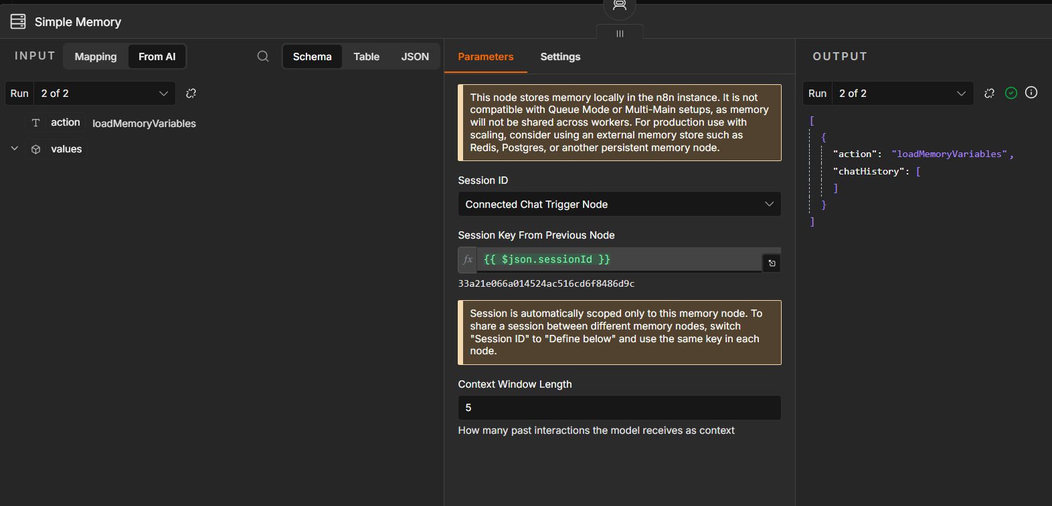
What is shown: This screen shows Simple Memory configured to use the session ID from the connected chat trigger through expression. The context window length is set to 5, meaning the memory node can retain up to five prior interactions as context according to the node's behavior.
Why it matters: Memory is separate from RAG. RAG retrieves information from the policy document; memory helps the chat maintain context from the current conversation, such as understanding a follow-up question.
Key takeaway: The memory node is connected to the chat session. It stores memory locally in the n8n instance and is not a persistent vector database.

Screenshot 10 — Simple Vector Store1 Retrieves Document Content
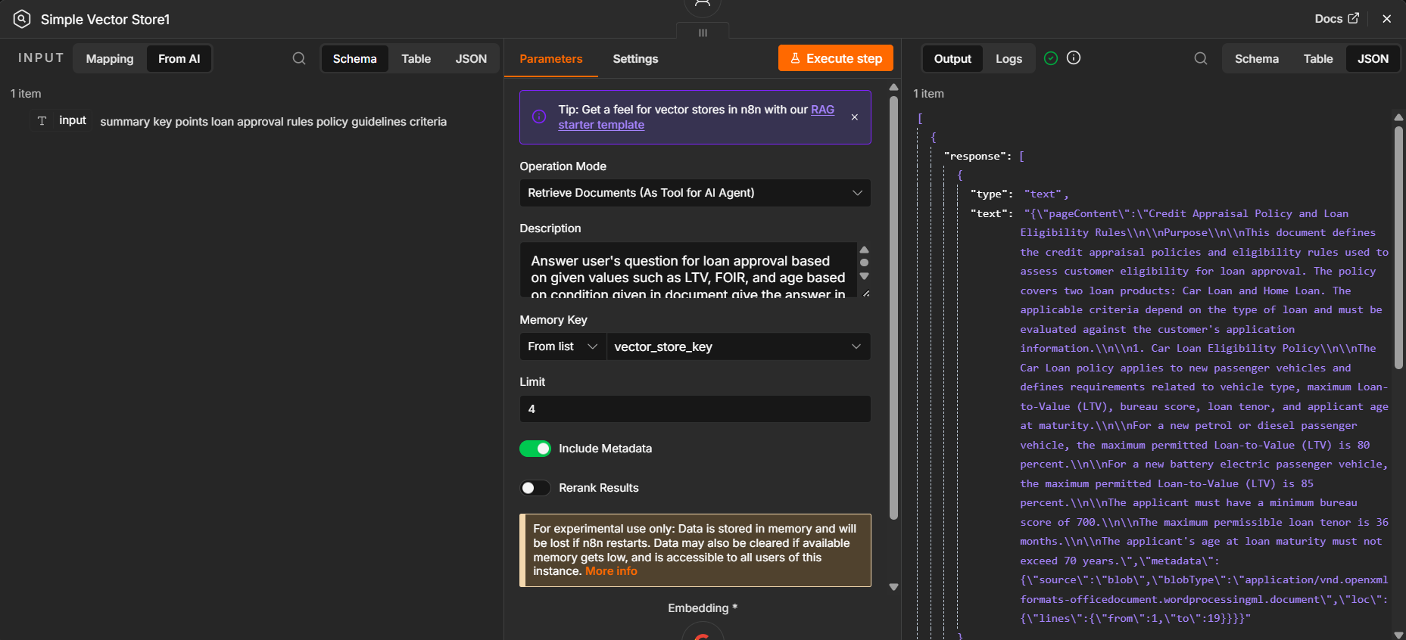
What is shown: This screenshot shows Simple Vector Store1 in Retrieve Documents (As Tool for AI Agent) mode. The user query is visible on the input side, and the output includes the Credit Appraisal Policy text under pageContent, along with metadata. The retrieval limit is 4 and Include Metadata is enabled.
Why it matters: This is the retrieval part of RAG. Instead of asking Gemini to rely only on general knowledge, the agent can search the vector store and receive relevant text from the uploaded policy.
Key takeaway: The output visibly contains the source policy content, which is strong evidence that retrieval is returning document material for the agent.

Screenshot 11 — Chatbot Response in the Chat Panel
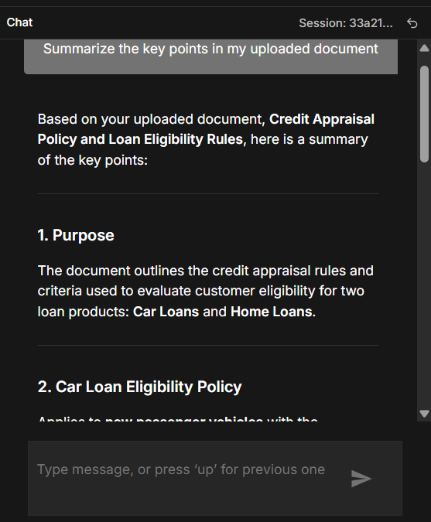
What is shown: This screenshot shows the chatbot's user-facing answer to “Summarize the key points in my uploaded document”. The response identifies the Credit Appraisal Policy and begins outlining its purpose and car-loan eligibility rules.
Why it matters: This is the visible interface a user interacts with. It demonstrates that the technical workflow produces a readable response rather than only returning raw JSON or document chunks.
Key takeaway: The chatbot is responding in natural language. Test additional exact-rule questions to confirm that the returned values are accurate and that the bot admits when information is missing.

9. Testing and Results
The screenshots show a successful ingestion run, with green execution indicators and three items shown at the vector-store output. The retrieval node output includes the policy's page content. The AI Agent also produced a summary in response to the prompt “Summarize the key points in my uploaded document”. These results demonstrate that the main workflow path executed and returned source content for the test.

Recommended further tests
- Ask: “What is the maximum LTV for a new electric passenger vehicle?” Expected policy value: 85%.
- Ask: “What is the maximum FOIR for a home loan?” Expected policy value: 50%.
- Ask about a rule not specified in the policy and check that the bot says the information is unavailable.
- Ask a follow-up question to verify session memory.

10. Limitations and Security
- Simple Vector Store uses in-memory storage; stored content may be lost after an n8n restart, so re-ingestion may be required.
- The current workflow uses one AI Agent with a retrieval tool; it is not a multi-agent architecture.
- This is a learning/demo project, not a production credit-decision system. Real credit decisions require validation, governance, audit logs, and human oversight.
- Do not publish API keys, OAuth credentials, private customer data, or confidential policy documents in a public repository.
- Check the exported n8n workflow JSON before sharing it and configure credentials separately on any imported instance.

11. Conclusion
The project demonstrates an end-to-end RAG flow: download a document, load it, embed it, index it, retrieve relevant content, and generate a conversational answer. The screenshots provide evidence of the node configuration, successful ingestion, retrieval output, and user-facing answer.

