N8N MULTI-AGENT CHATBOT

Detailed Project Documentation
A web-research and reporting chatbot built with n8n, Google Gemini, and Tavily
User Question → AI Agent 1 (Researcher + Tavily) → AI Agent 2 (Analyst) → Final Answer

SADICSHA KHANDAIT
25030242046
Agentic AI
SCIT

1. Project Overview
The Multi-Agent Chatbot is a workflow created in n8n. It accepts a question from a user, uses a research agent to search for relevant information on the web, and passes the research to a second agent that prepares a structured response. Google Gemini provides the language model for the agents, while Tavily Search supplies web-search results.
For example, a user can ask: “What are the benefits of using artificial intelligence in education? Give me 3 examples with reliable source URLs and summarize them in simple language.” The first agent gathers information and source links. The second agent organizes the information into sections such as an executive summary, key findings, examples, sources, and limitations.

2. Problem Statement
Finding information online can require opening many pages, identifying useful facts, comparing sources, and writing a summary. This workflow aims to simplify that process by separating it into two roles: web research and final analysis/reporting. The separation makes the workflow easier to understand and gives each agent a specific responsibility.

3. Project Objectives
- Accept natural-language questions through an n8n chat interface.
- Use Tavily Search to find relevant web information and source URLs.
- Use Google Gemini to interpret the question and draft research findings.
- Pass the first agent’s output and the original question to the second agent.
- Produce a readable, organized response in simple language.
- Encourage source transparency and avoid invented facts or links.

4. Tools and Technologies
Tool / Component | Role in the project | Where it is used
n8n | Visual workflow automation platform | Connects the trigger, agents, model, and search tool
When chat message received | Receives the user's question | Beginning of the workflow
AI Agent 1 – Researcher | Plans and carries out web research | First AI agent
Tavily Search | Retrieves web-search results and source URLs | Tool connected to AI Agent 1
Google Gemini Chat Model | Generates and processes natural-language text | Model connection for the agents
AI Agent 2 – Analyst | Reviews research and writes the final report | Second AI agent

5. Workflow Design
The workflow follows this sequence:
- User enters a question in the chat interface.
- The chat trigger sends the message to AI Agent 1.
- AI Agent 1 uses Google Gemini to understand the question and Tavily to search the web.
- AI Agent 1 returns research findings, evidence, and source URLs where available.
- AI Agent 2 receives the original question and the output from AI Agent 1.
- AI Agent 2 reviews the research and prepares a structured final response.
- The response is displayed in the n8n chat window.
Important configuration detail: AI Agent 2 uses a prompt expression that combines the original chat input with the output from AI Agent 1. This allows the second agent to analyze the first agent’s research instead of asking the user to provide it again.

6. How the Chatbot Works

AI Agent 1 – Researcher
The first agent is instructed to understand the user’s question, search the web through Tavily, identify useful findings, and include source URLs where available. Its output is formatted with sections such as the research question, key findings, supporting evidence, source URLs, and information gaps.

AI Agent 2 – Analyst and Reporter
The second agent reviews the research passed from AI Agent 1. It organizes the material into an executive summary, key findings, analysis and insights, sources, and limitations. It should preserve the links supplied by the researcher and should not invent facts or claim that a source was verified unless verification actually occurred.

Tavily Search
Tavily is connected as a tool to AI Agent 1. The screenshots show Tavily credentials selected and the Search resource with the Query operation. The query field can be supplied by the agent. The tool output includes result fields such as URL, title, and content. A search result is evidence to review, not automatic proof that every claim in the result is correct.

7. Screenshot-by-Screenshot Explanation
The following screenshots are included in the order supplied. Each explanation describes what the screenshot demonstrates and why it matters to the project.
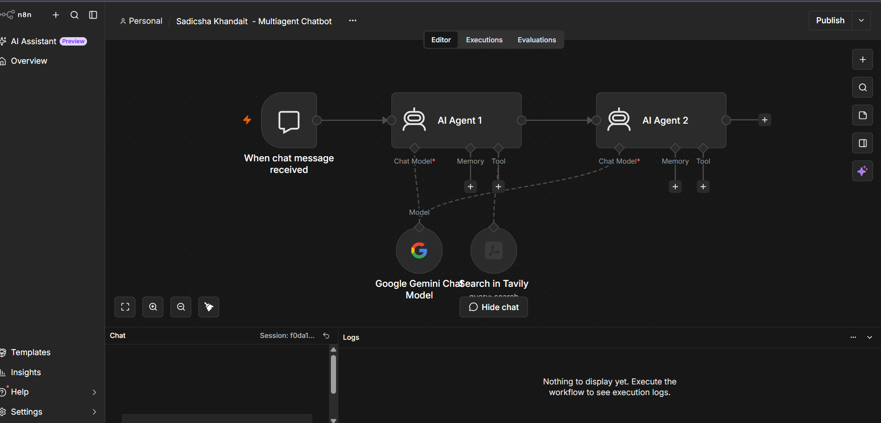
Screenshot 1. Workflow canvas and chat response
This screenshot shows the n8n workflow with the chat trigger, AI Agent 1, AI Agent 2, the Gemini model, and Tavily Search. The chat area displays a response to the education question. It demonstrates the intended research-to-report flow. The quality of the final answer still depends on whether the source links are relevant and support the claims.
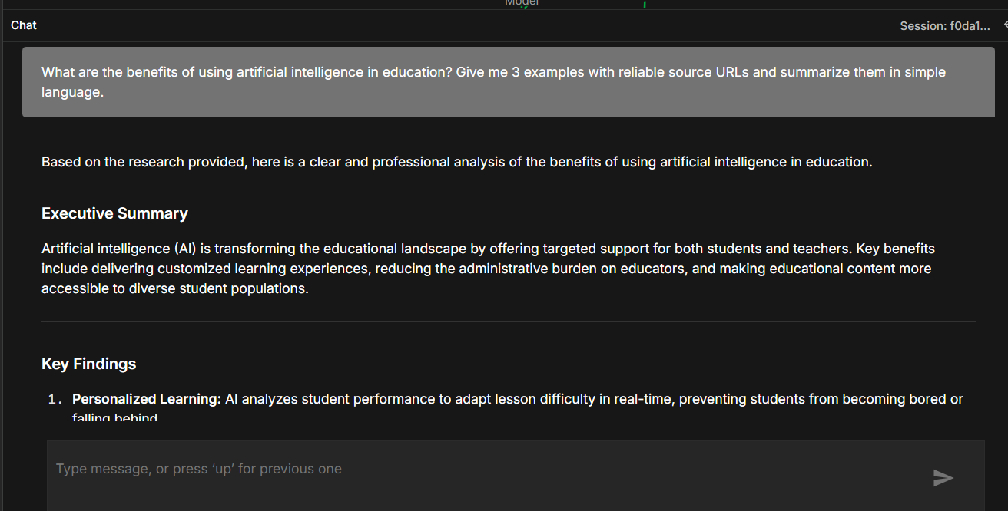
Screenshot 2. Chat output
The chat window shows the user’s question and the generated executive summary and key findings. This demonstrates that the workflow can return a readable response to a natural-language question. The visible response is only part of the full answer, so source quality should also be checked in the complete output.
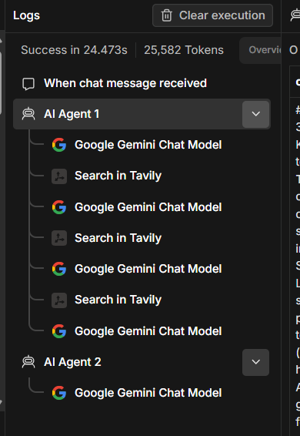
Screenshot 3. Execution log view
This narrow screenshot shows part of the execution/log area. Execution logs help identify which nodes ran and where a failure occurred. In n8n, checking the execution is useful when the final response is missing, incomplete, or generated with an error.
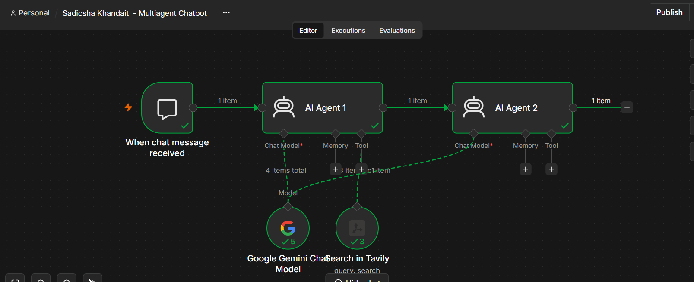
Screenshot 4. Successful workflow execution
Green check marks indicate that the chat trigger and both AI agents completed successfully in this run. The connected Gemini and Tavily nodes also show successful execution indicators. This is evidence that the workflow executed end to end for the tested input.
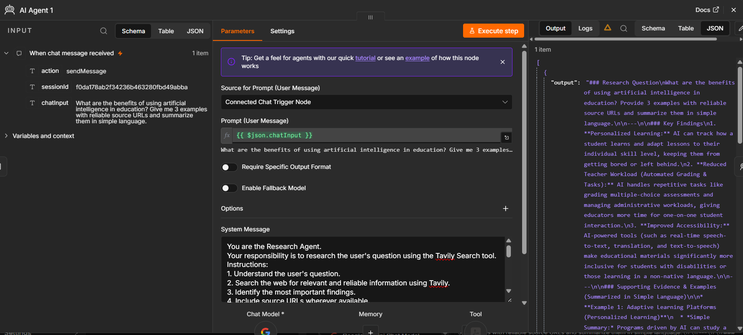
Screenshot 5. AI Agent 1 configuration and output
The parameters show that AI Agent 1 takes the message from the connected chat trigger using the chatInput field. Its system message defines the researcher role and instructs it to use Tavily. The output panel shows a structured research response. This screenshot explains the input, instructions, and output of the first agent.
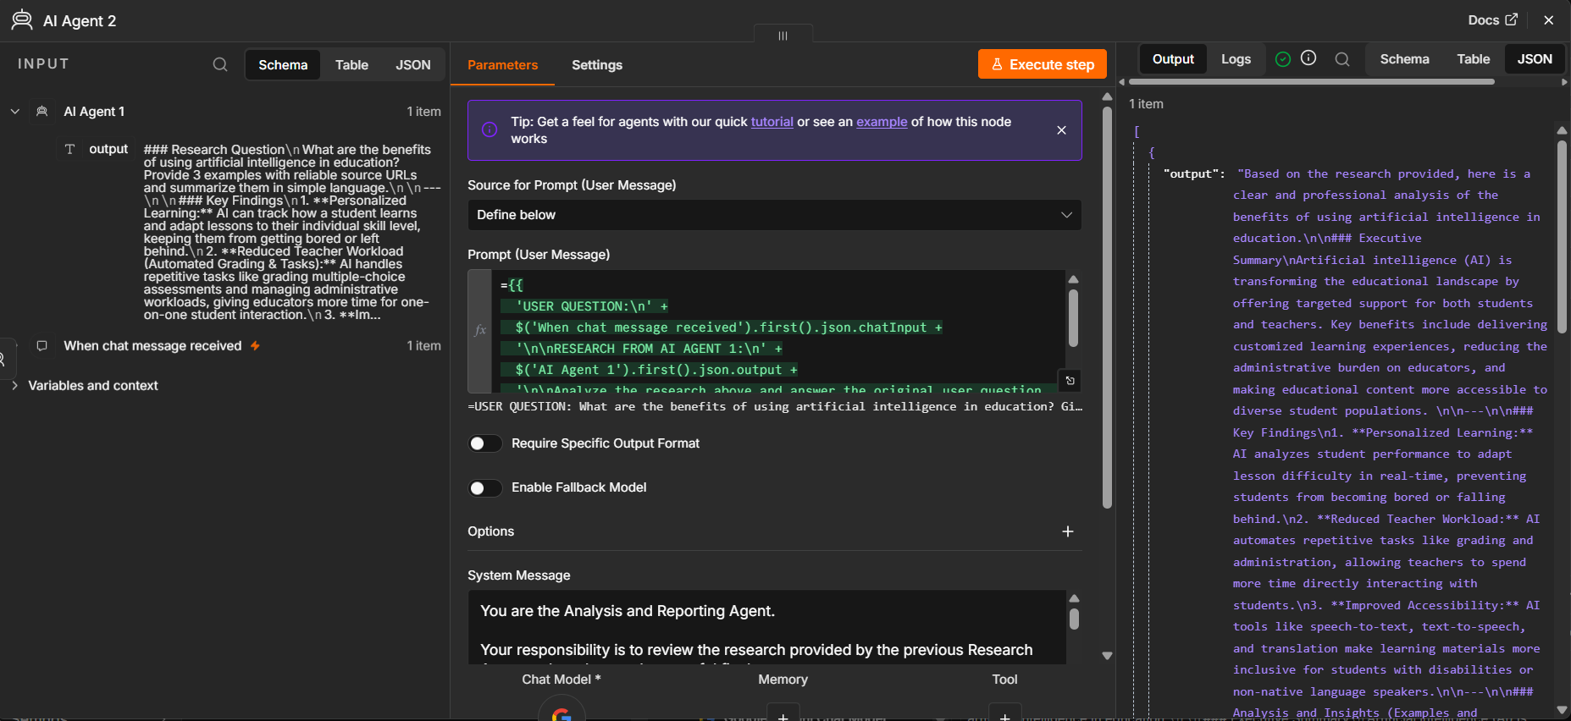
Screenshot 6. AI Agent 2 configuration and output
The input panel shows data from AI Agent 1 as well as the original chat trigger. The prompt expression combines the original user question with the research output. The system message assigns the analyst and reporting role. The output panel displays the final summarized answer. This is the key hand-off between the two agents.
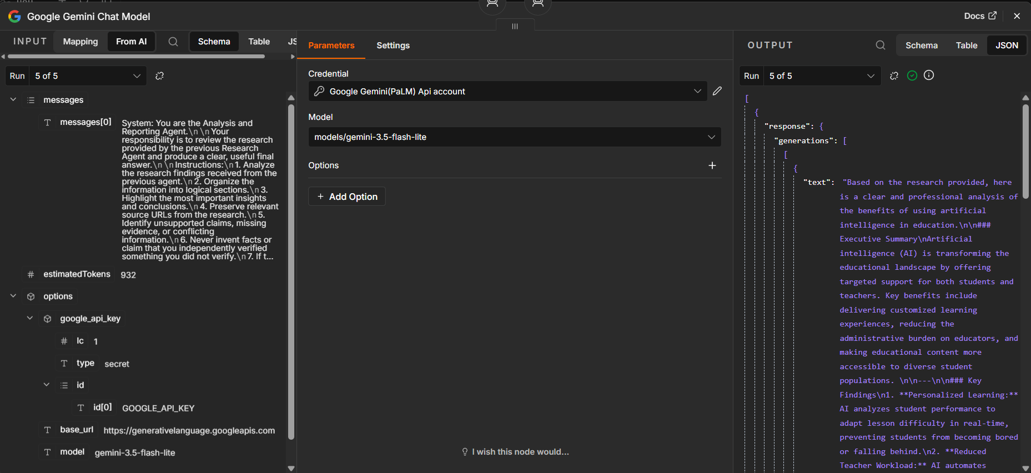
Screenshot 7. Google Gemini Chat Model configuration
This screenshot shows the Google Gemini API credential and the selected model, models/gemini-3.5-flash-lite. The output panel shows a generated response. The selected model is used by the connected agent to process natural-language input and produce text. Availability can change, so another currently available model may be needed if service errors occur.
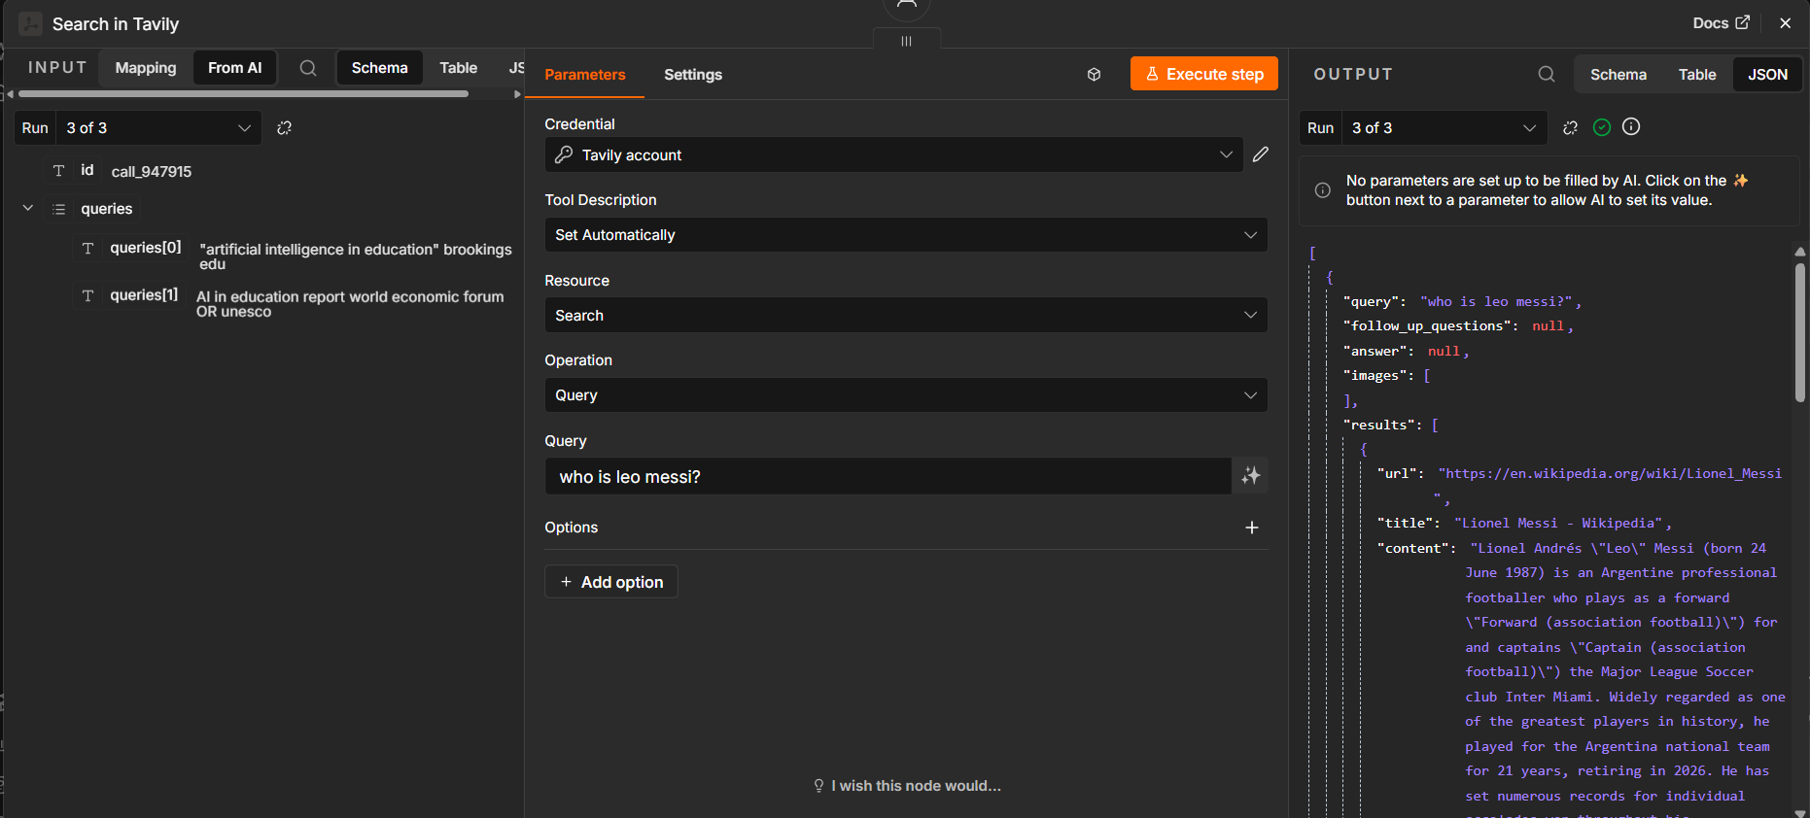
Screenshot 8. Tavily Search configuration and results
This screenshot shows the Tavily credential, Search resource, Query operation, and a search query. The results include a URL, title, and content snippet. The visible query is “who is leo messi?”, which appears to be a separate or earlier tool test rather than the education question. This screenshot demonstrates that Tavily can return search results, but it does not by itself prove that the returned results match every later user question. In a complete run, check that Tavily’s query is based on the current question.

8. Testing and Observed Results
The workflow was tested with the following example question:
“What are the benefits of using artificial intelligence in education? Give me 3 examples with reliable source URLs and summarize them in simple language.”
The resulting response discussed personalized learning, teacher workload reduction, and accessibility. It used an executive summary, key findings, examples, sources, and limitations. The workflow execution screenshots show successful completion for the displayed run.
A previous run encountered a 503 Service Unavailable error from the selected Gemini model. Switching AI Agent 2 to models/gemini-3.5-flash-lite was followed by a successful run in the supplied screenshots. This indicates that model availability can affect execution independently of the workflow connections.

Checks to perform during future tests
- Confirm that Tavily's search query matches the current user question.
- Open each source URL and check that it supports the related claim.
- Confirm that AI Agent 2 receives both the original question and AI Agent 1's output.
- Check that the final answer does not invent sources, statistics, or verification claims.
- If a Gemini service error occurs, retry or select another available model.

9. Benefits and Use Cases
- Research summaries: collect and summarize information about a topic.
- Business research: compare products, companies, or market trends using web sources.
- Academic support: prepare introductory summaries with references for further reading.
- Knowledge gathering: turn a broad question into organized findings and limitations.
- Workflow learning: demonstrate how two AI agents can work together in an automation platform.

10. Limitations and Improvements

Current limitations
- Search results may be incomplete, outdated, or unrelated to the question.
- A URL can look credible but still fail to support the exact statement being made.
- The model can produce plausible statements that are not supported by retrieved evidence.
- Temporary Gemini service errors can interrupt a workflow.
- The screenshots show a web-research and reporting workflow; they do not demonstrate a separate database, document-retrieval system, or automated fact-checking service.

Recommended improvements
- Require at least one direct, relevant source URL for each major factual example.
- Ask the researcher to return source title, publisher, URL, and the claim supported by each source.
- Instruct the analyst to preserve URLs and label claims as unverified when evidence is missing.
- Enable retry-on-failure where supported by the relevant n8n node settings.
- Test the workflow with different topics and inspect the execution data after each run.
- Consider adding a dedicated URL-checking or source-validation step if stronger verification is required.

11. Conclusion
The n8n Multi-Agent Chatbot demonstrates a simple two-agent workflow for web research and report writing. AI Agent 1 researches the user’s question with the help of Tavily Search, and AI Agent 2 turns the research into an organized response using Google Gemini. The screenshots document the workflow canvas, agent instructions, model configuration, search results, execution status, and sample response. The main next step is to strengthen source validation so that the final report is not only well written but also traceable to reliable evidence.

