library(tidyverse)
## ── Attaching core tidyverse packages ──────────────────────── tidyverse 2.0.0 ──
## ✔ dplyr 1.1.4 ✔ readr 2.1.5
## ✔ forcats 1.0.0 ✔ stringr 1.5.1
## ✔ ggplot2 3.5.1 ✔ tibble 3.2.1
## ✔ lubridate 1.9.3 ✔ tidyr 1.3.1
## ✔ purrr 1.0.2
## ── Conflicts ────────────────────────────────────────── tidyverse_conflicts() ──
## ✖ dplyr::filter() masks stats::filter()
## ✖ dplyr::lag() masks stats::lag()
## ℹ Use the conflicted package (<http://conflicted.r-lib.org/>) to force all conflicts to become errors
library(readxl)
library(dplyr)
library(tidymodels)
## ── Attaching packages ────────────────────────────────────── tidymodels 1.2.0 ──
## ✔ broom 1.0.7 ✔ rsample 1.2.1
## ✔ dials 1.3.0 ✔ tune 1.2.1
## ✔ infer 1.0.7 ✔ workflows 1.1.4
## ✔ modeldata 1.4.0 ✔ workflowsets 1.1.0
## ✔ parsnip 1.2.1 ✔ yardstick 1.3.1
## ✔ recipes 1.1.0
## ── Conflicts ───────────────────────────────────────── tidymodels_conflicts() ──
## ✖ scales::discard() masks purrr::discard()
## ✖ dplyr::filter() masks stats::filter()
## ✖ recipes::fixed() masks stringr::fixed()
## ✖ dplyr::lag() masks stats::lag()
## ✖ yardstick::spec() masks readr::spec()
## ✖ recipes::step() masks stats::step()
## • Dig deeper into tidy modeling with R at https://www.tmwr.org
library(ggplot2)
library(janitor)
##
## Attaching package: 'janitor'
##
## The following objects are masked from 'package:stats':
##
## chisq.test, fisher.test
statsdata <- read_excel("statsdata.xlsx")
wide_statsdata <- statsdata %>%
select(`Country Name`, `Series Name`, `2016 [YR2016]`) %>%
pivot_wider(
names_from = `Series Name`,
values_from = `2016 [YR2016]`,
values_fn = list(`2016 [YR2016]` = mean)
) %>%
filter(!is.na(`GDP per capita (current US$)`) & !is.na(`Life expectancy at birth, total (years)`))
#question 1
wide_statsdata %>%
summarise(
Mean = mean(`Life expectancy at birth, total (years)`),
Median = median(`Life expectancy at birth, total (years)`),
Std_Dev = sd(`Life expectancy at birth, total (years)`),
Min = min(`Life expectancy at birth, total (years)`),
Max = max(`Life expectancy at birth, total (years)`),
IQR = IQR(`Life expectancy at birth, total (years)`)
)
## # A tibble: 1 × 6
## Mean Median Std_Dev Min Max IQR
## <dbl> <dbl> <dbl> <dbl> <dbl> <dbl>
## 1 72.1 73.1 7.69 51.0 85.6 11.4
#question 2
wide_statsdata %>% filter(`Life expectancy at birth, total (years)` == min(`Life expectancy at birth, total (years)`))
## # A tibble: 1 × 4
## `Country Name` GDP per capita (curren…¹ Life expectancy at b…² `NA`
## <chr> <dbl> <dbl> <dbl>
## 1 Central African Republic 387. 51.0 NA
## # ℹ abbreviated names: ¹​`GDP per capita (current US$)`,
## # ²​`Life expectancy at birth, total (years)`
wide_statsdata %>% filter(`Life expectancy at birth, total (years)` == max(`Life expectancy at birth, total (years)`))
## # A tibble: 1 × 4
## `Country Name` `GDP per capita (current US$)` Life expectancy at birth…¹ `NA`
## <chr> <dbl> <dbl> <dbl>
## 1 Monaco 173605. 85.6 NA
## # ℹ abbreviated name: ¹​`Life expectancy at birth, total (years)`
#question 3
ggplot(wide_statsdata, aes(x = `Life expectancy at birth, total (years)`)) +
geom_histogram(bins = 15, fill = "#7bc0a3", color = "#2c5d63") +
labs(title = "Distribution of Life Expectancy (2016)",
x = "Life Expectancy (Years)",
y = "Number of Countries") +
theme_minimal() +
theme(plot.title = element_text(color = "#2c5d63", face = "bold"))
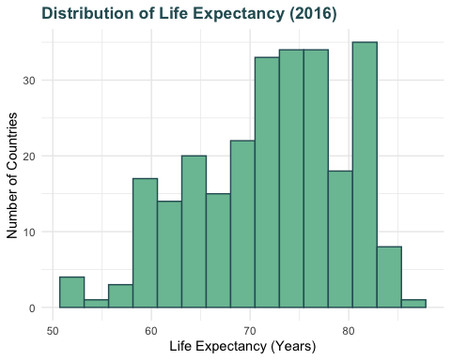
#question 4 - scatterplot
wide_statsdata %>%
ggplot(mapping = aes(x = log(`GDP per capita (current US$)`),
y = `Life expectancy at birth, total (years)`,
color = "#7bc0a3")) +
geom_point(alpha = 0.2) +
labs(x = "Log of GDP per Capita ($)",
y = "Life Expectancy (years)",
title = "Life Expectancy versus GDP per Capita")
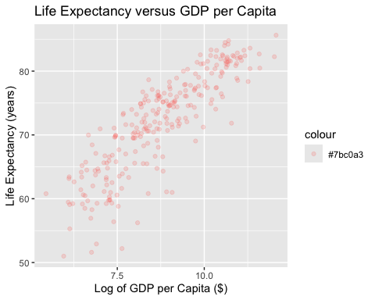
question4 <- lm(
`Life expectancy at birth, total (years)` ~ log(`GDP per capita (current US$)`),
data = wide_statsdata
)
summary(question4)$r.squared
## [1] 0.7413086
#question 5 - regression
question5 <- lm(
`Life expectancy at birth, total (years)` ~ log(`GDP per capita (current US$)`),
data = wide_statsdata
)
summary(question5)
##
## Call:
## lm(formula = `Life expectancy at birth, total (years)` ~ log(`GDP per capita (current US$)`),
## data = wide_statsdata)
##
## Residuals:
## Min 1Q Median 3Q Max
## -14.6948 -2.1653 0.5999 2.6754 8.1995
##
## Coefficients:
## Estimate Std. Error t value Pr(>|t|)
## (Intercept) 31.442 1.516 20.74 <2e-16 ***
## log(`GDP per capita (current US$)`) 4.642 0.171 27.14 <2e-16 ***
## ---
## Signif. codes: 0 '***' 0.001 '**' 0.01 '*' 0.05 '.' 0.1 ' ' 1
##
## Residual standard error: 3.918 on 257 degrees of freedom
## Multiple R-squared: 0.7413, Adjusted R-squared: 0.7403
## F-statistic: 736.5 on 1 and 257 DF, p-value: < 2.2e-16

