BRAINSTORMING & IDEATION PHASE

MODULE 2 : Define the Problem Statements
Date : | 27.09.2026
Team ID : | SWTID-2026-4107
Project Name : | Streamlining IT Procurement: Automating Standard Laptop Orders with Flow Designer

Customer Problem Statement Template
Create problem statements to understand the point of view of the users involved in the IT procurement process for standard laptop requests. The Customer Problem Statement template helps identify the difficulties faced by users and IT procurement staff while processing approved laptop requests, creating tasks, and assigning them to the appropriate team.
A well-articulated problem statement helps the team understand the challenges in the existing laptop procurement process and identify the requirements for a streamlined and automated solution using ServiceNow Flow Designer.

Framework Guidance & Field Definitions
Field | Description
I am... | Describe the customer/user and their role.
I'm trying to... | Describe what the customer/user is trying to achieve.
But... | Describe the problem or barrier they face.
Because... | Describe the reason causing the problem.
Which makes me feel... | Describe how the customer/user feels when facing the problem.

Customer Problem Statement Breakdown
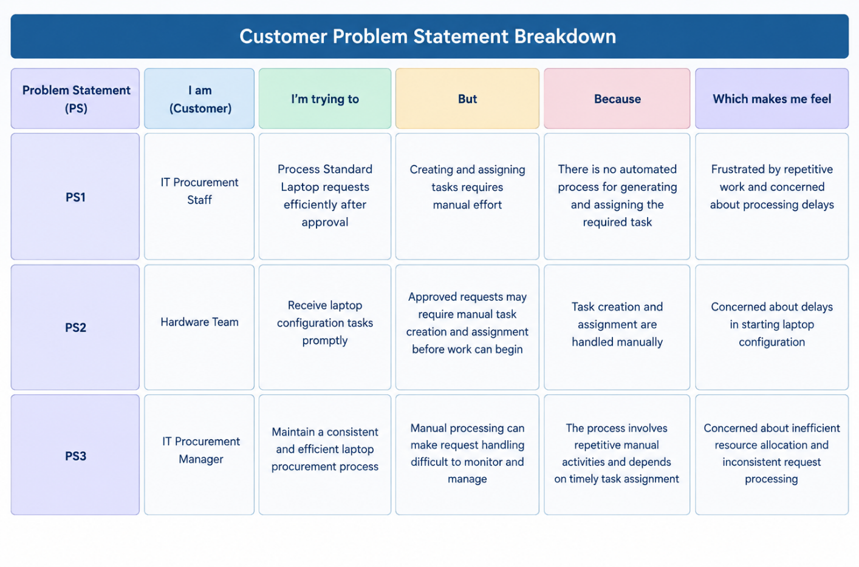

Selected Problem Focus
The project focuses on the problem faced by IT Procurement Staff in manually processing approved Standard Laptop requests and creating and assigning the required tasks. The proposed solution uses ServiceNow Flow Designer to streamline the process by automating task creation and assignment to the appropriate Hardware team.
This focus directly addresses the need to reduce manual effort, improve consistency, and support timely processing of Standard Laptop requests.

