PROJECT DOCUMENTATION
Date : | 27.09.2026
Team ID : | SWTID-2026-4107
Project Name : | Streamlining IT Procurement: Automating Standard Laptop Orders with Flow Designer
1. INTRODUCTION
1.1 Project Overview
This project focuses on streamlining the IT procurement process using the ServiceNow platform. In an organization, employees may need laptops for their work, but handling laptop requests manually can result in delays, incomplete information, repeated communication, and difficulties in tracking the request status.
The proposed solution uses ServiceNow Service Catalog, Catalog Items, Flow Designer, approval processes, and fulfillment tasks to automate the standard laptop request process. Employees can submit their laptop requirements through a structured request form, after which the request is automatically routed for approval and fulfillment.
This solution provides a centralized and organized process for managing laptop requests from submission to final fulfillment.
1.2 Purpose
The purpose of this project is to automate and simplify the standard laptop procurement process using ServiceNow.
- The main objectives are:
- To provide a simple and standardized laptop request form.
- To collect the required employee and laptop details.
- To automate the approval process.
- To automatically create fulfillment tasks.
- To reduce manual communication and processing time.
- To provide request status tracking.
- To improve the efficiency of IT procurement.
2. IDEATION PHASE
2.1 Problem Statement
In many organizations, laptop requests are handled through emails, phone calls, spreadsheets, or manual communication. This process can create several problems such as:
- Delayed processing of laptop requests.
- Missing or incorrect employee information.
- Lack of a standardized request process.
- Manual approval follow-ups.
- Difficulty in tracking request status.
- Increased workload for the IT and procurement teams.
- Possibility of duplicate or unnecessary requests.
Therefore, an automated system is required to make the laptop procurement process faster, organized, and easier to track.
2.2 Empathy Map Canvas
Says:
“I need a laptop for my work, but I want a simple way to request it.”
Thinks:
“I should be able to know whether my laptop request has been approved and when it will be fulfilled.”
Does:
Submits a laptop request and contacts the IT team to check the request status.
Pains:
- Long waiting time.
- Manual approval process.
- Repeated follow-ups.
- Unclear request status.
- Incomplete request information.
Gains:
- Easy laptop request submission.
- Faster approval.
- Automatic notifications.
- Standardized laptop options.
- Easy request tracking.
- Reduced manual work for IT teams.
2.3 Brainstorming
- Option A: Manual Email Requests
Employees can send their laptop requirements through email.
Limitation:
This method requires manual processing and makes tracking and approval difficult.
- Option B: Spreadsheet-Based Requests
Employees can enter their laptop requirements into a shared spreadsheet.
Limitation:
Managing multiple requests, approvals, and status updates manually can lead to errors and duplicate entries.
- Option C: ServiceNow Service Catalog and Flow Automation – Chosen
ServiceNow provides a centralized Service Catalog, automated approval process, fulfillment tasks, and request tracking.
Reason for Selection:
ServiceNow can automate the complete laptop request process and provide better visibility to employees, IT teams, and approvers.
3. REQUIREMENT ANALYSIS
3.1 Customer Journey Map
The customer journey for the standard laptop request consists of five stages:
Entice – Request Preparation
The employee identifies the requirement for a standard laptop and accesses the ServiceNow Service Catalog.
Enter – Request Submission
The employee opens the Standard Laptop Request and enters the required information such as employee details, department, laptop type, and business justification.
Engage – Approval
The submitted request is automatically sent to the appropriate manager or IT approver for review.
Exit – Fulfillment
After approval, a fulfillment task is created for the IT or procurement team. The team processes the laptop request.
Extend – Completion and Tracking
The request status is updated after fulfillment. The laptop can then be assigned to the employee and recorded as an IT asset.
3.2 Solution Requirement
Functional Requirements (FR)
- FR-1: The system shall provide a ServiceNow Catalog Item for standard laptop requests.
- FR-2: The system shall collect employee details and laptop requirement information.
- FR-3: The system shall validate mandatory fields before submitting the request.
- FR-4: The system shall automatically route the request to the appropriate approver.
- FR-5: The system shall create a fulfillment task after approval.
- FR-6: The system shall send notifications for request submission, approval, rejection, and completion.
- FR-7: The system shall allow users to track the status of their laptop requests.
- FR-8: The system shall maintain request and fulfillment records for future reference.
Non-Functional Requirements (NFR)
- NFR-1 – Usability: The laptop request form should be simple and user-friendly.
- NFR-2 – Security: Only authorized users should be able to approve and process laptop requests.
- NFR-3 – Reliability: The system should handle incomplete or invalid requests properly.
- NFR-4 – Performance: Requests should be submitted and processed without unnecessary delays.
- NFR-5 – Availability: The ServiceNow application should be available during normal organizational operations.
- NFR-6 – Scalability: The solution should support multiple laptop requests from different employees and departments.
3.3 Data Flow Diagram
[ Employee ]
|
v
[ Standard Laptop Request ]
|
v
[ Request Validation ]
|
v
[ Approval Process ]
/ \
/ \
v v
[ Rejected ] [ Approved ]
|
v
[ Fulfillment Task ]
|
v
[ IT / Procurement ]
|
v
[ Laptop Fulfillment ]
|
v
[ Employee Receives ]
|
v
[ Asset Assignment ]
  - Technology Stack
Layer 1 – User Interface
- ServiceNow Service Catalog
- Standard Laptop Request Catalog Item
- Request Form
Layer 2 – Request and Workflow
- Requested Item
- Catalog Tasks
- Flow Designer
- Approval Process
Layer 3 – Server-Side Processing
- Business Rules
- Client Scripts
- Data Policies
- GlideRecord
- Flow Designer Actions
Layer 4 – Infrastructure
- ServiceNow Cloud Platform
- ServiceNow Personal Developer Instance (PDI)
Layer 5 – Data Storage
- User Records
- Requested Items
- Catalog Tasks
- Approval Records
- Asset Records
- Layer 6 – Notifications
- Email Notifications
- Approval Notifications
- Request Status Notifications
4. PROJECT DESIGN
4.1 Problem Solution Fit
The proposed solution addresses the difficulties of manually managing laptop procurement requests by providing a centralized and automated process.
Employees can submit their laptop requirements through a standard ServiceNow Catalog Item. The system then manages approval, fulfillment, notifications, and status tracking.
This reduces manual effort and provides a structured process for managing standard laptop requests.
4.2 Proposed Solution
The proposed solution uses ServiceNow Service Catalog and Flow Designer to automate standard laptop requests.
The employee submits a laptop request through the Service Catalog. The system validates the information and sends the request to the appropriate approver.
If the request is approved, ServiceNow automatically creates a fulfillment task for the IT or procurement team. The team processes the laptop request and updates the task status.
After the laptop is provided to the employee, the request is marked as completed and the laptop can be associated with the employee's asset record.
4.3 Solution Architecture
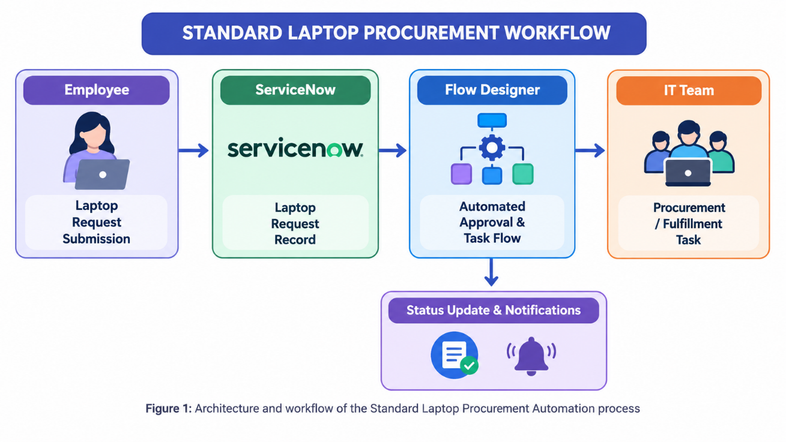
5. PROJECT PLANNING & SCHEDULING
5.1 Project Planning
The project is planned in the following stages:
Stage 1 – Service Catalog Configuration
- Create the Standard Laptop Request Catalog Item.
- Add the required laptop request fields.
- Configure mandatory fields.
- Configure standard laptop options.
Stage 2 – Approval Automation
- Configure the approval process.
- Define the appropriate approver.
- Configure approval and rejection conditions.
- Configure notifications.
Stage 3 – Fulfillment Automation
- Create fulfillment tasks for approved requests.
- Assign tasks to the IT/procurement team.
- Update request and task status.
- Complete the request after fulfillment.
Stage 4 – Testing
- Test request submission.
- Test mandatory field validation.
- Test approval and rejection.
- Test fulfillment.
- Verify the final request status.
6. FUNCTIONAL AND PERFORMANCE TESTING
6.1 Performance Testing
The system was tested to verify that standard laptop requests can be submitted and processed correctly.
The following scenarios were tested:
Test 1 – Request Submission:
A laptop request was submitted with all required information. The request was successfully created.
Test 2 – Mandatory Field Validation:
The request was tested without completing mandatory fields. The system prevented incomplete submission.
Test 3 – Approval:
The submitted request was routed to the appropriate approver.
Test 4 – Approval Success:
After approval, the system created the required fulfillment task.
Test 5 – Rejection:
A request was rejected to verify that the rejection process and notification worked correctly.
Test 6 – Fulfillment:
The fulfillment task was processed and the request status was updated successfully.
Test Result:
The complete laptop request workflow was successfully tested from request submission through approval and fulfillment.
7. RESULTS
7.1 Output Screenshots
The following section contains screenshots of the implemented project in the ServiceNow environment. The Screenshots demonstrate the standard laptop request process. Flow Desinger automation, approval,task processing, status updates,and completion of the request.

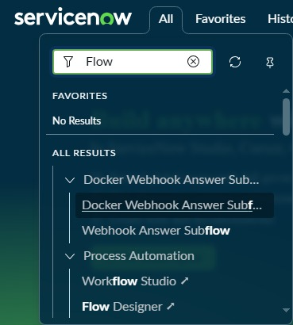
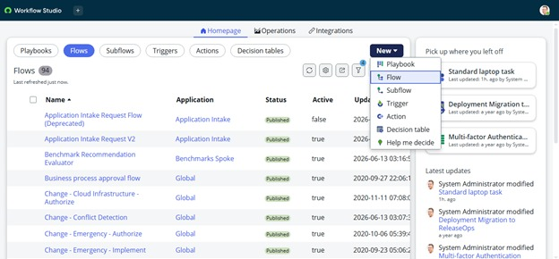

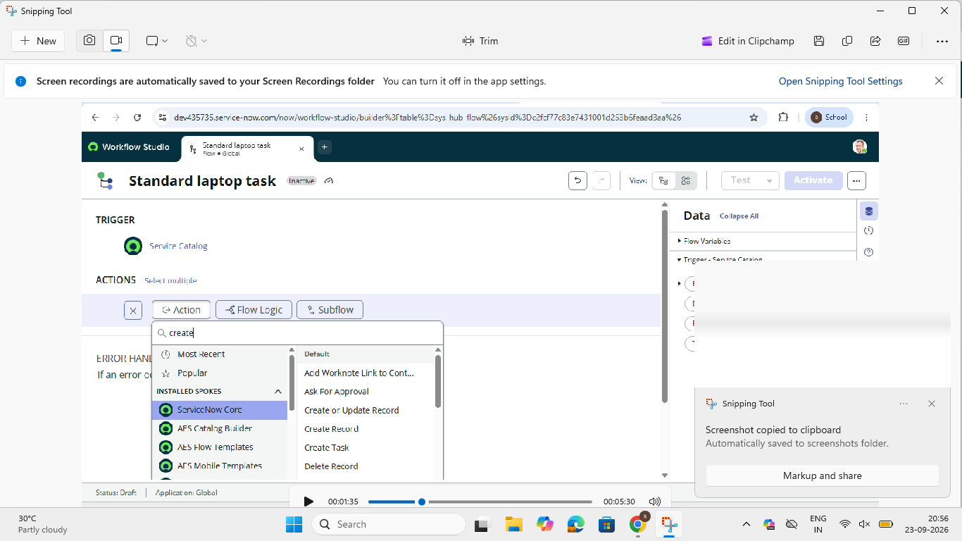
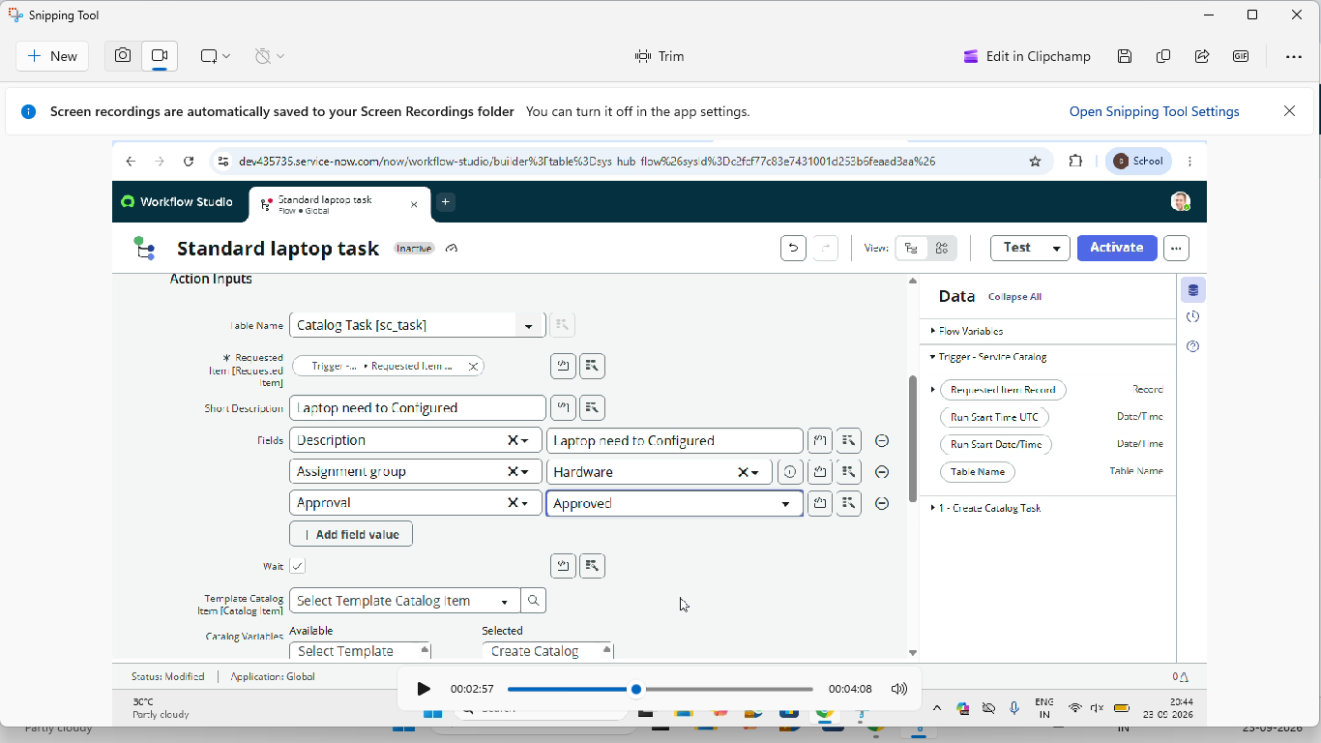
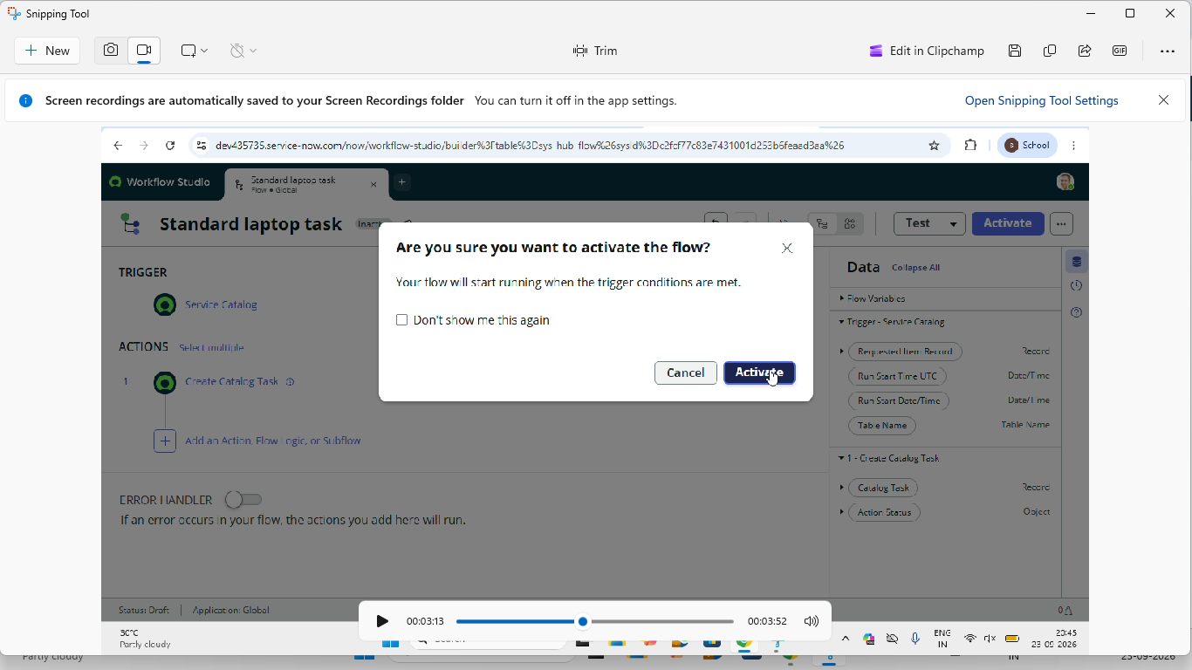
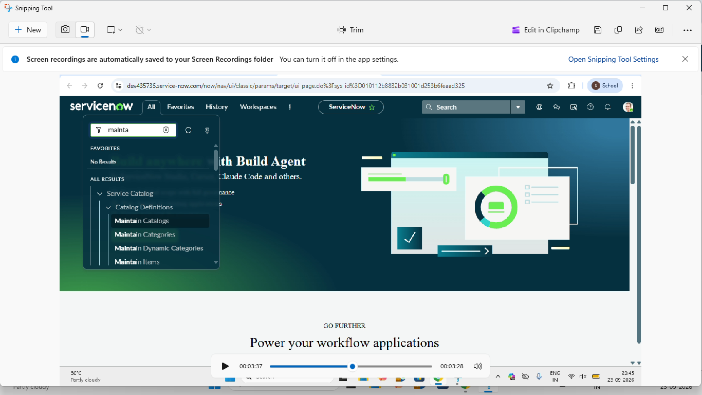
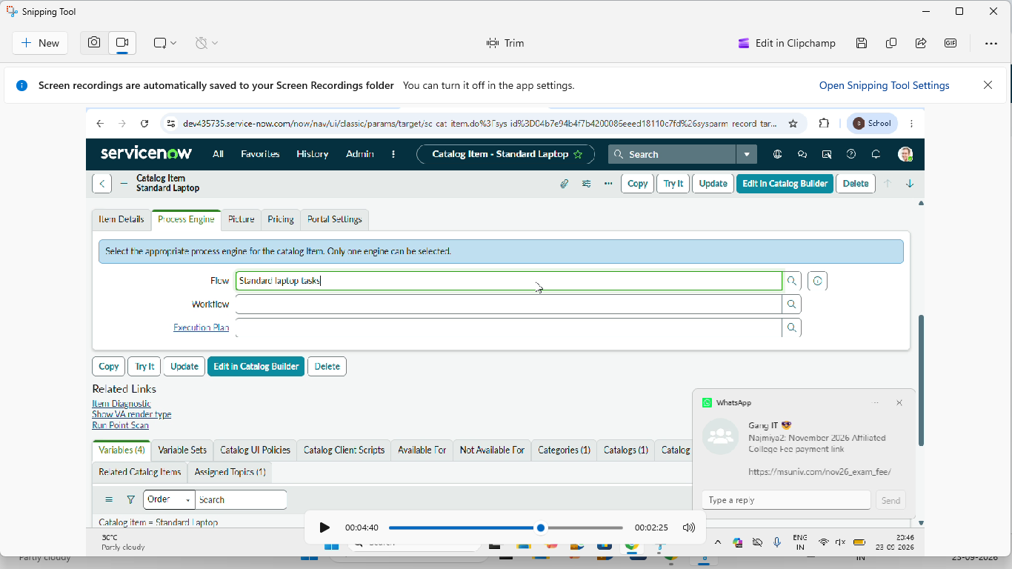
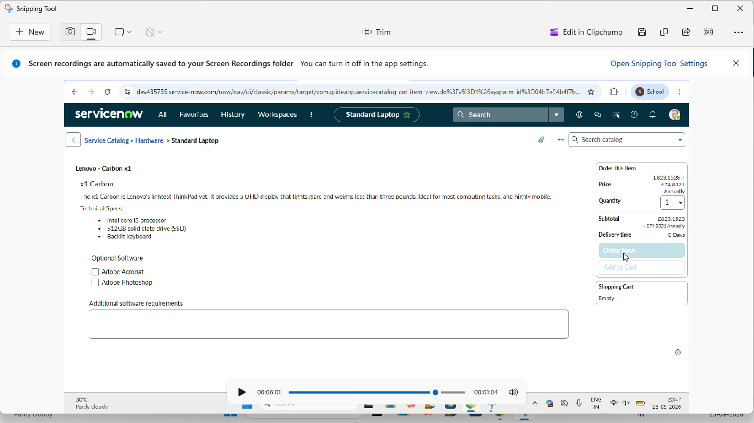
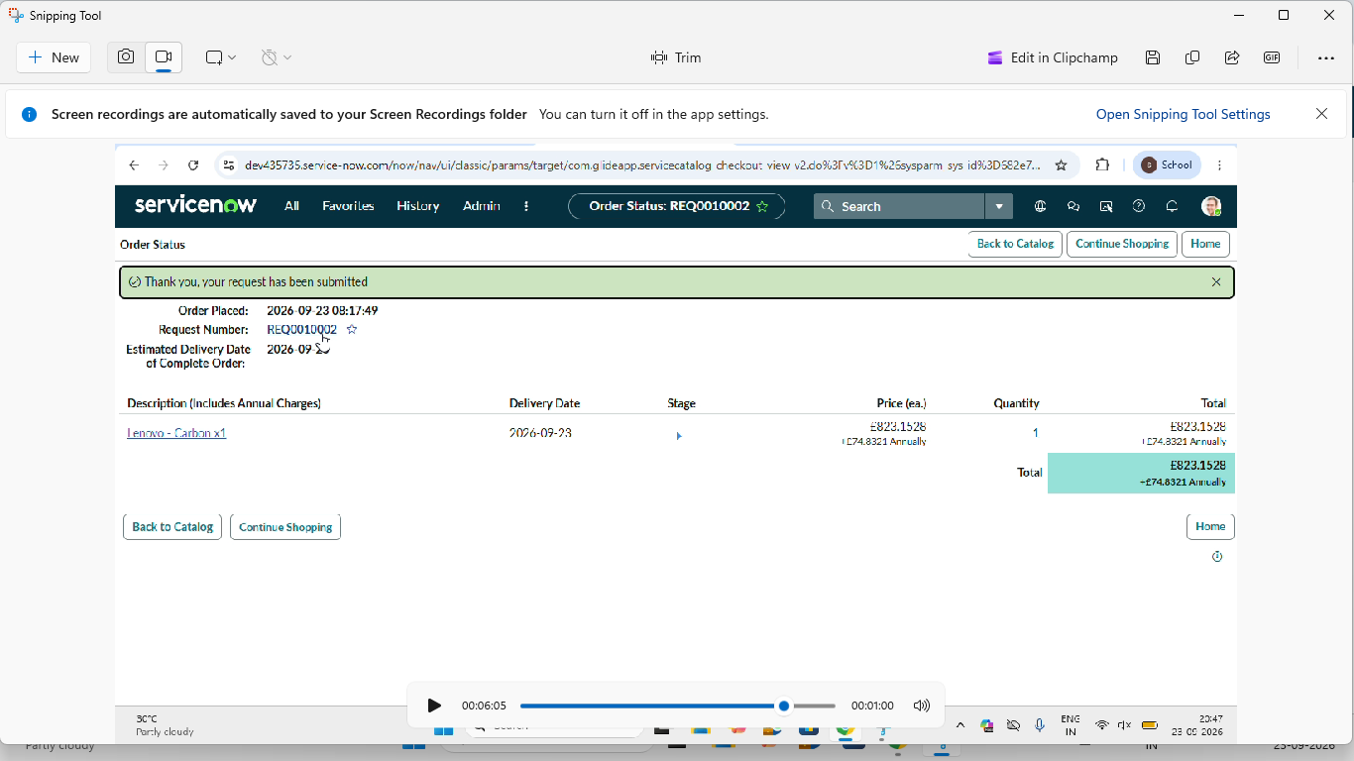
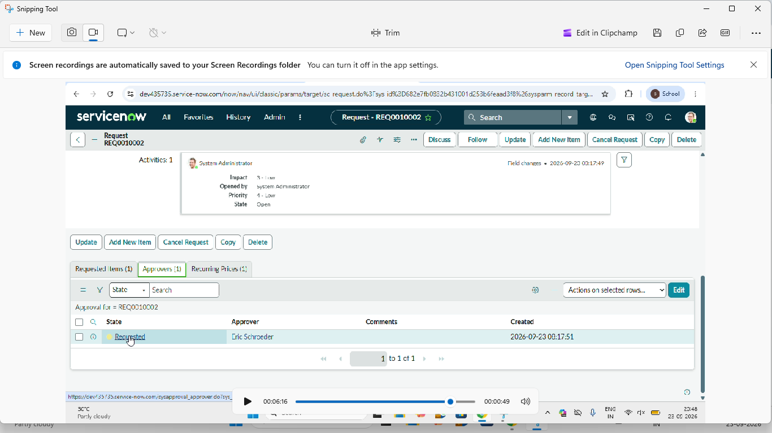
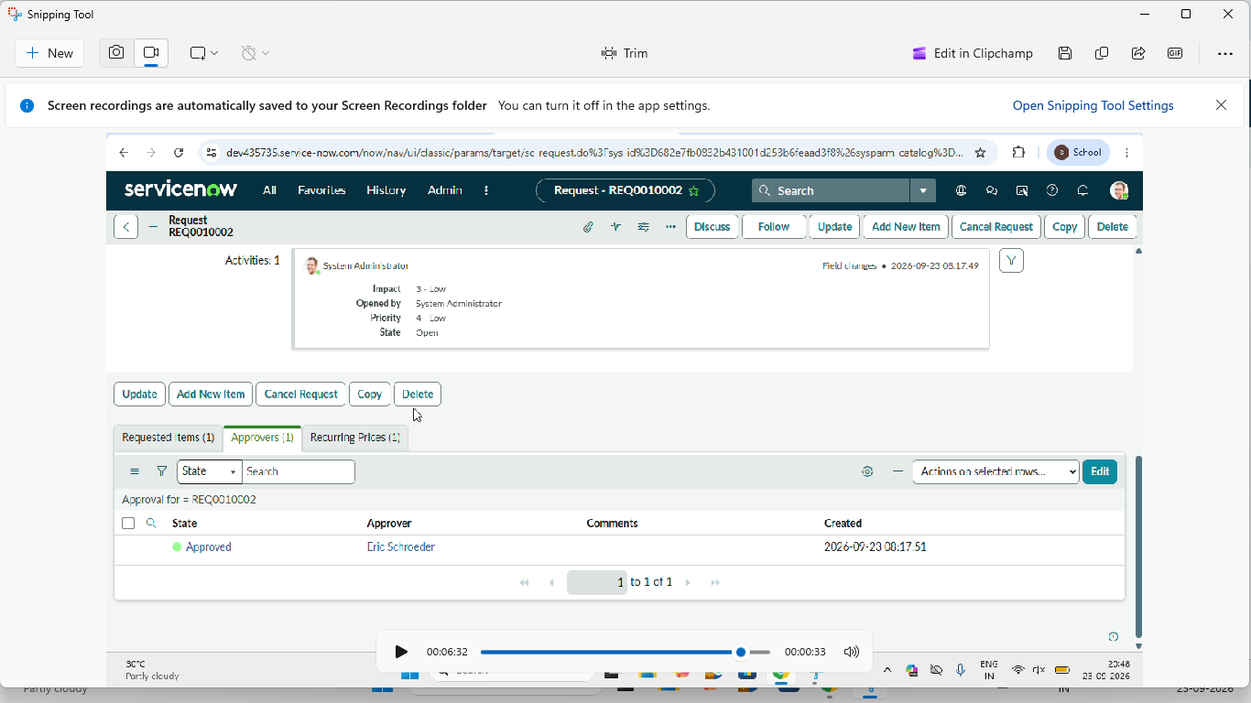
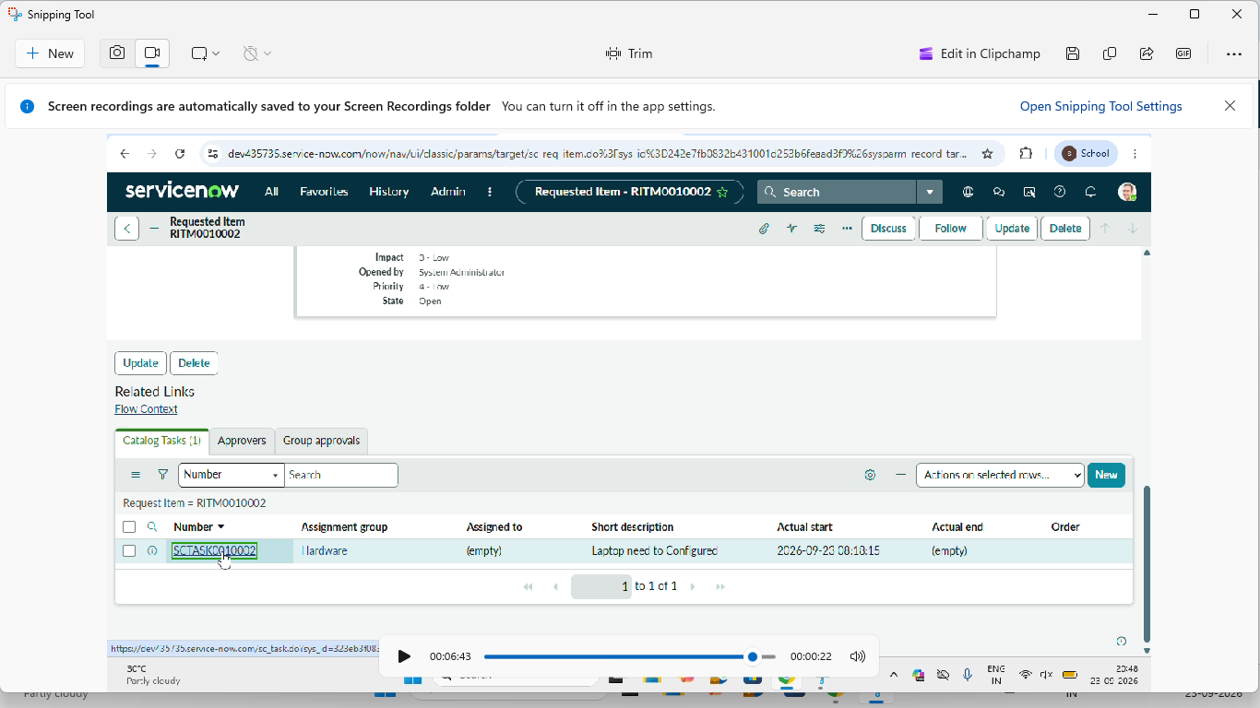
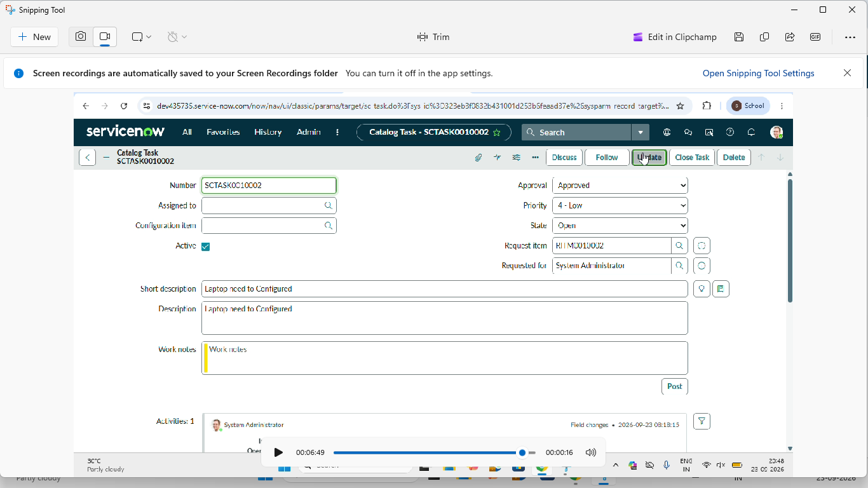

8. ADVANTAGES & DISADVANTAGES
8.1 Advantages
- Automation
The laptop request and approval process can be automated using ServiceNow workflows.
- Reduced Manual Work
The system reduces manual communication and repetitive administrative tasks.
- Standardization
All employees use a standardized laptop request form with predefined information.
- Faster Processing
Automated approval and fulfillment tasks can reduce unnecessary delays.
- Better Tracking
Employees and IT teams can easily track the progress of laptop requests.
- Improved Accuracy
Mandatory fields and validation help reduce incomplete or incorrect requests.
- Asset Management
Fulfilled laptops can be associated with employee asset records for better IT asset tracking.

8.2 Disadvantages
- Initial configuration requires ServiceNow administration knowledge.
- Complex approval requirements may require additional configuration.
- Changes in procurement policies may require workflow modifications.
- Integration with external procurement systems may require additional integration tools.
- Large organizations may require additional configurations for different departments and approval levels.

9. CONCLUSION
The “Streamlining IT Procurement: Automating Standard Laptop Requests” project provides an automated and structured solution for managing standard laptop requests using the ServiceNow platform.
The solution uses Service Catalog, Flow Designer, approval processes, fulfillment tasks, notifications, and asset management to manage the laptop request lifecycle.
Employees can submit their requests through a standardized form, while approvals and fulfillment activities are handled through an automated workflow.
Overall, the solution helps reduce manual effort, improve request tracking, standardize the procurement process, and provide a more efficient way to manage IT laptop requests.

