REQUIREMENT ANALYSIS

MODULE 3 – SOLUTION REQUIREMENTS
Date : | 27.09.2026
Team ID : | SWTID-2026-4107
Project Name : | Streamlining IT Procurement: Automating Standard Laptop Orders with Flow Designer

Functional Requirements
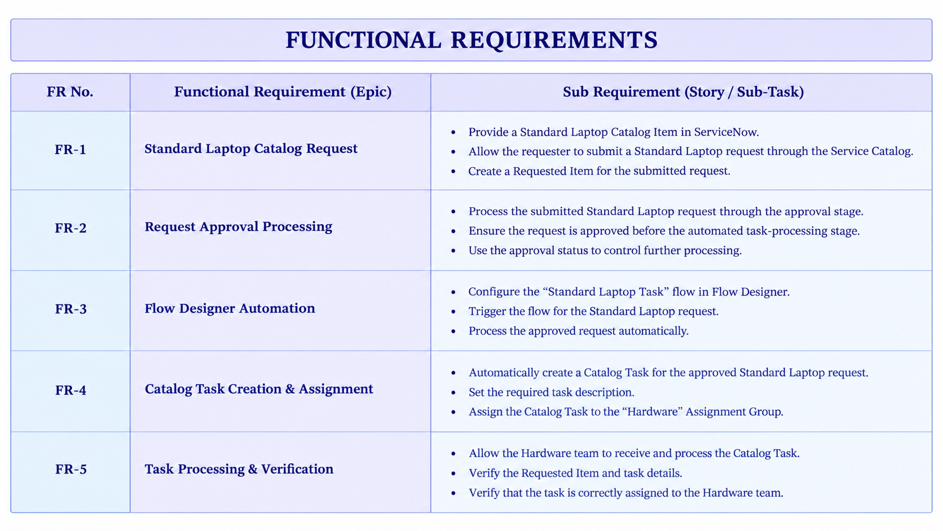

Non-Functional Requirement

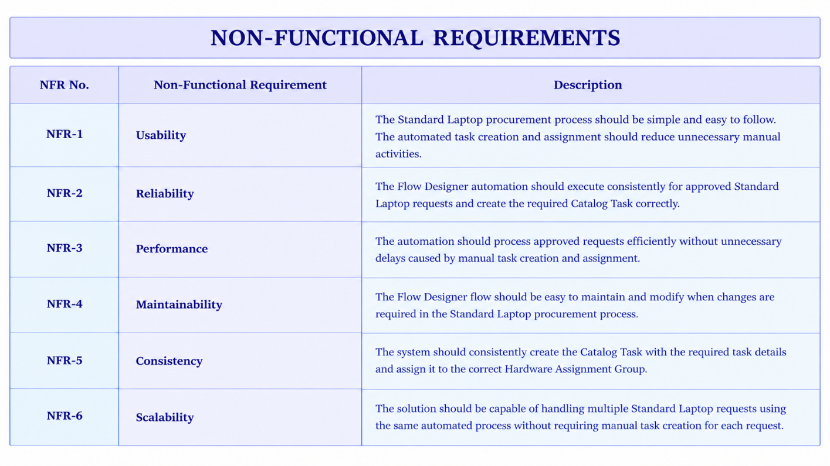
Data Requirements
Field / Data | Purpose
Requested Item | Identifies the Standard Laptop request being processed.
Catalog Item | Identifies the requested item as Standard Laptop.
Approval Status | Determines whether the request has been approved for further processing.
Catalog Task | Stores the task generated for the approved request
Short Description | Provides the required task description, such as “Laptop need to be Configured”.
Assignment Group | Identifies the team responsible for the task — Hardware.
Task Status | Tracks the processing status of the Catalog Task.

Automation Requirements
The solution should use Flow Designer to automate the Standard Laptop procurement process.
The flow should:
- Trigger for the Standard Laptop request.
- Process the request after the required approval.
- Create a Catalog Task automatically.
- Set the required task details.
- Assign the task to the Hardware Assignment Group.
- Allow the Hardware team to process the task.
- Support verification of the created task and assignment.

Maintenance Requirements
- The solution should be implemented using ServiceNow Flow Designer.
- The Standard Laptop Task flow should be easy to maintain and modify.
- The Standard Laptop Catalog Item should remain correctly associated with the configured flow.
- Task assignment should remain standardized to the Hardware Assignment Group.
- The solution should be extendable if additional laptop procurement requirements are introduced.

Expected Solution
The final solution should provide an automated Standard Laptop procurement process in ServiceNow.
The solution should:
- Reduce manual task creation.
- Automatically create the required Catalog Task after approval.
- Automatically assign the task to the Hardware team.
- Improve consistency in task processing.
- Help the Hardware team begin laptop configuration without unnecessary manual assignment.
- Provide a clear and verifiable procurement workflow.

