Middle East Technical University

Electrical and Electronics Engineering

EE464 Static Power Conversion-II



Project-1: Simulation and Design of the Hardware Project

Instructor: Assist. Prof. Dr. Ozan KEYSAN

Student: Sadık AKYAR -

Sonay ULUKAYA -

İsmail ATASEVEN - 2030120

Date: 31.03.2019

Table of Contents

Introduction 3

1) Design of an Isolated Power Supply 4

Part-a 4

Part-b 8

Reference 9

# Introduction

In this project, simulation and design of the hardware project is completed. We chose the flyback converter topology which has 10V output voltage and 60W output power. Moreover, output voltage ripple must be smaller than the 4% and line & load regulation must be smaller than the 2%. In this report simulation results of our design and analysis of them can be found. Furthermore, magnetic design and analysis of transformer is also considered. In addition to them, preliminary components are selected.

# Design of an Isolated Power Supply

Specifications of the chosen topology which is Flyback Converter are:

* Input Voltage: 24V – 48V
* Output Voltage: -10V
* Output Power: 60W
* Output voltage ripple: 4%
* Line regulation: 2%
* Load regulation: 2%

We chose 100kHz as a switching frequency because we are planning to use the UC2845 controller whose typical frequency is 100kHz.

## Part-a

Following simulation results shows the steady-state operation of the flyback converter with given specifications. Calculation of magnetizing inductance (Lm=31.61µH), transformer turns ratio (15:15) and duty cycle will be shown in the following parts. Figure-1 shows the circuit diagram of the simulation and Figure-2&3 shows the output voltage & current waveforms for 24V input. Also, Figure-5&6 shows the output voltage & current waveforms for 48V input. Input current waveforms are also shown in Figure-4&7 for 24V&48V input voltage respectively.

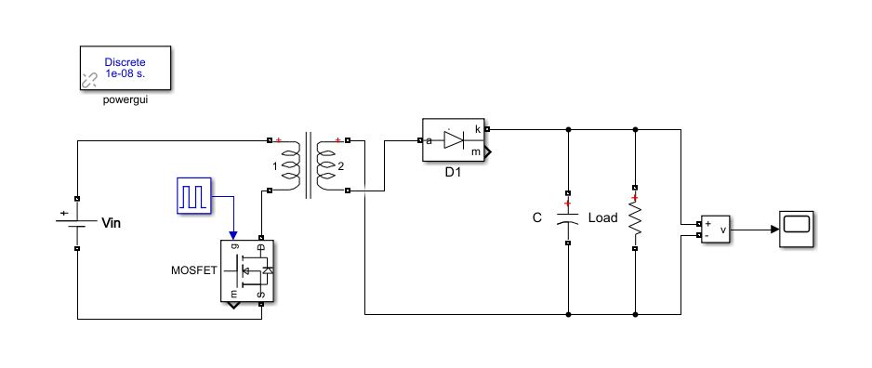

Figure 1: Circuit diagram of the flyback converter simulation

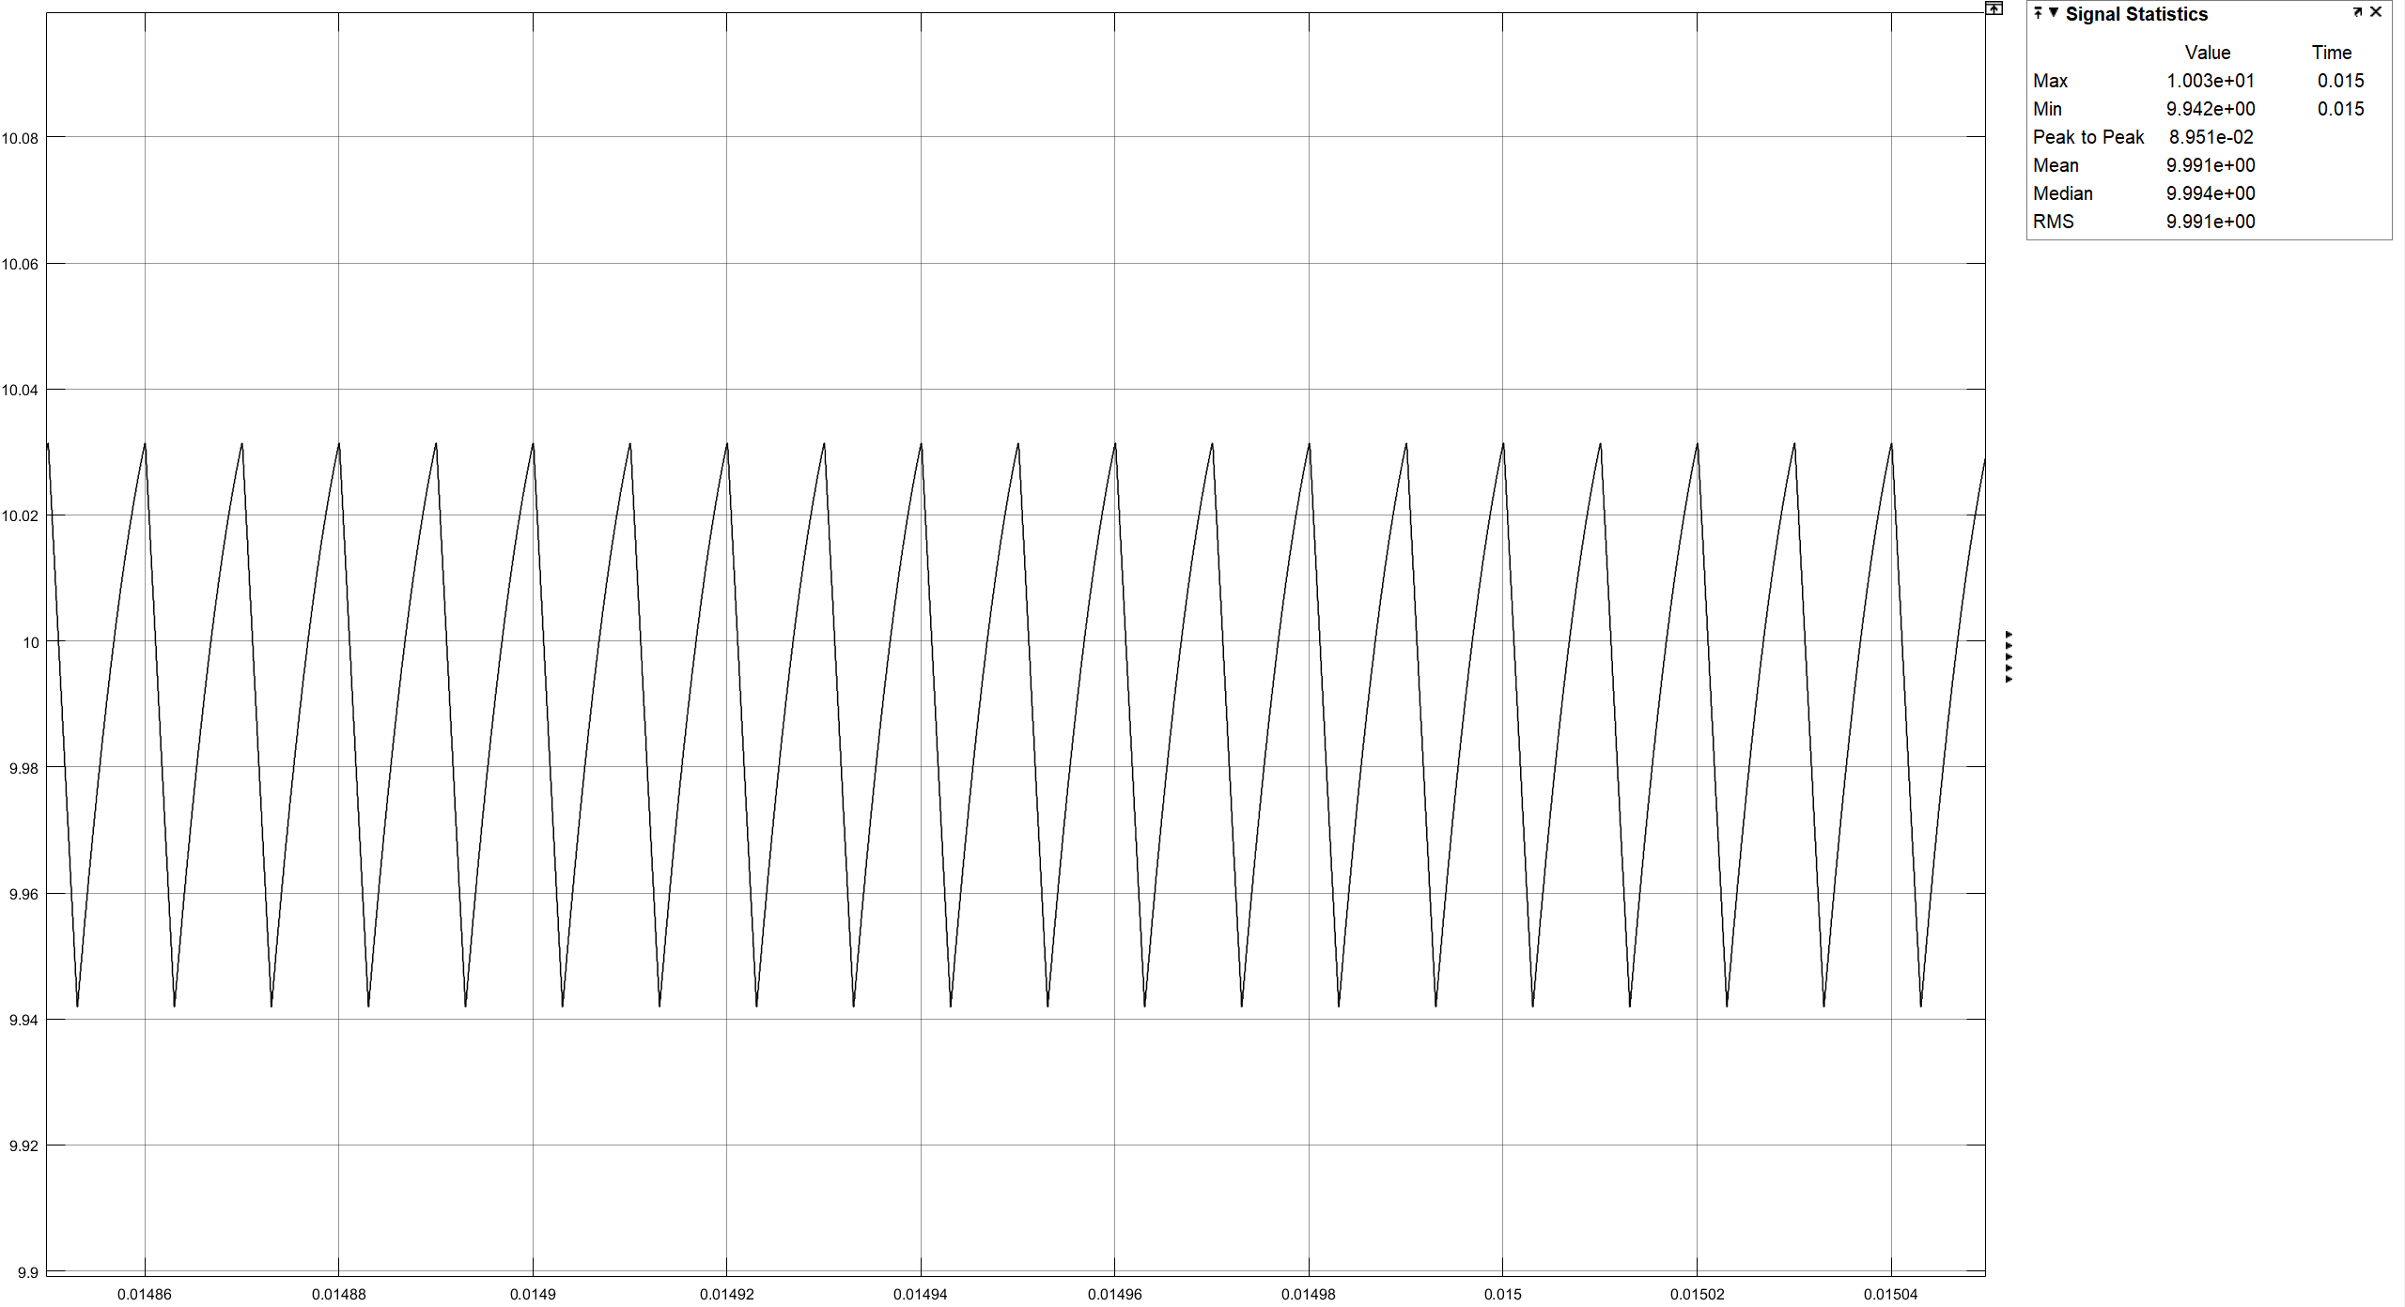

Figure 2: Output voltage waveform of the flyback converter (Vin=24V)

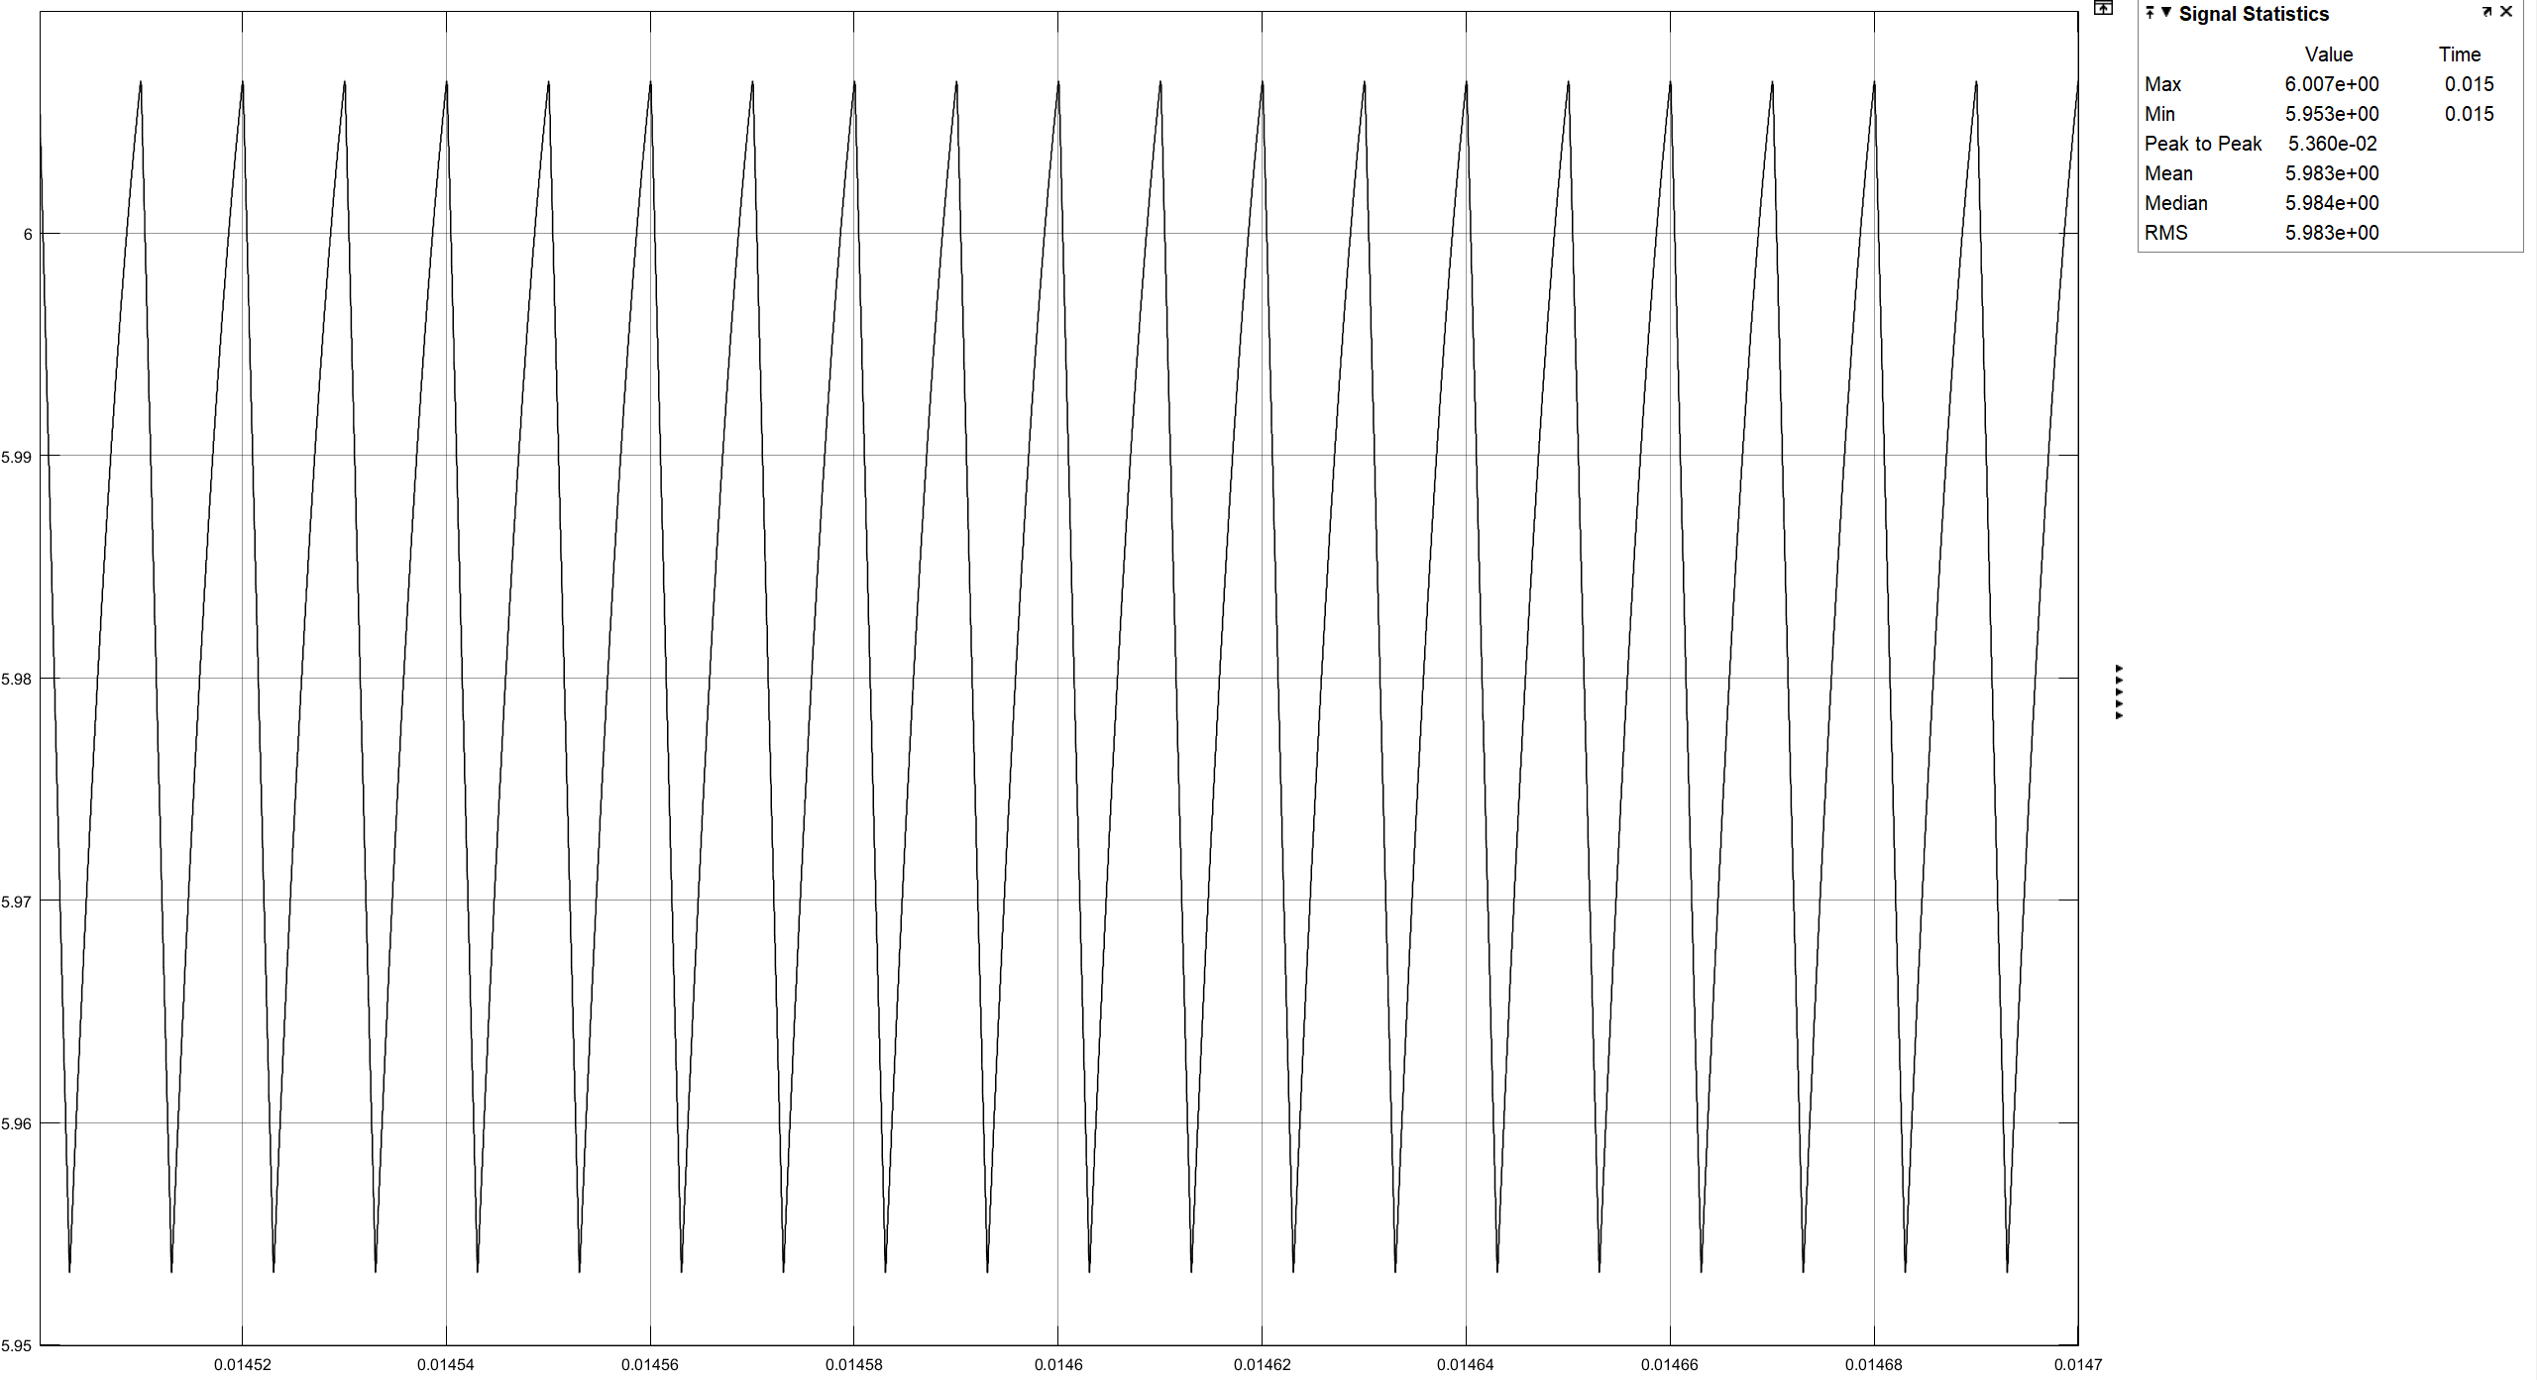

Figure 3: Output current waveform of the flyback converter (Vin=24V)

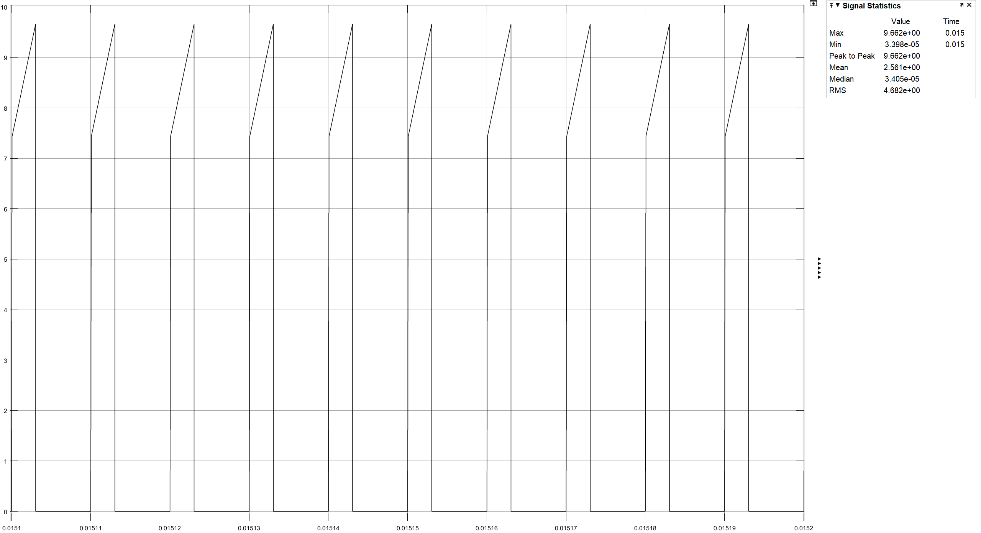

Figure 4: Input current waveform of the flyback converter (Vin=24V)

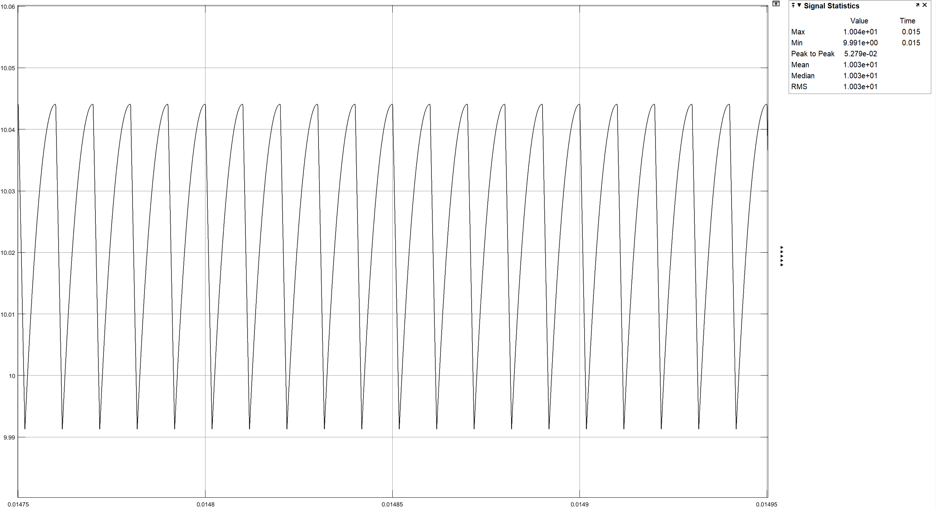

Figure 5: Output voltage waveform of the flyback converter (Vin=48V)

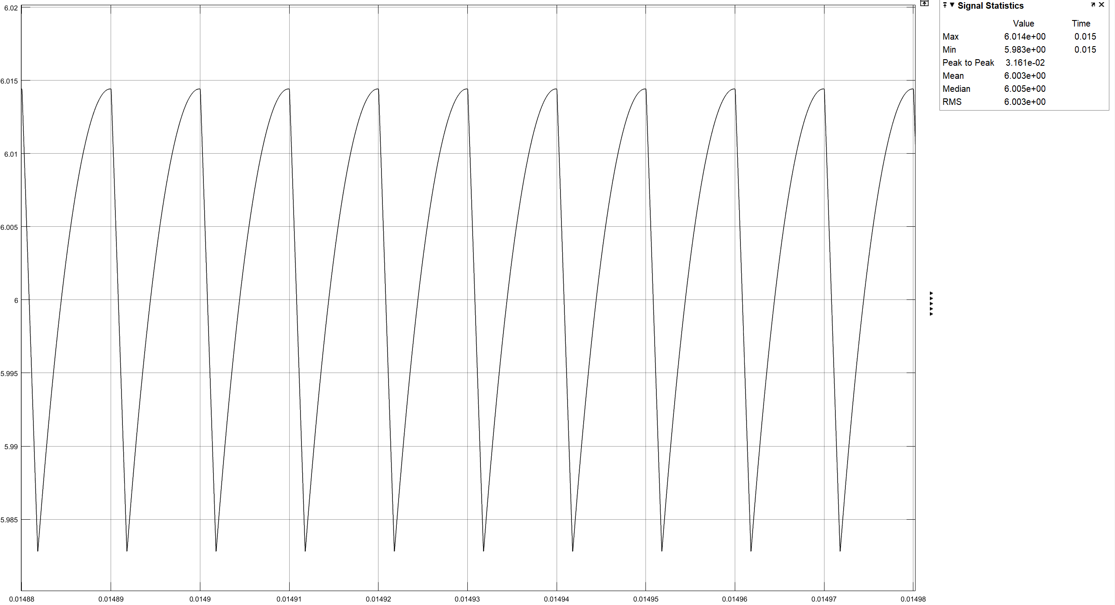

Figure 6: Output current waveform of the flyback converter (Vin=48V)

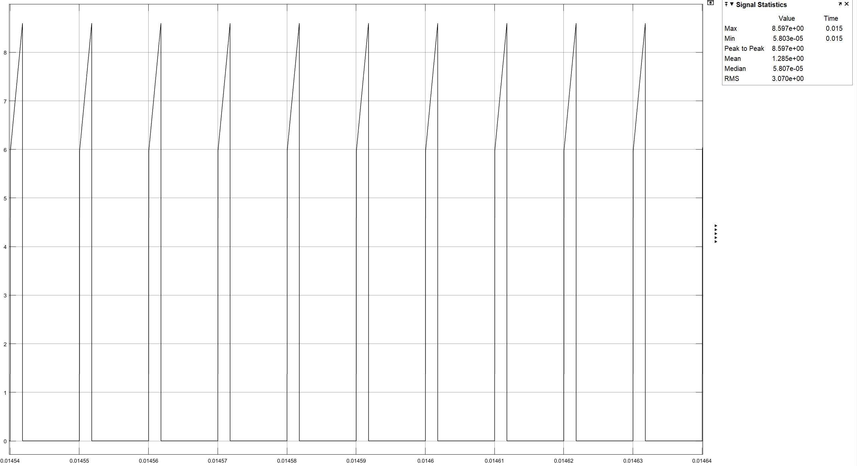

Figure 7: Input current waveform of the flyback converter (Vin=48V)

## Part-b

To adjust the output voltage, we decide to use 1:1 transformer because it also provides a small duty cycle for switching. According to that, duty cycle for 24V input voltage is 29.5% and 17.25% is for 48V input voltage. Below equations shows their calculations.

$$\frac{V_{out}}{V_{in}}=\frac{N_{2}}{N_{1}}*\frac{D}{\left(1-D\right)}$$

$$For V_{in}=24V \frac{10V}{24V}=\frac{1}{1}*\frac{D}{\left(1-D\right)} → D=29.5\%$$

$$For V_{in}=48V \frac{10V}{48V}=\frac{1}{1}*\frac{D}{\left(1-D\right)}→ D=17.25\%$$

To calculate the magnetizing inductance of the transformer we assumed the current ripple of the Lm is 40%. Following equations shows the calculation of the minimum Lm value.

$$∆i_{L}=i_{L}*\left(40\%\right) → ∆i_{L}=\frac{P_{out}}{V_{in}*D}*\left(40\%\right)$$

$$For V_{in}=24V ∆i_{L}=\frac{60}{24V*0.295}*\left(0.4\right)=3.389A$$

$$For V_{in}=48V ∆i_{L}=\frac{60}{48V*0.1725}*\left(0.4\right)=2.898A$$

$$∆i_{L}=\frac{V_{in}*D*T_{s}}{L_{m}}→ L_{m}=\frac{V_{in}*D*T_{s}}{∆i_{L}}$$

$${For V_{in}=24V L}_{m}=\frac{24V*0.295*{10}^{-5}}{3.389A}=20.89µH$$

$${For V_{in}=48V L}_{m}=\frac{48V*0.1725*{10}^{-5}}{2.898A}=28.57µH$$

According to these values we chose the Magnetics-00K4022E090 E-core to decrease the number of turns because its AL value is high compared to the other cores. Following equations shows the number of turns calculation. (To complete the magnetic path, we are planning to use the two E-core which are connected each other. Because of that the AL of the core become half of it.)

$$L_{m}=\left(\frac{A_{L}}{2}\right){{(N}_{1})}^{2} → 28.57µH=\left(\frac{281nH}{2}\right){{(N}_{1})}^{2}→ N_{1}=14.25 turns$$

Number of turns must be integer, so we chose 15 turns. With these turns and this core, magnetizing inductance is:

$$L_{m}=\left(\frac{A_{L}}{2}\right){{(N}_{1})}^{2} → L_{m}=31.61µH$$

Maximum current pass through the transformer is 8.47A, so we chose the AWG-10 cable which can carry maximum 15A. (Area of the cable=5.26mm2 and Resistance=3.276392Ω/km). Copper resistance calculation is shown in the following equations.

$$1 turn circumference=63.8mm \left(from core datasheet\right)$$

$$Total length of the cable of one side=15*63.8mm=957mm$$

$$Total resistance of one side=957mm*\frac{3.276392Ω}{km}=3.1355mΩ$$

To check, can cables fit the core wind area, we calculated the fill factor which is 57%, so all cables can easily fit the window area. Calculation of the fill factor is that:

$$k_{fill-factor}=\frac{N*Cable area}{Window area}*100=\frac{15*(5.26{mm}^{2})}{\left(9.27mm\right)*(14.9mm)}*100=57\%$$

Also, maximum B-field is checked to be sure about core is not saturated while working. Following equations shows that maximum B-field is 0.073T which means that core is not saturated (with the help of a Kool Mµ B-H curve).

$$N*I=B*A*R\left(reluctance\right)$$

$$15*8.47A=B*\left(237*{10}^{-6}{mm}^{2}\right)*\left(7340049.031\right)$$

$$B=0.073T$$

Finally core loss is calculated. Core loss multiplier 300mW/cm3 is given in the datasheet for 100kHz and 0.07T, so;

$$Core Loss=Volume*Core loss multiplier$$

$$Core loss=2*(23300{mm}^{3})*(300mw/{cm}^{3})=13.98W$$

Magnetizing resistance is taken 10kΩ and leakage inductance is taken as 1% of the magnetizing resistance for simulations.

# Reference

* E-Core: <https://www.mag-inc.com/Media/Magnetics/Datasheets/00K4022E090.pdf>
* AWG-10: <https://www.solar-electric.com/learning-center/wiring-cabling/electrical-characteristics-awg-copper-wire.html>
* Kool Mµ B-H curve and core-loss curve: <https://www.mag-inc.com/Products/Powder-Cores/Kool-Mu-Cores/Kool-Mu-Material-Curves>