Corner Grocer Item Tracking Program
Design and Functionality

The Corner Grocer item-tracking program was developed in C++ using Visual Studio 2022. The program reads a daily purchase log file named CS210_Project_Three_Input_File.txt, which lists grocery items purchased throughout the day in chronological order. Upon startup, the program automatically generates a backup file called frequency.dat that stores every item paired with its purchase count, requiring no user intervention.

The program is structured around a class called GroceryTracker, which contains both public and private sections. The public section includes the constructor and three methods that correspond to the menu options: getFrequency(), printAllFrequencies(), and printHistogram(). The private section contains the core data member, a std::map that maps each item name to its purchase frequency, along with three private helper methods: normalise(), which converts user input to Title Case for consistent matching; loadFromFile(), which reads the input file and populates the map; and writeBackupFile(), which writes the accumulated data to frequency.dat.

The program presents a four-option menu loop that runs until the user selects the exit option. Menu Option One prompts the user to enter an item name and returns the number of times that item was purchased. Menu Option Two displays a complete alphabetically sorted list of all items paired with their frequencies. Menu Option Three displays the same data in the form of a text-based histogram, where each item is followed by a number of asterisks equal to its purchase count. Menu Option Four exits the program with a farewell message. Input validation is implemented throughout the menu to handle non-integer input and out-of-range selections gracefully, preventing runtime errors.

Industry standard best practices were applied throughout the code. All variables, parameters, and class members follow clear naming conventions, such as m_frequencyMap for private data members and descriptive method names like printHistogram(). Inline comments are included throughout the code to explain the purpose of each section, method, and logical decision. The use of a std::map data structure ensures that item data is stored and retrieved efficiently, with automatic alphabetical sorting as an added benefit for output readability.

Screenshots of Program Output:
Menu and Option 1 - Single Item Frequency Lookup
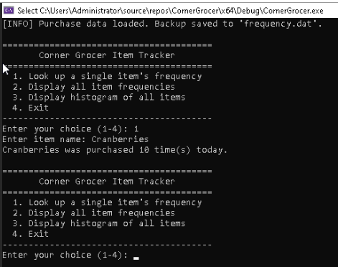

Option 2 - Full Item Frequency List
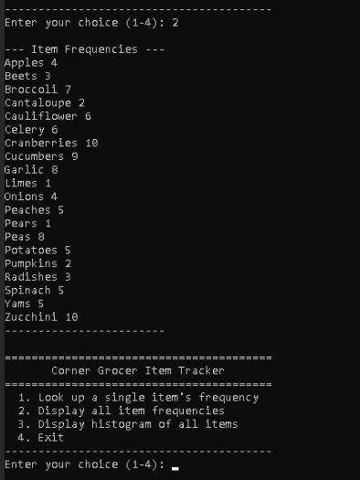
Option 3 - Histogram Output
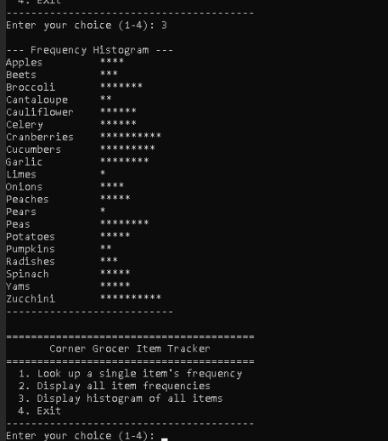

Option 4 - Exit Message
