**Describing mechanism of a serial port**

**Introduction**

Definition of function of a serial port

Serial port is a computer supporting device, which transfers data with one bit at a time. The word serial is used because of this transmission of one bit at a time. Serial port can be known as an interface for information transmission between two devices. This is the opposite of parallel transmission which sends multiple bits at a time. The use of serial ports was high throughout the history of computers.

After parallel transmission devices came into place, the usage of serial ports gradually became less. But even now there are lot of computer devices still use serial ports for data communication since there are many advantages of them. Serial ports can be seen in modems, terminals, networking devices like switches and routers and in many other devices.

Description

Serial ports are gendered. Which means one is a male connector and the other one is the female connector. When we consider about the male connector, it has protruding pins.

Female connectors have round hall sockets relevant to the size of the male connector as shown below.

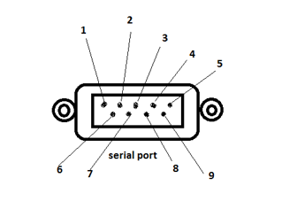

Structure of female connector

**Identification of main parts**

The main component of the port is the cylindrical copper pins that transmit the data. Other than that this has a plastic cover for the safety and two nails to fix the port to the PC.

**Definition and purpose**

|  |  |  |
| --- | --- | --- |
| Pin | Purpose | Signal Name |
| 1 | Data carrier detect | DCD |
| 2 | Received data | RXData |
| 3 | Transmitted data | TxData |
| 4 | Data terminal ready | DTR |
| 5 | Signal ground | Gnd |
| 6 | Data set ready | DSR |
| 7 | Request to send | RTS |
| 8 | Clear to send | CTS |
| 9 | Ring indicator | RI |

**Conclusion**

As described above, serial ports can transmit one bit at a time. So, data transmission speed of a serial port is less than the speed of a parallel transmitting device. Also the serial port is generally the slowest device we can find in a computer (if serial port is present). Modern computers have the USB ports instead of serial ports since we need a much faster transmission. If we want to connect a serial port to a such computer, we need a serial-USB converter. RS-232 is the most widely used standard for serial ports.