Project Name: Analysis

Date: 25th January 2019

By: Sadina jarga magar

Batch: 21’A’

NCC Id: 00170190

1. Functional and non-functional requirements of supermarket management system

|  |  |  |
| --- | --- | --- |
| Functional and Non-functional determination | Requirements | MoSCoW Prioritization |
| F(R1) | Registration for customer | M |
| F(R2) | Login system | M |
| F(R3) | Add category | M |
| F(R4) | Add product | M |
| F(R5) | Update category | M |
| F(R6) | Update product | M |
| F(R7) | Delete category | S |
| F(R8) | Delete product | S |
| F(R9) | View orders | M |
| F(R10) | View feedback | S |
| F(R11) | Order history | S |
| F(R12) | Search a product | M |
| F(R13) | Show stock details | M |
| F(R14) | Generate bill for customer | M |
| F(R15) | Add to shopping cart | M |
| F(R16) | Change password | S |
| NF(R17) | User-friendly interface | M |
| NF(R18) | Usability | S |
| NF(R19) | Maintainability | C |
| F(R20) | Make purchase by customer | M |
| NF(R21) | Website shall be secured from hacker | S |
| NF(R22) | Website shall be backed up | S |
| NF(R23) | Reliable | C |

1. Use-case diagram of supermarket management system

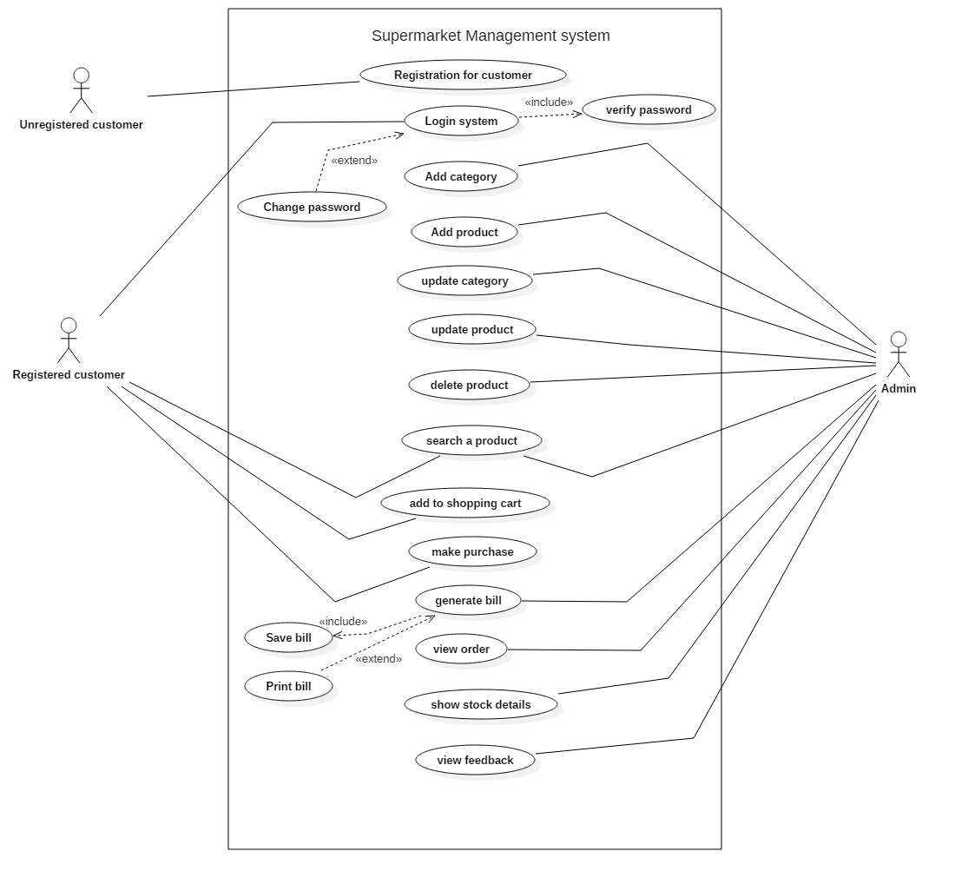

1. Initial class diagram of supermarket management system

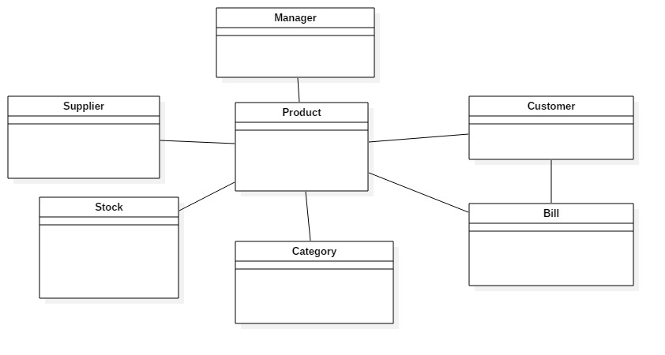

1. ER-diagram of supermarket management system

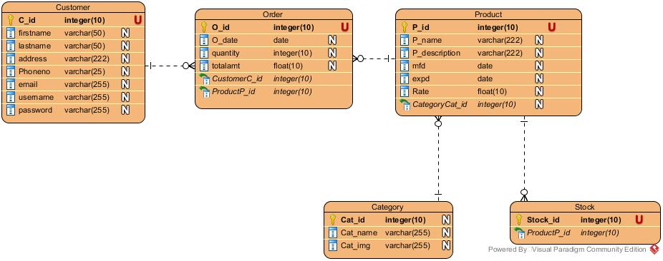

1. UI design of online supermarket.

* Home page

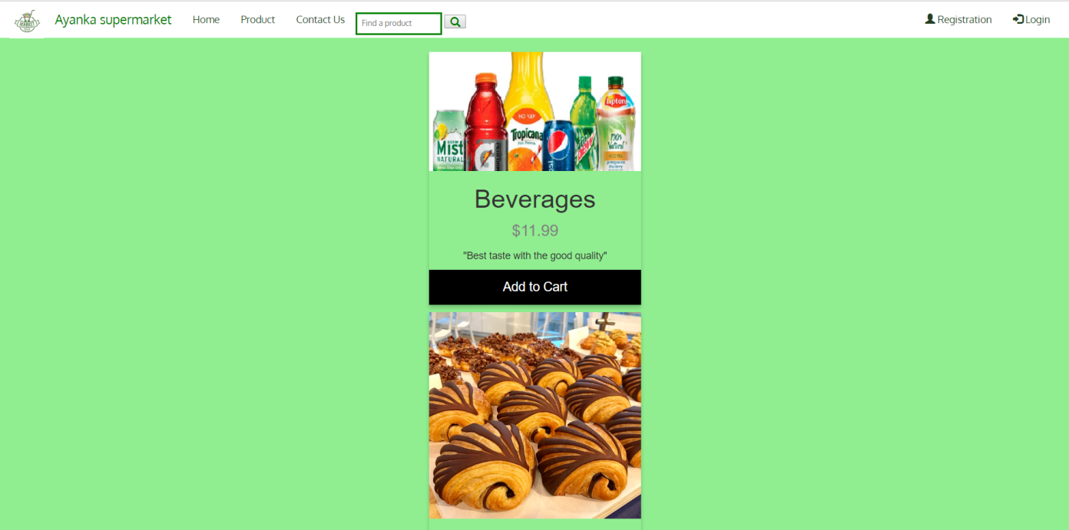

* Registration page

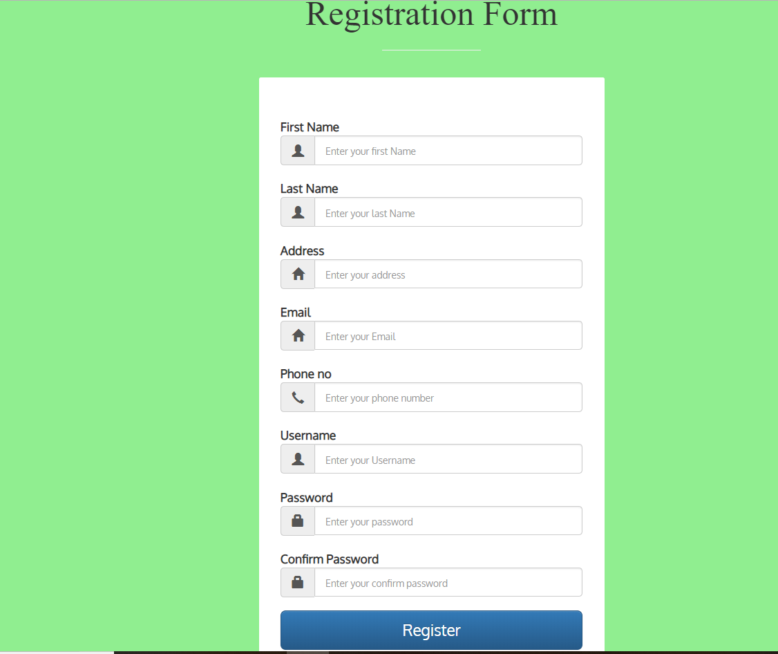

* Login page

