**Project Name:**

**Design phase**

**Date: 13th February 2019**

**By: Sadina jarga magar**

**Batch: 21’A’**

**NCC Id: 00170190**

* Class Diagram

1. Initial class diagram of supermarket management system.

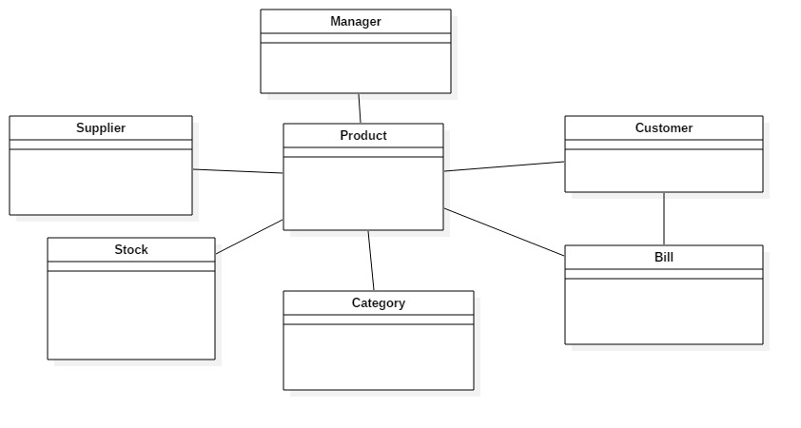

1. Final class diagram of supermarket management system.

* Entity-Relationship Diagram

1. ER- diagram of supermarket management system.

