Project Proposal

On

**Supermarket Management System**

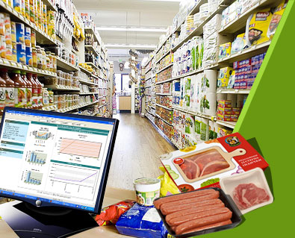

Sadina Jarga Magar

00172909

Computing Project

Level 5 Diploma in Computing

Softwarica College of IT and E-Commerce

Kathmandu , Nepal

4th January 2019

Submitted To : Kiran Rana

Contents

1. Introduction 1

1.1 Project Introduction 1

1.2 Justification for project 1

1.2.1 Background of the project 1

1.2.2 Problem Statement 2

1.3 Description of the project 2

1.3.1 Features 2

2. Project Scope 2

2.1 Scope and Limitation of project 3

2.2 Aims and Objectives 3

3. Development Methodology 4

3.1 Methodology used 4

3.2 Design Pattern 5

3.3 System Architecture 6

4. Work Breakdown Structure (WBS) / Scheduling 7

4.1 Work Breakdown Structure 7

4.2 Milestones 8

4.3 Scheduling / Gantt chart 9

5. Risk Management 11

6. Configuration Management 12

7. Conclusion 14

8. References 14

List of figures

Figure 1: Diagram of waterfall methodology 4

Figure 2: Diagram of MVC design pattern. 5

Figure 3: Diagram of 3-tier architecture. 6

Figure 4: WBS of supermarket management system. 7

Figure 5: Scheduling for supermarket management system project. 10

Figure 6: Gantt chart of supermarket management system project. 10

Figure 7: Screenshot of configuration in Git. 13

Figure 8: Screenshot of configuration in command prompt. 13

# 1. Introduction

## 1.1 Project Introduction

The project is on supermarket management system which is the web-based project. It is easy to manage mini markets as the customers entering the details such as the item in the inventory is too less. Human resource deployment and paper works can even manage effectively to the mini-market but no for the case with big-markets. Supermarket is the place where customers come to purchase their daily using products and pay for that. So there is need to calculate how many products are sold and need to generate the bill for their customers.

## 1.2 Justification for project

### 1.2.1 Background of the project

The supermarket management system is based on the sales transaction of items in a supermarket. Adding the item along with rate in the system is the first activity. The authority for the modification is given to the admin. Any modification has to be done in the item name or in the rate can be done by admin. He also has the right to delete any item. As the customer buys the product and comes to the billing counter, the user is supposed to enter the item name that he wanted to purchase. This is not a huge task. But the system should display the entire items whose name starts with the letter selected by the user. User can select out of those displayed. Finally the bill will be generated for the customer and the data is store in the database. At any time the periodic record can be viewed. Each employee provides unique username and password through which they can login by admin.

The prerequisites for the project are:

* Project libre
* Laravel
* Waterfall methodology

By managing the time, estimating budget, scheduling the task and prioritizing the problems can produce the expected amount of work.

### 1.2.2 Problem Statement

The existing system facing the problems in shopping because it was paper based in small and medium supermarkets. Though it is paper work and less manpower, the existing system was not very economical for the market. All kinds of information are stored such as relevant and irrelevant information in the same place. Which make the process very untidy and clumsy? In case of big supermarkets, the system is some extend computerized but it is not fully automation to cover all the aspects. The data entry, storing and retrieval are very inefficient. There are chances of misplacement and irrelevant information entered. The system is still insecure and not flexible to adapt to user requirements. It was difficult to generate report and the system was not user-friendly.

## 1.3 Description of the project

### 1.3.1 Features

The features of the project are given below:

* Login by admin and cashier.

There is login feature for admin which will allow only admin to access the system.

* Add product

We can add product to our stock.

* Display product

Admin can also view the stock to stay updated.

* Modify product

Update the stock in case wrong input is done.

* Delete product

Stock can be deleted automatically if customer buys the product or incase product is expired.

* Navigation

Navigation allows admin to navigate around the interface.

* Create and print bill

Admin can create bill once customer buys the product and check out from the supermarket. Created bill can be printed.

# 2. Project Scope

## 2.1 Scope and Limitation of project

Project scope is a part of planning and documenting the list of specific project goals, estimating cost, managing tasks and allocating deadlines.

The scope of this project is to provide the full automation of big, small and mini supermarkets by making the system reliable, fast, user-friendly, and informative.

Reducing the paper works, manpower requirements and increase the productivity of the supermarket. User can view the information about the products and can even pay through their mobile itself by using credit cards and debit cards. By using this application, one can add information about products, modify, update, save, delete, print details and give bill to the customers.

The limitation of this project is to require huge capital resources, large and extensive premises, personal attention, service of salesman for the explanation to be given to the purchasers, service like free home delivery, personal guidance are not provided.

## 2.2 Aims and Objectives

**Aims:**

* To manage their staffs, inventories and record of sales and purchase.
* To generate bill for customers.
* To make management system automated.
* Paper work can be reduced by implementing this system.

**Objectives:**

* To always be the first choice of customers.
* Training the entire employee up to international standards and given them awareness about customer relationship management.
* By supporting ISO standard throughout the organization.
* By providing the cheap product as far as possible.
* By providing the best possible services.
* By providing the high quality and trend basics at value for money prices.
* By analyzing and measuring the business trends; develop and apply plans to increase sales and accomplish the goals and objectives.
* By not compromising on the rules and regulations.
* By taking the feedback from the customers.

# 3. Development Methodology

## 3.1 Methodology used

I will be using waterfall methodology. It is a project management methodology depends on a sequential design process; it finishes on stage before another stage can begin.

Waterfall methodology will be using by the following given below reasons:

* It enables to find error early in the requirement analysis stage.
* It is easier to keep on budget.
* Due to the rigidity of the model each stage has certain deliverables and a review process which make easier to manage.
* In this model, stages do not overlap. There stages are processed and completed one at a time.

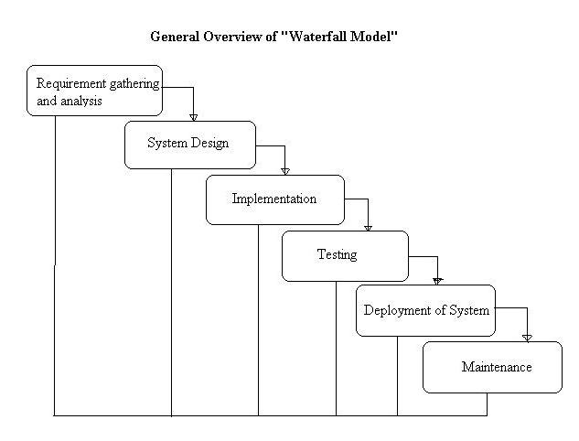

Figure 1: Diagram of waterfall methodology

## 3.2 Design Pattern

I will be using be using MVC design pattern and laravel framework in the project is a pattern which contains three folders i.e. model, view and controller that is used to separate application’s regard.

Laravel is a new generation web framework which follows the MVC architectural pattern. This framework helps to build application easily and whenever we create web-application or website it prevents re-writing the code each time.

M(Model) – It shows the functionality of the application.

V(View) - Deals with the interface. User can view the interface of the system.

C(Controller) – It handles the user interaction.

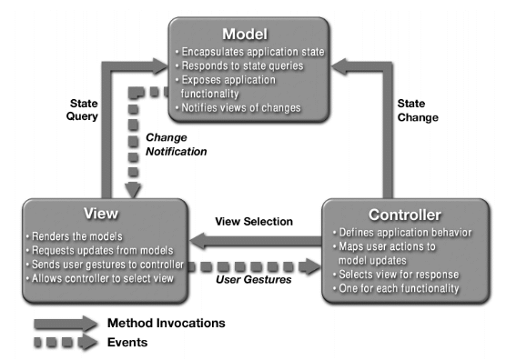

Figure 2: Diagram of MVC design pattern

## 3.3 System Architecture

I will be using 3-tier architecture in this project.

3-tier architecture is a software design pattern from client-server architecture in which client system handles presentation layer, application server handles application layer and server handles database layer. It has the ability to use new technology as they become available and ready to adopt and for the future.

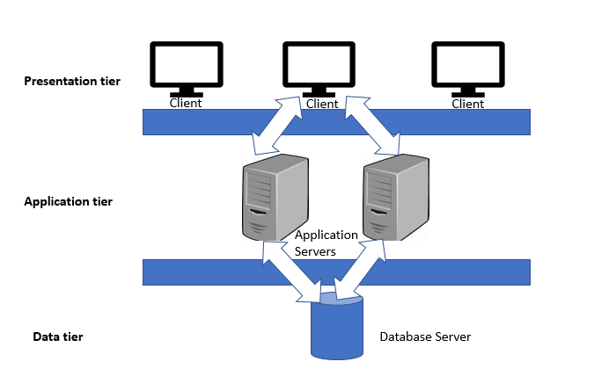

Figure 3: Diagram of 3-tier architecture.

# 

# 4. Work Breakdown Structure (WBS) / Scheduling

## 4.1 Work Breakdown Structure

Work breakdown structure in project management is a technique for solving the complex or multi-step project. It has two tasks:

* Summary tasks

It is consider as higher level tasks that abstract project work which illustrate each task process of the project including.

* Work packages

It is consider as lower level tasks that elucidate the details of the work that needs to be done.

WBS will be done by the following given below reasons:

* It is easier to estimate time and budget.
* It is easier to allocate work.
* It helps to measure progress by building checkpoint into our projects.
* It focuses on planning in the early phase.

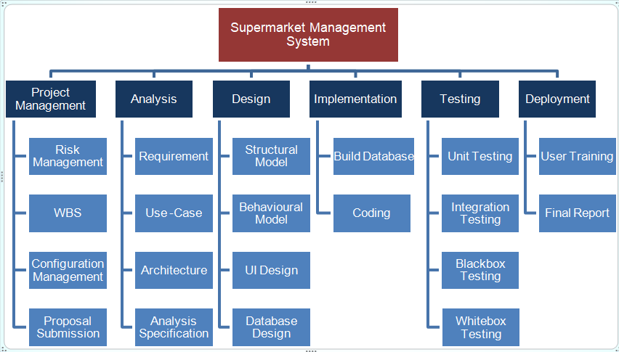

Figure 4: WBS of supermarket management system.

## 4.2 Milestones

|  |  |
| --- | --- |
| **Milestones** | **Date** |
| **Project Management**  Risk Management  WBS  Configuration Management  Proposal Submission | 12/21/18 to 1/3/19  12/21/18 to 12/26/18  12/27/18 to 12/29/18  12/30/18 to 1/2/19  1/3/19 to 1/3/19 |
| **Analysis**  Requirement  Use-Case  Architecture  Analysis specification | 1/4/19 to 1/28/19  1/4/19 to 1/14/19  1/15/19 to 1/18/19  1/19/19 to 1/24/19  1/25/19 to 1/28/19 |
| **Design**  Structural Model  Behavioral Model  UI Design  Database Design | 1/29/19 to 2/27/19  1/29/19 to 2/2/19  2/3/19 to 2/7/19  2/8/19 to 2/18/19  2/19/19 to 2/27/19 |
| **Implementation**  Building Database  Coding | 2/28/19 to 3/ 31/ 19  2/28/19 to 3/4/19  3/5/19 to 3/31/19 |
| **Testing**  Unit Testing  Integration Testing  Blackbox Testing  Whitebox Testing | 4/1/19 to 4/10/19  4/1/19 to 4/4/19  4/5/19 to 4/6/19  4/7/19 to 4/8/19  4/9/19 to 4/10/19 |
| **Deployment**  User Training  Final Report | 4/11/ 19 to 4/20/19  4/11/19 to 4/18/19  4/19/19 to 4/20/19 |

**Description of Milestones:**

* **Project management:** for this task, I have allocated total 14 days. I have even allocated in sub-tasks. 6 days for risk management, 3 days for WBS, 4 days for configuration management and 1 day for proposal submission.
* **Analysis:** for this task, I have allocated total 25 days. Even allocated in sub-tasks.11 days for requirement, 4 days for use-case, 6 days for architecture, and 4 days for analysis specification.
* **Design:**  for this task, I have allocated total 30 days. I have even allocated in sub-tasks. 5 days for structural model, 5 days for behavioral model, and 11 days for UI design and 9 days for database design.
* **Implementation:** for this task, I have allocated total 32 days. I have even allocated in sub-tasks. 5 days for build database and 27 days for coding.
* **Testing:** for this task, I have allocated total 10 days. I have even allocated in sub-tasks. 4 days for unit testing, 2 days for integration testing, 2 days for Blackbox testing and 2 days for Whitebox testing.
* **Deployment:** for this final task, I have allocated total 10 days. Even allocated in sub-tasks.8 days for user training and 2 days for final report.

## 4.3 Scheduling / Gantt chart

The method of arranging, controlling and optimizing the work is known as scheduling.

Scheduling is very important because it is the planning activity which helps to achieve the goals and a well work-life balance and make the priorities to the available time.

Gantt chart is a graphical representation of a schedule which enables to plan, coordinate and track a milestone in a project. To create Gantt chart, we can use any project management application such as excel, project libre, Microsoft project etc. but I have used project libre to create scheduling and Gantt chart.

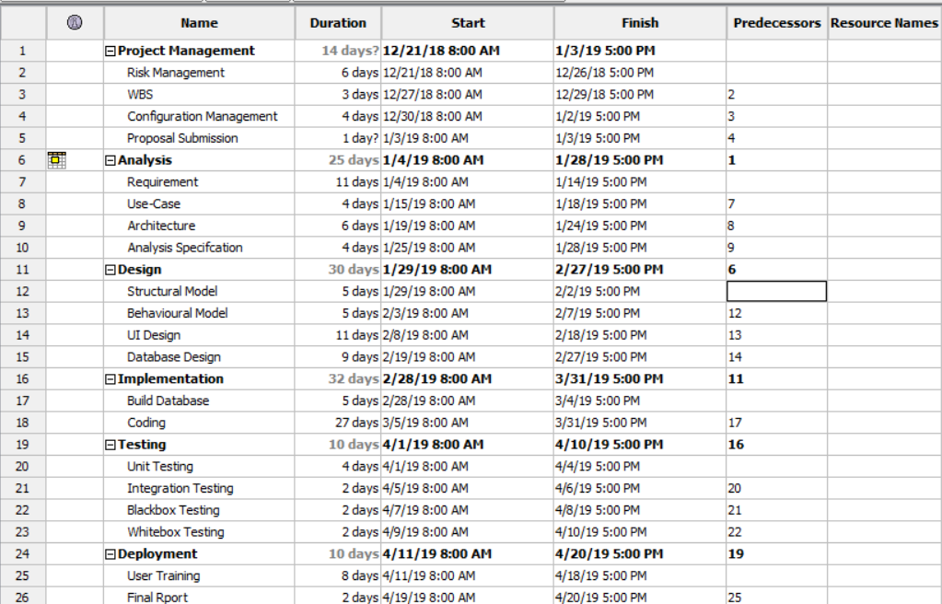

Figure 5: Scheduling for supermarket management system project.

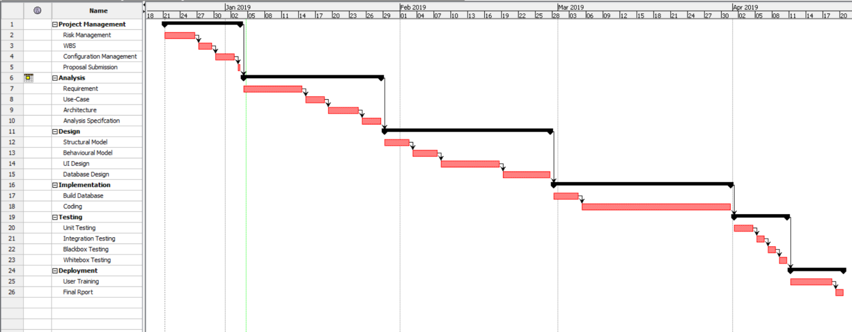 Figure 6: Gantt chart of supermarket management system project.

# 5. Risk Management

The way of identifying the potential risks, analyzing, and responding to them with the benefits of the objectives is called risk management.

Right risk management enables to reduce not only the possibility of upcoming events but also the magnitude of its impact.

The objective of risk management is given below:

* To identify the possible potential risks.
* To reduce risk.
* For the plan.

Risk can be controlled by using the four basic ways:

* Avoid: Avoiding is the best part we can do. If you prevent the risk then it definitely won’t harm your project and can walk away from the cliff.
* Mitigate: we can mitigate it, if we can’t avoid the risk. This means taking the some sorts of actions that may cause little harm to our project.
* Transfer: paying someone else to accept that risk such as buy insurance.
* Accept: when we can’t avoid, mitigate or transfer a risk then accepting is the best way. If we accept a risk then we have to looked alternatives at least and reduce its impact.

Impact = Likelihood * Consequence

Risk Likelihood values are shown as follows

|  |  |
| --- | --- |
| Likelihood | Value |
| Low | 1 |
| Medium | 2 |
| High | 3 |

Risk Consequence values are shown below

|  |  |
| --- | --- |
| Consequence | Value |
| Very low | 1 |
| Low | 2 |
| Medium | 3 |
| High | 4 |
| Very High | 5 |

|  |  |  |  |  |  |
| --- | --- | --- | --- | --- | --- |
| S. No | Risks | Likelihood | Consequences | Impact | Solution |
| 1 | Lack of resources | 2 | 4 | 8 | Involved the team in more planning and estimating. |
| 2 | Failure of hard disk | 1 | 5 | 5 | Back-up your data in external devices such as pen-drive, hard-drive or cloud. |
| 3 | Sudden growth in requirement | 2 | 4 | 8 | Continuous involvement of customers and developers. |
| 4 | Employee turnover | 1 | 3 | 3 | Share information and increase collaboration on the team. |
| 5 | Poor productivity | 2 | 5 | 10 | Right people on team, coaching, team development and short iterations. |
| 6 | Compromising on designs | 2 | 4 | 8 | Take the time and develop a good design. |
| 7 | Specification breakdown | 3 | 3 | 9 | Use a dutiful product manager to make critical trade off conclusions. |
| 8 | Lack of time management | 2 | 4 | 8 | We should keep on track of the work that we have done from the beginning. |

# 6. Configuration Management

Configuration management is the method for establishing, managing and maintaining items or the product’s performance during the project life cycle. It is also known as version control. It can improve the system change impact analysis.

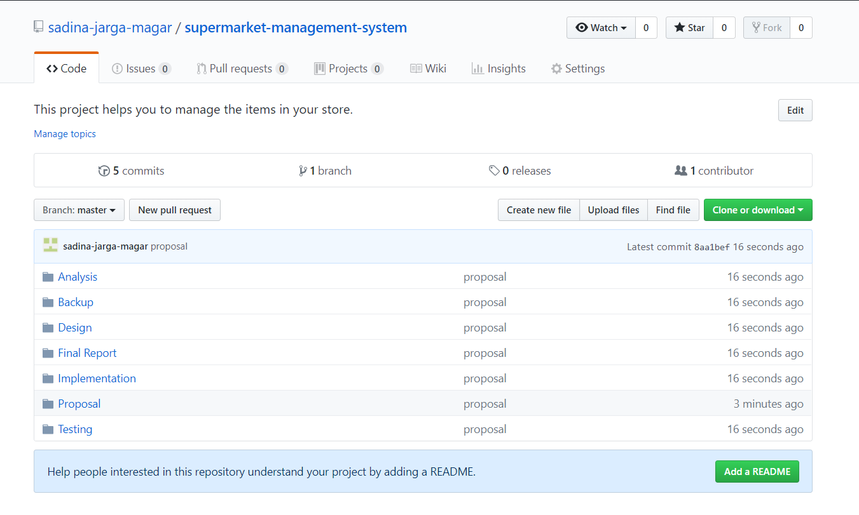

Figure 7: Screenshot of configuration in Git.

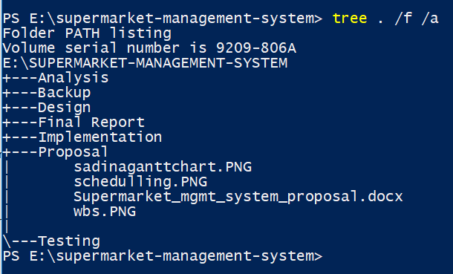

Figure 8: Screenshot of configuration in command prompt.

# 7. Conclusion

The conclusion of this project is useful for big supermarkets as well as small supermarket to manage their staffs, inventories and record of sales and purchase. To be adaptive into the system so that it is easy to change the user’s requirement in the supermarket. To make the management system automated.

# 8. References

* <https://www.codewithc.com/supermarket-management-system-vb-net-project/>

(Accessed on 23rd December)

* <https://www.ukessays.com/essays/environmental-studies/goals-and-objectives-of-power-supermarkets.php>

(Accessed on 25th December)

* <https://www.techopedia.com/definition/24649/three-tier-architecture>

(Accessed on 1st January)