INNOVATIVE PROJECT DEVELOPMENT REPORT
CLIMATE CHANGE PREDICTION THROUGH TEMPERTURE CHANGE BY ML
Submitted by

S.SAISRI | M.SAI TANMAI | S.SAITEJASWINI | P.MANOGNA
(22RH5A0228) | (21RH1A0220) | (22RH5A0229) | (21RH1A0221)

Under the Esteemed Guidance of

DR. S

Assistant Professor
In partial fulfillment of the Academic Requirements for the Degree of

BACHELOR OF TECHNOLOGY

Electrical & Electronics Engineering


MALLA REDDY ENGINEERING COLLEGE FOR WOMEN
(Autonomous Institution-UGC, Govt. of India)
Accredited by NBA& NAACwith ‘A’ Grade, UGC, Govt. of India
NIRF Indian Ranking–2018, Accepted by MHRD, Govt. of India Permanently Affiliated to JNTUH, Approved by AICTE, ISO 9001:2015 Certified Institution
AAAA+ Rated by Digital Learning Magazine, AAA+ Rated by Careers 360 Magazine,
6th ank CSR, Platinum Rated by AICTE-CII Survey, Top 100 Rank band by ARIIA, MHRD, Govt. of India
National Ranking-Top 100 Rank band by Outlook, National Ranking-Top 100 Rank band by Times News
Magazine
Maisammaguda, Dhullapally, Secunderabad, Kompally-500100
2023-2024

MALLA REDDY ENGINEERING COLLEGE FOR WOMEN

(Autonomous Institution-UGC, Govt. of India)

Accredited by NBA& NAAC with ‘A’ Grade, UGC, Govt. of India
NIRF Indian Ranking–2018, Accepted by MHRD, Govt. of India Permanently Affiliatto JNTUH,

Approved by AICTE, ISO 9001:2015 Certified Institution

AAAA+ Rated by Digital Learning Magazine, AAA+ Rated by Careers 360 Magazine,
6th Rank CSR, Platinum Rated by AICTE-CII Survey, Top 100 Rank band byARIIA, MHRD, Govt. of India
National Ranking-Top 100 Rank band by Outlook, National Ranking-Top 100 Rank band by Times
New Magazine Maisammaguda , Dhullapally , Secunderabad , Kompally-500100

DEPARTMENT OF ELECTRICAL & ELECTRONICS ENGINEERING
CERTIFICATE
This This is to certify that the Project work entitled “CLIMATE CHANGE PREDICTION THROUGH TEMPERTURE CHANGE BY ML” is carried out by S.SAISRI (22RH5A0228), M.SAITANMAI (21RH1A0220), S.SAITEJASWINI (22RH5A0229), P,MANOGNA(21RH1A0221) in
partial fulfillment for the award of degree of BACHELOR OF TECHNOLOGY in Electrical & Electronic Engineering, Malla Reddy Engineering College For Women (Autonomous), Hyderabad during the academic year 2023-2024.

Supervisor’s Signature Head of the Department
Mr.K.Obulesh Dr.VIJAYA MADHAVI
Assistant Professor Professor and HOD

EXTERNAL EXAMINER

ACKNOWLEDGEMENT

We feel ourselves honored and privileged to place our warm salutation to our college Malla Reddy Engineering College for Women and Department of Electrical and Electronics Engineering which gave us the opportunity to have expertise in engineering and profound technical knowledge.

We wish to convey gratitude to our Principal Dr. Y. Madhavee Latha, for providing us with the environment and mean to enrich our skills and motivating us in our endeavour and helping us to realize our full potential.

We would like to thank Prof. A. Radha Rani, Director of Computer Science and Engineering & Information Technology for encouraging us to take up a project on this subject and motivating us towards the Project Work.

We express my sincere gratitude to Dr. Vijaya Madhavi, Head of the Department of Electrical and Electronics Engineering for inspiring us to take up a project to this subject and successfully guiding us towards its completion.

We would like to thank our internal guide Mr. K.Obulesh , Assistant Professor and all the Faculty members for their valuable guidance and encouragement towards the completion of our project work.

With regards and gratitude,
S.SAISRI (22RH5A0228)
M.SAI TANMAI (21RH1A0220) S.SAITEJASWINI (22RH5A0229)
P.MANOGNA (21RH1A0

MALLA REDDY ENGINEERING COLLEGE FOR WOMEN


(Autonomous Institution-UGC, Govt. of India)
Accredited by NBA & NAAC with‘A’ Grade
UGC, Govt. ofIndia NIRF Indian Ranking–2018, Accepted by MHRD, Govt. of India Permanently Affiliated to JNTUH,Approved by AICTE, ISO 9001:2015 Certified Institution AAAA+ Rated by Digital Learning Magazine, AAA+ Rated by Careers 360 Magazine, 6th Rank CSR, Platinum Rated by AICTE-CII Survey, Top 100 Rank band by ARIIA, MHRD,Govt. of India National Ranking-Top 100 Rank band by Outlook, National Ranking-Top 100 Rank band by TimesNews Magazine Maisammaguda, Dhullapally, Secunderabad, Kompally-500100

DEPARTMENT OF ELECTRICAL AND ELECTRONICS ENGINEERING

DECLARATION

We hereby declare that our project entitled “CLIMATE CHANGE PREDICTION THROUGH TEMPERTURE CHANGE BY ML” submitted to Malla Reddy Engineering College for Women, Hyderabad for the award of the Degree of Bachelor of Technology in Electrical and Electronics Engineering is a result of original research work done by us.
It is declared that the project report or any part there of has not been previously submitted to any University or Institute for the award of Degree.

S.SAISRI (22RH5A0228)
M.SAI TANMAI(21RH1A0220) S.SAITEJASWINI(22RH5A0229)
P.MANOGNA(21RH1A0221)

ABSTRACT

This machine learning project focuses on predicting climate change through the analysis of temperature changes. By leveraging historical temperature data, advanced machine learning algorithms are applied to construct models capable of forecasting future temperature trends. The project places particular emphasis on optimizing prediction accuracy through thoughtful feature engineering, meticulous model selection, and rigorous validation techniques.
The process begins with the collection of extensive temperature data, serving as the foundation for the machine learning algorithms. Feature engineering involves selecting pertinent aspects of the temperature data to enhance the model's understanding of influential factors. The choice of the most suitable machine learning model is a critical decision, ensuring that the algorithm aligns with the intricacies of temperature change patterns. Validation procedures are implemented to assess the model's effectiveness in extrapolating beyond known data, confirming its ability to make accurate predictions for unseen scenarios. This project's significance lies in its potential to offer valuable insights into evolving climate patterns, empowering decision-makers with tools to anticipate and respond to future environmental changes proactively. By bridging the realms of climate science and machine learning, this endeavor contributes to a more comprehensive understanding of climate change dynamics. Ultimately, the project strives to equip stakeholders with actionable information, fostering a proactive approach to climate mitigation and adaptation strategies.

INDEX

TITLE | PAGE NO.
INTRODUCTION | 1
Introduction about the project | 1
Existing System | 2
Proposed System | 2
2. REQUIREMENT ANALYSIS | 4
Requirement Specification | 4
Languages used to Develop | 5
3. IMPLEMENTATION METHODOLY | 6
Data Collection | 6
Pre processing | 8
Decision Tree | 8
4.SYSTEM DESIGN | 8
Use case Diagram | 8
Class Diagram | 9
Sequence Diagram | 9
Activity Diagram | 10
5.MODULES | 11
6.ALGORITHMS | 12
Source code | 13
Source code | 13
7.SYSTEM TEST | 14
Types of Tests | 18
8.INPUT AND OUTPUT DESIGN | 19
Input and Output Design and Screens | 21
9.CONCLUSION | 22
10.FUTURE SCOPE | 23
11.REFERENCE | 24

CHAPTER 1

INTRODUCTION ABOUT THE PROJECT

Climate change poses a significant threat to our planet, necessitating proactive measures for understanding and mitigating its impact. In this project, we employ machine learning to predict climate change by examining changes in temperature. Imagine looking into the future of our environment – that's exactly what this endeavor aims to achieve. To kick things off, we gather historical temperature data. This data serves as the foundation for our machine learning algorithms. Think of these algorithms as smart assistants that can learn from the past to make predictions about the future. They analyze patterns and trends in the temperature data to identify how our climate is evolving. A crucial step in our project is feature engineering. Don't let the term intimidate you; it simply means selecting the right aspects of the temperature data to focus on. It's like picking the most important ingredients for a recipe – we want our algorithms to concentrate on the elements that truly influence temperature changes. Next up, we choose the best machine learning model for the job. Think of this as selecting the right tool for a specific task. Different algorithms have strengths and weaknesses, so we want to pick the one that's most effective for predicting temperature changes. This ensures our predictions are as accurate as possible. Validation is another vital part of the process. We need to make sure our machine learning model is not just memorizing the past data but can actually make smart predictions for new, unseen data. It's like testing a student to see if they truly understand the material rather than just memorizing answers. Now, let's talk about why this project matters. Predicting climate change through temperature analysis is like having a crystal ball for the environment. By understanding how temperatures are likely to change in the future, we can take steps to prepare and protect our planet. It's a bit like knowing it will rain tomorrow, so you bring an umbrella – but on a global scale. Imagine governments, scientists, and communities having a tool that helps them plan for extreme weather events, rising sea levels, or shifts in agricultural patterns. Our machine learning system becomes a guide for decision-makers, enabling them to make informed choices to safeguard our environment.

EXISTING SYSTEM

The enhancement in the banking sector lots of people are applying for bank loans but the bank has its limited assets which it has to grant to limited people only, so finding out to whom the loan can be granted which will be a safer option for the bank is a typical process. In existing process, they are use random forest, logistic regression algorithm in loan approval system. But the efficiency and accuracy was pretty low. Already banks are provide online transaction system, online bank account opening system, etc,. But there is no loan approval system in the banking sector. Then now we create a new system for loan approval. So now we move on to the proposed system.

PROPOSED SYSTEM
The proposed system for climate change prediction using machine learning aims to improve data quality, use advanced models, provide interpretability, adapt to changing conditions, and mitigate bias.
ADVANTAGES OF PROPOSED SYSTEM
    - 1. Improved Accuracy: Rigorous data cleaning and advanced modeling techniques enhance the accuracy of temperature predictions, providing more reliable insights into climate change patterns.
    - 2. Enhanced Robustness: The adoption of ensemble methods strengthens the predictive models, reducing the risk of overfitting and improving their ability to generalize to new data.
    - 3. Interpretability: Prioritizing transparent models ensures that users can easily understand how predictions are generated, fostering trust and facilitating informed decision-making.
    - 4. Adaptability: Continuous learning mechanisms enable the system to adapt to changing climate conditions over time, ensuring relevance and effectiveness in dynamic environmental scenarios.
    - 5. Bias Mitigation: Strategies to identify and mitigate biases contribute to fairer predictions, addressing concerns related to the equitable treatment of different populations and regions.

CHAPTER 2 REQUIREMENT ANALYSIS
INTRODUCTION
The requirement analysis for this project involves a meticulous examination of the essential components and functionalities needed to fulfill its objectives. To embark on a successful correlation analysis of attributes, we must first understand the overarching goals and scope of the project. This entails defining the specific attributes within the dataset that are of interest and relevance. Additionally, identifying the key stakeholders and their expectations is crucial for tailoring the analysis to meet their needs. The introduction phase also involves a comprehensive exploration of the data sources, ensuring a diverse and representative dataset for meaningful insights. Clear documentation of any constraints, such as budget, time, or data availability, is imperative for setting realistic expectations. Ultimately, the introduction lays the foundation for a comprehensive understanding of the project's context, guiding subsequent phases of the requirement analysis toward a successful and impactful correlation analysis of attributes.

REQUIREMENT SPECIFICATIONS SOFTWARE REQUIREMENTS:
For developing the applications the following are the software Requirements :

Operating System:


Windows 10
Windows 11

Technologies and Languages used to Develop
Python

HARDWARE REQUIREMENTS:

For developing the application the following are the Hardware Requirements :
- System : Pentium Dual core.

- Hard Disk : 120 GB.

- Input Device: Keyboard, Mouse.

- Ram : 4 GB.

PYTHON:

Python is a general-purpose interpreted, interactive, object-oriented ,and high- level programming language. An interpreted language, Python has design philosophy that emphasizes code readability (notably using whitespace indentation to delimit code blocks rather than curly brackets or keywords), and a syntax that allows programmers to express concepts in fewer lines of code than might be used in languages such as C++or Java. It provides constructs that enable clear programming on both small and large scales. Python interpreters are available for many operating systems.

CHAPTER 3
IMPLEMENTATION METHODOLY
Data Collection:
The dataset for climate change prediction is foretold into Training set and testing set. The data model which was created using Linear Regression is applied on the training set and hung on the test take fineness, Test set forecasting is done. Following are the attributes:

Preprocessing:
The collected data may contain missing values that may lead to inconsistency. To gain better results data need to be preprocessed and so it'll better the effectiveness of the algorithm. We should remove the outliers and we need to convert the variables. In order to flooring these issues we use chart function.
Train model on training data set:
Now we should train the model on the training dataset and make sooth sayings for the test dataset. We can divide our train dataset into two tract train and testimony. We can train the model on this training part and using that make sooth sayings for the testimony part. In this way, we can validate our sooth sayings as we've the true sooth sayings for the testimony part (which we don't have for the test dataset)
Correlating attributes:
The project involves establishing correlations between different attributes within a dataset. Using statistical methods and machine learning techniques, the goal is to uncover relationships and dependencies among variables. This correlation analysis can provide valuable insights into how changes in one attribute might influence or be influenced by changes in another.
Predicting the outcomes:
Using decision tree algorithm, the outcomes of all applicant can be stored in any file. Algorithm:
1. Import all the required python modules
2. Import the database for both TESTING and TRAINING.
3. Check any NULLVALUES are exists
4. If NULLVALUES exits ,fill the table with corresponding coding
5. Exploratory Data Analysis for all ATTRIBUTES from the table
6. Plot all graphs using MATPLOTLIB module
7. Build the DECISIONTREE MODEL for the coding
8. Send that output to CSV FIL

CHAPTER 4

SYSTEM DESIGN
USE CASE DIAGRAM:
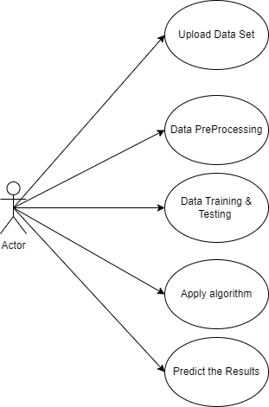
Fig 4.1 Use Case Diagram
CLASS DIAGRAM :
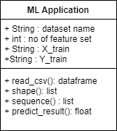
Fig 4.2 Class Diagram

SEQUENCE DIAGRAM:
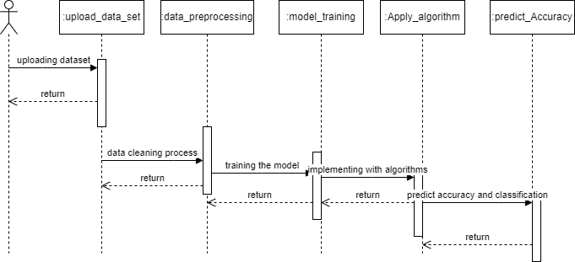

Fig 4.3 Sequence Diagram

ACTIVITY DIAGRAM:
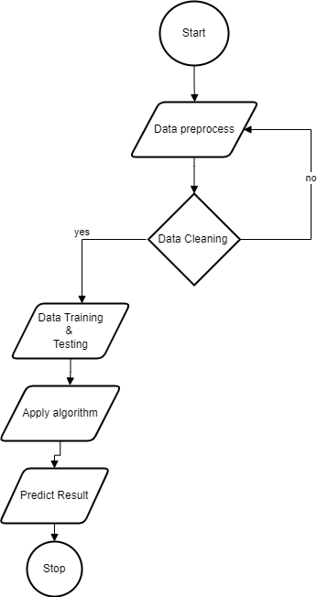



Fig 4.4 Activity Diagram

CHAPTER 5

MODULES
⮚ Data collection
⮚Machine Learning Algorithm
⮚ Prediction
MODULE EXPLANATION:
Dataset collection:
Dataset is collected from the kaggle.com. That dataset have some value like Date, Average Temperature, Average Temperature Uncertainty, City, Country, Latitude, Longitude Dataset has the information, the climate change depends upon the dataset information. That data well be preprocessed and proceed to the next step.
Machine learning Algorithm: In this stage, the collected data will be given to the machine algorithm for training process. We use Linear Regression algorithms to get high accuracy range of prediction. A preprocessed dataset are processed in machine learning algorithm. The algorithm gives some accuracy level.
✔ Linear Regression

CHAPTER 6
ALGORITHM

from flask import Flask, request, render_template
import os
import pickle
import numpy as np

app = Flask(_name_)

with open('model.pkl', 'rb') as file:
model = pickle.load(file)

@app.route("/")
def f():
return render_template("index.html")

@app.route("/inspect")
def inspect():
return render_template("inspect.html")

@app.route("/output", methods=["GET", "POST"])
def output():
if request.method == 'POST':
# Ensure that the form data is converted to appropriate data types
try:
var1 = float(request.form["dt"])
var2 = float(request.form["AverageTemperature"])
var3 = float(request.form["City"])
var4 = float(request.form["Country"])
var5 = float(request.form["Latitude"])
var6 = float(request.form["Longitude"])

# Convert the input data into a numpy array
predict_data = np.array([var1, var2, var3, var4, var5, var6]).reshape(1, -1)

# Use the loaded model to make predictions
predict = model.predict(predict_data)
print(predict)

except ValueError:
# Handle the case where form data cannot be converted to numeric types
return render_template('output.html', predict="Error: Invalid input data")

return render_template("output.html",predict = 'Predicted Average Temperture Uncertinity is' + ' ' +str(predict))

if _name_ == "_main_":
app.run(debug=False, port=1111)

CHAPTER 7

SYSTEM TEST

The purpose of testing is to discover errors. Testing is the process of trying to discover every conceivable fault or weakness in a work product. It provides a way to check the functionality of components, sub-assemblies, assemblies and/or a finished product It is the process of exercising software with the intent of ensuring that the Software system meets its requirements and user expectations and does not fail in an unacceptable manner. There are several types of tests. Each test type addresses a specific testing requirement.

TYPES OF TESTS

Unit testing
Unit testing involves the design of test cases that validate that the internal program logic is functioning properly, and that program inputs produce valid outputs. All decision branches and internal code flow should be validated. It is the testing of individual software units of the application. It is done after the completion of an individual unit before integration. This is a structural testing, that relies on knowledge of its construction and is invasive. Unit tests perform basic tests at component level and test a specific business process, application, and/or system configuration. Unit tests ensure that each unique path of a business process performs accurately to the documented specifications and contains clearly defined inputs and expected results.

Integration testing
Integration tests are designed to test integrated software components to determine if they run as one program. Testing is event driven and is more concerned with the basic outcome of screens or fields. Integration tests demonstrate that although the components were individually satisfaction, as shown by successfully unit testing, the combination of components is correct and consistent. Integration testing is aimed at exposing the problems arising from the combination of components.

Functional test
Functional tests provide systematic demonstrations that functions tested are available as specified by the business and technical requirements, system documentation, and

user manuals.

Functional testing is centered on the following items: Valid Input: identified classes of valid input must be accepted.
Invalid Input: identified classes of invalid input must be rejected. Functions: identified functions must be exercised.
Output: identified classes of application outputs must be exercised. Systems/Procedures: interfacing systems or procedures must be invoked.
Organization and preparation of functional tests is focused on requirements, key functions, or special test cases. In addition, systematic coverage pertaining to identify Business process flows; data fields, predefined processes, and successive processes must be considered for testing. Before functional testing is complete, additional tests are identified and the effective value of current tests is determined.

System Test
System testing ensures that the entire integrated software system meets

requirements. It tests a configuration to ensure known and predictable results. An example of system testing is the configuration-oriented system integration test. System testing is based on process descriptions and flows, emphasizing pre-driven process links and integration points.
STRUCTURED TEST
Structure Tests are concerned with exercising the internal logic of a program and traversing particular execution paths. The way in which White-Box test strategy was employed to ensure that the test cases could Guarantee that all independent paths within a module have been have been exercised at least once.
⮚ Exercise all logical decisions on their true or false sides.
⮚ Execute all loops at their boundaries and within their operational bounds.
⮚ Exercise internal data structures to assure their validity.
⮚ Checking attributes for their correctness.
⮚ Handling end of file condition, I/O errors, buffer problems and textual errors in output information

INTEGRATION TESTING
Integration testing is a systematic technique for construction the program structure while at the same time conducting tests to uncover errors associated with interfacing. i.e., integration testing is the complete testing of the set of modules which makes up the product. The objective is to take untested modules and build a program structure tester should identify critical modules. Critical modules should be tested as early as possible. One approach is to wait until all 55 the units have passed testing, and then combine them and then tested. This approach is evolved from unstructured testing of small programs. Another strategy is to construct the product in increments of tested units. A small set of modules are integrated together and tested, to which another module is added and tested in combination. And so on. The advantages of this approach are that, interface dispenses can be easily found and corrected.
The major error that was faced during the project is linking error. When all the modules are combined the link is not set properly with all support files. Then we checked out for interconnection and the links. Errors are localized to the new module and its intercommunications. The product development can be staged, and modules integrated in as they complete unit testing .Testing is completed when the last module is integrated and tested

White Box Testing
White Box Testing is a test in which the software tester has knowledge of the inner workings, structure, and language of the software, or at least its purpose. It is the purpose. It is used to test areas that cannot be reached from a black box level.
Basis path testing:
⮚ Flow graph notation
⮚ Cyclometric complexity
⮚ Deriving test cases
⮚ Graph matrices Control

Black Box Testing
Black Box Testing is testing the software without any knowledge of the inner workings, structure or language of the module being tested. Black box tests, like most other kinds of tests, must be written from a definitive source document, such as specification or
requirements document, such as specification or requirements document.
It is a test in which the software under test is treated as a black box.
The test provides inputs and responds to outputs without considering how the software works.
The steps involved in black box test case design are:
⮚ Graph based testing methods
⮚ Equivalence partitioning
⮚ Boundary value analysis
⮚ Comparison testing

Unit Testing

Unit testing is usually conducted as part of a combined code and unit test phase of the software lifecycle, although it is not uncommon for coding and unit testing to be conducted as two distinct phases.

Test strategy and approach

Field testing will be performed manually, and functional tests will be written in detail.

Test objectives
- All field entries must work properly.
- Pages must be activated from the identified link.
- The entry screen, messages and responses must not be delayed.

Features to be tested

- Verify that the entries are of the correct format
- No duplicate entries should be allowed
- All links should take the user to the correct page.

SECURITY TESTING:

Security testing attempts to verify the protection mechanisms built in to a system well, in fact, protect it from improper penetration. The system security must be tested for invulnerability from frontal attack must also be tested for invulnerability from rear attack. During security, the tester places the role of individual who desires to penetrate system

Integration Testing
Software integration testing is the incremental integration testing of two or more integrated software components on a single platform to produce failures caused by interface defects.
The task of the integration test is to check that components or software applications, e.g., components in a software system or – one step up – software applications at the company level
– interact without error.

Test Results:
All the test cases mentioned above passed successfully. No defects encountered.

Acceptance Testing

User Acceptance Testing is a critical phase of any project and requires significant.

CHAPTER 8

INPUT AND OUTPUT DESIGN

INPUT:

Data Collection:
Data Cleaning and Preprocessing:
Exploratory Data Analysis (EDA):
Data Splitting:

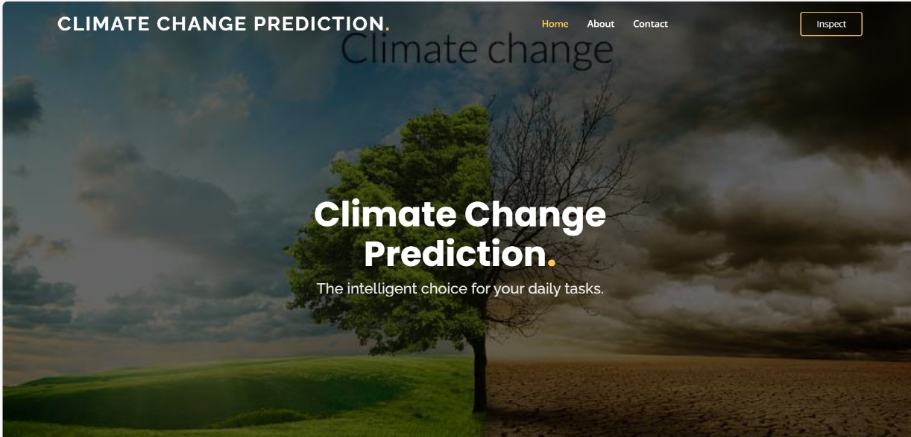
Fig 8.1: input to predict
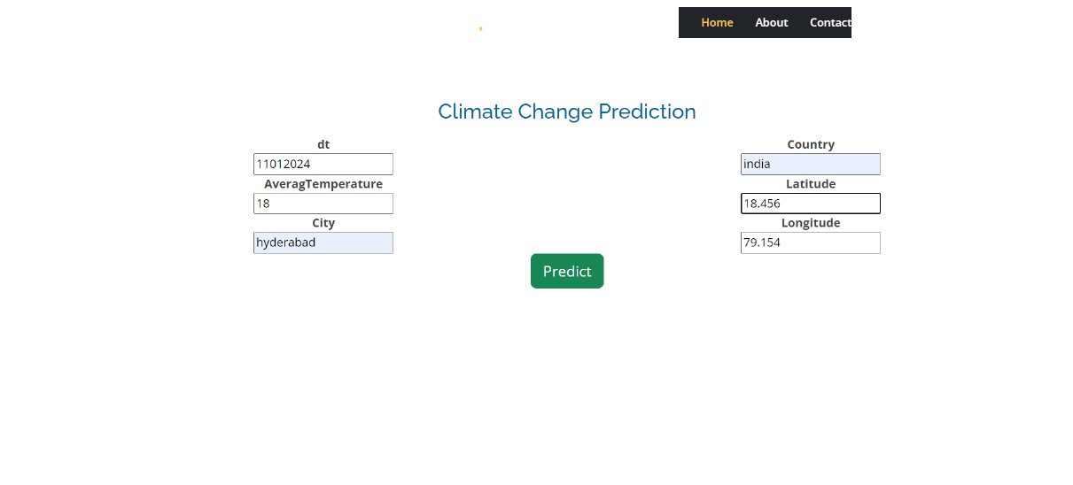
Fig 8.2: input details of perdiction

Output Design:

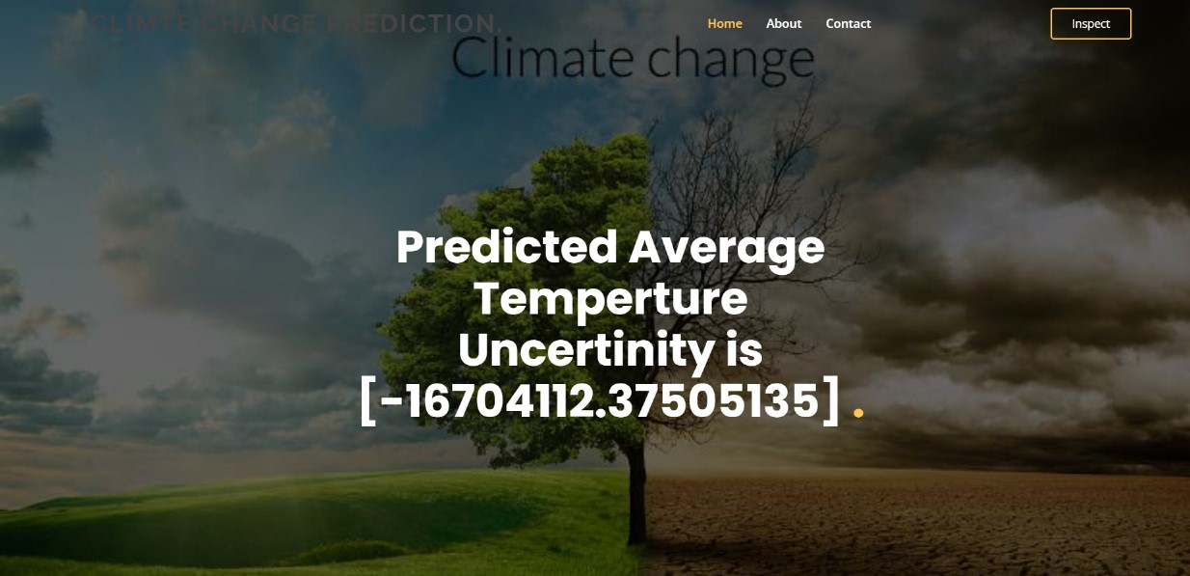

Fig8. 4: Predicted Average Temperature Uncertinity

CHAPTER 9

CONCLUSION
This machine learning project provides a promising approach to predicting climate change through temperature analysis. By leveraging historical temperature data and employing advanced algorithms, the system demonstrates a capacity to model and forecast future temperature trends with enhanced accuracy. The emphasis on feature engineering and model validation ensures the reliability of predictions, making it a valuable tool for understanding and addressing climate change

CHAPTER-10

FUTURE SCOPE

The future scope of this project extends into several key areas. Firstly, further refinement and optimization of machine learning models could enhance the accuracy of climate change predictions. Collaborative efforts with meteorological agencies and environmental researchers can lead to the incorporation of additional data sources, such as atmospheric conditions and oceanic patterns, for a more comprehensive analysis. Additionally, integrating real-time data streams could enable the system to adapt dynamically to evolving climate patterns. This adaptability is crucial in the face of rapidly changing environmental conditions. Exploring the application of this predictive model on a regional or local scale allows for more targeted and actionable insights, facilitating localized climate resilience strategies. Furthermore, the project could benefit from the development of a user-friendly interface, making the predictions and insights accessible to a wider audience, including policymakers, community leaders, and the general public. Promoting awareness and understanding of climate change through the dissemination of user-friendly information is vital for fostering collective responsibility and action. In the broader context, collaboration with international organizations and the integration of global climate models could contribute to a more comprehensive understanding of climate change at a global scale. This project lays the groundwork for continued research and innovation in the field of climate prediction, emphasizing the importance of technological advancements in addressing the challenges posed by climate change

CHAPTER 11 REFERENCES

https://en.wikipedia.org/wiki/Exploratory_data_analysis
https://dinsdalelab.sdsu.edu/metag.stats/code/randomforest.html.
Loan Prediction Using Ensemble Technique, International Journal of Advanced Research in Computer and Communication Engineering Vol. 5, Issue 3, March 2016

