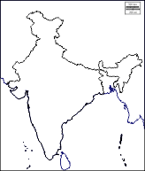

Airborne disease:

**Influenza (Commonly known as flu)**

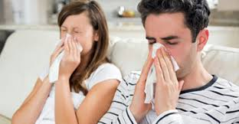

Chickenpox:

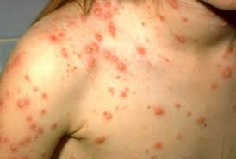

**Influenza** is a viral infection that attacks your respiratory system — your nose, throat and lungs. Influenza is commonly called the flu. common cold with a runny nose, sneezing and sore throat.

**Chickenpox** is a very contagious infection caused by the varicella-zoster virus. It mainly affects kids, but adults can get it, too. The tell-tale sign of **chickenpox** is a super-itchy skin rash with red blisters. Over the course of several days, the blisters pop and start to leak

Waterborne Disease

Cholera

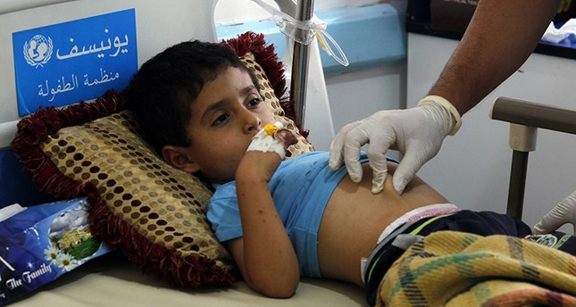

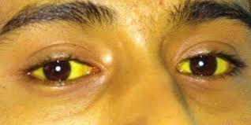

Jaundice

[Cholera](https://www.webmd.com/a-to-z-guides/cholera-faq) is an infectious disease that causes severe watery [diarrhea](https://www.webmd.com/digestive-disorders/digestive-diseases-diarrhea), which can lead to [dehydration](https://www.webmd.com/a-to-z-guides/dehydration-adults) and even death if untreated. It is caused by eating food or drinking water contaminated with a bacterium called *Vibrio cholerae*.

Rapid [heart rate](https://www.webmd.com/a-to-z-guides/cholera-faq#1), Loss of [skin](https://www.webmd.com/skin-problems-and-treatments/picture-of-the-skin) elasticity (the ability to return to original position quickly if pinched), Dry mucous membranes, including the inside of the [mouth](https://www.webmd.com/a-to-z-guides/cholera-faq#1), throat, nose, and eyelids, [Low blood pressure](https://www.webmd.com/heart/understanding-low-blood-pressure-basics), Thirst, [Muscle cramps](https://www.webmd.com/pain-management/muscle-spasms-cramps-charley-horse)

[Jaundice](https://www.emedicinehealth.com/image-gallery/jaundice_picture/images.htm) is a yellow discoloration of the skin, mucous membranes, and the whites of the eyes caused by increased amounts of bilirubin in the blood.

Fatigue, lethargy, loss of appetite, nausea, vomiting, itching skin, right upper abdominal pain, yellow skin or eyes, and fluid buildup in the abdomen are possible symptoms.

Contact Disease:

Conjuctivitis

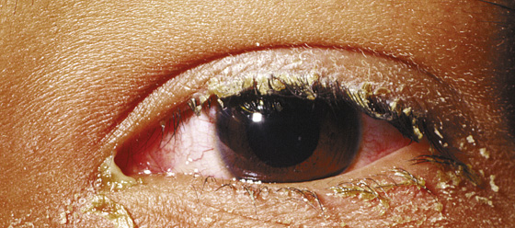

Skin Disease



**Conjunctivitis** is an inflammation or swelling of the conjunctiva. The conjunctiva is the thin transparent layer of tissue that lines the inner surface of the eyelid and covers the white part of the eye.

• Swollen **conjunctiva**.

• More tears than usual.

• Thick yellow discharge that crusts over the eyelashes, especially after sleep. ..

• Itchy eyes.• Burning eyes.• Blurred vision.

**Skin irregularities that are typically symptoms of a skin disorder include:**

• raised bumps that are red or white.

• a rash, which might be painful or itchy.

Dengue: Baries (dog bites)

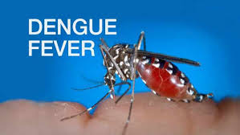

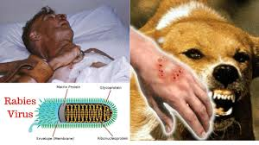

Dengue fever is transmitted by the bite of an Aedes mosquito infected with a dengue virus. The mosquito becomes infected when it bites a person with dengue virus in their [blood](https://www.webmd.com/heart/anatomy-picture-of-blood).

• Sudden, high **fever**.

• Severe headaches.

• Pain behind the eyes.

• Severe joint and muscle pain.

The **first symptoms of rabies** can appear from a few days to more than a year after the bite happens. At **first**, there's a tingling, prickling, or itching feeling around the bite area. A person also might have flu-like **symptoms** such as a fever, headache, muscle aches, loss of appetite, nausea, and tiredness

