Project Management System Guide

The Project Management System (PMS) defines six distinct roles: Admin, Manager, Developer, Digital Marketing, Content Creator, and Client. Each role is specifically designed to handle tasks and responsibilities related to project management. Users in these roles can track project progress, collaborate effectively, and contribute to the successful completion of projects based on their assigned duties. These roles ensure that all aspects of project development, marketing, content creation, and client interaction are well-organized and efficiently managed throughout the project lifecycle.

Admin :

Credentials : mail – [msadiqbasha777@gmail.com](mailto:msadiqbasha777@gmail.com), pswd : 123

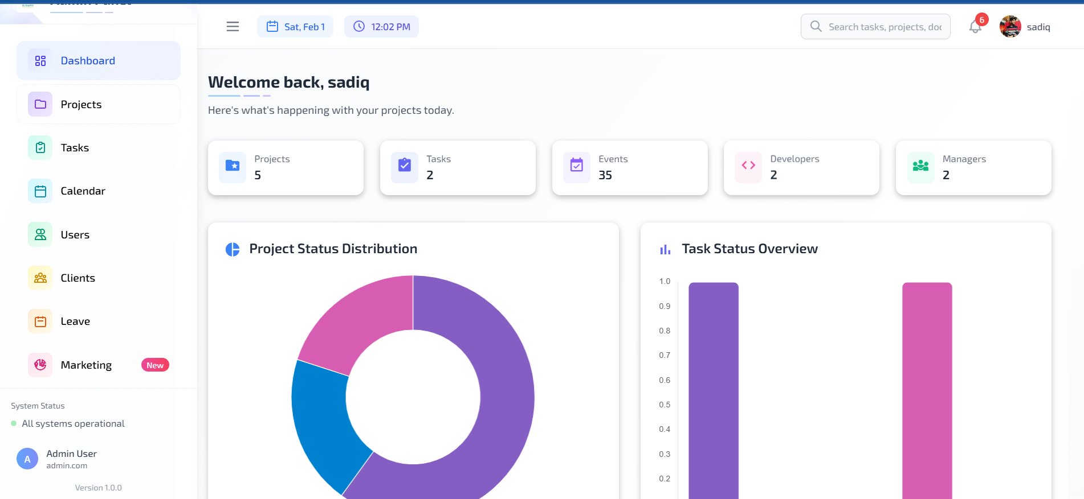

The Admin role in the Project Management System (PMS) has access to the following pages: Dashboard, Projects, Tasks, Calendar, Users, Clients, Leave Approval, and Marketing.

* **Dashboard Page**: The Admin can view an overview of the platform, including key metrics such as the number of active projects, tasks, users, upcoming meetings, and events.
* **Projects Page**: Admins can create, view, delete, and update projects. They can also view projects created by Managers and assign projects to Developers and Managers from this page.
* **Tasks Page**: Admins have the ability to create, view, delete, and update tasks. They can also see tasks created by Managers and assign tasks to Developers and Managers.
* **Calendar Page**: Admins can manage events by creating, viewing, deleting, and updating them. They can also create meetings, add participants, and manage meeting details from this page.
* **Users Page**: Admins can manage users on the platform, including creating, viewing, updating, and deleting roles for Developers, Managers, Digital Marketers, and Content Creators.
* **Clients Page**: Admins can create, update, delete, and view clients. When creating a client, they must assign a project to the client, so the project should be created first in order to assign it.
* **Leave Approval Page**: Admins have the authority to approve or reject leave requests submitted by Developers.
* **Marketing Page**: Admins can create, update, delete, and view marketing tasks. They can assign tasks to Digital Marketers and Content Creators. Additionally, there is a section where they can view the revenue generated from marketing tasks, which is updated by the Digital Marketer. Admins can also comment on updates related to marketing tasks.

Manager :

Credentials : mail – [msadiqbasha777@gmail.com](mailto:msadiqbasha777@gmail.com), pswd : 123

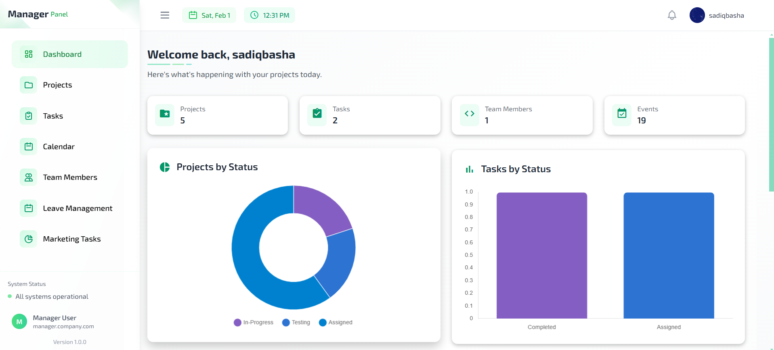

The Manager role in the Project Management System (PMS) has access to the following pages: Dashboard, Projects, Tasks, Calendar, Users, Leave Approval, and Marketing.

* **Dashboard Page**: The Manager can view a summary of key platform metrics related to their assigned team, such as the number of projects, tasks, events, meetings, and leaves for the team members they manage.
* **Projects Page**: Managers can create, view, delete, and update projects. They can only manage the projects that are assigned to their team, including Developers, Digital Marketers, and Content Creators. They cannot manage projects outside their assigned team.
* **Tasks Page**: Managers can create, view, delete, and update tasks within their team. They can assign tasks only to their assigned team members, such as Developers, Digital Marketers, and Content Creators.
* **Calendar Page**: Managers can create, view, delete, and update events for their team. They can also schedule meetings and add participants, limited to the team members they are managing.
* **Users Page**: The Manager can view the users in the system but does not have permission to create, update, or delete users. The users visible to them are only those assigned to their team, including Developers, Digital Marketers, and Content Creators.
* **Leave Approval Page**: Managers can approve or reject leave requests for the Developers, Digital Marketers, and Content Creators assigned to their team.
* **Marketing Page**: Managers can create, update, delete, and view marketing tasks but can assign these tasks only to their assigned Digital Marketers and Content Creators. They can also view the progress and comments on marketing tasks, but only for their team members.

In summary, the Manager role focuses on overseeing a specific team, having full control over their assigned members’ projects, tasks, marketing tasks, and leave approvals. Unlike the Admin, Managers cannot access the Clients page or manage users outside their team.

Developer:

Credentials: mail – [msadiqbasha777@gmail.com](mailto:msadiqbasha777@gmail.com), pswd : 123

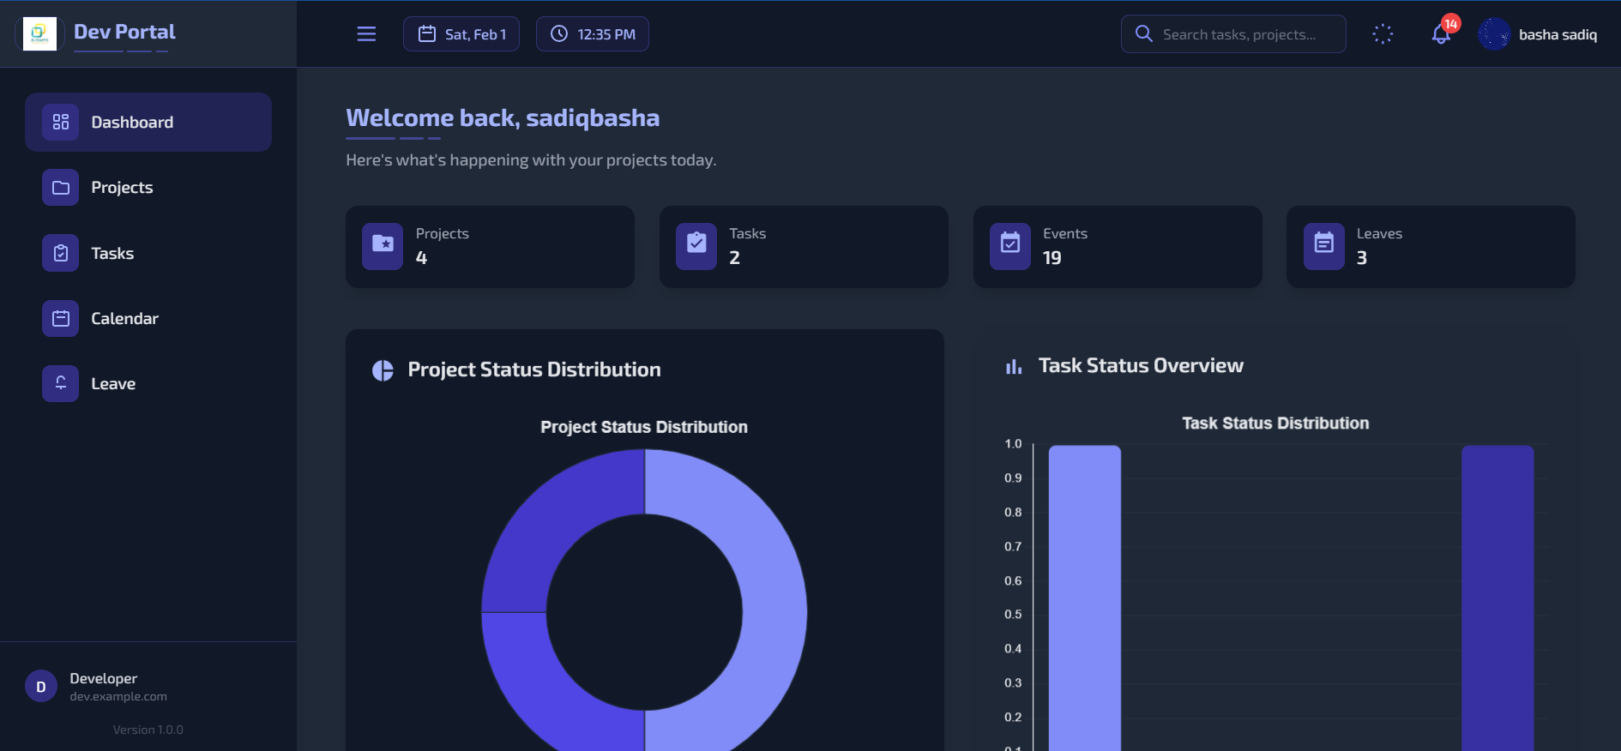

The Developer role in the Project Management System (PMS) has access to the following pages: Dashboard, Projects, Tasks, Calendar, and Leave.

* **Dashboard Page**: Developers can view a personalized summary of key platform metrics, such as the projects, tasks, meetings, events, and leave applications related to them.
* **Projects Page**: Developers can view the projects that are assigned to them. They do not have the ability to create, update, or delete projects, but they can track the progress of their assigned projects.
* **Tasks Page**: Developers can view the tasks assigned to them. They can provide updates on these tasks, submit timely progress reports, and submit the final results upon task completion. Developers cannot manage tasks outside their own assignments.
* **Calendar Page**: Developers can see their assigned meetings, events, project deadlines, and reminders in the calendar. They can stay updated on upcoming events and meetings but cannot create or modify events and meetings.
* **Leave Page**: Developers can apply for leave through this page. They can submit leave requests, but the approval process is handled by the Manager or Admin.

This structure ensures that Developers can focus on their assigned tasks and projects, providing timely updates and participating in meetings and events. They have limited access to other roles’ information and only interact with content relevant to their responsibilities.

Digital-marketing :

Credentials : mail – [khanbasha7777777@gmail.com](mailto:khanbasha7777777@gmail.com), pswd : 123

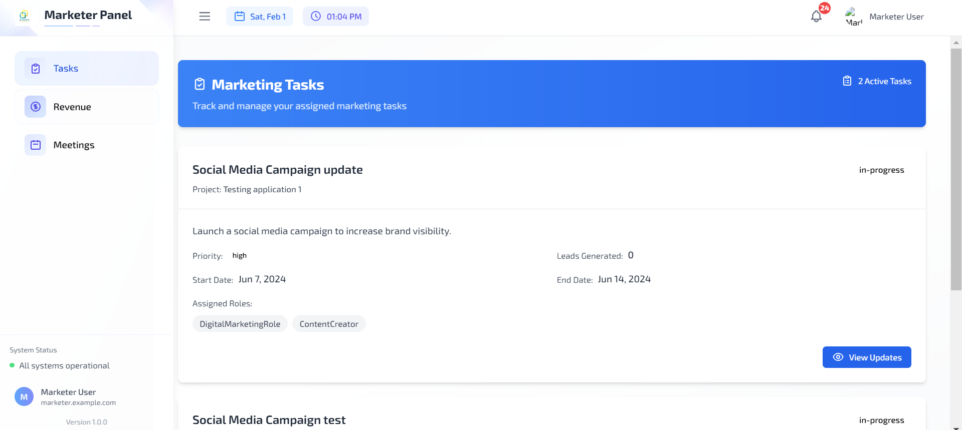

The Digital Marketer role in the Project Management System (PMS) has access to the following pages: Tasks, Revenue, and Meetings.

* **Tasks Page**: Digital Marketers can view the tasks assigned to them and provide updates on their progress. They can submit timely reports and mark tasks as complete once finished.
* **Revenue Page**: Digital Marketers are responsible for updating the revenue generated by their assigned projects. They can record and update revenue details, helping track the financial performance of marketing tasks.
* **Meetings Page**: Digital Marketers can view their assigned meetings and participate in them. They can stay updated on upcoming meetings but do not have the ability to create or manage meetings.

This role is designed to focus on marketing-related tasks, track project revenues, and participate in meetings related to their work, ensuring that marketing progress is documented and aligned with project goals.

Content creator:

Credentials : mail – [khanbasha7777777@gmail.com](mailto:khanbasha7777777@gmail.com), pswd : 123

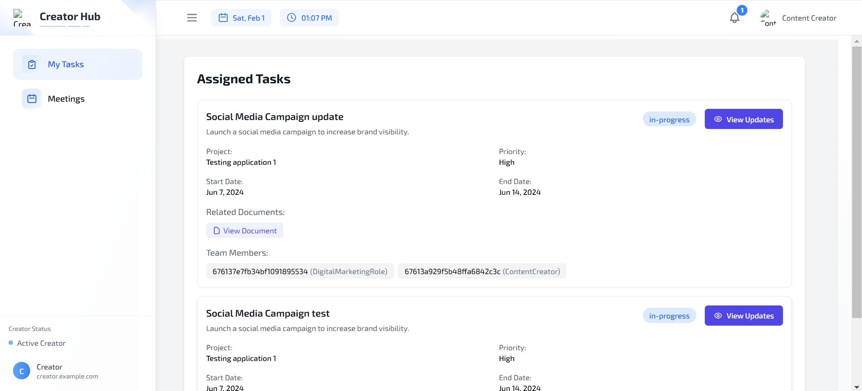

The Content Creator role in the Project Management System (PMS) has access to the following pages: Tasks, Meetings.

* **Tasks Page**: Content Creators can view the tasks assigned to them and provide updates on their progress. They can submit timely reports and mark tasks as complete once finished.
* **Meetings Page**: Content Creators can view their assigned meetings and participate in them. They stay updated on upcoming meetings but do not have the ability to create or manage meetings.

Content Creators focus primarily on their assigned tasks, such as content production and collaboration, and are involved in meetings relevant to their responsibilities. They do not have access to revenue-related information.

Client :

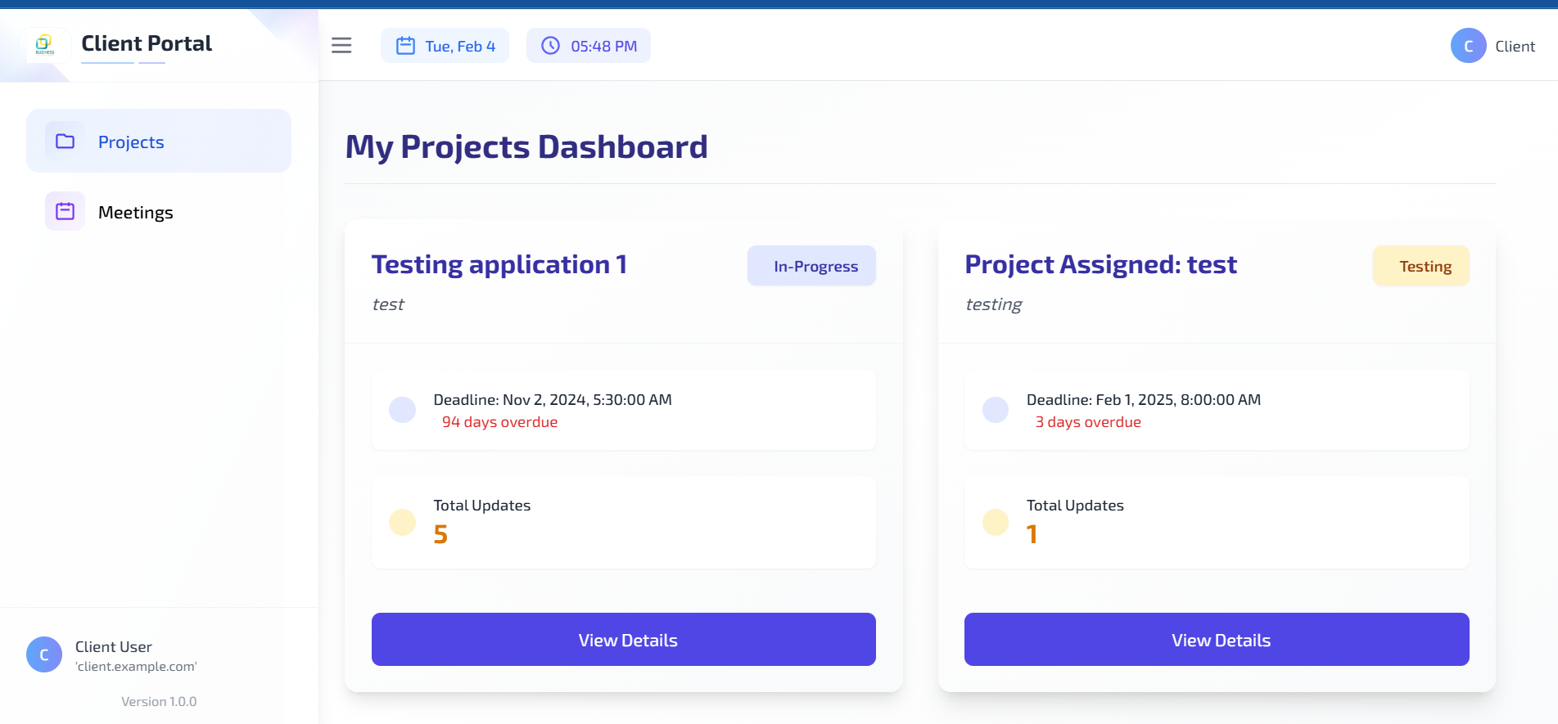

The Client role in the Project Management System (PMS) has access to the following pages: Projects and Meetings.

* **Projects Page**: Clients can view only the projects assigned to them. They can track project progress but cannot create, update, or delete projects.
* **Meetings Page**: Clients can see their scheduled meetings and participate in them. They do not have permission to create or manage meetings.

This role ensures that Clients can stay informed about their project status and attend relevant meetings without direct involvement in task management or internal team operations.