Module Name: Login Page - Functional & UI Test Cases
Test Case ID: st_01
Webpage URL:https://www.pinterest.com/

Scenario ID: 5a
Scenario: Login with valid credentials
Test Steps:
1. Open Pinterest
2. Click Log in
3. Enter email
4. Enter password
5. Click Log in
Screenshots:
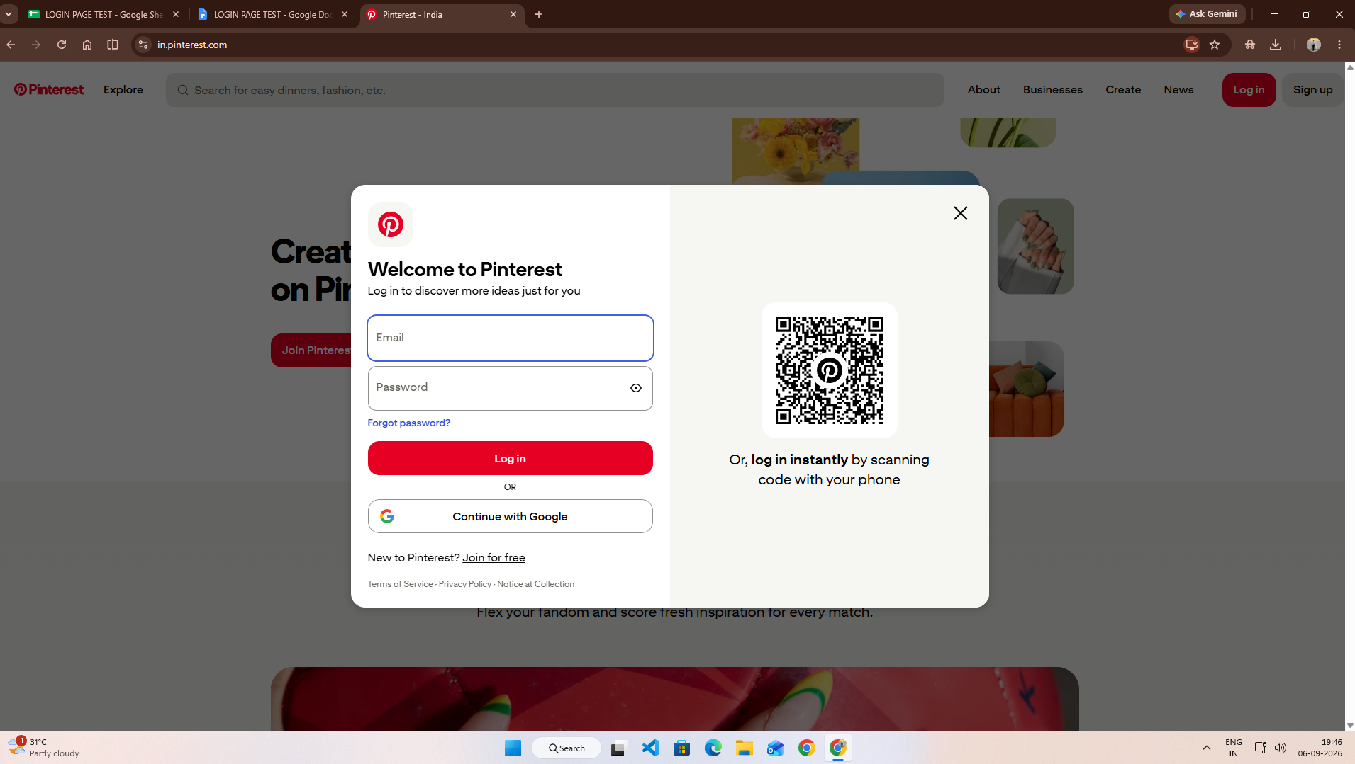
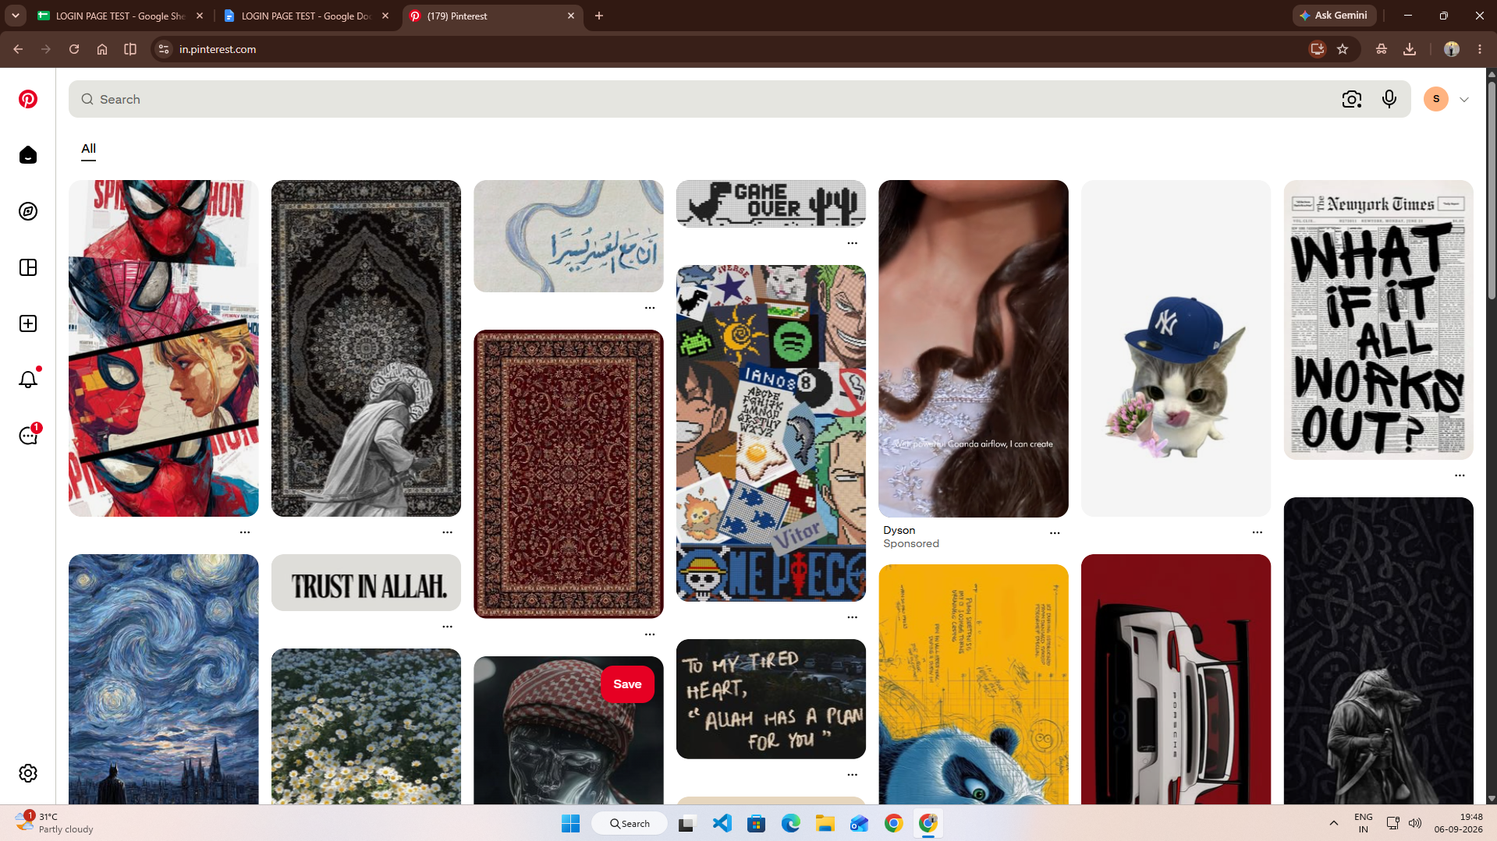

Scenario ID: 5b
Scenario: Login with invalid password
Test Steps:
1. Open Login page
2. Enter valid email
3. Enter incorrect password
4. Click Log in
Screenshots:
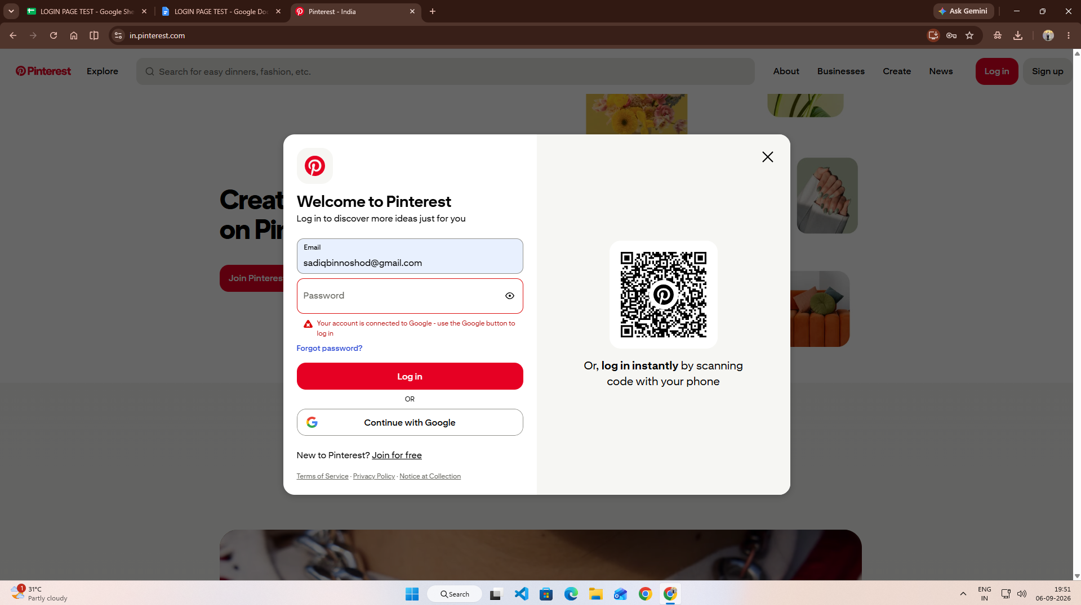

Scenario ID: 5c
Scenario: Login with invalid email
Test Steps:
1. Open Login page
2. Enter invalid email
3. Enter password
4. Click Log in
Screenshots:
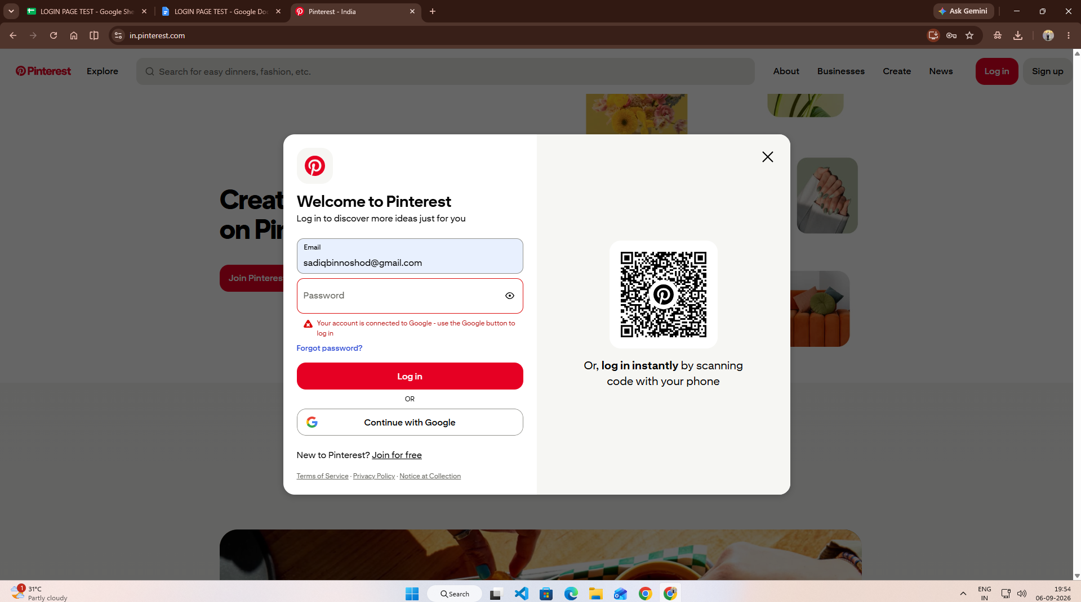

Scenario ID: 5d
Scenario: Login with empty fields
Test Steps:
1. Open Login page
2. Leave email blank
3. Leave password blank
4. Click Log in
Screenshots:
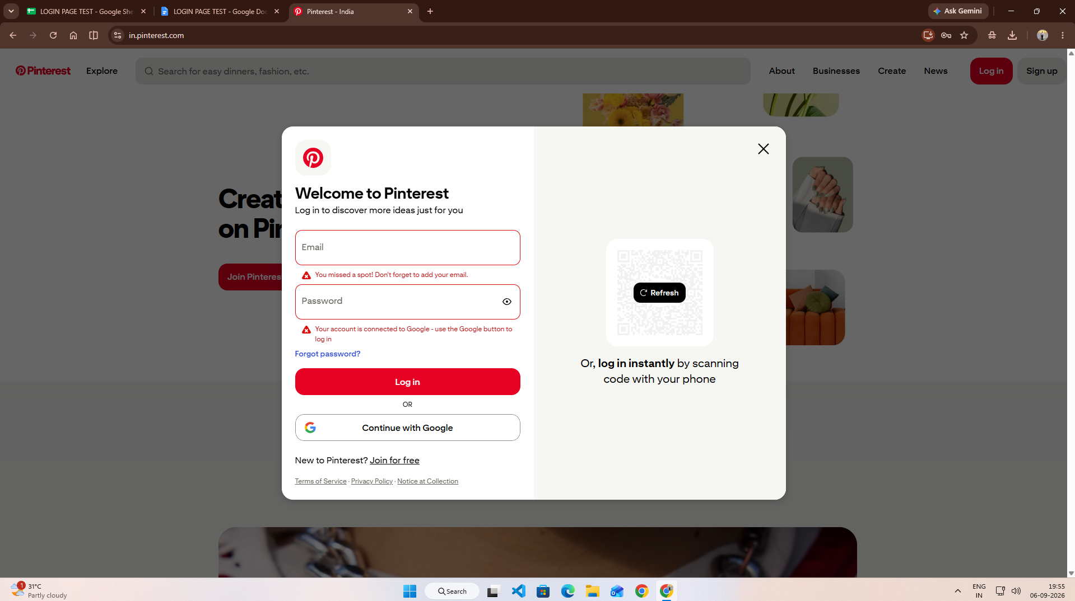

Scenario ID: 5e
Scenario: Login with invalid email format
Test Steps:
1. Open Login page
2. Enter invalid email format
3. Enter password
4. Click Log in
Screenshots:
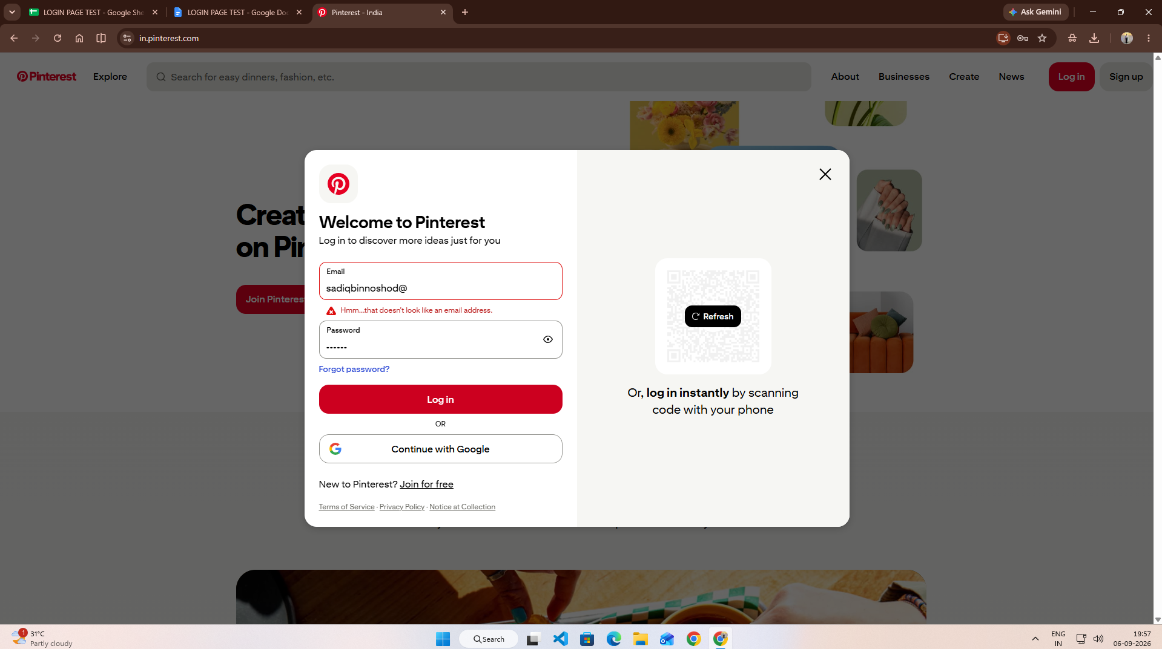

Scenario ID: 5f
Scenario: Check Forgot Password
Test Steps:
1. Open Login page
2. Click Forgot password
Screenshots:
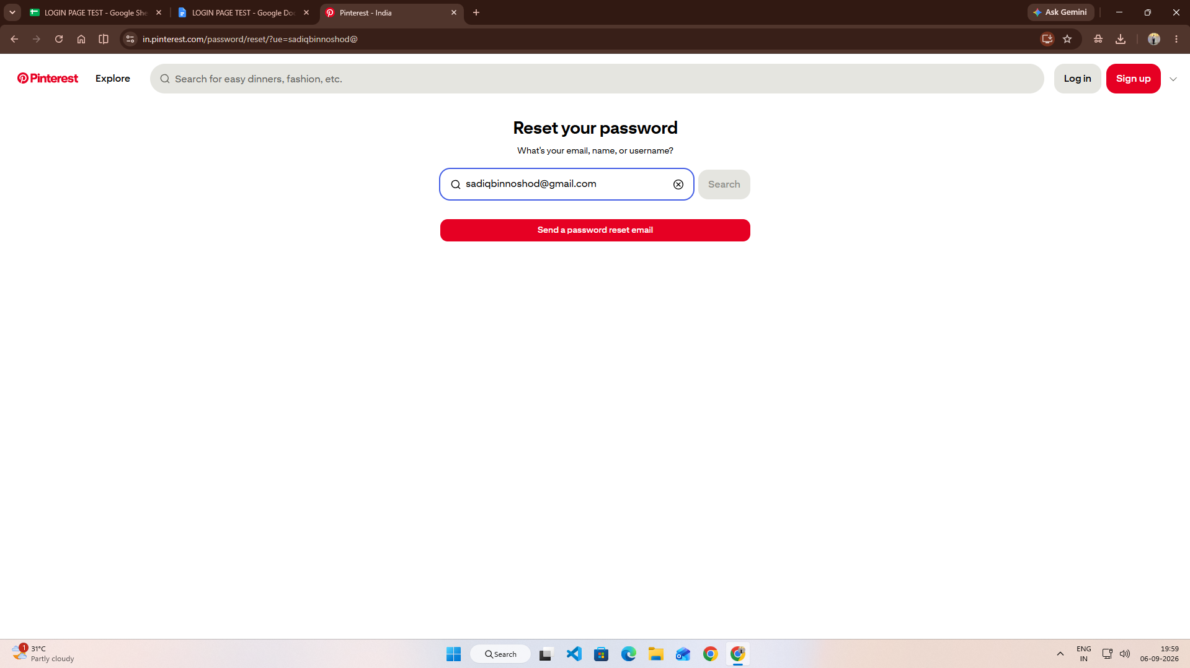

Scenario ID: 5g
Scenario: Check password visibility
Test Steps:
1. Open Login page
2. Enter password
3. Click Show password
Screenshots:
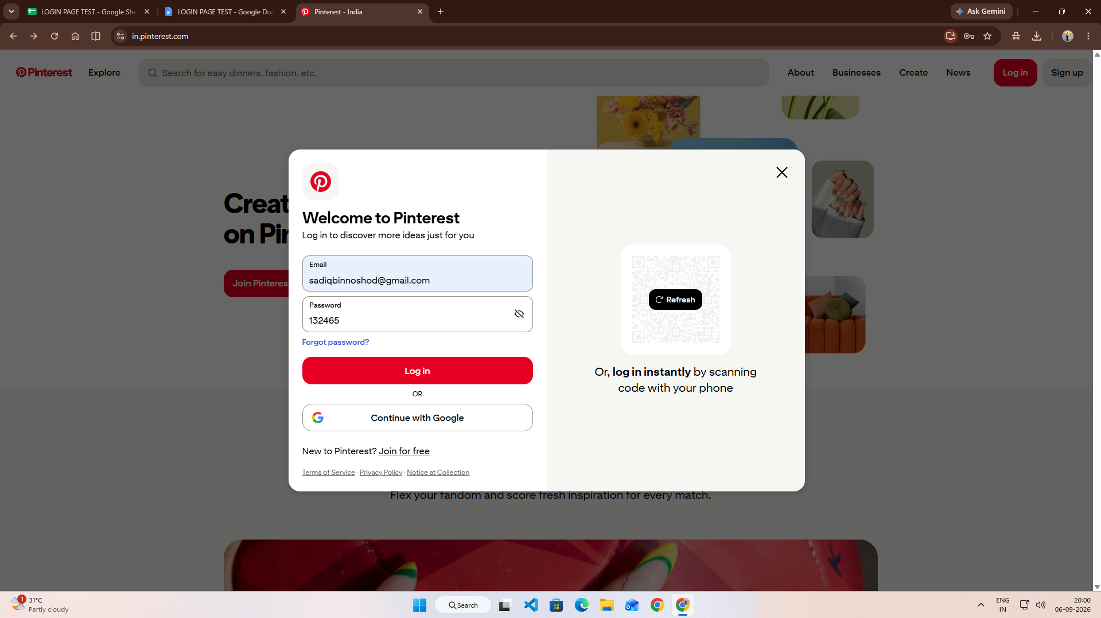

Scenario ID: 5h
Scenario: Check Sign Up option
Test Steps:
1. Open Login page
2. Click Sign up
Screenshots:
