Module Name: Login Page - Functional & UI Test Cases
Test Case ID: st_01
Webpage URL:https://studentportal.silveroakuni.ac.in/UMSStudents/login.aspx

Scenario ID: 6a
Scenario: Login with valid credentials
Test Steps:
1.Open Student Portal
2.Enter valid enrollment no
3.Enter valid password
4.Click Login
Screenshots:
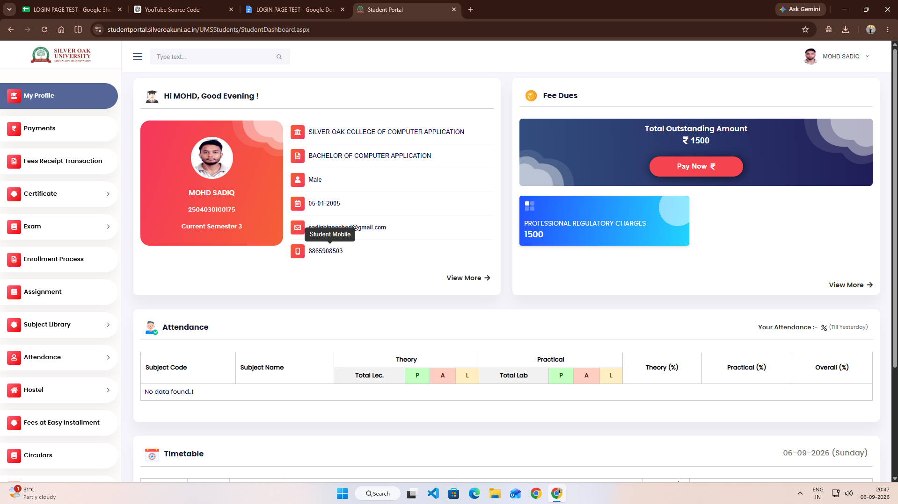

Scenario ID: 6b
Scenario: Login with invalid enrollment no
Test Steps:
1.Open Student Portal
2.Enter invalid enrollment no
3.Enter valid password
4.Click Login
Screenshots:
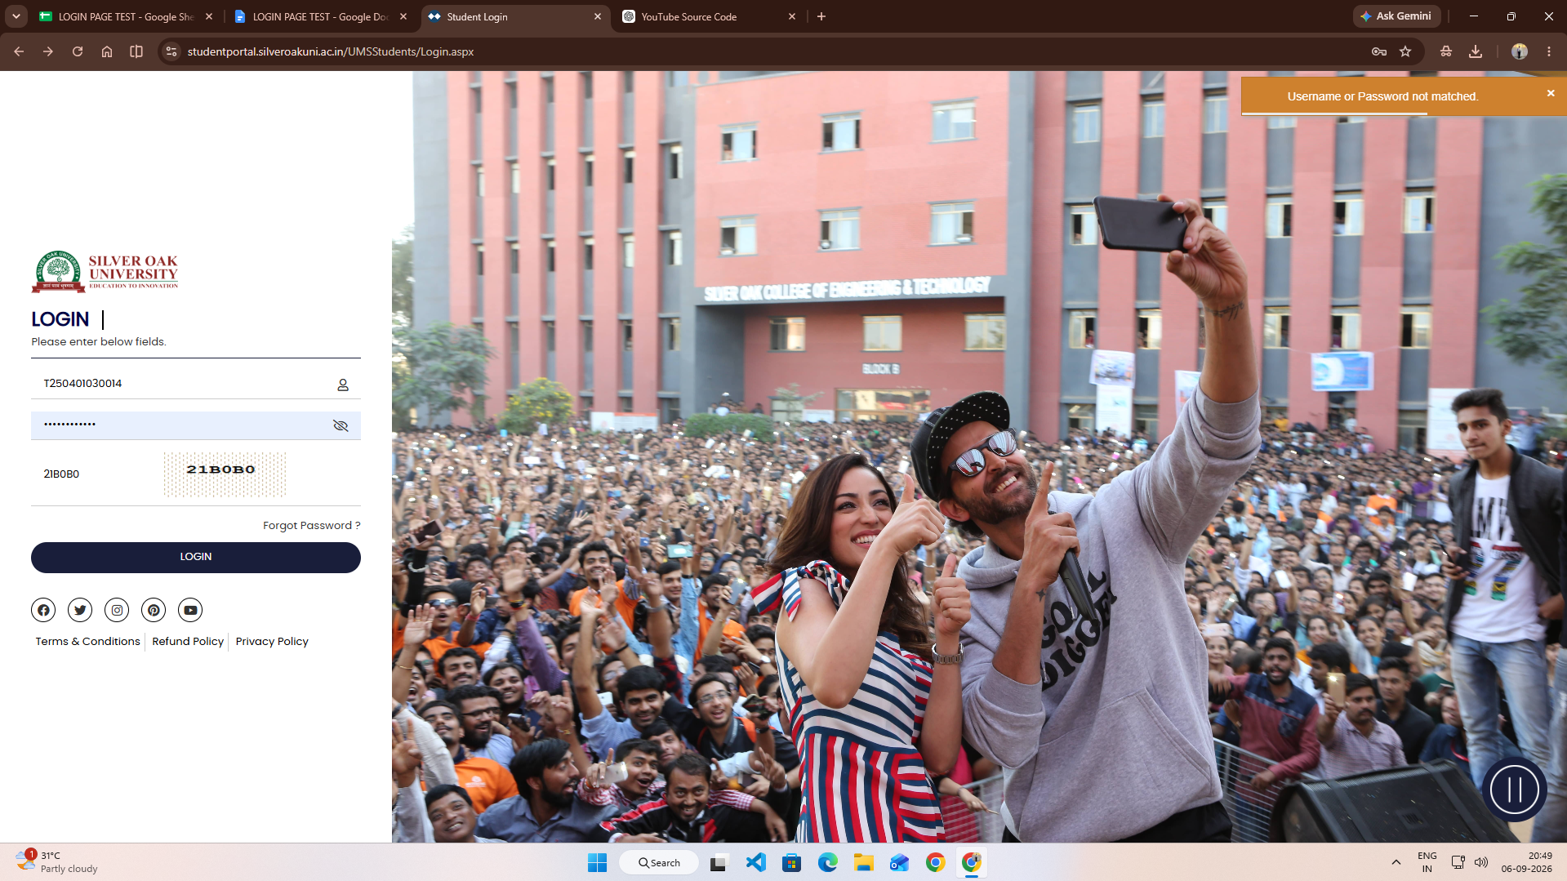

Scenario ID: 6c
Scenario: Login with invalid password
Test Steps:
1.Open Student Portal
2.Enter valid enrollment no
3.Enter invalid password
4.Click Login
Screenshots:
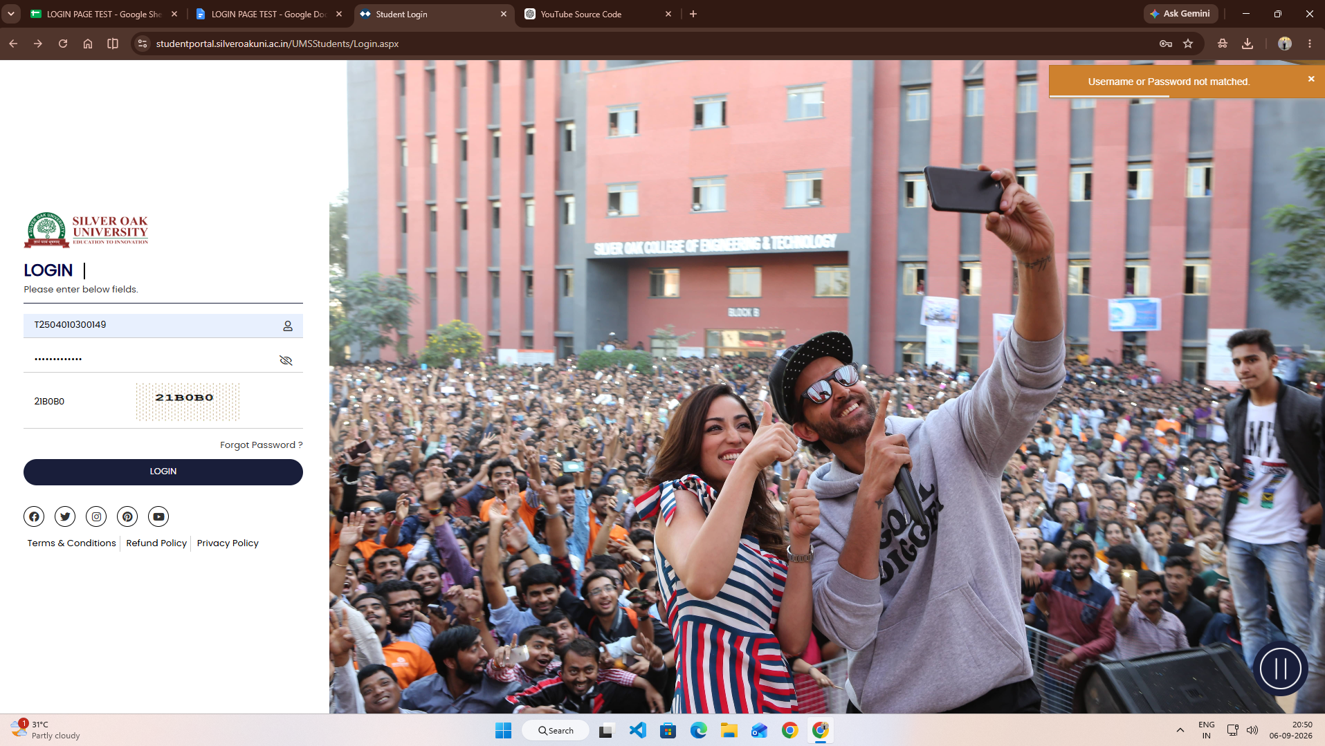

Scenario ID: 6d
Scenario: Login with blank fields
Test Steps:
1.Open Student Portal
2.Leave enrollment no blank
3.Leave password blank
4.Click Login
Screenshots:
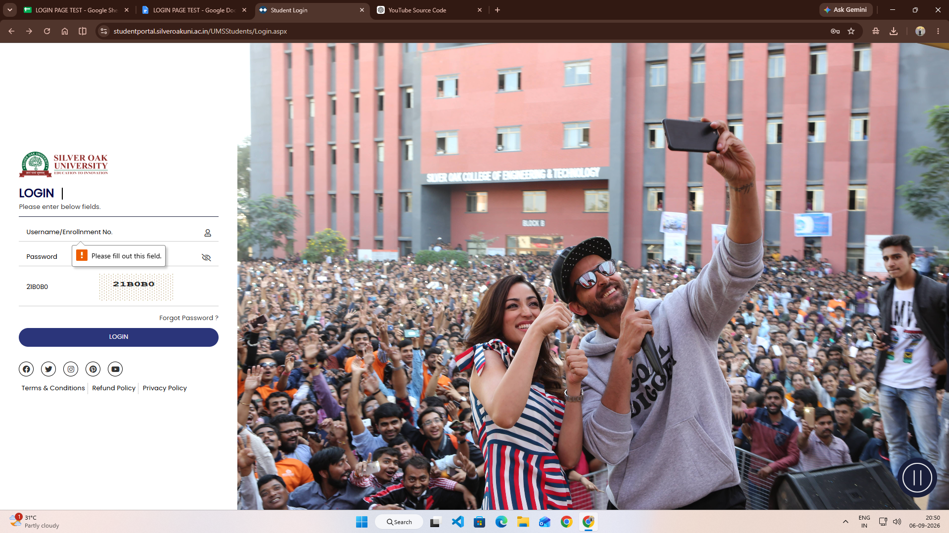

Scenario ID: 6e
Scenario: Forgot password
Test Steps:
1.Open Student Portal
2.Click Forgot Password
3.Enter registered enrollment no
4.Click Submit
Screenshots:
