Module Name: Login Page - Functional & UI Test Cases
Test Case ID: st_07
Webpage URL:https://www.flipkart.com/

Scenario ID: 7a
Scenario: Login with valid credentials
Test Steps:
1.Open Flipkart
2.Enter valid mobile number
3.Enter valid password
4.Click Login
Screenshots:
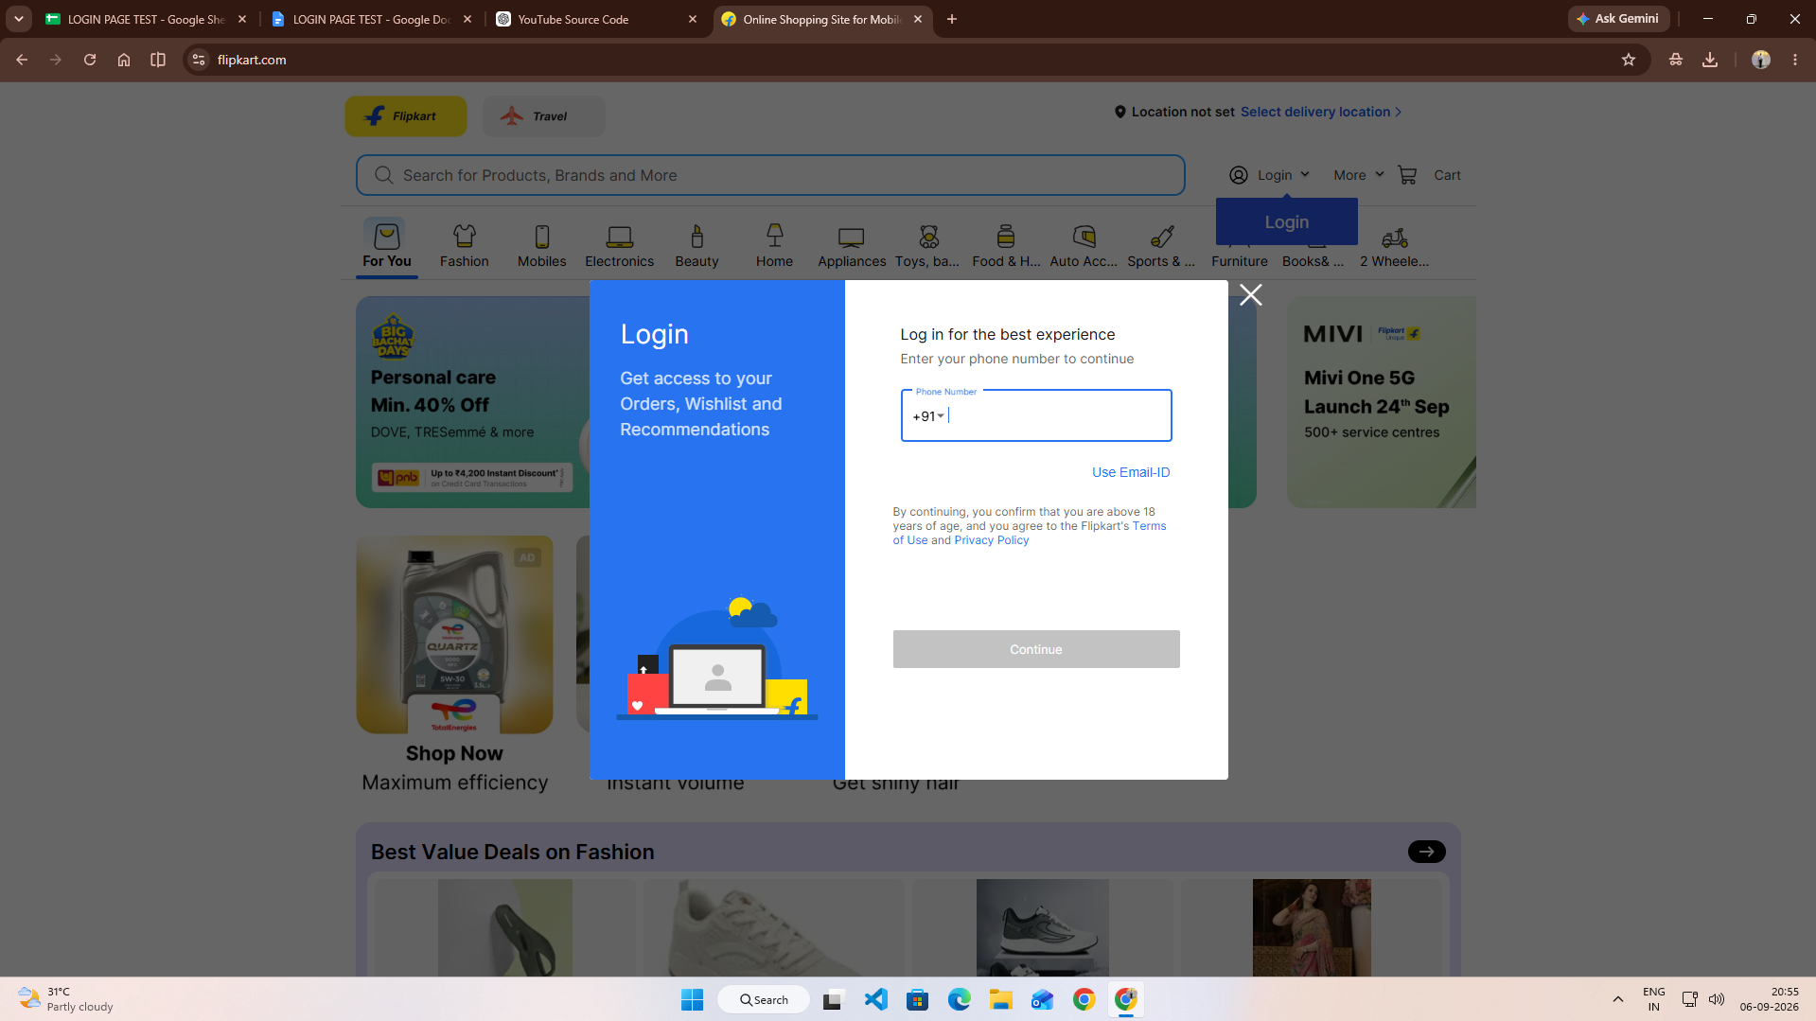

Scenario ID: 7b
Scenario: Login with invalid mobile number
Test Steps:
1.Open Flipkart
2.Enter invalid mobile number
3.Enter password
4.Click Login
Screenshots:
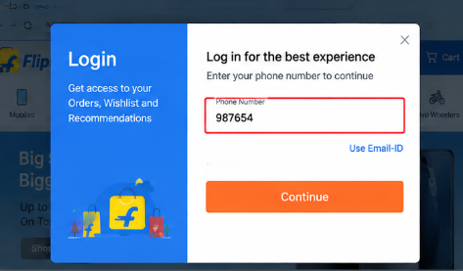

Scenario ID: 7c
Scenario:Login with invalid password
Test Steps:
1.Open Flipkart
2.Enter valid mobile number
3.Enter invalid password
4.Click Login
Screenshots:
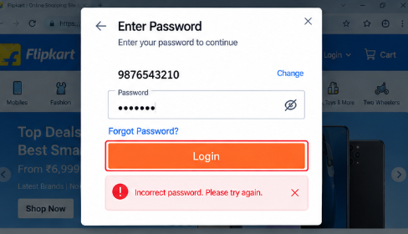

Scenario ID: 7d
Scenario: Login with blank fields
Test Steps:
1.Open Flipkart
2.Leave mobile number blank
3.Leave password blank
4.Click Login
Screenshots:
