Module Name: Login Page - Functional & UI Test Cases
Test Case ID: St_08
Website URL: https://www.facebook.com/
Scenario ID: 8a
Scenario: Login with valid credentials
Test Steps:
1. Open Facebook: https://www.facebook.com/
2. Enter a registered email
3. Enter the correct password.
4. Click Log in.
Screenshots:
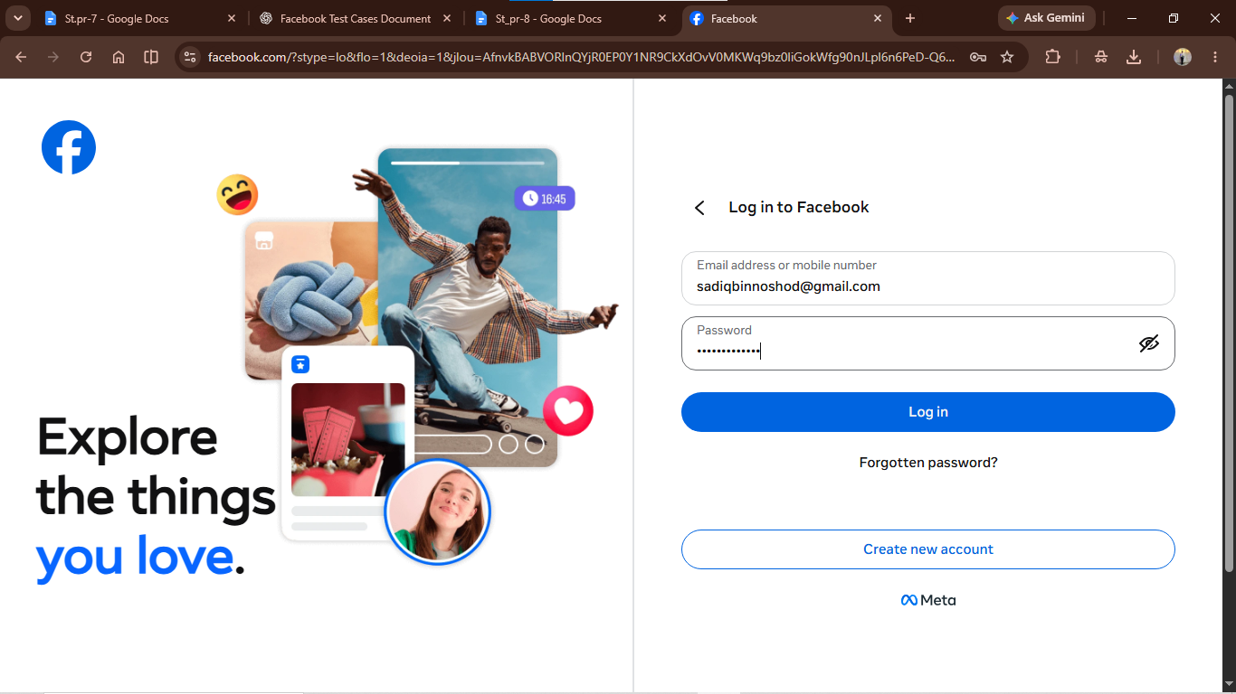
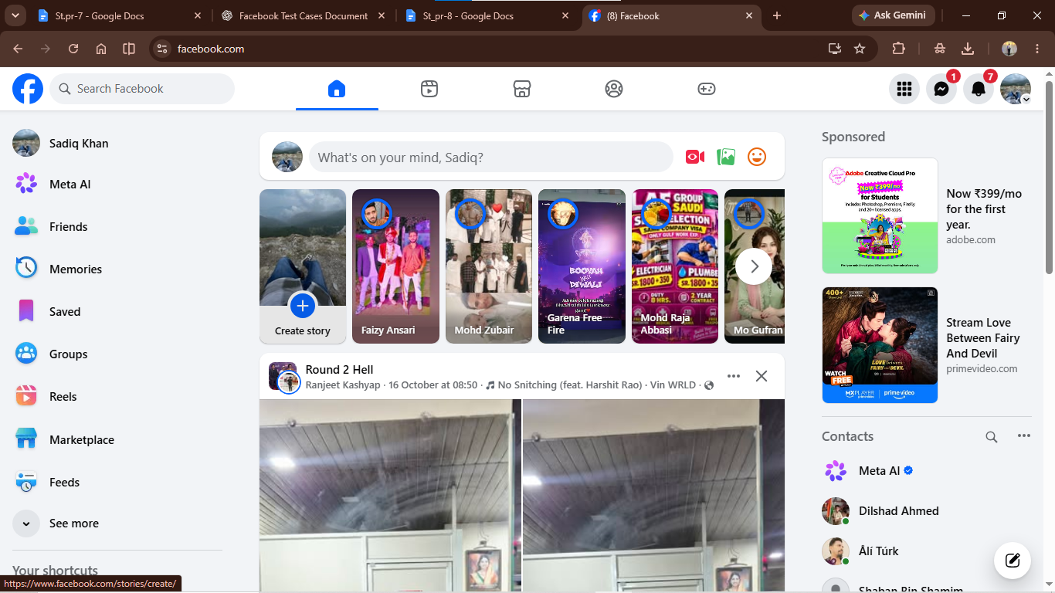
• Scenario ID: 8b
Scenario: Login with invalid email/mobile number
Test Steps:
1. Open Facebook: https://www.facebook.com/
2. Enter an invalid or unregistered email address
3. Enter a test password.
4. Click Log in.
Screenshots:
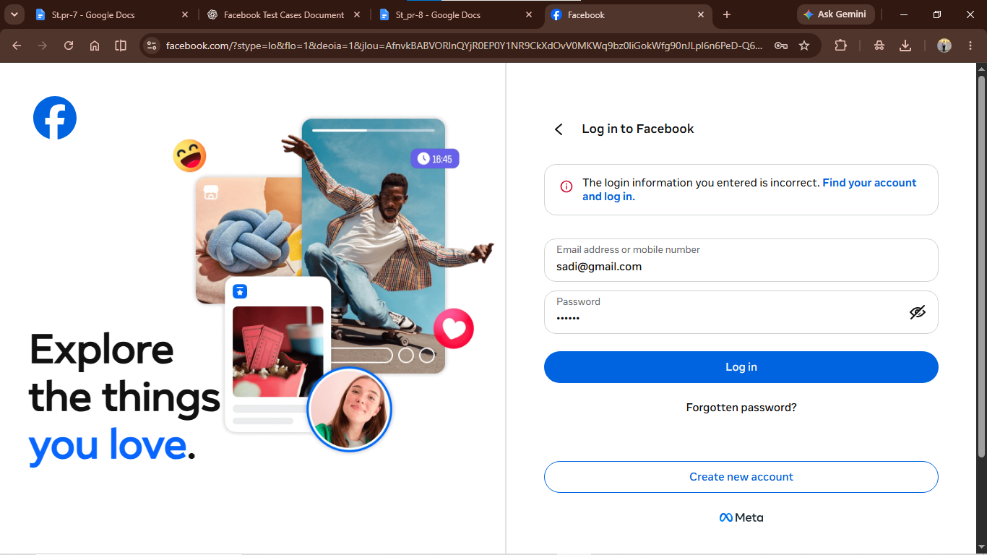
Scenario ID: 8c
Scenario: Login with invalid password
Test Steps:
1. Open Facebook: https://www.facebook.com/
2. Enter a registered test email address or mobile number.
3. Enter an incorrect password.
4. Click Log in.
Screenshots:
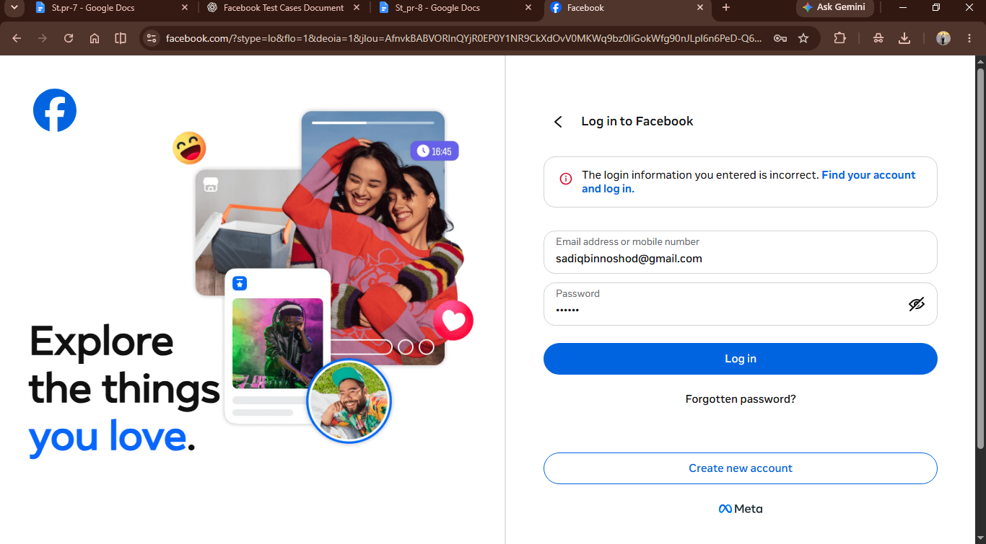
Scenario ID: 8d
Scenario: Login with blank fields
Test Steps:
1. Open Facebook: https://www.facebook.com/
2. Leave the email address/mobile number field blank.
3. Leave the password field blank.
4. Click Log in.
Screenshots:
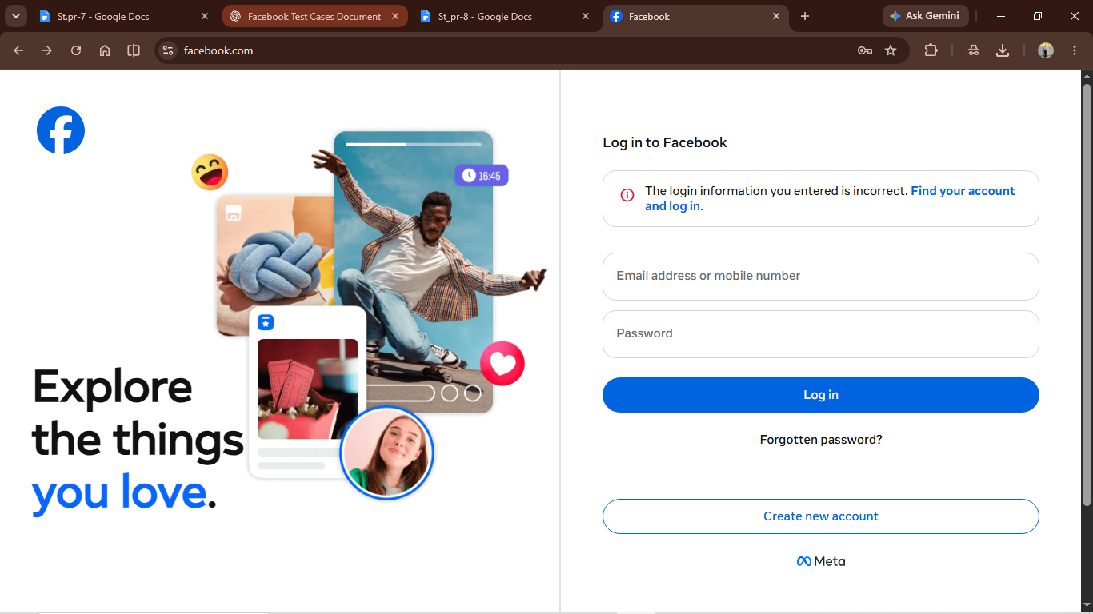
Scenario ID: 8e
Scenario: Forgot Password
Test Steps:
1. Open Facebook: https://www.facebook.com/
2. Click Forgot password?
3. Enter the registered email address or mobile number for the test account.
4. Click Search and verify that the account recovery flow opens.
Screenshots:
