Module Name: Login Page - Functional & UI Test Cases
Test Case ID: st_09
Webpage URL: https://www.swiggy.com/

Scenario ID: 9a
Scenario: Login with valid mobile number and OTP
Test Steps:
- Open Swiggy
- Enter mobile number
- Enter OTP
- Click Login
Screenshots:
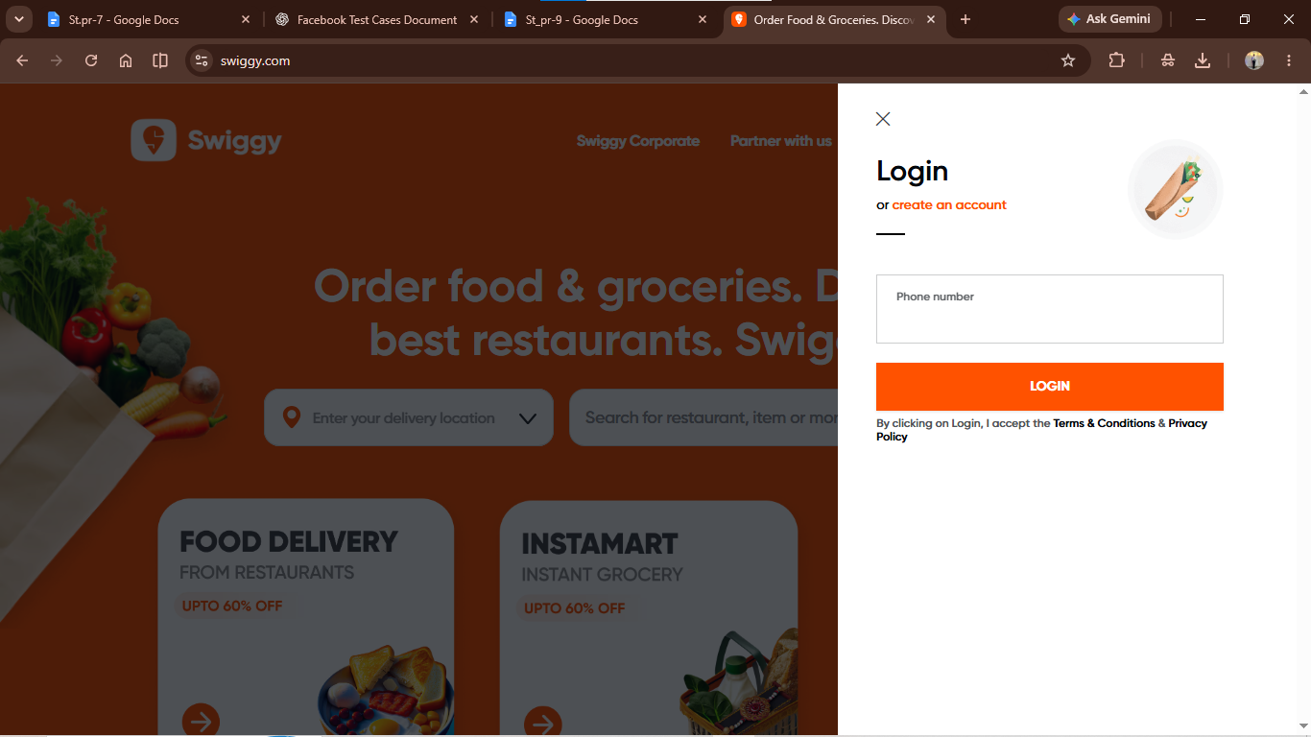
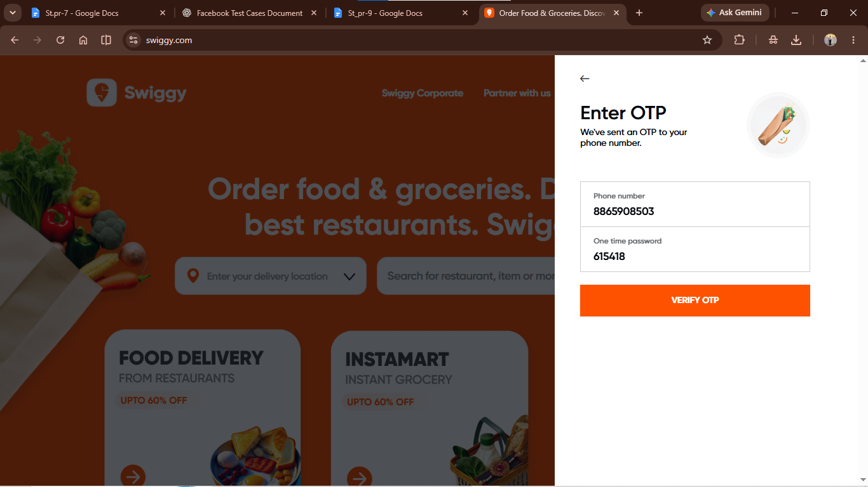
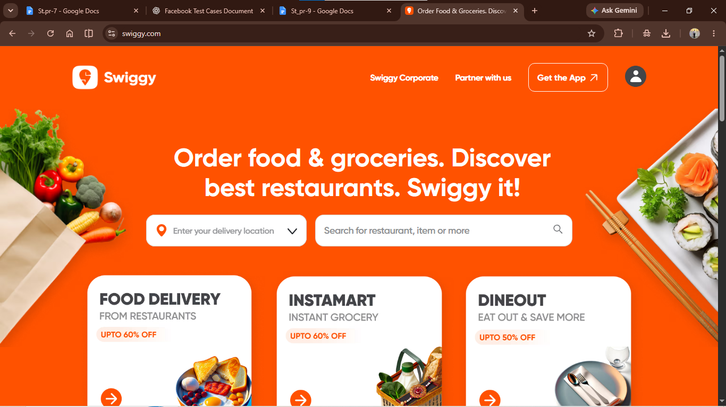

Scenario ID: 9b
Scenario: Login with invalid mobile number
Test Steps:
- Open Swiggy
- Enter invalid mobile number
- Click Continue
- Check error
Screenshots:

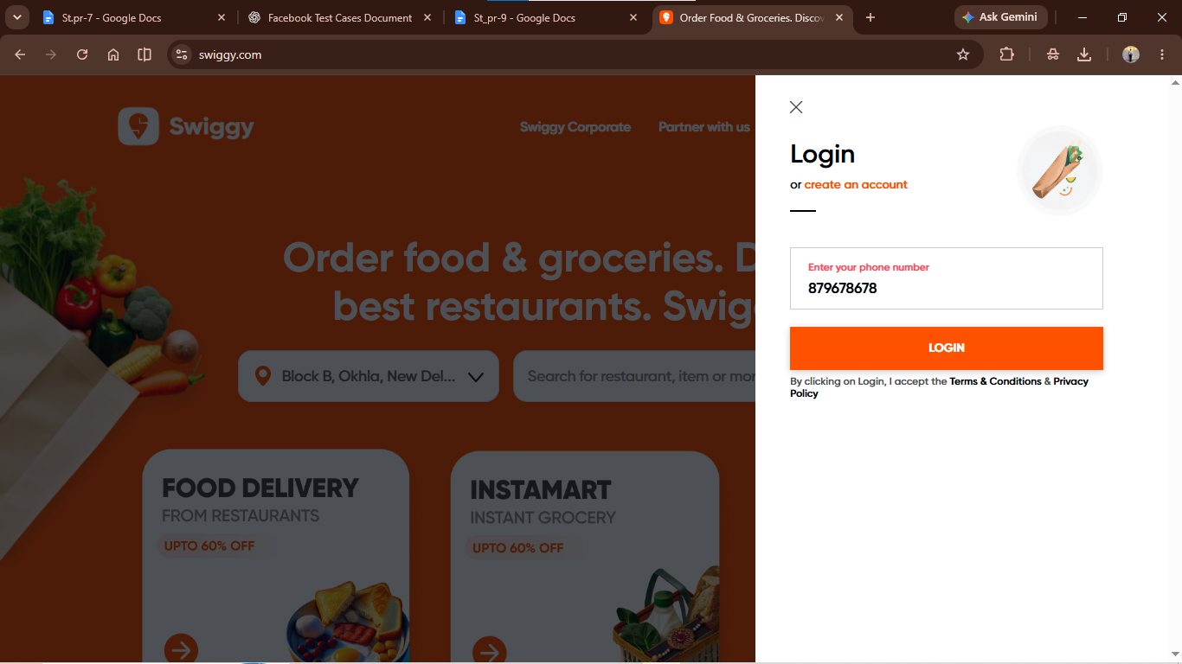

Scenario ID: 9c
Scenario: Login with wrong OTP
Test Steps:
- Open Swiggy
- Enter mobile number
- Enter wrong OTP
- Click Verify
Screenshots:
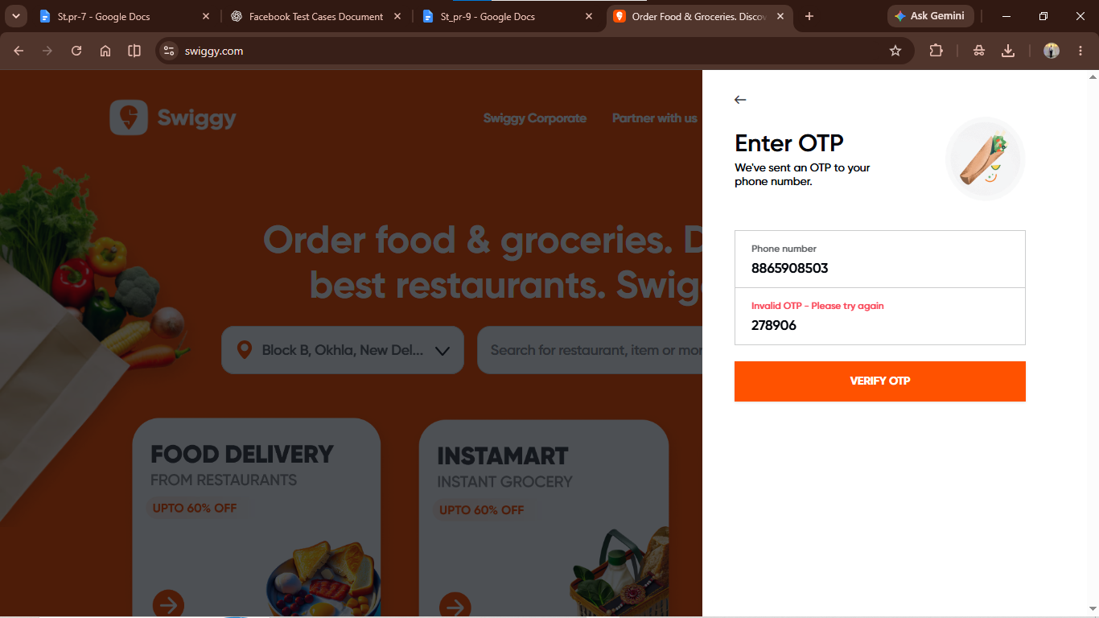

Scenario ID: 9d
Scenario: Login with blank mobile number
Test Steps:
- Open Swiggy
- Leave mobile number blank
- Click Continue
- Check error
Screenshots:
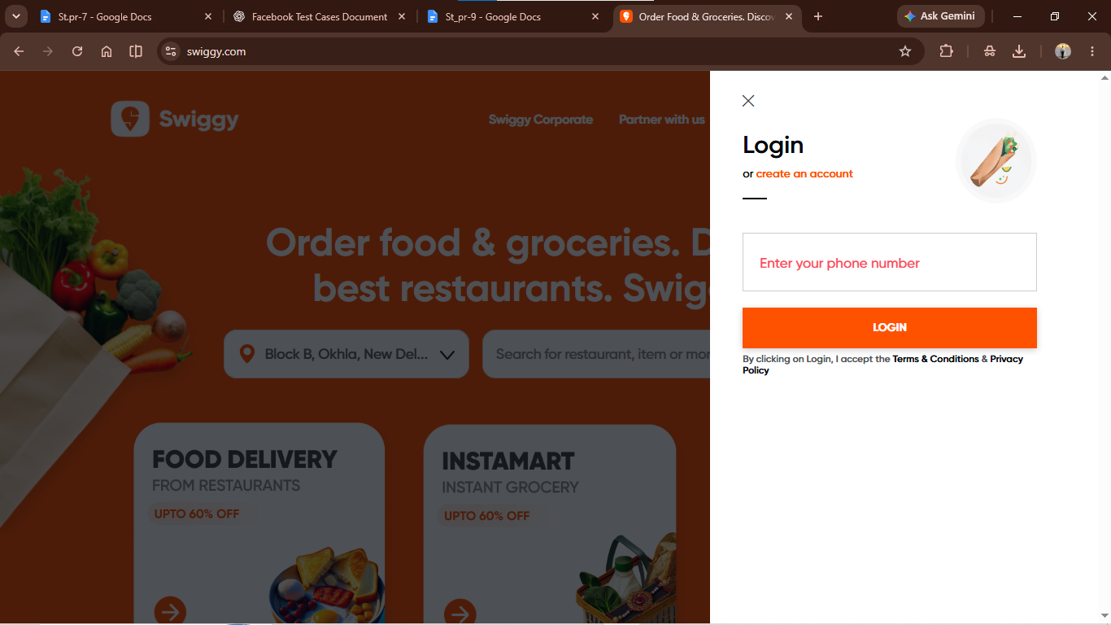

Scenario ID: 9e
Scenario: Resend OTP
Test Steps:
- Open Swiggy
- Enter mobile number
- Blank OTP
- Check error
Screenshots:
