Module Name: Expense Management Module
Test Case ID: 14
Webpage URL:https://tekpulse.in/tools/expense-tracker

Scenario 14a – Add Expense

Test Steps:
- Open PyCharm and script.py.
- Launch Chrome and open the Expense Tracker.
- Enter amount 150.
- Select Food category and enter a date.
- Enter Lunch in the note field.
- Click Add Expense.
- Verify the expense appears in the list.

Screenshots:
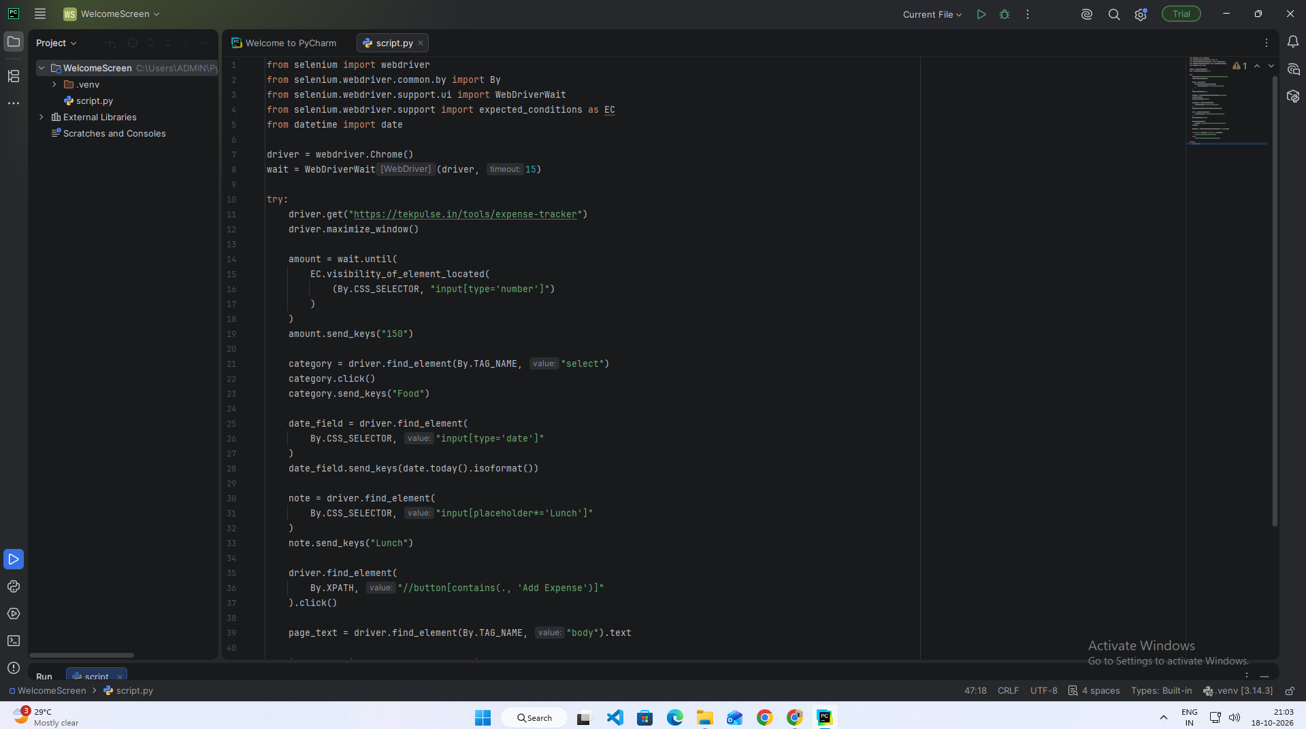
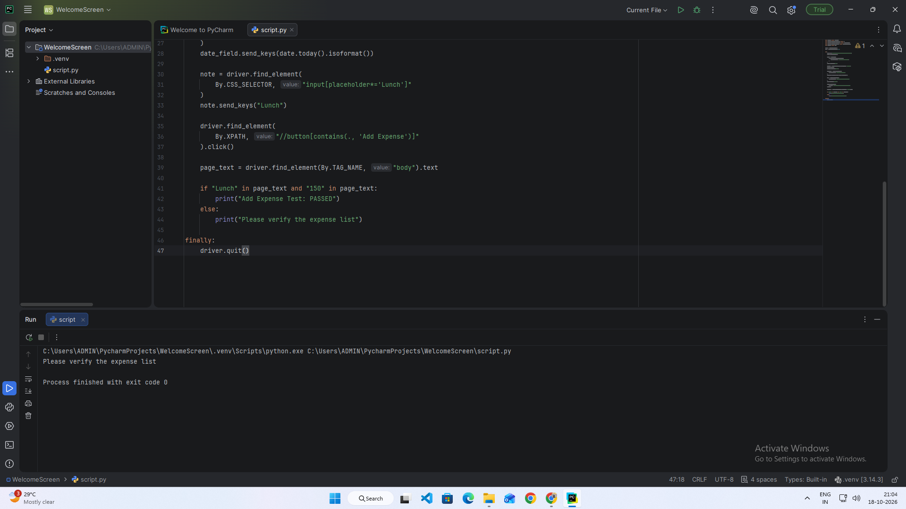

Scenario 14b – Verify Invalid Amount

Test Steps:
- Open the Expense Tracker.
- Enter zero as the amount.
- Fill the remaining required fields.
- Click Add Expense.
- Check whether the application rejects the amount.

Screenshots:
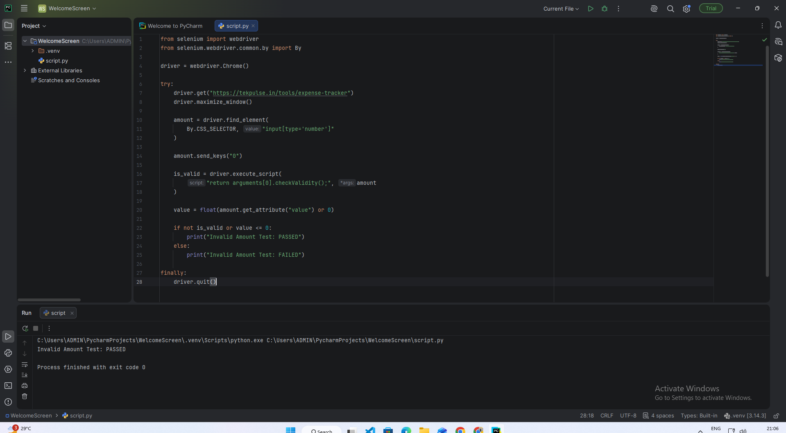

Scenario 14c – Verify Expense Category

Test Steps
- Open the PyCharm application.
- Open the existing Python automation project.
- Open script.py.
- Run the Selenium automation script.
- Open the Expense Tracker website: https://tekpulse.in/tools/expense-tracker
- Locate the expense category dropdown.
- Select the Food category.
- Verify that Food is selected.
- Display the test result in the console.
- Close the browser.
Screenshots:
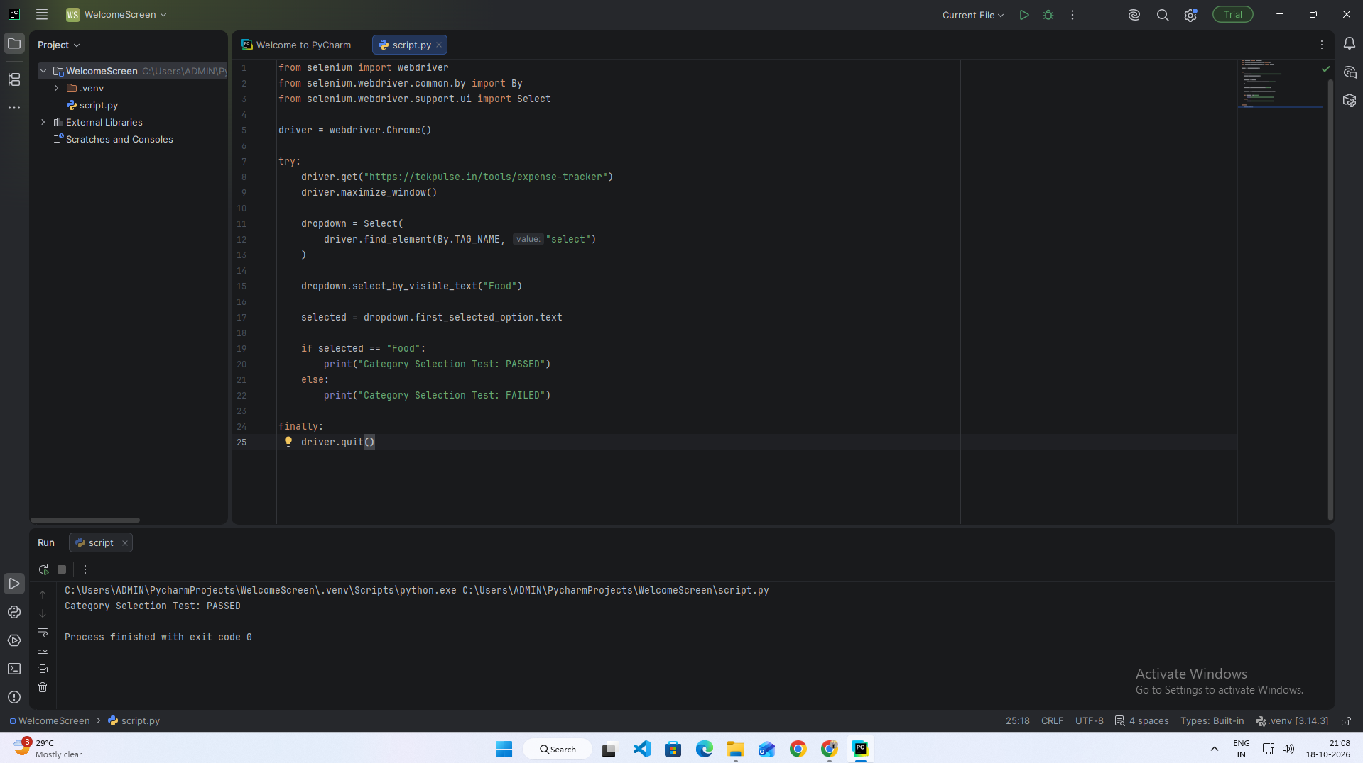
Scenario 14d – Delete an Expense
Test Steps:
- Open the Expense Tracker.
- Add a test expense.
- Locate its delete button.
- Click the delete button.
- Verify that the expense is removed.
Screenshots:
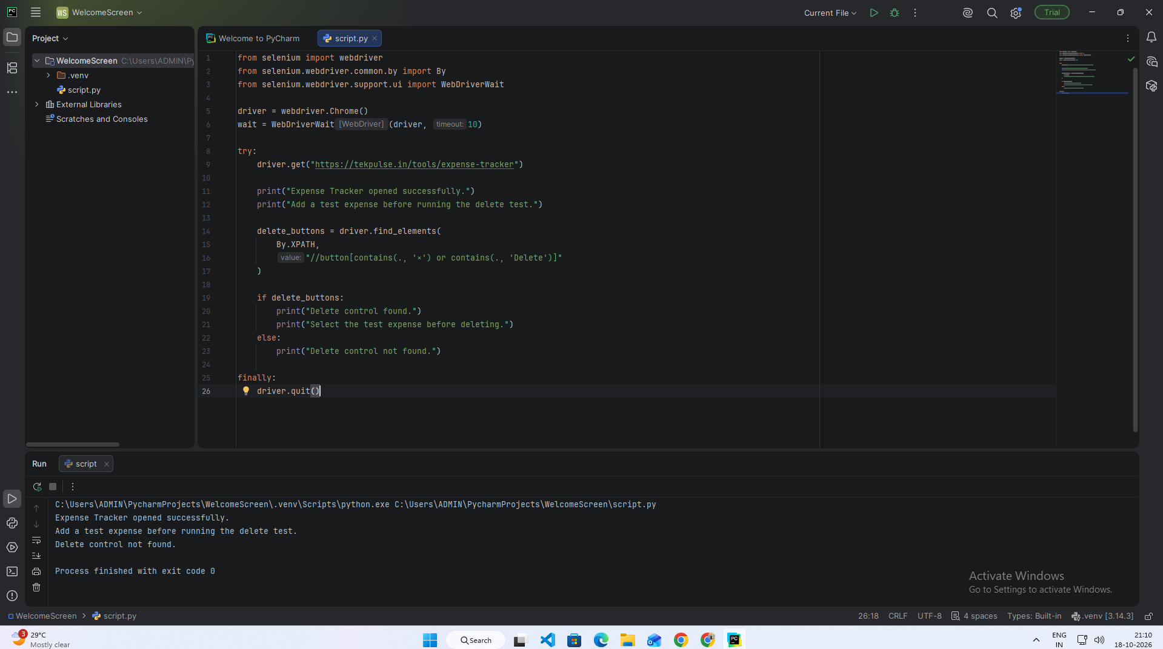
Scenario 14e – Verify Monthly Expense Total

Test Steps
- Open the PyCharm application.
- Open the existing Python automation project.
- Open script.py.
- Run the Selenium automation script.
- Open the Expense Tracker website: https://tekpulse.in/tools/expense-tracker
- Wait for the webpage to load completely.
- Locate the monthly expense summary.
- Verify that the “Total This Month” section is displayed.
- Display the test result in the console.
- Close the browser.
Screenshots:
