Module Name: Login Page - Functional & UI Test Cases
Test Case ID: st_10
Webpage URL: https://mail.google.com/

Scenario ID: 10a
Scenario: Login with valid credentials
Test Steps:
- Open Gmail
- Enter email
- Enter password
- Click Login
Screenshots:
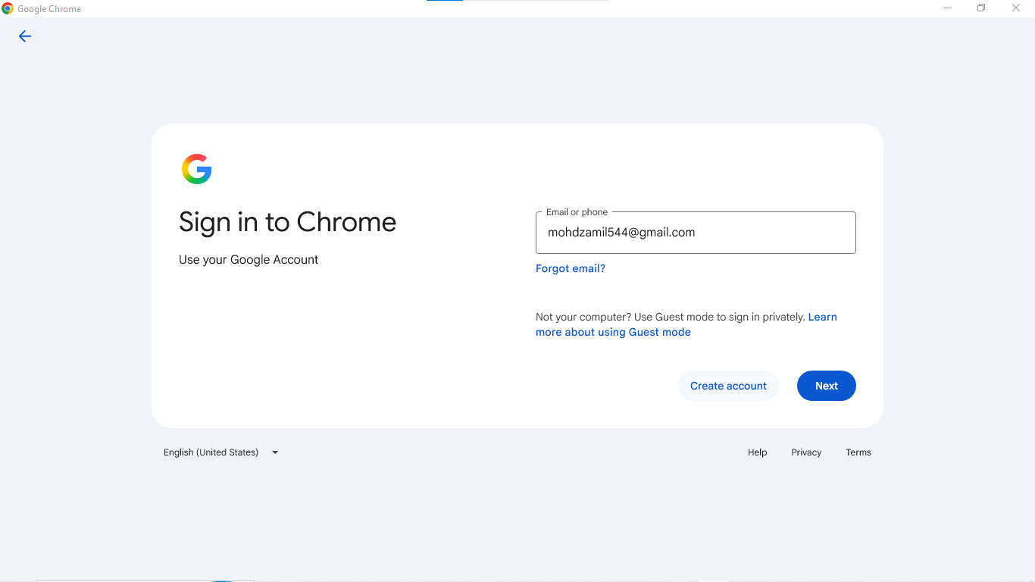
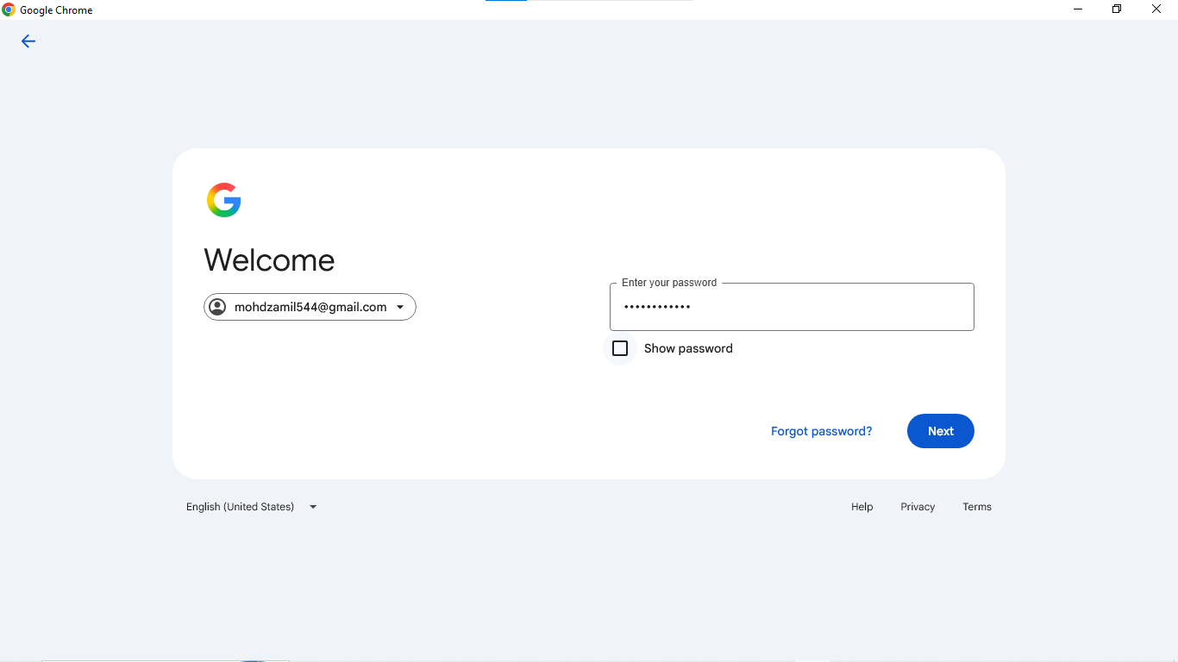
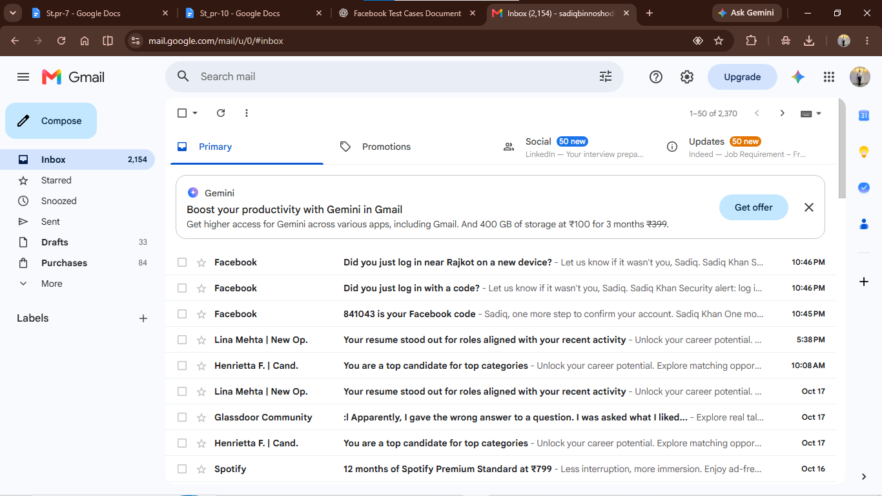

Scenario ID: 10b
Scenario: Login with invalid email
Test Steps:
- Open Gmail
- Enter invalid email
- Enter password
- Click Login

Screenshots:
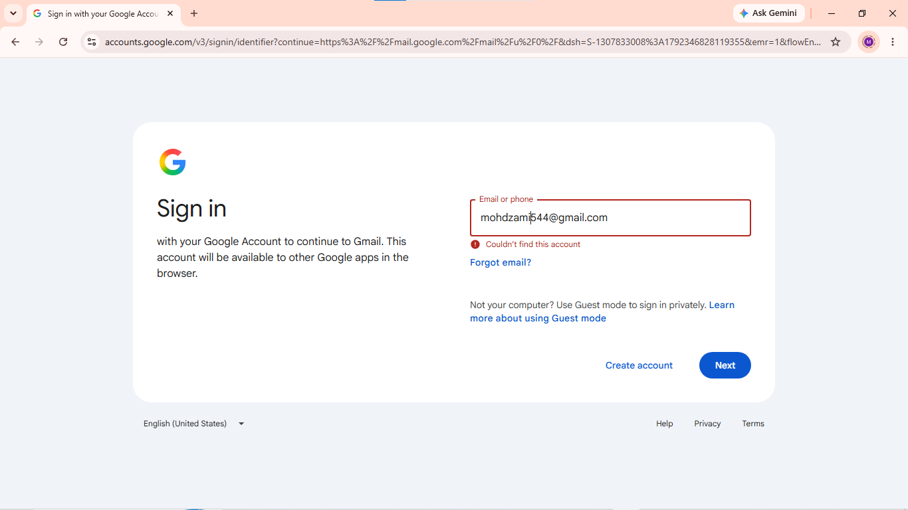

Scenario ID: 10c
Scenario: Login with wrong password
Test Steps:
- Open Gmail
- Enter email
- Enter wrong password
- Click Login

Screenshots:
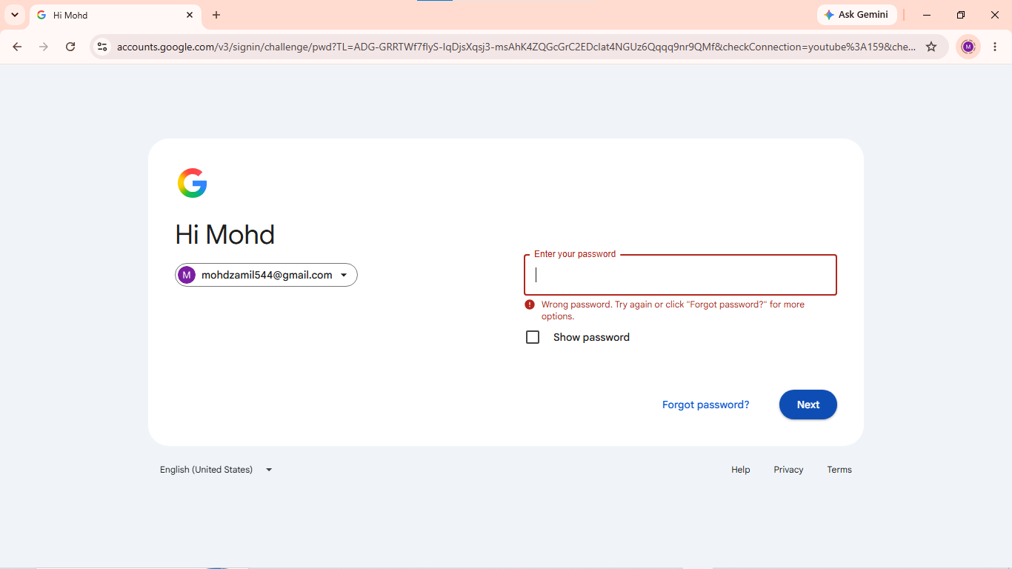

Scenario ID: 10d
Scenario: Login with blank fields
Test Steps:
- Open Gmail
- Leave email blank
- Leave password blank
- Click Login

Screenshots:
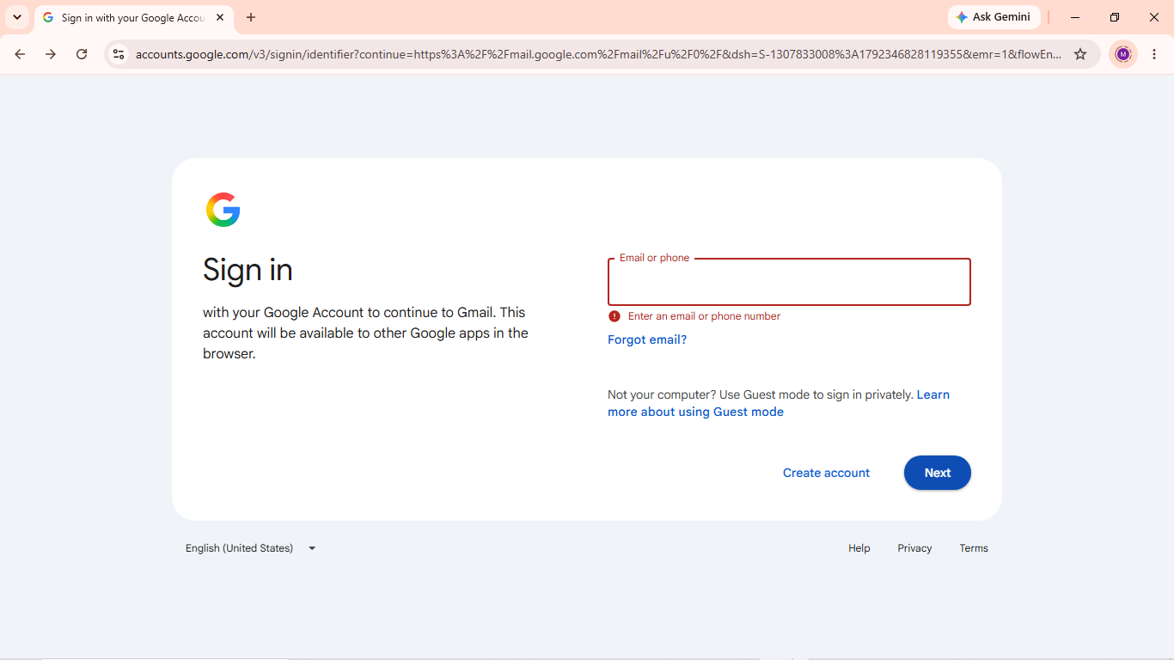
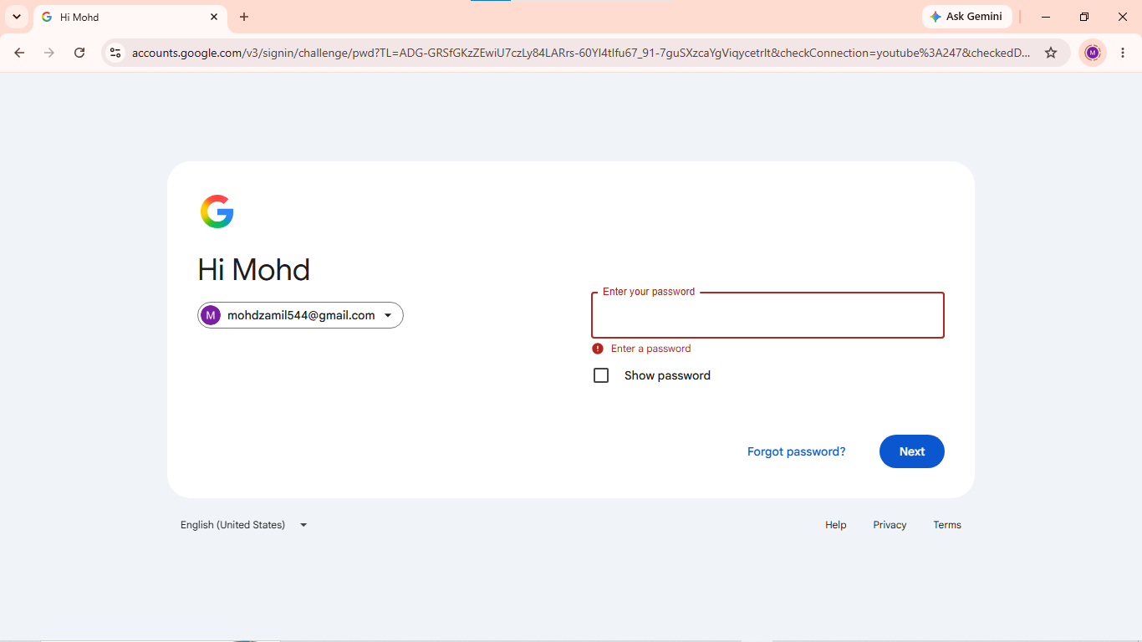

Scenario ID: 10e
Scenario: Forgot Password
Test Steps:
- Open Gmail
- Click Forgot Password
- Enter email
- Click Next
Screenshots:

