Module Name: Login and Navigation Module
Test Case ID: 11
Webpage URL: https://the-internet.herokuapp.com/

- Scenario 11a

Scenario - Valid Login
Test Steps:
- Open PyCharm and script.py.
- Open the website.
- Click Form Authentication.
- Enter username and password.
- Click Login and verify the success message.
- Click Logout and close the browser.
Screenshots:
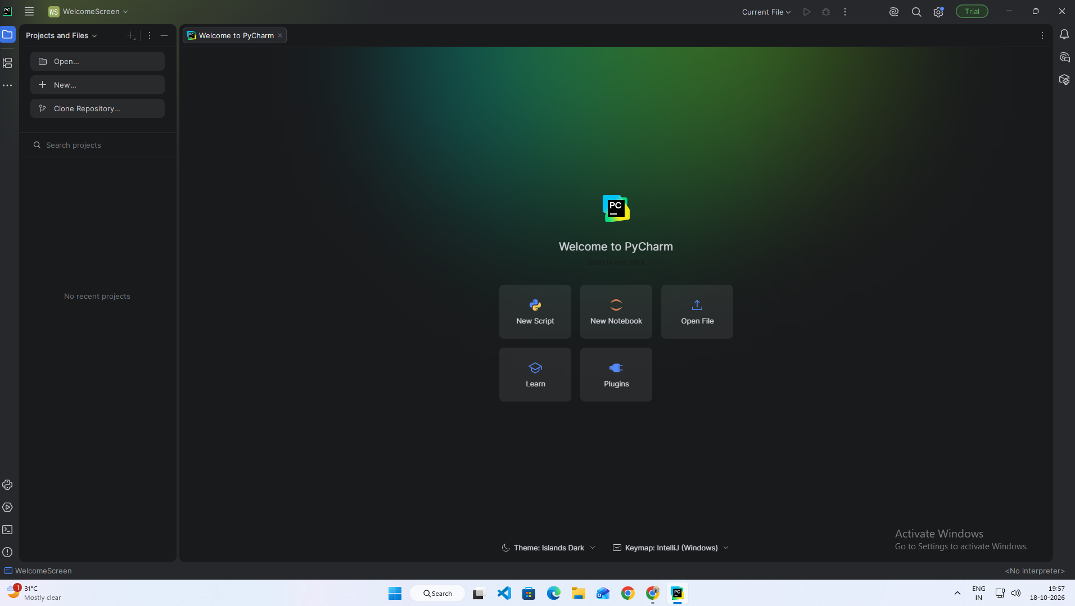

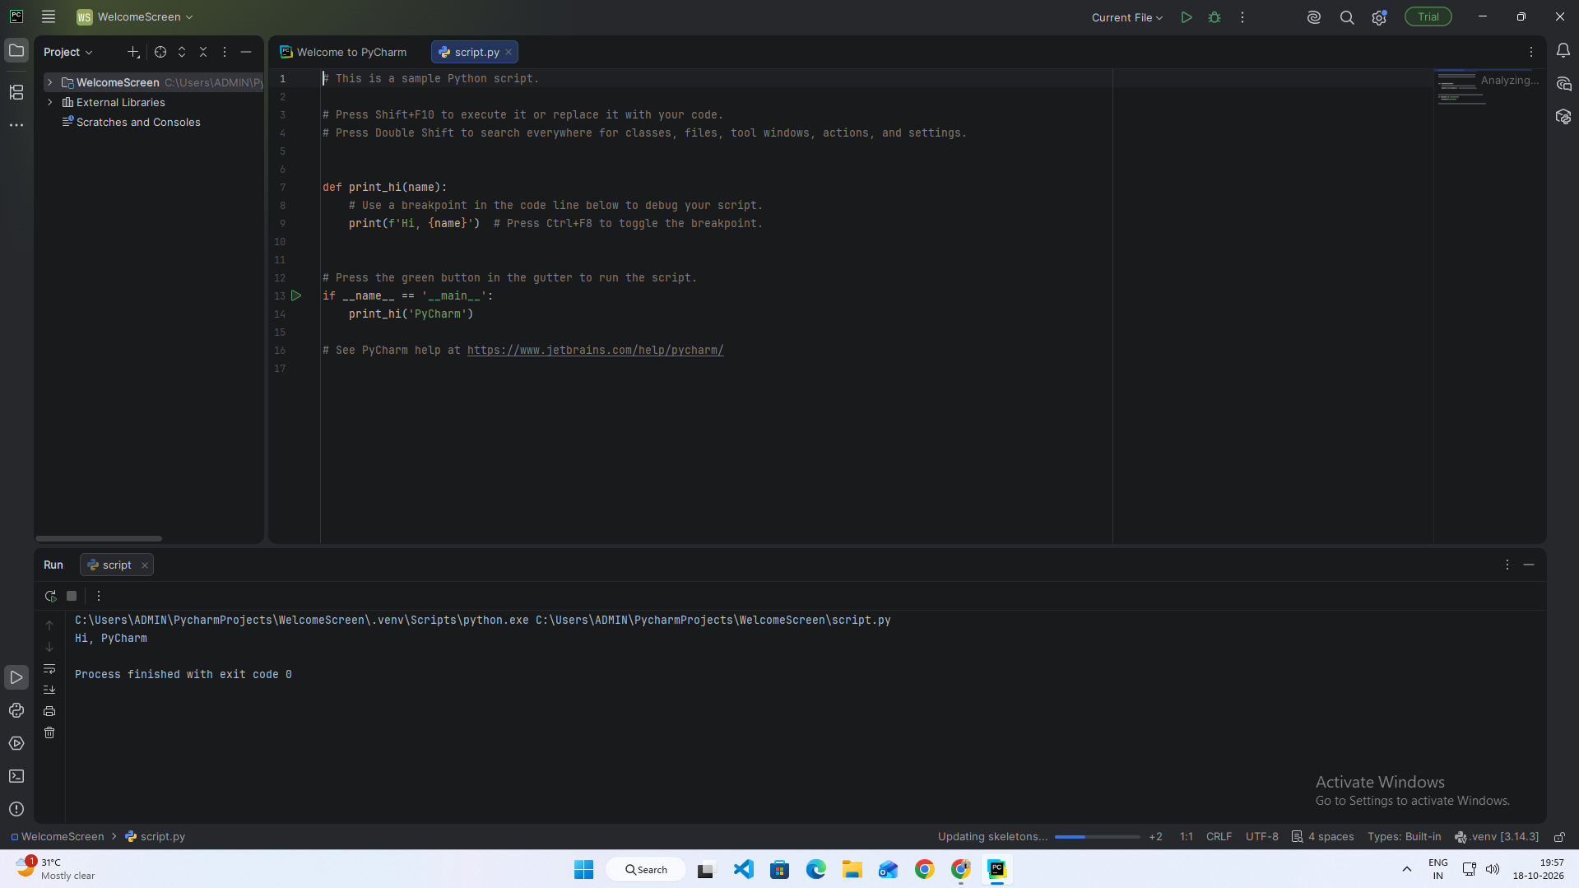
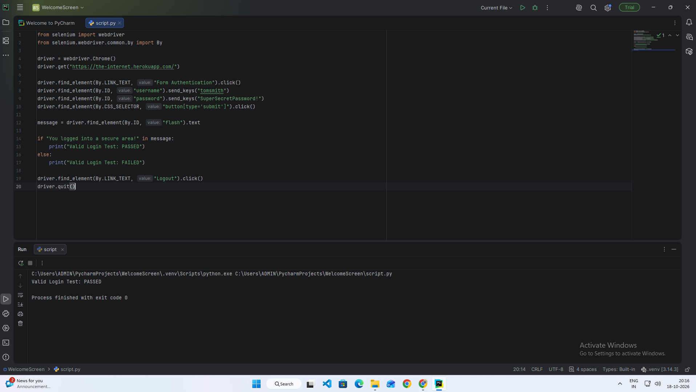

- Scenario 11b

Scenario - Checkboxes Selection
Test Steps:
- Open the website.
- Click Checkboxes.
- Identify both checkboxes.
- Select the first checkbox.
- Deselect the second checkbox.
- Verify and display the results.
Screenshots:
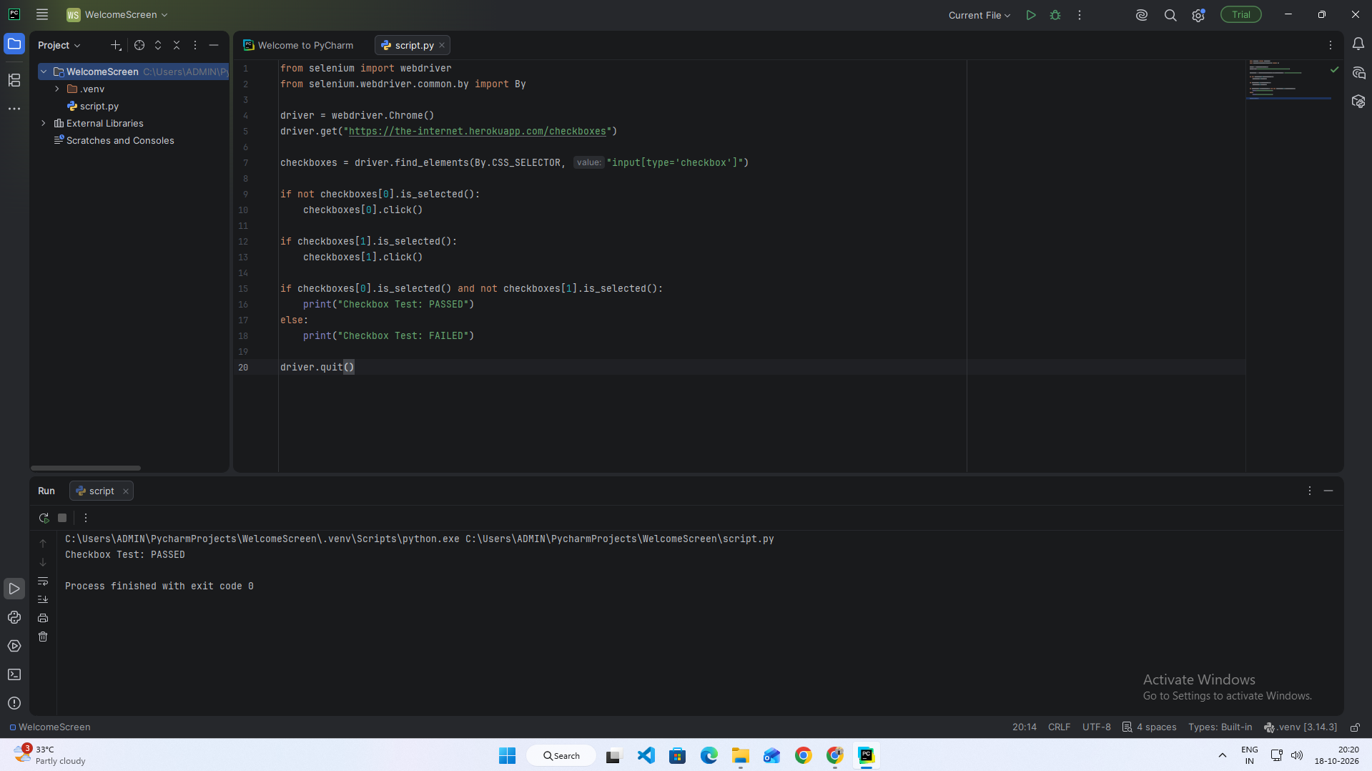
- Scenario 11c
Scenario - Dropdown Selection

Test Steps:
- Open the website.
- Click Dropdown.
- Locate the dropdown list.
- Select Option 1.
- Verify the selected option.
- Display the result and close the browser.
Screenshots:

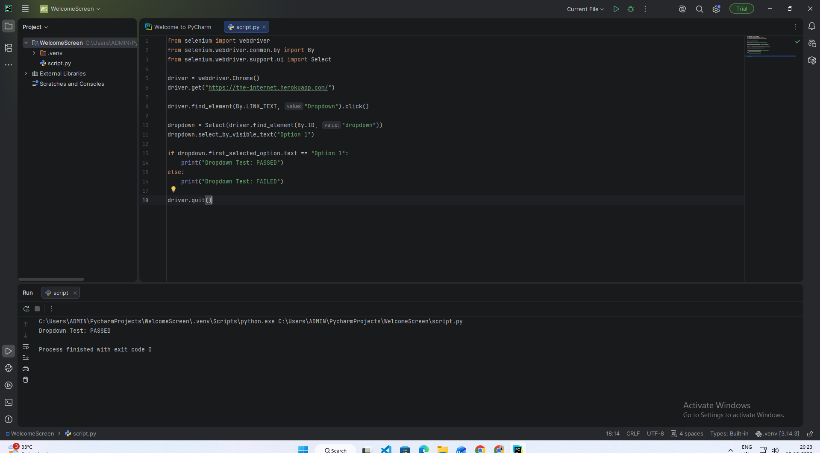

- Scenario 11d
Scenario - Multiple Window Navigation

Test Steps:
- Open the website.
- Click Multiple Windows.
- Click Click Here.
- Switch to the new window.
- Verify the text New Window.
- Switch back to the original window and close the browser.
Screenshots:

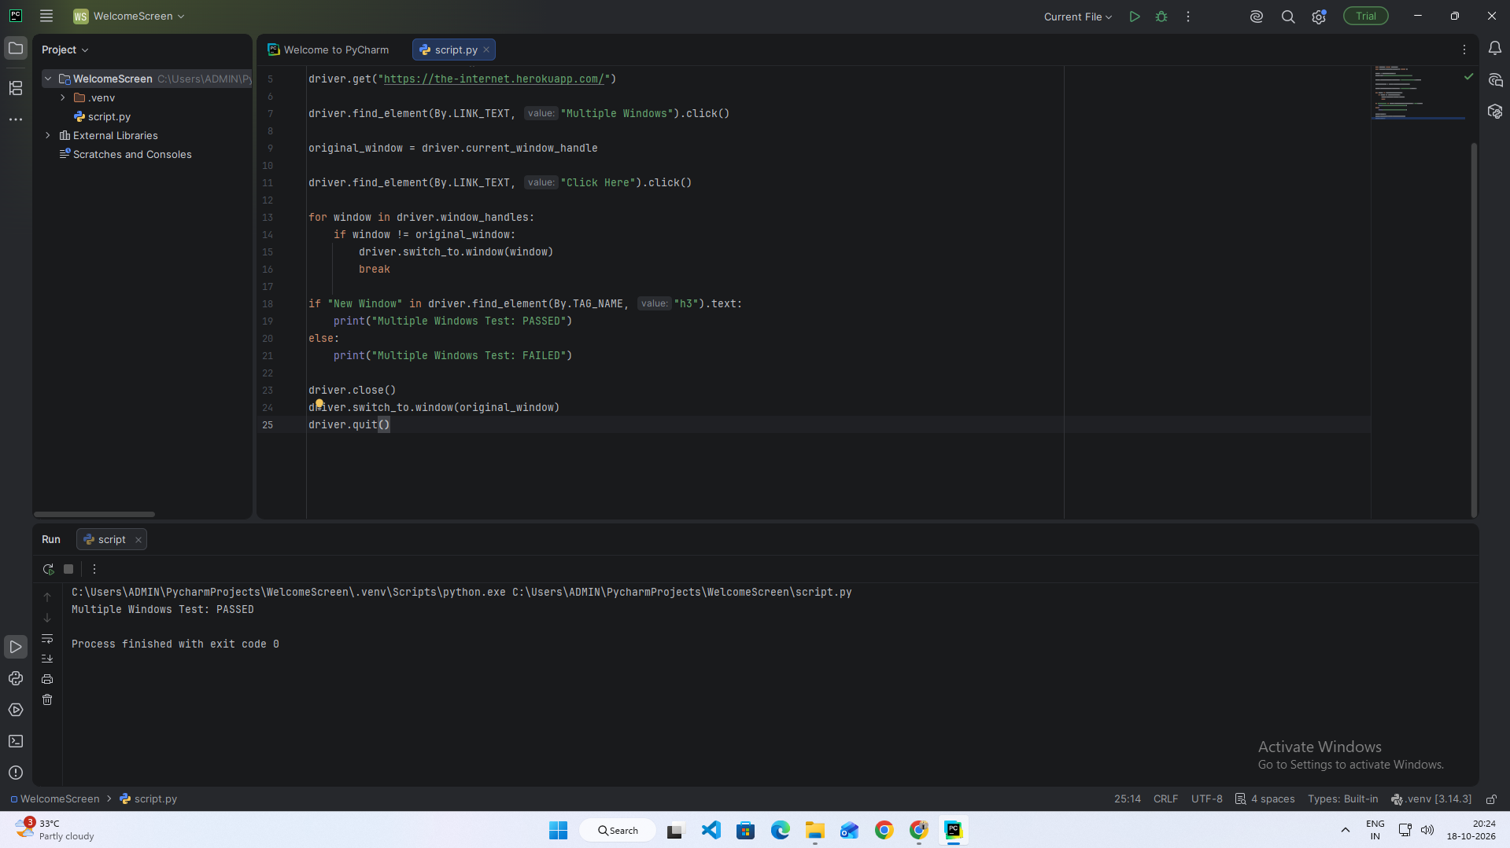
- Scenario 11e

Scenario - Regression Testing of Automated Test Scenarios

Test Steps:
- Open PyCharm and the existing project.
- Run the regression testing script.
- Verify the login scenario.
- Verify the checkboxes scenario.
- Verify the dropdown scenario.
- Verify the multiple-windows scenario.
- Check the results in the console.
- Close the browser.
Screenshots:

