Module Name: Weather Search Module
Test Case ID: 13
Webpage URL: https://www.timeanddate.com/weather/india/ahmedabad

Scenario 13a – Open Weather Website
Test Steps:
- Open PyCharm and script.py.
- Import Selenium WebDriver.
- Launch Chrome browser.
- Open the weather website.
- Verify the page title.
- Display the test result and close the browser.
Screenshots:
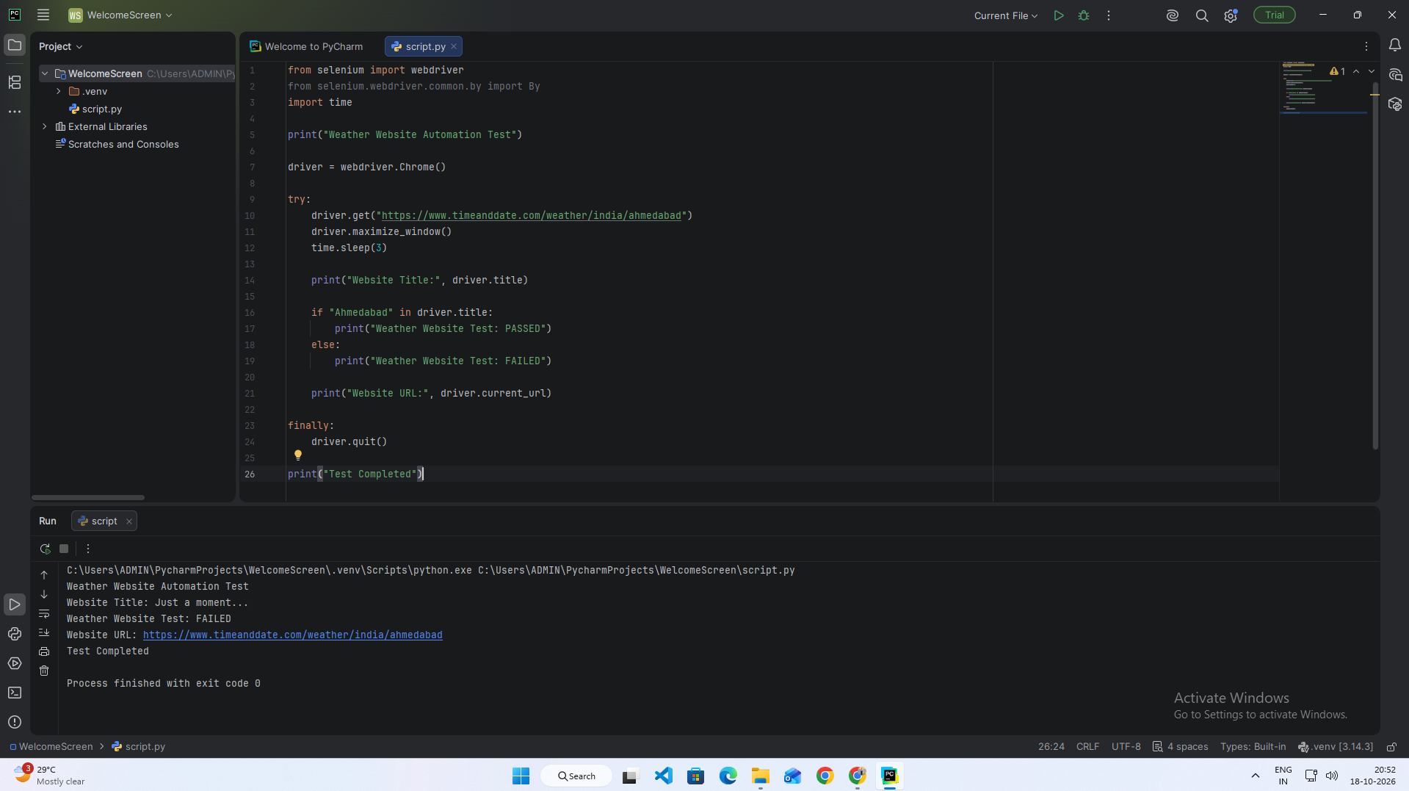

Scenario 13b – Verify Ahmedabad Weather Page
Test Steps:
- Launch Chrome.
- Open the Ahmedabad weather page.
- Wait for the page to load.
- Read the page title and content.
- Verify that Ahmedabad appears on the page.
- Display the result.
Screenshots:
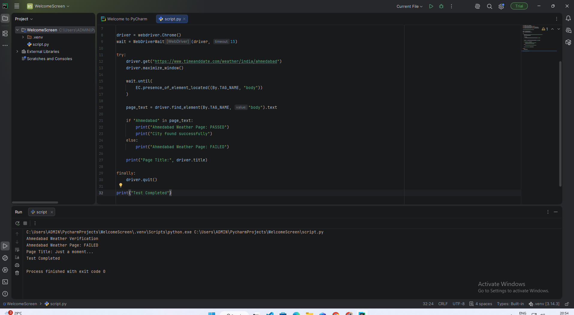
Scenario 13c – Verify Weather Page Content
Test Steps:
- Open the weather page.
- Wait until the page body loads.
- Read the visible page text.
- Check that the page contains weather-related information.
- Print PASS or FAIL.
- Close the browser.
Screenshots:
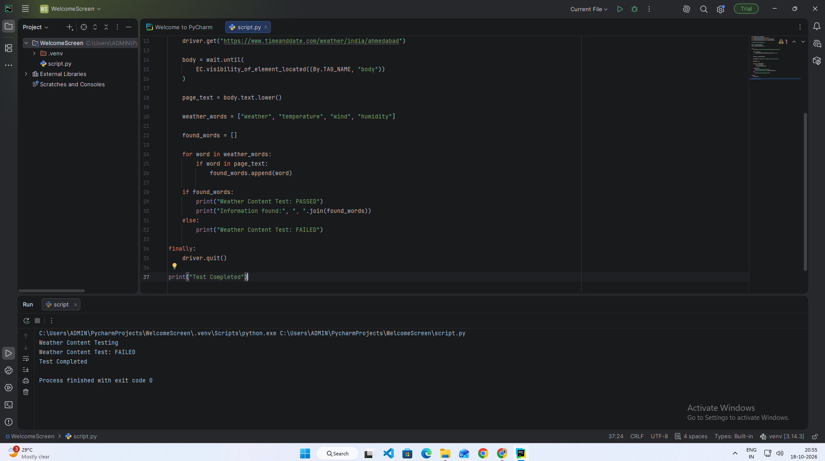
Scenario 13d – Verify Invalid City Handling
Test Steps:
- Enter an invalid city name.
- Validate the city input.
- Display an error if the city is invalid.
- Display the test result.
Screenshots:
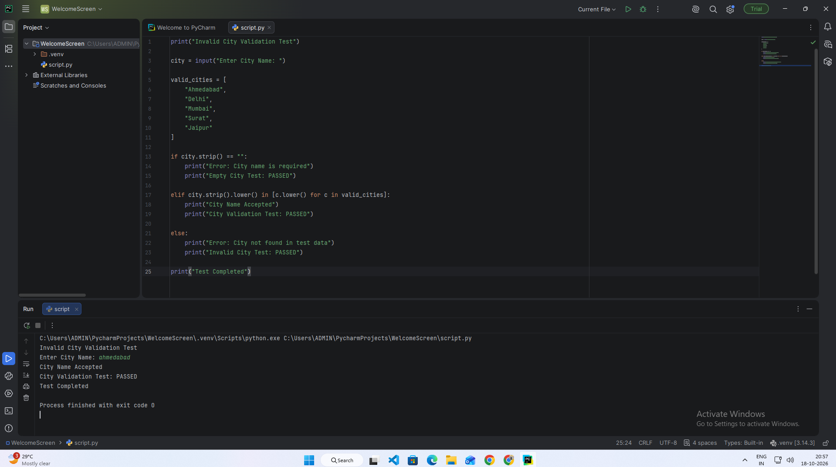

Scenario 13e – Regression Testing of Weather Scenarios
Test Steps:
- Open the weather page.
- Verify the page title.
- Check the city name.
- Check weather-related page content.
- Display each test result.
- Close the browser.
Screenshots:
