Module Name: Login Authentication Module
Test Case ID: 15
Webpage URL: https://the-internet.herokuapp.com/login

Scenario 15a – Valid Login

Test Steps:
- Open PyCharm and script.py.
- Launch Chrome browser.
- Open the login website.
- Enter valid username and password.
- Click Login.
- Verify the success message.
- Click Logout and close the browser.

Screenshots:
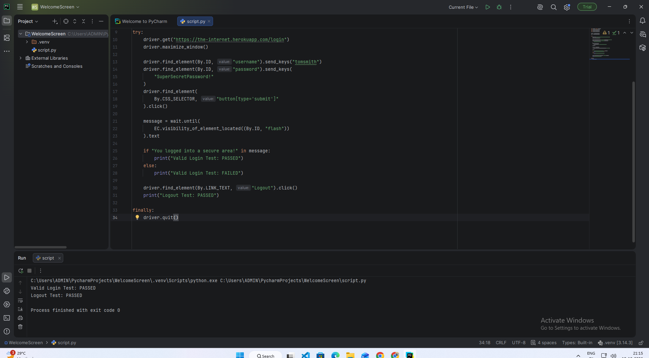
Scenario 15b – Invalid Password
Test Steps:
- Open the login website.
- Enter the valid username.
- Enter an incorrect password.
- Click Login.
- Verify that an error message appears.
- Close the browser.
Screenshots:
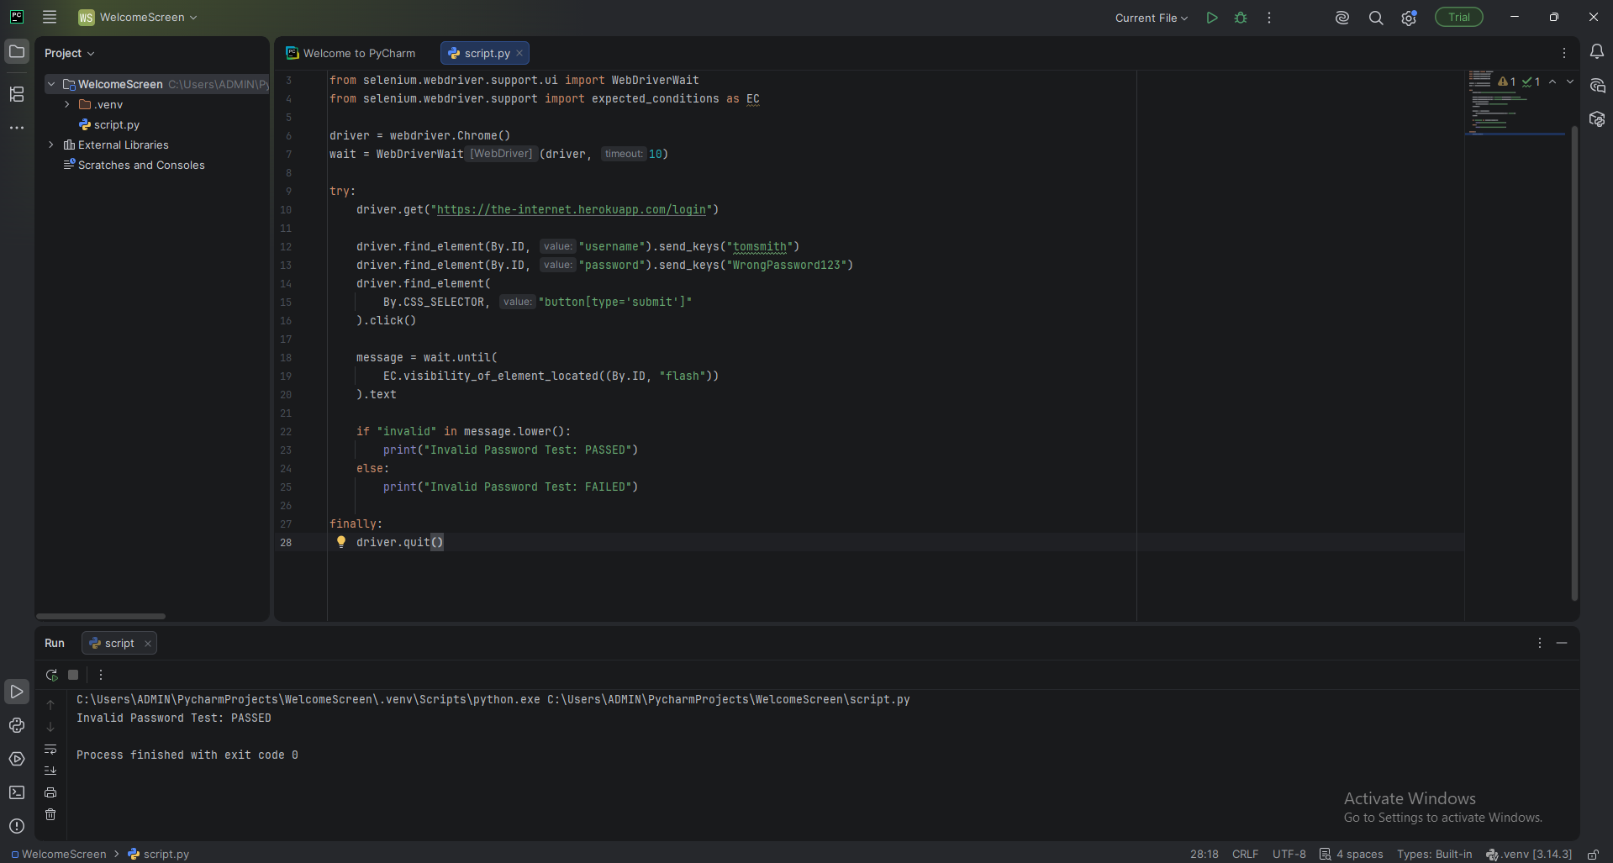

Scenario 15c – Blank Login Fields
Test Steps:
- Open the login website.
- Leave the username field blank.
- Leave the password field blank.
- Click Login.
- Verify that access is denied.
- Display the test result.
Screenshots:
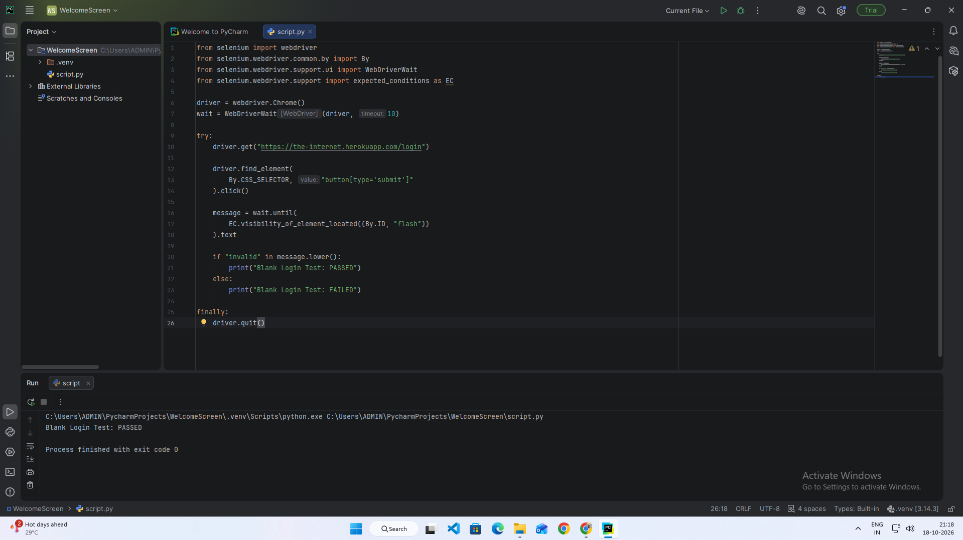
Scenario 15d – Invalid Username

Test Steps:
- Open the login website.
- Enter an incorrect username.
- Enter the correct password.
- Click Login.
- Verify the error message.
- Close the browser.
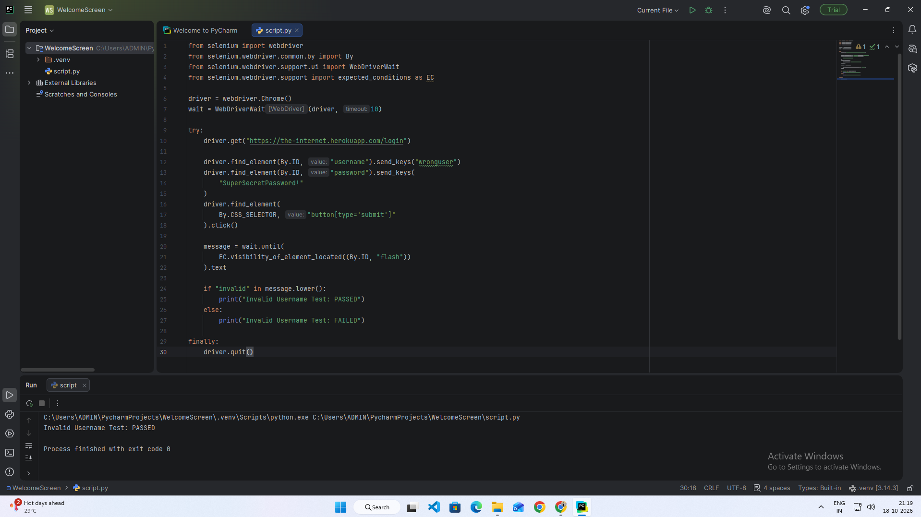
Scenario 15e – Regression Testing of Login Scenarios

Test Steps:
- Open PyCharm and the existing project.
- Run the regression testing script.
- Verify valid login.
- Verify invalid password.
- Verify blank login fields.
- Check the results in the console.
- Close the browser.
Screenshots:
