Module Name: Ticket Booking Testing Module
Test Case ID: 12
Website URL: https://www.irctc.co.in/nget/train-search

Scenario 12a – Valid Passenger Details
Test Steps:
- Open PyCharm and script.py.
- Enter valid passenger details.
- Enter source and destination.
- Enter a valid journey date.
- Verify all fields.
- Display the test result.
Screenshots:
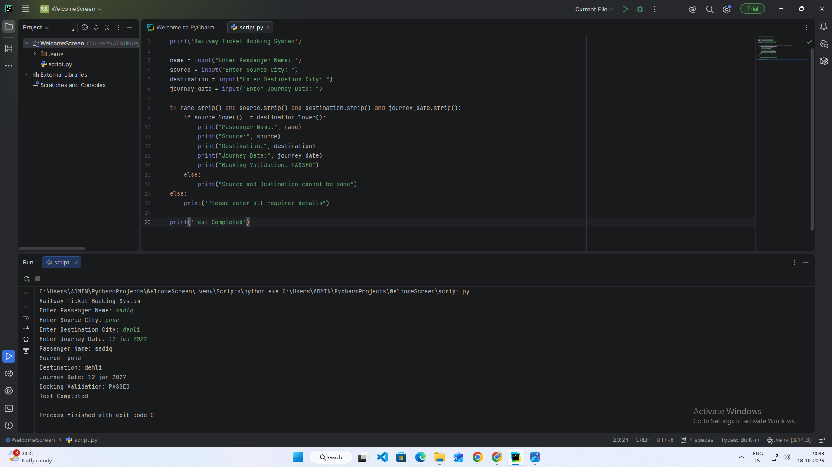

Scenario 12b – Missing Passenger Name
Test Steps:
- Enter a blank passenger name.
- Enter valid source and destination.
- Enter the journey date.
- Verify passenger-name validation.
- Display the result.
Screenshots:
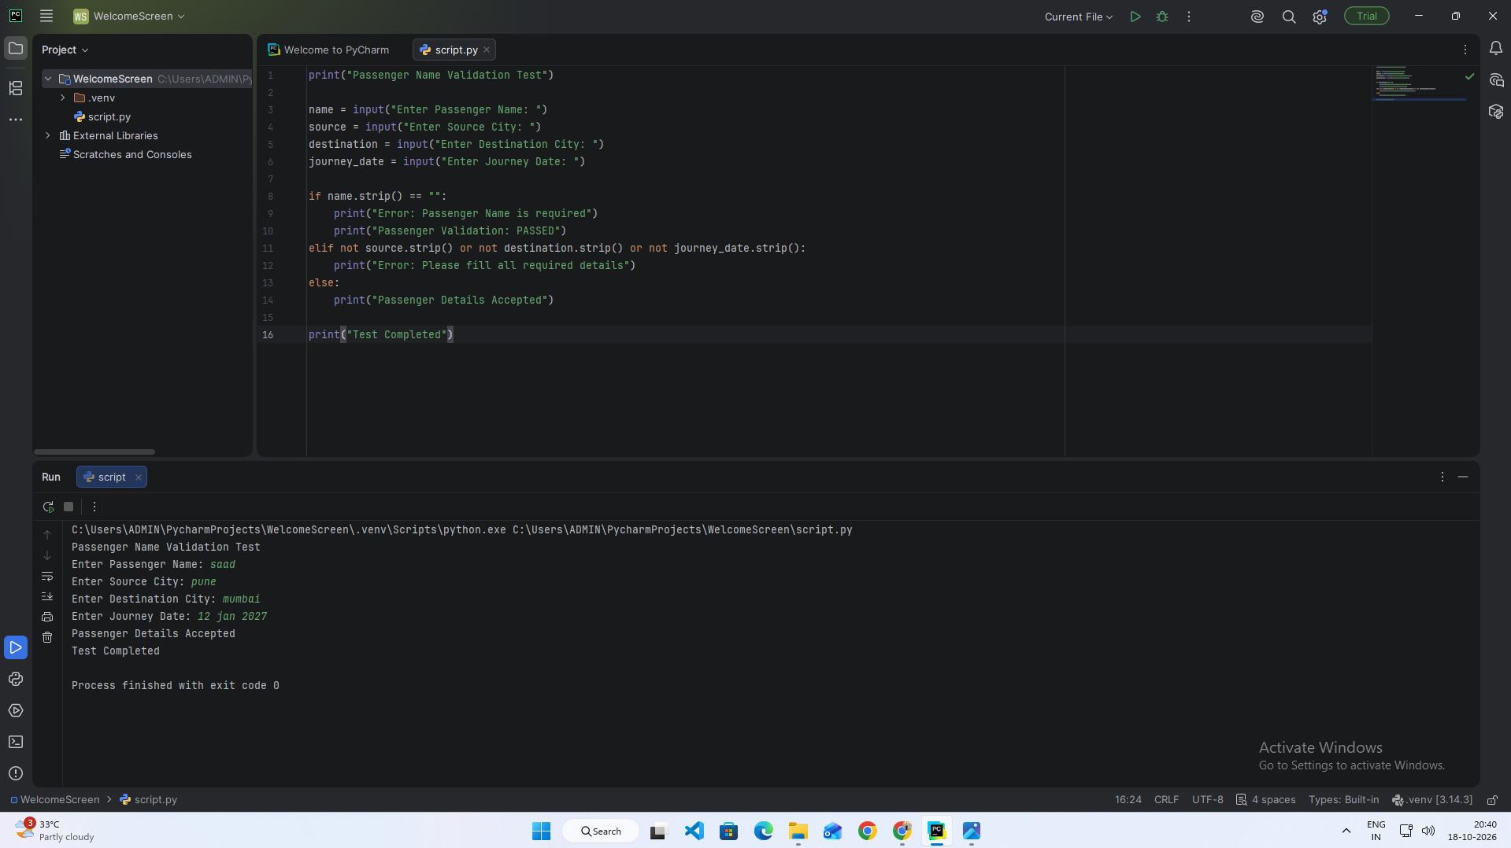

Scenario 12c – Same Source and Destination
Test Steps:
- Enter passenger name.
- Enter the same city as source and destination.
- Verify the validation.
- Display the result.
Screenshots:
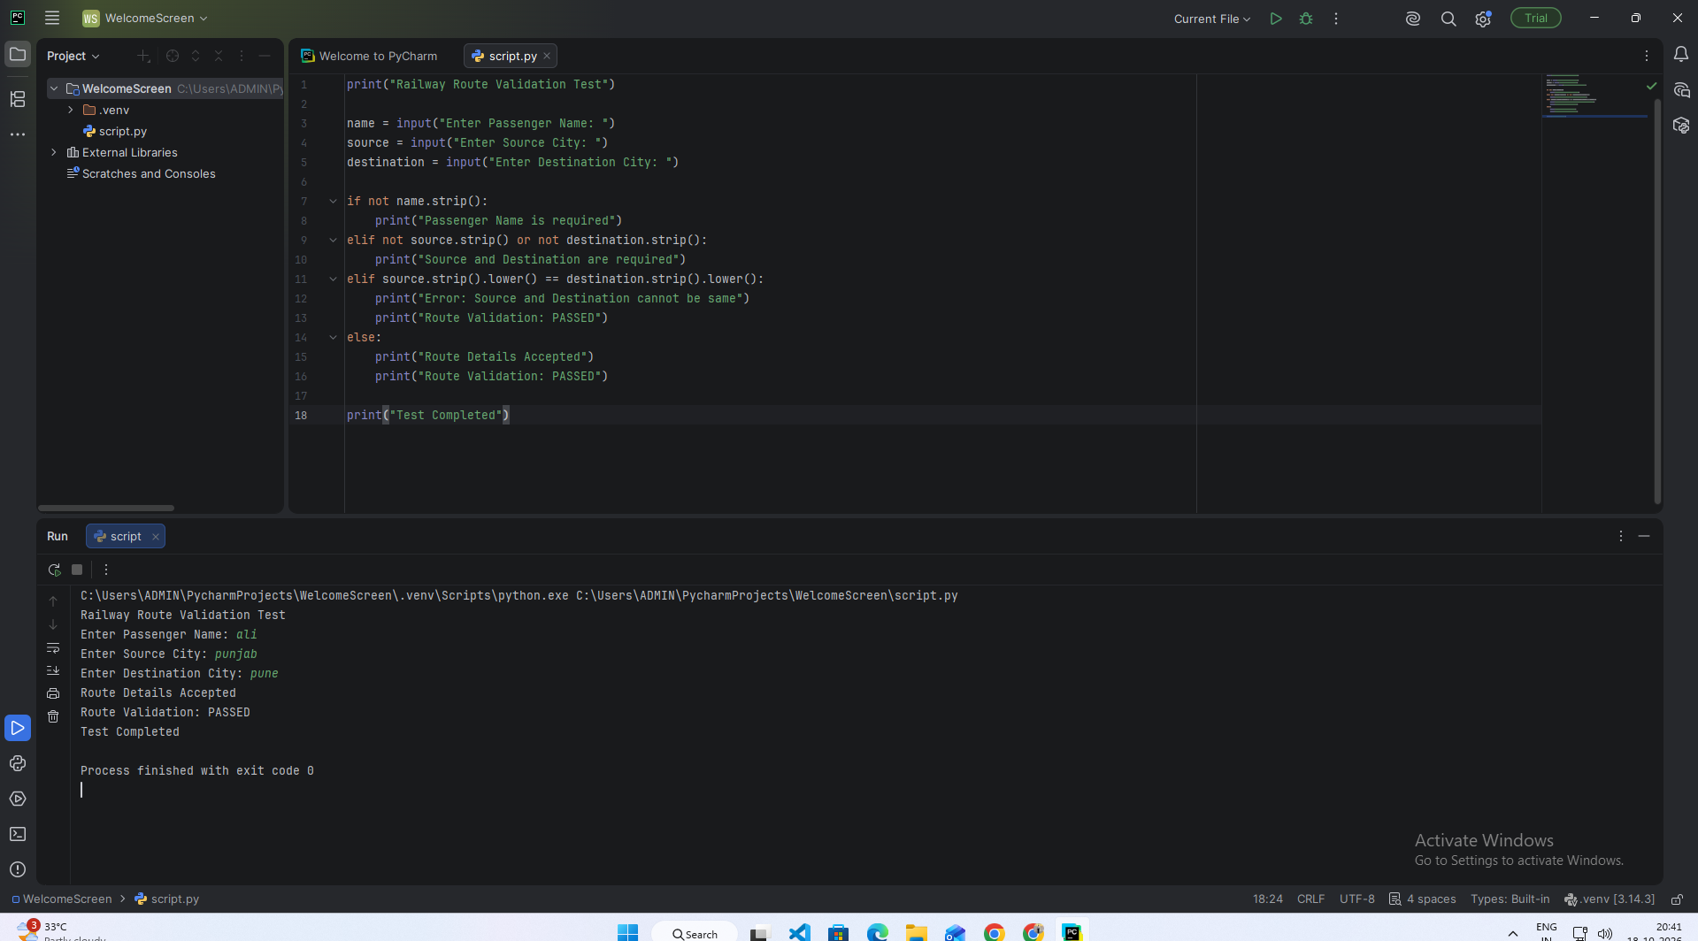

Scenario 12d – Missing Journey Date
Test Steps:
- Enter passenger name.
- Enter source and destination.
- Leave journey date blank.
- Verify date validation.
- Display the result.
Screenshots:
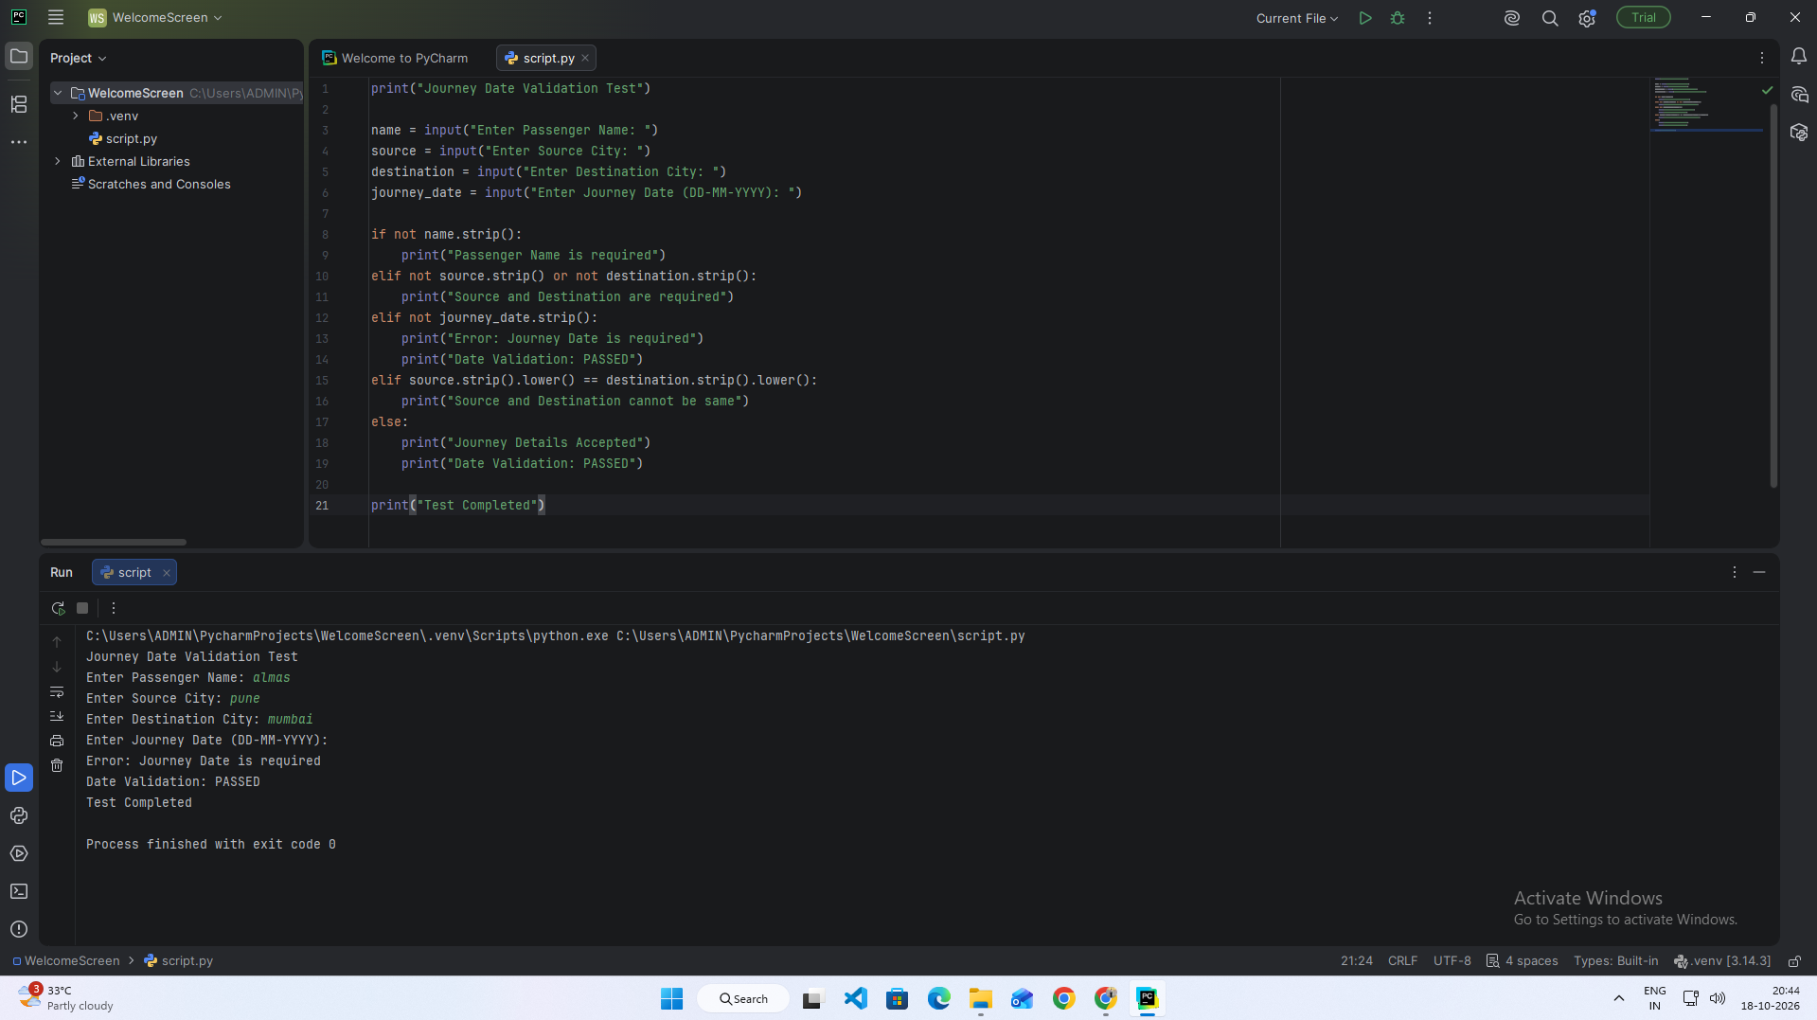

Scenario 12e – AI-Generated Test Cases
Test Steps:
- Prepare railway booking requirements.
- Use an AI tool to suggest positive and negative test cases.
- Review the generated test cases.
- Check valid and invalid booking data.
- Display the test result.

Screenshots:
