Module Name: Login Page - Functional & UI Test Cases
Test Case ID: st_02
Webpage URL:https://www.instagram.com/

Scenario ID: 2a
Scenario: Login with valid credentials
Test Steps:
1. Open Instagram
2. Enter username/email
3. Enter password
4. Click Log In
Screenshots:
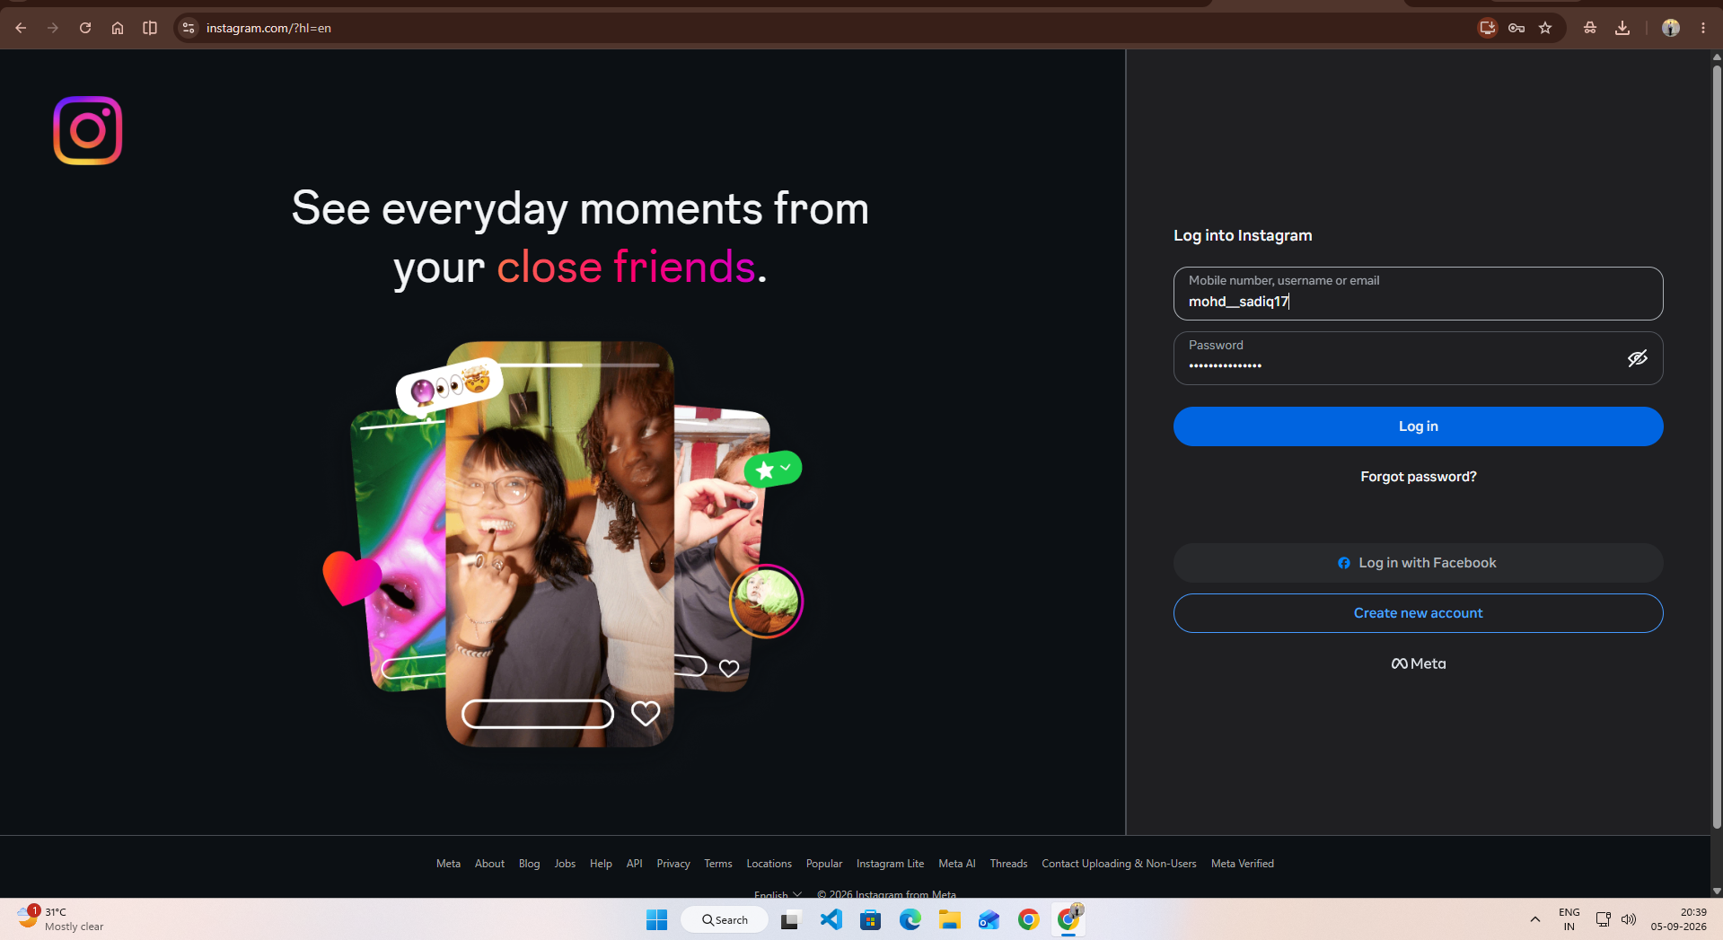
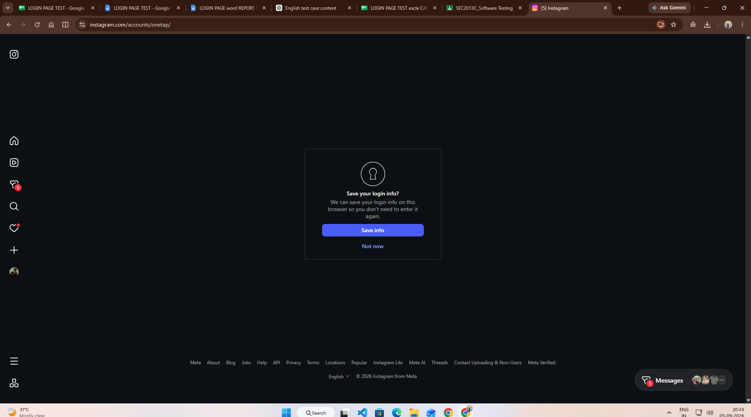

Scenario ID: 2b
Scenario: Login with wrong password
Test Steps:
1. Open Login page
2. Enter valid username
3. Enter incorrect password
4. Click Log In
Screenshots:
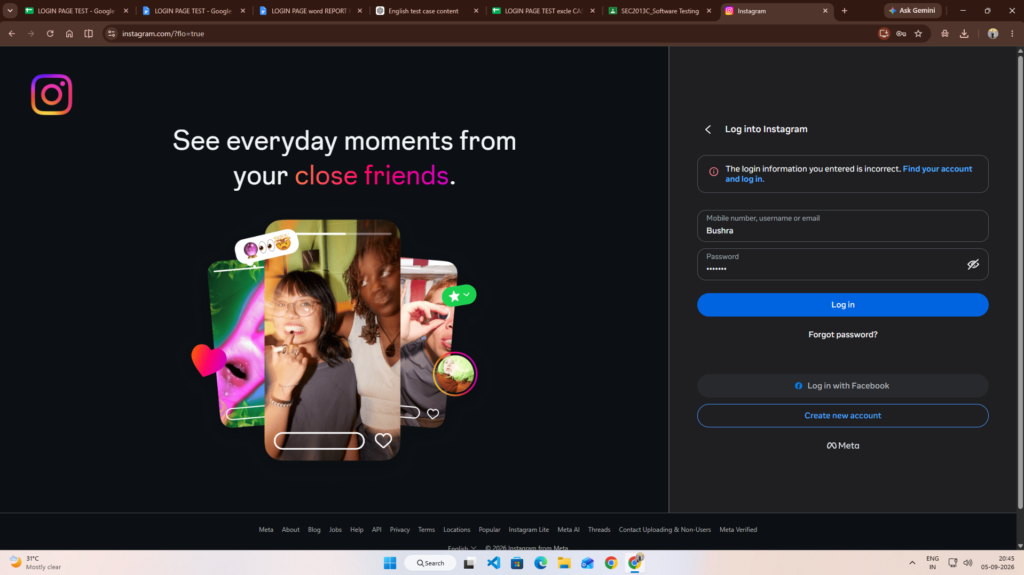

Scenario ID: 2c
Scenario: Login with invalid username
Test Steps:
1. Open Login page
2. Enter invalid username
3. Enter password
4. Click Log In
Screenshots:
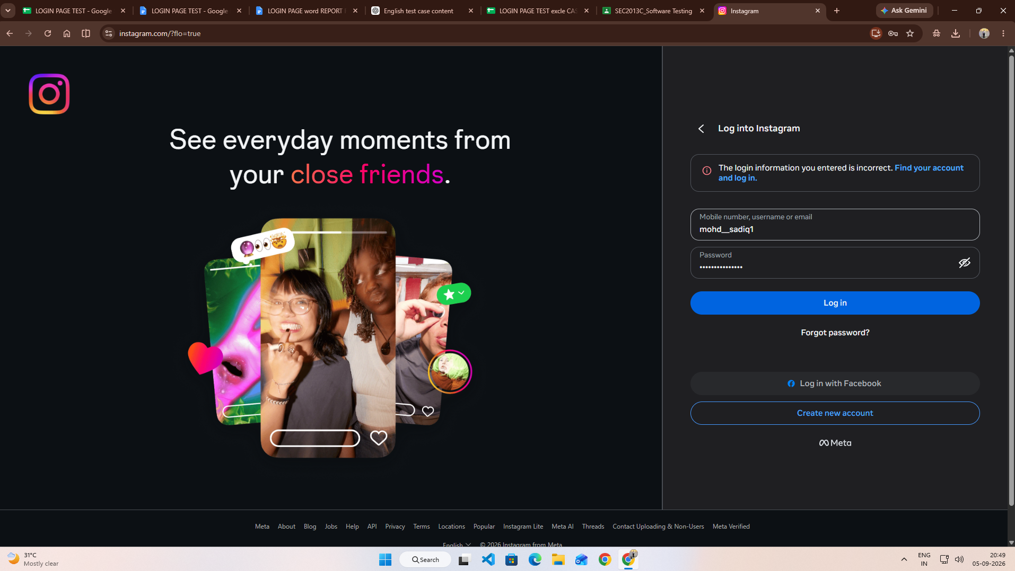

Scenario ID: 2d
Scenario: Login with empty fields
Test Steps:
1. Open Login page
2. Leave username empty
3. Leave password empty
4. Click Log In
Screenshots:
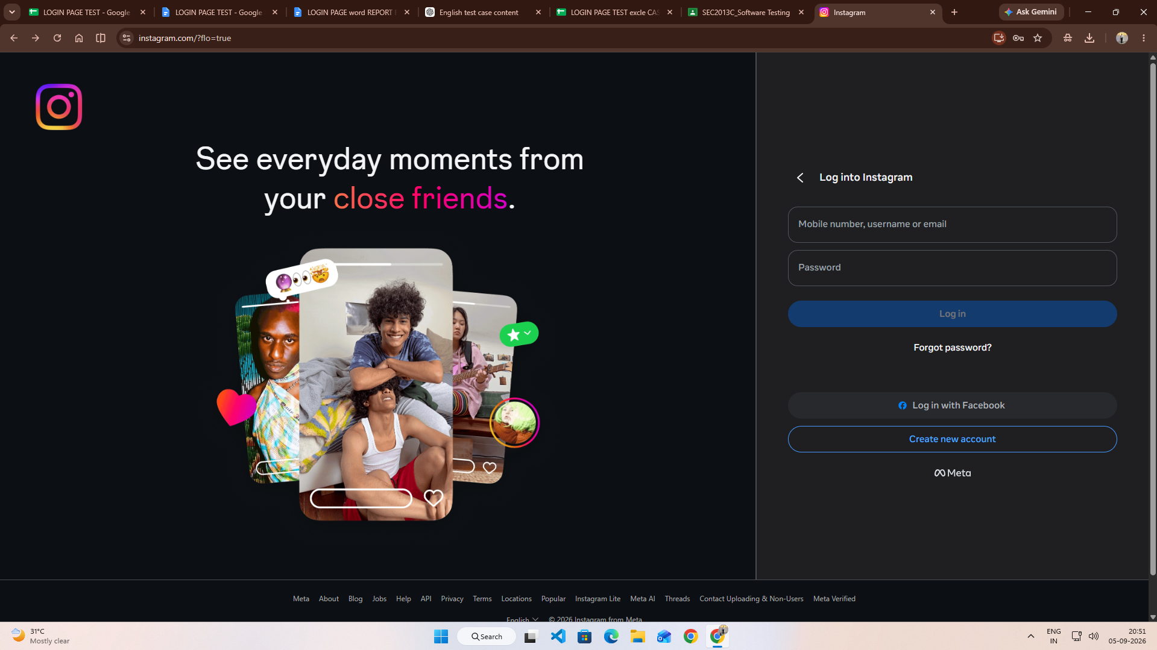

Scenario ID: 2e
Scenario: Check password visibility
Test Steps:
1. Open Login page
2. Enter password
3. Click password visibility icon
Screenshots:
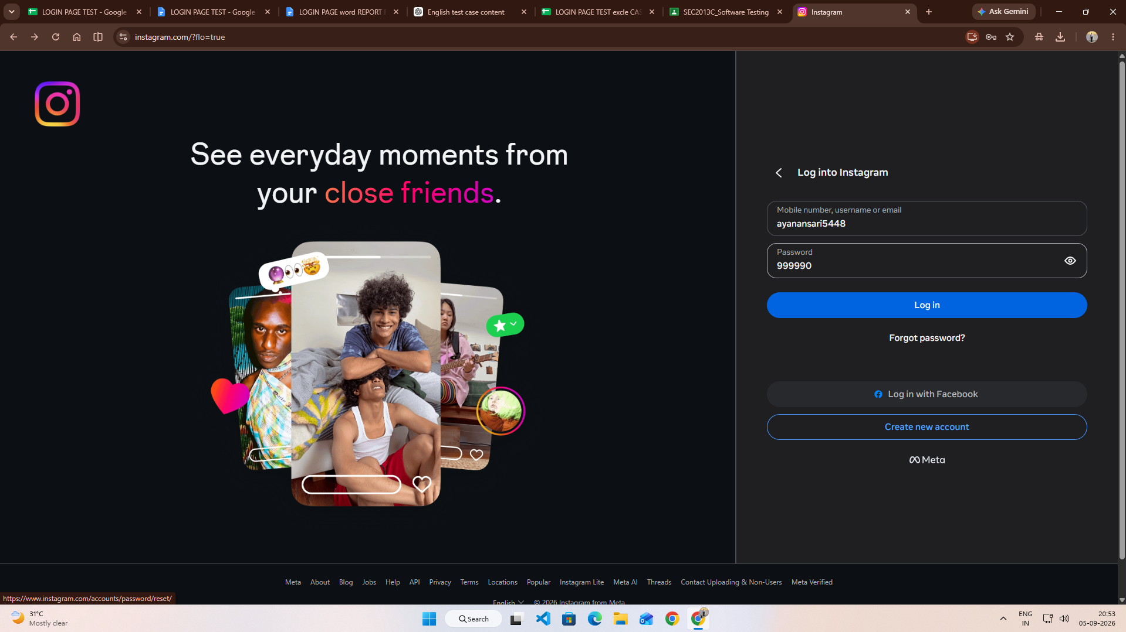

Scenario ID: 2f
Scenario: Check Forgot Password
Test Steps:
1. Open Login page
2. Click Forgot Password
3. Enter username/email
4. Continue
Screenshots:
