Module Name: Login Page - Functional & UI Test Cases
Test Case ID: st_03
Webpage URL:https://www.linkedin.com/

Scenario ID: 3a
Scenario: Login with valid credentials
Test Steps:
1. Open LinkedIn
2. Enter email/phone
3. Enter password
4. Click Sign in
Screenshots:
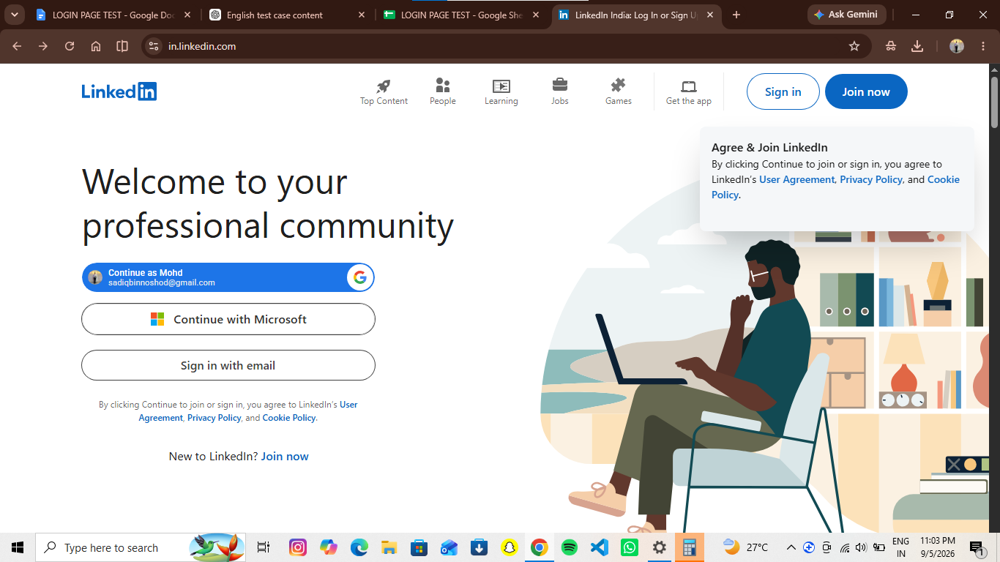
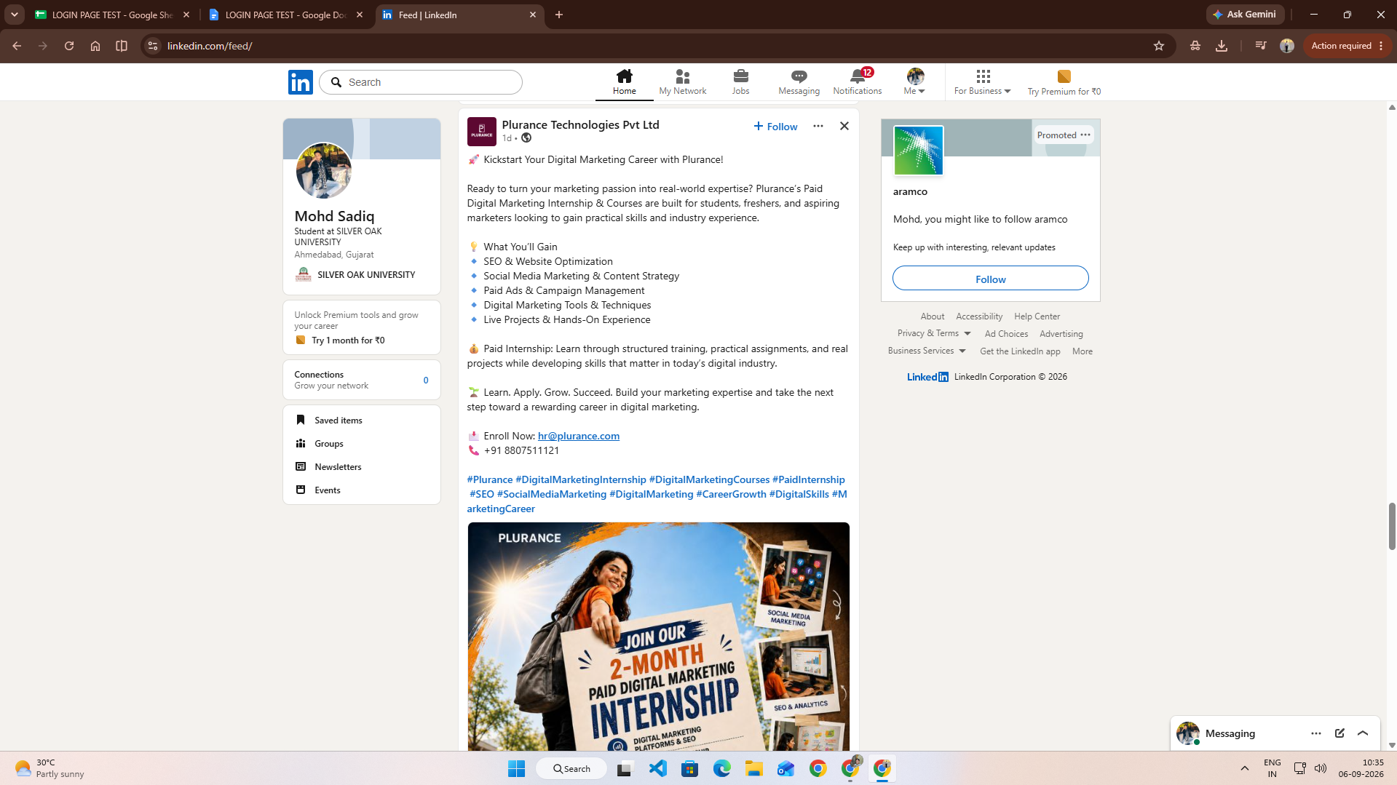

Scenario ID: 3b
Scenario: Login with invalid password
Test Steps:
1. Open Login page
2. Enter valid email
3. Enter incorrect password
4. Click Sign in
Screenshots:
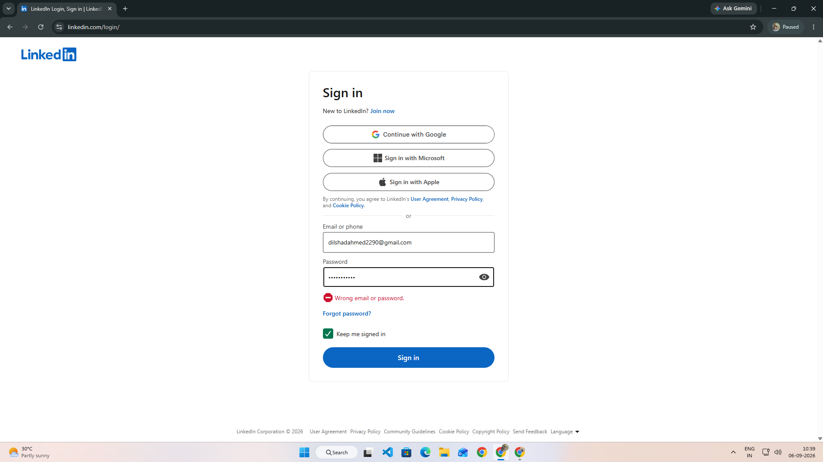

Scenario ID: 3c
Scenario: Login with invalid email
Test Steps:
1. Open LinkedIn Login page
2. Enter invalid email
3. Enter password
4. Click Sign in
Screenshots:
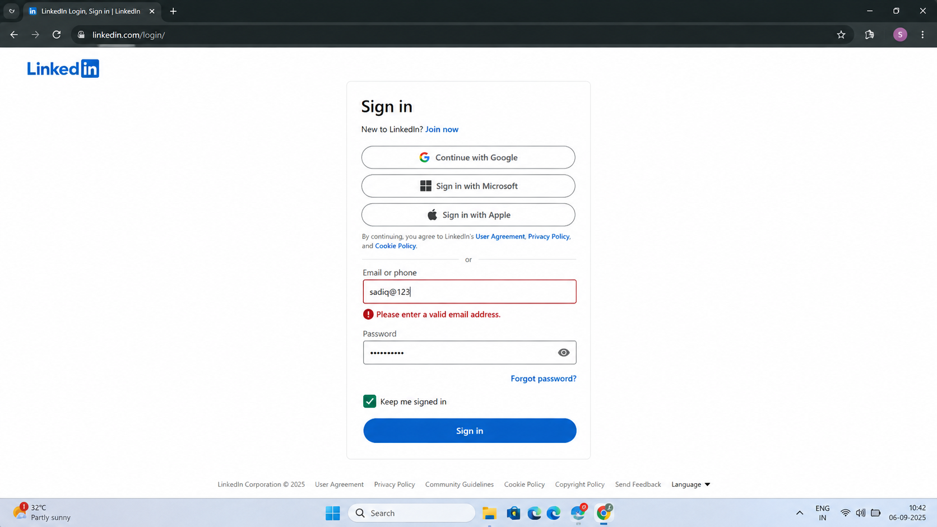

Scenario ID: 3d
Scenario: Login with empty fields
Test Steps:
1. Open Login page
2. Leave email field empty
3. Leave password field empty
4. Click Sign in
Screenshots:
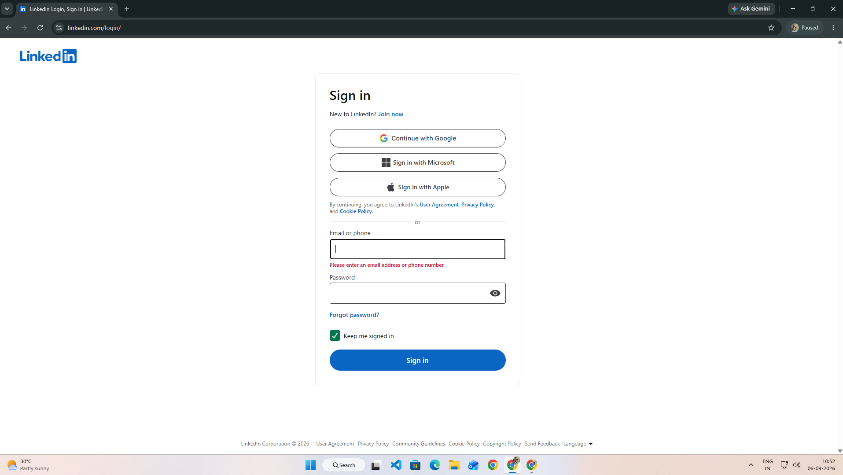

Scenario ID: 3e
Scenario: Login with invalid email format
Test Steps:
1. Open Login page
2. Enter invalid email format
3. Enter password
4. Click Sign in
Screenshots:
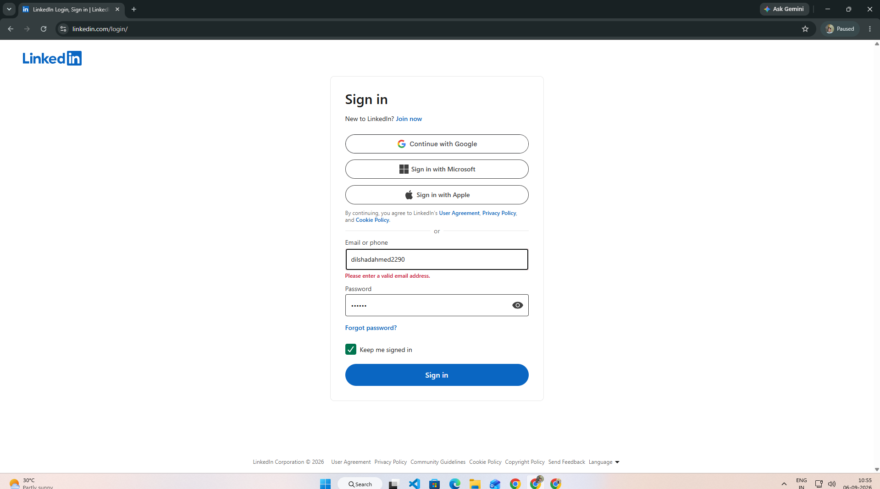

Scenario ID: 3f
Scenario: Check Forgot Password
Test Steps:
1. Open Login page
2. Click Forgot password
3. Enter registered email
4. Continue
Screenshots:
