Module Name: Login Page - Functional & UI Test Cases
Test Case ID: st_04
Webpage URL:https://www.youtube.com/

Scenario ID: 4a
Scenario: Login with valid credentials
Test Steps:
1. Open YouTube
2. Click Sign in
3. Enter email
4. Enter password
5. Click Next
Screenshots:
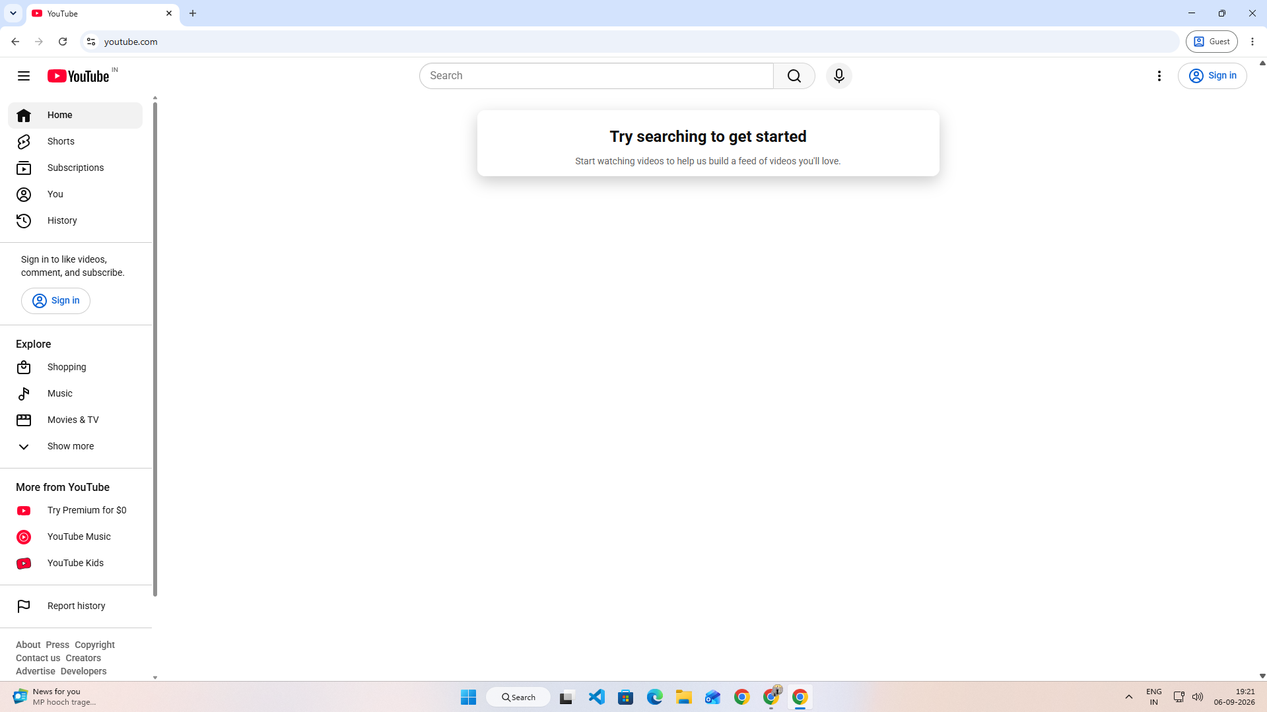
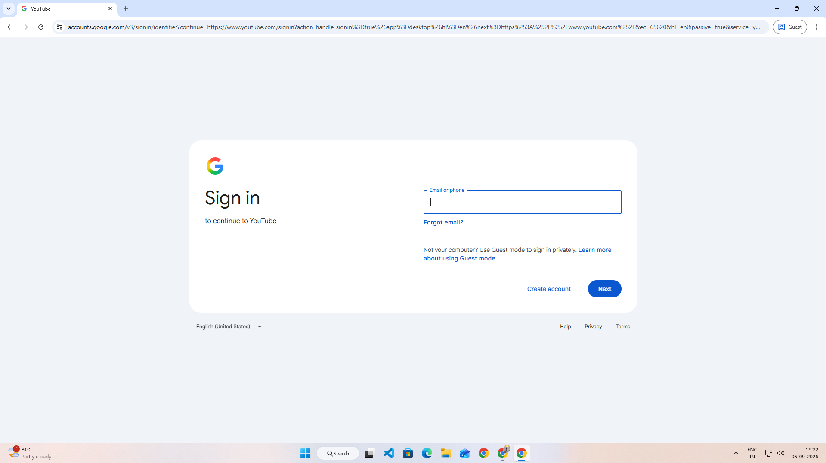
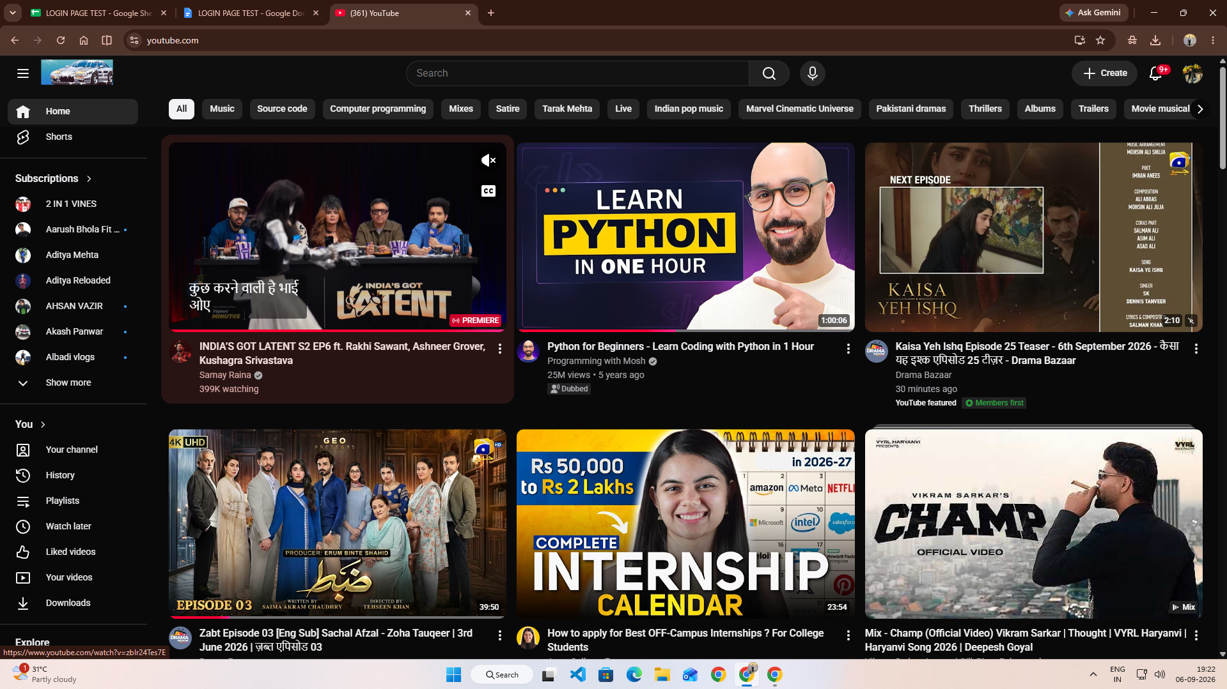

Scenario ID: 4b
Scenario: Login with invalid password
Test Steps:
1. Open Login page
2. Enter valid email
3. Enter incorrect password
4. Click Sign in
Screenshots:
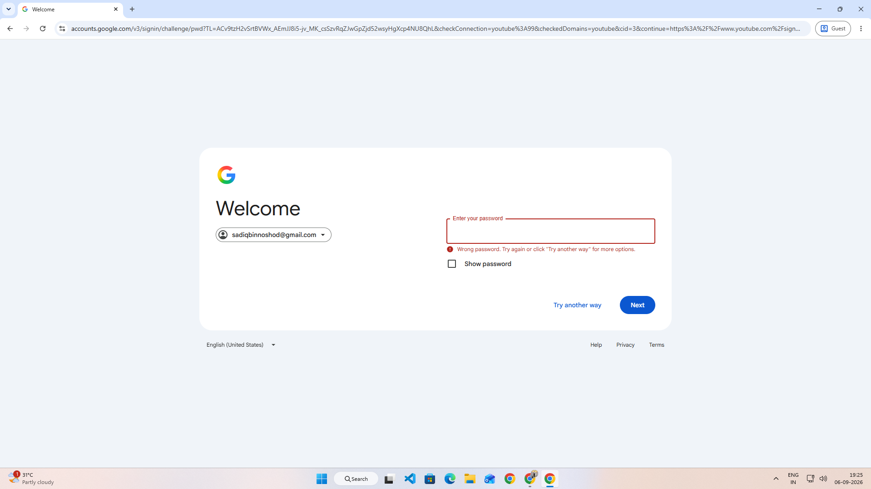

Scenario ID: 4c
Scenario: Login with invalid email
Test Steps:
1. Open Login page
2. Enter invalid email
3. Click Next
Screenshots:
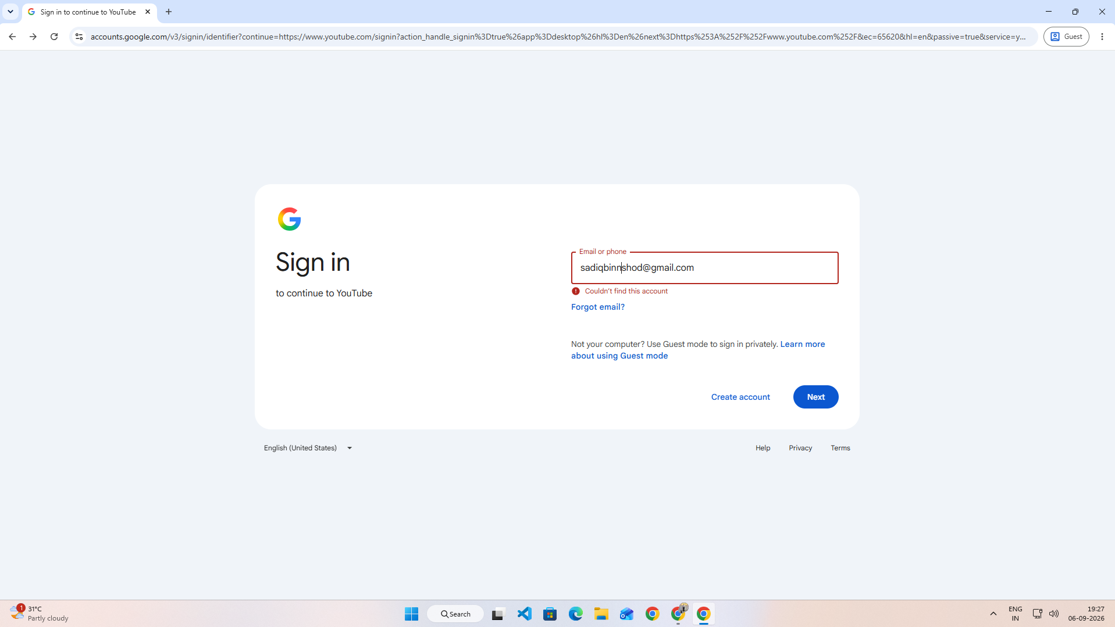

Scenario ID: 4d
Scenario: Login with empty email
Test Steps:
1. Open Login page
2. Leave email blank
3. Click Next
Screenshots:
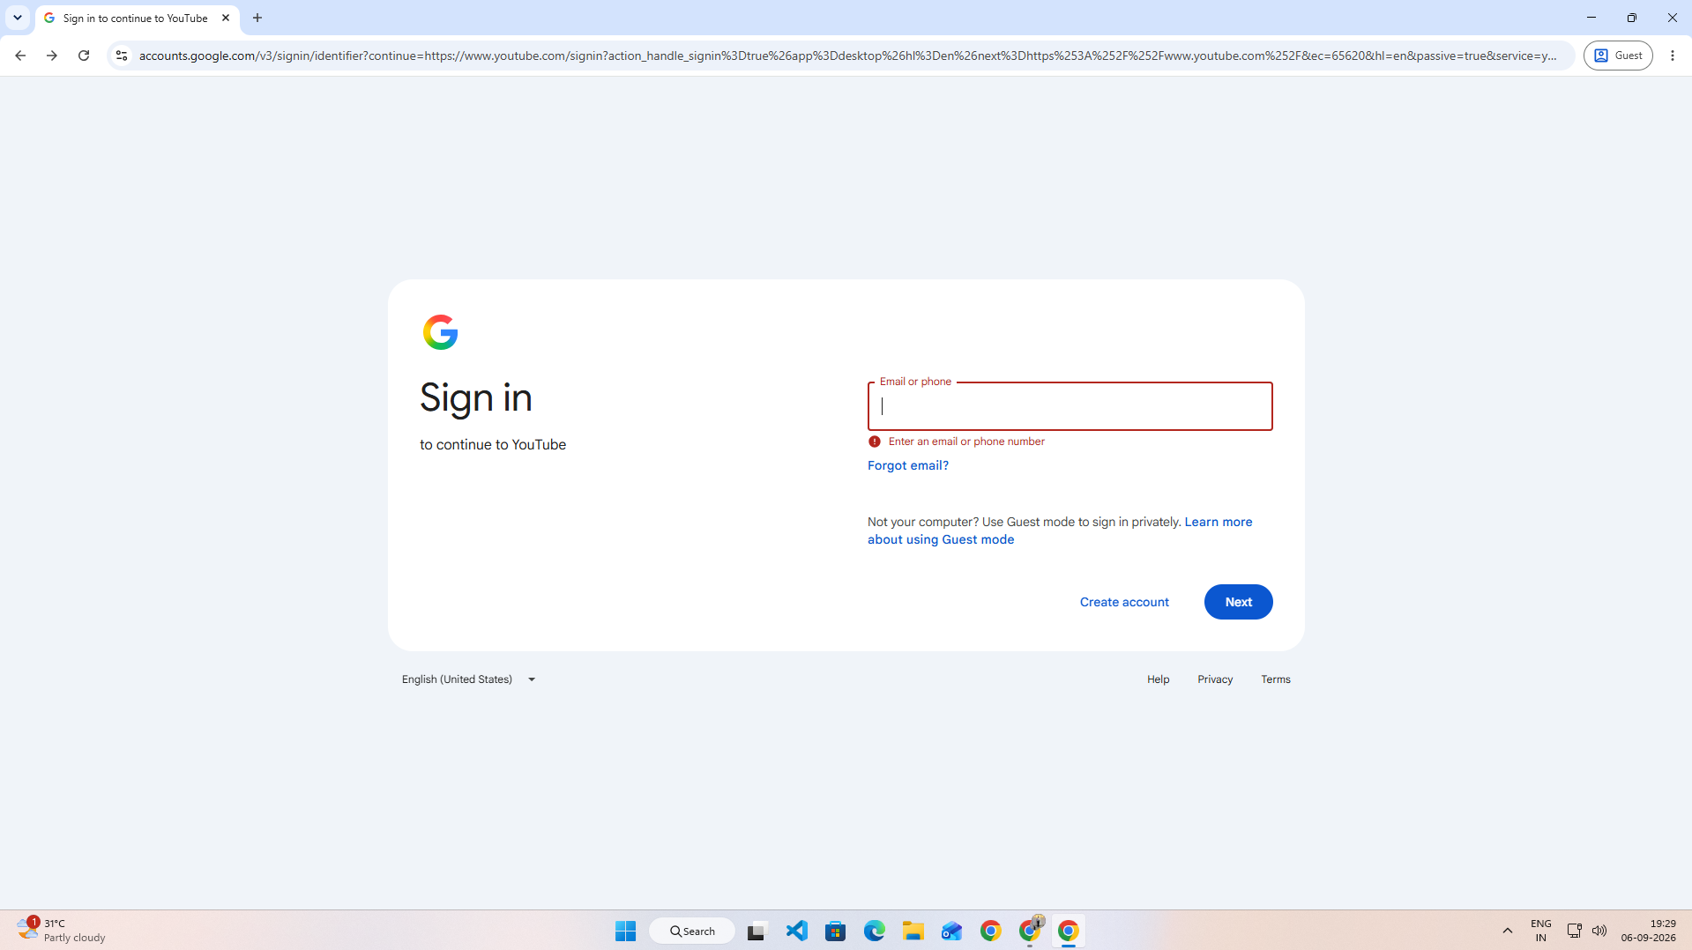

Scenario ID: 4e
Scenario: Login with invalid email format
Test Steps:
1. Open Login page
2. Enter invalid email format
3. Click Next
Screenshots:
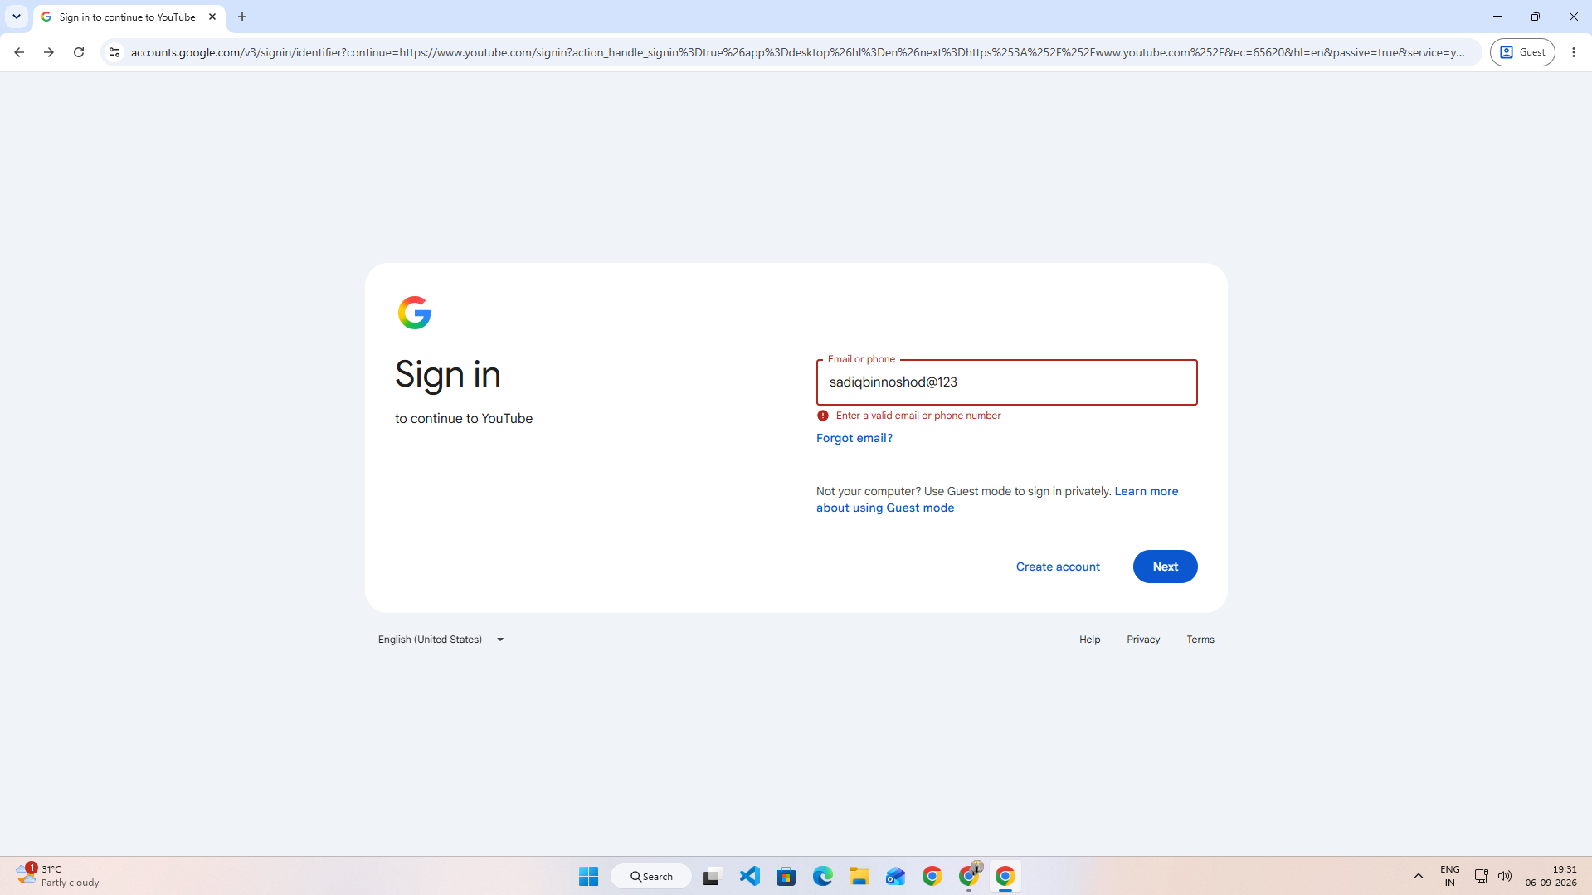

Scenario ID: 4f
Scenario: Check Forgot Email
Test Steps:
1. Open Login page
2. Click Forgot email
Screenshots:
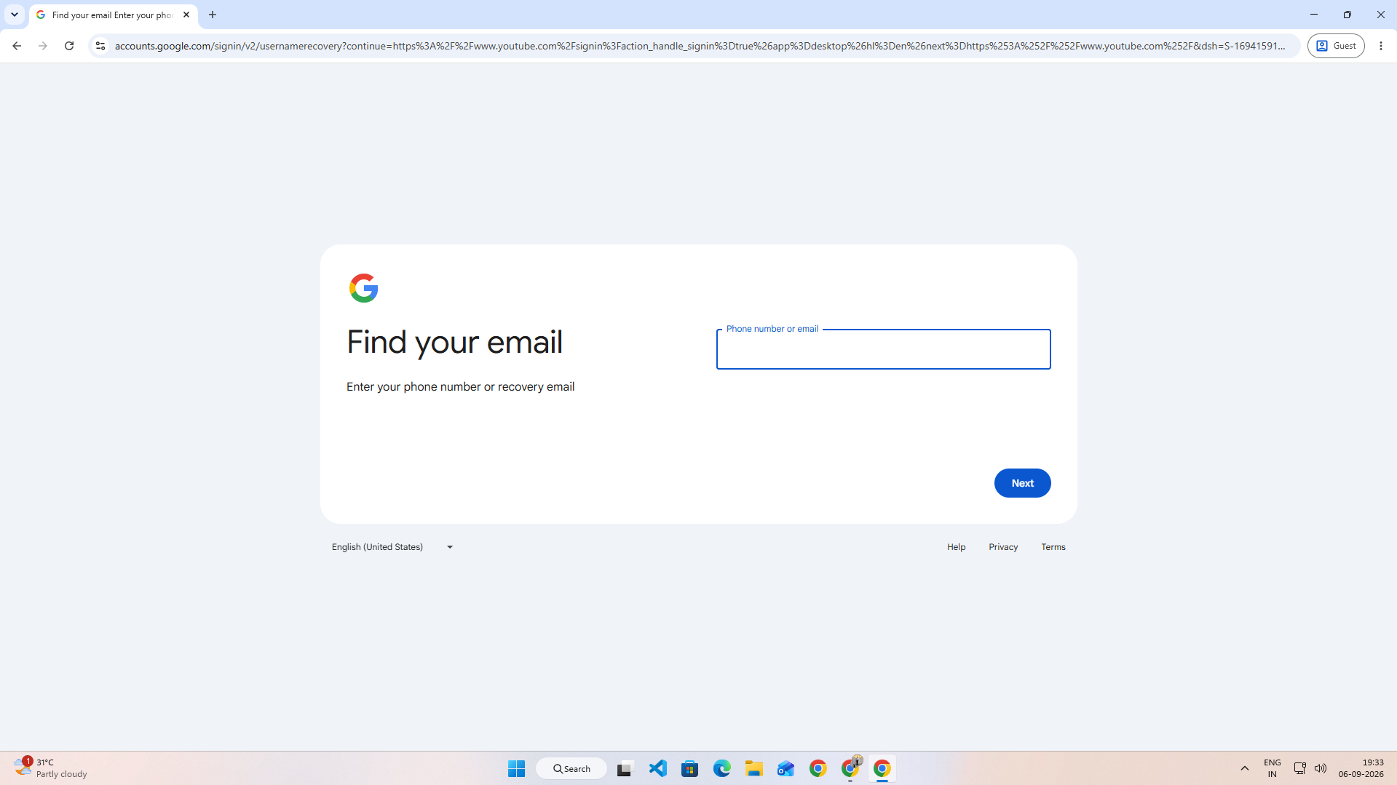

Scenario ID: 4g
Scenario: Check password visibility
Test Steps:
1. Enter password
2. Click Show password
Screenshots:
