# Assignment 1 - Week 2 - Reproducible Research

## Introduction

This assignment makes use of data from a personal activity monitoring device. This device collects data at 5 minute intervals through out the day. The data consists of two months of data from an anonymous individual collected during the months of October and November, 2012 and include the number of steps taken in 5 minute intervals each day.

The variables included in this dataset are:

* steps: Number of steps taking in a 5-minute interval (missing values are coded as NA)
* date: The date on which the measurement was taken in YYYY-MM-DD format
* interval: Identifier for the 5-minute interval in which measurement was taken

## Assignment steps

#### *Clear the workspace*

rm(list=ls())

#### *Required packages*

library (knitr)  
library(markdown)  
library(lubridate)

##   
## Attaching package: 'lubridate'

## The following object is masked from 'package:base':  
##   
## date

library(dplyr)

##   
## Attaching package: 'dplyr'

## The following objects are masked from 'package:lubridate':  
##   
## intersect, setdiff, union

## The following objects are masked from 'package:stats':  
##   
## filter, lag

## The following objects are masked from 'package:base':  
##   
## intersect, setdiff, setequal, union

library(ggplot2)

#### *Loading and preprocessing the data*

The folder repdata_data_activity containing the dataset Activity monitoring data has been downloaded and unzipped within the folder Assignment1. The path to this working directory is applied.

setwd("~/Coursera/ReproducibleResearch/Week2/Week2/Assignment1/repdata_data_activity")

Now load the raw data from the csv file, then know the information about the structure of the file and have a summary of it

raw_data <- read.csv("activity.csv", header = TRUE, sep = ",",stringsAsFactors=FALSE)  
str(raw_data)

## 'data.frame': 17568 obs. of 3 variables:  
## $ steps : int NA NA NA NA NA NA NA NA NA NA ...  
## $ date : chr "2012-10-01" "2012-10-01" "2012-10-01" "2012-10-01" ...  
## $ interval: int 0 5 10 15 20 25 30 35 40 45 ...

summary(raw_data)

## steps date interval   
## Min. : 0.00 Length:17568 Min. : 0.0   
## 1st Qu.: 0.00 Class :character 1st Qu.: 588.8   
## Median : 0.00 Mode :character Median :1177.5   
## Mean : 37.38 Mean :1177.5   
## 3rd Qu.: 12.00 3rd Qu.:1766.2   
## Max. :806.00 Max. :2355.0   
## NA's :2304

Lubridate's parsing functions read strings into R as POSIXct date-time objects. This package is used to format the date in the dataset. And, see the first 15 rows of the data.

raw_data$date <- ymd(raw_data$date)  
head(raw_data,15)

## steps date interval  
## 1 NA 2012-10-01 0  
## 2 NA 2012-10-01 5  
## 3 NA 2012-10-01 10  
## 4 NA 2012-10-01 15  
## 5 NA 2012-10-01 20  
## 6 NA 2012-10-01 25  
## 7 NA 2012-10-01 30  
## 8 NA 2012-10-01 35  
## 9 NA 2012-10-01 40  
## 10 NA 2012-10-01 45  
## 11 NA 2012-10-01 50  
## 12 NA 2012-10-01 55  
## 13 NA 2012-10-01 100  
## 14 NA 2012-10-01 105  
## 15 NA 2012-10-01 110

Get/set days component of a date-time using wday function from Lubridate is invoked and the first and last several rows of the data set is viewed. The variables included in this dataset are:

* steps: number of steps taken per 5-minute interval (missing values are coded as NA)
* date: year-month-day format
* interval: identifier for the 5-minute interval
* Weekday: the relevant day of the week

raw_data$Weekday<-wday(raw_data$date, label = TRUE, abbr = FALSE)  
head(raw_data)

## steps date interval Weekday  
## 1 NA 2012-10-01 0 Monday  
## 2 NA 2012-10-01 5 Monday  
## 3 NA 2012-10-01 10 Monday  
## 4 NA 2012-10-01 15 Monday  
## 5 NA 2012-10-01 20 Monday  
## 6 NA 2012-10-01 25 Monday

tail(raw_data)

## steps date interval Weekday  
## 17563 NA 2012-11-30 2330 Friday  
## 17564 NA 2012-11-30 2335 Friday  
## 17565 NA 2012-11-30 2340 Friday  
## 17566 NA 2012-11-30 2345 Friday  
## 17567 NA 2012-11-30 2350 Friday  
## 17568 NA 2012-11-30 2355 Friday

#### *Mean total number of steps taken/day*

##### Bar plot of the total number of steps taken by ignoring the missing values/day

Daytot <- raw_data %>% group_by(date) %>%summarise(sum_steps=sum(steps,na.rm=TRUE),na=mean(is.na(steps)))  
head(Daytot, 20) ## The first 20 rows for example

## Source: local data frame [20 x 3]  
##   
## date sum_steps na  
## (date) (int) (dbl)  
## 1 2012-10-01 0 1  
## 2 2012-10-02 126 0  
## 3 2012-10-03 11352 0  
## 4 2012-10-04 12116 0  
## 5 2012-10-05 13294 0  
## 6 2012-10-06 15420 0  
## 7 2012-10-07 11015 0  
## 8 2012-10-08 0 1  
## 9 2012-10-09 12811 0  
## 10 2012-10-10 9900 0  
## 11 2012-10-11 10304 0  
## 12 2012-10-12 17382 0  
## 13 2012-10-13 12426 0  
## 14 2012-10-14 15098 0  
## 15 2012-10-15 10139 0  
## 16 2012-10-16 15084 0  
## 17 2012-10-17 13452 0  
## 18 2012-10-18 10056 0  
## 19 2012-10-19 11829 0  
## 20 2012-10-20 10395 0

And, the total number of steps taken per day can be presented by a bar diagram using the following code:

barplot(height=Daytot$sum_steps,names.arg=Daytot$date,cex.axis= 2, cex.names=0.75,las=3, col=heat.colors(7))  
legend("topright", fill=heat.colors(7), legend=c("Mon", "Tue", "Wed", "Thu", "Fri", "Sat", "Sun"))  
abline(h=median(Daytot$sum_steps), col="blue",lwd=2)  
abline(h=mean(Daytot$sum_steps),lwd=2)  
text(x = 0.5,y=median(Daytot$sum_steps),pos=3,labels = "median", col="blue")  
text(x = -0.5,y=mean(Daytot$sum_steps),pos=1,labels = "mean")

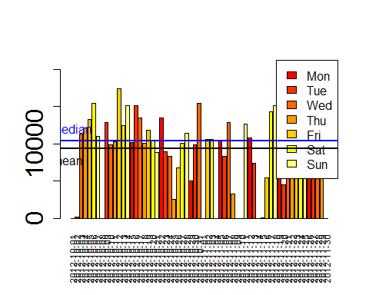

##### Histogram of the total number of steps taken each day

A histogram of total number of steps taken each day does not contain those days where there are missing observations. So a filter is set to filter all the missing values and sum the steps.

Daytot <- filter(Daytot, na < 1)  
hist(Daytot$sum_steps,col="cyan",breaks=20,main="Histogram of the total number of steps taken each day",xlab="Steps per day")  
abline(v=median(Daytot$sum_steps), lty=1,lwd=2)  
legend("topright",lty=1,lwd=2,legend="Median")

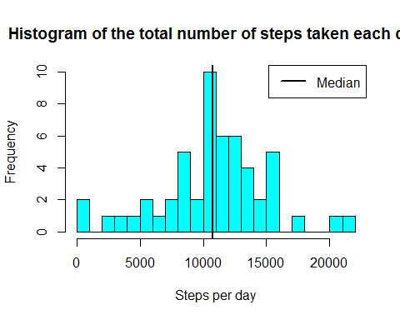

##### Mean and median of the total number of steps taken/day

Based on the data, the mean and the median total number of steps take per day are calculated from

SMean <- mean(Daytot$sum_steps,na.rm=TRUE)  
SMedian <- median(Daytot$sum_steps,na.rm=TRUE)  
options(scipen = 999) # disables the scientific notation  
SMean <- round(SMean) # rounding off  
SMeadian <- round(SMedian) # rounding off

and are 10766 and 10765 respectively.

#### *Average daily activity pattern*

##### Time series plot (i.e. type = "l") of the 5-minute interval (x-axis) and the average number of steps taken, averaged across all days (y-axis)

raw_data_na_omit <- na.omit(raw_data)  
MSI <- tapply(raw_data_na_omit$steps, raw_data_na_omit$interval, mean, na.rm = TRUE) # mean of the steps but broken by interval  
MSIC <- cbind.data.frame(interval = as.integer(names(MSI)),avgsteps = unname(MSI))  
plot(MSIC$interval,MSIC$avgsteps,type = "l",xlab = "Interval",ylab = "Average number of steps",main = " Everyday's activity", col="red", lwd=2)

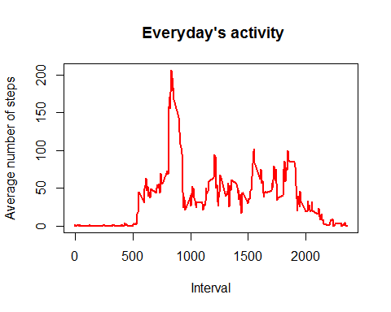

##### The 5-minute interval, on average across all the days in the dataset, which contains the maximum number of steps

Max_Avg_Int = MSIC$interval[MSIC$avgsteps == max(MSIC$avgsteps)]

Hence, the 5-minute interval that contains the maximum of steps, on average across all days is 835.

#### *To input missing values*

##### The total number of missing values in the dataset is calculated using

TMV=nrow(raw_data[is.na(raw_data$steps),])

and is found to be 2304.

##### Strategy for filling in the missing values

##### Creating a new dataset that is equal to the original dataset but with the missing data filled in (i.e. by replacing the NAs by the mean of the interval).

The strategy is to replace the missing NA values with the corresponding mean of the 5-minute interval attribute calculated as follows

Replaceddata <- raw_data  
sapply(unique(raw_data$interval),function(x) Replaceddata[!complete.cases(Replaceddata) & (Replaceddata$interval == x),1] <<- MSIC$avgsteps[MSIC$interval == x])

## [1] 1.7169811 0.3396226 0.1320755 0.1509434 0.0754717  
## [6] 2.0943396 0.5283019 0.8679245 0.0000000 1.4716981  
## [11] 0.3018868 0.1320755 0.3207547 0.6792453 0.1509434  
## [16] 0.3396226 0.0000000 1.1132075 1.8301887 0.1698113  
## [21] 0.1698113 0.3773585 0.2641509 0.0000000 0.0000000  
## [26] 0.0000000 1.1320755 0.0000000 0.0000000 0.1320755  
## [31] 0.0000000 0.2264151 0.0000000 0.0000000 1.5471698  
## [36] 0.9433962 0.0000000 0.0000000 0.0000000 0.0000000  
## [41] 0.2075472 0.6226415 1.6226415 0.5849057 0.4905660  
## [46] 0.0754717 0.0000000 0.0000000 1.1886792 0.9433962  
## [51] 2.5660377 0.0000000 0.3396226 0.3584906 4.1132075  
## [56] 0.6603774 3.4905660 0.8301887 3.1132075 1.1132075  
## [61] 0.0000000 1.5660377 3.0000000 2.2452830 3.3207547  
## [66] 2.9622642 2.0943396 6.0566038 16.0188679 18.3396226  
## [71] 39.4528302 44.4905660 31.4905660 49.2641509 53.7735849  
## [76] 63.4528302 49.9622642 47.0754717 52.1509434 39.3396226  
## [81] 44.0188679 44.1698113 37.3584906 49.0377358 43.8113208  
## [86] 44.3773585 50.5094340 54.5094340 49.9245283 50.9811321  
## [91] 55.6792453 44.3207547 52.2641509 69.5471698 57.8490566  
## [96] 56.1509434 73.3773585 68.2075472 129.4339623 157.5283019  
## [101] 171.1509434 155.3962264 177.3018868 206.1698113 195.9245283  
## [106] 179.5660377 183.3962264 167.0188679 143.4528302 124.0377358  
## [111] 109.1132075 108.1132075 103.7169811 95.9622642 66.2075472  
## [116] 45.2264151 24.7924528 38.7547170 34.9811321 21.0566038  
## [121] 40.5660377 26.9811321 42.4150943 52.6603774 38.9245283  
## [126] 50.7924528 44.2830189 37.4150943 34.6981132 28.3396226  
## [131] 25.0943396 31.9433962 31.3584906 29.6792453 21.3207547  
## [136] 25.5471698 28.3773585 26.4716981 33.4339623 49.9811321  
## [141] 42.0377358 44.6037736 46.0377358 59.1886792 63.8679245  
## [146] 87.6981132 94.8490566 92.7735849 63.3962264 50.1698113  
## [151] 54.4716981 32.4150943 26.5283019 37.7358491 45.0566038  
## [156] 67.2830189 42.3396226 39.8867925 43.2641509 40.9811321  
## [161] 46.2452830 56.4339623 42.7547170 25.1320755 39.9622642  
## [166] 53.5471698 47.3207547 60.8113208 55.7547170 51.9622642  
## [171] 43.5849057 48.6981132 35.4716981 37.5471698 41.8490566  
## [176] 27.5094340 17.1132075 26.0754717 43.6226415 43.7735849  
## [181] 30.0188679 36.0754717 35.4905660 38.8490566 45.9622642  
## [186] 47.7547170 48.1320755 65.3207547 82.9056604 98.6603774  
## [191] 102.1132075 83.9622642 62.1320755 64.1320755 74.5471698  
## [196] 63.1698113 56.9056604 59.7735849 43.8679245 38.5660377  
## [201] 44.6603774 45.4528302 46.2075472 43.6792453 46.6226415  
## [206] 56.3018868 50.7169811 61.2264151 72.7169811 78.9433962  
## [211] 68.9433962 59.6603774 75.0943396 56.5094340 34.7735849  
## [216] 37.4528302 40.6792453 58.0188679 74.6981132 85.3207547  
## [221] 59.2641509 67.7735849 77.6981132 74.2452830 85.3396226  
## [226] 99.4528302 86.5849057 85.6037736 84.8679245 77.8301887  
## [231] 58.0377358 53.3584906 36.3207547 20.7169811 27.3962264  
## [236] 40.0188679 30.2075472 25.5471698 45.6603774 33.5283019  
## [241] 19.6226415 19.0188679 19.3396226 33.3396226 26.8113208  
## [246] 21.1698113 27.3018868 21.3396226 19.5471698 21.3207547  
## [251] 32.3018868 20.1509434 15.9433962 17.2264151 23.4528302  
## [256] 19.2452830 12.4528302 8.0188679 14.6603774 16.3018868  
## [261] 8.6792453 7.7924528 8.1320755 2.6226415 1.4528302  
## [266] 3.6792453 4.8113208 8.5094340 7.0754717 8.6981132  
## [271] 9.7547170 2.2075472 0.3207547 0.1132075 1.6037736  
## [276] 4.6037736 3.3018868 2.8490566 0.0000000 0.8301887  
## [281] 0.9622642 1.5849057 2.6037736 4.6981132 3.3018868  
## [286] 0.6415094 0.2264151 1.0754717

head(Replaceddata)

## steps date interval Weekday  
## 1 1.7169811 2012-10-01 0 Monday  
## 2 0.3396226 2012-10-01 5 Monday  
## 3 0.1320755 2012-10-01 10 Monday  
## 4 0.1509434 2012-10-01 15 Monday  
## 5 0.0754717 2012-10-01 20 Monday  
## 6 2.0943396 2012-10-01 25 Monday

##### Histogram of the total number of steps taken each day, and the mean and median total number of steps taken per day.

MSD <- tapply(Replaceddata$steps, Replaceddata$date, sum, na.rm = TRUE); # mean of the steps but broken by date  
MSDC <- cbind.data.frame(date = names(MSD),totalsteps = unname(MSD))  
hist(MSDC[,2], xlab = "Number of Steps Per Day", ylab = "Number of Days", main = "Frequency of Total Steps in a day", col = "cyan")

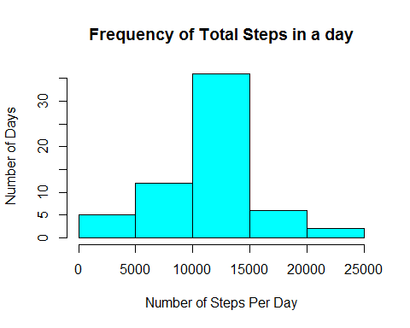

The mean and median total number of steps taken per day are calculated using

meansteps <- mean(MSDC$totalsteps)

mediansteps <- median(MSDC$totalsteps)

and are found to be 10766.1886792 and 10766.1886792 after filling the data respectively. These values differ from the first part of the assignment slightly such that before filling the data, they were found to be 10766 and 10765 after rounding respectively.

#### *Are there differences in activity patterns between weekdays and weekends?*

##### Create a new factor variable in the dataset with two levels - "weekday" and "weekend" indicating whether a given date is a weekday or weekend day.

##### Make a panel plot containing a time series plot (i.e. type = "l") of the 5-minute interval (x-axis) and the average number of steps taken, averaged across all weekday days or weekend days (y-axis).

Replaceddata$date <- as.Date(Replaceddata$date, "%Y-%m-%d")  
Replaceddata$weekend <- "weekday"  
Replaceddata$weekend[weekdays(Replaceddata$date) %in% c("Saturday","Sunday")] <- "weekend"  
Replaceddata$weekend <- as.factor(Replaceddata$weekend)  
ArrangedData <- Replaceddata %>%  
group_by(interval, weekend) %>%  
summarize(avgsteps = mean(steps))

The following figure shows that the activity during the weekend has more peaks than the weekday activity, with a better distribution of effort along the time, though the activity on the weekday has the greatest peak from all steps intervals.

ggplot(ArrangedData, aes(x=interval, y=avgsteps)) +   
geom_line(color="red", size=1) +   
facet_wrap(~ weekend, c(2, 1)) +  
labs(x="5-minute interval", y="Average number of steps") +  
ggtitle("Average number of steps taken - averaged accross weekdays/ weekend") +  
theme_bw()

## Warning: Only the first value of `nrow` will be used.

