SmartHire System Diagrams
Block Diagram and UML Structural, Behavioural, and Interaction Diagrams
Project: SmartHire - AI-Powered Interview Preparation Assistant
This document contains project-specific diagrams for the implemented SmartHire codebase: React/Vite frontend, Express REST API, MongoDB persistence, JWT authentication, optional Google login, and Python/OpenAI/fallback answer evaluation.
Diagram Index
1. Block Diagram
2. UML Component Diagram
3. UML Package Diagram
4. UML Deployment Diagram
5. UML Class Diagram
6. UML Activity Diagram
7. UML Sequence Diagram
8. UML Collaboration Diagram
Block Diagram
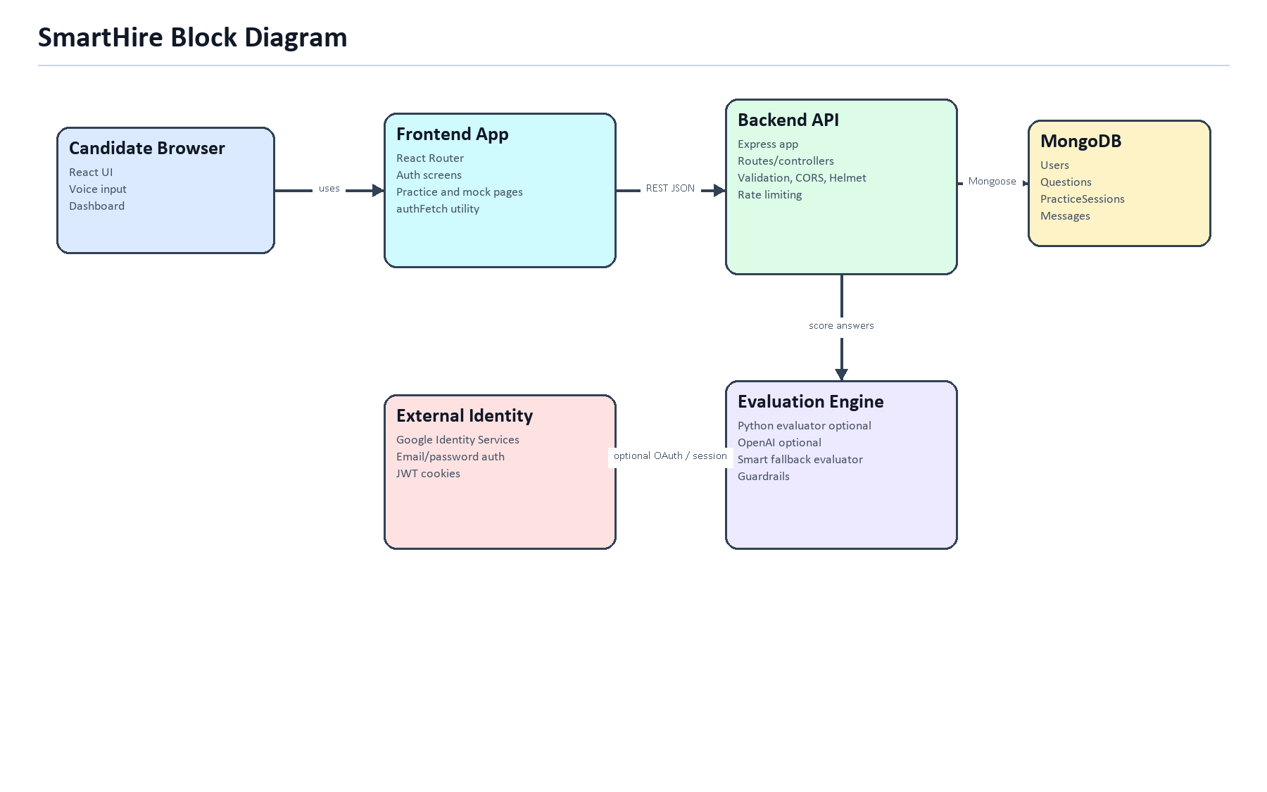
Figure 1: SmartHire high-level block diagram showing browser, frontend, backend, database, authentication, and evaluation blocks.
UML Structural Diagram - Component Diagram
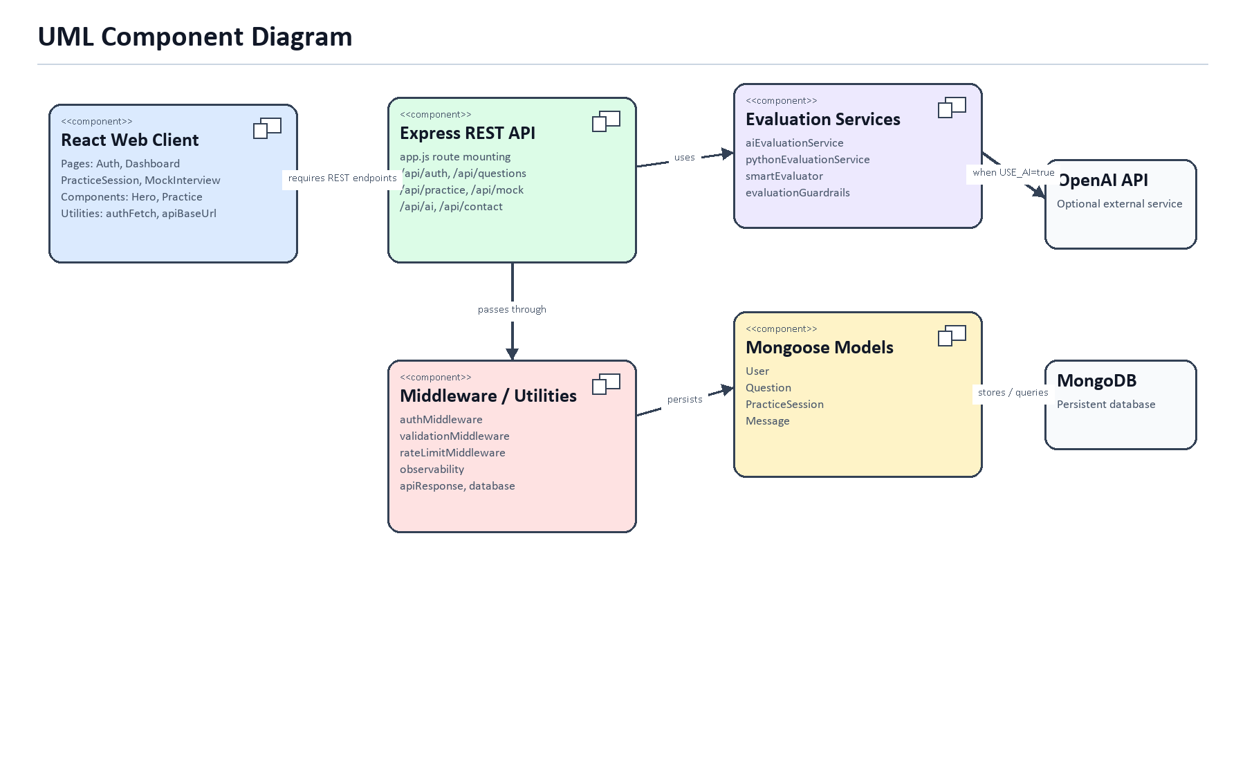
Figure 2: UML component diagram showing React client components, Express API routes, middleware, services, models, MongoDB, and OpenAI integration.
UML Structural Diagram - Package Diagram
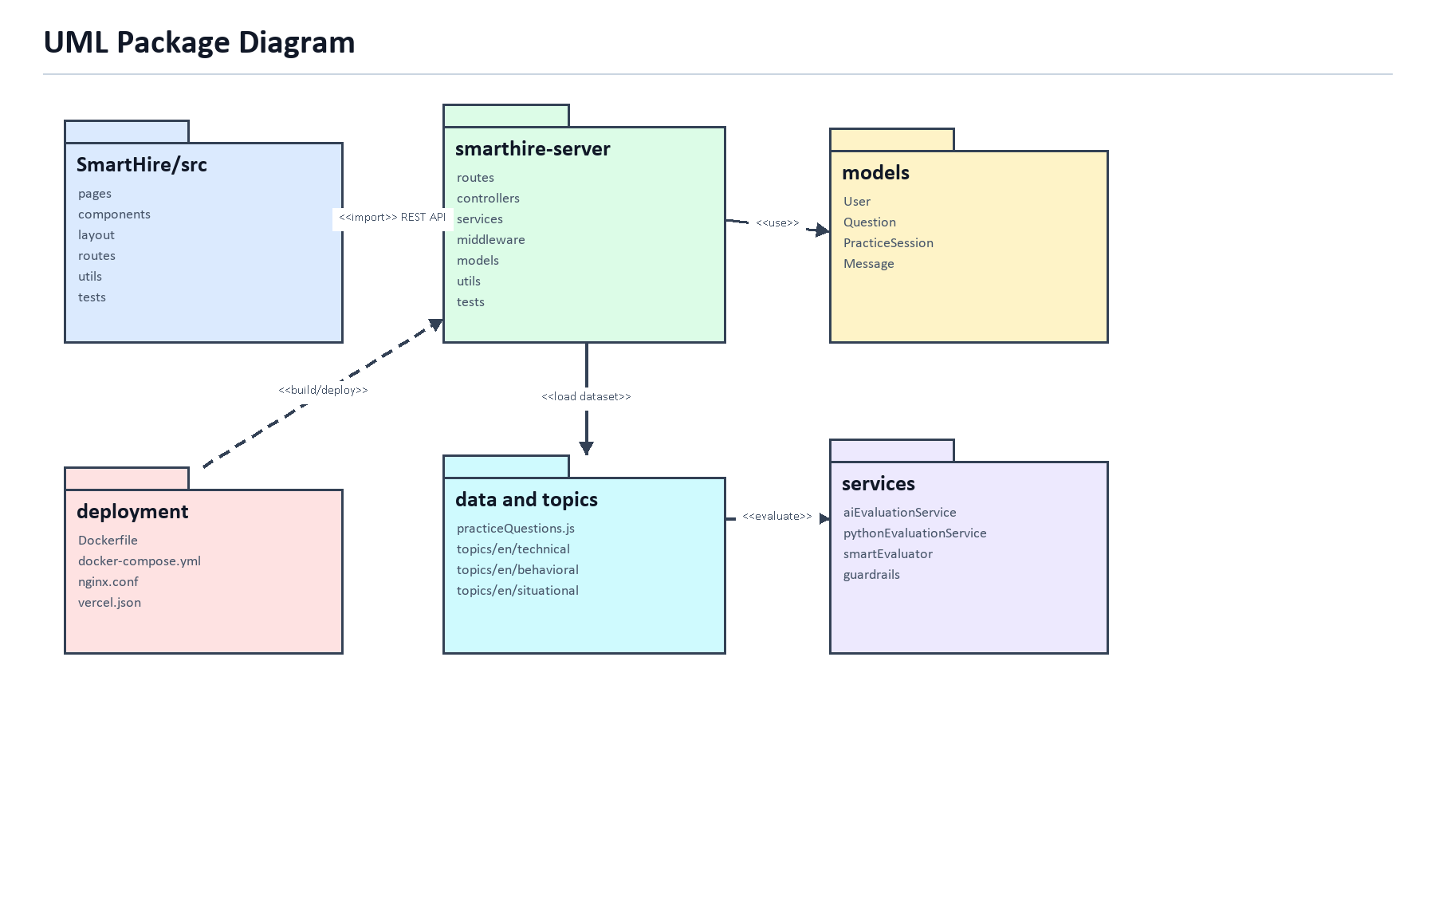
Figure 3: UML package diagram showing frontend, backend, model, service, dataset, and deployment packages.
UML Structural Diagram - Deployment Diagram
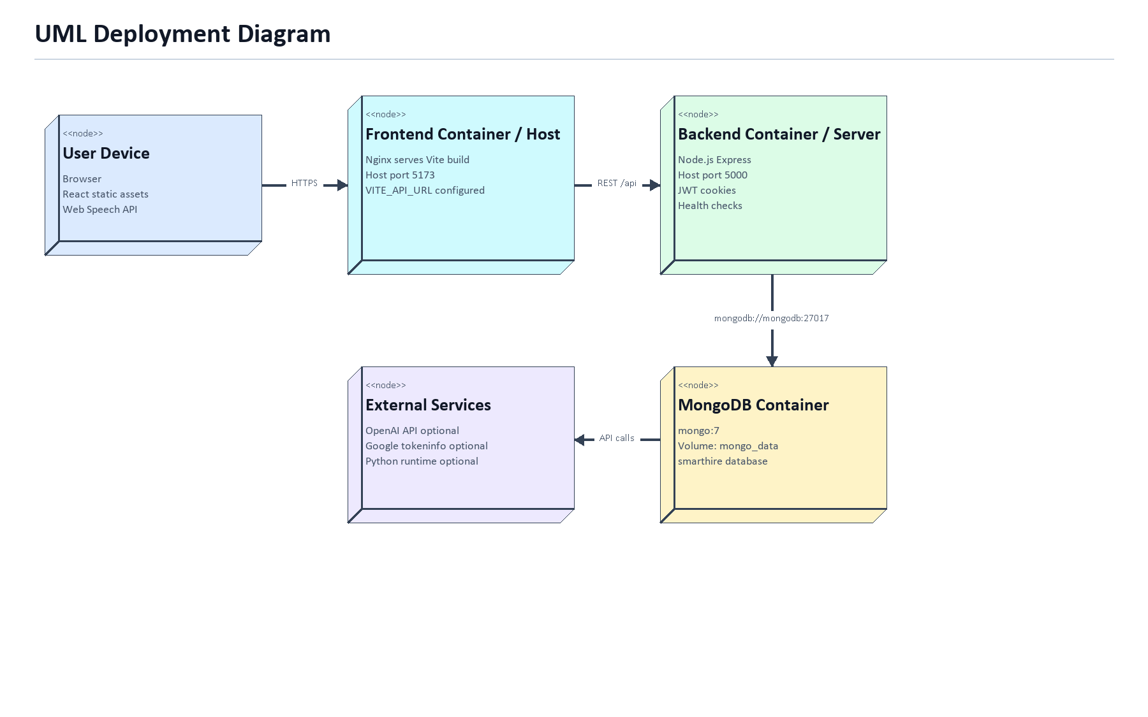
Figure 4: UML deployment diagram for browser, frontend host/container, backend server, MongoDB, and external services.
UML Structural Diagram - Class Diagram
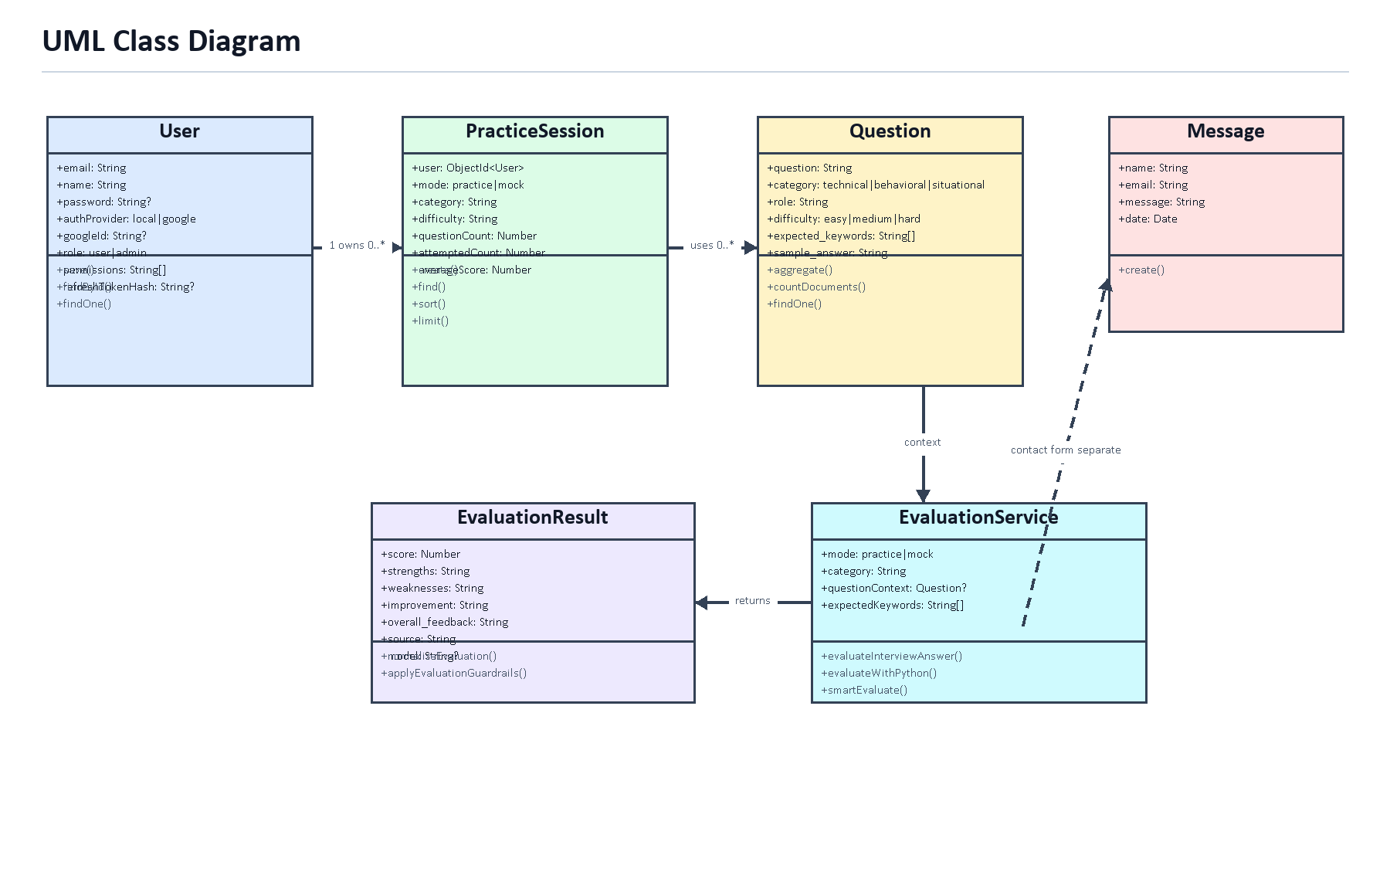
Figure 5: UML class diagram for SmartHire persistent models and evaluation result/service structures.
UML Behaviour Diagram - Activity Diagram
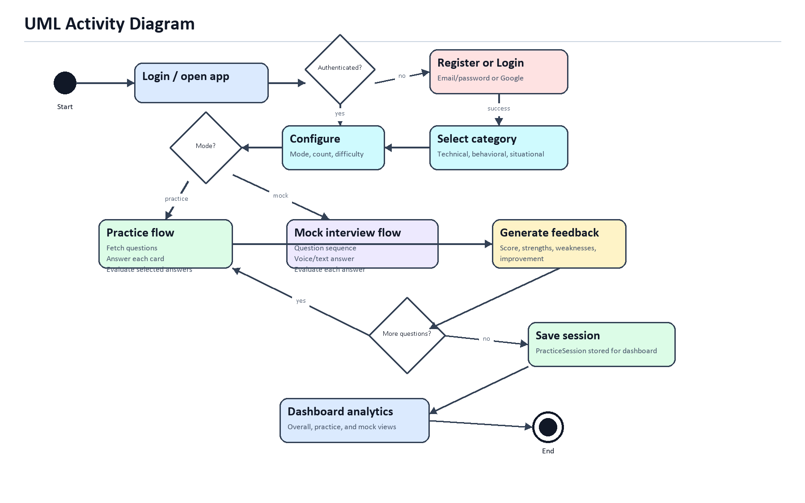
Figure 6: UML activity diagram for authentication, practice/mock configuration, answer evaluation, saving, and dashboard review.
UML Interaction Diagram - Sequence Diagram
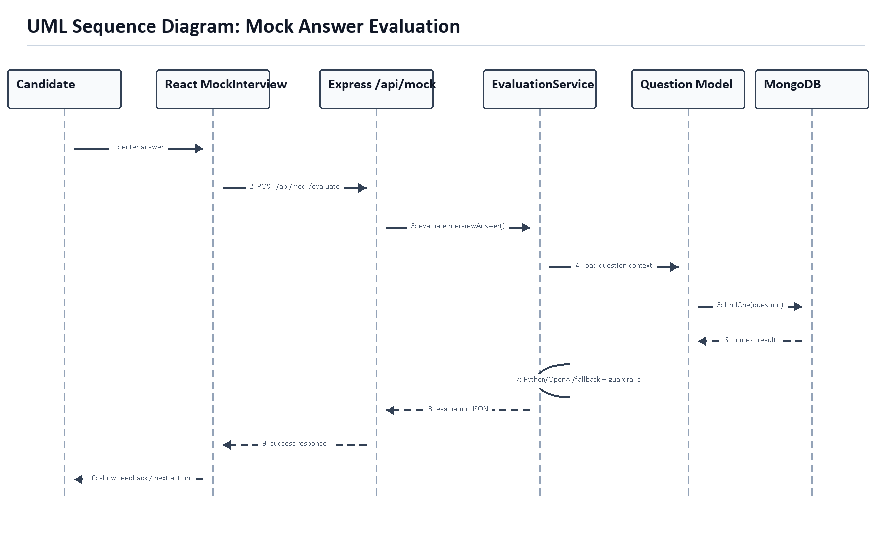
Figure 7: UML sequence diagram for mock answer evaluation from candidate input to feedback display.
UML Interaction Diagram - Collaboration Diagram
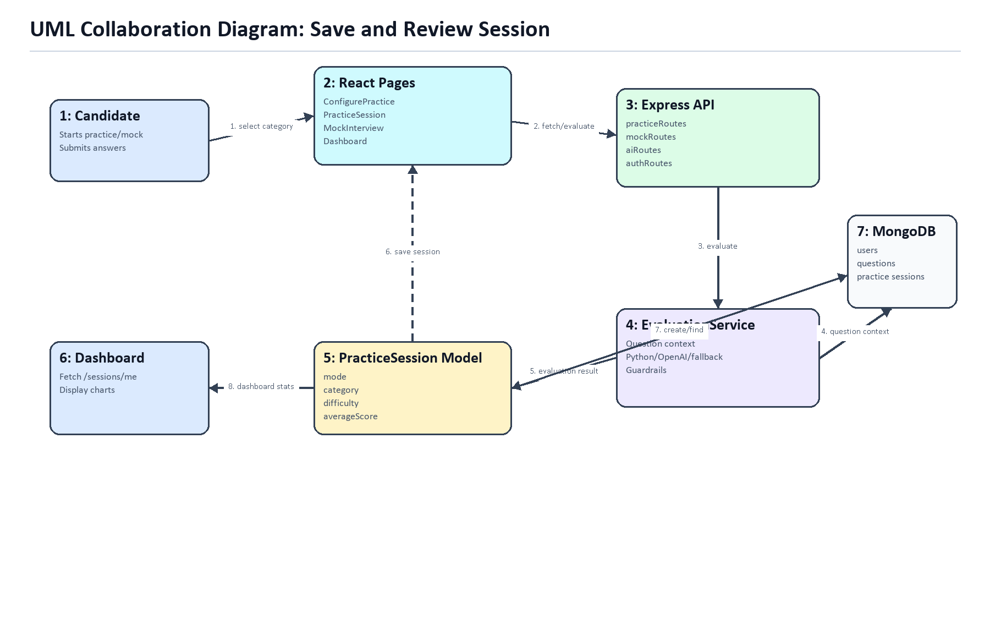
Figure 8: UML collaboration diagram showing object links and numbered messages for saving and reviewing sessions.

