**My home.com is an online property dealer which list the various property available for sale across various cities.**

**Create a database for myhome.com with the date that content property info such as property id city locality carpet area type of flat and price**

**Design an asp.net web page with two dropdown list for city and locality and a grid view for displaying the detail of various property**

**In the first drop down list various city should be loaded, on the selection which the locality in those city should be populated the second drop down list.**

**On the selection of the locality on the drop down list the detail of the properties in that locality should be displayed in the grid**

**Code:**

**Step 1:**

Create a database using Ms Access

Select Blank Database

Delete the default table

After that click on create and table Design to create a database.

Make property Id as primary key.

Save the database in (.mdb) extension.

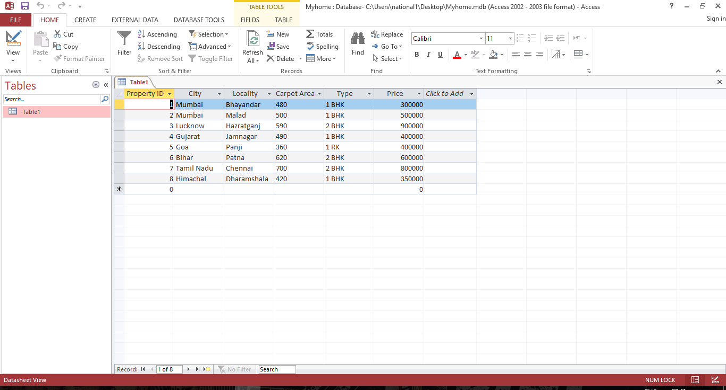

**Step 2:**

Open a new ASP.Net website

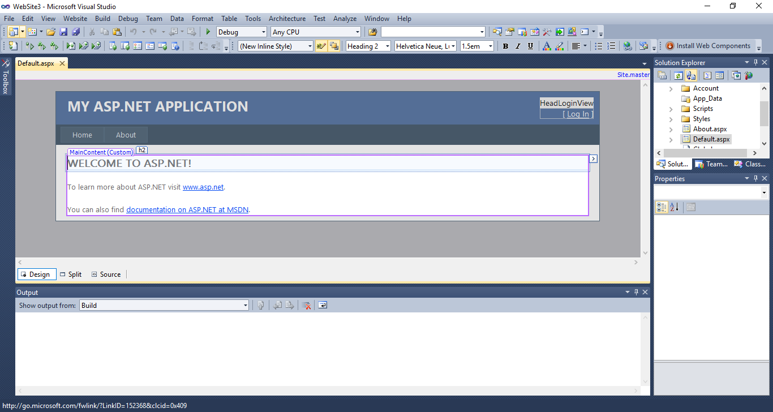

**Step 3:**

Add 2 drop down list for city and locality.

And a grid view to show all the details of the property.

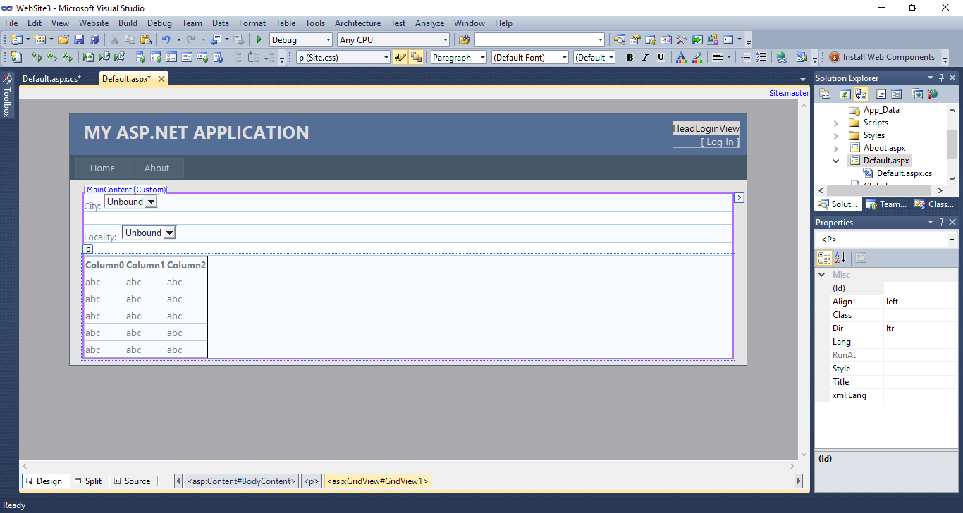

**Step 4:**

Copy the database file in the ASP.Net file

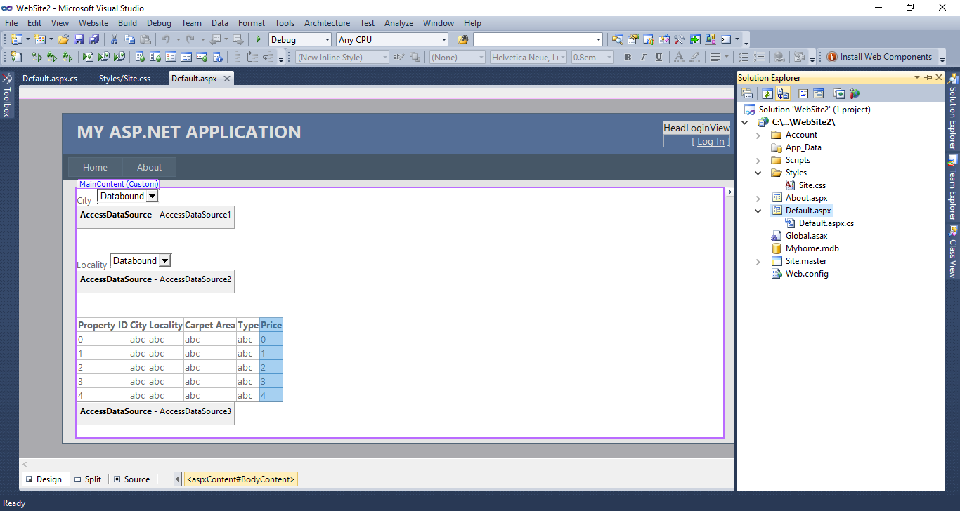

**Step 5:**

Bound the drop down list with the database table by clicking the arrow (>).

Select the option choose the database source.

Select new data source.

Select Access Database

Browse the database path.

