HTML,CSS OUTPUT

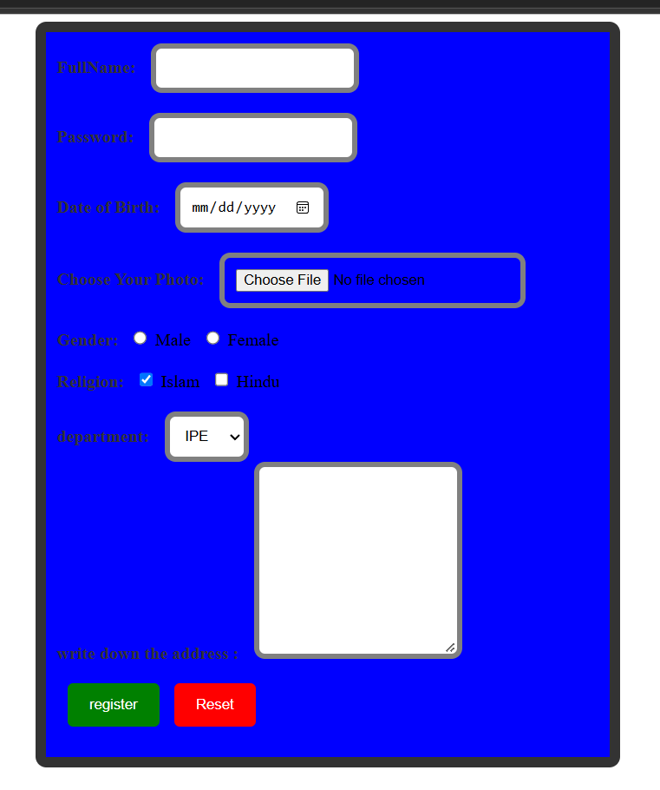

JAVA SCRIP OUTPUT
