
Sri Lanka Institute of Information Technology
Master of Science in Information Technology
SE6020 : Cloud Computing
Semester 3
Assignment

Wonderland Theme Park Booking Admission and Analytics

T.M.S.U Tennakoon
MS21930386

Report overview
  - Wonderland cloud implementation and evidence
MSc in Information Technology
Enterprise Application Development
2026 Semester 03
Report date 17 October 2026
Lecturer Lasitha Petthawadu

Summary
Wonderland is a cloud-hosted minimum viable product for discovering attractions, booking tickets, paying online, admitting guests and analysing park activity. The solution combines four Python microservices, separate React visitor and administrator applications, AWS managed services and a Minikube Kubernetes cluster on EC2.
The implementation was deployed and exercised on AWS. The latest checks passed 212 Python tests, both frontend builds, six Terraform configurations and live payment, admission, reporting and recovery tests. After testing, a verified database backup was retained and the chargeable demo infrastructure was removed. The final AWS inventory found no active demo resources.
Repository https://github.com/saditha93/wonderland
Source package wonderland-source.zip
Live access Recreated for the viva using the deployment commands in Section 8

Reading guide
Sections 1 to 3 explain the requirements and architecture. Sections 4 to 8 cover implementation and deployment. Sections 9 to 12 present results, coverage and limitations. Section 13 lists references and the assistance acknowledgement.

Contents
1 Project objective and requirements 3
2 Deployed cloud architecture 4
3 Microservices and cloud design patterns 5
4 Booking payment and admission workflow 6
5 Authentication security and data protection 7
6 Minikube Kubernetes and Ingress 8
7 Monitoring and analytics pipeline 9
8 Infrastructure automation and deployment 10
9 Testing and observed results 11
10 Screenshots and defects corrected 12
11 Assignment coverage and evaluation 13
12 Implementation limits and conclusion 14
13 References and acknowledgement 15

1 Project objective and requirements
The assignment requires a cloud-native platform for Wonderland theme park, serving individuals, couples, families and groups. The visitor journey covers discovery, authentication, a single ticket tier per booking, date and slot selection, payment, a digital reference or QR ticket, and owned booking and visit history. Administrators need attraction and price management, gate admissions and operational reporting. [1]

Implemented scope
The visitor website and administrator website are separate React applications hosted on AWS Amplify. Four FastAPI services manage attractions, booking and payment, gate and ride activity, and analytics. PostgreSQL stores operational data and reporting facts. Cognito provides managed identity; API Gateway provides the public API entry point; SQS carries business events; Metabase visualises stored reporting data.
Tier | Guests | Price per booking
Individual | 1 | USD 40
Couple | 2 | USD 75
Family | Up to 4 | USD 140
Group | Up to 5 | USD 165

Prices and tier rules are stored in the database and can be updated by an administrator. Each booking preserves the selected tier revision and amount, so a later price change does not rewrite an earlier transaction. Party-size and time-slot rules are validated by the API, not only by the form.

Quality requirements
Scalability is addressed with stateless replicas, a bounded CPU-based horizontal pod autoscaler and queue-based asynchronous processing. Security includes managed authentication, backend role and ownership checks, TLS, encrypted AWS storage, signed payment webhooks and signed tickets. Fault isolation is supported by independent gate verification, outboxes, retries, circuit breakers and Kubernetes health probes.
Cost control uses a bounded demonstration size, actual Terraform plan review, a six-hour stop timer, backup-before-destroy and an inventory audit. A stopped server can still retain billable storage and an address, so teardown is necessary after a demonstration.

Scope boundaries
The MVP does not implement refunds, cancellation workflows, partial-party arrival, re-entry or production capacity planning. It runs on one EC2 host and one PostgreSQL instance. It therefore demonstrates process recovery and service isolation, but does not provide protection against a complete host or shared-database outage.

2 Deployed cloud architecture
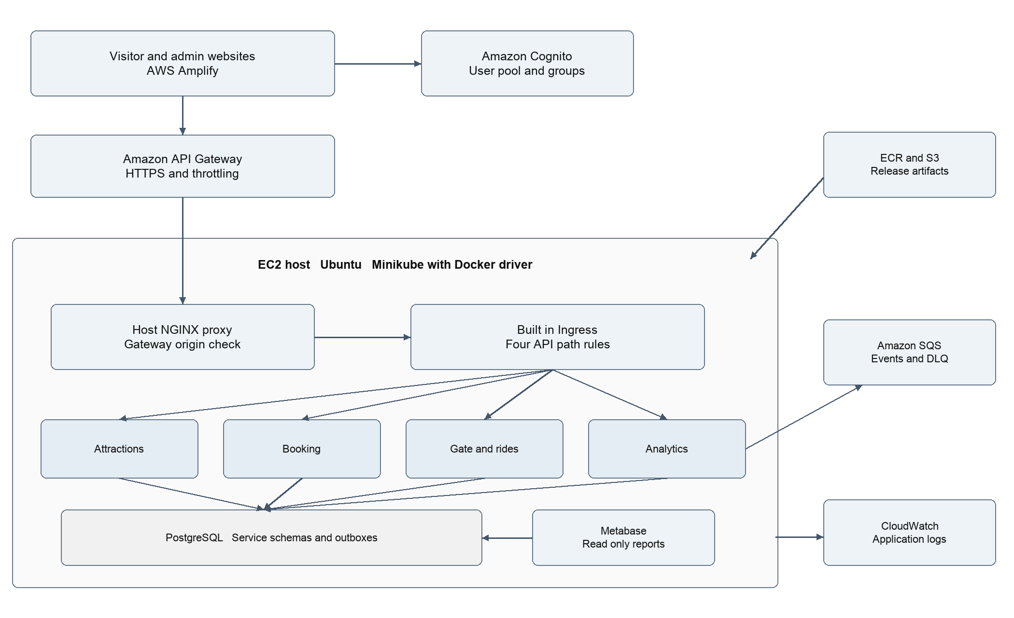
Figure 1 Implemented AWS topology with Minikube and Ingress on one EC2 host
Amplify serves the visitor and administrator websites over HTTPS. The applications authenticate directly with a Cognito user pool and send the resulting access token to the APIs. API Gateway forwards requests to the EC2 host over HTTPS and adds a private origin header. The host proxy rejects direct requests without that header.
The host proxy sends accepted requests over verified TLS to Minikube Ingress. Four Ingress rules route the API prefixes to internal Kubernetes Services, which select ready service pods. The cluster uses the Docker driver on Linux and containerd inside the node; this avoids requiring a nested virtual machine on EC2. [2]
PostgreSQL and Metabase run inside the cluster. PostgreSQL persists data through a StatefulSet and volume claim on the encrypted server disk. Metabase is reachable through a private SSM port-forwarding session, rather than a public dashboard port. The analytics worker exchanges events with SQS, and the log collector sends application logs to CloudWatch.
ECR stores release-tagged container images. The current release workflow uses a private S3 bucket for verified source and installation artifacts. The implemented release still builds on the server; GitHub-based automatic deployment and removal of this S3 artifact path are future improvements, not completed features.

3 Microservices and cloud design patterns
Service | Responsibilities | Owned schema
Attractions | Descriptions, categories, suitability guidance, status and administrator changes | attractions
Booking | Profiles, tiers, reservations, price snapshots, checkout, payment confirmation and tickets | booking
Gate and rides | Ticket verification, timestamped check-ins, ride events and visit history | visits
Analytics | Outbox transfer, SQS consumption, duplicate suppression and reporting facts | reporting

Each service has its own source package, Dockerfile, routes and database migrations. A shared Python package provides common authentication, ticket verification, database access and reliability helpers. Separate database roles restrict ordinary service access to its owned schema. This preserves clear business boundaries while retaining a single database for a manageable demonstration.

Gateway and service discovery
API Gateway centralises the public endpoint, allowed origins and request throttling. Ingress handles routing inside Kubernetes. Kubernetes Services provide stable DNS names while Deployments replace pods. These are separate responsibilities: API Gateway remains the external AWS entry point, and Ingress selects the internal API service.

Transactional outbox and idempotent consumers
A business transaction writes its operational record and an outbox event together. The worker later transfers the event through SQS and writes a reporting fact after checking its event identifier. This avoids losing the event between a successful database commit and a queue send. SQS standard delivery can repeat a message; deduplication therefore belongs in the application. [3]

Separate reporting model
Reporting uses purchase, arrival and ride facts rather than issuing unrestricted reporting queries against every operational schema. This is a lightweight separation of commands and read models. Reports are eventually consistent: a short delay is acceptable, but source transactions must remain durable while the worker is unavailable.

Bounded failures
Timeouts and circuit breakers bound synchronous dependency failures. Startup, readiness and liveness probes separate initialization, ability to serve requests and process health. These patterns reduce failure propagation, but per-process breaker state and a shared host remain deliberate MVP limitations.

4 Booking payment and admission workflow
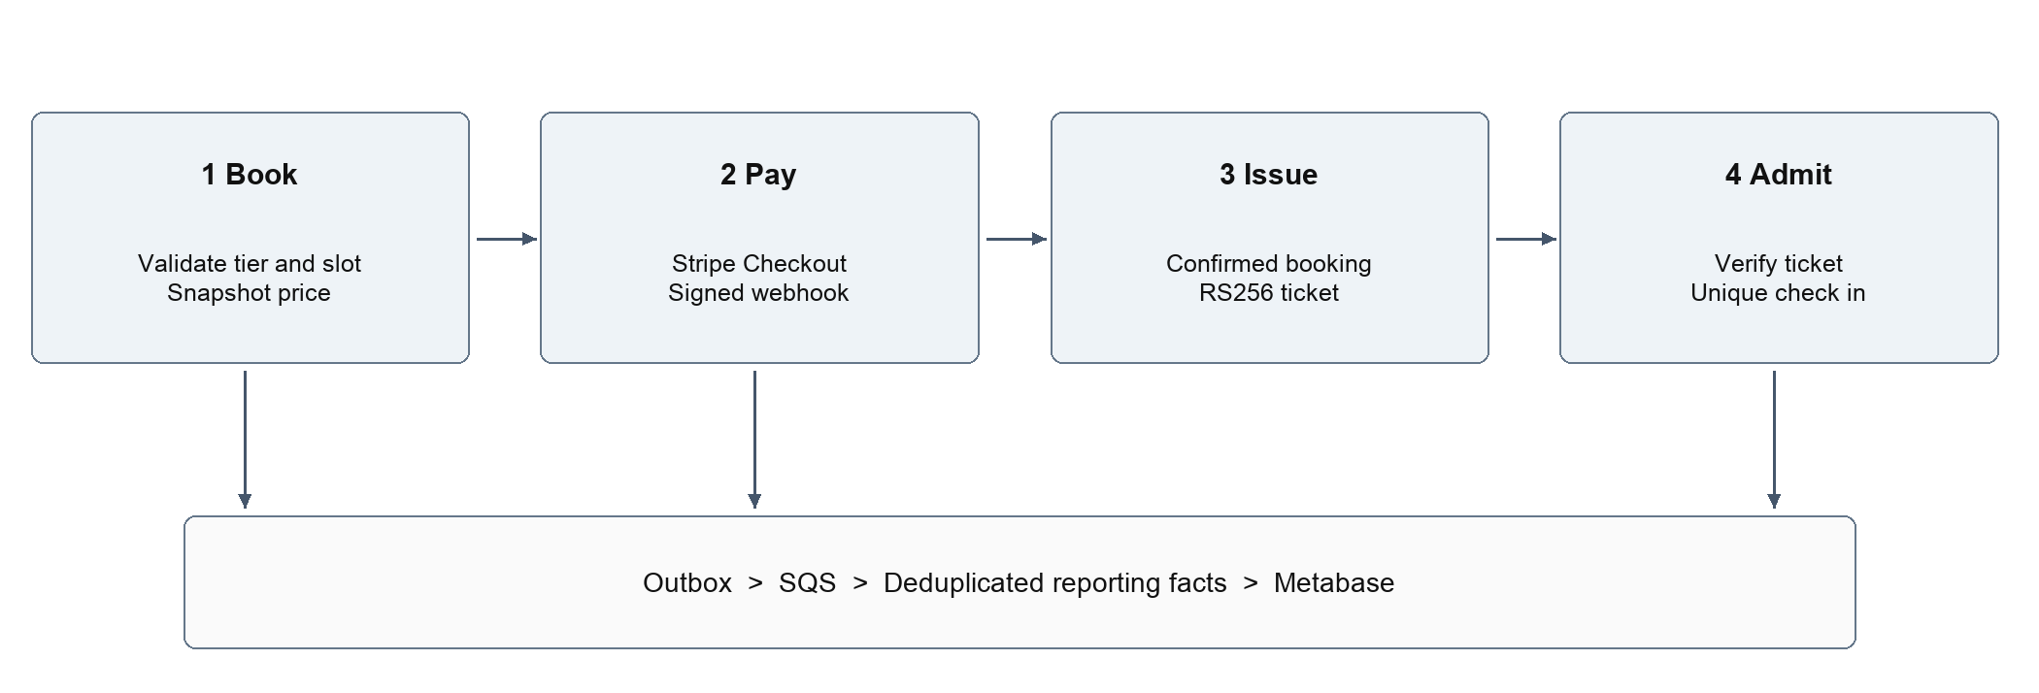
Figure 2 Booking and admission workflow with asynchronous operational reporting

Booking and price integrity
The booking API validates the tier, party size, date and selected slot. It stores a price snapshot and creates a pending reservation. The client supplies an idempotency key; a unique owner-and-key constraint makes concurrent retries return one logical booking. Reusing the same key with a different request is rejected. Prices are represented in integer cents rather than floating-point amounts.

Secure sandbox payment
The booking service creates a Stripe Checkout session using its private test key. The browser redirects to Stripe, keeping card handling outside the application. A return URL alone cannot confirm payment. The webhook handler verifies the signature and compares the session, booking reference, amount and currency with stored values. It then confirms the booking and writes a purchase event in one transaction. Replayed notifications do not create another payment or purchase fact.

Digital ticket and gate validation
A confirmed booking receives an RS256-signed digital ticket. The booking service signs with its private key; the gate verifies with the public key. Issuer, audience, ticket type, signature and visit date are checked. This allows a valid paid guest to enter even when the booking API is unavailable. A unique check-in constraint admits the full booked party once; concurrent repeats receive a conflict response.

Ride events and history
A ride event requires an admitted booking, a valid visit day, an open attraction and a guest count within the admitted party. Each event has an identifier for retry deduplication. Visitors can read their own booking and visit history; administrators manage operational activity. Backend ownership checks prevent an unrelated account from reading a booking by guessing its reference.

5 Authentication security and data protection

Cognito configuration and application roles
Terraform creates a Cognito user pool with email usernames, automatic email verification, a minimum twelve-character password policy and optional software-token MFA. A public browser client has no client secret. Access and ID tokens are configured for fifteen minutes, with token revocation enabled. The administrators group distinguishes staff accounts from visitors. Cognito provides the managed user directory and authentication flows. [4]
The React form supports signup, confirmation and sign-in through the Amplify authentication library. API services validate the token and enforce role and ownership rules. Hiding administrator buttons is not an authorization control. API Gateway routes the request, while application code verifies the Cognito identity; a gateway JWT authorizer is not claimed for this implementation.
Authentication tokens stay in browser memory rather than persistent local storage. Reloading the application requires a new sign-in. Testing exposed a partial-login case when Cognito succeeded but the booking identity endpoint failed. The corrected frontend clears the managed session when backend session acceptance fails, allowing a clean retry after recovery.

Network and encryption boundaries
The EC2 security group permits HTTP for the certificate challenge, HTTPS for the protected API origin and SSH only from the operator laptop address as a single IPv4 /32. Database, Kubernetes and Metabase ports are not exposed publicly. The PEM key remains on the laptop; Terraform references the existing key-pair name without uploading its private key.
The public IP endpoint uses a publicly trusted TLS certificate. Host-to-Ingress, Ingress-to-service and service-to-database connections verify the relevant CA and peer name. EBS is encrypted, and S3/SQS encryption is configured. Secrets Manager holds runtime credentials and signing material; public frontend settings contain only identifiers and endpoint URLs. Server-side build credentials are temporary and removed from the current runtime secret after use.

Operational access and remaining trust limits
SSM provides administration and private port forwarding without opening a monitoring port. Runtime IAM is bounded separately from the reusable deployment policies. The EC2 instance role is shared by this trusted single-node cluster; workload-specific IRSA isolation is not implemented. IMDSv2 is required, with a hop limit of three to support the Docker node and pod network. Minikube does not inherit the former K3s-specific secret encryption setting; encrypted EBS protects the backing disk.

6 Minikube Kubernetes and Ingress
The EC2 bootstrap installs Minikube v1.39.0 and kubectl v1.36.5, verifies their download checksums and starts a persistent profile named wonderland as the Ubuntu user. The cluster uses two CPUs and a 5 GiB memory setting on an 8 GiB m7i-flex.large host. The built-in ingress and metrics-server add-ons provide routing and CPU metrics. No Helm or separate Traefik setup is required.
minikube start -p wonderland --driver=docker \
--container-runtime=containerd --cpus=2 --memory=5120 \
--kubernetes-version=v1.36.5 --addons=ingress,metrics-server

The four cloud Ingress rules are stored in infrastructure/kubernetes/aws/ingress.yaml. A booking request such as /api/booking/bookings is rewritten to /bookings and forwarded to booking-service on port 8000 using HTTPS. Each route verifies the backend CA and expected service name. PostgreSQL and Metabase have no public Ingress rules.

Workload management
Deployments keep two catalog and two booking replicas, with one gate API and one analytics worker. Metabase runs as one Deployment; PostgreSQL runs as a StatefulSet with persistent storage. A migration Job applies schemas before the APIs start. The catalog HPA is bounded from two to three replicas and uses a 70 percent CPU target.
Live testing found that the original CPU reservations left Metabase pending after Minikube reserved CPU for its control plane. The cloud renderer now requests 50 millicores per API container and 100 millicores for Metabase and PostgreSQL. This leaves headroom for startup, a rolling update and an extra catalog replica. Memory limits and application behavior were retained.

Restart and inspection
Systemd starts Minikube after Docker. Minikube reapplies add-on defaults during restart, so a dependent wonderland-routing service restores the private TLS certificate and routing settings. The private Metabase forwarder starts after the cluster. The restart check confirmed healthy pods and preserved reporting data.
minikube -p wonderland status
kubectl get nodes
kubectl -n wonderland get pods,svc,ingress,hpa
kubectl -n wonderland describe ingress api-booking

The built-in add-on uses ingress-nginx, which was retired in March 2026. It is retained here for the requested lab setup. A maintained controller and a managed multi-node cluster are appropriate production improvements. [5]

7 Monitoring and analytics pipeline
Timestamped purchases, gate arrivals and ride events are stored as operational records and durable outbox entries. The analytics worker uses SQS for event transport and maintains reporting facts with unique processed-event identifiers. A failure after receiving a message can cause redelivery; duplicate suppression prevents the repeated message from increasing a business total.
Metabase connects to the reporting data using a separate read-only BI role. Its application metadata is also stored in PostgreSQL. The deployment provisions seven saved SQL cards from analytics/dashboard.json and analytics/queries. The queries answer the assignment questions using stored records rather than hard-coded dashboard figures.
Card | Business interpretation
Daily visitor arrivals | Count admitted guests for each park date
Purchased tickets by tier | Count confirmed booking purchases by tier
Revenue by tier | Sum confirmed amounts in USD cents
Most popular attractions | Rank attractions by recorded rider counts
Busiest and quietest hours | Compare arrivals across provisional opening hours
Daily arrivals by opening hour | Include zero-activity hours to avoid missing quiet periods
Arrivals outside opening hours | Expose events outside the provisional schedule

The reporting timezone is Asia/Colombo and the provisional opening window is 09:00 to 18:00. Equal hourly counts share ranks. Zero-filled hours are necessary because an absent record does not mean an hour should disappear from the quiet-period comparison. The small rehearsal dataset verifies query behavior but cannot establish a reliable operational peak.

Private dashboard access
./demo.sh monitor
# Open http://127.0.0.1:3001 while the tunnel remains active

The command opens an encrypted SSM session to the server loopback forwarder, which connects to the Metabase Service. Credentials remain in ignored private files and are not included in the report. All seven stored SQL cards were queried successfully in the live run and again after restart. CloudWatch received sanitized application logs in 22 observed streams; request IDs support correlation, but full distributed tracing is not implemented.

8 Infrastructure automation and deployment
The application stack is defined in infrastructure/terraform/aws. Terraform 1.16.6 and AWS provider 6.68.0 are pinned. Files separate network, server, storage, identity, hosting, gateway and monitoring concerns while sharing one private local state. A separate permissions root manages reusable deployment grants. The main lifecycle retains those grants and local configuration.
Terraform area | Resources or responsibility
Network and server | VPC, subnet, routing, security group, EC2 host, encrypted root disk and fixed public IP
Storage and identity | Private S3 artifacts, ECR repositories, runtime secret, instance role and Cognito
Hosting and gateway | Visitor/admin Amplify apps, API Gateway integration, routes and allowed origins
Monitoring | Application log group and runtime access for log delivery

Reproducible lifecycle
./demo.sh test
./demo.sh terraform-check
./demo.sh audit
./demo.sh up
./demo.sh status
./demo.sh check
./demo.sh monitor
./demo.sh down
./demo.sh audit

The up command checks the account, active Free plan, supported instance size, Ubuntu AMI, SSH key and narrow operator network. It saves an actual Terraform plan and binds execution to source, target and plan digests. Terraform creates the AWS resources. Release helpers then prepare runtime material, build/push images, install workloads and migrations, build the websites, publish Amplify deployments and verify the hosted platform. [6]
The down command takes a fresh off-server database backup, verifies its checksum and gzip contents, prepares the approved deletion settings, destroys the demo stack, removes the matching Stripe test webhook and audits AWS for leftovers. Preview-only plan and plan-down commands remain available. Local configuration, state, evidence and backups are retained privately.

Cost and lifecycle result
The observed compute quote was USD 0.09576 per hour, approximately USD 0.58 for six hours, excluding storage, public IPv4 and other AWS services. Free-plan eligibility consumes available credits and does not imply unlimited zero-cost usage. The latest teardown was resumed after an interruption; the final independent inventory found no active demo resources and Terraform state contained zero managed resources.

9 Testing and observed results
The final Minikube rehearsal on 17 October 2026 used release r20261017-minikube3. Runtime fixes were installed and exercised on the server; the next clean deployment uses a fresh release tag. The following results are recorded in docs/results/evidence/aws-rehearsal.json under minikube_rehearsal. Earlier K3s measurements are separate and are not presented as new Minikube results.
Test area | Observed result
Regression and build | 212 Python tests passed; visitor and administrator production builds passed
Terraform | All six roots validated and mock-tested; actual demo created 45 AWS resources
Routing and identity | Four API health routes, seeded catalog, Cognito roles, CORS and direct-origin denial passed
Payment | Real Stripe sandbox success and decline; invalid signature rejected; duplicate event replay detected
Booking concurrency | Four simultaneous retries produced one logical booking reference
Admission concurrency | One HTTP 201 admission and three HTTP 409 duplicate conflicts
Service isolation | Gate admitted a signed ticket while booking was stopped; booking worked while gate was stopped
Recovery | Catalog replacement stayed available; queued ride event drained after analytics restarted
Persistence and monitoring | Restart preserved reporting; all seven Metabase SQL cards passed; CloudWatch logs received
Load and cleanup | 2,724 HTTP 200 responses with zero failures at 18 requests/second; verified backup; final AWS audit empty

Reporting reconciliation
One confirmed family booking produced one reporting purchase worth USD 140. One gate check-in admitted four guests. Two ride events represented eight riders. Operational and reporting counts matched, and both source outboxes were drained. The booking used a valid same-day future time slot during park hours; the latest run required no visit-date database fixture.

Meaning of the load result
The API Gateway limit is 20 requests per second with a burst limit of 40. The bounded 18-request-per-second run returned 2,724 successes and zero failures. CPU remained below the autoscaling threshold, so two replicas were retained. This run verifies that particular demo workload; it does not establish production capacity or a newly observed two-to-three-to-two HPA cycle.

10 Screenshots and defects corrected
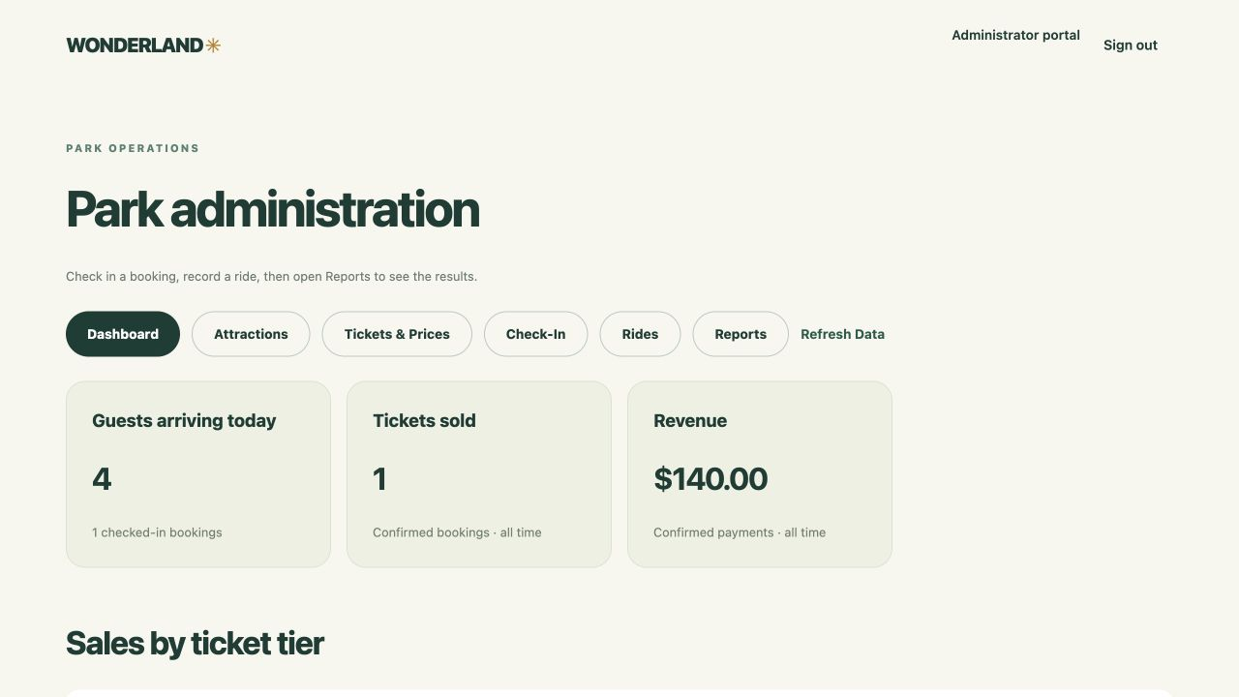
Figure 3 Live administrator dashboard showing four arrivals one paid ticket and USD 140 revenue
The administrator dashboard displays reconciled values from the live purchase, admission and ride records. Browser checks also confirmed the visitor booking history and the administrator reports. The hosted URLs were temporary; the infrastructure was removed after verification.
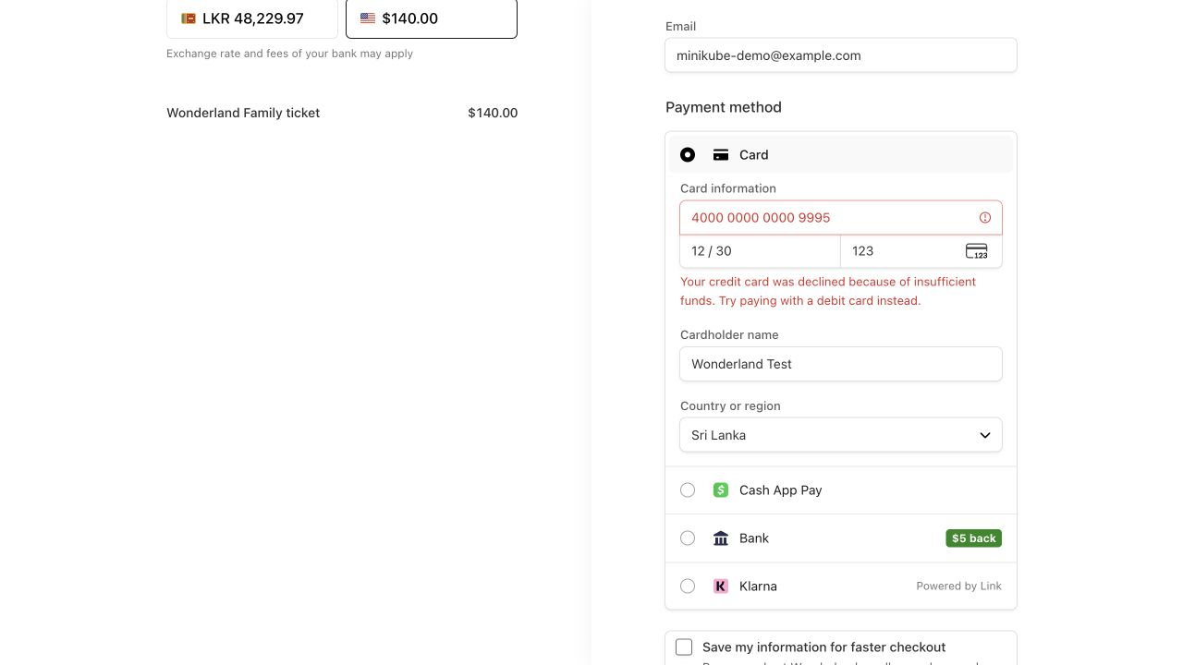
Figure 4 Stripe sandbox insufficient funds response before a successful test card payment
The decline left the booking pending and Stripe payment unpaid. A later successful test card confirmed the booking only through its signed webhook. Test card data is synthetic and no real payment was made.

11 Assignment coverage and evaluation
Task | Implemented deliverable | Evidence or limit
1 Report and design | Architecture, design decisions and automation explanation | This report; diagrams; Terraform source
2 Microservices | Four FastAPI services with database ownership | 212 tests and live business flow
3 Web and identity | React visitor/admin apps, Amplify and Cognito | Browser login, history, dashboard and reports
4 Analytics | Outbox, SQS, reporting facts and Metabase | Seven stored SQL cards and reconciliation
5 Containers | Service images, migration and static frontend image | Dockerfiles and six published ECR images
6 Kubernetes | Minikube, kubectl, Ingress and API Gateway | Ready pods; four routes; recovery and restart
7 Database | PostgreSQL with schemas and persistent storage | Self-managed on EC2 rather than managed RDS
8 Infrastructure as Code | Terraform plus application release scripts | 45-resource creation, verified backup and teardown
9 GitHub integration | Real repository configured and CI workflow supplied | Successful remote workflow and examiner access not verified

Repository and continuous integration
The repository is configured as https://github.com/saditha93/wonderland. The workflow in .github/workflows/ci.yml runs on push, pull request or manual dispatch. It specifies Python regression, frontend build and audit, Terraform validation, container checks and source packaging. Its AWS-free CI definition is present, but no successful remote run is claimed in this report. Automatic cloud deployment from GitHub and replacement of the current S3 release path remain unimplemented.

12 Implementation limits and conclusion
The database guidance mentions managed services. This implementation uses self-managed PostgreSQL on encrypted EC2 storage; the optional EKS/RDS alternative was checked offline and is not live evidence. A production version should use a managed database with rehearsed recovery, a maintained Ingress controller, multiple failure domains and workload-specific IAM. The bundled ingress-nginx controller is retired and is retained only for the requested lab demonstration.
A fresh backup was validated and includes the paid booking, but restoring it into an independent environment was not rehearsed. New signup/email confirmation and a complete HPA scale-up/down cycle were not repeated in the latest run. They must not be inferred from the passing platform checks.

Conclusion
The project demonstrates the required visitor-to-reporting journey and the interaction between managed AWS services and Kubernetes workloads. Live testing confirmed payment integrity, concurrent admission protection, service isolation, eventual reporting and reproducible teardown. Its main trade-off is using one teaching-oriented server for a complete demonstration, with the production limitations stated above.

13 References and acknowledgement
[1] SLIIT. Assignment Cloud Computing 2026 AUG. SE6020, MSc in IT, Semester 03. Supplied assignment, pages 1 to 4. Tasks, functional requirements, non-functional requirements and marking rubric.
[2] Kubernetes Minikube. Docker driver documentation. https://minikube.sigs.k8s.io/docs/drivers/docker/ Accessed 17 October 2026.
[3] Amazon Web Services. Amazon SQS at least once delivery. https://docs.aws.amazon.com/AWSSimpleQueueService/latest/SQSDeveloperGuide/standard-queues-at-least-once-delivery.html Accessed 17 October 2026.
[4] Amazon Web Services. Authenticating users with Amazon Cognito user pools. https://docs.aws.amazon.com/cognito/latest/developerguide/cognito-user-pools.html Accessed 17 October 2026.
[5] Kubernetes ingress-nginx project. Retirement notice in the project README. https://github.com/kubernetes/ingress-nginx/blob/main/README.md Accessed 17 October 2026.
[6] Amazon Web Services. Deploying an application to Amplify without a Git repository. https://docs.aws.amazon.com/amplify/latest/userguide/manual-deploys.html Accessed 17 October 2026.
[7] Wonderland project source. https://github.com/saditha93/wonderland Main implementation: services, frontend, infrastructure/terraform/aws and infrastructure/kubernetes/aws/ingress.yaml.
[8] Wonderland project evidence. docs/results/evidence/aws-rehearsal.json, minikube_rehearsal; docs/results/aws-rehearsal.md; docs/deployment.md. Live checks and cleanup recorded on 17 October 2026.

Assistance acknowledgement
OpenAI Codex assisted with implementation, refactoring, infrastructure scripts, testing, troubleshooting and drafting this report. I am responsible for reviewing the implementation, verifying the submitted evidence and explaining the architecture and code during the viva. This acknowledgement does not replace the course requirements for individual understanding or the lecturer's rules on permitted assistance.
Any help provided to or received from other students should be recorded with the student index number and the nature of the assistance, as required by the assignment. This report does not assert an unverified collaboration history.

Submission notes
The supplied assignment requires a softcopy report in Moodle, links to code and other artifacts, and a demonstrable solution for the viva. Its stated deadline is 11 October 2026 and viva date is 8 November 2026. Any revised deadline must be checked through the course communication; this report does not assume an extension. Before submission, confirm the cover details, repository access and successful remote CI evidence.

