Name: _________________

Lab 4 - Soils

All students must submit their own work.

Web Soil Survey

Click on the “Web Soil Survey” hyperlink: https://websoilsurvey.nrcs.usda.gov/app/ . (Or search “Web soil survey” and click on the first link that appears). Click on the green button that says “Start WSS”.
The first task is to define AOI (area of interest). You can do it by following the method here:
- Download the zip file “uiuc_mainQuad” from canvas Week 6 module. Under the ‘Area of Interest’ menu on the left, click on ‘Import AOI’, then ‘Create AOI from Zipped Shapefile’ and then ‘Choose File’. You should select the zip file “uiuc_mainQuad” that you downloaded from canvas. Click ‘open’ and then click ‘Set AOI’. Your AOI should look like the one in the figure below.

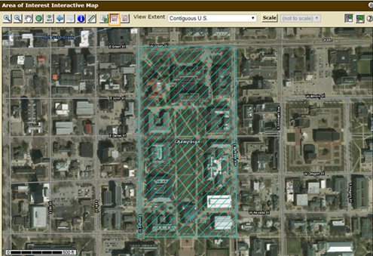

- Above the interactive map, click on the tab “Soil Data Explorer”, and on the tab menu that appears below that click on “Soil Properties and Qualities”. Make sure that your AOI is still selected. Under the “Properties and Qualities Ratings” menu on the left, click on “Soil Physical Properties” and then “Organic Matter”. Leave all of the default settings as they are, except at the bottom check the option “All layers (weighted average)”. Then click “View rating”. Fill in the blank spaces in the table on the next page: (1 pt)

Map unit symbol | Map unit name  (ignore percent slopes) | Rating (percent)

Which soil has the highest percentage of organic matter? (Hint/fun fact: This is our state soil)

Soils are commonly classified based on their particle size distribution. Sand, silt, and clay are the three broad particle classes. The USDA defines them as follows: Clay particle diameter is less than 0.002 mm, silt particle diameter = 0.002-0.05 mm, and sand particle diameter is greater than 0.05 mm. While there are more specific subcategories, we’ll only deal with these three broad categories in this lab.

2.(a) Now click “Percent Clay” in the menu on the left and again leave all of the default settings except check “All layers (weighted average)”. Then click “View rating”. Fill out the table below: (3 pt)

Clay
Map unit symbol | Map unit name  (ignore percent slopes) | Rating (percent)

2.(b) Do the same as question 2 but for “Percent Sand”. Fill out the table below:

Sand
Map unit symbol | Map unit name  (ignore percent slopes) | Rating (percent)

2.(c) Do the same as above but for “Percent Silt”. Fill out the table below:

Silt
Map unit symbol | Map unit name  (ignore percent slopes) | Rating (percent)

- Plot the three soil units from above on the USDA soil texture diagram below. Reference the clay, sand, and silt compositions to complete this. Label the units on the diagram with the first letter of their respective map unit name (i.e., D, F, or C). (1 pt)

Hint: You can re-arrange the values you got from 2(a), 2(b), and 2(c) in the table below. It will help you to plot the soil texture diagram.
 | Drummer | Flanagan | Catlin
Clay
Sand
Silt

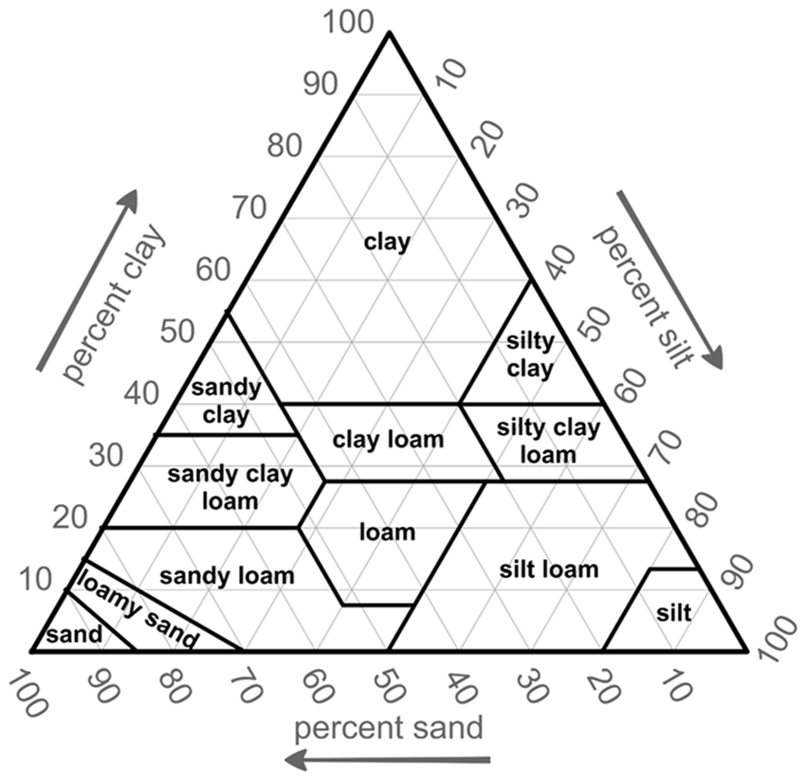

4. Switch to the “Suitability and Limitations for Use” tab. Click on “Vegetative Productivity”, then click on “Yields of Non-Irrigated Crops (Component)”. Make sure the crop is set to corn and then click “View Rating”. The rating displayed indicated crop yield in bushels per acre. All three of the soil types present on the quad have a high yield index, but which has the best? (Circle one) (1 pt)

Drummer silty clay loam Flanagan silt loam Catlin silt loam

5. Now click on the “Soil Map” in the upper row of tabs. Then click on the soil name that you chose for the previous question. In the window that appears, use the “Typical Profile” section to fill out horizon information for the soil you chose. (1 pt)

Horizon | Depth | Textural Class

6. According to where the soil units are plotted in Question 3, are their names accurate? For example, is the Drummer Silty Clay Loam actually a silty clay loam? If not, speculate why using the table in Question 5? (1 pt)

7. Climatic variables like precipitation and temperature are major drivers of soil formation processes. In the map unit description report window for the soil that you chose for question 4, locate and record the “Mean annual precipitation” and the “Mean annual air temperature” for the soil (under the Map Unit Setting section at the top). (1 pt)

Mean annual air temperature: ___________________degrees F

Mean annual precipitation: _____________________Inches

8. Open the link: https://www.usclimatedata.com/climate/champaign/illinois/united-states/usil2051 (or go the website of “Illinois and Weather averages Champaign - U.S. Climate Data”). Do the actual average annual rainfall/air temperature measurements fit within/close to the ranges above? (1 pt)

