Name: _____________________________

GGIS 103 Lab Assignment 2: Plate Tectonics and Volcanoes

Due at the beginning of the next lab. All students must submit their own work.

Part 1: Plate Tectonics (6 points) - use your lecture notes and lab notes/slides to answer the following questions

- Why is the oldest continental crust so much older than the oceanic crust? (1 pt)

Continental crust is subducted and recycled in the mantle. Since continental crust is less dense and is never subducted, it exists as crust for much longer and is therefore always older than oceanic crust.
* continental crust is almost always much older than oceanic crust. Because continental crust is rarely destroyed and recycled in the process of subduction,

- At a collision boundary, what physical property determines which of the two plates will subduct? (1 pt)

Density

- Consider the two statements:
  - An earthquake measured 7.5 on a Richter scale.
  - Most people in the region felt strong ground vibrations, and extensive damage was recorded over large areas.
Which of the two statements tells us the magnitude of the earthquake, and which tells us its intensity? Explain why. (1 pt)

- Magnitude – because magnitude measure the energy released from the earthquake, which is measured using a seismograph, and the Richter scale shows the results from the seismograph
- Intensity – this describes the effect the earthquake had on people, structures, and the environment

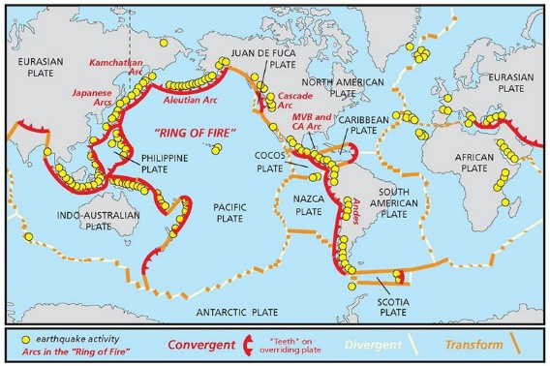
- Refer to the figure above. Are earthquakes and volcanoes evenly distributed around the earth? Or is there a certain type of locale they tend to be concentrated in? (1 pt)

No, most are located in the Ring of Fire at subduction zones where oceanic and continental plates converge

- Two faults are depicted below. First, label the footwall (F) and the hanging wall (H) of both faults, then label the faults as either normal or reverse on the given line. Then draw arrows indicating relative motion. (1 pt)
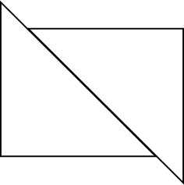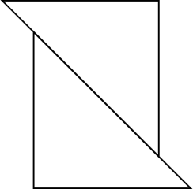
F
H
F
H

_____Normal________ _________Reverse________

- Label the P, S, and surface waves in the sample seismograph below. (0.5 pt)
Surface
S
P
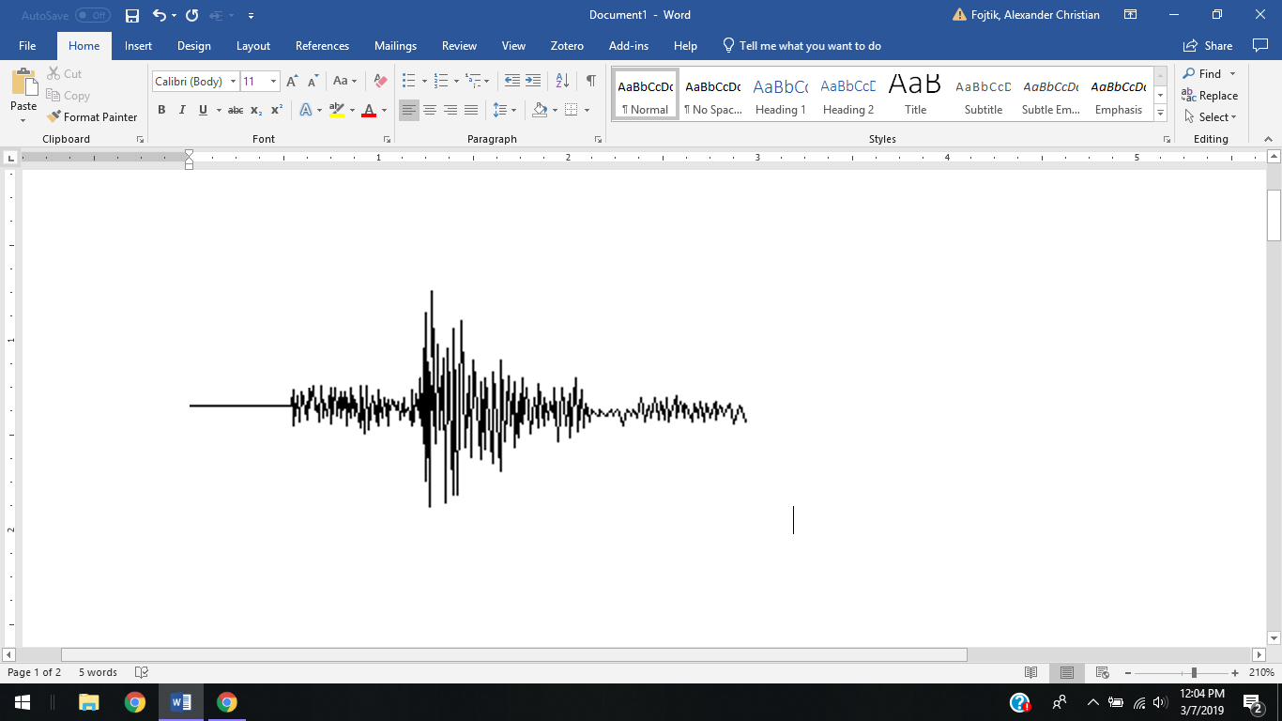

- How much larger is the amplitude of an earthquake measuring 6.0 on the Richter scale than that of an earthquake measuring 4.0? (0.5 pt)
100 times larger

Part 2- Use Google Earth Pro and refer to lecture and lab materials to complete this part. Download the .kml and .kmz files called “Lab 2-I” and “plate-boundaries” in the Lab 2 folder in Compass. Import the files into Google Earth and check that the layers are visible.

- Double-click on the layer “Question 1”. The highlighted area displays the Hawaii Hotspot. Remember that hotspots are fixed and independent of overlying tectonic plates/plate boundaries. Zoom out to an eye altitude of ~ 2000 mi (located at bottom right corner of window). Determine which direction the plate that lies over the Hawaii Hotspot is moving. Circle one of the options below. (Hint: Hawaii’s big island is the youngest island in the chain)

Northwest to Southeast Southeast to Northwest Northeast to Southwest
ventually the plate motion carries the island away from the hotspot; volcanism wanes and then stops entirely. The island and surrounding ocean floor sink down as the underlying mantle cools and contracts, and erosion wears away at the island. The Hawaiian Islands thus get progressively smaller and lower as they move away from the hotspot. As time wears on the islands are so low that only coral reefs extend above the sea,

- Double-click on the layer “Question 2”. The highlighted area displays part of the Cascade Range and western US coastline. Here, the Juan de Fuca (JF) oceanic plate and the North American (NA) plate are moving towards each other. What kind of plate boundary is this? What is happening to the Juan de Fuca plate in relation to the Pacific (PA) plate as a result and why?

JF is subducting under the NA plate, which is a convergent plate boundary. In response, the JF plate is diverging from the PA plate.

- Double-click on the layer “Question 3”. The highlighted area showcases the Himalayas, the world’s highest mountain range. The Himalayas mark the location of a plate boundary. What kind of plate boundary is this? Explain how you reached your conclusion.

The two bordering continental plates are converging (convergent boundary), which pushed the Himalayas together and upwards.

Download the .kml file “Lab 2-II” from Canvas and look at it in Google Earth Pro.

- Identify the type of volcano (shield volcano, cinder cone, or stratovolcano/composite) in the highlighted area. Investigate the slope (remember that there is a tool to visualize this) and general morphology of the feature to determine the type. Refer lecture and lab slides if needed. Hint: Enabling 3D terrain will aid in identifying.

  - What type is “Volcano 1”? Stratovolcano
  - What type is “Volcano 2”? shield Cone
  - What type is “Volcano 3”? cinder Volcano
  - What type is “Volcano 4”? Stratovolcano

