Name:
GGIS/ESE 103 Lab Assignment 3: Plate Tectonics and Volcanoes

Part 1: Plate Tectonics (7 points) - use your lecture notes and lab notes/slides to answer the following questions.

- At a collision boundary, what physical property determines which of the two plates will subduct? (0.5 pt)

- At an oceanic–continental convergent boundary, name one major surface feature that forms at the subduction zone (near the plate contact), and one type of volcanic landform that forms on the overriding continent. (0.5pt)

- Consider the two statements:
  - An earthquake measured 7.5 on a Richter scale.
  - Most people in the region felt strong ground vibrations, and extensive damage was recorded over large areas.
Which of the two statements tells us the magnitude of the earthquake, and which tells us its intensity? Explain why. (1 pt)

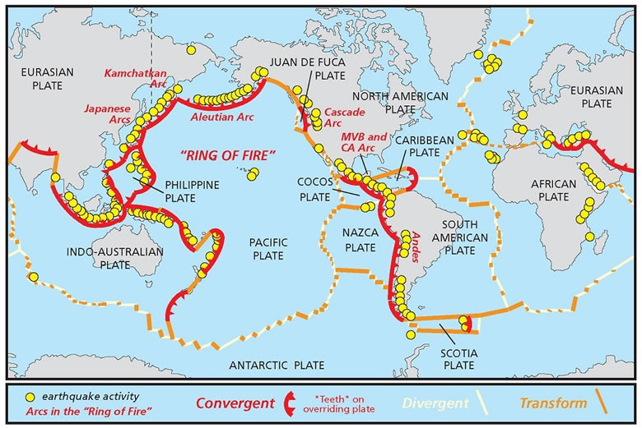
4. Refer to the figure above. Are earthquakes and volcanoes evenly distributed around the earth? Or is there a certain type of locale they tend to be concentrated in? (1 pt)

5. Two faults are depicted below. First, label the footwall and the hanging wall of both faults, then label the faults as either normal or reverse on the given line. Then draw arrows indicating relative motion. (1 pt)
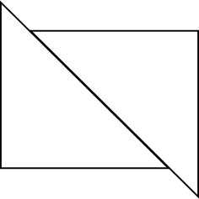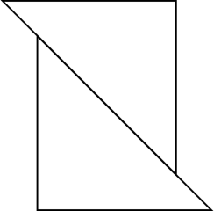

__________________________ __________________________

6. Label the P, S, and surface waves in the sample seismograph below. (1 pt)

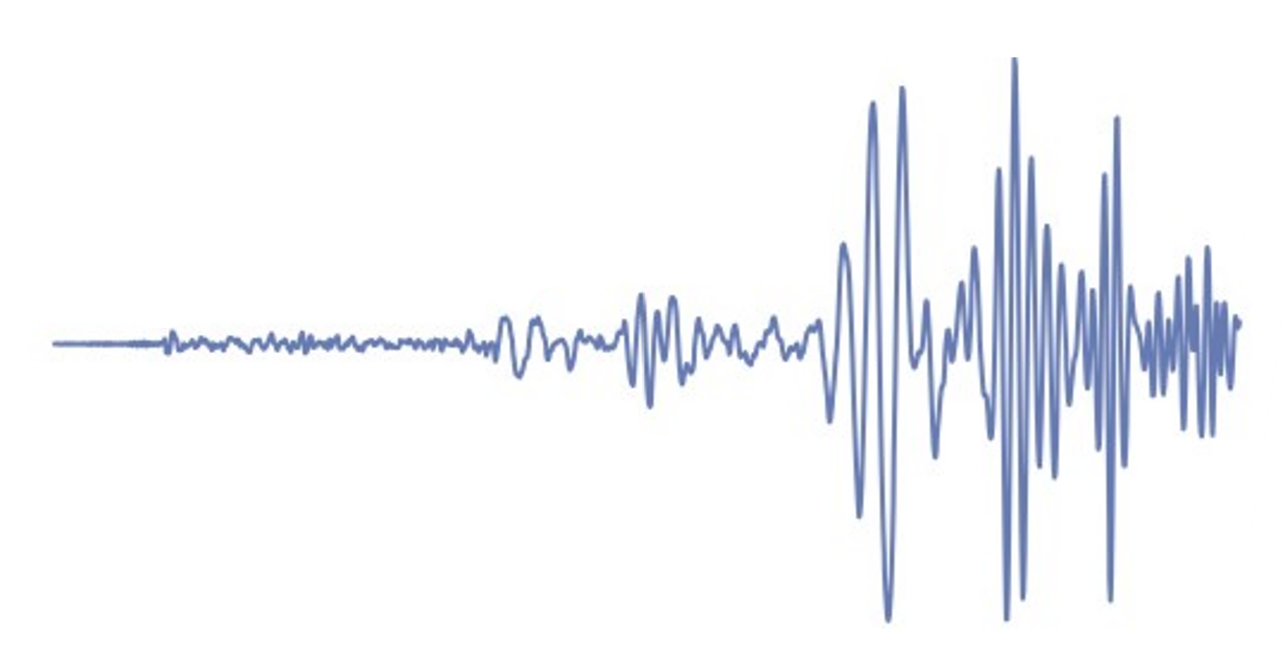

7. How much larger is the amplitude of an earthquake measuring 6.0 on the Richter scale than that of an earthquake measuring 4.0? (1 pt)

8. A Richter magnitude 5.0 earthquake is recorded at a station with a maximum wave amplitude of 1 mm. If a similar earthquake produces a maximum amplitude of 10 mm at the same station, what is the earthquake’s Richter magnitude? (1 pt)
A) 5.5
B) 6.0
C) 6.5
D) 7.0

Part 2 (3 points) - Use Google Earth Pro and refer to lecture and lab materials to complete this part. Download the .kml and .kmz files called “Lab 3-I” and “Lab 3-II” from the Week 4 module in Canvas. Import the files into Google Earth and check that the layers are visible.

Look at the .kml file “Lab 3-I” in Google Earth Pro and expand the file. Under this file, you will have 3 separate kmls named as “Question 1”, “Question 2” and “Question 3”
- Double-click on the layer “Question 1”. The highlighted area displays the Hawaii Hotspot. Remember that hotspots are fixed and independent of overlying tectonic plates/plate boundaries. Zoom out to an eye altitude of ~ 2000 mi. Determine which direction the plate that lies over the Hawaii Hotspot is moving. Circle one of the options below. (Hint: Hawaii’s big island is the youngest island in the chain)

Northwest to Southeast Southeast to Northwest Northeast to Southwest

- Double-click on the layer “Question 2”. The highlighted area displays part of the Cascade Range and western US coastline. Here, the Juan de Fuca (JF) oceanic plate and the North American (NA) plate are moving towards each other. What kind of plate boundary is this? What is happening to the Juan de Fuca plate in relation to the Pacific (PA) plate as a result and why? (picture below for reference)
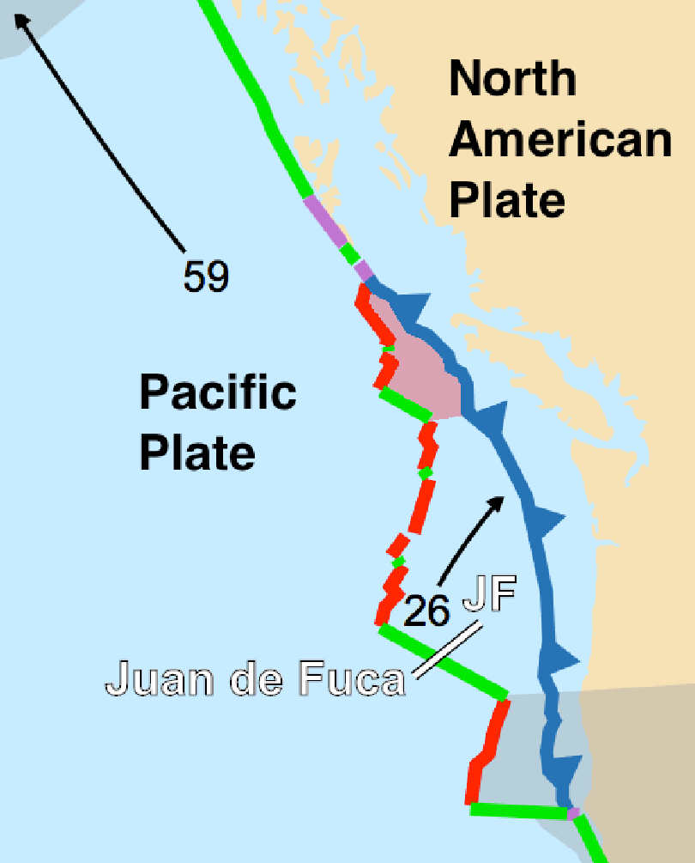

- Double-click on the layer “Question 3”. The highlighted area showcases the Himalayas, the world’s highest mountain range. The Himalayas mark the location of a plate boundary. What kind of plate boundary is this? Explain how you reached your conclusion.

