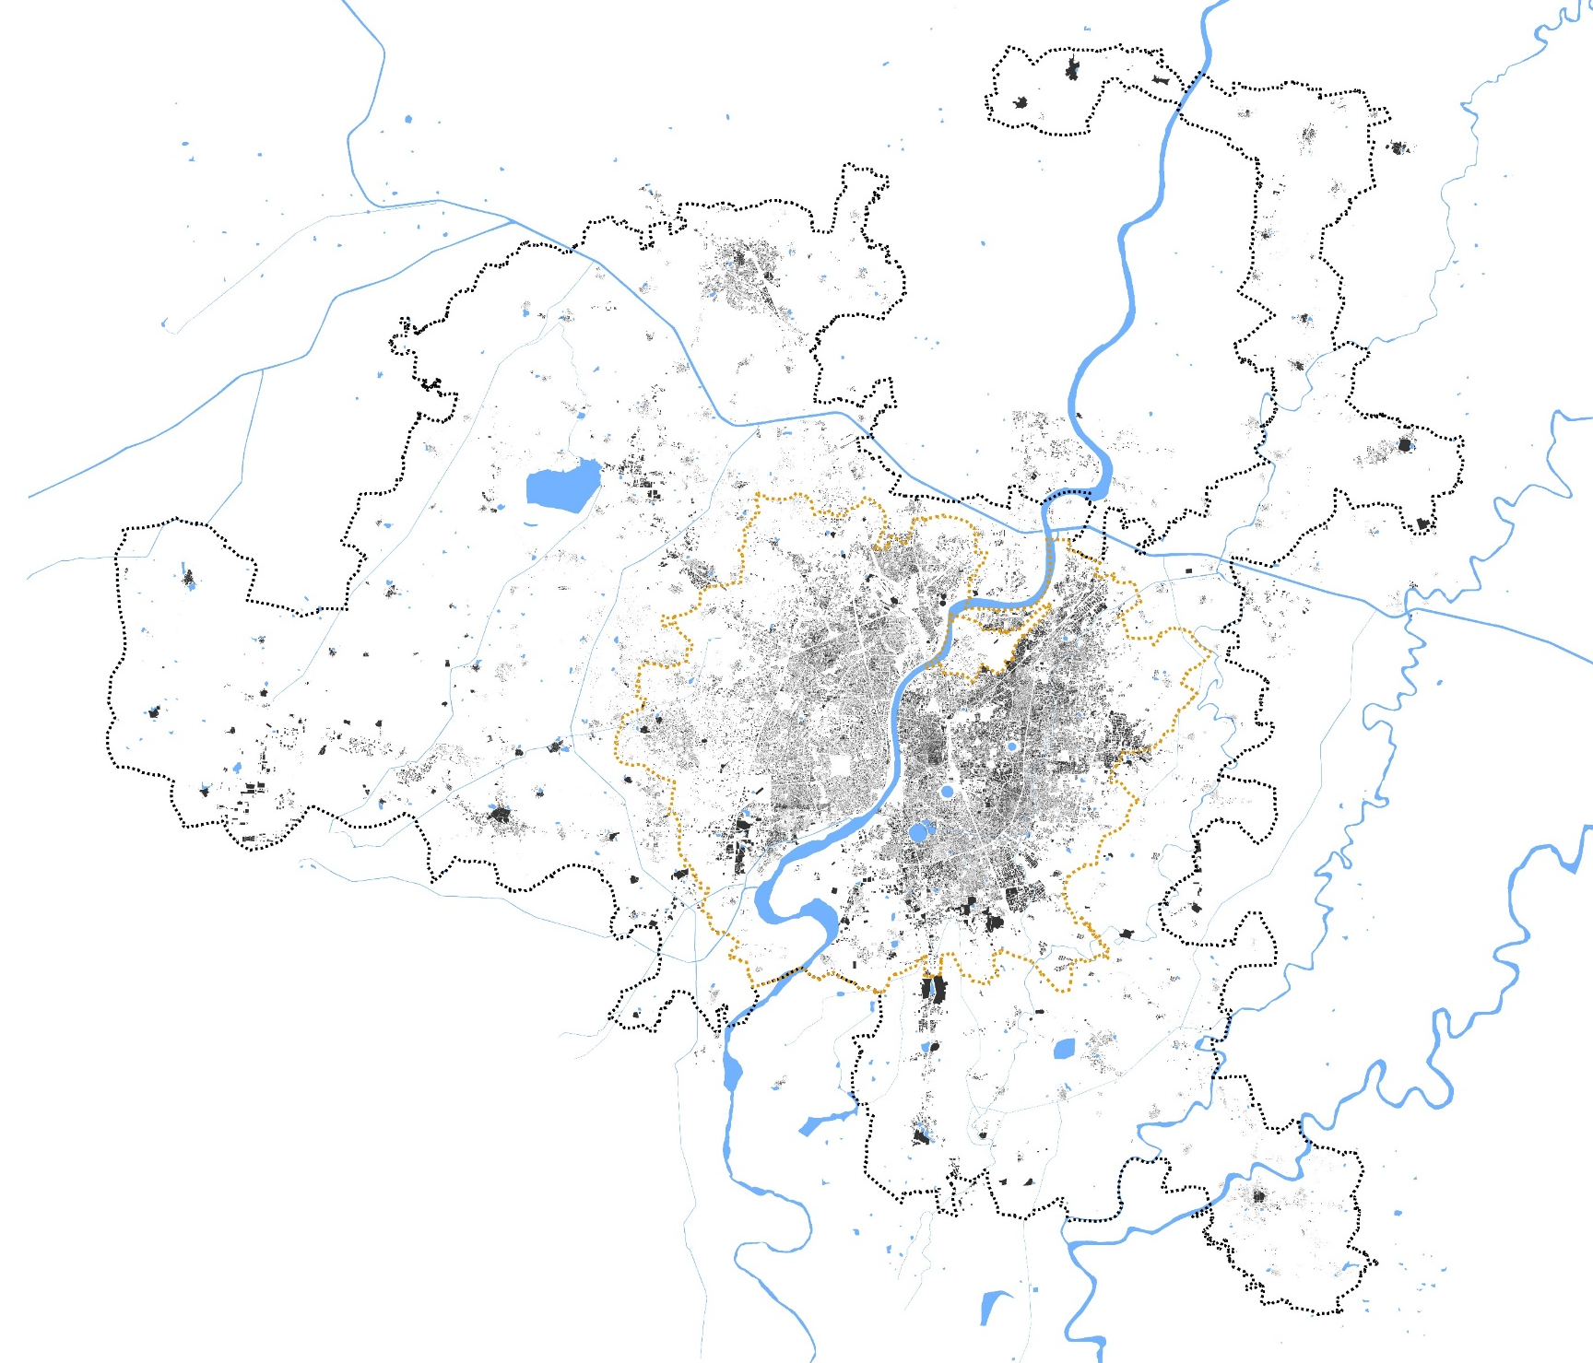
Urban Expansion and Environmental Change across AUDA, Gujarat (2015–2025)
A Geospatial Assessment of Built-up Growth, Vegetation Greenness, Surface Heat and Flood Susceptibility

Report by – Sadiya Sharmin

ABSTRACT
Rapid urban expansion across the Ahmedabad Urban Development Authority (AUDA) region of Gujarat has increased the importance of understanding how urban growth is affecting the environment and vice versa. This report examines changes in built-up areas, vegetation, surface temperature, water-related conditions, rainfall, and flood susceptibility between 2015 and 2025 across the 1,866 km² study area. The findings indicate an increase of 54.57 km² in built-up land, representing a growth of 13.45% over the study period. Vegetation analysis reveals a mixed pattern, with some areas experiencing declining greenness while others show improvement or little change. Surface temperature patterns highlight the need to consider rising heat exposure in urban development, while water-related indicators and terrain analysis identify areas that warrant further attention to drainage and flood management. Overall, the findings highlight the interconnected challenges of urban expansion, environmental degradation, heat stress, and water-related risks. The report emphasises the need for integrated urban planning that balances development with the protection of green and blue spaces, climate-sensitive infrastructure, and improved stormwater management. These findings provide a basis for identifying planning priorities and supporting more environmentally resilient urban development across the AUDA region.

KEYWORDS
Ahmedabad; AUDA(Ahmedabad Urban Development Authority); urban expansion; remote sensing; built-up land; NDVI; land-surface temperature; NDWI; rainfall; flood susceptibility; green-blue infrastructure; climate-resilient planning.

STUDY AREA  AUDA · 1,866 km² | PERIOD  2015–2025 | EVIDENCE  GIS & remote sensing

INTRODUCTION, RESEARCH QUESTION & METHODOLOGY

Introduction

Ahmedabad is a major urban and industrial centre in Gujarat, western India, situated along the Sabarmati River and within its wider river basin. Research on the city describes Ahmedabad as a hot semi-arid setting, with high pre-monsoon temperatures and strongly seasonal rainfall concentrated in the monsoon period; land-cover seasonality in surrounding rural areas can affect the interpretation of surface-urban-heat patterns (Mohammad et al., 2019). Urban regions change through land conversion, vegetation dynamics, surface-energy differences, hydrological modification and infrastructure expansion.

The Ahmedabad Urban Development Authority (AUDA) is a statutory planning authority which guides urban development beyond the periphery of Ahmedabad Municipal Corporation (AMC). Its jurisdiction covers approximately 1,866 km², including the municipal area, surrounding growth centres and villages. As Ahmedabad continues to expand, understanding the environmental implications of this growth is essential.

This report examines urban expansion and environmental change across AUDA between 2015 and 2025. It assesses changes in built-up areas, vegetation greenness, land surface temperature, water-related conditions, rainfall and terrain-based flood susceptibility using geospatial and remote-sensing analysis. By examining these indicators together, the report aims to identify emerging environmental concerns and spatial patterns that can inform urban growth management, green infrastructure protection, heat mitigation and drainage planning.

Research question
How has urban expansion across AUDA between 2015 and 2025 spatially corresponded with changes in vegetation greenness and land-surface temperature, and what do the wider water-related, rainfall, terrain and preliminary flood-susceptibility outputs imply for climate-resilient urban planning?

Objectives
  - Quantify mapped built-up land change from 2015 to 2025, including net change and class transitions.
  - Assess vegetation greenness and the spatial/temporal patterns of LST and relative heat anomalies.
  - Examine the spatial correspondence of built-up expansion with NDVI change and thermal patterns, distinguishing visual coincidence from statistically tested relationships.
  - Interpret NDWI, rainfall, elevation, slope, HAND and preliminary flood-susceptibility classes together.
  - Develop planning recommendations addressing heat stress, water stress, flooding and loss of green-blue assets.

Study details and indicator coverage

Indicator | Assessment
Built-up land | Net mapped change and gross class transitions.
NDVI | Vegetation greenness, not direct canopy or biodiversity.
LST / heat anomaly | Surface-temperature variation and relative hotspots.
NDWI / rainfall | Spectral water-related index and annual rainfall accumulation.
Terrain / flood screen | Terrain and drainage screening; not a validated flood-risk model.

- FINDINGS
2.1 Built-up expansion

Findings
  - Mapped built-up area increased from 405.77 km² in 2015 to 460.34 km² in 2025: a net gain of 54.57 km² (13.45%).
  - The transition chart reports 109.27 km² newly classified as built-up and 54.70 km² no longer classified as built-up.
  - The spatial map and year-on-year frames show the distribution of mapped built-up change across AUDA.

Analysis
  - The increase in built-up area indicates that Ahmedabad’s urban footprint is expanding across the
AUDA region, reflecting the continued growth of the city into its surrounding areas.

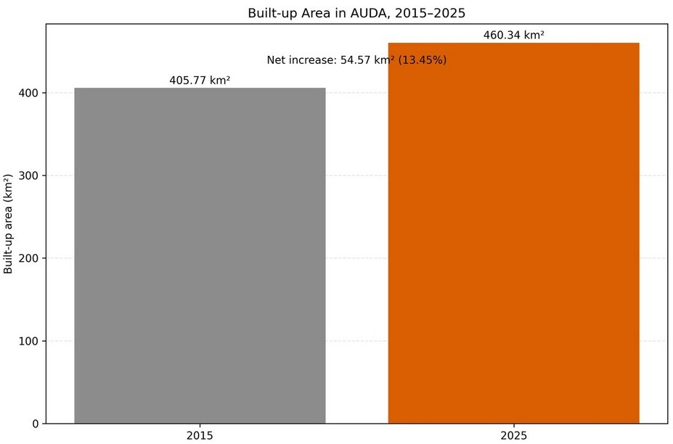  Figure 1. Built-up area in AUDA, 2015 and 2025. | 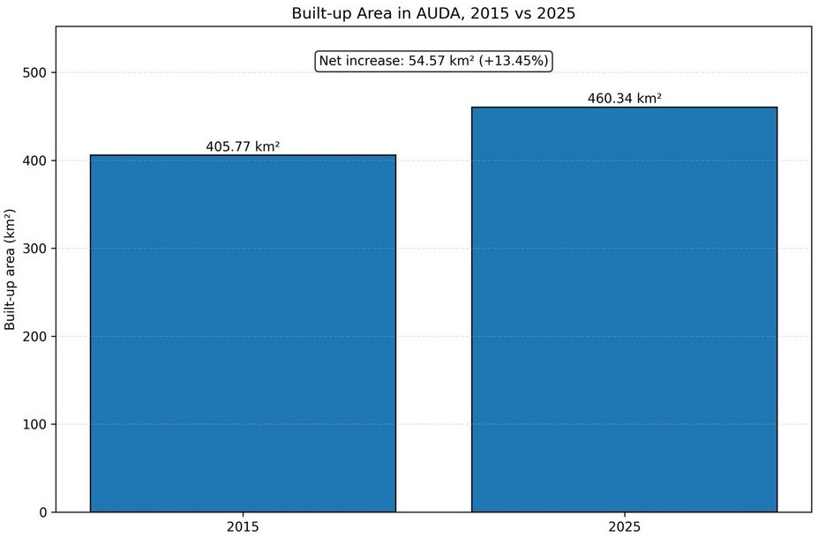  Figure 2. Net change in mapped built-up area, 2015–2025.
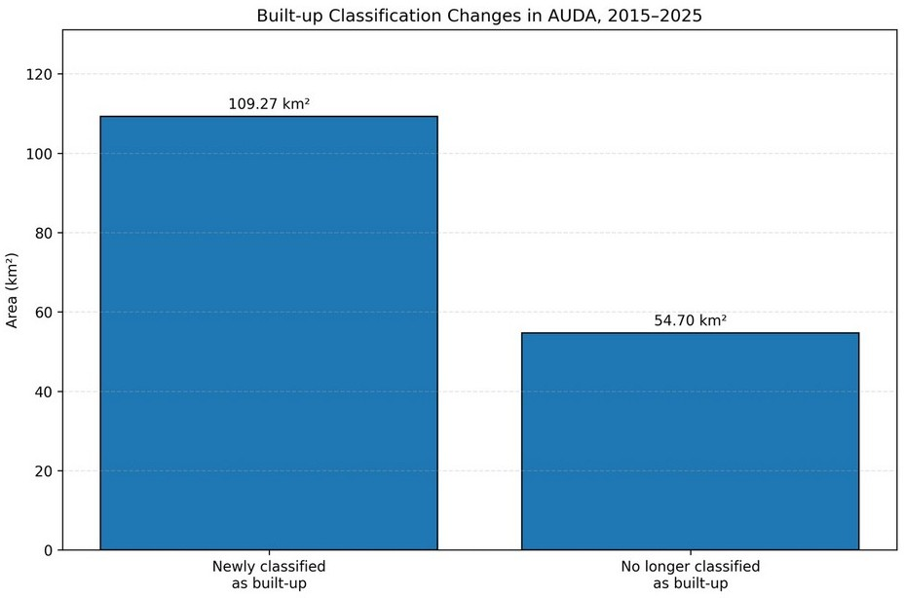  Figure 3. Built-up classification transitions, 2015–2025. | 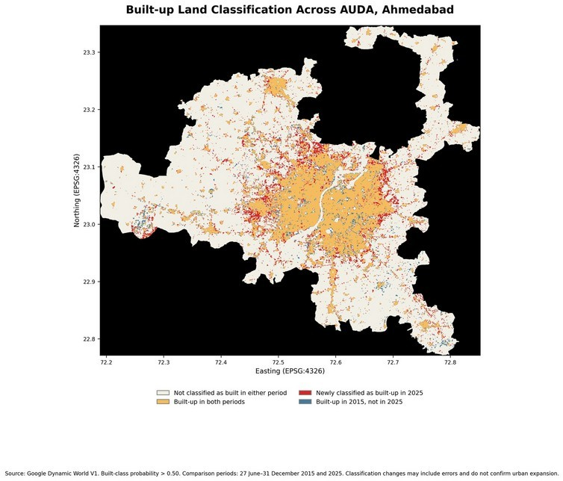  Figure 4. Spatial pattern of built-up expansion across AUDA,  2015–2025.
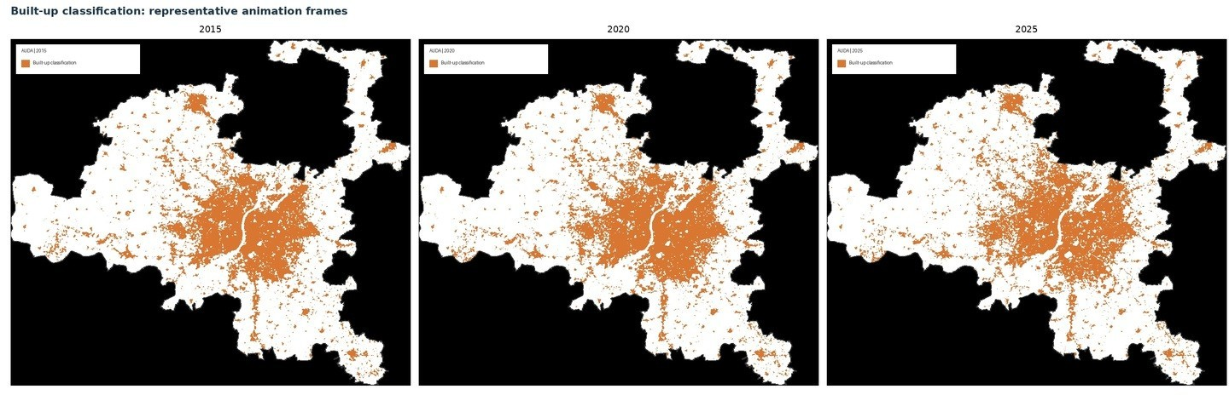
Figure 5. Year-on-year built-up classification, selected frames.

2.2 Vegetation greenness (NDVI)

Findings
  - The 2025 NDVI maps show spatial variation in vegetation greenness across AUDA.
  - Vegetation greenness across AUDA shows a mixed pattern, with 30.8% of the area experiencing declining greenness.

Analysis
  - Declining greenness across 574.2 km² indicates substantial areas of vegetation stress or loss.
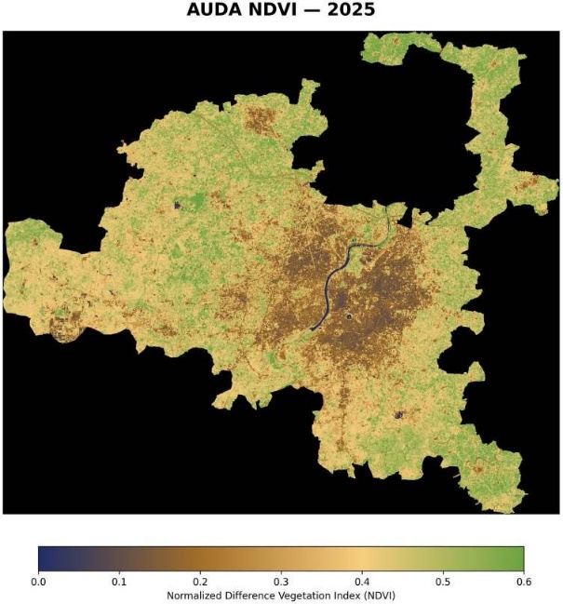
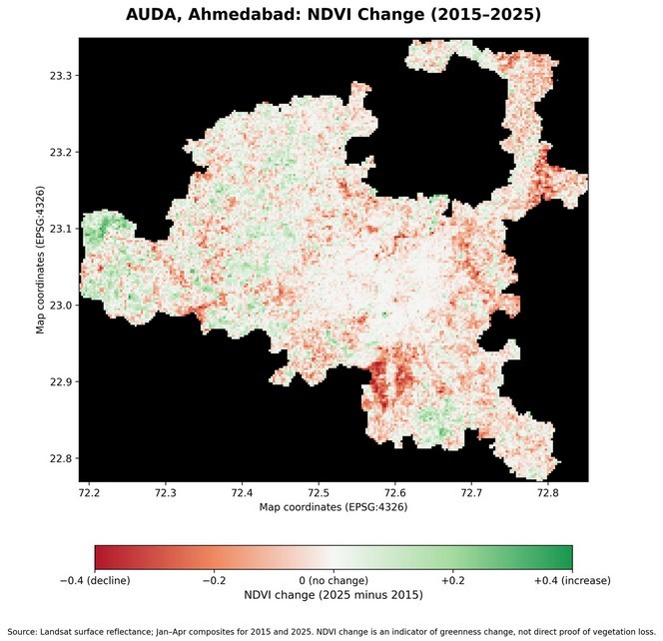
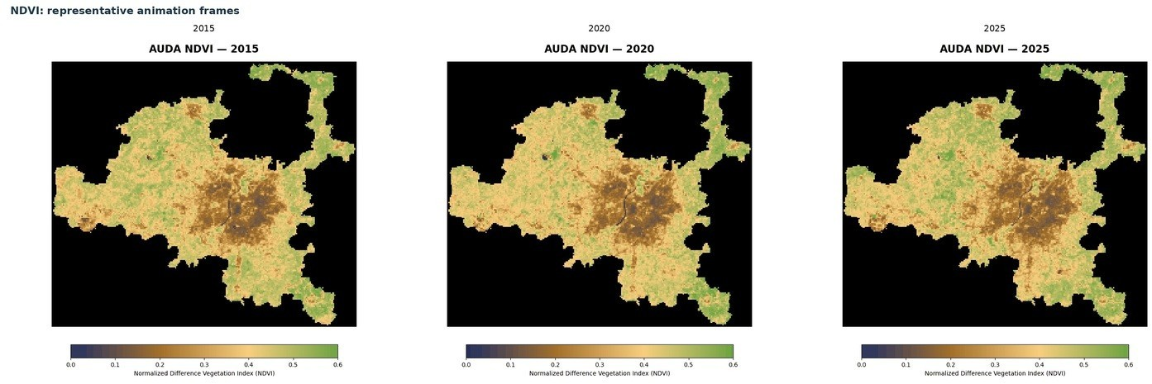
Figure 6. NDVI map, 2025. Figure 7. Mapped NDVI change, 2015–2025.

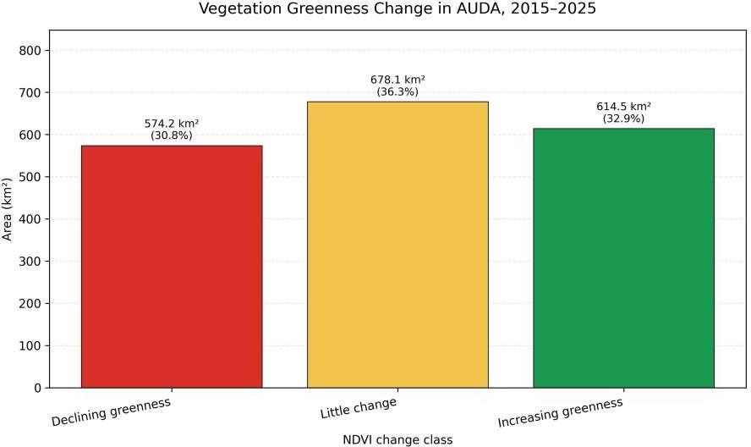
Figure 8. NDVI, 2015–2025, selected frames.

Figure 9. Vegetative Greenness Change in AUDA, 2015 - 2025

2.3 Land surface temperature and relative heat anomalies

Findings
  - The 2025 LST map shows spatial variation in surface temperatures across AUDA, indicating uneven heat distribution.
  - Year-to-year(2015-2025) fluctuations suggest that heat conditions vary over time, highlighting the need to prioritise localised heat mitigation rather than assuming uniform warming across the region.

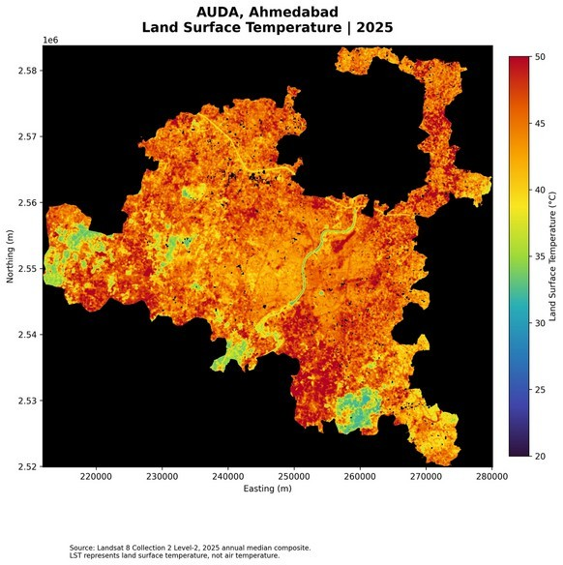  Figure 10. Land-surface temperature (LST), 2025. | 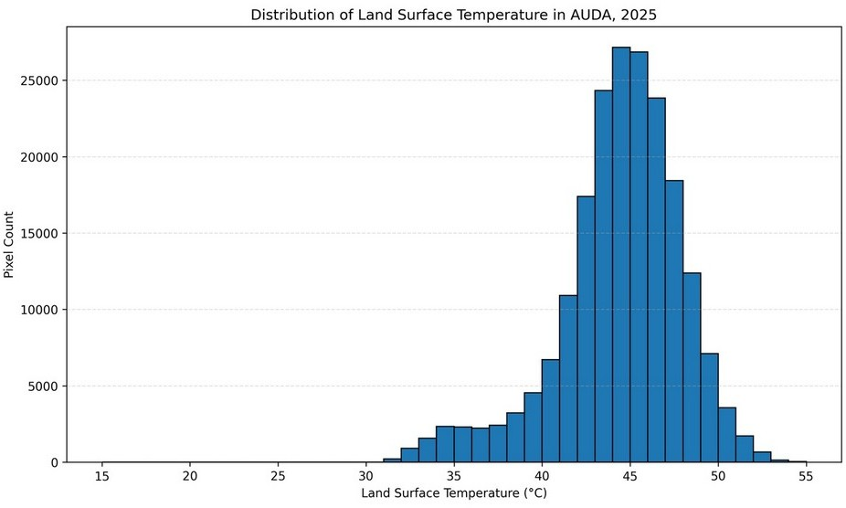  Figure 11. Distribution of mapped LST values, 2025.
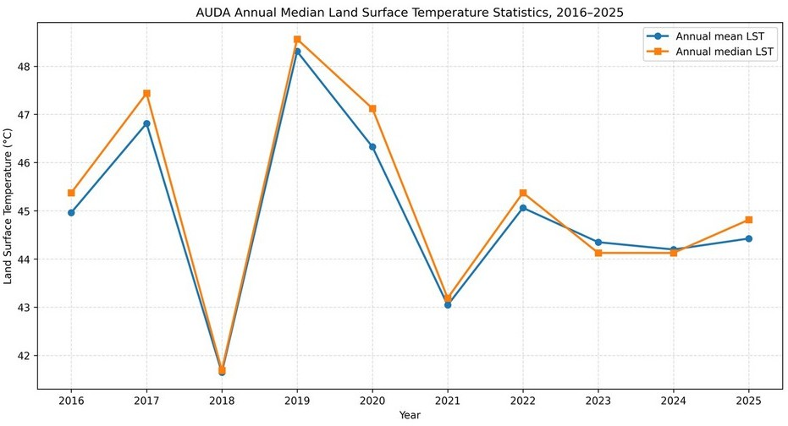  Figure 12. Annual mean and median LST, 2016–2025. | 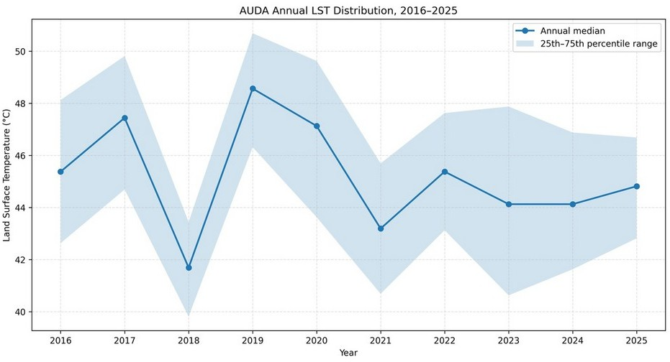  Figure 13. Annual median LST and interquartile range, 2016–2025.
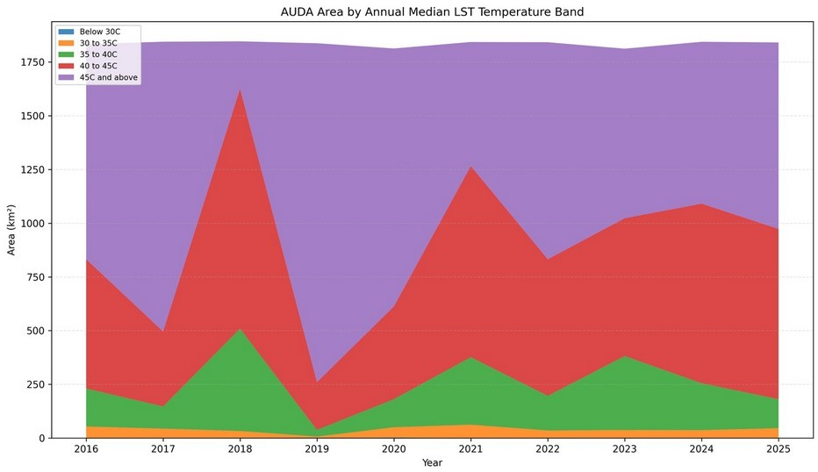  Figure 14. Area by LST temperature band, 2016–2025. | 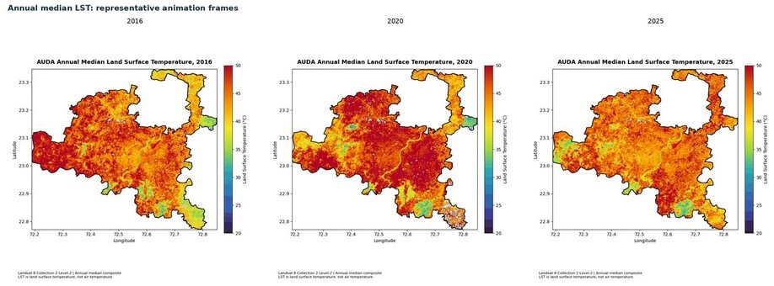  Figure 15. Annual median LST, 2016–2025, selected frames.

2.3.1 Relative surface-heat anomalies

Findings
  - The UHI maps highlight areas with surface temperatures above the annual median reference, identifying relative hotspots across AUDA.
  - The hotspot chart compares area above thresholds labelled annual median +2°C and +4°C; the temporal frames show relative anomaly patterns across 2016–2025.

Analysis
  - Heat hotspots overlapping with expanding built-up areas and declining NDVI indicate potential links between urbanisation, vegetation loss and increased surface heating across AUDA.

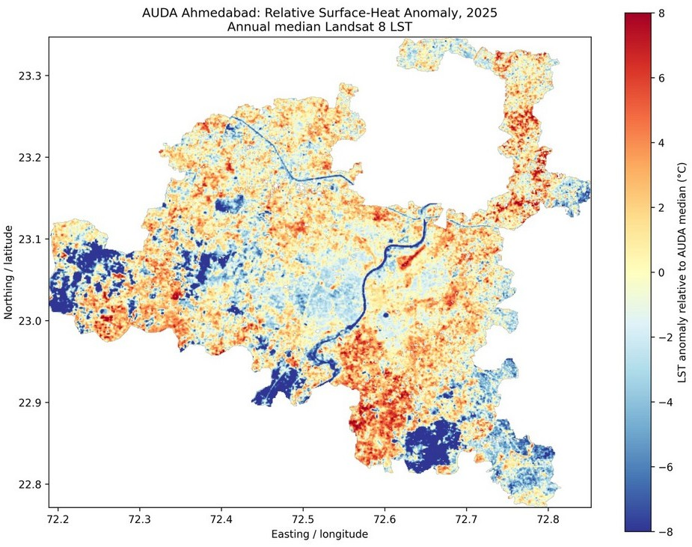  Figure 16. Relative surface-temperature anomaly map, 2025. | 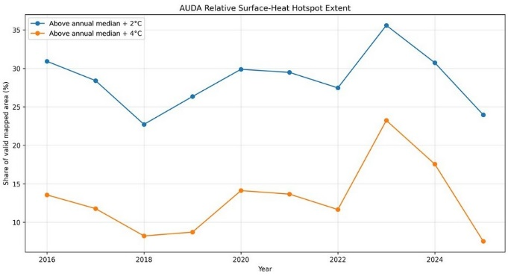  Figure 17. Area above relative surface-temperature thresholds, 2016–2025.
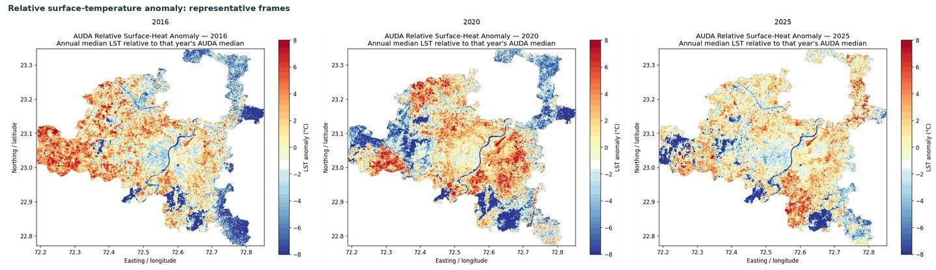

Figure 18. Relative surface-temperature anomaly, 2016–2025, selected frames.

2.4 NDWI and water-related surface conditions

Findings
  - The 2025 NDWI map and distribution figures describe spatial and statistical variation in index values.
  - The distribution chart reports a mean of −0.432 and a median of −0.456.

Analysis
  - The NDWI output is a spectral index snapshot; it does not by itself measure water availability, groundwater stress, water demand or open-water extent.

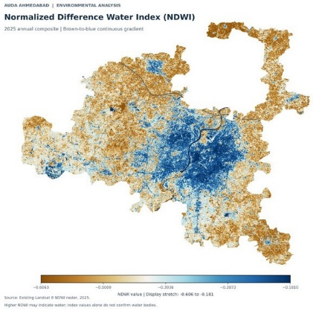  Figure 20. NDWI surface-condition map, 2025. | 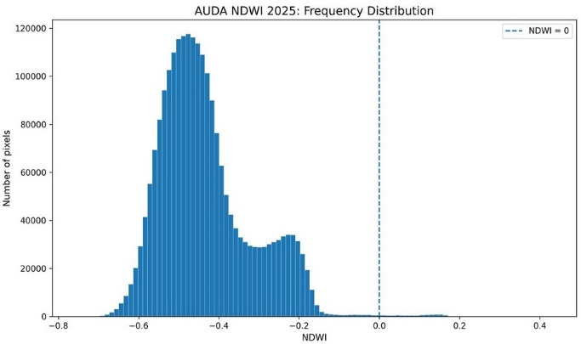  Figure 21. NDWI frequency histogram, 2025.
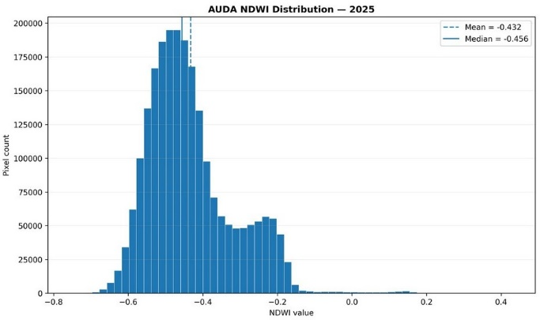  Figure 22. NDWI distribution, 2025. | 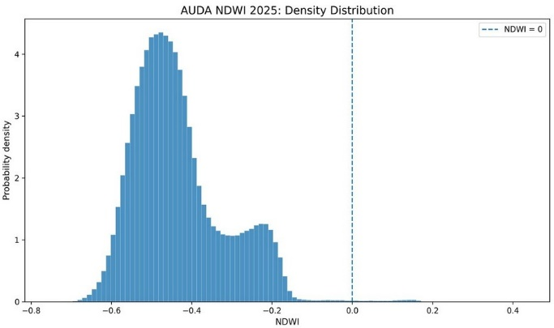  Figure 23. NDWI density distribution, 2025.
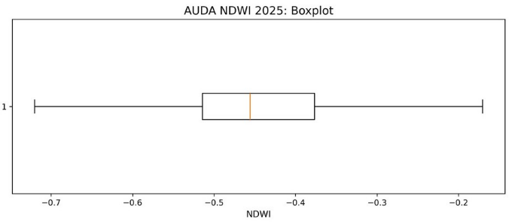  Figure 24. NDWI boxplot, 2025. | 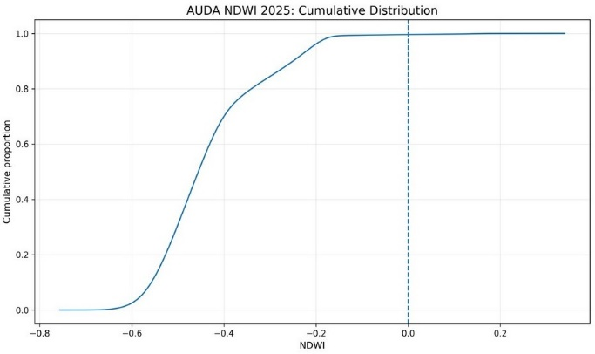  Figure 25. Cumulative NDWI distribution, 2025.

2.5 Rainfall

Findings
  - The 2025 CHIRPS rainfall map shows spatial variation in annual rainfall estimates across AUDA.
  - Reported annual rainfall ranges from 918.1 to 1,333.6 mm, with a mean of 1,104.8 mm and standard deviation of 93.5 mm.
  - The distribution chart shows the spread of estimated annual totals across the mapped area.

Analysis
  - Annual accumulated rainfall provides broad environmental context, not short-duration storm intensity, drainage performance or flood timing.

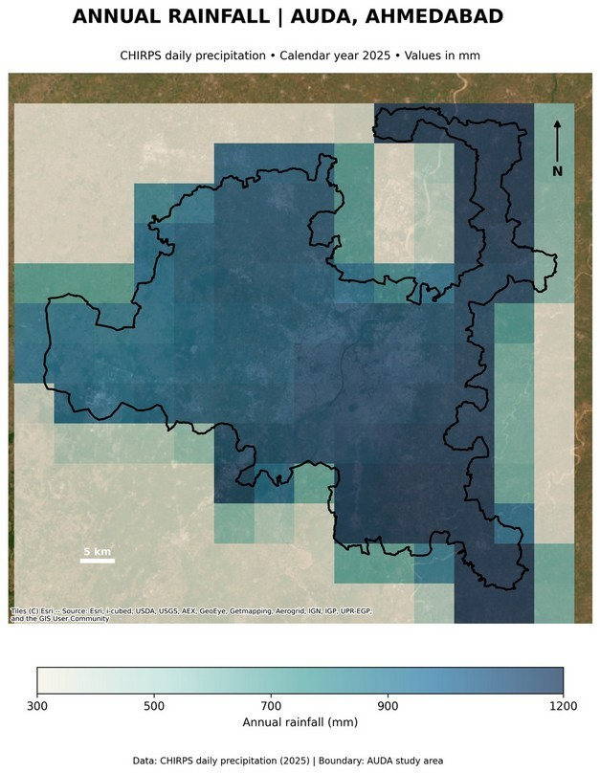  Figure 26. Spatial distribution of annual rainfall estimates, 2025. | 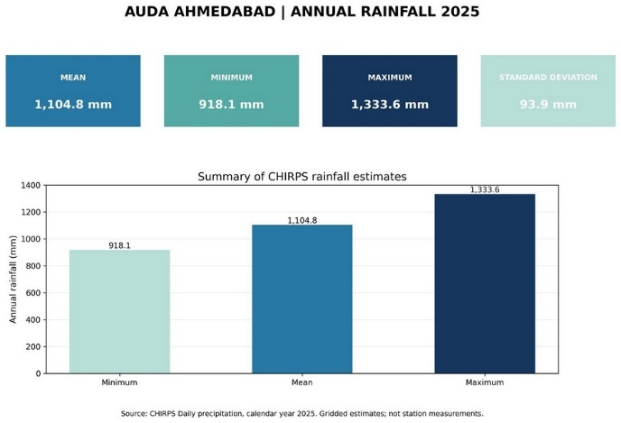  Figure 27. CHIRPS rainfall summary, 2025.
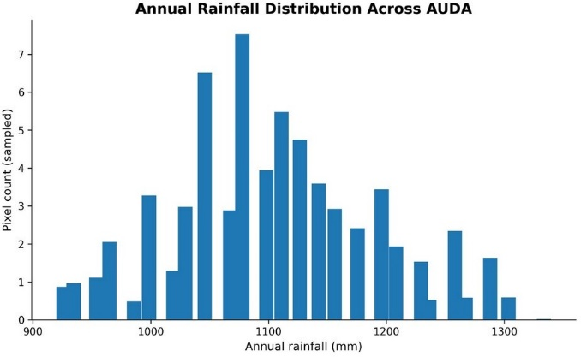
Figure 28. Distribution of annual rainfall across AUDA, 2025.

2.6 Terrain and drainage context

Findings
  - The NASADEM-derived elevation and slope maps describe terrain across the study area.
  - The slope distribution is concentrated at low values, with a tail towards higher slopes.
  - The HAND distribution has most sampled pixels in the lower height-above-drainage bins, with fewer at greater heights.

Analysis
  - Low-slope and low-HAND conditions can inform drainage screening but do not independently predict inundation.

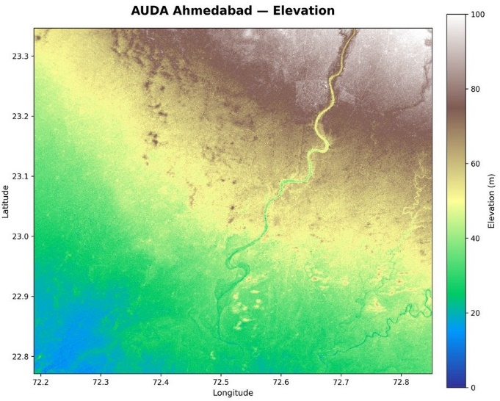  Figure 29. Elevation surface from NASADEM. | 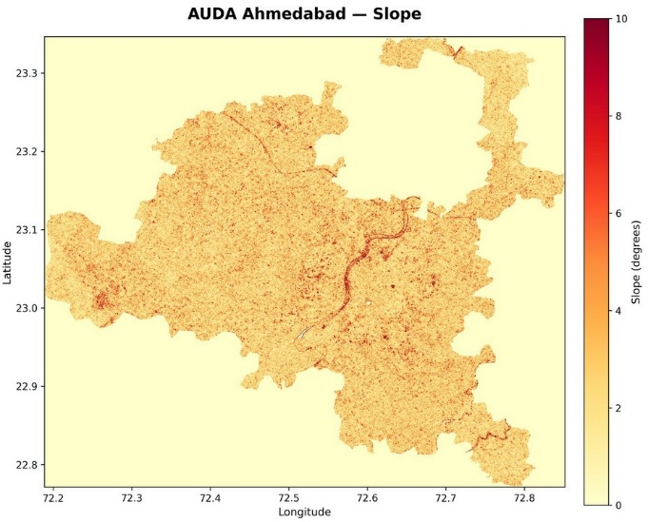  Figure 30. Slope derived from NASADEM.
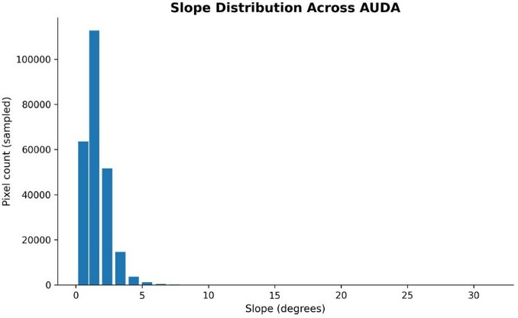  Figure 31. Slope distribution across AUDA. | 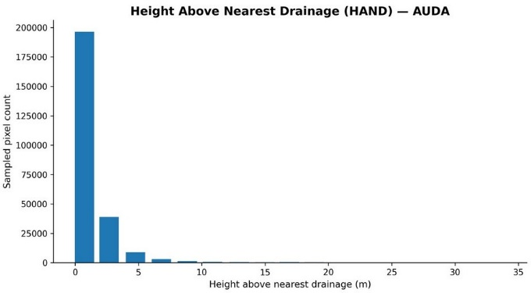  Figure 32. Height Above Nearest Drainage (HAND) distribution.

2.7 Preliminary flood susceptibility

Findings
  - The five-class map reports 234.14 km² Very Low, 643.32 km² Low, 682.20 km² Moderate, 261.08 km² High and 33.72 km² Very High susceptibility.
  - High and Very High classes total 294.80 km², approximately 15.9% of the classified area.
  - The built-up-by-susceptibility chart totals 369.8 km², below the overall 2025 built-up estimate of 460.34 km².

Analysis
  - This is an unvalidated screening layer, not a flood-probability, depth, damage or parcel-risk map; the built-up overlay discrepancy remains unresolved.

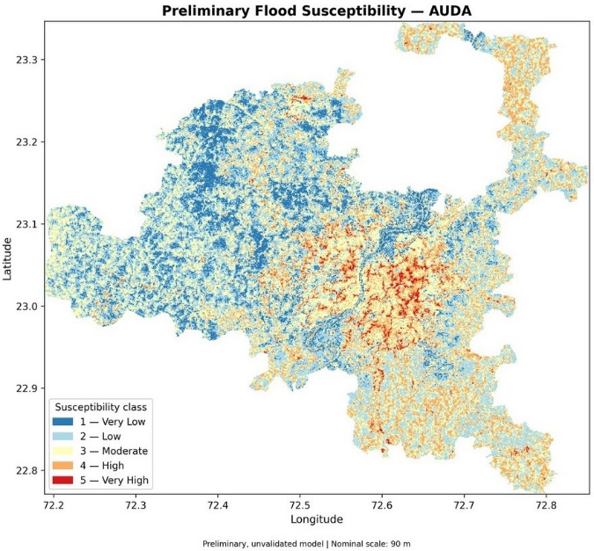  Figure 33. Preliminary five-class flood-susceptibility map. | 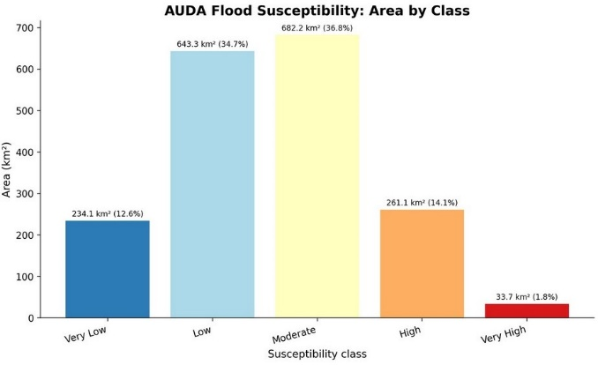  Figure 34. Area by preliminary flood-susceptibility class.
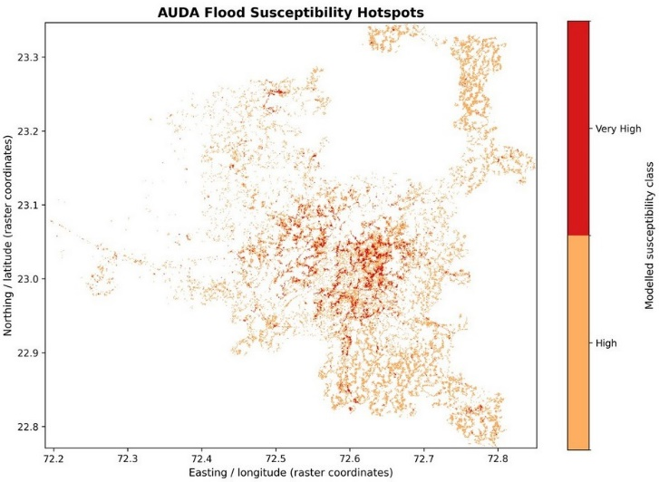  Figure 35. High and Very High flood-susceptibility cells. | 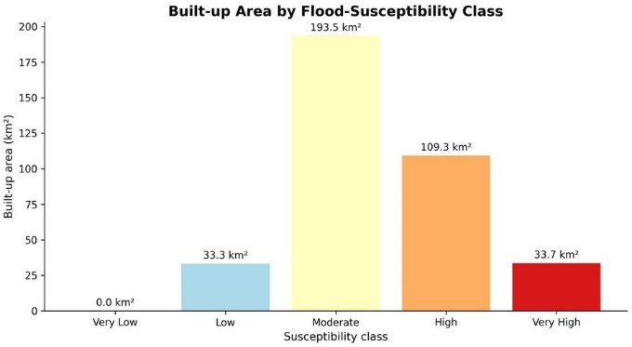  Figure 36. Mapped built-up area by flood-susceptibility class.

INTEGRATED ENVIRONMENTAL ANALYSIS

The analysis of the Ahmedabad Urban Development Authority (AUDA) region therefore connects the major five dimensions: built-up expansion, vegetation greenness and surface heat, spatial relationships between these changes, water and terrain conditions, and their implications for climate-resilient planning. This approach is consistent with the IPCC's assessment that urban form, ecological infrastructure and land-use decisions shape environmental exposure and resilience

Objective | Evidence-based synthesis | Interpretation
Urban expansion | Built-up land increased from 405.77 to 460.34 km²; net change was +54.57 km² (+13.45%). | AUDA's mapped urban footprint expanded over the study period.
Greenness and heat | NDVI shows mixed change; LST and relative thermal anomalies vary spatially and between years. | Environmental patterns are identified, but neither uniform vegetation decline nor a consistent region-wide LST increase is demonstrated.
Water and terrain | The 2025 NDWI and rainfall outputs describe one-year conditions; susceptibility mapping identifies 294.80 km² in High and Very High classes. | The results identify areas and processes warranting further investigation on water security or validated flood risk.
Identify climate-resilient planning priorities | The combined indicators highlight built-up expansion, mixed greenness change, thermal hotspots and terrain-based susceptibility. | The evidence supports targeted investigation and precautionary planning.

The integrated analysis identifies four priorities for regional planning:
- Guide urban expansion: Use land-cover transitions to identify development fronts and assess potential conflicts with open land, vegetation and drainage systems.
- Target heat mitigation: Prioritise further investigation of locations where built-up expansion, elevated surface temperatures and declining greenness coincide. Protect existing vegetation and integrate appropriate green infrastructure into development.
- Integrate water-sensitive planning: Protect surface-water features and drainage pathways, and incorporate terrain susceptibility into development screening, stormwater management and infrastructure planning.
- Strengthen evidence-led monitoring: Establish consistent spatial overlays and multi-year monitoring to distinguish persistent environmental change from seasonal and annual variation.

The key planning implication emerges from considering these indicators together: areas undergoing development need to be assessed not only for their land-cover and thermal characteristics, but also for their relationship to drainage pathways, surface-water features and terrain-based susceptibility. This supports precautionary screening of development locations and the integration of green-blue infrastructure with engineered drainage. Such integrated approaches align with the IPCC's assessment of ecological infrastructure and sustainable water management as complementary components of urban adaptation.

POLICY RECOMMENDATIONS AND CONCLUSION

The mapped evidence identifies urban expansion, mixed vegetation-greenness change, spatial variation in surface heat and preliminary drainage-related patterns. These findings indicate where planning attention is needed. The following recommendations could be adopted through the relevant at different scales during the preparation of the next development plan for the region.

Heat stress
Issue: LST and relative heat-anomaly maps show variation in surface thermal conditions, and interannual fluctuation rather than a uniform upward trend. The planning challenge is to reduce heat-absorbing surfaces and shade deficits in locations where mapped hotspots coincide with public activity and infrastructure.
Recommendations: Apply heat-sensitive design controls in higher relative-heat areas.
  - Prioritise cool roofs, shaded open spaces and reduced exposed paving in mapped heat hotspots.
  - Provide shaded walking routes, transit stops, schools and healthcare facilities in high-heat areas.
  - Integrate heat mitigation with Ahmedabad’s Heat Action Plan and relevant development approvals.

Water stress
Issue: The planning challenge is to balance urban water demand with available supplies while reducing pressure on surface water and groundwater resources.
Recommendations: Integrate water-sensitive planning into urban development and infrastructure provision.
- Prepare city water balances to assess water demand, supply reliability and reuse potential.
- Prioritise groundwater conservation and recharge based on hydrogeological assessments and official groundwater classifications.

Flooding
Issue: Terrain-based mapping identifies 294.80 km² in High and Very High susceptibility classes. The planning challenge is to protect drainage pathways and reduce runoff in flood-susceptible locations.
Recommendations: Integrate verified drainage conditions and engineering assessments into development planning.
- Use susceptibility maps for preliminary screening, followed by site-specific drainage and engineering assessments.
- Protect verified drainage channels, outfalls, floodplains and water-storage areas through appropriate planning controls.
- Require suitable stormwater detention, retention and permeable surfaces in new developments, subject to site conditions.

Loss of green-blue assets
Issue: Built-up land increased by 54.57 km², while NDVI results show both declining and increasing greenness.The planning challenge is to prevent the avoidable conversion and fragmentation of existing green-blue assets.
Recommendations: Integrate verified drainage conditions and engineering assessments into development planning.
- Map and protect existing parks, vegetation, water bodies, natural drainage channels and river corridors.
- Prevent avoidable conversion and fragmentation of verified green-blue assets through development plans and planning approvals.
- Prioritise restoration within connected green-blue corridors where environmental loss is unavoidable and mitigation is required.

Conclusion
The study provides a regional assessment of urban expansion and associated environmental conditions across the Ahmedabad Urban Development Authority (AUDA) region between 2015 and 2025. The increase in mapped built-up land from 405.77 km² to 460.34 km², representing a net gain of 54.57 km² (13.45%), establishes the scale of urban expansion and highlights the importance of integrating environmental considerations into regional development planning.

The environmental findings reveal a spatially varied picture. Vegetation greenness shows both decline and improvement, while land surface temperature and relative heat anomalies indicate uneven thermal conditions across AUDA, with year-to-year fluctuations rather than a consistent upward trend. These patterns highlight the need to examine urban development alongside vegetation cover and localised heat conditions. Meanwhile, the 2025 rainfall and water-index outputs, together with terrain-based susceptibility mapping that identifies 294.80 km² in High and Very High classes, provide preliminary evidence for assessing drainage and water-management concerns. However, these indicators do not independently establish water stress, flood probability or the direct effects of urbanisation.

Taken together, the findings support a more integrated approach to urban planning across AUDA, prioritising heat-sensitive design, reliable water management, improved stormwater drainage and the protection of connected green-blue assets. Development decisions should be informed by verified environmental features, site-specific assessments and appropriate planning controls. Although the current analysis does not quantify the spatial relationship between newly built-up land, vegetation change and thermal anomalies, it establishes a useful baseline for further investigation and environmental monitoring.

Ultimately, the study highlights that the challenge for AUDA is not simply to accommodate urban growth, but to guide it in ways that safeguard environmental systems and strengthen long-term urban resilience. Combining land-use planning with geospatial monitoring and targeted environmental interventions can help ensure that regional development is more responsive to the interconnected challenges of heat,
vegetation change and water management.

REFERENCES

- Ahmedabad District Administration. (2026). Demography. Government of Gujarat. https://ahmedabad.nic.in/demography/ Ahmedabad Municipal Corporation, Indian Institute of Public Health Gandhinagar, & Natural Resources Defense Council. (2018).
- Ahmedabad Heat Action Plan 2018. https://www.nrdc.org/sites/default/files/ahmedabad-heat-action-plan-2018.pdf Ahmedabad Urban Development Authority. (2024a). About us. https://www.auda.org.in/Content.aspx?Id=42&Type=C Ahmedabad Urban Development Authority. (2024b). Revised Development Plan 2021. https://www.auda.org.in/RDP/
- Central Ground Water Board. (2025). Dynamic ground water resources of Gujarat State, 2024. Government of India. https://cgwb.gov.in/cgwbpnm/public/uploads/documents/17435854451549973771file.pdf
- Funk, C., Peterson, P., Landsfeld, M., Pedreros, D., Verdin, J., Shukla, S., Husak, G., Rowland, J., Harrison, L., & Hoell, A. (2015). The climate hazards infrared precipitation with stations—a new environmental record for monitoring extremes. Scientific Data, 2, Article 150066. https://doi.org/10.1038/sdata.2015.66
- Gao, B.-C. (1996). NDWI—A normalized difference water index for remote sensing of vegetation liquid water from space. Remote Sensing of Environment, 58(3), 257–266. https://doi.org/10.1016/S0034-4257(96)00067-3
- Google for Developers. (n.d.). NASADEM: NASA 30m digital elevation model (Earth Engine data catalog). https://developers.google.com/earth-engine/datasets/catalog/NASA_NASADEM_HGT_001
- Intergovernmental Panel on Climate Change. (2022). Chapter 6: Cities, settlements and key infrastructure. In Climate change 2022: Impacts, adaptation and vulnerability. Cambridge University Press. https://www.ipcc.ch/report/ar6/wg2/chapter/chapter-6/
- McFeeters, S. K. (1996). The use of the Normalized Difference Water Index (NDWI) in the delineation of open water features.
- International Journal of Remote Sensing, 17(7), 1425–1432. https://doi.org/10.1080/01431169608948714
- Mohammad, P., Goswami, A., & Bonafoni, S. (2019). The impact of the land cover dynamics on surface urban heat island variations in semi-arid cities: A case study in Ahmedabad city, India, using multi-sensor/source data. Sensors, 19(17), Article 3701. https://doi.org/10.3390/s19173701
- Ministry of Environment, Forest and Climate Change. (2017). Wetlands (Conservation and Management) Rules, 2017. Government of India. https://moef.gov.in/uploads/2019/09/Wetlands2017.pdf
- Ministry of Housing and Urban Affairs. (2021). Atal Mission for Rejuvenation and Urban Transformation 2.0: Operational guidelines.
- Government of India. https://amrut.mohua.gov.in/uploads/AMRUT_2.0_Operational_Guidelines.pdf

APPENDIX
No. | Figure title
20 | NDWI surface-condition map, 2025
21 | NDWI frequency histogram, 2025
22 | NDWI distribution, 2025
23 | NDWI density distribution, 2025
24 | NDWI boxplot, 2025
25 | Cumulative NDWI distribution, 2025
26 | Spatial distribution of annual rainfall estimates, 2025
27 | CHIRPS rainfall summary, 2025
28 | Distribution of annual rainfall across AUDA, 2025
29 | Elevation surface from NASADEM
30 | Slope derived from NASADEM
31 | Slope distribution across AUDA
32 | Height Above Nearest Drainage (HAND) distribution
33 | Preliminary five-class flood-susceptibility map
34 | Area by preliminary flood-susceptibility class
35 | High and Very High flood-susceptibility cells
36 | Mapped built-up area by flood-susceptibility class

The report uses 36 selected maps, charts and temporal-frame montages from the supplied GIS/remote-sensing archive. Alternate exports were omitted where they duplicated the same visual product; figure numbers below match this report.
No. | Figure title
1 | Built-up area in AUDA, 2015 and 2025
2 | Net change in mapped built-up area, 2015–2025
3 | Built-up classification transitions, 2015–2025
4 | Spatial pattern of built-up expansion across AUDA, 2015–2025
5 | Year-on-year built-up classification, selected frames
6 | NDVI map, 2025
7 | Mapped NDVI change, 2015–2025
8 | NDVI change-area summary, June–December, 2015–2025
9 | NDVI, 2015–2025, selected frames
10 | Land-surface temperature (LST), 2025
11 | Distribution of mapped LST values, 2025
12 | Annual mean and median LST, 2016–2025
13 | Annual median LST and interquartile range, 2016–2025
14 | Area by LST temperature band, 2016–2025
15 | Annual median LST, 2016–2025, selected frames
16 | Relative surface-temperature anomaly map, 2025
17 | Area above relative surface-temperature thresholds, 2016–2025
18 | Relative surface-temperature anomaly, 2016–2025, selected frames

