CHAPTER 1

INTRODUCTION
In recent years, emerging technologies like blockchain, smart contracts, and decentralized storage systems have revolutionized data management across critical sectors—including healthcare. This mini project presents a robust framework for organ donation management that leverages blockchain as a secure, immutable ledger to record donor and recipient transactions. By integrating IPFS for decentralized file storage, QR codes for rapid data retrieval, and smart contracts for automated matching and verification, the system ensures transparency, efficiency, and trust among stakeholders. Decentralization eliminates reliance on a central authority, distributing control across blockchain nodes to prevent data manipulation and single points of failure. Together, these components form a cohesive, tamper-proof ecosystem that streamlines organ allocation while safeguarding sensitive medical records.

PROBLEM DEFINITION
The organ donation ecosystem is plagued by systemic inefficiencies, data vulnerabilities, and operational delays that can have life-threatening consequences. Traditional systems rely heavily on centralized databases and manual processes, which are susceptible to human error, unauthorized data manipulation, and poor interoperability between institutions. These limitations hinder timely donor-recipient matching, complicate verification procedures, and erode trust among stakeholders—including patients, donors, hospitals, and regulatory bodies.
Furthermore, the absence of a secure, transparent, and automated mechanism for managing sensitive medical records and organ allocation decisions results in administrative bottlenecks, increased paperwork, and missed opportunities for life-saving transplants. To address these challenges, there is a pressing need for a decentralized, tamper-proof framework that ensures data integrity, accelerates matching and verification, and fosters trust through transparent and auditable processes.

OBJECTIVES

The primary objective of this project is to develop a secure, transparent, and decentralized organ donation management system using blockchain technology, IPFS, and smart contracts—aimed at improving the efficiency, accuracy, and trustworthiness of donor-recipient matching, data storage, and organ allocation processes:
1. To create a secure, transparent, and efficient organ donation process
This objective focuses on overcoming the drawbacks of centralized systems and ensuring the safety
and reliability of donated organs.
2. To implement decentralized storage and smart contracts
By using IPFS for medical and donor–recipient records and automating processes with smart
contracts, the system streamlines and enhances various aspects of organ donation.
3. To enhance trust and speed up donor–recipient matching
Building trust among stakeholders helps reduce delays, minimize manual errors, and ultimately save
more lives.
4. To integrate technologies like QR codes for verification
QR code–based verification improves efficiency, reliability, and fairness in organ allocation.

SCOPE OF THE PROJECT

This project focuses on designing a blockchain-based organ donation management system that addresses the limitations of traditional centralized models. It explores the integration of decentralized technologies such as IPFS for secure storage of medical and donor-recipient records, and smart contracts for automating critical processes like organ matching, allocation, and verification. The scope includes:
•Developing a framework that combines blockchain, IPFS, QR codes, and smart contracts to ensure data integrity, transparency, and automation.
•Conducting a comparative analysis between centralized and decentralized organ donation systems to highlight performance, security, and trust factors.
•Implementing smart contracts to streamline donor recipient matching and reduce human intervention and error.
•Using IPFS to store sensitive medical data in a distributed manner, ensuring high availability and resistance to tampering.
•Integrating QR codes for fast and secure access to donor-recipient information by authorized medical personnel.
•Ensuring compliance with ethical and regulatory standards while enhancing trust among stakeholders patients, donors, hospitals, and authorities.
This project is limited to the conceptual design, prototype development, and evaluation of the proposed system’s feasibility and advantages over existing models. It does not include full-scale deployment or integration with national health databases.

1.4 APPLICATIONS

1. Organ Donation Management Systems
Enables secure storage, transparent donor-recipient matching, and automated organ allocation using blockchain and smart contracts.

2. Hospital and Transplant Centers
Facilitates quick access to verified donor-recipient data via QR codes, reducing paperwork and speeding up decision-making during critical procedures.

3. Government and Regulatory Bodies
Provides a tamper-proof audit trail for monitoring organ donation activities, ensuring compliance with ethical and legal standards.

4. Medical Record Storage
Uses IPFS to store sensitive medical data in a decentralized manner, improving data availability, integrity, and resistance to manipulation.

5. Healthcare Data Sharing Platforms
Enables secure and permissioned sharing of patient data across institutions without compromising privacy or trust.

6. Emergency Response Systems
Supports rapid verification and allocation of organs in time-sensitive scenarios, potentially saving lives through faster coordination.

7. Public Trust and Awareness Campaigns
Builds confidence among donors and recipients by showcasing a transparent, bias-free, and secure organ donation process.

CHAPTER 2

LITERATURE SURVEY

[1] Q. Xia et al., “MeDShare: A Secure Medical Data Sharing Scheme Based on Blockchain,” IEEE Access, 2017
Xia et al. (2017) introduced MeDShare, a blockchain-based framework designed to enable secure, efficient, and controlled sharing of medical data among healthcare organizations. The authors highlight that traditional medical data-sharing systems often rely on centralized cloud infrastructures, which make them vulnerable to data breaches, unauthorized data disclosure, and lack of transparency in data access. MeDShare addresses these problems by incorporating blockchain’s decentralized architecture, smart contracts, and access-control mechanisms. The system uses a permissioned blockchain, ensuring that only authorized entities—such as hospitals, labs, and research institutions—can participate. The paper also proposes smart contracts to automate data access requests, granting permissions based on predefined rules and reducing manual intervention. Another key contribution is the introduction of a trustless audit trail, which records all data access events immutably, enabling accountability and preventing tampering. Using cryptographic hashing and secure storage methods, MeDShare ensures data integrity even when medical records are stored off-chain. The authors conducted experiments to demonstrate the system’s performance, showing that blockchain introduces minimal overhead while significantly improving data traceability and security. Overall, MeDShare provides an effective solution for secure inter-organizational medical data sharing, establishing strong foundations that directly support modern healthcare applications such as organ donation management, where data integrity and controlled access are critical.

[2] N. Szabo, “Smart Contracts: Building Blocks for Digital Markets,” Extropy, 1997
Nick Szabo’s landmark 1997 work lays the theoretical foundation for what later became modern blockchain smart contracts. Szabo defines smart contracts as digital protocols that enforce, verify, or execute an agreement without the need for intermediaries. The article discusses how traditional contract execution often relies on third-party institutions, which introduces delays, costs, and potential manipulation. Szabo argues that by embedding contractual clauses into electronic systems, transactions can be automated, making them more secure, reliable, and efficient. His examples—such as digital cash, property rights management, and automated credit systems—illustrate how smart contracts can revolutionize digital markets by enforcing trust between mutually unknown parties. A major emphasis of the paper is the idea of minimizing fraud and accidental errors by replacing human-dependent processes with cryptographic and automated execution logic. Although blockchain did not exist at the time, Szabo’s principles directly predict how smart contracts operate on platforms like Ethereum today. In organ donation systems, these concepts translate into automated donor–recipient matching, transparent allocation policies, and secure rule enforcement without the possibility of human manipulation. Szabo’s work remains foundational for all blockchain-based healthcare applications and continues to influence modern decentralized system design.

[3] P. Zhang et al., “Applying Blockchain Technology in Healthcare: Privacy and Security,” Journal of Biomedical Informatics, 2018
Zhang et al. (2018) present a comprehensive examination of blockchain's potential to enhance healthcare privacy and security, addressing long-standing challenges related to centralized health record systems. The authors note that conventional digital health systems suffer from vulnerabilities such as unauthorized access, insecure data storage, data fragmentation, and the inability to guarantee data provenance. Their work evaluates how blockchain’s core properties—immutability, decentralization, time-stamped records, and cryptographic security—can counter these limitations. They propose a blockchain-driven architecture where sensitive medical data is stored off-chain, while blockchain maintains a secure reference and audit trail to ensure transparency and prevent tampering. The study also highlights the importance of fine-grained access control using smart contracts, enabling patients to define precisely who can access their records. Through simulation and architectural design, Zhang et al. demonstrate that blockchain enhances trust between stakeholders, increases resilience against cyberattacks, and improves interoperability among healthcare organizations. The paper also examines privacy concerns, noting that healthcare requires a balance between transparency and confidentiality. Techniques such as hashing, encryption, and pseudonymization are proposed to ensure privacy-preserving data sharing. Their findings directly support blockchain-based organ donation frameworks by emphasizing accountable record-keeping, tamper-proof donor data, and secure communication across hospitals.

[4] B. Geet et al., “Exploring Perspectives of Blockchain Technology and Traditional Centralized Technology in Organ Donation Management,” Information, 2024
Geet et al. (2024) deliver a comprehensive comparative study analyzing both centralized and decentralized (blockchain-based) approaches in organ donation management. The authors review 370 papers published between 2016 and 2023, ultimately selecting 85 for detailed analysis. They identify pressing challenges in traditional organ donation systems, including organ trafficking, illegal trade, long waiting times, and manipulation during organ allocation. A recurring issue highlighted is the lack of transparency within centralized systems, which erodes public trust and often leads to biased or unethical allocation choices. Centralized databases, developed with technologies like SQL, Java, and Python, are shown to be vulnerable to cyberattacks, unauthorized modifications, and single-point failures. The study contrasts this with blockchain-based models, which significantly enhance traceability, security, and fairness through decentralization, cryptographic integrity, and distributed consensus. Smart contracts further ensure unbiased, rule-based allocation of organs. The authors also find a research gap: only 38.7% of blockchain-focused studies developed real decentralized applications (DApps), suggesting a need for more practical implementations. Their findings strongly reinforce the suitability of blockchain for transparent, secure, and reliable organ donation ecosystems.

[5] A. Anselmo et al., “Implementation of Blockchain Technology Could Increase Equity and Transparency in Organ Transplantation,” Transplant International, 2023
Anselmo et al. (2023) present a narrative review exploring how blockchain technology can enhance equity, transparency, and trust within organ transplantation systems. The authors highlight that organ transplantation has evolved into a highly data-dependent field, requiring secure management of sensitive donor and recipient information. They emphasize that digital privacy is now recognized as a “novel human right” by the United Nations, underscoring the need for secure medical-data handling. The paper critiques traditional centralized organ transplant databases, noting serious risks including cyberattacks, corruption, biased allocation, and manipulation by privileged groups. A real-world example cited is the 2021 ransomware attack in Lazio, Italy, which disrupted health services and demonstrated the fragility of centralized platforms. The authors propose blockchain as a solution due to its immutability, distributed consensus, traceability, and tamper resistance. They explore use cases such as cross-border donor matching, automated verification of transplant eligibility, real-time traceability of organs, and detection of counterfeit medical documents. They argue that permissioned blockchains are ideal for healthcare because they balance decentralization with regulatory control. The study concludes that blockchain can significantly reduce inequalities and administrative barriers, making organ transplantation systems more transparent, ethical, and resilient.

[6] E. Calik and M. Bendechache, “Blockchain for Organ Transplantation: A Survey,” Blockchains, 2024
Calik and Bendechache (2024) conduct a systematic survey on the role of blockchain in the organ transplantation process (OTP). Recognizing OTP as a complex, multi-phase workflow involving numerous stakeholders—including hospitals, donors, recipients, procurement organizations, and regulators—they analyze existing solutions and challenges in applying blockchain. The authors emphasize that traditional centralized databases struggle to maintain transparency, confidentiality, and traceability, making them susceptible to data tampering and unauthorized access. Their survey finds that blockchain's decentralized nature, immutability, and cryptographic security offer strong protection for sensitive medical data and enhance trust among participants. The paper also discusses blockchain’s applicability in supply chain traceability, ensuring that each organ’s movement is trackable from donor to recipient, thereby minimizing delays and human error. However, the authors also identify challenges such as GDPR compliance, especially regarding the “right to be forgotten,” interoperability with existing hospital systems, and smart contract vulnerabilities. They recommend permissioned blockchains as the most suitable model for healthcare due to their controlled access. Their survey concludes that blockchain can significantly improve transparency, security, and trust in OTP but requires careful implementation to address legal, social, and ethical constraints.

[7] L. Soltanisehat et al., “Technical, Temporal, and Spatial Research Challenges & Opportunities in Blockchain-Based Healthcare,” IEEE TEM, 2023
Soltanisehat et al. (2023) perform a systematic literature review of 64 studies on blockchain in healthcare, focusing on technical, temporal, and spatial challenges. The authors classify blockchain as a “horizontal technology,” meaning it has applications across many sectors, including organ donation systems. They discuss key advantages such as tamper-proof records, decentralized data access, improved interoperability, and secure information exchange among hospitals. The paper highlights that most systems studied use private blockchains, often based on Ethereum, due to their ability to restrict participants and enforce regulatory controls. A major contribution of the study is the classification of existing challenges. Technical challenges include scalability, smart contract bugs, storage limitations, and the need for high computational resources. Temporal challenges refer to latency and delays in consensus mechanisms. Spatial challenges include issues with globally distributed nodes and compliance with region-specific medical regulations. The authors also emphasize blockchain’s potential in organ transplantation for tracking organ availability, ensuring transparent allocation, and reducing mismatches. Future research directions include integrating blockchain with cloud systems to overcome storage limitations, and combining artificial intelligence for predictive analytics in medical decision-making. Their findings underscore that blockchain can transform healthcare but must overcome systemic barriers.

[8] P. K. Kumar & M. M. Sandarsh Gowda, “Using Blockchain Technology for Tracking Organ Transfers,” IJARCCE, 2024
Kumar and Gowda (2024) propose a blockchain-based system focused specifically on tracking organ transfers throughout the organ donation and transplantation lifecycle. They highlight that current tracking mechanisms rely on manual record-keeping, fragmented hospital systems, and centralized databases, all of which increase the risk of data loss, tampering, and delays. Their solution leverages blockchain to create an immutable audit trail that records every step—from donor registration to organ retrieval, transportation, storage, and transplantation. Smart contracts automate notifications and status updates, ensuring that all stakeholders receive real-time information about organ availability and movement. The authors discuss the importance of transparency, noting that organ trafficking and unethical practices thrive in opaque systems. By contrast, blockchain ensures full visibility to authorized parties, enabling better decision-making and reducing the chances of organ misallocation. They also emphasize security benefits: cryptographic hashing prevents record manipulation, while decentralization eliminates single-point failures. The paper presents a prototype implementation using Ethereum-based smart contracts and validates the concept with simulated data. Their findings demonstrate improved traceability, faster updates, and higher trust among stakeholders. The proposed model supports a more ethical, accountable, and efficient organ donation ecosystem.

[9] S. T. Shanmathi et al., “Blockchain-Based Management for Organ Donation and Transplantation,” IJSREM, 2024
Shanmathi et al. (2024) present a blockchain-based organ donation management system aimed at improving transparency, security, and efficiency in donor–recipient matching and organ allocation. The authors note that traditional systems face challenges such as data duplication, manipulation of donor lists, fraudulent registrations, and delays due to manual verification processes. Their proposed model utilizes a decentralized ledger to store donor and recipient information, ensuring immutability and traceability. Smart contracts automate matching based on predefined medical criteria such as blood group, organ type, tissue compatibility, and urgency levels. This automation reduces human involvement, minimizing bias and errors. The paper also highlights the role of blockchain in preventing organ trafficking by maintaining a transparent, tamper-proof ledger of all transactions and medical procedures. A major strength of their system is the integration of access-control rules within smart contracts, ensuring that only authorized hospitals and transplant authorities can access sensitive data. The authors provide experimental results showing that their solution enhances system reliability and reduces processing time. Overall, their framework demonstrates that blockchain can significantly enhance the fairness and trustworthiness of organ donation processes.

[10] S. Begum et al., “Blockchain-Based Organ Donation System: A Secure and Transparent Solution,” IJARCCE, 2024
Begum et al. (2024) propose a blockchain-based organ donation system emphasizing security, transparency, and efficiency. Their research identifies critical issues in existing systems, including inaccurate donor records, unauthenticated registrations, loopholes enabling illegal organ trade, and slow beneficiary identification processes. The authors design a blockchain architecture where donor and recipient details are captured securely and stored on a tamper-proof decentralized ledger. Smart contracts handle automated validation, eliminating the need for third-party intermediaries. The paper describes how the immutable ledger prevents unauthorized modifications to organ waitlists, ensuring fairness. Furthermore, the authors implement role-based access control to ensure data privacy, allowing only verified medical professionals to access sensitive records. The system also incorporates real-time alerts, enabling quicker communication between hospitals during organ availability. Performance tests show reduced verification time and increased reliability compared to centralized platforms. The study concludes that blockchain can effectively resolve existing inefficiencies and support a secure, transparent organ allocation process.

[11] R. O. Reddy et al., “Decentralized Organ Giving Using Blockchain DApp,” IJSREM, 2024
Reddy et al. (2024) present a fully decentralized application (DApp) designed for organ donation management using blockchain technology. Unlike traditional systems, which rely on centralized servers, the proposed DApp operates on a distributed network, ensuring high availability, tamper resistance, and trustless interaction among users. The authors emphasize that existing systems often lack interoperability, suffer from inconsistent records, and are prone to manipulation during organ allocation. Their DApp includes modules for donor registration, recipient eligibility verification, organ availability tracking, and automated donor-recipient matching. Smart contracts enforce transparent rules, ensuring unbiased allocation based on medical urgency and compatibility. The paper highlights the use of Web3 technologies, enabling secure interaction between users and the blockchain through decentralized wallets. The authors also analyze the system’s performance, demonstrating low latency, robust security, and resilience against data loss. Simulation results show that blockchain significantly enhances system integrity, traceability, and operational efficiency. They conclude that decentralized architectures offer a promising foundation for future healthcare applications.

CHAPTER 3

REQUIREMENT SPECIFICATION

3.1 HARDWARE REQUIREMENTS
These are the hardware requirements for building the project locally.
Processor:
Minimum: 1 GHz
- Recommended: Intel Core i5 or above
RAM:
- Minimum: 2 GB
- Recommended: 4 GB or higher
Hard Disk:
- Minimum: 20 GB free space
Input Devices:
- Standard Keyboard, Mouse, Webcam/Mobile Camer
Output Device:
- VGA or higher-resolution Monitor
Other Requirements:
- Stable internet connection for blockchain node synchronization and IPFS access.
- Backup power (UPS) for ensuring uninterrupted operation during sensitive processes like donor-recipient matching.
3.2 SOFTWARE REQUIREMENTS
Operating System:
- Windows 10 or higher
Programming Language:
- Python (3.8 or above)
- HTML, CSS, JavaScript for frontend
Backend:
- Python Flask / Django framework
Database:
- IPFS (InterPlanetary File System) for decentralized storage
IDE/Tools:
- Visual Studio Code
- Ganache (for blockchain simulation)
- Ethereum Wallet/MetaMask
QR Code Implementation:
- Python libraries (qrcode, pyzbar)

3.3 SOFTWARE TOOLS AND TECHNOLOGIES

3.3.1 Python
Python is an open-source, high-level programming language widely used in artificial intelligence, data science, web development, and blockchain applications. It is well known for its simple syntax and powerful libraries, which make it a preferred choice for rapid application development. In this project, Python is utilized for implementing blockchain logic, backend services, and integration of smart contracts. Through libraries such as web3.py, it enables seamless communication with the Ethereum blockchain, while the qrcode library is used to generate unique QR codes for donor and recipient identification. Python’s ability to handle both blockchain transactions and backend operations makes it central to the functioning of the proposed system.

3.3.2 HTML (HyperText Markup Language)
HTML is the standard markup language that forms the foundation of every web page, defining its structure and content layout. It provides the backbone for the system’s user interfaces by organizing input fields, text, images, and other elements into meaningful web pages. In this project, HTML is used to design donor and recipient registration forms, verification dashboards, and hospital portals. It ensures that critical information such as donor details, recipient medical records, and organ allocation updates are properly structured for display and interaction. Without HTML, the system would lack the necessary structure for users to access and interact with the blockchain-based application.

3.3.3 JavaScript
JavaScript is a powerful client-side scripting language that enables dynamic functionality and interactivity within web applications. It is capable of validating user inputs, performing real-time updates, and integrating seamlessly with blockchain technologies. In this project, JavaScript plays a crucial role in validating donor and recipient details at the time of registration, reducing errors and ensuring data integrity. It also works alongside Web3.js, a JavaScript library that allows the application to interact with Ethereum smart contracts directly from the browser. Furthermore, JavaScript enables real-time updates of organ allocation status, ensuring that all stakeholders—hospitals, patients, and administrators—have immediate access to the most recent information.

3.3.4 Ganache
Ganache is a widely used blockchain simulation tool that provides developers with a personal Ethereum blockchain for testing and development purposes. It allows for the quick deployment of smart contracts and execution of transactions in a controlled environment without the need to use the actual Ethereum mainnet. In this project, Ganache is used to test the donor–recipient matching logic and organ allocation mechanisms before implementation in a live network. It generates test accounts with simulated Ether, enabling developers to perform realistic blockchain operations such as contract deployment, gas consumption testing, and transaction validation. By using Ganache, the system ensures that potential issues can be identified and resolved during development, reducing risks when deployed in real-world scenarios.

3.3.5 IPFS (InterPlanetary File System)

IPFS is a decentralized, peer-to-peer storage protocol designed to make the web faster, safer, and more resilient by distributing files across a network of nodes. Unlike traditional centralized storage systems, IPFS stores data based on content addressing, which guarantees immutability and prevents unauthorized modification. In this project, IPFS is employed to store sensitive medical records of donors and recipients in a secure and tamper-proof manner. Storing files on IPFS ensures that the data remains available across multiple nodes without reliance on a single server, thus improving reliability and security. This distributed storage mechanism is essential for protecting medical information, maintaining transparency, and ensuring trust in the organ donation and allocation process.

3.3.6 MetaMask / Ethereum Wallet
MetaMask is a cryptocurrency wallet and a gateway to blockchain applications that allows users to securely manage their Ethereum accounts and interact with decentralized applications (dApps). Available as a browser extension and mobile app, it provides an intuitive interface for handling keys, signing transactions, and executing smart contracts. In this project, MetaMask is integrated to authenticate users, manage blockchain identities, and facilitate secure transactions related to donor and recipient registration, verification, and organ allocation. It acts as the bridge between the web interface and the Ethereum blockchain, ensuring that users can seamlessly connect their wallets, approve transactions, and participate in the decentralized organ donation ecosystem.

CHAPTER 4

SYSTEM DESIGN

SYSTEM ARCHITECTURE
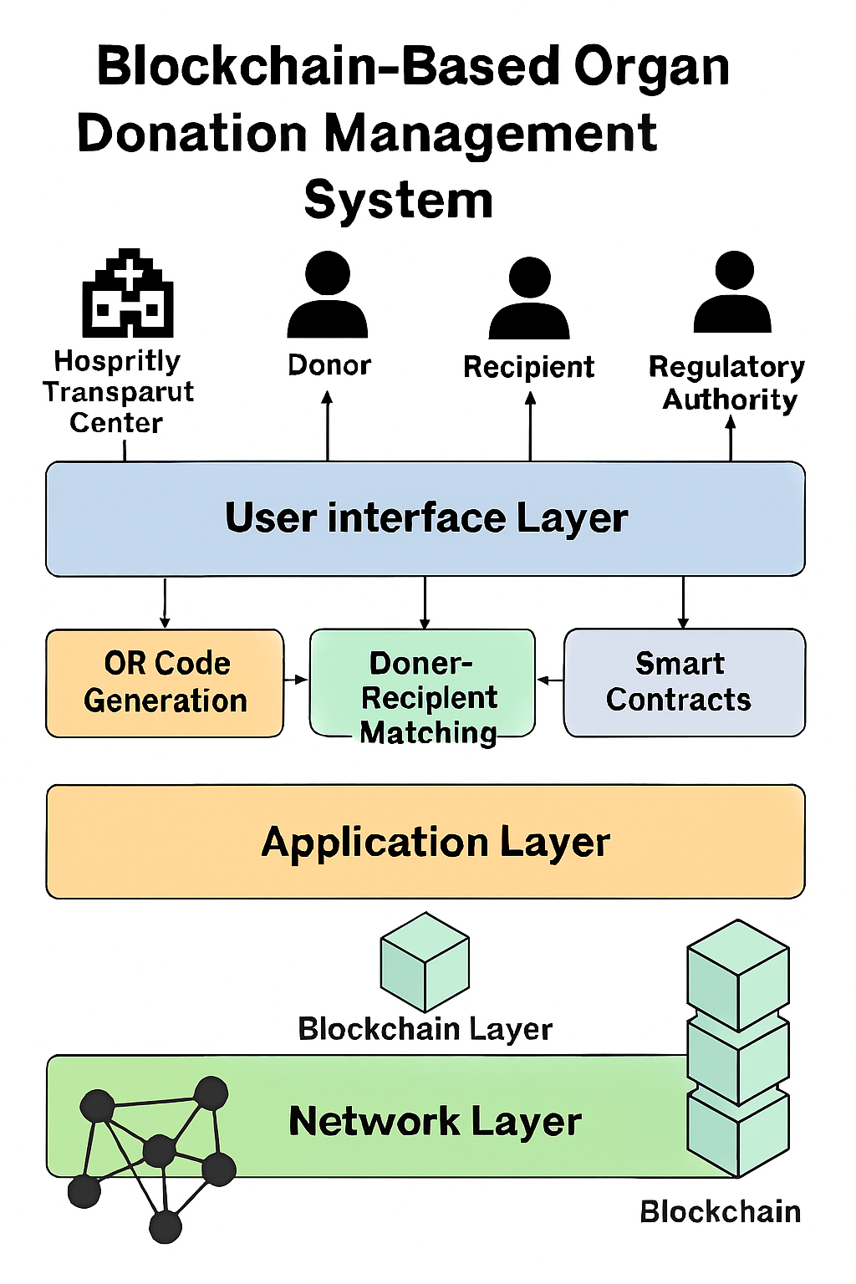
Figure.4.1. System Architectural Model.

METHODOLOGY

A project methodology is a framework for managing projects. The main purpose of the methodology is to be able to come up with an original and significant outcome that will contribute towards the field of the research. It is the science of dealing with principles of procedure in and explains the exact activities and processes of research is, methods to measure the data and how to interpret the outcomes.
Figure 4.1 illustrates the System Architectural Model of a Blockchain-Based Organ Donation Management System, showcasing a multi-layered framework designed to enhance transparency, security, and efficiency in organ donation processes. At the top, key stakeholders—including the Hospital Transplant Center, Donor, Recipient, and Regulatory Authority—interact with the system through a dedicated User Interface Layer. This layer facilitates essential operations such as QR code generation for secure identification, donor-recipient matching based on medical compatibility, and the execution of smart contracts to automate consent and compliance. Beneath this interface lies the Application Layer, which processes user inputs and coordinates system logic. It connects to the Network Layer, where the Blockchain Layer ensures immutable data storage and decentralized trust. The blockchain itself serves as the backbone of the system, maintaining secure, tamper-proof records of donor and recipient information, consent forms, and transaction histories. Together, these layers form a robust architecture that supports ethical, traceable, and streamlined organ donation management.

INTRODUCTION TO METHODOLOGY
To address the inefficiencies and trust issues in traditional organ donation systems, this project adopts a decentralized, technology-driven methodology. The approach begins by exploring the use of IPFS (InterPlanetary File System) for storing sensitive medical and donor-recipient records in a distributed, tamper-resistant manner. This ensures high data availability and integrity without relying on a central server. A comparative study is conducted between centralized and blockchain-based models to evaluate their performance, transparency, and reliability. The goal is to highlight how decentralization can overcome limitations such as data manipulation, delayed matching, and lack of stakeholder trust.
Building on this foundation, the project integrates smart contracts to automate critical processes like donor-recipient matching, organ allocation, and verification. These self-executing contracts eliminate manual intervention, reduce human error, and ensure rule-based decision-making. QR codes are incorporated to enable instant access to blockchain-verified records by authorized medical personnel, streamlining verification and reducing paperwork. Together, these components form a secure, transparent, and efficient organ donation management system that enhances operational speed, safeguards sensitive data, and fosters trust among patients, hospitals, and regulatory authorities.

Phase 1: Problem Understanding and Scope Definition
The current organ donation system faces significant challenges, including unreliable record-keeping, delayed donor-recipient matching, and a lack of transparency that undermines trust among stakeholders. These issues often result in life-threatening delays and administrative inefficiencies. To address this, the project proposes a decentralized framework that leverages blockchain for secure and immutable data storage, IPFS for distributed record management, and smart contracts to automate organ allocation and verification. The scope of the project includes designing and prototyping a system that integrates these technologies, conducting a comparative study with centralized models, and demonstrating how decentralization can enhance security, efficiency, and stakeholder confidence in organ donation processes.

Phase 2: Data Collection and Preprocessing
It involves gathering relevant donor and recipient information, including medical history, organ compatibility parameters, registration details, and verification documents. This data is sourced from hospital databases, donor registries, and authorized healthcare platforms. To ensure privacy and compliance, only verified and consented records are considered for integration into the system.
Once collected, the data undergoes preprocessing to ensure consistency, accuracy, and readiness for blockchain integration. This includes removing duplicates, validating entries, standardizing formats (e.g., blood type, organ type, timestamps), and anonymizing sensitive identifiers to protect patient privacy. Structured data is then encoded for smart contract execution, while unstructured records such as medical reports are stored securely using IPFS. Each record is hashed.

Phase 3: Model Design and Development
The proposed system is designed as a decentralized organ donation management framework that integrates blockchain, IPFS, smart contracts, and QR code technology to ensure secure, transparent, and efficient data handling. Blockchain serves as the core ledger for storing immutable records of donor and recipient registrations, matches, and transactions. IPFS is used to store detailed medical documents in a distributed manner, with each file linked to the blockchain via cryptographic hashes to maintain integrity and traceability. Smart contracts are developed to automate donor-recipient matching, organ allocation, and verification processes, ensuring rule-based execution without manual intervention. QR codes are generated for each verified profile, allowing hospitals and authorized personnel to instantly access blockchain-validated data. The system architecture is modular and scalable, enabling seamless integration with existing healthcare platforms. A functional prototype is built to simulate real-world scenarios, demonstrating how decentralized technologies can overcome the limitations of traditional systems and enhance trust, speed, and security in organ donation management.

Phase 4: Web Application Development
To demonstrate the practical implementation of the decentralized organ donation framework, a web-based application is developed as the user interface for stakeholders such as hospitals, donors, recipients, and regulatory authorities. The application is designed to be intuitive, secure, and responsive, enabling users to register, verify, and access organ donation records seamlessly. Front-end development is carried out using HTML, CSS, and JavaScript for a clean and user-friendly experience, while the back-end is powered by blockchain integration and smart contract logic to ensure secure data handling and automated workflows.
The application connects to IPFS for decentralized storage of medical records and uses QR code generation for quick access to verified donor-recipient profiles. Smart contracts deployed on the blockchain handle core operations such as donor matching, organ allocation, and eligibility checks. Role-based access control is implemented to ensure that only authorized users can view or modify sensitive data. The web app serves as a bridge between decentralized infrastructure and real-world healthcare operations, showcasing how blockchain technology can be applied to improve transparency, efficiency, and trust in organ donation management.

Phase 5: Validation and Testing
To ensure the reliability, security, and functionality of the proposed organ donation management system, a structured validation and testing process is carried out. The smart contracts are tested for logical accuracy, rule enforcement, and edge-case handling to confirm that donor-recipient matching and organ allocation occur without bias or error. IPFS integration is validated by uploading sample medical records and verifying their retrievability through content hashes, ensuring data integrity and availability across distributed nodes.

Phase 6: Deployment and Monitoring
Once the decentralized organ donation management system is developed and validated, the deployment phase involves hosting the web application on a secure cloud platform and connecting it to the blockchain network and IPFS nodes. Smart contracts are deployed on a test net or private blockchain to simulate real-world operations, ensuring secure execution of donor-recipient matching and organ allocation. The front-end interface is made accessible to authorized users such as hospitals, donors, and regulatory bodies through role-based authentication.
Monitoring mechanisms are implemented to track system performance, smart contract execution, and data access patterns. Real-time logs and analytics help identify anomalies, failed transactions, or unauthorized access attempts. Blockchain explorers are used to audit transaction history, while IPFS gateways monitor file availability and integrity. Regular updates and patches are applied to maintain security and scalability. This phase ensures that the system remains reliable, transparent, and responsive under operational conditions, reinforcing trust and accountability in the organ donation process.

Phase 7: Ethical Considerations and User Feedback

The project prioritizes ethical integrity by ensuring that sensitive donor and recipient data is securely handled, anonymized, and accessible only to authorized users through role-based controls. Blockchain immutability and smart contract automation eliminate bias and manipulation in organ allocation, promoting fairness and transparency. IPFS ensures secure, distributed storage of medical records, while QR codes enable rapid, verified access during emergencies. User feedback from simulated testing with healthcare professionals highlighted the system’s ease of use, trustworthiness, and efficiency, leading to refinements in the interface and data handling. Overall, the solution aligns with ethical standards and demonstrates strong potential for real-world adoption.

DATA FLOW DIAGRAM

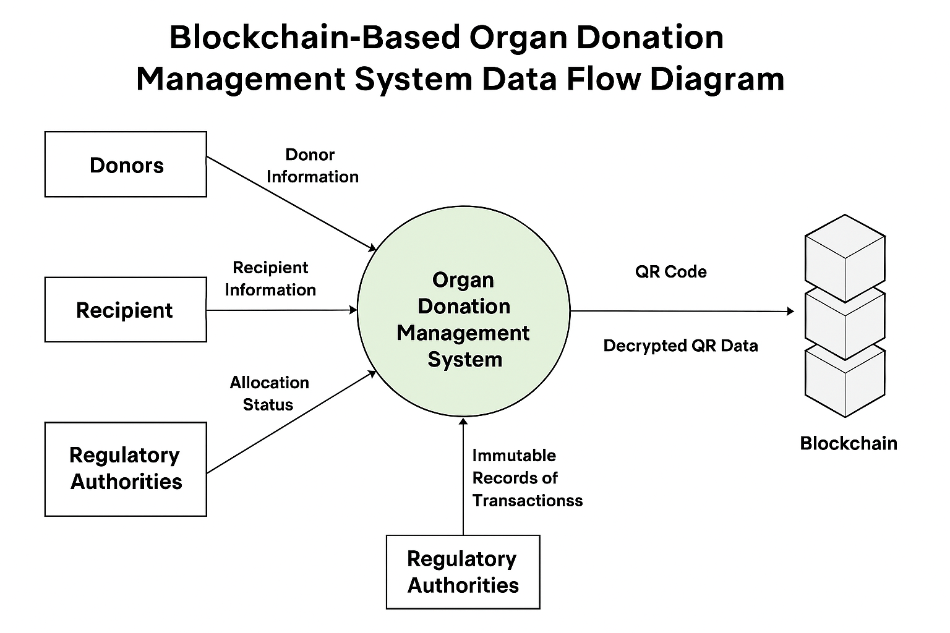
Figure.4.2. Data flow diagram.

Figure 4.2 presents the Data Flow Diagram of the Blockchain-Based Organ Donation Management System, offering a clear visualization of how information circulates among key entities within the platform. At the center of the diagram is the Organ Donation Management System, which serves as the core processing unit. Donors contribute their personal and medical data as "Donor Information," while recipients submit "Recipient Information" and receive updates on their "Allocation Status" from the system. Regulatory Authorities are provided with "Immutable Records of Transactions," ensuring transparency and compliance with ethical standards. The system also interacts with the Blockchain, which receives "Decrypted QR Data" and returns a secure "QR Code" to the system. This integration of blockchain technology ensures that all data exchanges are secure, traceable, and tamper-proof, reinforcing trust among stakeholders and streamlining the organ donation process.

CHAPTER 5

IMPLEMENTATION

STEP 1: IMPORTING PYTHON LIBRARIES
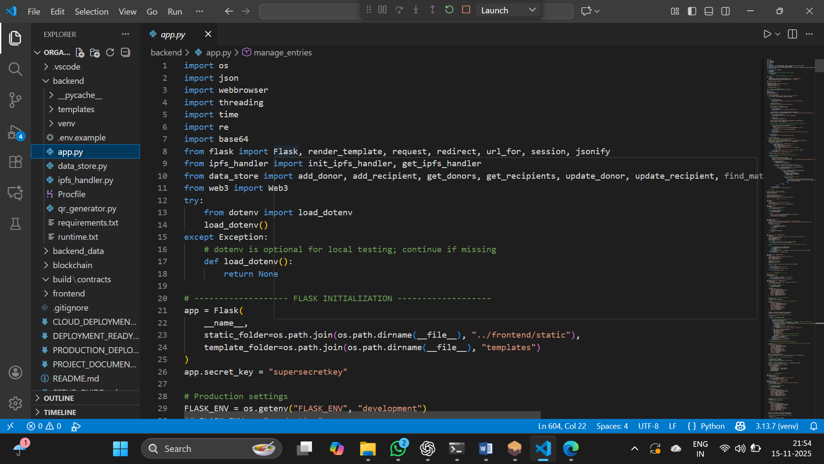

STEP 2: MAIN BACKEND
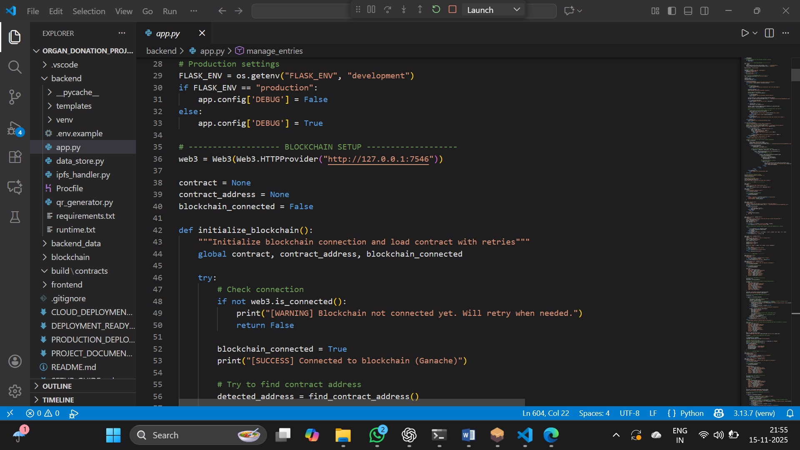

STEP 3: IPFS INTEGRATION
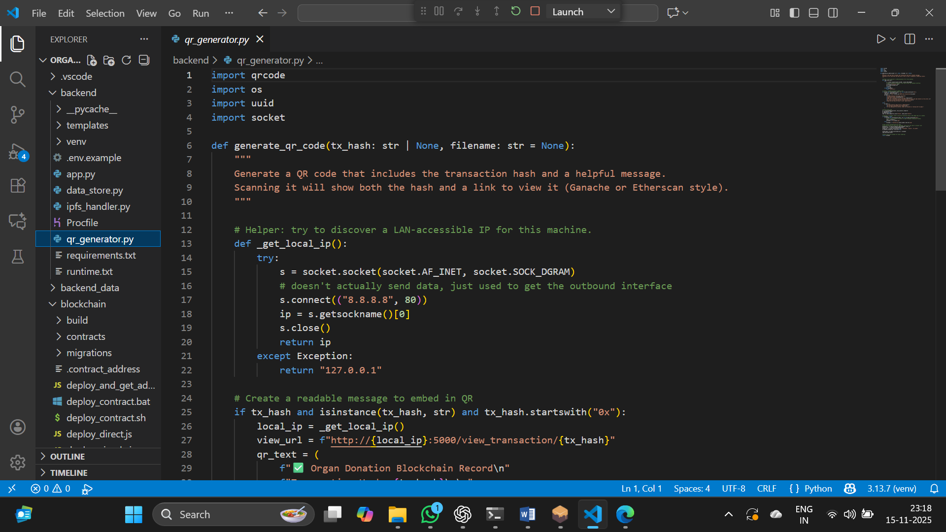
STEP 4: QRCODE GENERATOR
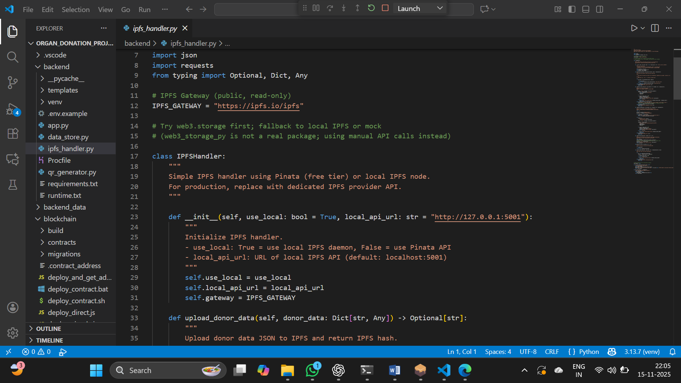

STEP 5: CREATING CONTRACT ADDRESS & BLOCKCHAIN SETUP
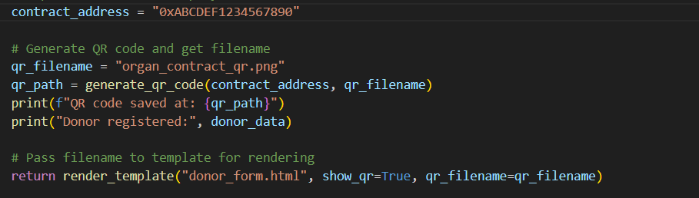
STEP 6: CREATING TRUFFLE MIGRATE
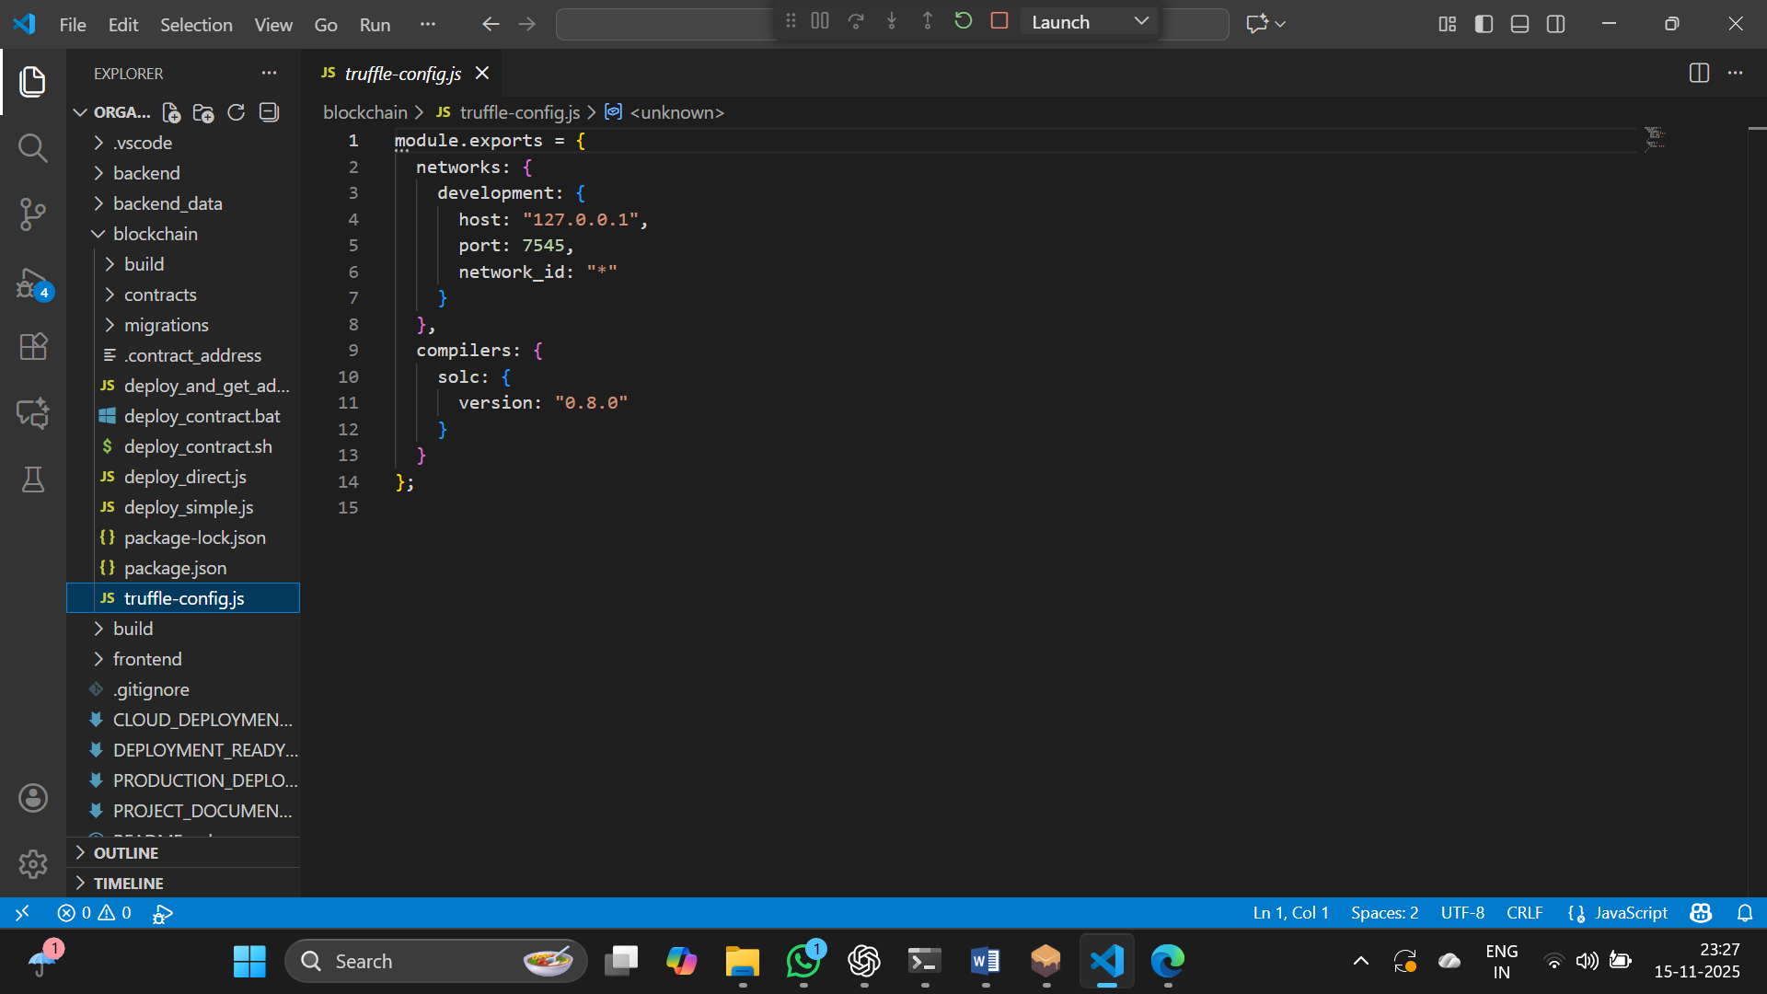

STEP 7: CREATING REGISTER FORM
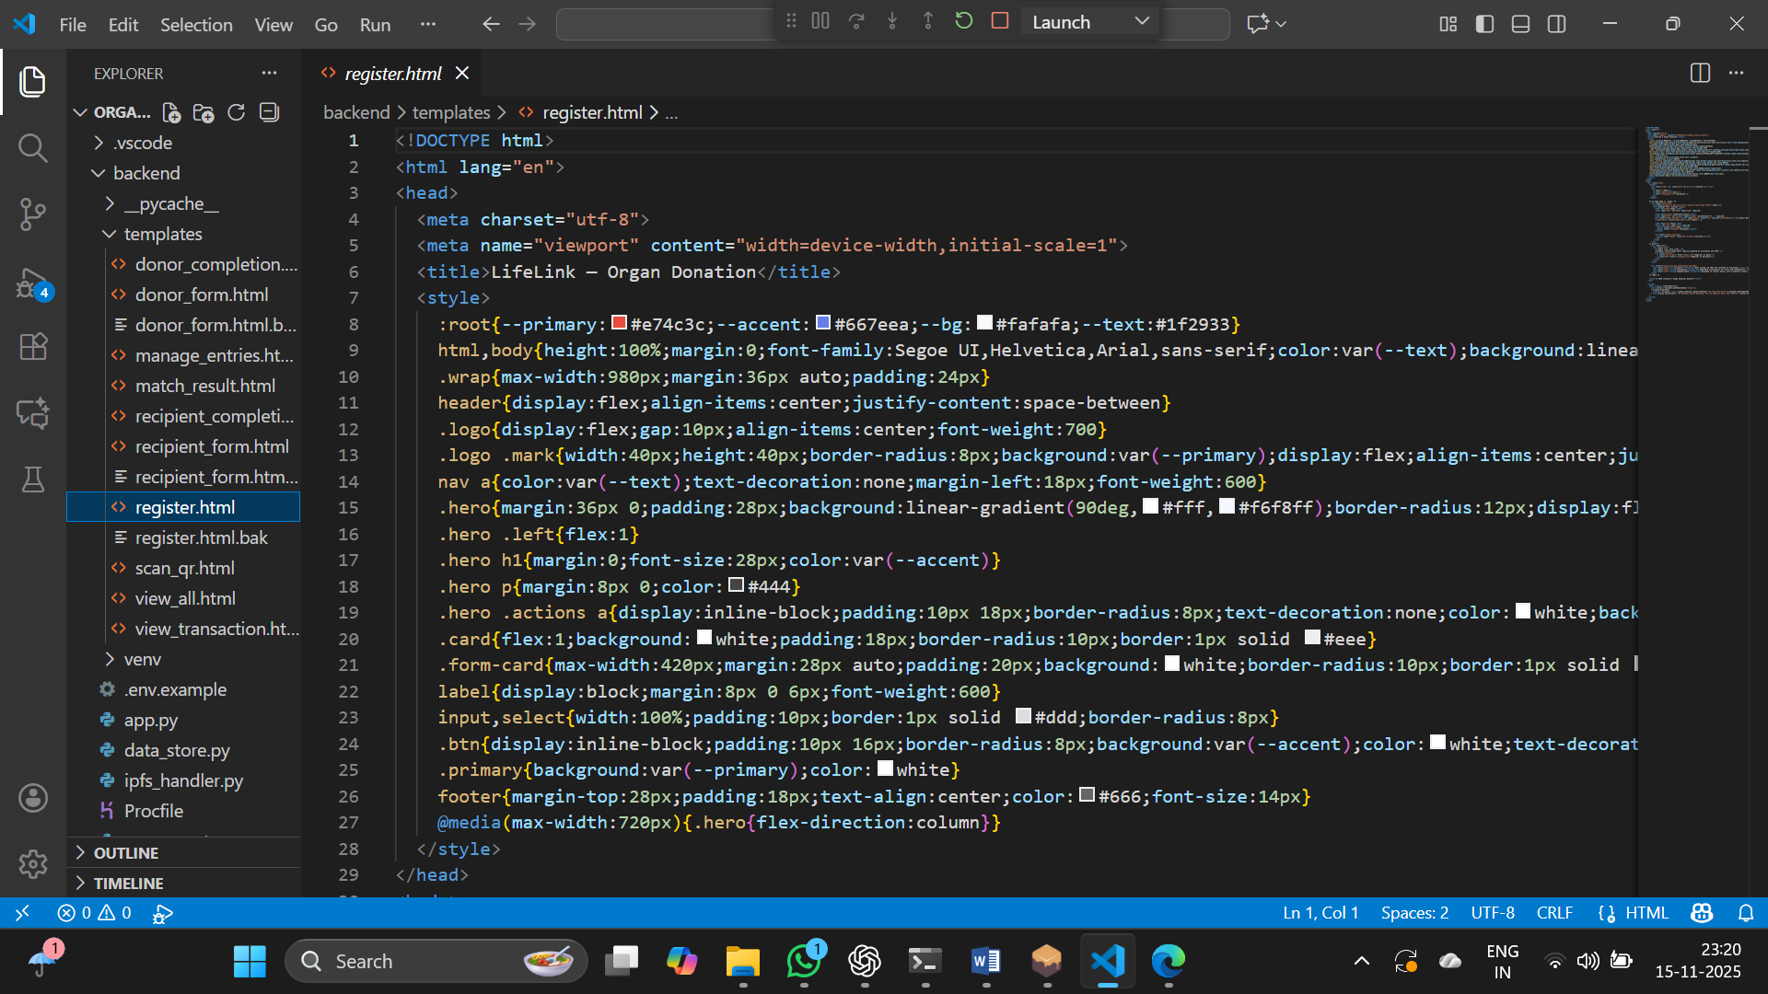

STEP 8: CREATING DONOR FORM
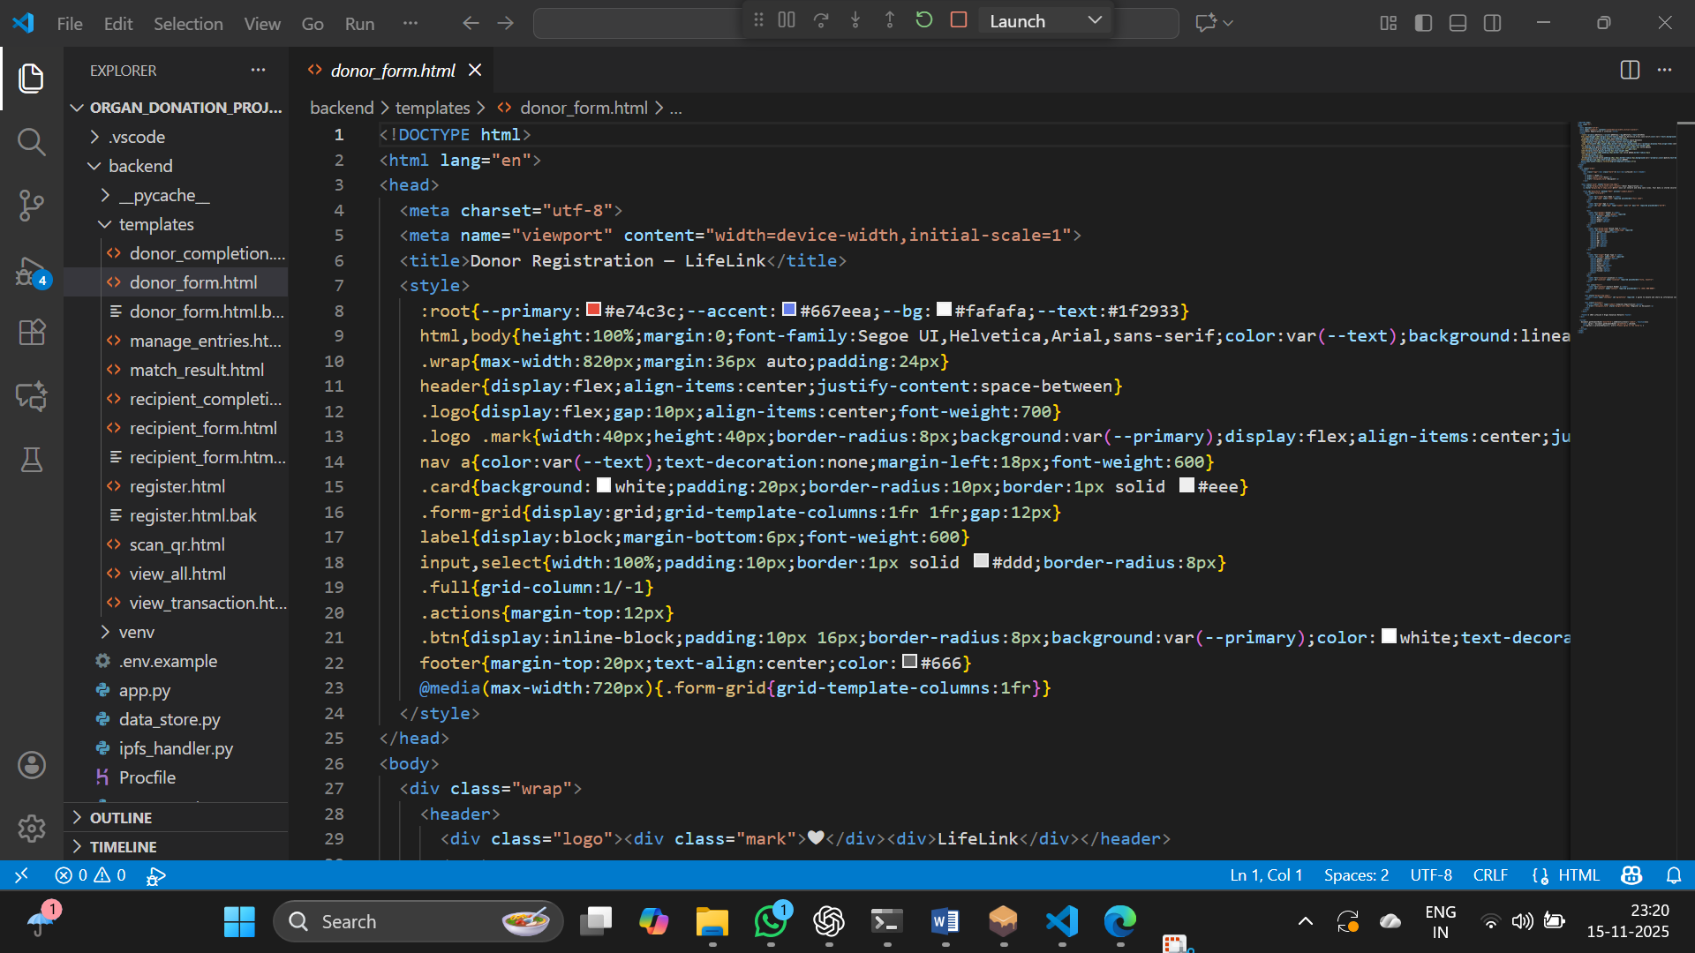

STEP 9: CREATING RECIPIENT FORM
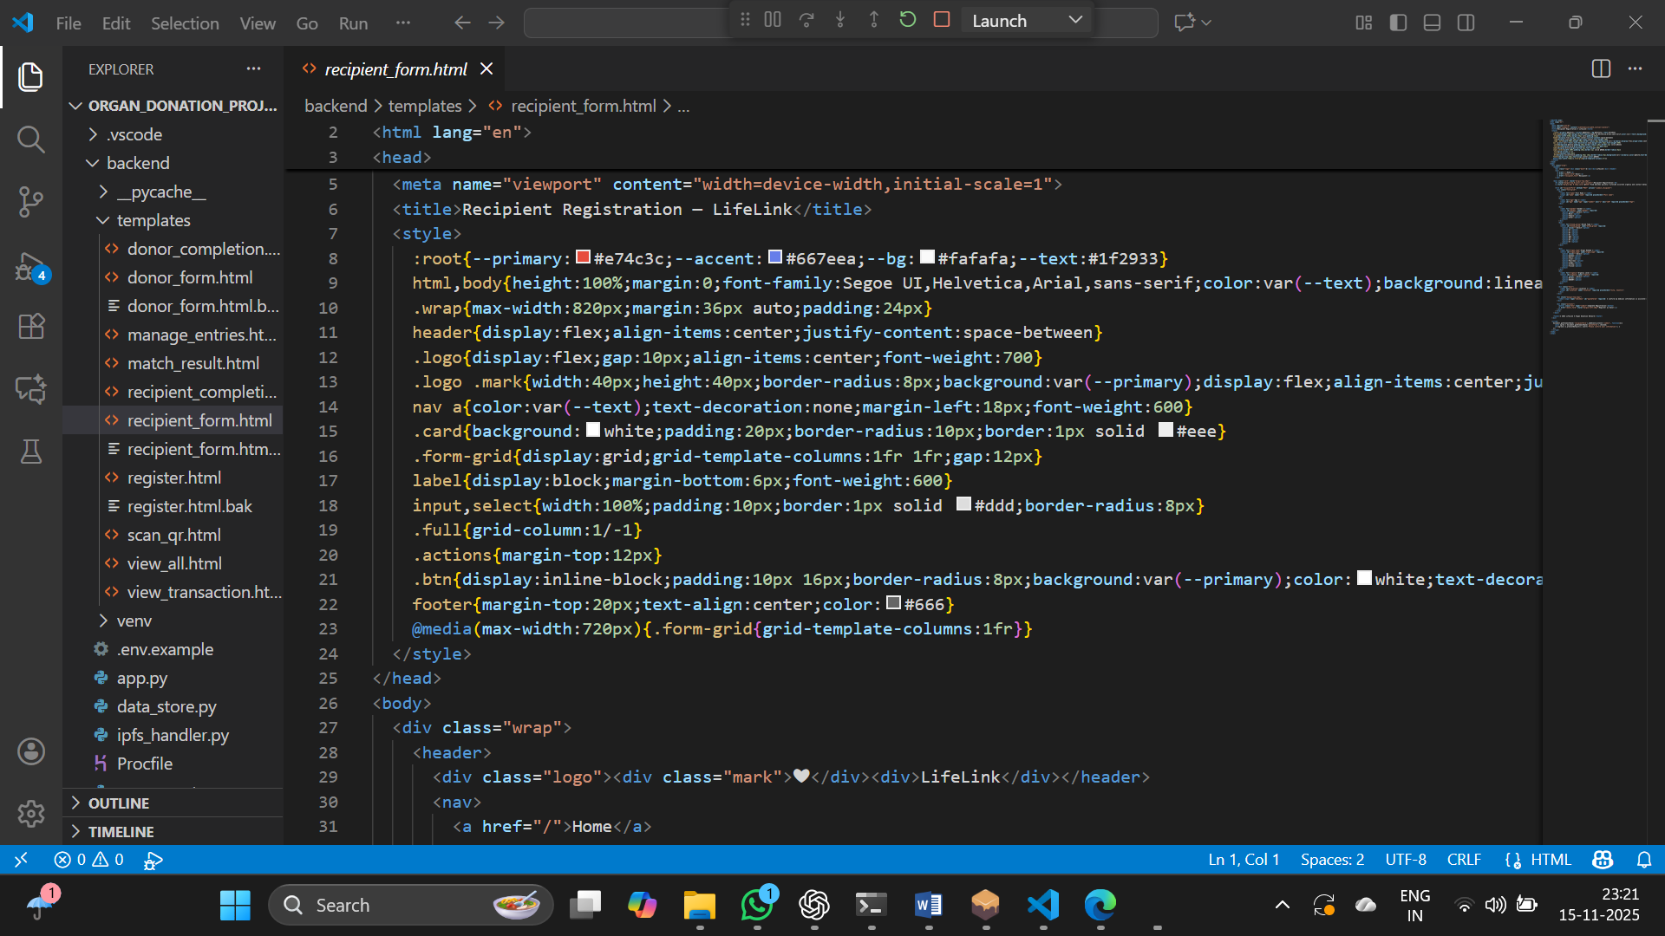

STEP 10: CREATING UI TO DISPLAY ALL ENTRIES
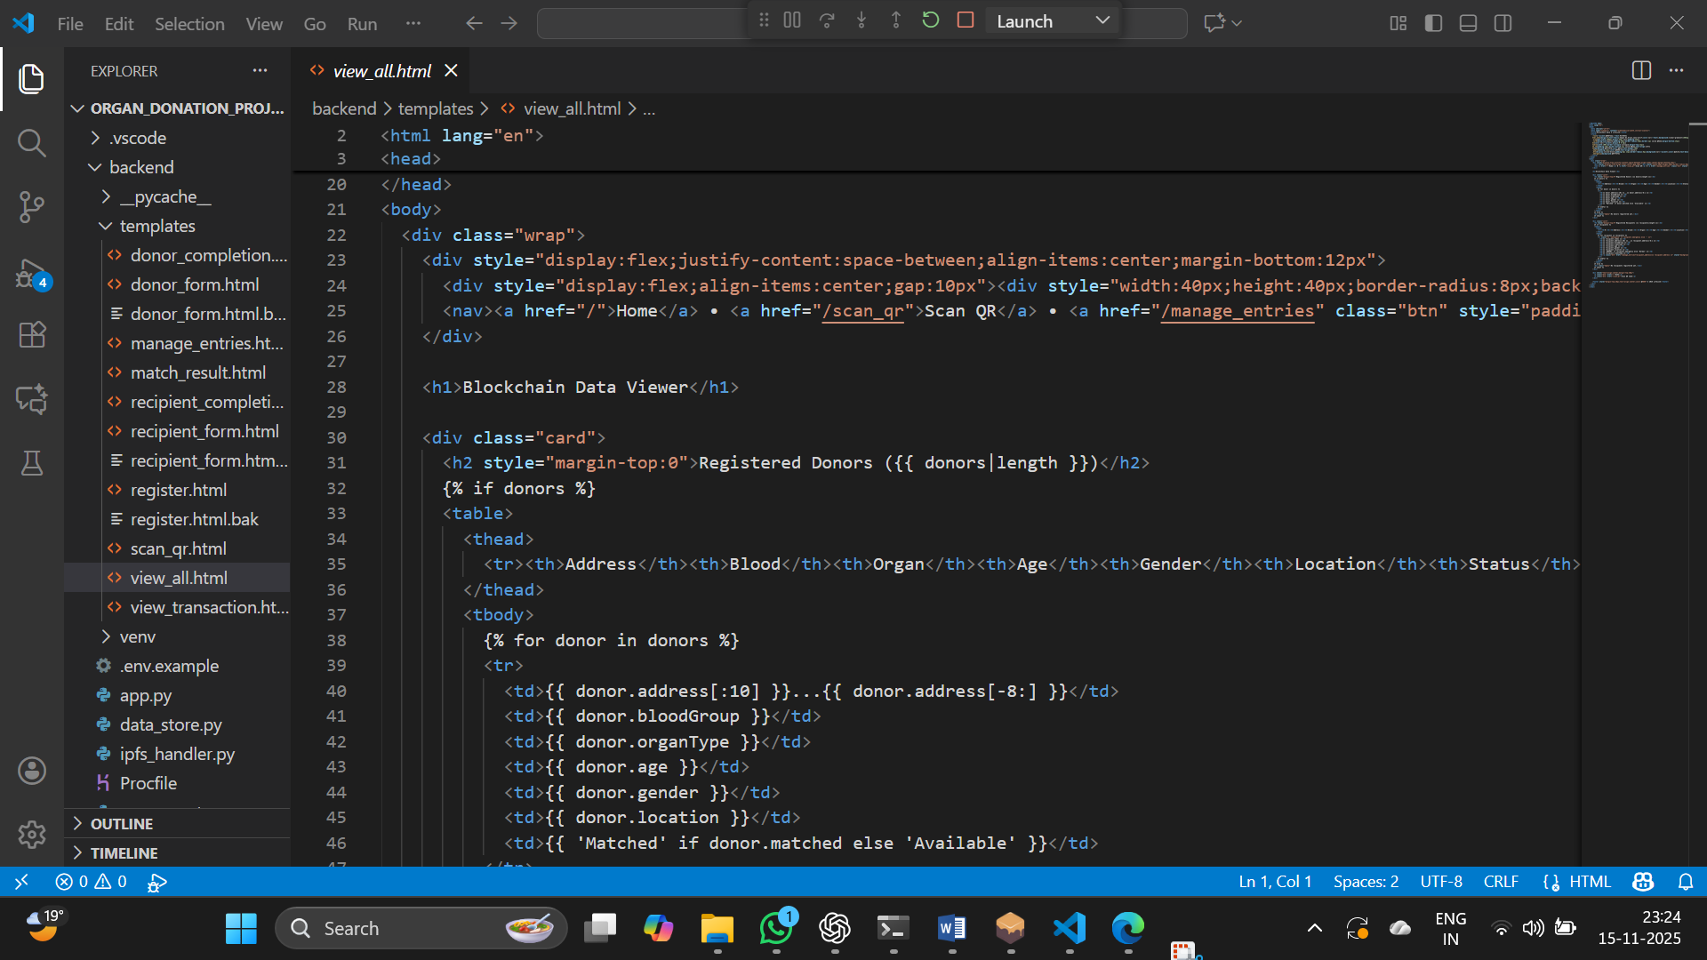

STEP 11: CREATING INTERFACE TO DISPLAY THE ORGAN MATCH
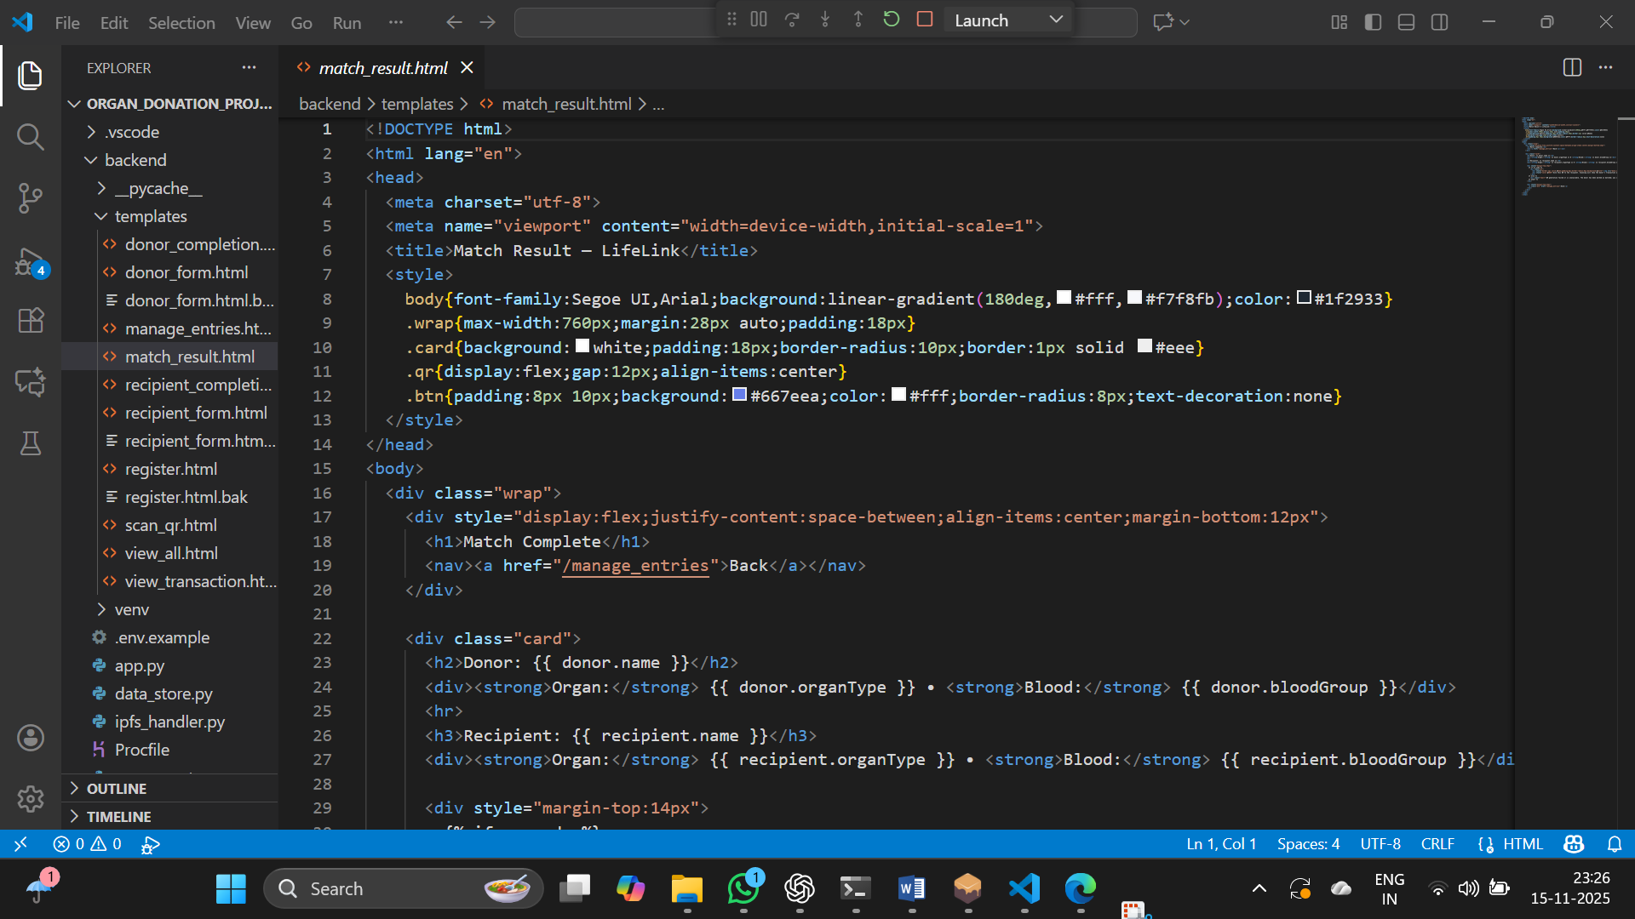

Description of the Implementation:
- app.py is the core Flask application server containing over 550 lines of Python code. It handles all HTTP routes for user registration, donor/recipient submissions, blockchain interactions, and data viewing. The file initializes the Flask app, manages blockchain connection to Ganache, loads the smart contract ABI, attempts IPFS integration, and defines all application endpoints. Key features include session management for user roles (donor/recipient), integration with the local data store for persistence, QR code generation on donor-recipient matching, tolerant QR code extraction that suggests candidates when exact matches aren't found, and fallback logic that loads locally stored entries when blockchain data is unavailable.

- ipfs_handler.py manages IPFS (InterPlanetary File System) integration, providing functions to upload donor and recipient data to IPFS and retrieve it later. The handler supports both local IPFS daemon mode and Pinata cloud storage, with a mock fallback for testing. It abstracts away the complexity of IPFS operations so the main application can simply call upload and download functions without worrying about the underlying protocol.

- qr_generator.py handles QR code generation, converting transaction hashes into scannable QR images. It takes a transaction hash as input and generates a PNG QR code file that is saved to the qr_code directory. This file is used during the matching workflow to provide donors with a QR code representing their transaction, which recipients or authorized personnel can later scan to verify the match.

- register.html is a multi-page UI that guides users through login and initial form selection. It provides input fields for entering a name, account address, and selecting a role (donor or recipient), then posts this data to the /login endpoint to start the registration process.

- donor_form.html is a standalone form for donor registration. It collects information such as name, blood type, organ type to donate, age, gender, location, and contact information. When submitted, it sends a POST request to /submit_donor which uploads the data to IPFS and registers it on the blockchain.

- recipient_form.html is a form for recipient registration that collects name, organ needed, blood type, age, gender, urgency level (reduced to just Normal or URGENT after recent changes), and location. Upon submission, the data is sent to /submit_recipient for blockchain registration.

- view_all.html displays all registered donors and recipients from the blockchain or local store in two tables. It includes a "Manage Entries" button in the header for quick access to the admin interface, and each recipient row has a green "Manage" button that links to the matching admin page with the recipient pre-selected via query parameter.

- manage_entries.html is the admin interface displaying lists of pending recipients and available donors. It allows an administrator to select a donor from a dropdown (filtered by organ type and blood group match) and click "Match" to pair them with a recipient. When a recipient is selected via query parameter from /view_all, that recipient's row is highlighted with a pale background for easy identification.

- match_result.html is shown after a successful donor-recipient match. It displays information about both the matched donor and recipient, and prominently shows the generated QR code to be given to the recipient or used for verification purposes.

CHAPTER 6

RESULTS

LOGIN PAGE:
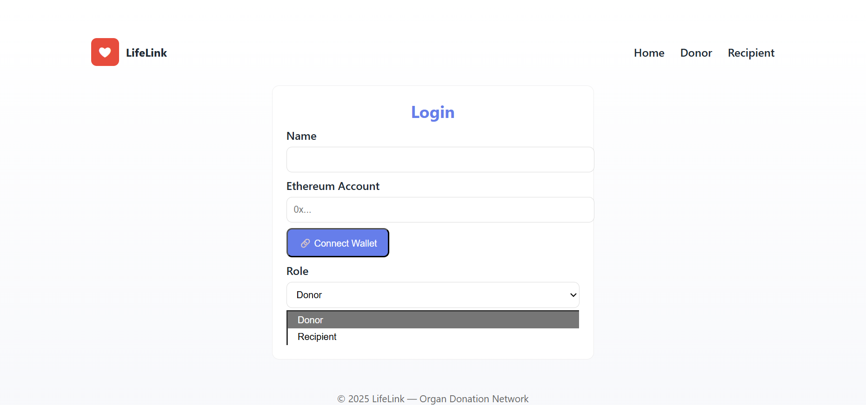

DONOR REGISTRATION:
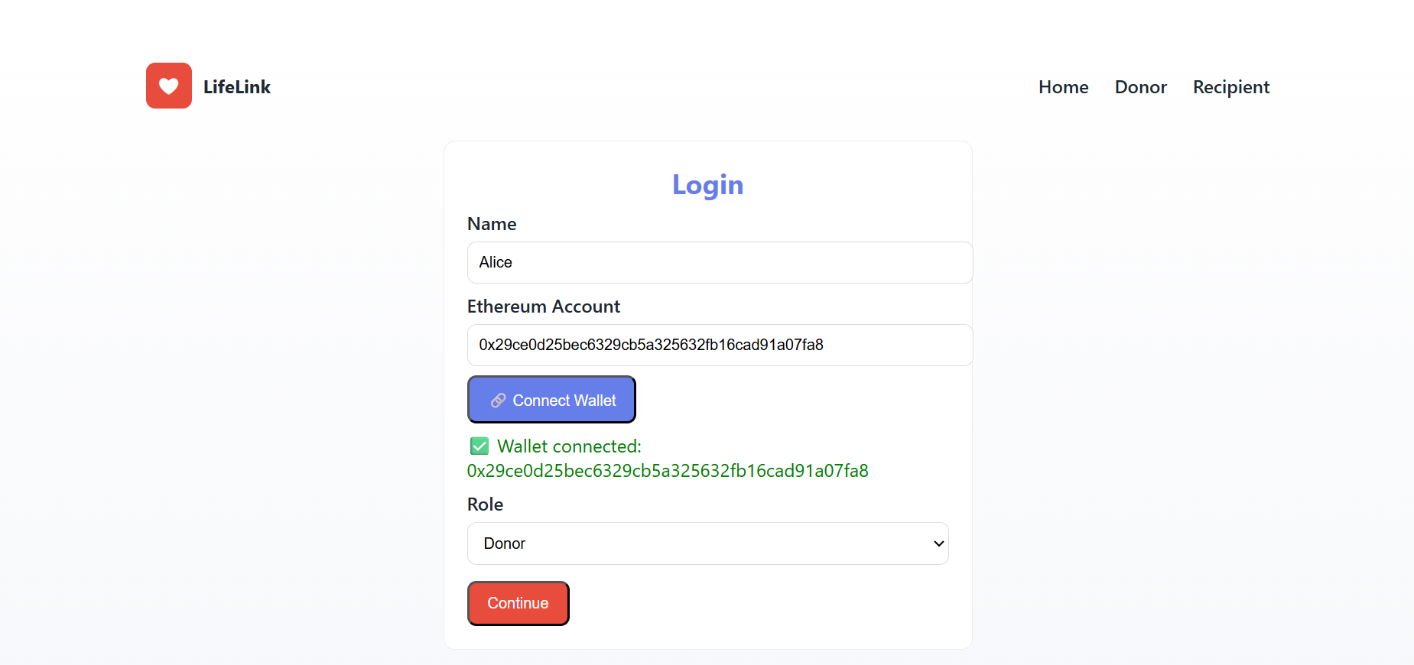

DONOR ENTRY:

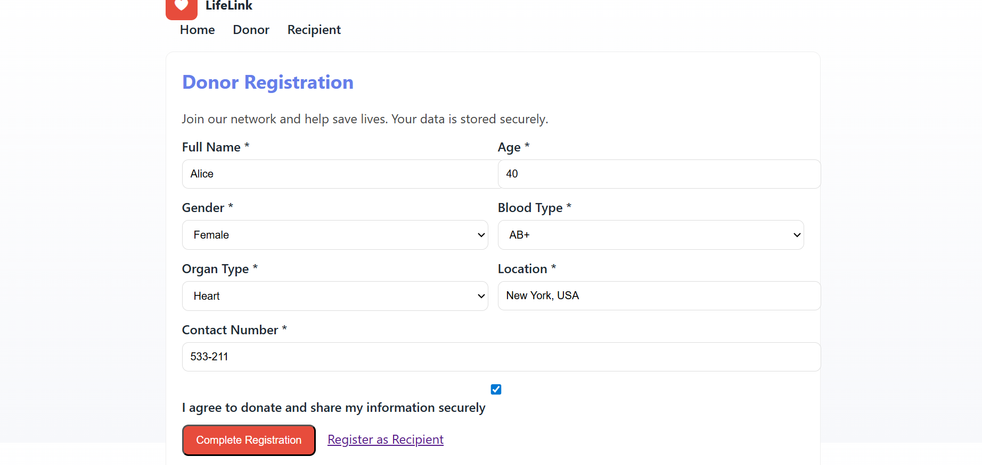

DONOR REGISTERATION SUCCESSFUL:
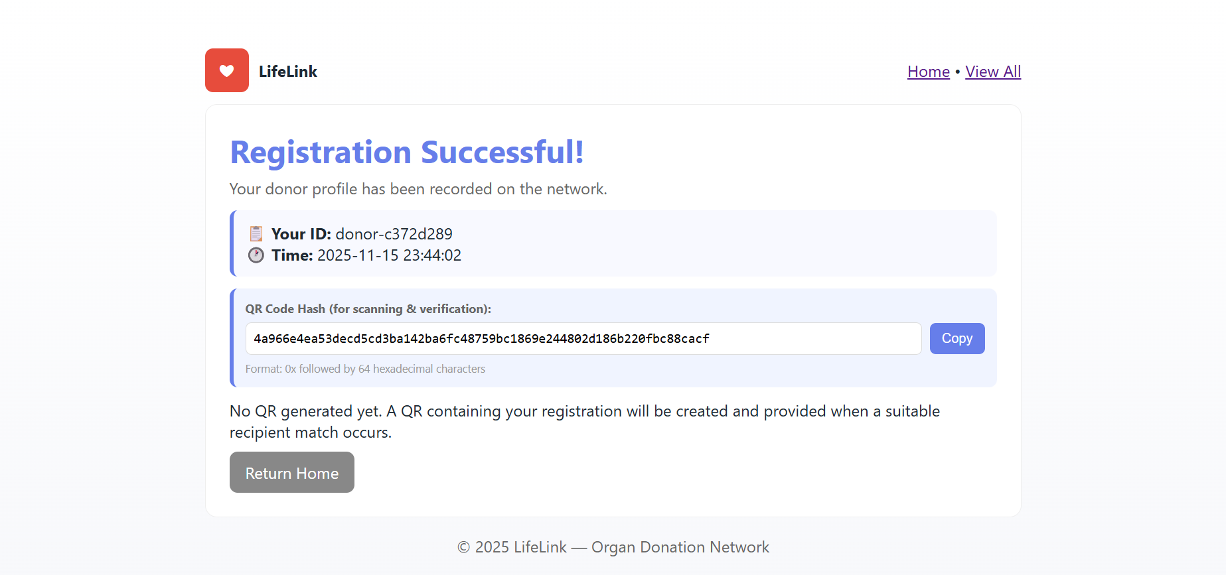

RECIPIENT REGISTRATION:
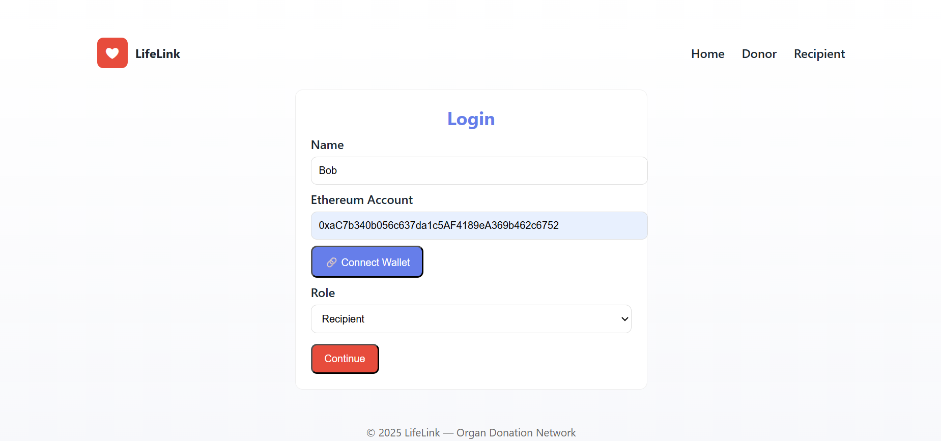

RECIPIENT ENTRY:

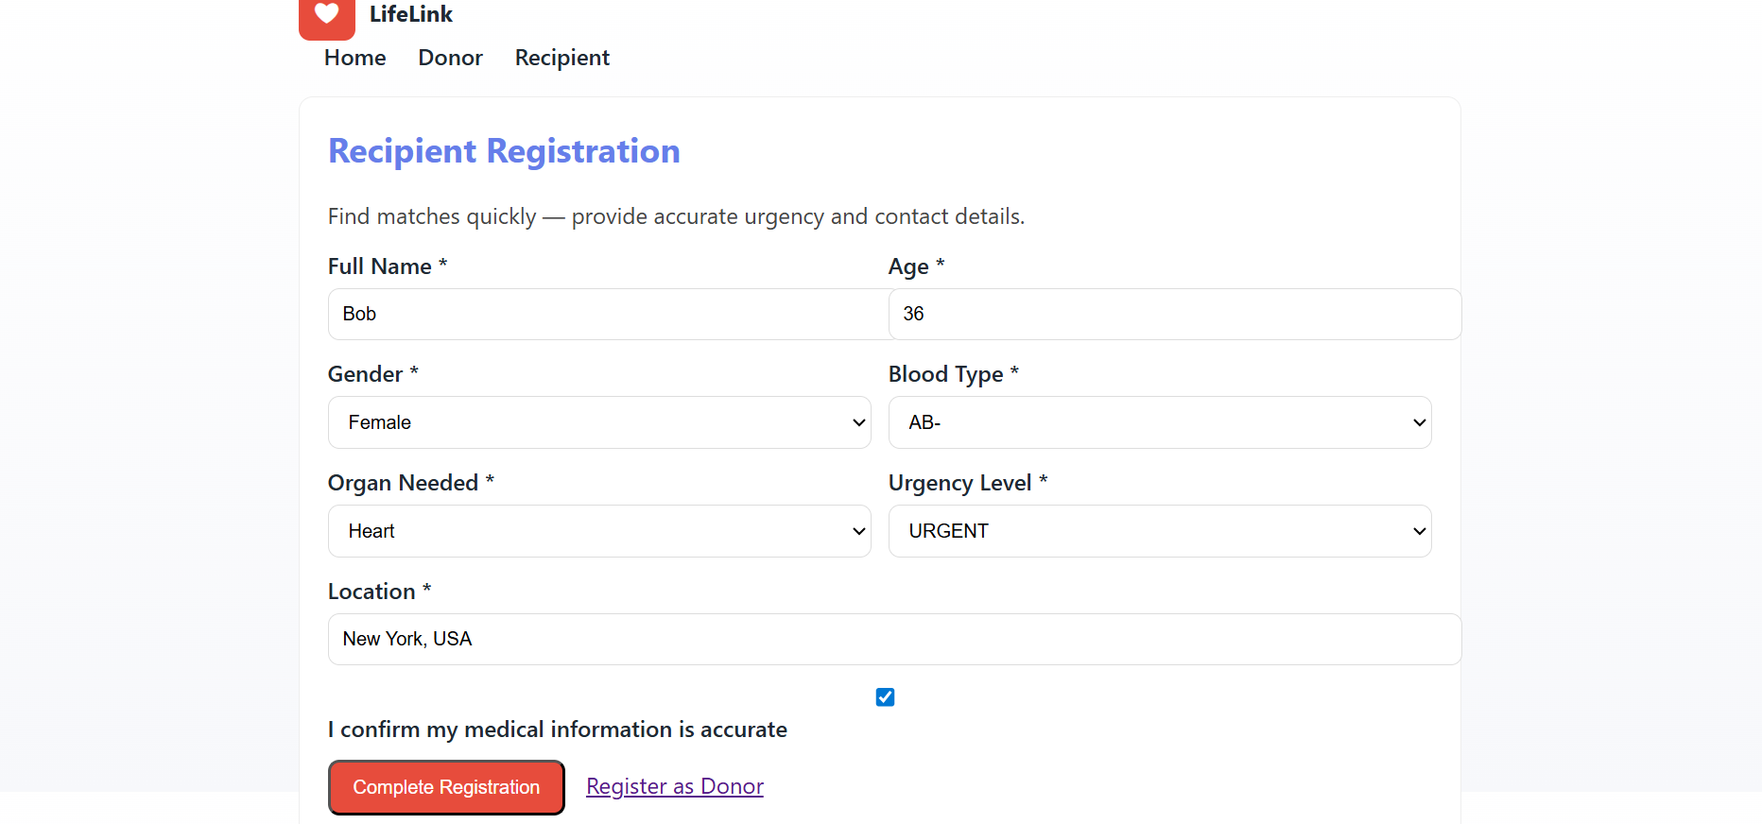

RECIPIENT REGISTERATION SUCCESSFUL:
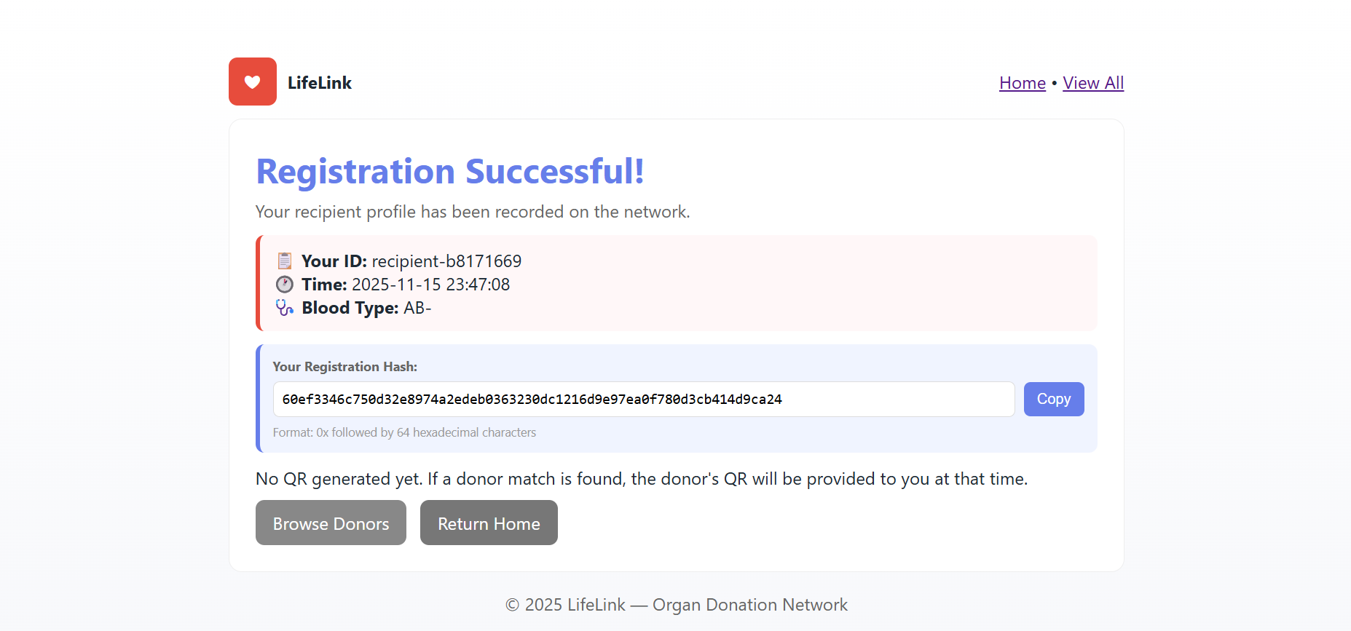

DATA STORED IN BLOCKCHAIN:

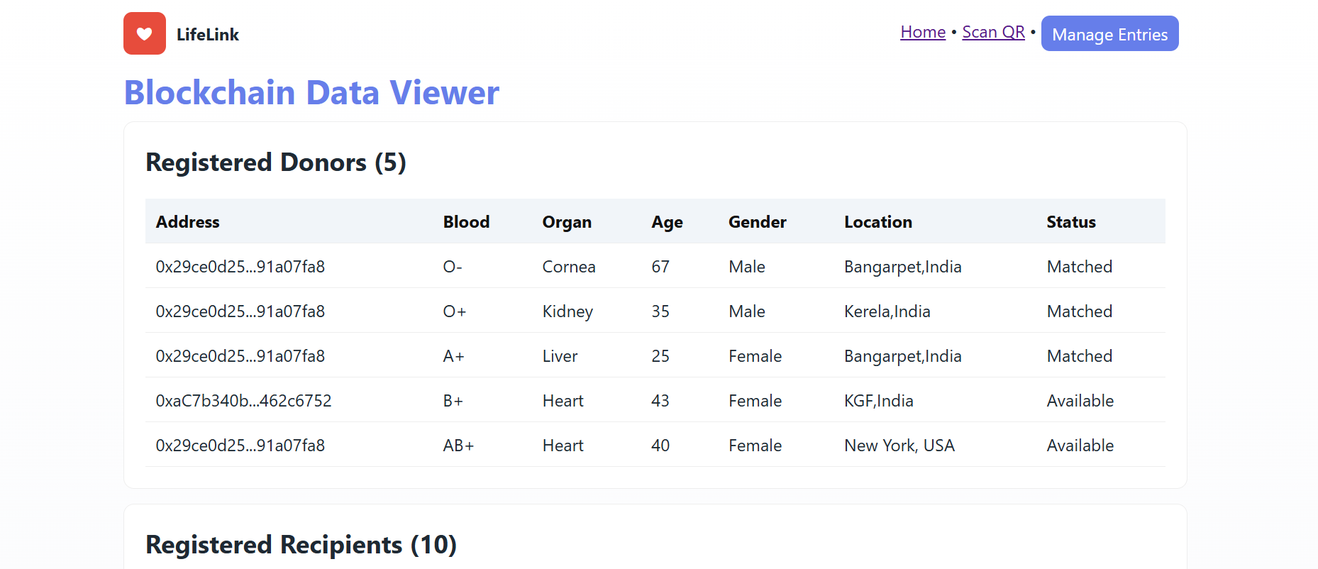

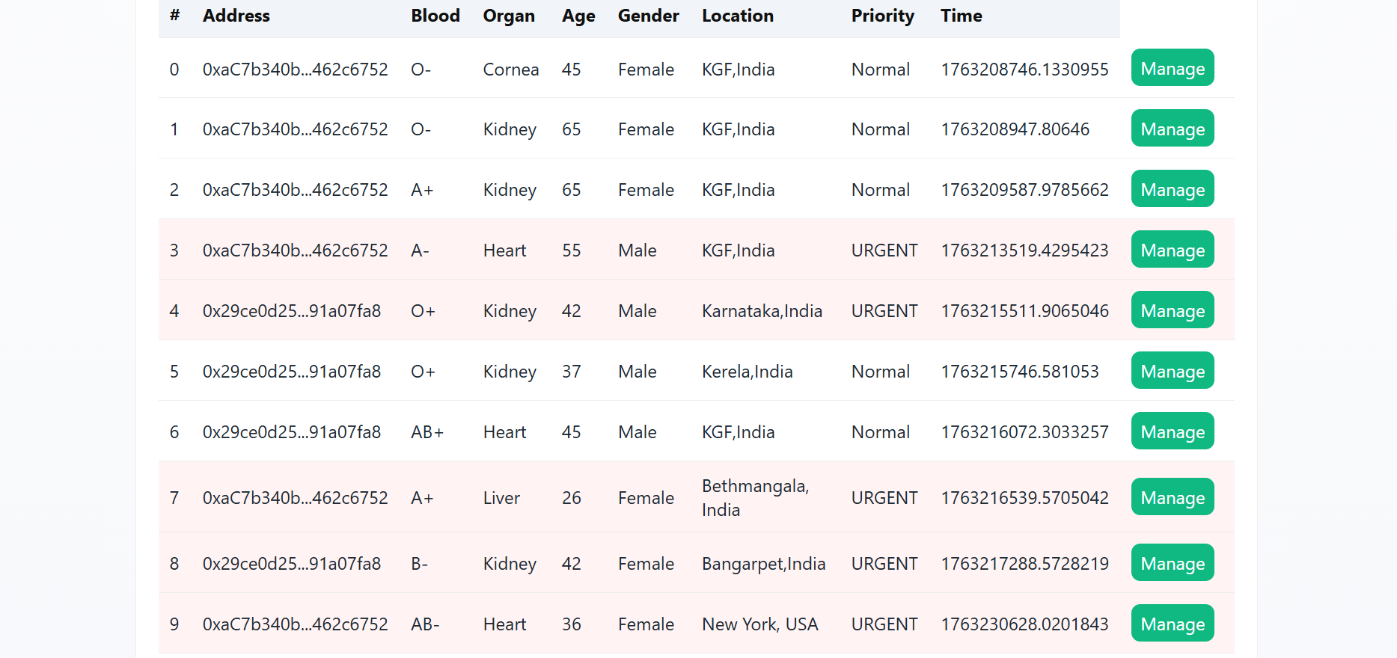

SCANNING GENERATED QR CODE DATA:
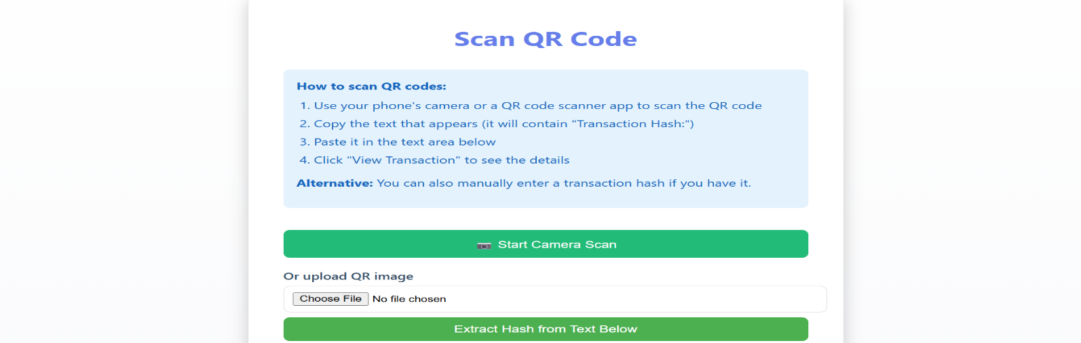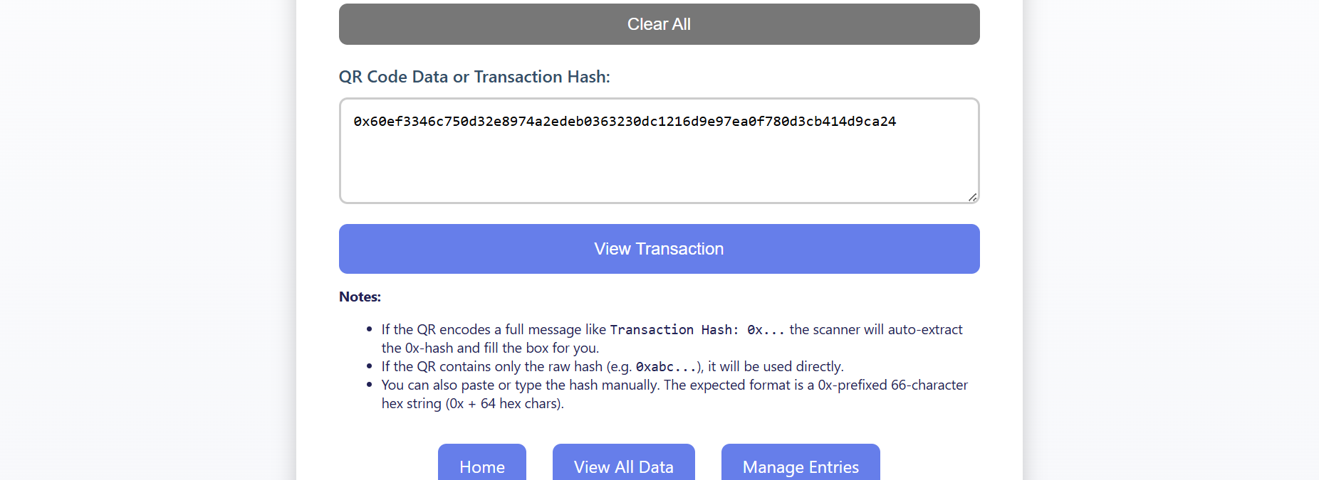

TRANSACTION DETAILS:
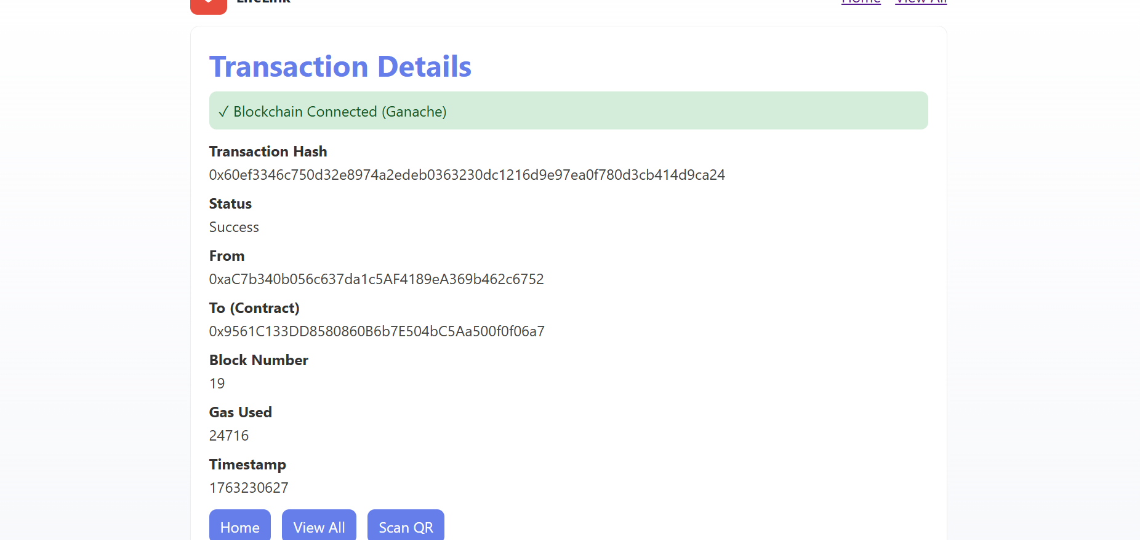

CHOOSING ORGAN TO MATCH:

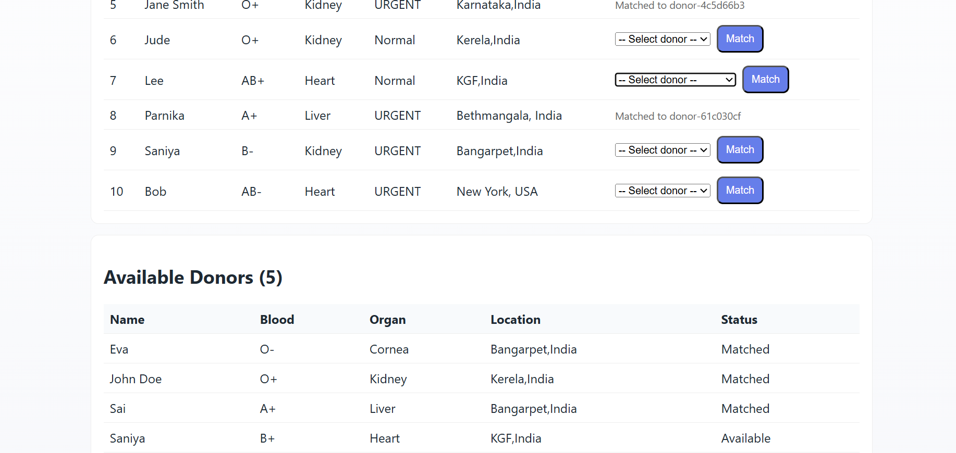

ORGAN MATCH COMPLETE:

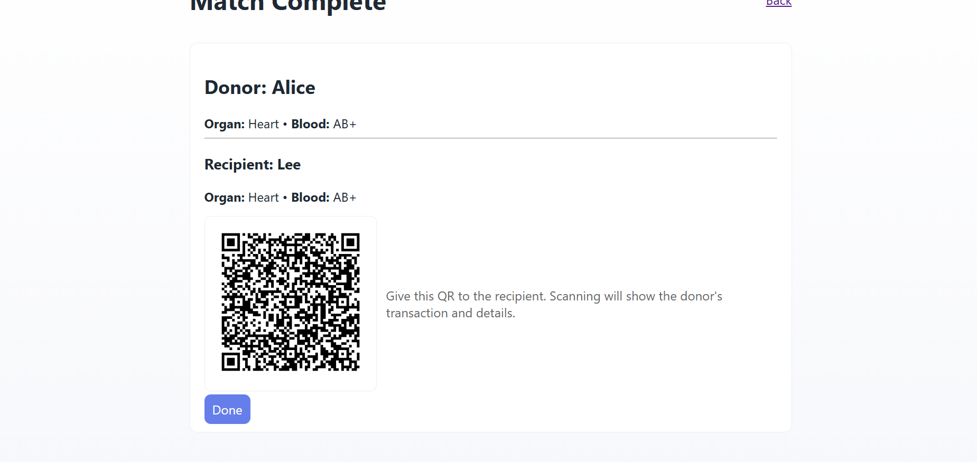

ORGAN MATCH SUCCESSFUL:

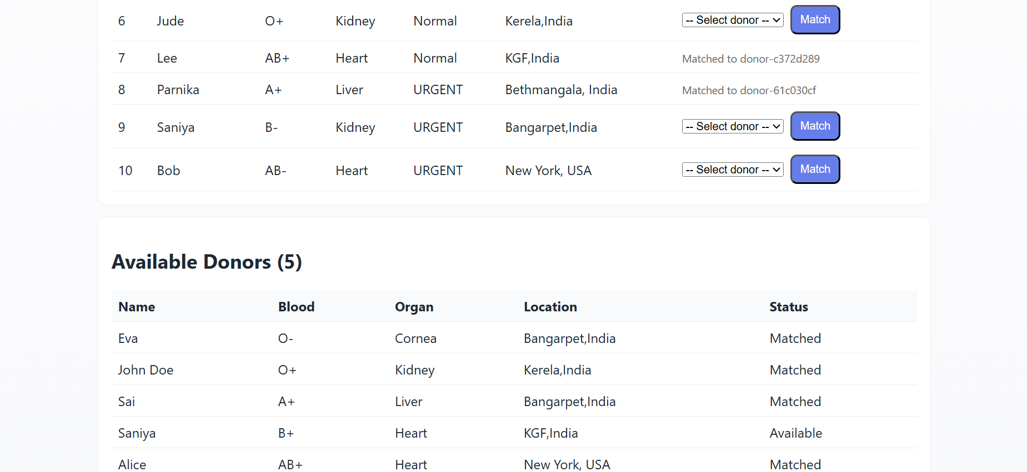

CHAPTER 7

CONCLUSION
CONCLUSION:
The proposed Blockchain-Based Secure Framework for Organ Donation presents a robust and technologically advanced solution to the challenges associated with conventional organ donation and transplantation systems. Centralized databases are prone to manipulation, delays, and inconsistencies, which can adversely affect organ allocation and reduce trust among stakeholders. By integrating blockchain technology, smart contracts, and QR-based verification, the framework ensures secure, transparent, and efficient management of donor and recipient data.
Blockchain’s immutable ledger guarantees that medical records and registration information remain tamper-proof, thereby enhancing data integrity throughout the organ donation workflow. Smart contracts automate the donor–recipient matching process based on validated medical parameters, reducing manual intervention and minimizing the likelihood of human error. This automation accelerates the allocation process and promotes fairness by ensuring that organs are assigned according to predefined and transparent criteria. The incorporation of QR-based authentication further strengthens security by enabling rapid and accurate verification of identities and records during critical stages of transplantation.
The decentralized architecture eliminates dependency on a single authority and mitigates risks associated with system failures or unauthorized modifications. By enabling multiple authorized nodes—such as hospitals, transplant coordinators, and regulatory bodies—to access synchronized and verified data, the framework significantly improves operational efficiency and inter-institutional coordination. Its scalability allows seamless integration of additional hospitals, donors, and organ types without compromising performance or security.
Overall, the framework demonstrates that blockchain technology can effectively address long-standing issues in organ donation systems by providing a secure, transparent, and reliable platform. By reducing delays, improving accuracy, and fostering trust, the proposed model contributes to a more equitable and efficient organ allocation process. This advancement highlights the potential of emerging technologies to enhance critical healthcare services and ultimately support better patient outcomes.
REFERENCES:
[1] Q. Xia, E. B. Sifah, K. O. Asamoah, J. Gao, X. Du, and M. Guizani, “MeDShare: A Secure Medical Data Sharing Scheme Based on Blockchain,” IEEE Access, vol. 5, pp. 14757–14767, 2017. Available:https://www.researchgate.net/publication/318666875_MeDShare_Trust-less_Medical_Data_Sharing_Among_Cloud_Service_Providers_Via_Blockchain?utm_source=chatgpt.com
[2] N. Szabo, “Smart Contracts: Building Blocks for Digital Markets,” Extropy Journal, 1997. Available: https://docslib.org/doc/246577/smart-contract-building-blocks-for-digital-markets?utm_source=chatgpt.com
[3] P. Zhang, J. White, D. C. Schmidt, and G. Lenz, “Applying Blockchain Technology in Healthcare: Privacy and Security,” Journal of Biomedical Informatics, 2018. Available:https://www.dre.vanderbilt.edu/~schmidt/PDF/blockchain-bookchapter-2018.pdf?utm_source=chatgpt.com
[4] B. Geet, H. Singh, S. Rani, A. Kataria, and H. Min, “Exploring Perspectives of Blockchain Technology and Traditional Centralized Technology in Organ Donation Management,” Information, vol. 15, no. 11, p. 703, 2024.
Available: https://www.mdpi.com/2078-2489/15/11/703?utm_source=chatgpt.com#metrics
[5] A. Anselmo, M. Materazzo, N. Di Lorenzo, B. Sensi, C. Riccetti, M. T. Lonardo, M. Pellicciaro, F. D’Amico, L. Siragusa, and G. Tisone, “Implementation of Blockchain Technology Could Increase Equity and Transparency in Organ Transplantation: A Narrative Review of an Emergent Tool,” Transplant International, vol. 36, p. 10800, 2023. Available:https://pmc.ncbi.nlm.nih.gov/articles/PMC9945518/?utm_source=chatgpt.com
[6] E. Calik and M. Bendechache, “Blockchain for Organ Transplantation: A Survey,” Blockchains, vol. 2, no. 2, p. 8, 2024.
Available: https://www.mdpi.com/2813-5288/2/2/8?utm_source=chatgpt.com
[7] L. Soltanisehat, A. Alizadeh, A. Rahmani, S. Soltanisehat, and G. Wright, “Technical, Temporal, and Spatial Research Challenges & Opportunities in Blockchain-Based Healthcare: A Systematic Literature Review,” IEEE Transactions on Engineering Management, 2023. Available:https://www.econbiz.de/Record/technical-temporal-and-spatial-research-challenges-and-opportunities-in-blockchain-based-healthcare-a-systematic-literature-review-soltanisehat-leili/10014231523?utm_source=chatgpt.com
[8] P. K. Kumar and M. M. Sandarsh Gowda, “Using Blockchain Technology for Tracking Organ Transfers and Donation Procedures,” IJARCCE, 2024.
Available: https://ijarcce.com/papers/using-blockchain-technology-for-tracking-organ-transfers-and-donation-procedures/?utm_source=chatgpt.com
[9] S. T. Shanmathi, K. S. Kumar, R. Kiruthika, and G. Kiruthika, “Blockchain-Based Management for Organ Donation and Transplantation,” IJSREM, 2024. Available:https://ijsrem.com/download/blockchain-based-management-for-organ-donation-and-transplantation/?utm_source=chatgpt.com
[10] S. Begum S., G. Hanvitha, T. Mahalakshmi, and A. Prathyusha, “Blockchain-Based Organ Donation System: A Secure and Transparent Solution,” IJARCCE, 2024.
Available: https://ijarcce.com/papers/blockchain-based-organ-donation-system-a-secure-and-transparent-solution/?utm_source=chatgpt.com
[11] R. O. Reddy, K. R. Sai Prasanna, and P. V. P. Krishna, “A Comprehensive Implementation and Analysis: Decentralized Organ Giving Using Blockchain DApp,” IJSREM, 2024.
Available: https://ijsrem.com/download/a-comprehensive-implementation-and-analysis-decentralized-organ-giving-using-blockchain-dapp-for-organ-donation/?utm_source=chatgpt.com

