Business Requirements Document

**Prepared by: Zhao Fei**

Version:1.0

Month 08, 2023

Revision History

|  |  |  |  |
| --- | --- | --- | --- |
| **Version** | **Date of Revision** | **Author of Revision** | **Brief Description of Revision** |
| 1.0 | 2023.08.1 | Zhao Fei(AA/BDO1-APAC) | Creation document |
|  |  |  |  |
|  |  |  |  |
|  |  |  |  |
|  |  |  |  |
|  |  |  |  |
|  |  |  |  |
|  |  |  |  |

Reviewers

|  |  |  |
| --- | --- | --- |
| **Reviewers** | **Representing Area** | **Date of Review** |
|  | *Example: BA / Project Manager / Architect / Technical Leader* |  |
|  |  |  |
|  |  |  |
|  |  |  |
|  |  |  |
|  |  |  |
|  |  |  |
|  |  |  |

* *This table is used to track the people who review this document.*

**Table of Contents**

1 Introduction 4

1.1 Project Background 4

1.2 Project Scope 4

1.3 Definitions, Acronyms, and Abbreviations 4

2 Functional Requirements 5

2.1 Affected Functional Areas 5

2.2 Detailed Functional Requirements 5

2.2.1 Indicator List and Definition 5

2.2.2 < Requirements ID: Indicator > 6

2.2.2.1 Define < Table Name > 6

2.2.2.2 Populate < Table Name > 6

2.2.3 < Requirements ID: Indicator > 6

3 Non-functional Requirements 6

3.1 Non-functional Affected Areas 7

3.2 Performance Requirements 7

3.3 Usability Requirements 7

3.4 Security Requirements 7

3.5 Legal Requirements 8

4 Project Impact Considerations 8

4.1 Project Assumptions 8

4.2 Project Constraints 8

4.3 Project Risks 8

5 Appendix 9

# Introduction

## Project Background

* Describe current situation
  + Dealer ERP transfer sellout and stock data to Bosch. In [Requirement 3010](https://dev.azure.com/AA-Digital-Transformation-APAC/AA%20Data%20Mart%20(APAC)/_workitems/edit/3010) and [Requirement 2525](https://dev.azure.com/AA-Digital-Transformation-APAC/AA%20Data%20Mart%20(APAC)/_workitems/edit/2525), data cleansing logic defined and development to convert material number from dealer ERP system to bosch material number.
  + Conversion logic define and develop for each data object separately, e.g. dealer ERP selllout and stock has different coding to convert bosch material number
* Describe business objectives of the project
  + Enhance data cleansing logic to increase successful conversion rate. Project Scope
  + Create a reusable function module to convert customer material number to Bosch material number for multiple data objects to reduce future maintenance complexity
* Document the scope of what this project will cover, including indicators, rules, data sources, etc.
  + Data source
    - Dealer data domain
      * Regional dealer sellout
      * Regional dealer stock
    - Product data domain
      * Dealer product number mapping
      * Bosch product master data
* Document the system overview and boundries.

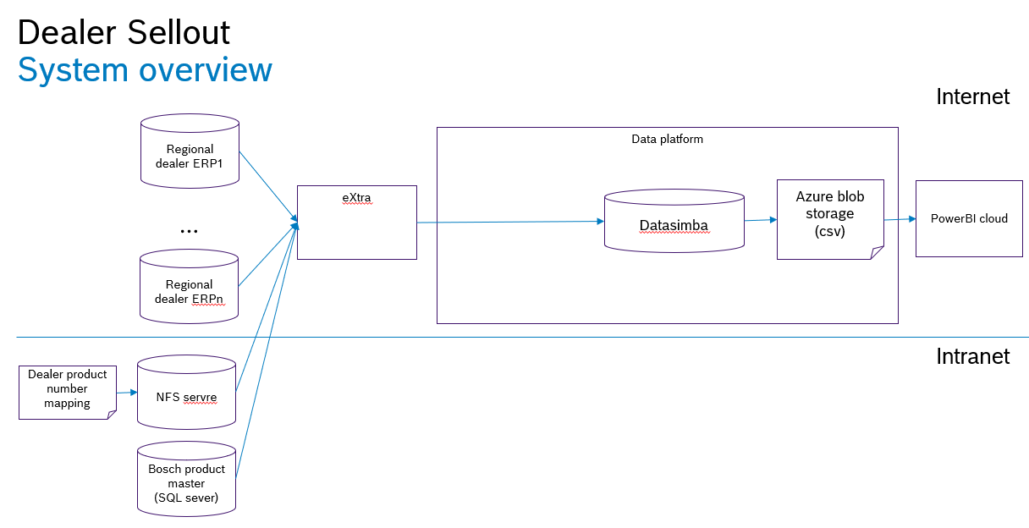

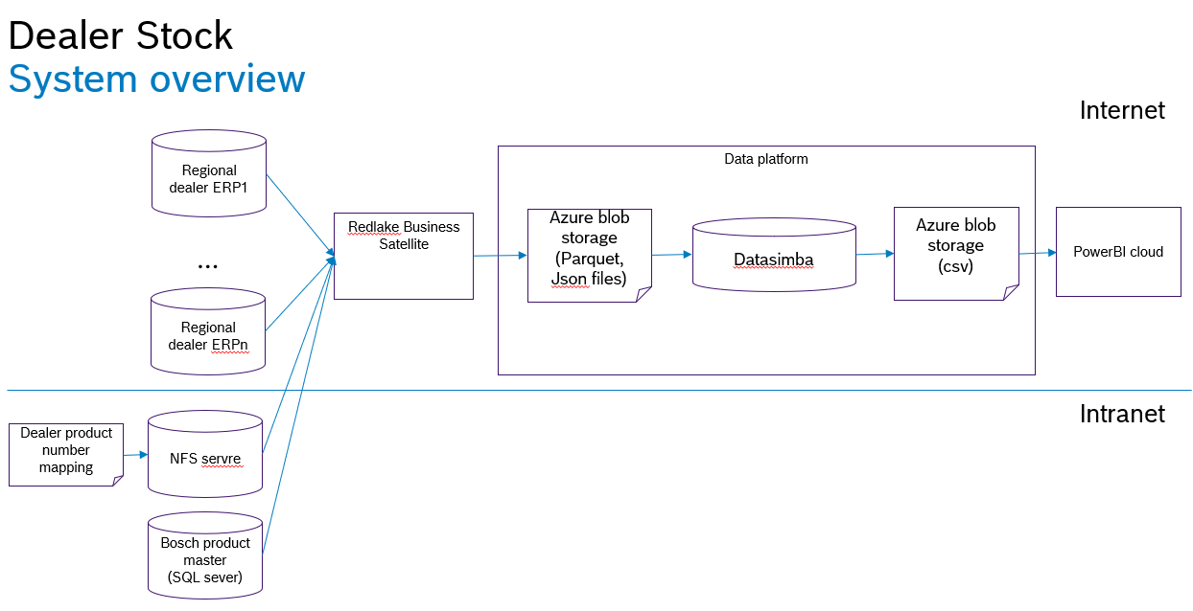

* Document functionality that is out of scope.

## Definitions, Acronyms, and Abbreviations

The first-time usage of any term, acronym, or abbreviation within this document are defined in the table below.

*Table 1. Definitions, Acronyms, and Abbreviations*

| Term | Definition |
| --- | --- |
| *Example:*  *BRD* | *Business Requirements Document. The document recording changes in work activities and work practices, usually including the introduction of new information systems and/or services, to help the organization achieve its aims and objectives.* |
|  |  |

# Functional Requirements

This section describes the detailed functional requirements.

## Affected Functional Areas

The following table is a checklist indicating areas that are or are not affected by this project. Note that “Areas” and “Considerations” are not all-inclusive, but is meant to elicit dialog between different teams and groups.

*Table 2. Affected Functional Areas*

| Areas | Considerations | Affected (Yes or No) | Manner Affected |
| --- | --- | --- | --- |
| *Dealer* | *Are change needed in Dealer data domain* | Yes | Dealer sellout  Dealer Stock |
|  |  |  |  |

## Detailed Functional Requirements

This section documents all detailed requirements.

### < Requirements 1: boschpartno>

#### Enhance data cleansing logic for boschpartno

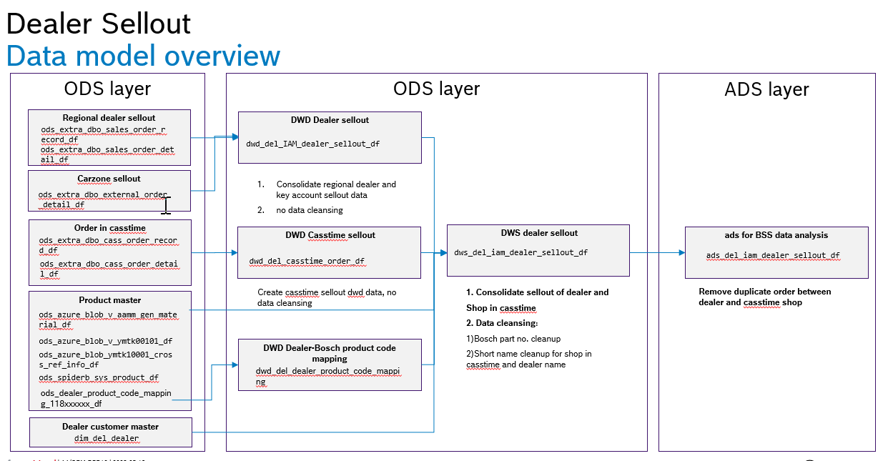

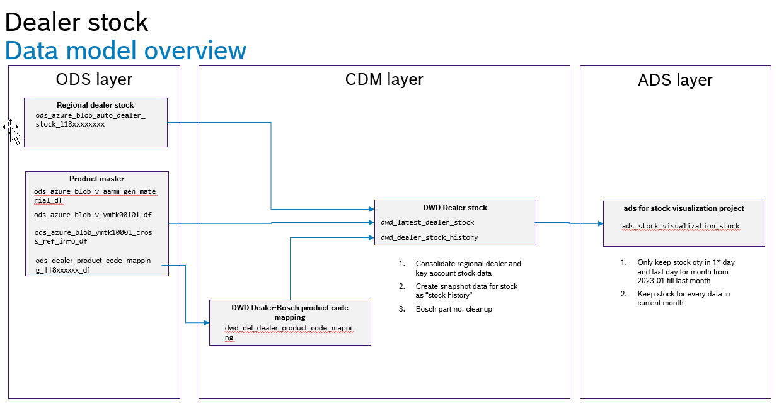

Data cleansing logic to be enhanced for below table and attribute

**Table name attribute**

dws_del_iam_dealer_sellout_df boschpartno

dwd_latest_dealer_stock boschpartno_verified

dwd_dealer_stock_history boschpartno_verified

**Current data cleansing logic is:**

1、和【dwd_del_dealer_product_code_mapping】中的【product_code】进行匹配，成功则输出此表中的【boschpartno】

2、清洗掉除字母、数字之外的符号后取前10位

3、和 “gen_material表” 中的“10位料号”进行匹配——ods_azure_blob_v_aamm_gen_material_df【material_10_digits】,如匹配上则填入【material_10_digits】，匹配不上进入步骤3

4、和 【ods_azure_blob_v_ymtk00101_df 】中的 “alternative number”【 comp_alt_no】 进行匹配，匹配成功输出此表中的“物料”字段【material】

5、和 【ods_azure_blob_ymtk10001_cross_ref_info_df】中的”原厂料号“【khnr_verd】进行匹配，成功则输出此表中“料号”字段【matnr】

6、如以上步骤都不能匹配到正确的博世料号，则输出0

**Target data cleansing logic:**

1、和【dwd_del_dealer_product_code_mapping】中的【product_code】进行匹配，成功则输出此表中的【boschpartno】

2、 以“|”和“/”为分隔符对dws_del_iam_dealer_sellout_df中的【product_code】和dwd_latest_dealer_stock中boschpartno进行分割，分割为多个product code/boschpartno。对于分割出来的多个product code/boschpartno，逐个做如下处理，如果识别出博世料号则完成步骤2.

* 2a. 清洗掉除字母、数字之外的符号
* 2b.取前10位，和 “gen_material表” 中的“10位料号”进行匹配【ods_azure_blob_v_aamm_gen_material_df】的【material_10_digits】,如匹配上则填入boschpartno【material_10_digits】，匹配不上进入步骤2c
* 2c.和 【ods_azure_blob_v_ymtk00101_df 】中的 “alternative number”【 comp_alt_no】 进行匹配，匹配成功输出此表中的“物料”字段【material】
* 2d.和 【ods_azure_blob_ymtk10001_cross_ref_info_df】中的”原厂料号“【khnr_verd】进行匹配，成功则输出此表中“料号”字段【matnr】
* 注意2c和2d不需要取前10位
* 当分割出得多个product code能成功匹配到多个不同得boschpartno时，取匹配到的第一个boschpartno输出

3、如以上步骤都不能匹配到正确的博世料号，则输出0

**Reusable function module for customer material number conversion**

Create a reusable function module to convert customer material number to Bosch material number for multiple data objects to reduce future maintenance complexity

**Rename DWD table name of stock**

Current table name ‘dwd_latest_dealer_stock’, ‘dwd_dealer_stock_history’ should be rename to ‘dwd_del_latest_dealer_stock’, ‘dwd_del_dealer_stock_history’

Test data:

* From app = ‘118002298’ 测试target logic step1
* From app = ‘118005947’ 测试target logic step2,3

### < Requirements 2: >

#### Automate data ingestion for dealer product code mapping table

Sales persons will collect “dealer product code mapping data” and manual upload the csv file to below NFS share folder. Different dealer will have different files with naming conversion “118xxxxx” (118xxxxx is the unique customer number in Bosch SAP system for specific customer)

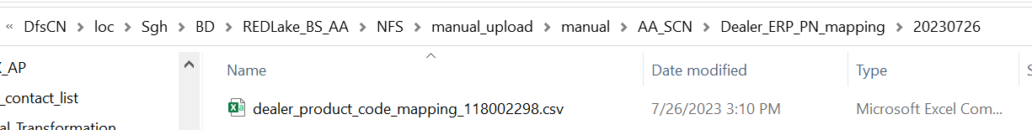

Redlake business satellite will sycronize the csv file from NFS to Azure blob storage in below container and folder

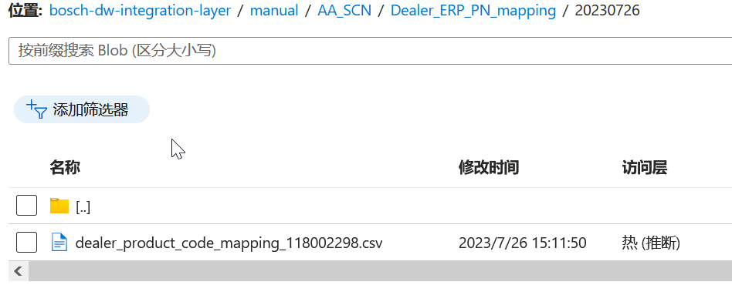

ods data to should be created automatically from the csv file. Each dealer should have different table name, e.g. ods_dealer_product_code_mapping_118xxxxxx_df

dwd table ‘dwd_del_dealer_product_code_mapping’ should consolidate all ods_dealer_product_code_mapping_118xxxxxx_df tables which already finished in [Requirement 3010](https://dev.azure.com/AA-Digital-Transformation-APAC/AA%20Data%20Mart%20(APAC)/_workitems/edit/3010)

# Non-functional Requirements

This section addresses non-functional requirements not associated with specific business functions but that must be met for project success.

## Non-functional Affected Areas

The following tables delineate whether or not specific non-functional areas relating to are/are not impacted by the implementation of this project.

*Table 7. Affected Non-functional Considerations*

| Area | Description | Affected (Yes or No) | Manner Affected |
| --- | --- | --- | --- |
| *Data Retention* | *\*\* Consult with Technical Lead and/or Architect* |  |  |
| *System Logging* | *\*\* Note: To be addressed with the Architect* |  |  |
| *Disaster Recovery* | *\*\* Note: To be addressed with the Architect* |  |  |
|  |  |  |  |

## Performance Requirements

Document requirements related to the speed of response, scalability, throughput, execution time and storage capacity.

## Usability Requirements

Document requirements related to the ease of use and understandability of the system for the end-users.

## Security Requirements

This section documents requirements related to the protection of the data from unauthorized access. This includes but is not limited to the followings:

1. Authorization from the data owner is required to access data.
2. Data permission should be assigned based on user roles.
3. Provide a list of data which must be stored or displayed in an encrypted form.
4. The data should be classified, and it is mandatory to review the classification with DSP.

*Table 8. Data Classification*

|  |  |  |  |  |  |
| --- | --- | --- | --- | --- | --- |
| **Business Object** | **Data Fields** | **Personal-related Data**  **(Yes/No)** | **C-SC Security Class** | **I-SC Security**  **Class** | **A-SC**  **Security**  **Class** |
| *Example:*  *Dealer stock* | *warehouseName*  *warehouseNo*  *productName*  *productCategory*  *stockQty*  *unit*  *loadTime* | *No* | *1* | *1* | *1* |
|  |  |  |  |  |  |

## Legal Requirements

The source and use of data must comply with legal requirements. This includes but is not limited to the followings:

1. Personal Information Protection Law should be obeyed when personal information is involved.
2. Provisions on the Administration of Algorithm Recommendation of Internet Information Services must be abided by, when the requirement includes algorithm recommendation services.

# Project Impact Considerations

## Project Assumptions

The following assumptions have been made for this project:

* <Assumption 1>.
* <Assumption 2>.
* <Assumption Etc.>.

## Project Constraints

The following constraints are associated with the delivery of this project:

* <Constraint 1>.
* <Constraint 2>.
* <Constraint, etc.>.

## Project Risks

The following risks have been identified during this phase of this project:

* <Risk 1>.
* <Risk 2>.
* <Risk, etc.>.

# Appendix

The following documents provide supporting information for this project:

* Appendix 1 - <Source to Target (Template)>
* <Appendix 2> - <Name of Document 2>

<Attached Document 2>

* <Appendix, etc.> - <Name of Document, etc.>

<Attached Document, etc.>